IOT BASED GAS LEAKAGE DETECTION AND CONTROL USING GSM AND ARDUINO WITH SMART SMS ALERT
Prof. Soniya Milmile¹, Ashwini Meshram², Apeksha Sakhare³, Priyanka Bansod⁴, Moin Ansari⁵
¹Assistant Professor, Department of ETC, Guru Nanak Institute Engineering and Technology, Nagpur, India.
¹²³⁴⁵Department of ETC, Guru Nanak Institute Engineering and Technology, Nagpur, India.
ABSTRACT
Leakage of gas is a significant issue in modem areas, private structures, and internal combustion vehicles, one of the preventive methods to stop mishaps related to gas leakage is to install gas leakage detection devices. The focal point of this work is to propose a device that can identify gas leakage and caution the proprietors to deflect issues because of gas leakages. The framework depends on a microcontroller that utilizes a gas sensor as well as a GSM module, an LCD display, and a ringer. The framework was intended for gas leakage checking and cautions with SMS by means of an Arduino microcontroller with a signal and a MQ2 gas sensor. The circuit contains a microcontroller MQ2 gas sensor, a signal, an LCD display, and a GSM module. At the point when the sensor recognizes gas leakage, it communicates the data to the microcontroller while the microcontroller pursues a choice and then sends an admonition message to the client as an SMS to a portable telephone for the choice to be taken appropriately. The result of this exploration will be critical in deflecting issues related with gas leakages now and in the future.
Keywords: Gas Leakage, GSM module, Gas Leakage Detector, Gas Sensor, GSM module.
- INTRODUCTION
The Internet of Things is the internet working of physical devices like vehicles, buildings, electronic or any general appliances, and other connected devices embedded with sensors, network connectivity, actuators, etc., which lets these devices exchange data among themselves and perform any action as per requirement. It enables sensing and control from a remote location. Hence, it creates a platform for the integration of the physical world with the network infrastructure, leading to improved accuracy and efficiency while minimizing the time needed to carry out the process manually. The economic benefits are also huge and are penetrating global market share. The connectivity goes beyond machine-to-machine communications, hence leading to not only the connection of servers or hosts but also the devices, leading to automation in almost every field. The applications of IOT encompass almost every field.
A few of them are listed as:
  - Smart Home
  - Smart Logistics
  - Smart City
  - Wearables
  - Smart Supply chain
  - Smart farming
  - Intelligent Transportation System
Each device in the network is identified by a unique address because of an embedded computing system and can operate in that network infrastructure with the help of existing protocols and domains. As per the estimates by the experts, the IoT will comprise approximately 50 billion devices as part of some network infrastructure. With the expansion of network and increase in the number of devices being automated, there will be large amount of data generation from distinctive locations which need quick processing and analysis to act as per the scenario. IOT can be extended for application in manufacturing for process control and asset management. Intelligent Manufacturing will not only increase throughput but will also optimize the real-time production and supply chain. Lesser the human intervention and greater automation will result in better accuracy and efficiency. IoT is often encountered in manufacturing industries, which have corporate IoT in production and manufacturing processes. It can be pictured as an industrial subset of IOT. It is estimated that the industries will be able to improve productivity by creating new business model sand expositional tics for faster data processing. As per their ostrecen test inmate, the potential growth by implementing in Git will generate a huge amount of revenue, approximately $12 trillion, by 2030. Their productivity by creating new business model sand exploitanaly tics for faster data processing. As per their ostrecen test inmate, the potential growth by implementing in Git will generate a huge amount of revenue, approximately $12 trillion, by 2030. There is a need to control and redirect the data flow for the A huge amount of data is generated Hence, it may pose a need for new routing algorithms and data mining capabilities to coordinate among the interconnected devices. The most important thing to keep in mind while connecting things is the limited memory capability built into these devices or things. Hence, they must be loaded with lightweight operating systems and use light-weight protocols, which should be able to fulfil the demands made by interconnectivity. Connecting devices to the network and the data generated raises security concerns about the limited capabilities of IoT devices. These security issues, from a technical point of view, are like those of traditional servers, but due to constraints posed by their limited capabilities, it is difficult to install firewalls or antimalware systems to protect these devices from unauthorized access. Recently, in 2016, a distributed denial-of-service attack by IoT-connected devices took place, which was powered by Mirai malware, and it ended up taking down not only major websites but also a few DNS providers. Hence, the security concerns need to be resolved for safe and secure coordination and control between devices.
Traditional gas leakage detection approaches fall into two categories: fixed instrumentation and mobile sensing in fixed instrumentation. Sensors are appended in regions associated with leakage (valves, compressors, and so on). These instruments normally require a consistent power source and generate alerts considering the inspected information. These cautions can be visual, capable of being heard, or can be formulated specifically in a plant administration. A mobile sensor is generally a hand- held device. The specialist needs to place this at the presumed leakage source and assess the readings. Estimated reports are transferred progressively, either through a remote association or by coordinating correspondence between the specialist and other plant representatives. Both of these strategies have their favorable circumstances and disadvantages, but regularly, a hybrid arrangement of fixed and portable sensors is executed. Specifically, a fixed sensor can persistently screen a region, rather than a laborer who tests a similar district for a couple of moments. As our proposed solution is static, we are interested in fixed sensors. Several wireless safety devices for gas leakage detection are proposed. It is designed for household safety applications. Most of them include the detection and transmission module and the receiving module, which detects the change in gas concentration using a special sensing circuit, checks if a change in gas concentration has exceeded a certain pre-determined threshold, activates an audiovisual alarm and sends an assignment to another receiver module, which acts as a mobile alarm device to allow the mobility within the house premises.
- LITERATURE REVIEW
The literature on IoT-based hazardous gas leakage detection with GSM/GPRS integration highlights the significance of real time monitoring for industrial safety. Research often emphasizes the integration of sensors for accurate detection and the use of GSM/GPRS for swift data transmission and alert systems. Studies explore various gas detection technologies, such as MQ series sensors, and address challenges like sensor calibration and reliability. Additionally, the literature underscores the importance of energy-efficient designs for prolonged device operation in remote locations. Overall, the focus is on enhancing safety measures through advanced connectivity and sensing technologies in hazardous environments.
Belkacem Khadi et al. [1] have proposed in an undertaking the idea of multi-robot keenness, alluded to as SR (swarm mechanical technology), roused ordinarily and noticing gatherings like gatherings of subterranean insects, herds of birds, schools of fish, and gatherings of honey bees. In SR, on the off chance that a gathering of robots plays out an undertaking with a scholarly methodology, they are alluded to as SI (swarm knowledge). It is an uninvolved systems administration framework where each unmistakable individual from the gathering communicates with each other and with the external feel. The field manages the plans of countless straightforward robots, their actual properties, and their controlling ways of behaving. There are different reenactment stages that are utilized to test the construction and calculation of a multitude of robots. R. Imtiaz et al. [2] have proposed work on executing two various types of robots, which incorporate a wayfarer robot and a transporter robot. In this arrangement, there are four robots, one expert robot, or wayfarer robot, which fills in as the pioneer, and three slave robots, or transporter robots. The wayfarer robot ventures to every part of the whole way set towards the objective and gives guidelines about the way to the transporter robots. Transporter robots follow the same path as indicated by ACE robot orders. Hence, any work can be finished significantly quicker and all the more proficiently. Zigbee module are utilized as specialized device for intercommunication among robots and are utilized in every robot.
- Internet of Things (IOT) Based Gas Leakage Monitoring and Alerting System with MQ-2 Sensor- Rohan Chandra pandey, Manish Verma, Lumesh Kumar Sahu 2017- This paper choice of using a real time gas leakage monitor in gand sensing the output levels of gas has been clearly observed by the help of this system. Gas Leakage Detection and Smart Alerting And Prediction Using IOT- Asmita Varma, Prabhakar S, Kayalvizhi Jayavel-2017- The proposed gas leakage detector is promisingin the Field of Safety.
- Gas Leakage Detection and Smart Alerting System Using IOT Shital Imade, Priyanka Raj manes, Aishwarya Gavali- 2018-In this paper we use IOT technology for enhancing the existing safety standards. While making this prototype has been to bring a revolution in the field of safety against the harmful and toxic gases.

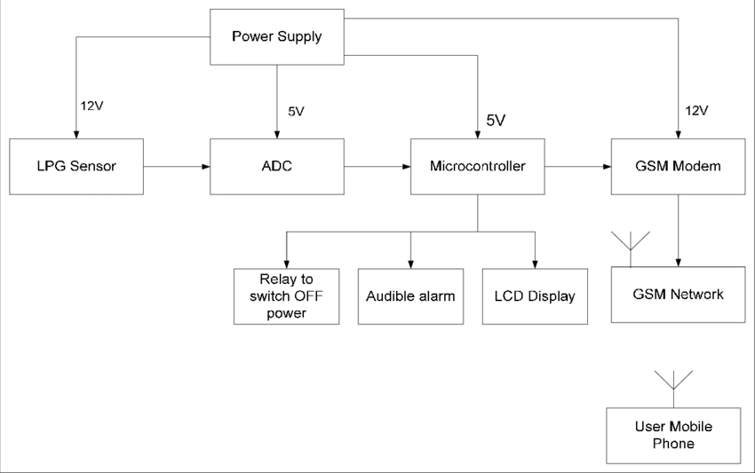
- BLOCK DIAGRAM
Figure 1: Proposed Block Diagram.

- FLOW CHART
Start
Is GSM Module
replies ‘OK’?
NO
YES
Is LPG Sensor’s O/P
value is greater than threshold value?
NO
YES
Turn on LED & Buzzer Start Exhaust Fan by enabling the respective POART
Send massage to stored Mobile No
Turn off the regulator Start Exhaust Fan

MCU send ‘AT to GSM Module’
Power ON

Figure 2: Flow Chart

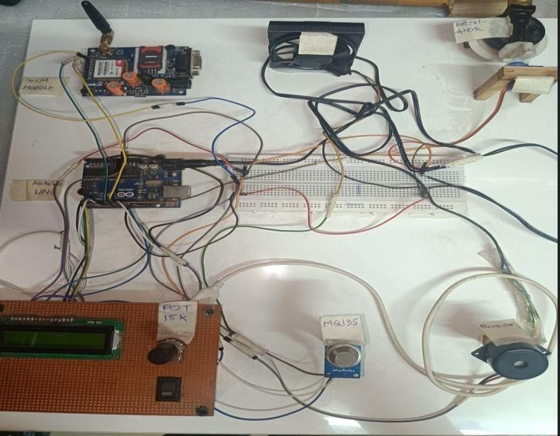
- CIRCUIT DIAGRAM

Figure 3: Hardware of Circuit Diagram

- WORKING
Sure, I can outline the basic steps for creating an IoT-based gas leakage detection and control system using GSM and Arduino:
1. Components Needed:
- Arduino Uno or similar microcontroller
- Gas sensor (such as MQ-2, MQ-5, etc.)
- GSM module (SIM900, SIM800, etc.)
- Relay module for controlling appliances
- LCD display (optional)
- Buzzer (optional)
- Power supply
- Connecting wires
2. Circuit Setup:
- Interface the gas sensor to the Arduino board.
- Associate the GSM module to the Arduino for sending SMS alerts.
- Connect the relay module to control appliances like fans or gas valves.
- Optional: Connect an LCD display to show gas levels or system status.
3. Arduino Programming:
- Write a code to read data from the gas sensor and detect gas leakage.
- Define a threshold level for gas concentration above which the system should trigger an alert.
- If gas concentration exceeds the threshold, activate the GSM module to send an SMS alert to predefined numbers.
- Optionally, activate a buzzer and display the gas concentration on an LCD screen.
4. SMS Alert Configuration:
- Set up the GSM module to send SMS alerts. This usually involves configuring the module with the appropriate AT commands.
- Store the phone numbers of recipients to whom alerts should be sent.
5. Control Mechanism:
- Implement a mechanism to control appliances in case of gas leakage. This could involve activating a relay to turn off gas valves or triggering ventilation systems.
6. Testing and Deployment:
- Test the system thoroughly to ensure proper detection and alert mechanisms.
- Deploy the system in the desired location, ensuring proper placement of sensors for effective gas detection.
7. Smart SMS Alerts:
- Optionally, add intelligence to the SMS alerts by including relevant information such as the type of gas detected, location, and instructions for action.
8. Maintenance:
- Regularly check and calibrate the gas sensor to maintain accurate detection.
- Ensure the GSM module has sufficient credit and network connectivity for sending alerts when needed. By following these steps, you can create an IoT-based gas leakage detection and control system using GSM and Arduino with smart SMS alerts.
Arduino UNO
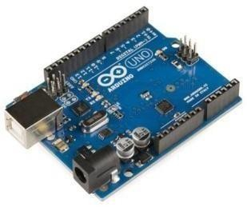
The Arduino UNO is an open-source microcontroller board in light of Microprocessor's ATmega328P microcontroller and was created by Arduino. Its main aim is to make electronics as easy as possible. It utilizes different microcontrollers, containing a few information and result pins. It provides an integrated development environment (IDE). Arduino contains several numbers of parts and integrated interfaces on a particular circuit board.
Fig:1
GSM Module
A GSM/GPRS module is used to establish communication between a computer and a GSM/GPRS system. The Global System for Mobile Communication (GSM) is an architecture used for mobile communication in most countries. Global Packet Radio Service (GPRS) is an extension of GSM that enables a higher data transmission rate. A GSM/GPRS module consists of a GSM/GPRS modem assembled together with a power supply circuit and communication interfaces (like RS-232, USB, etc.) for the computer. GSM/GPRS MODEM is a class of wireless MODEM devices that are designed for communication between a computer and the GSM and GPRS networks. It requires a SIM (Subscriber Identity Module) card, just like mobile phones, to activate communication with the network. Also, they have an IMEI (International Mobile Equipment Identity) number similar to their phone number for their identification. A GSM/GPRS model can perform their identification.
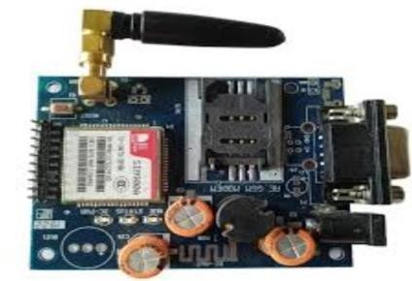
Fig:2
MQ135 Sensor
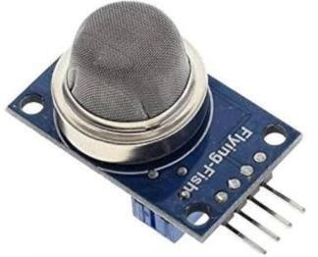
MQ135 Sensor The MQ-135 gas sensor uses a tin dioxide (SnO2) semiconductor as its detecting component. Tin dioxide has the property of being a brilliant guide at high temperatures when exposed to specific gases. The sensor consists of a fired component covered with SnO2, and when this component comes into contact with a particular gas, the conductivity of the sensor changes. This adjustment of conductivity is then changed into an electrical sign that can be estimated and deciphered. The awareness of the MQ-135 sensor is impacted by the centralization of gases in the general climate. The higher the convergence of the objective gas, the more noteworthy the adjustment of conductivity, bringing about a larger electrical sign. This makes the MQ-135 a powerful instrument for estimating air quality and distinguishing the presence of unsafe gases.
Fig:3
Buzzer

A buzzer or buzzer is a mechanical, electromechanical, or piezoelectric (piezo for short) audible signalling device. Common uses of buzzers and beeps include alarm devices, timers, and user acknowledgment of user input such as mouse clicks and keys.
Fig:4
LCD Display
The LCD is utilized to show the message "Gas in Zone Distinguished" on the main coded display in the program to demonstrate risks. All messages, information, and orders shown on the LCD will be LCD registers. its operating power supply ranges from +5.0 V or +3.0 V.
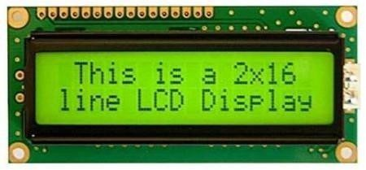
Fig:5

Potentiometer

The potentiometer is an instrument used to quantify the obscure voltage by contrasting it with the known voltage. It very well may be utilized to determine the emf and inside obstruction of a given cell and, furthermore, to look at the emf of various cells. A similar technique is utilized by the potentiometer.
Fig:6
Bread Board
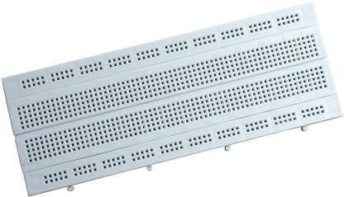
A breadboard consists of a plastic block holding a network of electrical attachments of a size reasonable for grasping flimsy interfacing wires, part wires, or the pins of semiconductors and incorporated circuits (ICs). The attachments are associated inside the board, ordinarily in lines of five attachments. A breadboard (sometimes called a protoboard) is basically the establishment for developing and prototyping gadgets. A breadboard takes into consideration simple and speedy making of impermanent electronic circuits or to complete trials with a circuit plan. Breadboards empower designers to effortlessly interface parts or wires thanks to the lines and sections of inside associated spring cuts under the punctured plastic fenced in area. The network is comprised of impeccably adjusted spring cut openings that are 0.1 separated in both the X and Y aspects.
Fig:7
Gas Regulator
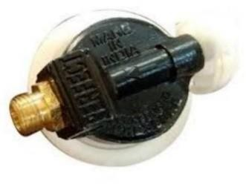
Developing an IoT-based hazardous gas leakage detection system with GSM/GPRS and a gas regulator involves integrating gas sensors, a microcontroller (e.g., Arduino or Raspberry Pi), a GSM/GPRS module, and a gas regulator. The gas sensor detects leaks, the microcontroller processes data, and the GSM/GPRS module sends alerts. The gas regulator controls gas flow. Ensure compatibility among components, program the microcontroller for data processing and GSM communication, and implement safety protocols. Regular testing and maintenance are crucial for reliability.
Fig:8

Servo Motor
A Servo motors are specially designed motors to be used in control applications and robotics. They are utilized for exact position and speed control at high forces. It consists of a suitable motor, a position sensor, and a sophisticated controller. Servo motors can be characterized according to the motor controlled by servomechanism; i.e., if a DC motor is controlled using servomechanism, it is called a DC servo motor. Thus, the major types of servo motors may be DC servo motors or AC servo motors.
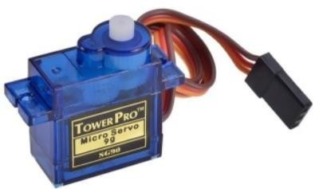
Servo motors are available in power ratings ranging from a fraction of a watt up to a few hundred watts. They have high torque capabilities. The rotor of a servo motor is made smaller in diameter and longer in length, so that it has low inertia.
Fig:9
Exhaust Fan
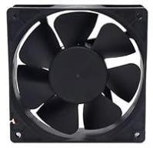
One fume is utilized to drain the gas out of the room. Another fan is used to pull in fresh air from outside while at the same time sending out an alert message to turn off the gas supply. The system efficiently avoids the chances of any fires or blasts that could have been caused by gas leakage. As expressed, exhaust fans work by eliminating undesirable smells, dampness, smoke, and different contaminations from the air. At the point when steam and dampness are in the air, they can create shapes. At the point when you use an exhaust fan, the steam is released outside, which assists you with controlling mold in your home.
Fig:10

- CONCLUSION
This paper aims to ensure the monitoring and detection of hazardous gases to meet safety standards. The system detects gas in the atmosphere and continuously updates and displays the gas values which can be easily viewed by the user via an LCD screen. The system is quite responsive and can stop crisis situations more quickly than manual methods. The system alerts and responds to leakage by alerting the user. In the future, this system will be packed with advanced features to provide users with greater security and relaxation. The popularity of handheld devices has advanced the field of smart gas sensors, greatly expanding the range. The need to ensure workplace safety is expected to be the main driver of the market in the upcoming years.
REFERENCES
- Belkacem Khaldi, Foudil Cherif, “An Overview of Swarm Robotics , Swarm Intelligence Applied to Multirobotics,”
International Journal of Computer Applications (0975 – 8887) Vol 126 – No.2, September 2015, India
- R. Imtiaz, B. Ashokkumar, M. Danny Frazer “Implementation Of Load Sharing Using Swarm Robotics,” International Research Journal of Engineering and Technology, Volume: 03 Issue: 03, (pages: 1855 – 1862) | March-2016 , India.
- Mohd. Daneel Khan, Krantee Jamdaade; ”Application of Swarm Intelligence in Disaster Management”, International Journal on Future Revolution in Computer Science & Communication Engineering Volume: 4 Issue: 6 | pp 77-84 June - 2018 , India.
- Abhishek, P. Bharath“Automation of lpg cylinder booking and leakage monitoring system-IJCRD” P. M. Vidya, S. Abinaya, G. G. Rajeswari, and N. Guna“Automatic lpg leakage detection and hazard prevention for home security-National Conference on VLSI, Embedded and Communication & Networks”
- Kavitha B C,VallikannuR“IOT Based Intelligent Industry MonitoringSystem –SPIN 2019”
- Kalpesh Gupta, Gokul Krishna G and Anjali T ”An IoT Based System for Domestic Air Quality Monitoring and Cooking Gas Leak Detection for A Safer Home International Conference on Communication and Signal Processing, 2020”

