**Proctor Calling System**

**Suhana Manjur Attar1, Manali Satish Chigare2, Sakshi Prakash Kore3,Prajakta Prakash Khochage4, Ms.Aarati Chougle5**

1, 2, 3, 4Department of Diploma in Computer Engineering, Third Year, Sharad Institute of Technology, Polytechnic Yadrav, Ichalkaranji, Kolhapur, Maharashtra, India

5Lecturer, Department of Diploma in Computer Engineering, Sharad Institute of Technology, Polytechnic Yadrav, Ichalkaranji, Kolhapur, Maharashtra, India

**ABSTRACT**

In many institutions academic attendance is very important,so that’s why we want to develop a proctor calling software that help’s teachers to watch and understand the overall attendance of all students.The Proctor calling system is web based application(web page) that helps education institution to keep track on attendance system efficiently. It eliminates all paper work of teacher,then Proctors will call absent students, after they record it calling as informed successfully or not. And students who’s has attendence is tor calling application which help to reduce the extra cook load of proctor's. These application call’s the absent student with communication the proctor and their parents will feel safe parents with the calling information. Also send to messages & emails. To students less then 80% that student goes to defaulter list automatically. With the help of proctor calling software result of colleges is increased and also towards their children’s .It stores real-time data , and it provides awareness to the ladies parents, it is less consuming process and it also helps colleges to understand average attendance of student each day.

1. **INTRODUCTION**

Proctor calling system is students by the mentors. The proctors who are absents. This application provides the defaulter list.Long years ago, student's goes to their teacher's for the purpose of education &students are and gain the knowledge& also they live with their teacher’s These all done in ancient time.But, in recent year's many modern colleges & Schools are developed We have done a college information in college. These application Proctor calling which also automatically calling. Messaging to the absent have done college Survey different metro cities & small villages also we have noticed something in that college survey international universities colleges are not providing proctor calling system, proctor means teacher Or mentor who have watch on student in class room. Ok, so that's why, the student. Attendance system is get decreased -day by day, and also the result of College. In many institutions academic attendance is very important, so that's why we want to devolve a proctor calling application that help's teachers to watch & under star the overall attendance of all student’s.The proctor calling is a web application technology that to improve the processes of proctor calling and recording The student attendence which is daily and monthly with presenting their default list. This system uses proctor calls. Email messages for every student. This Paper proposes a system is based on a student’s regarding to Calling or information their Attendance which is displayed. Performed with their mentor. The proctors will need to work on this attendence.

This system offers several advantage Attendance student, firstly, it eliminates present record of students, then record every student’s attendance the need for manual which including present students & absent students Then, Proctors. Will call to the absent students, after they record it calling is informed successfully or not if informed then who received application for maintain student at it (in parent Then, recording the list who's present is below than 80%. Also it present the defaulter list of student. So, this is very time consuming procedure. So, the proctor calling is stay investing son of to solution this all challenges. By using proctor calling application technology it will solve the challenge’s or questions or work more easily and performed very effectively.

,

1. **MODELING AND ANALYSIS**

Master panel:-

Fill all the student details such as student name, mobile number, gender, division, department, semester. & fill all the collage details such as collage name, landline number, collage website , collage email.

HOD panel:-

Firstly ,HOD enter their username and password to login & HOD contain all the authority to see all the modules present in the software.

Faculty panel:-

Faculty enter their username and password to login and fill the attendance sheet of students.

Proctor panel:-

Proctor enter their username and password to login and automatically display all the absent student list then proctor call to the their parents.

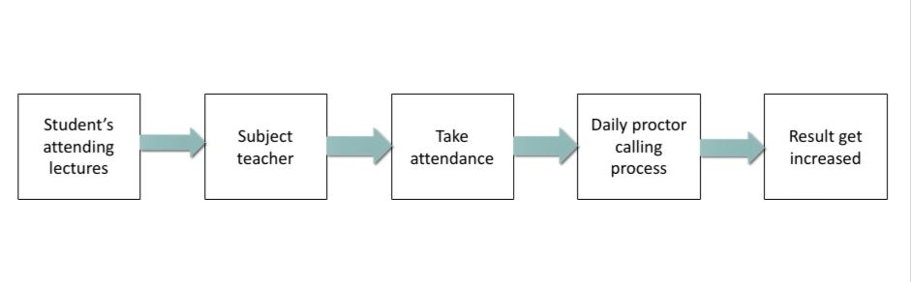

. 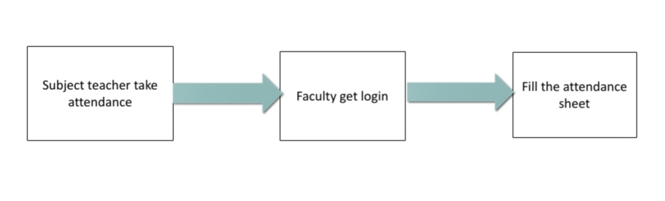

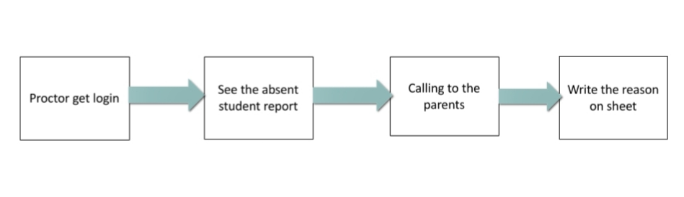

Figure 1.Block Diagram

**RESULTS AND DISCUSSION**

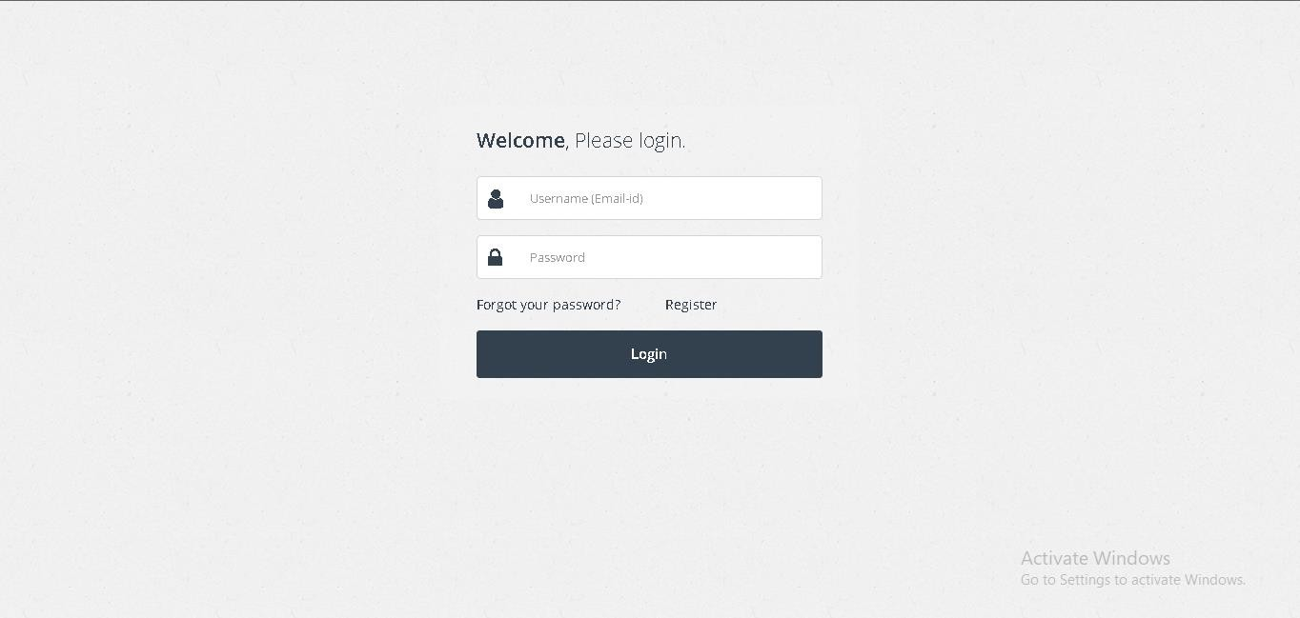

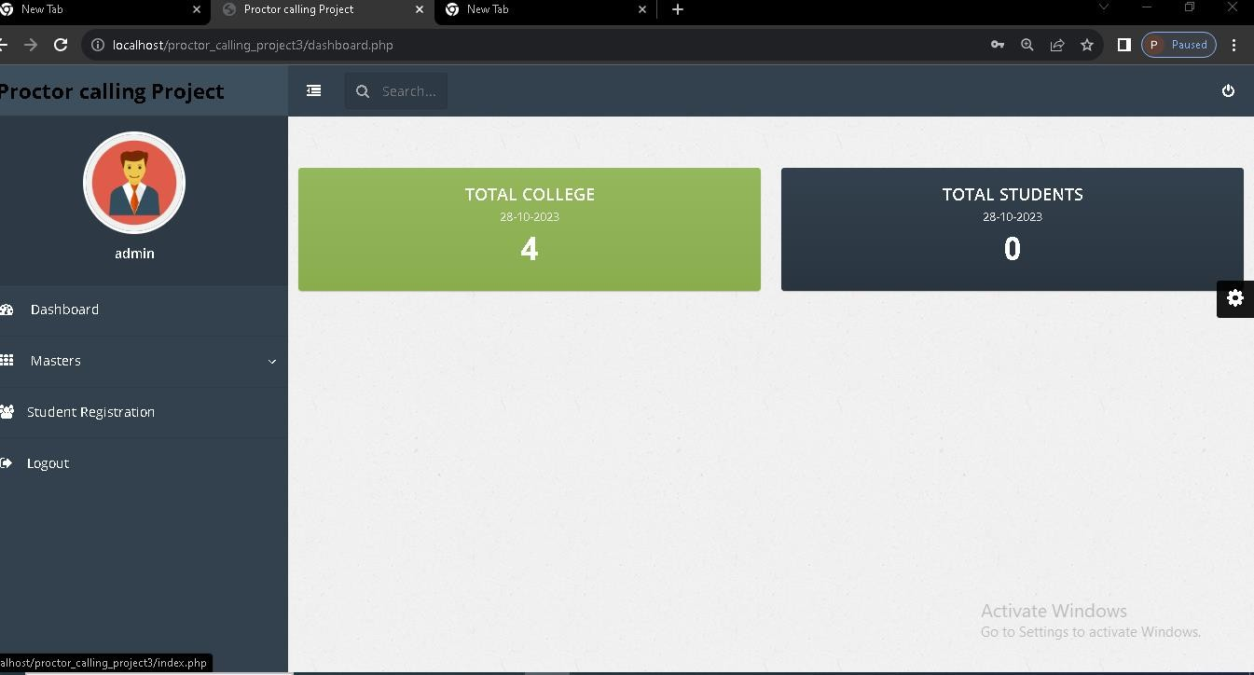

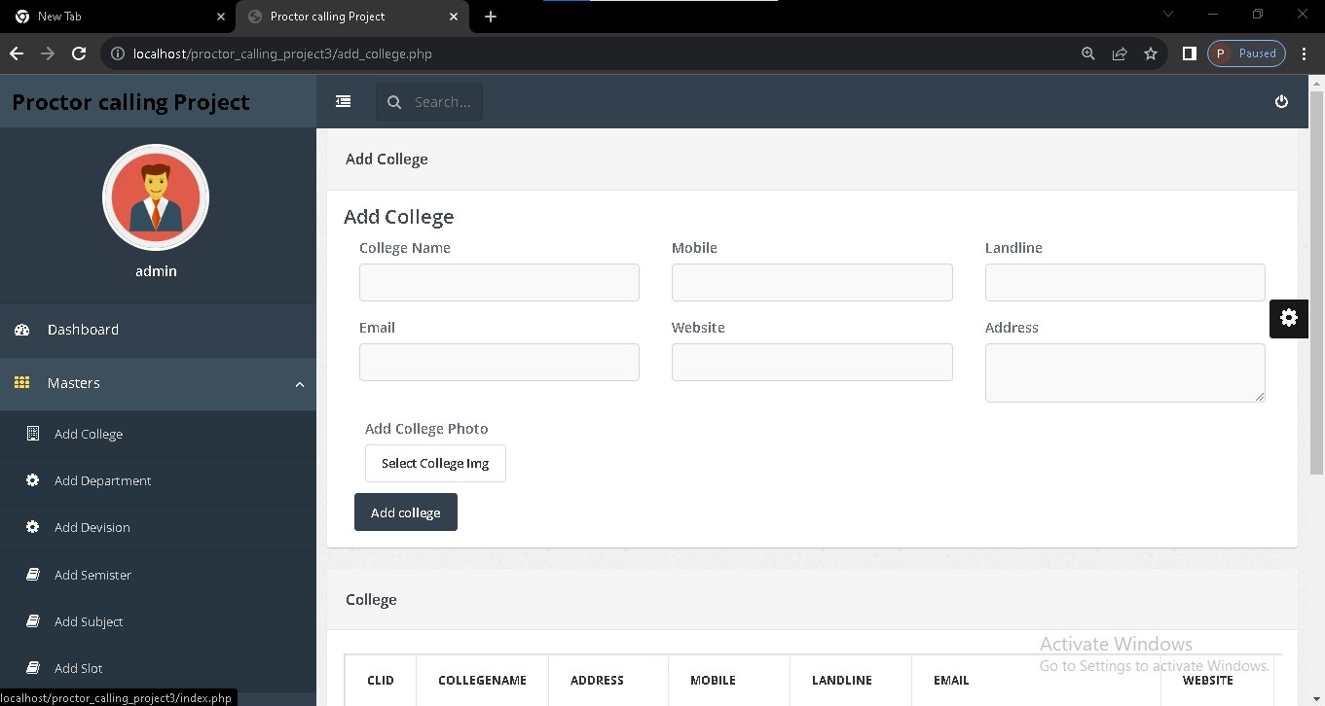

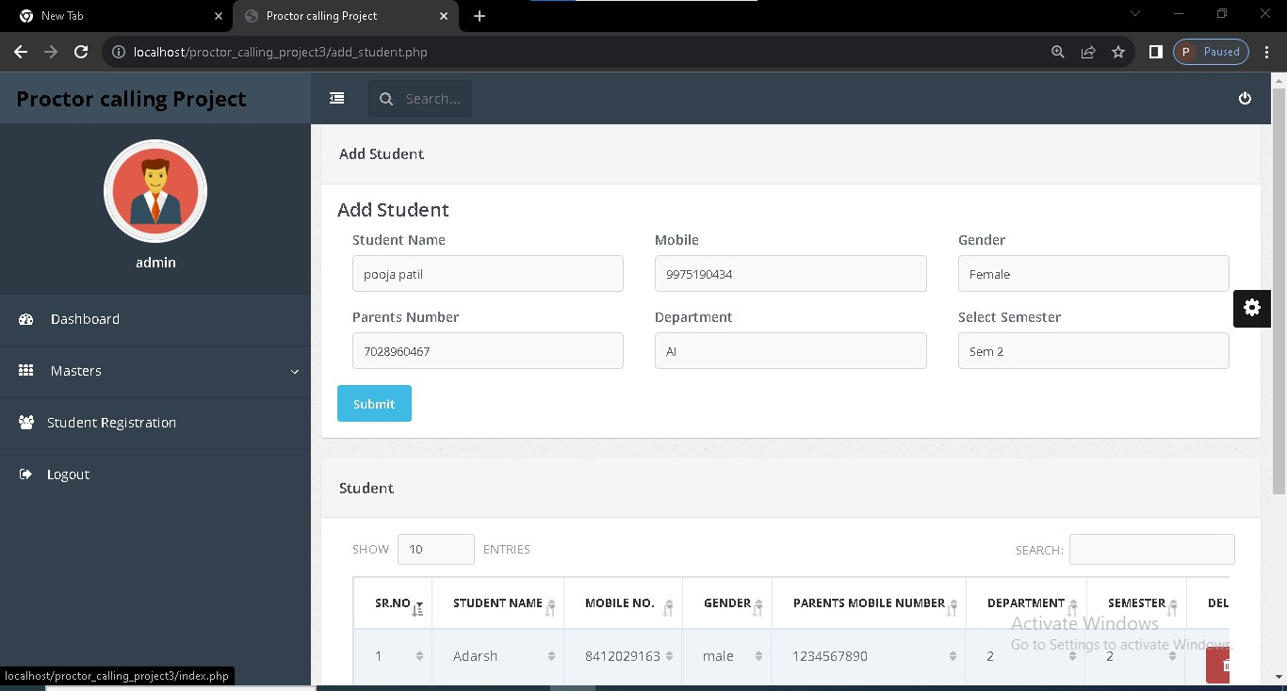

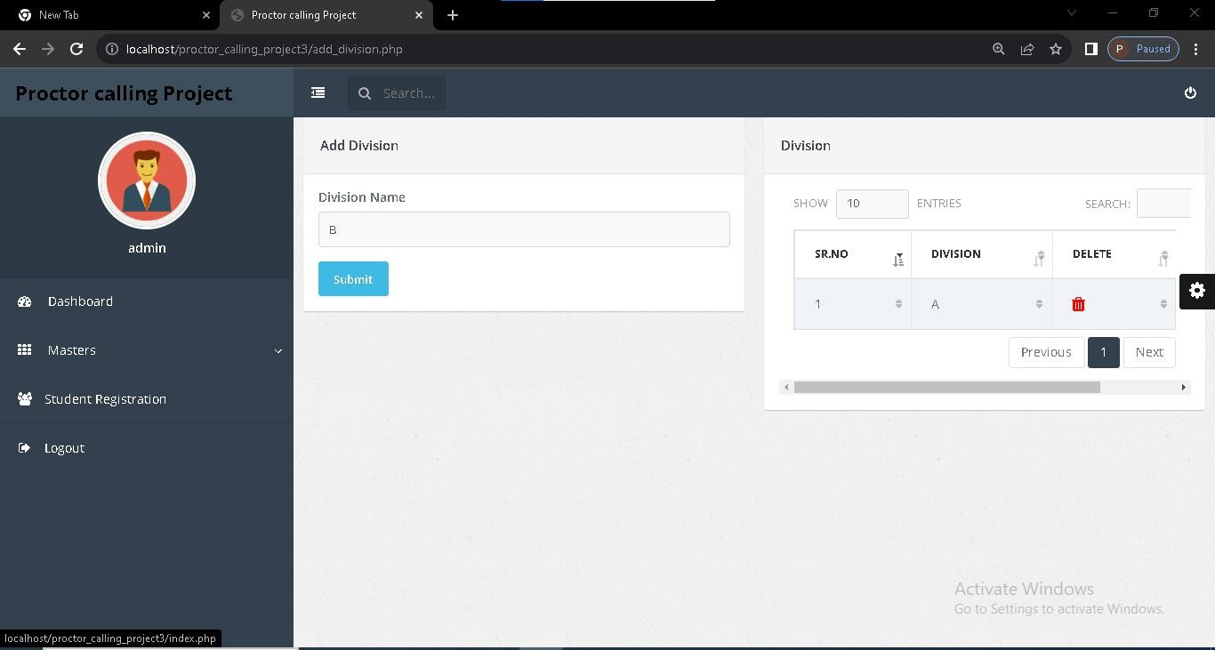

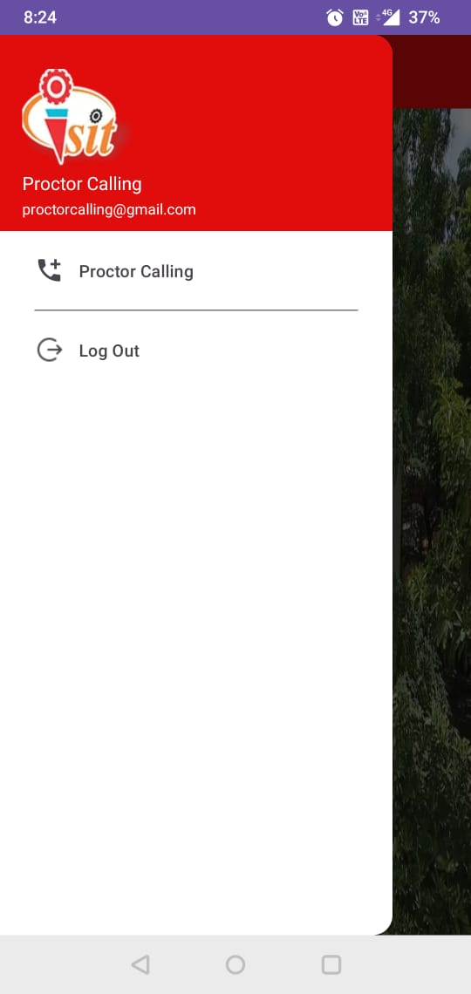

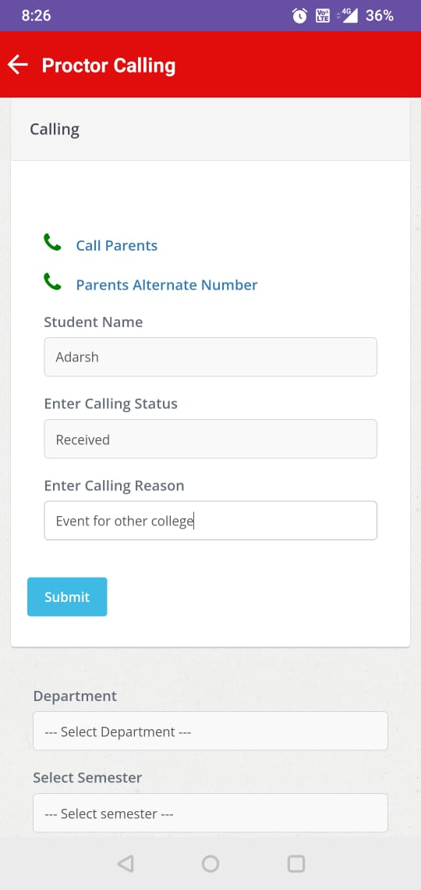

**Table 1.**Sample Comparison

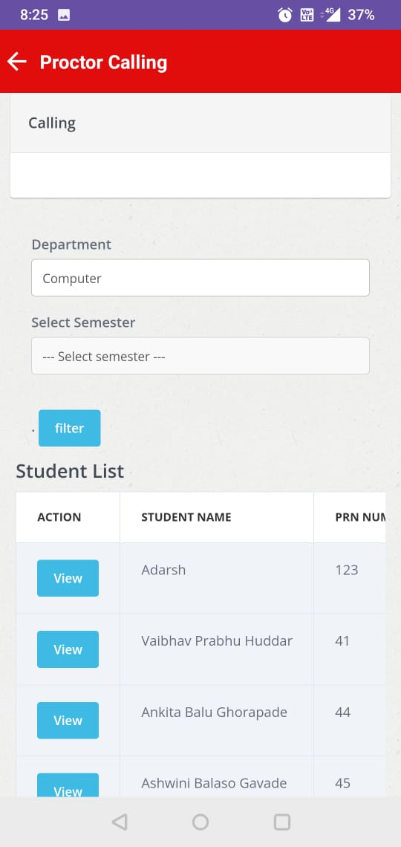

1. **CONCLUSION**

Proctor calling application is used to developed smart attendance proctor calling system. Individual Proctors needs to maintain or filled record of students in firstly with including the student's. Contact number for calling absent students with to parents to take the information their recording.

This product development used the adaption from the prototype model. This prototype model has five phases. It is namely planning, analysis, design, prototype development & testing. This model is suitable for the development of this product because it can give the real picture about the product of the operational of the product.

1. **REFERENCES**

[1] Anita V Pai, Krishna A, Kashma PM, Correa M. Web service for student attendance management system www.ijarse.com. 5(3): Mar 2016

[2] Gangagowri G, Muthuselvi J, Sujitha S. Attendance management system based on SMS technology.

[3] Pradnesh Dinesh Kore, Shubham Chandrakanth Kelkar, Gaurav Sunil Khare, Prof.Neha Singh. Published in (IJSRD/Conf/NACTT/2016/013)

[4] Arbian N, Nordin NF, Isa NM, and Saaidin S. LAS: Web based laboratory attendance system by integrating RFID-Ardiuno technology. In IEEE: 2014.p.84-94.

[5] Srinidhi M, Roy R. A web enabled secured system for attendance monitoring and real time location tracking using biometric and RFID technology. In IEEE: 2015.p.125.

[6] Arulogun O,Olatunbosun A, Fakolujo O, Olaniyi O. RFID-based student’s attendance management system. Int J Sci Eng Res. 2013;4(2):1-9.

[7] Kassim M, Mazlan H, Zaini N, Salleh MK. Web-based student attendance system using RFID technology. In IEEE; 2012.p.213-8.

[8] Karwan Jacksi, Falah Ibrahim, Shahab Ali. Student Attendance Management System. In SJET, Feb 2018; 6(2):49-53.