# ANALYSIS AND DESIGN OF ARESIDENTIAL BUILDING WITH PROPER SUNLIGHT BY USING AUTOCAD,

**SKETCHUP AND STAAD PRO**

**Kuchipudi Harish,Adireddy Venkatadri**,**Chavala Kiranmai**, **Gampa Kiran**- **UG Students final year**

**P. Narendra Babu -Associate professor&HOD Department of Civil Engineering**

**,NRI Institute of technology,agiripalli,india**

### ***

**Abstract–** This study investigates the importance of proper sunlight exposure in residential building planning. Adequate sunlight in living spaces not only enhances the aesthetic appeal but also contributes to the occupants' physical and mental well-being. Through a comprehensive review of literature and case studies, this research explores various strategies for optimizing sunlight penetration in residential buildings, including site orientation, building massing, window design, and shading devices. The impact of sunlight on energy efficiency, indoor comfort, and overall building performance is analyzed.

Additionally, computational tools and simulation techniques for assessing sunlight exposure in building design are discussed. The findings of this study provide valuable insights for architects, urban planners, and developers to integrate sustainable sunlight strategies into residential building projects, ultimately promoting healthier and more liable environments for inhabitants. Now a days everyone effected by deceases.by searching all the things the main issue comes from lack of sunlight. sun is the main resource to avoid deceases and to lead a healthy and happy life. Has by providing the main resource that is shelter with proper sunlight we can avoid many deceases. Building planning made with software has time and cost saving and so many benefits are there by creating the 3-D modelling using auto cad and sketch up and Staad pro.

**KEYWORDS**: AUTO CAD & SKETCHUP AND STAAD PRO.

1. **INTRODUCTION**

SketchUp is a surface modeling program used by interior designers for space planning, conceptual design, etc. Any construction project includes layout and modelling of the building for a clear picturization of the structure and to minimize the errors as we can see the 3D model of the building before head.

we can have realistic view with high efficiency**.** This project involves the layout and 3D model of a gated community. For completing the project, software's such as AutoCAD and Sketchup have been used. The planning and drafting of any structure in 2D is done by using AutoCAD. The 3D modelling of structure is done by using Autodesk Google sketchup.

The software is fully compatible with all windows operating system but is optimized for windows XP. Staad pro software is used for static or dynamic analysis for structure, etc. First step in Staad pro is to specify the geometry of the structure and then the properties of the members are mentioned. Then the supports and then generated and loadings are specified on the structure. Finally, the structure is analyzed.

## LITERATUREREVIES

**Mr. Dhruv Patel** The design communication is gradually being changed from 2D based on integrated 3D digital interface. Building information modelling (BIM) is a model-based design concept. This project analysis and planning of a building is done on both software named AUTOCAD& SKETCHUP.

**Jinan 251000 China** This paper mainly introduces the methods and techniques of using Auto-CAD to draw the structure design of the house. The main contents include: the preparation of interior design and mapping knowledge, Auto-CAD basic knowledge; according to the different needs of the design of the structure.

**Robin de Jongh** is the author of several books on professional workflows with SketchUp, BIM, and Unity3D. He has worked for many years in the construction industry as a CAD designer and at one time ran his own architectural visualization company using SketchUp as the main presentation tool.

**Nicole panorkou** Dimension is a powerful mathematical construct that is rarely taught or researched explicitly. The study reported on here explored how the software Google SketchUp can facilitate students’ experiences of dimension.

**Safwan Ahmad (2017),** have designed a residential building using SKETCHUP by applying suitable sectional details to component within the main aim of this factor was to study the extent of credibility of using SKETCHUP for analysis.

### **Muhamma E-**Learning based about auto **cad** 3D interactive multimedia on vocational education (VE) learnin.The addition 2D on of new technologies in learning process especially vocational education.

**Herminarto sofyan** attention and even increasing the learning speed the research focus is to develops an E- learning based interactive multimedia auto CAD. this method is used in this research and dovelopment (R&D).

**Robin** is the author of several books on professional workflows with SketchUp, BIM, and Unity3D. He has worked for many years in the construction industry as a CAD designer and at one time ran his own architectural visualization.

**De Jongh** company using SketchUp as the main presentation tool. He now works as an acquisitions editor for Manning Publications where he mentors new authors, and publishes books on Open Source technology topics.

**Nicole panorkou** Dimension is a powerful mathematical construct that is rarely taught or researched explicitly. The study reported on here explored how the software Google SketchUp can facilitate students’ experiences of dimension.

**Safwan Ahmad (2017)** have designed a residential building using SKETCHUP by applying suitable sectional details to component within the main aim of this factor was to study the extent of credibility of using SKETCHUP for analysis.

**Guntur Zulfiqar (2014)** This article offers evidence from the data on how the task setting, including Sketchup’s dimensional tools identified in the software, prompted the construction of ideas about dimension. More specifically, children expressed intuitive ideas about an object/space’s freedom to move within a space/object of higher dimension and its capacity to house other objects/spaces of lower dimension.

**Ezeli** In this paper, it focuses on 2D drafting which is useful for various engineering sectors such as electrical design, mechanical design, product design, building design, and architectural rendering and design.

**Nekomimi, 2016** SketchUp is a 3D modeling software that is designed for businesses in several industry segments, including architecture, construction, urban planning, woodworking and interior designing.

Automated learning programs help the teacher organize the learning process and help students master the science. They have the benefits of speeding up the learning process, making the teaching materials simpler and clearer.

1. **ANALYSIS AND MODELLING**

For the drafting and design of any construction, AutoCAD is quite beneficial. The fields of architecture and construction also employ this software. The software's several built-in capabilities enable complex drafting. In addition to 2D, 3D, and other dimensions, AutoCAD is also appropriate for perspective design, which refers to a way of perceiving objects. Below are listed the many house plans.

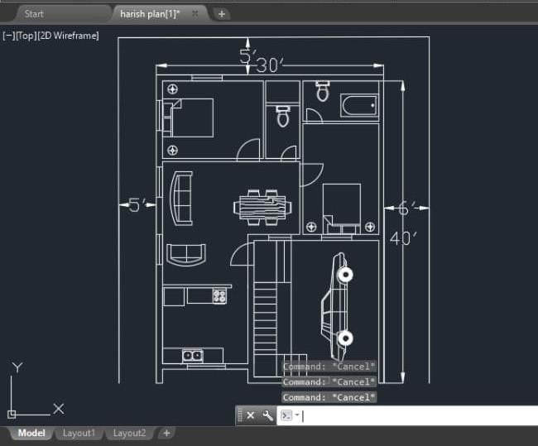

## Fig 1. Plan of residential building

* + SITE AREA =1845 sqft [41’X45’]
  + BUILT UP AREA =1200 sqft [30’X40’]
  + EXTERIOR WALL THICKNESS = 9”
  + INTERIOR WALL THICKNESS = 4.5”
  + BEDROOM [1] = 13’4”X10’4”
  + BEDROOM [2] = 10’X14’8
  + DRAWING = 18’X16’4”X10’4”
  + KITCHEN = 11’4”X10’
  + TOILET [1] =10’4”X4’8”
  + TOILET [2] = 10’X5’4”
  + PARKING = 14’X19’

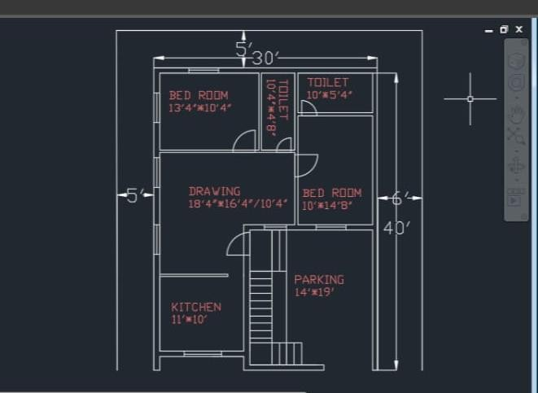

## Fig 2. Dimensions of the building

1. **3D MODEL**

Layout planning, 3D modeling, and realistic effects are all done with Sketch Up. Additionally, there are certain applications in the creation of movies and video games as well as in architecture, interior design, landscape architecture, civil and mechanical engineering. It is a web-based program. Trimble Inc. owes Sketch up money in August 2000.

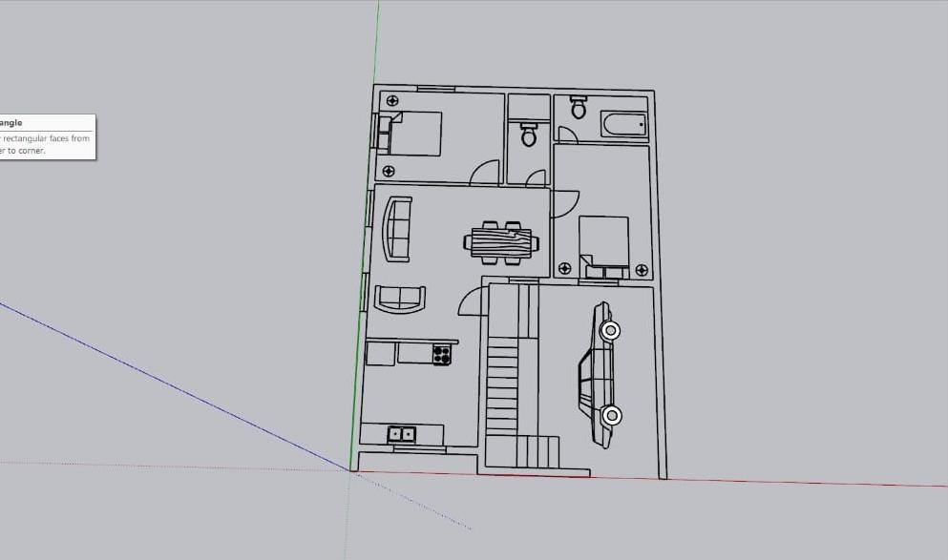

## Fig 3. Sketch up plan

1. **INTERIOR VIEWS**

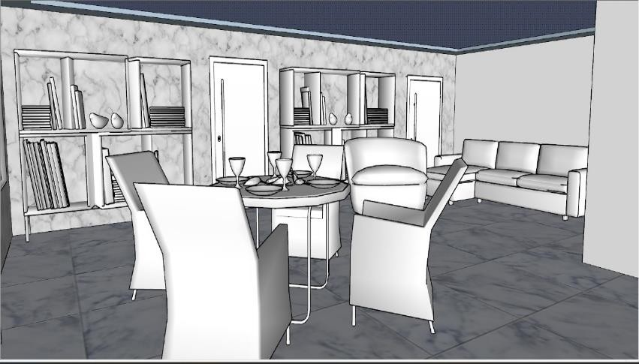

## Fig 4. Dinning hall

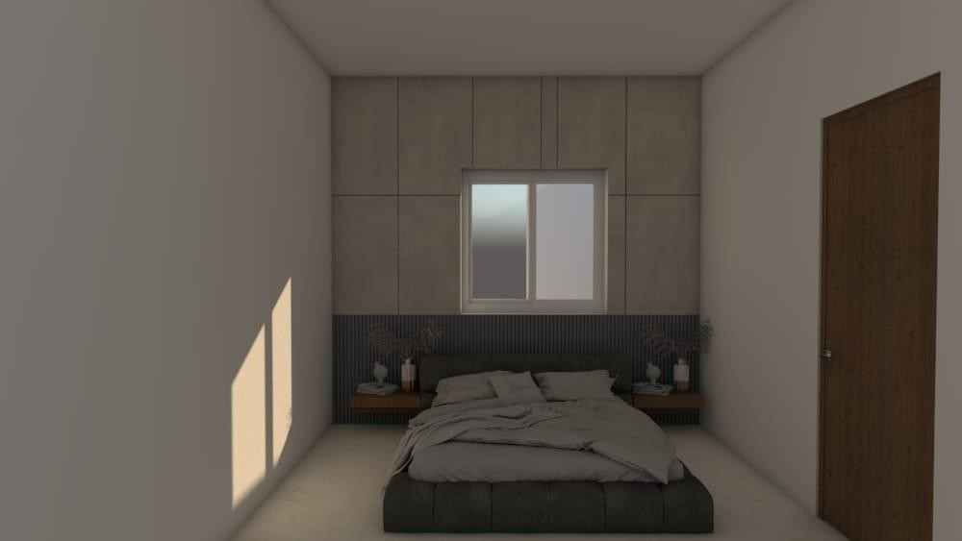

**Fig 5. Bedroom**

## RENDERING:

Enscape is a Sketch up real – time render plugin that empowers you to create beautiful, realistic renderings in a matter of seconds, all from within your favourite modelling software.



## FIG 6. ENSCAPE INTERFACE LAYOUT

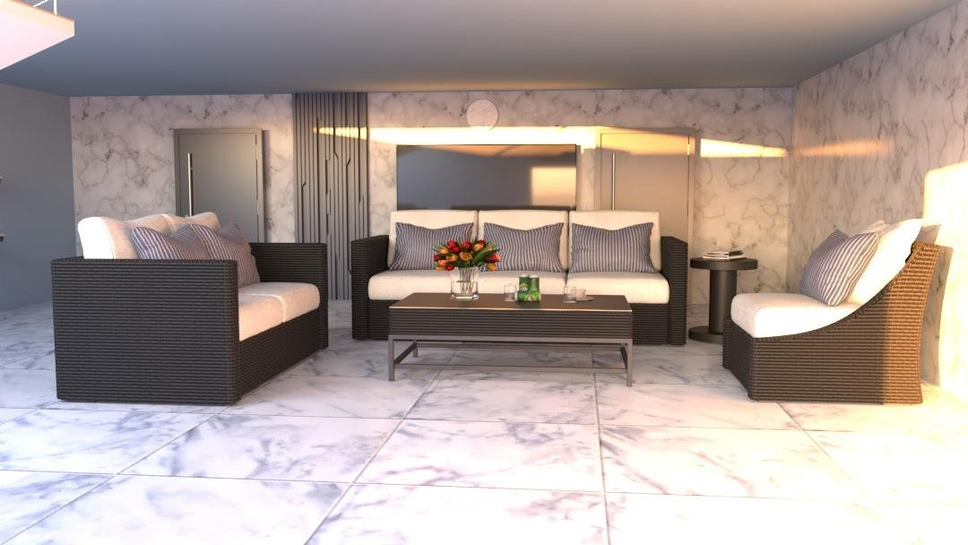

**FIG 7. HALL ENSCAPE VIEW**

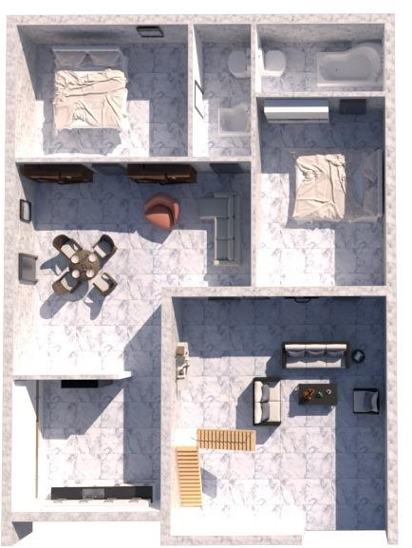

**FIG 8. TOP VIEW**

# STAAD. PRO

**STAAD.PRO** is user – friendly software which is used for analyzing and designing of structure by the structural engineers. Staad pro provides a lot of precise and correct results than manual techniques. It’s the foremost computer code for 3D model generation and multi material design. The software is fully compatible with all windows operating system but is optimized for windows XP. Staad pro software is used for static or dynamic analysis for structure, etc. First step in Staad pro is to specify the geometry of the structure and then the properties of the members are mentioned. Then the supports and then generated and loadings are specified on the structure. Finally, the structure is analyzed.

## SCOPE OF THE BUILDING

**BUILDING DETAILS AND SPECIFICATIONS**

* Size of the building – 9.144m X 12.192m.
* Set backs of the building – 1.52m X 1.82m.
* Plot size – 1200sq.m.
* Height of the floor - 3m.
* Grade of concrete – M20
* Grade of steel – Fe415
* Plinth height above the ground level – 0.9m
* Depth of the foundation – 0.3m
* External wall thickness – 0.15m
* Internal wall thickness – 0.114m
* Wind intensity – 40m/s
* Wind category – category 3
* Size of the column – 0.38X0.23m
* Fc – 20000KN/Sq.m.
* Fy main – 415000KN/Sq.m.
* Fy sec – 25000KN/Sq.m.
* Max main – 20mm.
* Max sec – 12mm.
* Percentage of reinforcement in RCC – 3.5.

**NOTE:**

IS 456-2000 &

IS 875,

Part I – Dead load’ Part II – Live load,

Part III – Wind load have been applied.

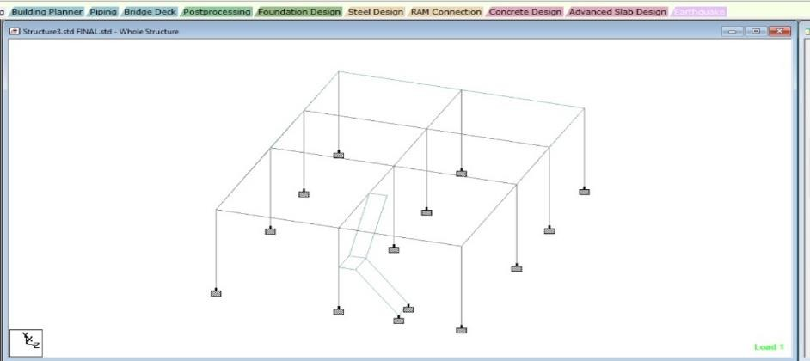

## FIG 9. SKELETAL STRUCTURE OF THE BUILDING

1. **LOAD DISTRIBUTIONS DEAD LOAD:**

Dead loads consist of the permanent construction materials loads compressing the roof, wall, and foundation systems, including claddings, finishes and fixed equipments. Dead load is the total load of all of the components of the building that generally do not change over time, such as the steel columns, concrete floors, bricks, roofing material etc.

In staadpro assignment of dead load is automatically done by giving the property of the member. In load case we have option called self weight which automatically calculates weights using the properties of material i.e., density and after assignment of dead load the skeletal structure looks red in colour as shown in the figure.

The above example shows a sample calculations of dead load.

Dead load is calculated as per IS 875 part I

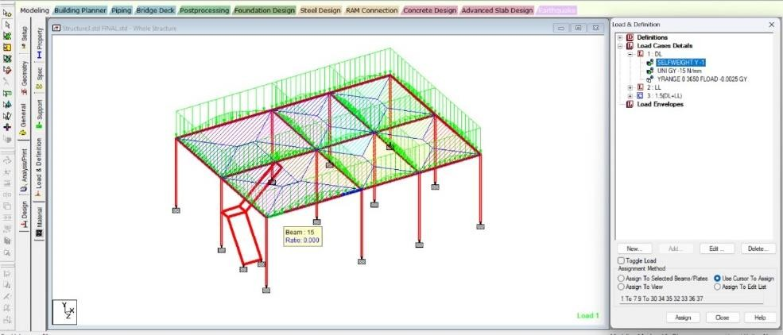

## FIG 10. DEAD LOAD ACT LOAD 15N/mm

1. **ANALYSIS OF THE BUILDING**

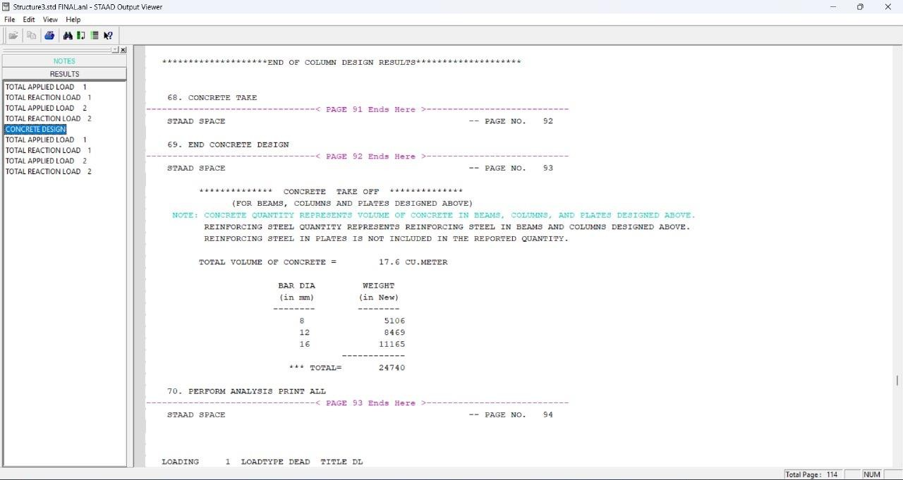

## FIG 11. OUT PUT OF THE BUILDING

1. **SHEAR FORCE**

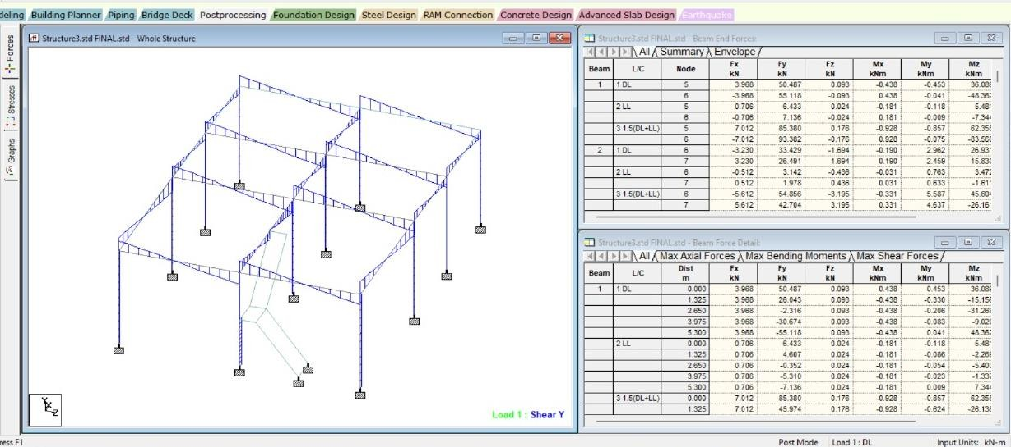

## BENDING MOMENT

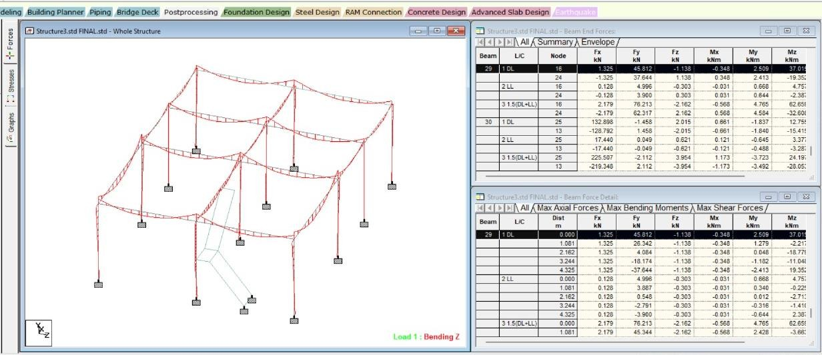

1. **COLUMN DEFLECTION**

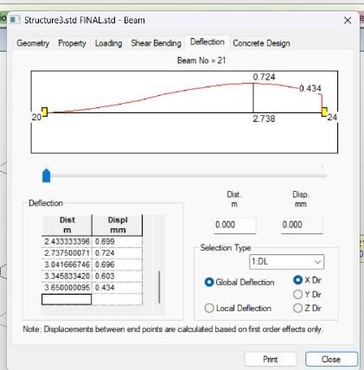

## BEAM DEFLECTION

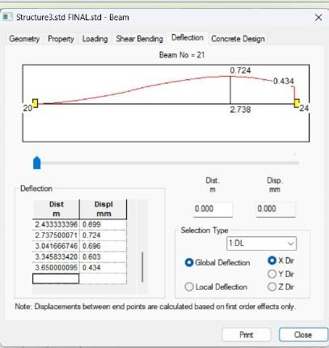

1. **STRESS GRAPHS**

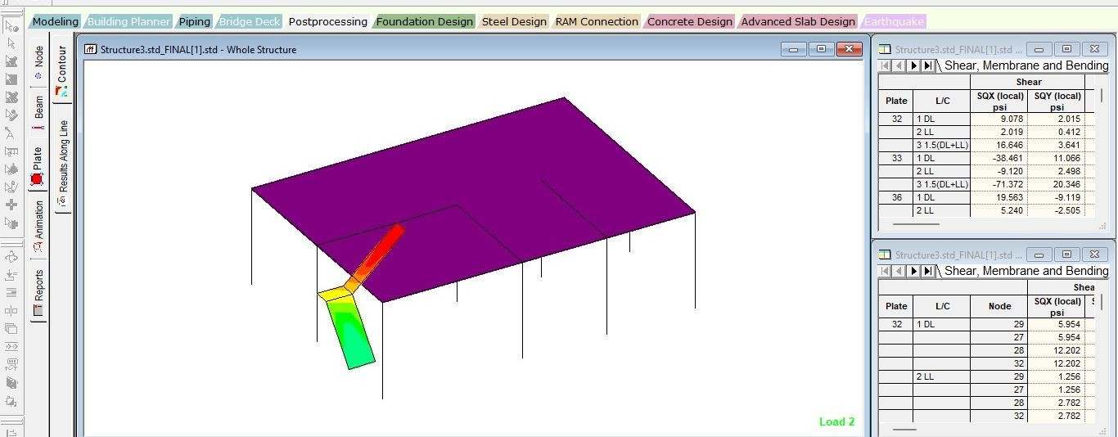

## STAAD EDTIOR

1. STAAD SPACE

INPUT FILE: D:\STAAD FILE\Structure3.std FINAL [1].STD

1. START JOB INFORMATION
2. ENGINEER DATE 05-MAR-24
3. END JOB INFORMATION
4. INPUT WIDTH 79
5. UNIT METER KN
6. JOINT COORDINATES

8. 1 0 0 0; 2 5.3 0 0; 3 8.5 0 0; 4 11.87 0 0; 5 0 3.65 0; 6 5.3 3.65 0

9. 7 8.5 3.65 0; 8 11.87 3.65 0; 9 0 0 4.325; 10 5.3 0 4.325; 11 8.5 0 4.325

10. 12 11.87 0 4.325; 13 0 3.65 4.325; 14 5.3 3.65 4.325; 15 8.5 3.65 4.325

11. 16 11.87 3.65 4.325; 17 0 0 8.65; 18 5.3 0 8.65; 19 8.5 0 8.65

12. 20 11.87 0 8.65; 21 0 3.65 8.65; 22 5.3 3.65 8.65; 23 8.5 3.65 8.65

13. 24 11.87 3.65 8.65; 25 0 1.825 4.325; 26 1 1.825 4.325; 27 0 1.825 4.925

14. 28 1 1.825 4.925; 29 0 0 6.425; 32 1 0 6.425; 33 3 3.65 4.325; 34 3 3.65 4.925

15. MEMBER INCIDENCES

16. 1 5 6; 2 6 7; 3 7 8; 4 1 5; 5 2 6; 6 3 7; 7 4 8; 9 14 15; 10 15 16; 11 9 25

17. 12 10 14; 13 11 15; 14 12 16; 15 21 22; 16 22 23; 17 23 24; 18 17 21; 19 18 22

18. 20 19 23; 21 20 24; 22 5 13; 23 6 14; 24 7 15; 25 8 16; 26 13 21; 27 14 22

19. 28 15 23; 29 16 24; 30 25 13; 34 13 33; 35 33 14

20. ELEMENT INCIDENCES SHELL

21. 32 29 27 28 32; 33 27 25 26 28; 36 26 33 34 28; 37 5 8 24 21

22. ELEMENT PROPERTY

23. 32 33 36 37 THICKNESS 0.12

1. DEFINE MATERIAL START
2. ISOTROPIC CONCRETE 26. E 2.17185E+007
3. POISSON 0.17
4. DENSITY 25
5. ALPHA 1E-005
6. DAMP 0.05
7. TYPE CONCRETE
8. STRENGTH FCU 27579
9. END DEFINE MATERIAL
10. MEMBER PROPERTY AMERICAN

35. 1 TO 3 9 10 15 TO 17 22 TO 29 34 35 PRIS YD 0.3 ZD 0.23

36. 4 TO 7 11 TO 14 18 TO 21 30 PRIS YD 0.3 ZD 0.3

1. CONSTANTS
2. MATERIAL CONCRETE ALL STAAD SPACE
3. SUPPORTS

40. 1 TO 4 9 TO 12 17 TO 20 29 32 FIXED

1. LOAD 1 LOADTYPE DEAD TITLE DL
2. SELFWEIGHT Y -1
3. MEMBER LOAD

44. 1 TO 3 9 10 15 TO 17 22 TO 29 34 35 UNI GY -15

1. FLOOR LOAD
2. YRANGE 0 3.65 FLOAD -2.5 GY

**NOTE** about Floor/OneWay Loads/Weights.

Please note that depending on the shape of the floor you may

have to break up the FLOOR/ONEWAY LOAD into multiple commands. For details please refer to Technical Reference Manual

Section 5.32.4.2 Note d and/or "5.32.4.3 Note f.

1. LOAD 2 LOADTYPE LIVE REDUCIBLE TITLE LL
2. FLOOR LOAD
3. YRANGE 0 3.65 FLOAD -2 GY
4. LOAD COMB 3 1.5(DL+LL) 51. 1 1.5 2 1.5

52. PERFORM ANALYSIS PRINT ALL

## CONCLUSION

We can conclude that there is difference between the theoretical and practical work done. As the scope of understanding will be much practical work is done. As we get more knowledge in such a situation where we have great experience doing the practical work. The sunlight effects on house is depends on aspect, material used for doors and windows and the projection’s view makes the viewers effective towards building and they come to know how the building looks like after construction. All the structural components were designed manually and detailed using AutoCAD. The analysis and design were done according to standard 8 specifications using STAAD.PRO for static and dynamic loads. The dimensions of structural members are specified and the loads such as dead load, live load, floor load and earthquake load are applied. Deflection and shear tests are checked for beams, column and slabs. The tests provide to be safe. Theoretical work has been done. Hence, I conclude that we can gain more knowledge in practical work when compared to theoretical work.

## REFERENCES:

1. Bedabrata Bhattacharjee & A.S.V.Nagender, Computer aided analysis and design of multi-storeyed buildings.
2. Arjun Sahu, Anurag Verma, Ankit Singh, Aryan Pal , Mohd. Shariq, Design & analysis of multistorey (g+3) residential building using staad.pro & AutoCAD.
3. Amar Hugar, Sharanabasappa M Pujari, Beerappa G Pujari,Anaveerappa N Biradar, Gajendra, Analysis and Design of a Commercial cum Residential Building By Using STAAD Pro.
4. Mr. K. Prabin kumar, R.Sanjaynath, A study on design of multi-storey residential building - a review.
5. Rashmi Agashe, Marshal Baghele, Vaishnavi Deshmukh, Sharad Khomane, Gaurav Pale, Kushal Yadav,Tostudy analysis and design of multi-storey building using STAAD-pro and comparing with manual calculations.
6. Dunnala Lakshmi Anuja, V.S.Nagasai, Planning,Analysis and Design of Residential Building(G+5) By using STAAD Pro.
7. B. Gireesh Babu, Seismic Analysis and Design of G+7 Residential Building Using STAADPRO.
8. G.B. Ramesh kumar, A. Gopi,Design and analysis of g+10 residential building with different building materials using STAAD Pro.
9. Aman, Manjunath Nalwadgi,Vishal T, Gajendra,Analysis and design of multistorey building by using staadpro
10. S.Sudheer,Analysis & design of g+5 residential building using STAAD Pro.

11 .Mr. A. P. Patil, Mr. A. A. Choudhari, Mr. P. A. Mudhole, Mr. V. V. Patole, Ms. A. D. Dange, Ms S. K. Chendake, Design & Analysis of Multi Storeyed Building (G+10) By Using. Staad Pro V8i

12.S. Karthiga, Hanna Elza Titus, Reetwiz Raj Hazarika, Mohamed Harris, Design and comparison of a residential building for seismic forces using the IS1893.

1. P. Jayachandran, S.Raja sekaran, Structural Design of Multi-story Residential Building for in Salem, India.
2. E.PavanKumar, A.Naresh, M.Nagajyothi, M.Rajasekhar, Earthquake Analysis of Multi Storied Residential Building.
3. Syed Rehan,S.H.Mahure, Study of Seismic and Wind Effect on Multi Storey R.C.C. Steel and Composite Building.
4. Pawan Pandey, Dilip Kumar, Effect of Configuration of building subjected to Seismic load and Design of RCC Framed Structure by STAAD Pro.
5. Shraddha J. Patil, Mahesh Z. Mali, Dr.R.S.Talikoti, Effect of Wind Load on High Rise Structure.
6. Baldev D. Prajapati, D. R. Panchal, Study of seismic and wind effect on multi storey R.C.C., steel and composite building.
7. Rakesh R. Shinde, Survey paper on behaviour of multi-storied R.C.C. frame structure.
8. COMMON SCHEDULE OF RATES AS PER A.P. REVISED STANDARD DATA FOR THE YEAR 2020- 21, (Effective from 1st June, 2020).
9. ACI (1999). “Building Code Requirements for Structural Concrete (ACI 318-99) and Commentary (ACI 318R-99)”, American Concrete Institute, Farmington Hills, U.S.A.
10. Al-Ali, A.A.K. and Krawinkler, H. (1998). “Effects of Vertical Irregularities on Seismic Behaviour of Building Structures”, Report No. 130, The John A. Blume Earthquake Engineering Center, Department of Civil and Environmental Engineering, Stanford University, and Stanford, U.S.A.
11. Aranda, G.R. (1984). “Ductility Demands for R/C Frames Irregular in Elevation”, Proceedings of the Eighth World Conference on Earthquake Engineering, San Francisco, U.S.A., Vol. 4, pp. 559-566.