HEALTH INSURANCE SERVICES: ITS BUSINESS PERFORMANCE AND DETERMINANTS OF POLICYHOLDERS’ SATISFACTION
Dr. B. Angamuthu
Assistant Professor in Commerce,
PSG College of Arts & Science,
Avinashi Road, Civil Aerodrome (PO),
Coimbatore – 641 014
Tamilnadu, INDIA.
E-mail: muthuanga82@gmail.com
ABSTRACT
The Government of India spends a little over 1 per cent of Gross Domestic Product (GDP) on health, which is inadequate to provide better health care facilities to the people. It has been resulted that Indians spend major portions of health expenditure in the country from their personal resources. With the rise in health care costs due to emergence of private hospitals, expensive health technology and pharmaceuticals, there is need for adequate planning to protect sudden hospitalization. So, health insurance becomes imperative for everyone to look and be covered under a good health insurance policy. In order to health insurance industry has come up with innovative products due to increasing demand and facilitates access of comprehensive services to the people. This empirical and analytical research aimed to measure the growth of business performance in the health insurance market and also to identify the determinants of policyholders’ satisfaction level. The analysis reveals that there exists positive growth in different sectors’ health insurance services with respect to premium collection for the reference period 2009-10 to 2018-19. In addition, this study shows that more than 6/10th of the policy holders are highly satisfied with health insurance services. The factors namely coverage of illness, premium of the scheme, timely service, availability of web-based information and accessibility of branch offices are mainly determine to policyholders’ with lower and higher satisfaction towards health insurance services.

Keywords: Health care, Health insurance, Non-life insurance, Business performance

- INTRODUCTION AND EXECUTION OF THE STUDY
1.1 Introduction
India is the fastest growing nation both in economies and in population. In 1947, the Bhore committed made recommendation to improve healthcare in the country. The Government introduced two different schemes namely employees’ State Insurance Scheme (1948) and Central Government Health Scheme (1954) for the welfare of blue-collar workers in private sector and central government employees respectively. Even though, the country faces distinctive challenges and opportunities in sphere of health care since its independence. The challenges faced are inadequate manpower of doctors, huge investment required for infrastructure in the hospitals, like medicine, furniture and equipment to expand public sector health care services across the nation. So, largely private, and other non-profit organizations have entered into health care services and facilitate medical services to the public. On the demand side public worried about increased cost of access health care services and most of the health expenditure is an out-of-pocket including doctor visits, surgery, pharmacy, medical devices and much more. For every year, more than a billion transactions takes place in the country (Niti Aayog, 2019), where individual patients seek care from a million healthcare providers dominated by the private sector negotiating their own prices for medical services they undergo. The Indian context individuals spend on medical treatment amounted to INR three lakh crores annually, of which only INR 20,000 crores are through insurance cover. The rest INR 2.8 lakh crore is spent on medical treatment, particularly by the poor and lower middle class through out-of-pocket expenditure (Economic times, 2019). This consume into accumulated savings of families for meeting long term financial objectives. Thus, to overcome these many challenges health insurance services gained much importance in our nation for past two decades. Health insurance, in the form of Mediclaim, was introduced in India during the 1980s. Thereafter, the Government adopted liberalization policies during 1990s and the commencement of IRDA legislation in 2000 was pioneer milestone in health insurance services. Considering the importance of health insurance in India, IRDA welcomed private participation in health insurance services with intends to promote competition in order to enhance customer satisfaction through comprehensive product choice and reduced price of the scheme, while ensuring the financial security of the insurance market. Further, the major reforms in the health insurance segment like licensing of Third Party Administrators (TPAs) by 2001 in order to popularize health insurance and entering standalone healthcare specialists in 2006. This attracted a major transformation in the health insurance services to the society. So far, health insurance services in India has increased with private & public sector companies, standalone insurer have given a boost to the growth of health insurance segment and the health insurance services is emerged as fastest growing segment in the non-life business arena. Presently, more than 550 million Indians now have some form of health insurance coverage, representing nearly ten-fold increase over the number a decade back (World Bank; 2019). Currently, 32 companies are providing health insurance services which constitute 21 private sector, 4 public sector and 7 standalone insurance companies. In the health insurance business scenario, the services are categorized into Government sponsored; group health insurance (other than govt. sponsored) and individual health insurance. The companies issued 2.07 crore health insurance policies (IRDA, 2019) across these business categories and the market share of group health schemes get better performance than other categories in terms of its premium collection.

1.2 Statement of the Problem
The health insurance market continues to witness more and more regulatory changes in 21st century. The Regulator is opening up new distribution networks to increase penetration of insurance and also creating ease of doing business by simplifying product development and approval process. So, this study concentrates on the measures of business performance among different sectors in the health insurance market. Owing to a rise in lifestyle, there is an increase in diseases and increasing health care cost in India every year, health insurance has become a necessity for every individual. Buying or Renewal of health insurance scheme protects from the unexpected costs of hospitalization which leads to major debt from household savings or even lead to indebtedness. Therefore, this study focused on the demand side of health insurance services in terms of policyholders’ satisfaction.

1.3 Objectives of the study
- To measure the business growth of health insurance services in different sector
- To assess and analyze the policyholders’ satisfaction level towards health insurance services
- To explore the factors that determinants of satisfaction level among the policyholders

1.4 Hypotheses of the study
- Ho: There is no significant difference in the business growth of health insurance services in different sector.
- Ho: Majority of the policyholders are having lower satisfaction of health insurance services

II. REVIEW OF LITERATURES

Panchal (2014) suggested that most of the people having knowledge about health insurance services whereas purchase decision of the services associated with different demographic profile (Abu Bakar et al., 2012; Subbalakshmi, 2012; Baloul and Dahlui, 2014). Hero et al., 2019 pointed that decision-making processes for select health insurance scheme has been influenced by literacy levels on health insurance, confidence, and also to capacity of insure (Brown et al., 2016). Diversity in coverage, income constraint, social obligations, availability of subsidized Government services, linkage with government hospitals and preference for government schemes are some of the responsible factors that determinants of enrolment decisions (Pooja and Harinder Singh; 2017). Anjali (2018) in her descriptive and analytical study reveals that majority of the insured persons are spend between Rs. 5,000 – 10,000 per annum. The study demonstrate customers mostly perceived on availability of risk coverage and better treatment, high medical cost, tax benefit (Panchal, 2014) under health insurance services. Thomas (2017) suggested that consumers preference of health insurance service influenced by lower premium, hospital network and coverage benefits and expects wide choice of products, responsiveness from the company and good service at hospital insight Subhashini (2012) suggested that the absence of a well laid out public policy is the main reason for lack of proper access to health care services. Further, the health insurance market in India need to expertise different strategies to tackle the supply-side moral hazards and fraudulent activities (Rohit Kumar et al., 2011). In India, private health insurance service plays an important role in spreading universal health coverage but Government health insurance schemes have demonstrated varying success level, funding shortfalls have constrained their expansion plans (Thomas; 2016). The study identified economic, environmental and psychological factors are the major reasons for failure of the universal health insurance scheme offered by public sector companies (Bagchi, 2006).

III. METHODS AND MATERIALS

This analytical and descriptive research were used both secondary and primary data in order to achieve the objectives of the study. The secondary data has been used to measure the business growth with respect to premium collection of public & private sector health insurance and standalone insurer as well. The business growth has been measured for the reference period 2009-10 to 2018-19 and also to predict business growth by 2021-22. The relevant data are collected from various reports published by Insurance Regulatory Authority of India (IRDA). Moreover, the primary data were collected through self-designed questionnaire in order to assess the policyholders’ satisfaction level towards health insurance services. Totally, 300 questionnaires distributed to policyholders in Coimbatore District of Tamil Nadu State. The target samples were contacted in insurance branch offices and with the help of agents, employees of insurance company. But, 269 valid responses used for final study with the response rate 90%. The purposive sampling method is most appropriate for the study. The statistical tools namely mean, co-efficient of variation (CV), Compound Annual Growth Rate (CAGR), Linear trend, Chi-square analysis (χ²) and Discriminant function were used to draw the inference of the study.

IV. ANALYSIS AND DISCUSSIONS
4.1 Business Performance of Health Insurance Services
{Table – 1: Insert Here}
{Table – 2: Insert Here}
{Figure – 1: Insert Here}
{Figure – 2: Insert Here}
{Figure – 3: Insert Here}
{Figure – 4: Insert Here}
Business Growth in Public Sector: Year-on-Year basis the actual business growth of health insurance services has been increased and it increased from Rs. 4883 Crore in 2009-10 to Rs. 23,536 Crore (Refer Figure – 1), registering increase of nearly five times for the reference period. The business growth showed that an average of Rs. 13,275 Crore and its CV is 0.49 (Refer Table – 1). Hence, it is reported that the growth movement of health insurance services has been moderately fluctuated. The CAGR for the reference period is 19.09 per cent which indicates a normal growth in the health insurance business of public sector (Refer Table – 1). Moreover, business growth is predicted upto 2021-22 on the basis of trend co-efficient. It is likely to attain over and above Rs. 29000 Crore in 2021-22 (Refer Table – 2) with a respective increase of 23.56 per cent in the year 2018-19. The actual growth rate of health insurance services has a little variance than its linear assessment among different years (Refer Figure – 2).
Business Growth in Private Sector: Year-on-Year basis the actual business growth of health insurance services has been increased except 2014–15 and it increased from Rs. 2350 Crore in 2009-10 to Rs. 10,655 Crore (Refer Figure – 1), registering increase of four and half times for the reference period. The business growth showed that an average of Rs. 5,061 Crore and its CV is 0.49 (Refer Table – 1). Thus, the growth movement of health insurance services for the reference period has been moderately fluctuated. The CAGR for the reference period is 18.29 per cent which indicates a normal growth in the health insurance business of private sector (Refer Table – 1). Further, the business growth is predicted upto 2021-22 on the basis of trend co-efficient and is expected to reach over and above Rs. 10,000 Crore in 2021-22 (Refer Table – 2). The actual growth rate of health insurance services has a little variance than its linear assessment among different years (Refer Figure – 3).
Business Growth in Standalone insurer: Year-on-Year basis the actual business growth of health insurance services has been increased and it increased from Rs. 1072 Crore in 2009-10 to Rs. 10,681 Crore (Refer Figure – 1), registering increase of nearly ten times for the reference period. The business growth showed that an average of Rs. 3,883 Crore and its CV is 0.82 (Refer Table – 1). Thus, it is reported that the growth movement of health insurance services has been highly fluctuated. The CAGR for the reference period is 29.1 per cent which indicates a better growth in the health insurance business of standalone insurer (Refer Table – 1). Moreover, on the basis of trend co-efficient the business growth is predicted over and above Rs. 11,000 Crore in 2021-22 (Refer Table – 2) with a respective increase of 3.58 per cent in the year 2018-19. The actual growth rate of health insurance services has much variance than its linear assessment among different years (Refer Figure – 4).
4.2 Business Growth of Health Insurance Services: Application of Chi-square Analysis
For Public Sector:

Ho: There is no significant difference in the business growth of health insurance services in public sector for the reference period.

Calculated Value of χ² = 13.795^{NS}
Table value of χ² at 5% level 15.51 (d.f. 8)
The equation of straight line (Y) is Yc = 29.21+(-1.977)x
The calculated χ² value comes out 13.795 which is lesser than table value 15.51 at five percent significant level. Therefore, null hypothesis is accepted and it is concluded that there is no significant difference in the business growth of health insurance services in public sector for the reference period.
For Private Sector

Ho: There is no significant difference in the business growth of health insurance services in private sector for the reference period.

Calculated Value of χ² = 52.292**
Table value of χ² at 1% level 20.09 (d.f. 8)
The equation of straight line (Y) is Yc = 15.47+2.877x
The calculated χ² value comes out 52.292 which is higher than table value 20.09 at one percent significant level. Hence, null hypothesis is rejected and it is reported that there exists significant variation in the business growth of health insurance services in private sector for the reference period.
For Standalone insurer:

Ho: There is no significant difference in the business growth of health insurance services in standalone insurer for the reference period.
Calculated Value of χ² = 62.963**
Table value of χ² at 1% level 20.09 (d.f. 8)
The equation of straight line (Y) is Yc = 10.04+0.1.778x
The calculated χ² value comes out 62.963 which is higher than table value 20.09 at one percent significant level. Hence, null hypothesis is rejected and it is reported that there exists significant variation in the business growth of health insurance services in standalone insurer for the reference period.
4.3 Policyholders’ Satisfaction level towards Health Insurance Services: Discriminant Analysis
The objective of the function is to classify objects, by a set of independent variables, into one of two or more mutually exclusive and exhaustive categories. In the present study, policyholders overall satisfaction level in health insurance services has been analyzed. For expository purpose, discriminant function restricted this discussion into two classifications namely with lower and higher satisfaction. Twenty five explanatory variables considered for the analysis namely X1-, X2-, X3-, X4-, X5-, X6-, X7-, X8-, X9-……………, and X25. The form of the discriminat function is: D= v1 X1+ v2 X2+ v3X3+ ... + viXi + a
Where D = discriminate function;
v = the discriminant coefficient or weight for that variable;
X = policyholder’s score for that variable;
a = constant;
i = the number of predictor variables
For the purpose of predict group membership discriminant analysis involve to examine whether there are any significant differences or not between groups on each of the independent variables using group means and ANOVA results.
{Table – 3: Insert Here}
Table - 3 shows represents for satisfaction level towards various attributes of health insurance services between lower and higher satisfaction groups. In the higher satisfaction group mean scores falls between 2.921 to 4.433 and in the lower satisfaction groups the score falls between 1.741 to 3.296. Further, tests of equality of group mean provide this information and it explains that there exists significant difference between groups on each the attributes (except the attribute X8) selected for the study because the calculated values of ‘f’ statistically significant (Refer Table – 3).
Test Functions:
Eigen value: 1.744
Percentage of variance explained: 100
Wilks Lambda: 0.364
χ² = 199.867** DF = 10; p= <0.01
Canonical correlation: 0.797
The canonical correlation studied the multiple correlation between the predictors and the discriminant function. With only one function it provides an index of overall model fit which is interpreted as being the maximum proportion of variance explained (R²). The calculated value comes out 0.797 when squared 0.635 that is 63.5% of the variance in the discriminant group can be accounted by this model. Moreover, Wilks’ lambda value 0.364 indicates the significance of the discriminant function at one percent level (χ² = 199.867**;df=10; p<0.01). The attributes which are considered for the study having better influence to discriminating the lower and higher satisfied groups . Based on the selected variables the corresponding discrimininat functional coefficients are calculated. The fitted model is represented by
D = -10.107+.396 X1+.353 X3+ .144 X5 + .181X6 + .195 X7+ .310 X9+.215 X12+.244 X15+.392 X16+.231 X20
{Table – 4: Insert Here}

Table 4 shows the classification table in which the rows are the observed categories of the dependent and the columns are the predicted categories based on the discriminant fitted model. When prediction is perfect all cases will lie on the diagonal. The % of cases on the diagonal is the % of correct classifications. It is observed that out of 178 policyholders with very higher satisfaction, 174 (97.8%) are correctly classified; out of 27 policyholders with lower satisfaction, 27(100%) are correctly classified. Thus the percentage of correct classification is (201/205)*100 % or 98% of original grouped cases correctly classified. Finally, this observation clearly indicates the adequacy of the model in discriminating between the lower and higher satisfaction groups.
{Table – 5: Insert Here}
Table – 5 shows that the relative importance of each predictor variables in discriminating between the two groups. Among the attributes under study, five attributes namely, X1-Coverage of illness and medical emergencies, X9-Affordable premium, X3-Timely service, X16-Availability of complete information by web portal and X15-Availability of branch offices are substantially much important attributed in discriminating between groups, namely, policyholders with lower satisfaction and policyholders with higher satisfaction about health insurance services.
V. CONCLUSION
Health Insurance segment has responded well to the large number of reforms initiated by the Insurance Regulator and introduced a number of easier-to-understand products. This is helped to improve the business performance of health insurance services in different sectors. The actual business performance of private & public sector, standalone insurer has positively grown in terms of premium collection for the reference period. There exists higher growth rate in standalone insurer than private and public sector. Several factors such as young population, growing middle class, double earning family system, rising disposable income, improved technology oriented services and increasing awareness towards the need for protection and retirement planning are poised to contribute to further growth. This study expected to business growth of public sector to be reached INR 29,000 Crore while over INR 10,000 Crore in private sector and standalone insurer as well by 2021-22. Moreover, this study reveals that 2/3rd of the policyholders highly satisfied with services available in the health insurance segment. Among the various services coverage of illness, premium of the scheme, timely service, availability of web-based information and branch offices are decided to policyholders’ satisfaction level.
REFERENCES
- Anjali, J., (2018). A study on customer perception towards health insurance in Ranny Thaluk. International Journal of Advance Research and Development, Vol.3(12), pp. 41-48
- Abu Bakar, A., Regupathi. A., Aljunid, S.M., et al., (2012). Factors Affecting demand for Individual Health Insurance in Malaysia. BMC Public Health, Vo.12,A10.
- Bagchi, D. (2006). A model for health insurance for the poor in India- Part I. IRDA Journal, Vol.4(10), pp. 29-34
- Baloul, I., and Dahlui, M., (2014). Determinants of health insurance enrolment in Sudan: evidence from Health Utilisation and Expenditure Household Survey 2009, BMC Health Services Research, Vol14, O17.

Brown, V., Russell, M., Ginter, A., Braun, B., Lynn Little., Pippidis, M., and McCoy, T., (2016). Smart Choice Health Insurance©: A New, Interdisciplinary Program to Enhance Health Insurance Literacy. Health Promotion Practice, Vol.17(2), pp. 209-216

EH News Bureau (2019). Milestones in Indian Healthcare – Available athttps://www.expresshealthcare.in/features/milestones-in-indian-healthcare/191620/, accessed on 10-1-2019

Hero, J.O., Sinaiko, A.D., Kingsdale, J., Gruver, R.S., and Galbraith, A.A., (2019). Decision-Making Experiences Of Consumers Choosing Individual-Market Health Insurance Plans. Health Affairs, Vol. 38(3), pp. 464-472

Himani Chandna., (2019). At 1.28% of GDP, India’s expenditure on health is still low although higher than before Available at https://theprint.in/health/at-1-28-gdp-india-expenditure-on-health-still-low-although-higher-than-before/313702/ accessed on 31-10-2019
- Niti Aaayog, (2019). Health System for a New India – Building Blocks, Potential Pathways to reform,
- Panchal, N., (2013). Customer’s Perception Towards Health Insurance: An Empirical Study in Bardoli & Mandvi Region. Indian Journal of Applied Research, Vol.3(4), pp.62-64
- Pooja, K., and Harinder Singh, G., (2017). Role of Perceptions in Health Insurance Buying Behaviour of Workers Employed in Informal Sector of India. Global Business Review, Vol.18(1), pp. 250-266
- Rohit Kumar, K., Rangarajan., and Nagarajan, R., (2011). Health Insurance in India - A Study of Provider’s Perceptions in Delhi & the NCR. Journal of Health Management, Vol.13(3), pp. 259-277
- Sastry, D. V. S., (2011). Life insurance penetration in India. Journal of Social and Economic Policy, Vol. 8(2), pp.207-215.
- Subba Lakshmi, T., (2012). Determinants of private health insurance in Andhra Pradesh: a case study. International Journal of Behavioural and Healthcare Research, Vol. 5(1,2), pp. 2-72

Subhashini, R., (2012). National health policy, the need of the hour: an analysis in Indian perspective. Leadership in Health Services, Vol.25(3), pp.232-248

Thomas, K.T., (2016). Role of health insurance in enabling universal health coverage in India: A critical review. Health services in Management Research, Vol. 29(4), pp. 99-106

Why India has more health insurance schemes than it needs – Available at https://economictimes.indiatimes.com/industry/healthcare/biotech/healthcare/why-india-has-more-health-insurance-schemes-than-it-needs/reforms-to-ensure-affordable-healthcare-niti-aayog/slideshow/72288631.cms (Accessed on 29-11-2019)
- Thomas, K.T., (2017). Health Insurance in India: A Study of Consumer Insights. IRDA Journal, Vol.15(1), pp.25-31
- https://www.cii.in/sectors.aspx?enc=prvePUj2bdMtgTmvPwvisYH+5EnGjyGXO9hLECvTuNu2yMtqEr4D408mSsgiIyM/
- https://consumeraffairs.nic.in/sites/default/files/file-uploads/ctocpas/Standalone%20Health%20Insurers.pdf

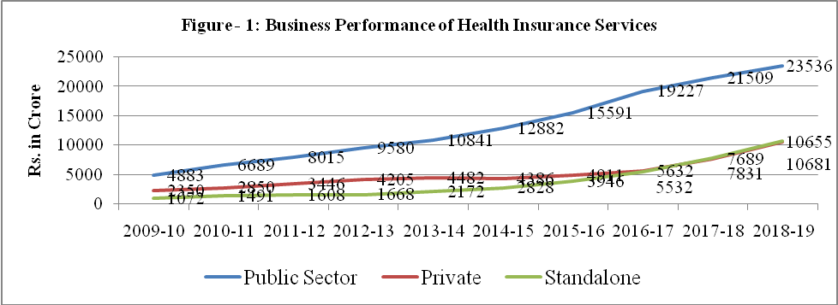

Source: Reports from IRDA

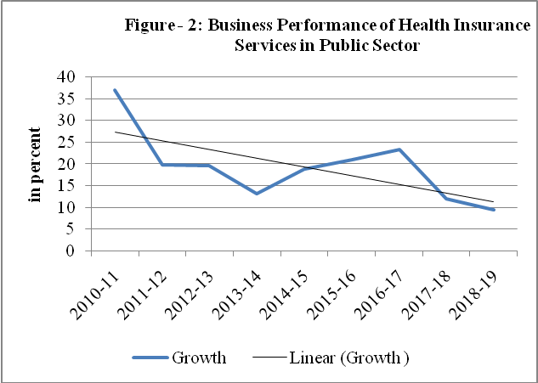

Source: Computed by Author

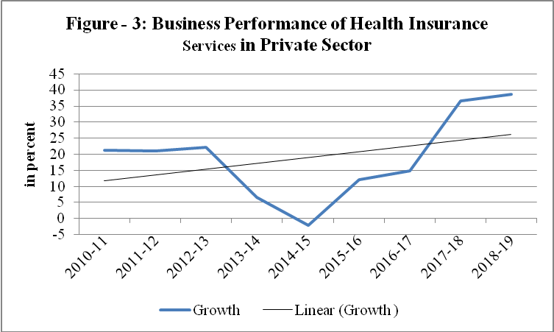

Source: Computed by Author

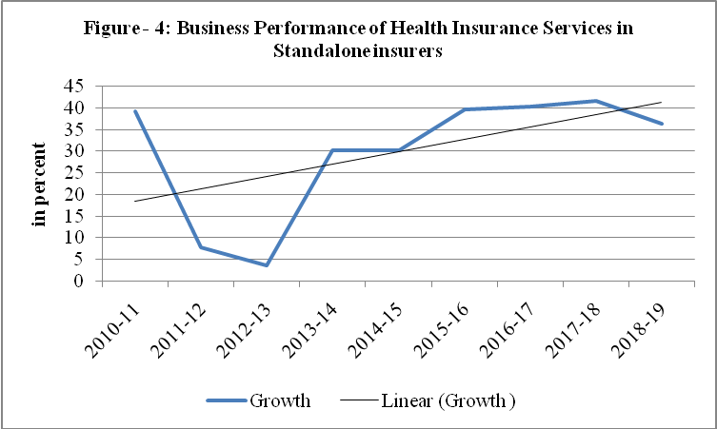

Source: Computed by Author
Table - 1: Business Growth of Health Insurance Services during 2009-10 to 2018-19
 | Public | Private | Standalone
Mean (Rs. in Crore) | 13275 | 5061 | 3883
SD (Rs. in Crore) | 6456 | 2470 | 3202
CV | 0.49 | 0.49 | 0.82
CAGR (%) | 19.09 | 18.29 | 29.1
Source: Reports from IRDA

Table -2: Business Growth of Health Insurance Services - Projected Analysis
Year | Public sector | Private Sector | Standalone
Year | (Rs. in Crore) | (Rs. in Crore) | (Rs. in Crore)
2019-20 | 24867 | 9113 | 9149
2020-21 | 26975 | 9850 | 10106
2021-22 | 29082 | 10587 | 11063
Source: Computed by Author

Table – 3: Mean Scores on Satisfaction towards Health Insurance Services
Attributes | Satisfaction level |  | Tests of Equality of Group Means Univariate ANOVA
Attributes | Lower (n=10%) | Higher (n=66.17%) | Wilks' Lambda | F(df =1, 203)
X1 - Coverage of illness and medical emergencies | 1.852 | 3.584 | 0.779 | 57.445**
X2 - Wide sum insured options | 2.815 | 3.719 | 0.929 | 15.565**
X3 - Timely service | 2.815 | 4.219 | 0.796 | 51.986**
X4 - Transparent in customer service | 2.370 | 2.921 | 0.980 | 4.234*
X5- Hassle-free claim settlement procedure | 1.815 | 3.983 | 0.742 | 70.581**
X6 - Company tie-up with reputed hospital | 1.741 | 3.500 | 0.838 | 39.207**
X7 - Employees attention | 2.444 | 3.466 | 0.932 | 14.925**
X8 - Allowed period for pre hospitalization | 3.074 | 3.421 | 0.992 | 1.607^{NS}
X9 - Affordable premium | 2.556 | 4.202 | 0.775 | 58.822**
X10 - Availability of schemes | 2.815 | 3.691 | 0.937 | 13.629**
X11 - Allowed period for post hospitalization | 1.741 | 3.213 | 0.867 | 31.179**
X12 - Digitalization in service | 2.852 | 4.017 | 0.896 | 23.543**
X13 - Speedy response on queries | 2.926 | 4.219 | 0.849 | 36.125**
X14 - Agents approach in customer service | 2.111 | 3.652 | 0.877 | 28.590**
X15 - Availability of branch offices | 2.741 | 4.129 | 0.852 | 35.124**
X16 - Availability of complete information by web portal | 3.296 | 4.433 | 0.810 | 47.515**
X17 - 24x7 Claims helpdesk | 2.481 | 3.579 | 0.911 | 19.882**
X18 - Quality of service | 2.704 | 3.899 | 0.903 | 21.802**
X19 - Introduction of new schemes | 1.815 | 3.483 | 0.862 | 32.584**
X20 - Allowable grace period to policy renewal | 2.556 | 3.989 | 0.858 | 33.634**
X21 - Coverage of alternative treatments like Ayurveda, Homeopathy etc. | 2.778 | 3.410 | 0.973 | 5.702*
X22 - Procedures related to reimbursement of medical expenses | 2.333 | 3.287 | 0.934 | 14.395**
X23 - Employees courtesy | 3.185 | 4.022 | 0.950 | 10.694**
X24 - Standard exclusions in coverage | 2.926 | 3.433 | 0.980 | 4.134*
X25 - Restriction in number of persons covered | 2.815 | 4.264 | 0.845 | 37.204**
Source: Field Survey

Table – 4: Percentage of Correct Classification of the Policyholders
Satisfaction level towards Health Insurance Services | Lower | Higher | Total
Lower | 27 (100) | 0 (0) | 27 (100)
Higher | 4 (2.2) | 174 (97.8) | 178 (100)
Source: Primary data (The values in brackets are percentages)

Table - 5: Relative importance of Attributes in Discriminating between the Groups
Explanatory Attribute | Relative Importance | Rank
X1 - Coverage of illness and medical emergencies | 17.64 | I
X3 - Timely service | 12.75 | III
X5 - Hassle-free claim settlement procedure | 8.02 | VIII
X6 - Company tie-up with reputed hospital | 8.20 | VII
X7 - Employees attention | 5.14 | X
X9 - Affordable premium | 13.15 | II
X12 - Digitalization in service | 6.43 | IX
X15 - Availability of branch offices | 8.71 | V
X16 - Availability of complete information by web portal | 11.45 | IV
X20 - Allowable grace period to policy renewal | 8.51 | VI
Source: Field Survey

