**EXPERIMENTAL STUDY ON PARTIAL REPLACEMENT OF CEMENT WITH COW DUNG ASH IN CONCRETE**

Roopa Kamakshi, Pasumarti Noma Shankar, Shaik Mehaboob, Shaik Ruksana,

Pamarthi Gowtham Sri Harsha, E. Srinivas, N A G K Manikanta Kopuri

UG Students – Final Year, Associate Professor, Associate Professor

Department of Civil Engineering, NRI Institute of Technology, Agriripalli, India

------------------------------------------------------------------*****-------------------------------------------------------------------

Abstract: - The consumption of cement in concrete industries increasing day by day. Concrete is the most widely used construction material in civil engineering industry because of its high structural strength and stability. The most important part of concrete is the cement. Use of cement alone as a binder material produces large heat of hydration since the production of this raw material emits huge amount of CO2. The carbon dioxide emission from cement is very harmful to the environmental changes. The concrete industry is looking for supplementary cementations material with the objective of reducing the carbon dioxide emission which is harmful to environment. The effective way of reducing CO2 emission from the cement industry is to use the industrial by products or use of supplementary cementing material such fly ash, silica fume. In this present experimental work, an attempt is made to replace cement by Cow dung ash (CDA) to overcome these problems. The cement has been replaced by CDA in the range of 5%, 10%&15% by weight of cement for M20 grade mix. It was tested for compressive strength at the age of 7, 14 and 28 days and compared with those of conventional concrete. Results showed that 10% replacement of cement by cow dung ash makes a considerable increase in compressive strength*.*

**KEYWORDS: Cow dung ash (CDA), Compressive strength*.***

**1.INTRODUCTION**

Concrete is the most popular building material in the world. However, the production of cement has diminished the limestone reserves in the world and requires a great consumption of energy. River sand has been most popular choice for the fine aggregate component of concrete in the past, but overuse of the material has led to environmental concerns, the depleting of securable river sand deposit and a concomitance price increase the material Therefore, it is desirable to obtain cheap, environmentally friendly substitutes for cement and river sand that are preferable by product. Concrete is the world’s most utilized construction material. The need for infrastructural development in both the developing and developed countries has placed a great demand on Ordinary Portland Cement (OPC) since its invention in the first half of the 19th century Portland cement has become the most widely available material.

There is need for affordable building materials in providing adequate housing for the teaming populace of the world. The cost of conventional building materials continues to increase as the majority of the population continues to fall below the poverty line. Thus, it is necessary to use a supplementary local material as alternative for the construction of low-cost buildings in both rural and urban areas. A huge amount of concrete is consumed by the construction industry. The production of Portland cement is not only costly and energy intensive, but it also produces large amounts of carbon emission. The production of cement poses environmental

Problems due to emission of gaseous pollutants. The emissions of poisonous gases like CO2, NO., etc. by cement production companies have depleted the natural environment. They have caused environmental pollution and global warming due to the depletion of ozone layer. Some industrial wastes have been studied for use as supplementary cementing materials such as fly ash, silica fume, metakaolin etc. The disposal and management of waste material is a potential challenge.

Sustainable materials are currently widely considered and investigated in construction engineering research. Some examples of sustainable research are the use of recycled concrete aggregates, coal fly ash, ground clay brick and pervious paver block system. Further, substantial research work has been conducted on fiber-reinforced concrete which is a concrete primarily made of a mix of hydraulic cement, aggregates, water and reinforcing fibers. Cow dung is the undigested residue of plant matter which comes from cows gut. In cow dung nitrogen, calcium, carbon, potassium, and phosphorus have a high content. About 10- 15 kg cow dung is produced by a cow in a day, which contains about 28% water in fresh state. 34% of cow dung becomes ash when it is burnt. In the present study, cement was replaced by cow dung ash by 0%, 5%, 10%&15%

**2.LITERATURE REVIEW**

Various researches for the partial replacement of coarse aggregate with demolished concrete, which are related to my work, are as under:

**Abdelghani (2009):** Partial replacement for cement in the production of cement mortar. Clinker was replaced by waste brick in different proportions (0%, 5%, 10%, 15% and 20%) by weight for cement. A substitution of cement by 10% of waste brick increased mechanical strengths of mortar. The results of the investigation confirmed the potential use of this waste material to produce pozzolanic cement.

## J Manasseh (2010): Bone powder ash (BPA) to partially replace cement as a binder was reviewed. Analysis of results, using oxide composition, compound composition obtained using Bogue’s model, and results of test conducted in the laboratory, showed that only the replacement of cement with 10%BPA exhibited a convincing increase in compressive strength of 7.14% above that obtain with the use of cement

**Balwaik and S P Raut (2011):** The cement has been replaced by waste paper sludge accordingly in the range of 5% to 20% by weight for M-20 and M-30 mix. By using adequate amount of the waste paper pulp and water, concrete mixtures were produced and compared in terms of slump and strength with the conventional concrete. As a result, the compressive, splitting tensile and flexural strength increased up to 10% addition of waste paper pulp and further increased in waste paper pulp reduces the strengths gradually

**O. Rodríguez, et al (2012):** they have analyzed the chemical, physical, morphological, mineralogical and pozzolanic characteristics of several reservoir sludges and assesses their potential for use as 20% additions in blended cement manufacture. The studied sludges exhibit good pozzolanic properties, especially sample 5 which has highSiO2, Al2O3 and Fe2O3 contents. Blended cements prepared with 20% sludge additions complied with the European standard on compressive strength of one of the standardized cements, above 32.5 MPa at28 days of curing; except for sample 5, which showed similar compressive strength values to the reference cement and up to 2% higher values at long curing times.

**Utsev, J. T., Taku, J. K (2012):** Concrete cubes were produced using various replacement levels of 0, 10, 15, 20, 25 and 30 percent of OPC with CSA. A total of 54 cubes were produced and cured by immersing them in water for 7, 14 and 28 days respectively. Properties such as compressive strength, density, setting times and pozzolanic activity index were determined. The results showed that the densities of concrete cubes for 10 -15% replacement was above 2400Kg/m3 and the compressive strength increased from 12.45N/mm2 at 7days to 31.78N/mm2 at 28 days curing thus meeting the requirement for use in both heavy weight and light weight concreting. Thus, 10 -15% replacement of OPC with CSA is recommended for both heavy weight and light weight concrete production.

**C.Marthong (2012):** A comparative study on effects of concrete properties when OPC of varying grades was partially replaced by SDA is discussed in this paper. Percentage replacement of OPC with SDA was 0, 10, 20, 30 and 40% respectively. Experimental investigations are carried out on mortar cubes, concrete cubes and beams specimens. The mix was designed for target cube strength of 30 MPa at 28 days with water cement ratio of 0.38. Test results shows that, inclusion of SDA cause little expansion due to low calcium content. Early strength development was observed to be about 50-60% of their 28 days strength. The study suggests the use of SDA as partial replacement of cement up to a maximum of 10% by volume in all grades of cement.

**D.K.S. Roy, et al (2012):** Very little or no work has been carried out using silica fume as a replacement of cement. Moreover, no such attempt has been made in substituting silica fume with cement for low/medium grade concretes (viz. M20, M25). Properties of hardened concrete viz Ultimate Compressive strength, Flexural strength, Splitting Tensile strength has been determined for different mix combinations of materials and these values are compared with the corresponding values of conventional concrete

**J. Kumar, et al (2012):** The cement has been replaced by fly ash accordingly in the range of 0% (without fly ash), 10%, 20%, 30% & 40% by weight of cement for M-25 and M-40 mix. These tests were carried out to evaluate the mechanical properties for the test results for compressive strength up to 28 days and split strength for 56 days are taken.

**Yogendra, et al (2013):** The production of cement results in emission of many greenhouse gases in atmosphere, which are responsible for global warming. Hence, the researchers are currently focused on use of waste material having cementing properties, which can be added in cement concrete as partial replacement of cement, without compromising on its strength and durability, which will result in decrease of cement production thus reduction in emission in greenhouse gases, in addition to sustainable management of the waste. It is concluded that the 20% replacement of cement is possible without compromising the strength with 90 days curing.

**Bawankule, et al (2015):** This paper addresses the experimental studies on strength characteristics of cement mortar in which rice husk ash (RHA) is used as partial replacement of ordinary Portland cement (OPC). This paper is aimed at putting into effective use Rice Hush Ash a local additive which has been investigated to be super pozzolanic in a good proportion to reduce the high cost of structural concrete. Cement mortar paste were proportioned with varying dosages of RHA as partial replacement of OPC in the range of 0% to 15% with the gradual increase of RHA by 2.5%. It is found that the compressive strength of hardened concrete is decreasing with percentage increase in RHA.

**A. Shrivas, et al (2015):** Diverse modern and rural waste materials with pozzolanic properties, for example, saw dust ash, fly ash, micro silica, and rice husk ash and so on have had critical influence in the generation of superior cement The primary point of this work is to focus the ideal rate of rice husk ash, Wheat Straw Ash, Fly Ash, Glass powder, Sugarcane Bagasse Ash, Paper Pulp as incomplete trade of bond for M30 and M40 evaluation of cement up to 30% at interim of 10%.

**Oyejobi, et al (2015):** Burning of agricultural wastes as a means of disposal contributes to environmental degradation and can be reduced by utilizing the materials for other purposes such as construction materials. The optimum compressive strength of 23.77 N/mm2 was obtained for10% replacement at 28 days of age with percentage strength to the control of 92.24%. While 20% and 30% replacement of cement with POFA yielded compressive strength of 20.67N/mm2 and 15.36N/mm2 respectively.

**Mujedu K. A. and Adebara S. A. (2016):** This project is an experimental investigation on the use of Groundnut Shell Ash (GSA) as a partial replacement for cement in concrete. A total number of Seventy - Two (72) concrete cubes of different percentages of Groundnut shell ash which varies from 0% to 75% at intervals of 15% were produced. Substitution of cement with groundnut shell ash in concrete production was relatively possible not exceeding 15%.

**G.M. S. Islam(2017):** 1% super plasticizing admixture dose (by weight of cement) and generally found an increase in [compressive strength](https://www.sciencedirect.com/topics/materials-science/compressive-strength) of mortars with admixture. As with mortar, concrete cube samples were prepared and tested for strength (until 1 year curing). The compressive strength test results indicated that recycled glass mortar and concrete gave better strength compared to control samples. A 20% replacement of cement with waste glass was found convincing considering cost and the environment.

**S.A. Mangi** **(2017):** Two grades of concrete M15 and M20 were used for the experimental analysis. The cement was partially replaced by SCBA at 0%, 5%, and 10%, by weight in normal strength concrete (NSC). The innovative part of this study is to consider two grades of concrete mixes to evaluate the performance of concrete while cement is replaced by sugarcane bagasse ash outcome of this work indicates that maximum strength of concrete could be attained at 5% replacement of cement with SCBA, also gives compatible slump values which increase the workability of concrete.

**Singh.M, et al (2017):** Indigenous fabrication of equipment for percentage air content, Figg’s air and water permeability and surface resistivity. It is observed that the mechanical properties of concrete enhanced with incorporation of dried marble slurry for up to 15% replacement. The quality of concrete improves as per ultrasonic pulse velocity and durability tests. Reinforced concrete with marble slurry also shows promising results with increased bond strength

**Parthasarathi, et al (2017):** Greatest of egg shell waste is willing in landfills short of any pre-treatment since it is conventionally unusable and eventually makes thoughtful eco glitches. Egg shell powder is replaced by 5%, 10% and 15% in addition with the silica fume by 2.5%, 5%, and 7.5% of weight of cement. It is found the strength of the concrete rises with the adding of egg shell powder and silica fume.

**G.A. Lakshmi and P. S.Pravallika (2019):** In the present study Metakaolin and marble duat used as a partial replacement for cement. Metakaolin is a calcinied clay and It is a Dehydroxylated form of the clay mineral Kaolinite. Stone having higher percentage of Kaolinite are known as china clay or kaolin was traditionally used in the manufacture of porcelain ceramic material. The particle size of Metakaolin is smaller than cement particles and where as Marble dust is obtained from cutting and manufacturing industries of marble. In India near about 3500 metric tons of marble dust slurry per day is generated. So, Marble dust is very easily available with very less cost. Kaolinite is also called as green pozzolana because it emits less co2. This paper presents results of an experimental program to determine mechanical properties of concrete with metakaoline and marble dust is replaced with cement with the known percentages of 0%,5%+5%,7.5%+7.5%,10%+10%,12.5%+12.5%,15%+15% for the grade of M30.

**Jalil, et al (2019):** Tests were conducted at 3, 7 and 28 days of concrete age. Results show a decrease of 14% in compressive strength, 7.5% in tensile strength and 10.5% in flexure strength for 10% replacement vis-à-vis control specimens at 28 days. For 20% replacement, the decrease in compressive, tensile and flexure strength are 25.5%, 29%, 31% respectively. Additionally, ASTM standard strength activity index test with finer slag particles passing through ASTM sieve# 200 provided compressive strength more than that of control specimen. Based on the results, it is concluded that the industrial slag has the potential to partially replace the cement if slag is ground to the particles, passing through ASTM sieve# 200. This could lead to a huge reduction of cement quantity in concrete and the environmental burden due to deposition of waste slag in landfills.

**Kathirvel, et al (2019):** PJA is used as partial replacement of cement in the production of concrete. Mechanical are discussed using [compressive strength](https://www.sciencedirect.com/topics/materials-science/compressive-strength) and impact test.The microstructural properties are discussed using [XRD](https://www.sciencedirect.com/topics/engineering/ray-diffraction) and analysis. Flexural of [reinforced concrete beams](https://www.sciencedirect.com/topics/engineering/reinforced-concrete-beam) is also discussed. This results in greater reduction of loss of groundwater due to the growth of PJA as well as reduction in the pollution rate due to effective utilization of PJA and reduced cement production.

## 3.MATERIALS USED:

The constituent materials used in this project were gathered from different sources. Necessary tests were conducted on these materials to choose the kind and type of material.

**3.1 CEMENT:** Cement when mixed with minerals fragments and water, binds the particles into a whole compact. Cement is the most important and costliest ingredient of concrete. Ordinary Portland cement of 53 grade confirming to requirements of IS: 12269 – 1987

|  |  |  |
| --- | --- | --- |
| **S.NO** | **PROPERTIES** | **OBTAINED VALUES** |
| 1 | Specific gravity | 3.14 |
| 2 | Fineness test | 6% |
| 3 | Normal consistency | 33 % |
| 4 | Initial setting time | 40 min |
| 5 | Final setting time | 330 min |

**Table -1 Physical properties of cement**

**3.2 FINE AGGREGATE:** As per IS 383-2016, Fine aggregate is defined as material that will pass a 4.75mm sieve. For increased workability and for economy as reflected by use of less cement, the fine aggregate should have a rounded shape.

**Table-2: Physical properties of fine aggregates**

|  |  |  |
| --- | --- | --- |
| **S.NO** | **PROPERTIES** | **OBTAINED VALUES** |
| 1 | Specific gravity | 2.65 |
| 2 | Fineness modulus | 2.78 |
| 3 | Bulking | 26.40 |
| 4 | Zone | II |

**3.3 COARSE AGGREGATE:** As per IS 383-2016, Coarse aggregates can be defined as irregular broken stone or naturally-occurring rounded gravel used for making concrete. Coarse aggregates are retained on the sieve of mesh size 4.75mm. It acts as volume increasing component and is responsible for strength, hardness and durability of concrete.

**Table 3: Physical properties of Coarse aggregate**

|  |  |  |
| --- | --- | --- |
| **S.NO** | **PROPERTIES** | **OBTAINED VALUES** |
| 1 | Specific gravity | 2.8 |
| 2 | Fineness modulus | 7.2 |
| 3 | Impact test | 20.27 % |
| 4 | crushing strength test | 21.06 % |

**3.4 COW DUND ASH(CDA):** When sterilized, is entirely odorless and offers some wonderful characteristics for the production of variety of fiberboard building materials. The manure essentially replaces the role of sawdust in the production of particle boards, which would cut down wood usage as well as posing a creative solution of huge.

The cow dung is said to have strong antibacterial properties it works as a good disinfectant by keeping house cool in summer and warm in winter cow dung’s used as construction material for house encourages utilization of material resources and minimizes wastages. In this CDA was obtained from rural housing the cow dung is collected and dried for an period of 12 days and it is burned to form an ash which is added to cement by partially replacing from 5% to 20% the cow dung is an good.

**Table 4: physical properties of cow dung ash**

|  |  |  |
| --- | --- | --- |
| **S.NO** | **PROPERTIES** | **OBTAINED VALUES** |
| 1 | Specific gravity | 2.59 |
| 2 | Fineness modulus | 2.35 |

**4.RESULTS AND DISCUSSIONS**

**4.1Compressive strength:**

The strength in compression has a definite relationship with all other properties of concrete In India cubical moulds of size 150mm *150mm*150mm had casted and tested for 7 days,14 days and 28 days. The test results are tabulated below.

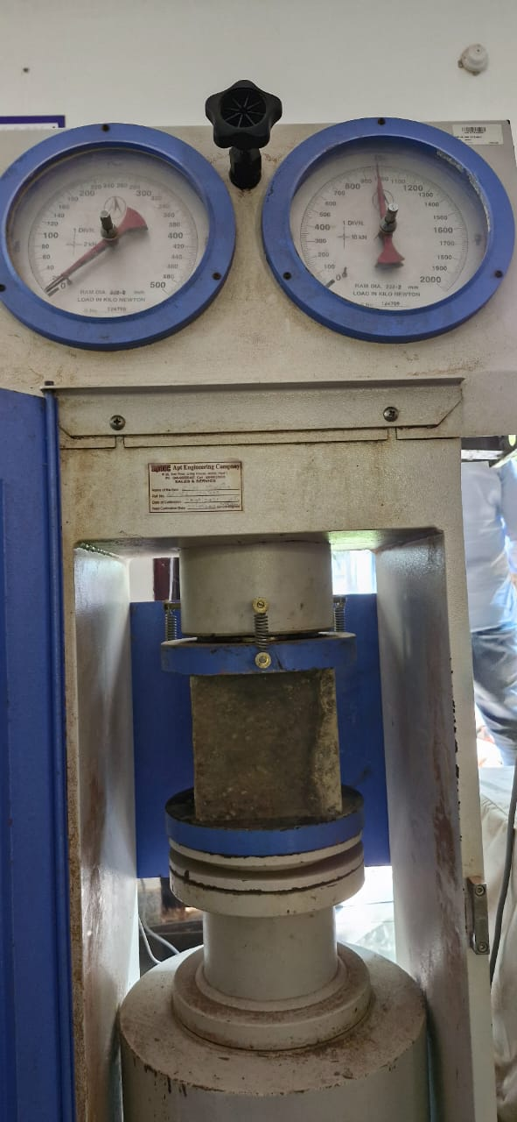

**Fig.1 Compressive strength**

|  |  |  |  |  |
| --- | --- | --- | --- | --- |
| **S.NO** | **% COW DUNG ASH** | **Compressive strength (N/mm2)** | | |
| **7Days** | **14Days** | **28Days** |
| 1 | 0 | 14.24 | 17.52 | 22.07 |
| 2 | 5 | 14.20 | 16.68 | 21.08 |
| 3 | 10 | 17.50 | 18.88 | 24.56 |
| 4 | 15 | 15.89 | 17.72 | 19.5 |

**Table 5: Compressive Strength Values**

**4.2 SPLIT TENSILE STRENGTH**

The split tensile strength obtained by testing the specimen for M30 grade of concrete to all the mixes designed for various replacement given below.

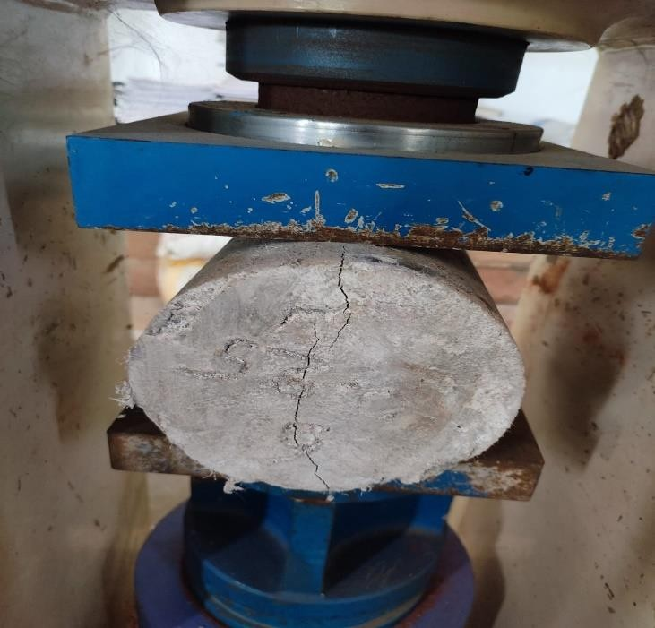

**Fig.2 Split tensile strength**

**Table 6: Split tensile strength values**

|  |  |  |  |  |
| --- | --- | --- | --- | --- |
| **z** | **% replacement of cow dung ash** | **Split tensile strength (N/mm2)** | | |
| **7 Days** | **14 Days** | **28 days** |
| 1 | 0 | 2.12 | 2.4 | 3.39 |
| 2 | 5 | 1.98 | 2.12 | 3.12 |
| 3 | 10 | 1.69 | 1.94 | 2.12 |
| 4 | 15 | 1.27 | 1.84 | 1.98 |

**5.CONCLUSIONS**

## For a given water cement ratio, use of UPVC plastic waste in concrete lower the density, compressive strength and split tensile strength.

## The compressive strength for 0% replacement of coarse aggregate is 39.55 N/mm2 and for 15% is 33.2 N/mm2.The tensile strength for 0% replacement of coarse aggregate is 3.39

## UPVC waste can be used to replace coarse aggregate in concrete. The compressive strength varies from 0% replacement to 5% replacement of Natural coarse aggregates, but with strength equal to or more than Target mean compressive strength.

## So, 5% Replacement of coarse aggregate with Plastics is suggestable. Compressive, tensile strength are decreases from 5% to 15% replacement with C.A.

**6.REFRENCES**

1. Naceri, A., & Hamina, M. C. (2009). Use of waste brick as a partial replacement of cement in mortar. Waste management, 29(8), 2378-2384.
2. Manasseh, J. (2010). A review of partial replacement of cement with some agro wastes. Nigerian journal of Technology, 29(2), 12-20.
3. Balwaik, S. A., & Raut, S. P. (2011). Utilization of waste paper pulp by partial replacement of cement in concrete. International Journal of Engineering Research and Applications, 1(2), 300-309.
4. Rodríguez, N., Murillo, R., & Abanades, J. C. (2012). CO2 capture from cement plants using oxyfired precalcination and/or calcium looping. Environmental science & technology, 46(4), 2460-2466.
5. Utsev, J. T., & Taku, J. K. (2012). Coconut shell ash as partial replacement of ordinary Portland cement in concrete production. International Journal of Scientific and Technology Research, 1(8), 86-89.
6. Marthong, C. (2012). Sawdust ash (SDA) as partial replacement of cement. International Journal of Engineering Research and Applications, 2(4), 1980-1985.
7. Roy, D. K. S., & Sil, A. (2012). Effect of partial replacement of cement by silica fume on hardened concrete. International Journal of Emerging Technology and Advanced Engineering, 2(8), 472-475
8. Pitroda, J., Zala, L. B., & Umrigar, F. S.(2012).Experimental Investigations on Partial Replacement of Cement with Fly ash in design mix concrete. International Journal of Advanced Engineering Technology, 3(4), 126-129.
9. Patil, Y. O., Patil, P. N., & Kumar, D. A. (2013). GGBS as partial replacement of OPC in cement concrete–An experimental study. International Journal of Scientific Research, 2(11), 189-191.
10. Bawankule, S. P., & Balwani, M. S. (2015). Effect of partial replacement of cement by rice husk ash in concrete. Int. J. Sci. Res, 4, 1572-1574.
11. Shrivas, A., Jain, D., & Joshi, R. (2015). Application of different waste in concrete as a partial replacement of cement. Int. J. Sci. Technol. Eng, 2, 89-107.
12. Oyejobi, D. O., Abdulkadir, T. S., & Ahmed, A. T. (2015). A study of partial replacement of cement with palm oil fuel ash in concrete production. Journal of Agricultural Technology, 12(4), 619-631.
13. Mujedu, K. A., & Adebara, S. A. (2016). The use of groundnut shell ash as a partial replacement for cement in concrete production. International Journal of Sciences, Engineering and Environmental Technology (IJOSEET), 1(3), 32-39.
14. Islam, G. S., Rahman, M., & Kazi, N. (2017). Waste glass powder as partial replacement of cement for sustainable concrete practice. International Journal of Sustainable Built Environment, 6(1), 37-44.
15. Mangi, S. A., Jamaluddin, N., Ibrahim, M. W., Awal, A. A., Sohu, S., & Ali, N. (2017, November). Utilization of sugarcane bagasse ash in concrete as partial replacement of cement. In IOP conference series: materials science and engineering (Vol. 271, No. 1, p. 012001). IOP Publishing.
16. Singh, M., Srivastava, A., & Bhunia, D. (2017). An investigation on effect of partial //////replacement of cement by waste marble slurry. Construction and Building Materials, 134, 471-488.
17. Parthasarathi, N., Prakash, M., & Satyanarayana, K. S. (2017). Experimental study on partial replacement of cement with egg shell powder and silica fume. Rashaan Journal of Chemistry, 10(2), 442-449.
18. Asha Lakshmi, G., & Pravallika, P. S. (2019). strength and durability properties of concrete with partial replacement of cement with metakaoline and marble dust.
19. Jalil, A., Kitab, A., Ishtiaq, H., Bukhari, S. H., Arshad, M. T., & Anwar, W. (2019). Evaluation of steel industrial slag as partial replacement of cement in concrete. Civil Engineering Journal, 5(1), 181-190.
20. Kathirvel, P., Anik, G. A., & Kaliyaperumal, S. R. M. (2019). Effect of partial replacement of cement with Prosopis Juli flora ash on the strength and microstructural characteristics of cement concrete. Construction and Building Materials, 225, 273-282.