**Hybrid Power Charging Station**

# Mr. B. J. Vispute1, Mr. Tushar Damodar Mahale2, Mr. Dhruv Mrinmoy Dutta3,

# Mr. Gaurav Rajendra Mahale4, Mr. Roshan Trambak Kalekare5

2,3,4,5student, Information Technology, Sandip Foundation's Sandip Polytechnic, Nashik, Maharashtra, India.

1Professor, Information Technology, Sandip Foundation's Sandip Polytechnic, Nashik, Maharashtra, India.

# ABSTRACT

﻿The Hybrid Power Charging Station, integrating solar and wind strength, represents an revolutionary method to sustainable power technology for electric powered vehicle (EV) charging infrastructure. This mission objectives to discover the layout, implementation, and advantages of this kind of hybrid device in addressing the developing demand for smooth transportation solutions at the same time as decreasing reliance on conventional fossil fuels.

Key additives of the abstract include:

Introduction to Hybrid Power Charging Stations:Overview of the increasing adoption of electrical automobiles and the want for sustainable charging infrastructure. Introduction to the concept of hybrid electricity technology the use of renewable resources like solar and wind strength.

Design Considerations: Discussion at the design elements for most effective integration of sun panels and wind turbines in the charging station infrastructure. Consideration of geographical region, climate styles, and strength call for in determining the sizing and location of renewable energy components. System Integration and Operation: Explanation of the technical factors involved in integrating solar panels, wind generators, electricity garage structures, and EV charging infrastructure. Discussion at the manage and monitoring systems required for green operation, along with strength management and grid connectivity.

Benefits and Sustainability: Analysis of the environmental and economic advantages of hybrid strength charging stations, which include decreased carbon emissions, strength cost financial savings, and grid resilience. Exploration of the capacity for electricity independence and scalability, especially in faraway or off-grid places.

Technological Innovations and Challenges: Examination of technological improvements in sun and wind electricity technologies that decorate the performance and reliability of hybrid energy structures. Identification of demanding situations including intermittency, power garage barriers, and regulatory hurdles, and dialogue on techniques to mitigate these limitations.

Case Studies and Future Directions: Review of existing hybrid strength charging station tasks worldwide, highlighting a success implementations and lessons discovered. Exploration of destiny developments and possibilities for innovation in renewable energy integration, which include improvements in battery garage, clever grid technology, and coverage assist.

# INTRODUCTION

The idea of sun and wind energies dates returned to nearly 7,000 years in the past. However, inside the past due 1800s the Danes advanced the primary wind generators to supply industrial strength. In the early 1900s small- scale wind turbines became extra widely used round Europe in particular in the rural regions for generating electricity using vintage vehicle generators and carved rotors. The wind strength added power to the rural regions and the electric power changed into used to rate batteries to run radios and to draw water from deep wells. Except in Denmark where wind electricity manufacturing and research endured, wind electricity did not play any major function in the era of power until the late 1900s. The fast increase of sun and wind powers is due in component to favorable worldwide political climate towards those energies, efforts to reduce carbon dioxide (CO2) and greenhouse gases (GHG) and different power plant pollution, worldwide awareness of climate adjustments, and the urgency to expand renewable power sources. Other elements inclusive of moneymaking tax incentives and rules man-relationship country wide renewable energy standards have multiplied the march in the direction of sun and wind energies. For instance inside the US, a few states have enacted “renewable portfolio wellknown (RPS)” law that requires utilities to promote a positive percent of the power from sustainable strength sources within affordable stipulated times. Even although Europe and North America have the largest in-stalled ability of wind turbine capability, China, India, and developing global have the biggest capacity for wind energy. Our project is primarily based on usage of non-traditional sources of strength to meet fundamental. Energy call for like powering road lights using wind and solar electricity. The motive of the use of two resources of energy like wind and sun is to eliminate seasonal dependency of the tool .When one supply, say sun strength is not to be had in abundance at some stage in monsoon, wind power comes to the rescue and similarly opposite may be the case at some stage in the time when the winds aren't severe enough. Also it includes the analysis of the VAWT, in order that max strength and efficiency may be acquired.

# METHODOLOGY

﻿The underneath drift chart indicates the sequential operation/steps that will be accomplished

throughout the task procedure.

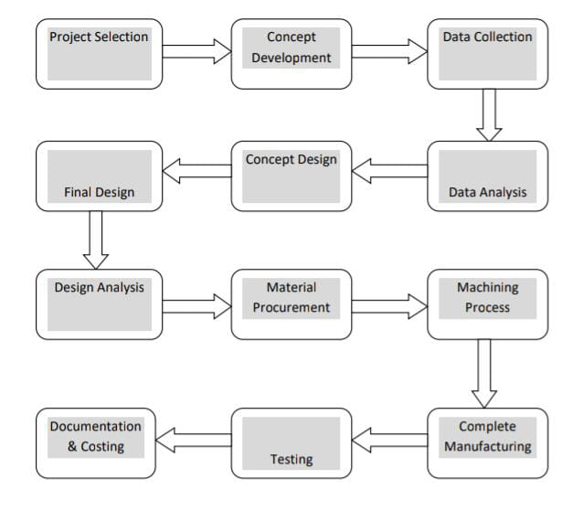

# MODELING AND ANALYSIS

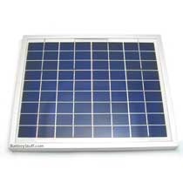 

**Fig.1.** Solar panel. **Fig.2.** Photovoltaic Effect.

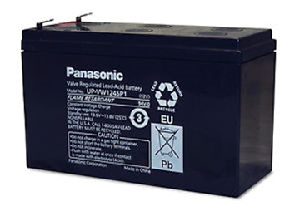 

**Fig.3.** Battery. **Fig.4.** DC Motors.

 

**Fig.5.** Pedestal bearing. **Fig.6.** Shaft.

**[](http://www.screwfix.com/c/screws-nails-fixings/washers/cat840104)** **[](http://www.screwfix.com/c/screws-nails-fixings/nuts/cat840096)[](http://www.screwfix.com/c/screws-nails-fixings/bolts/cat840086)**

**Fig.7.** Washer. **Fig.8.** Nut and Bolt

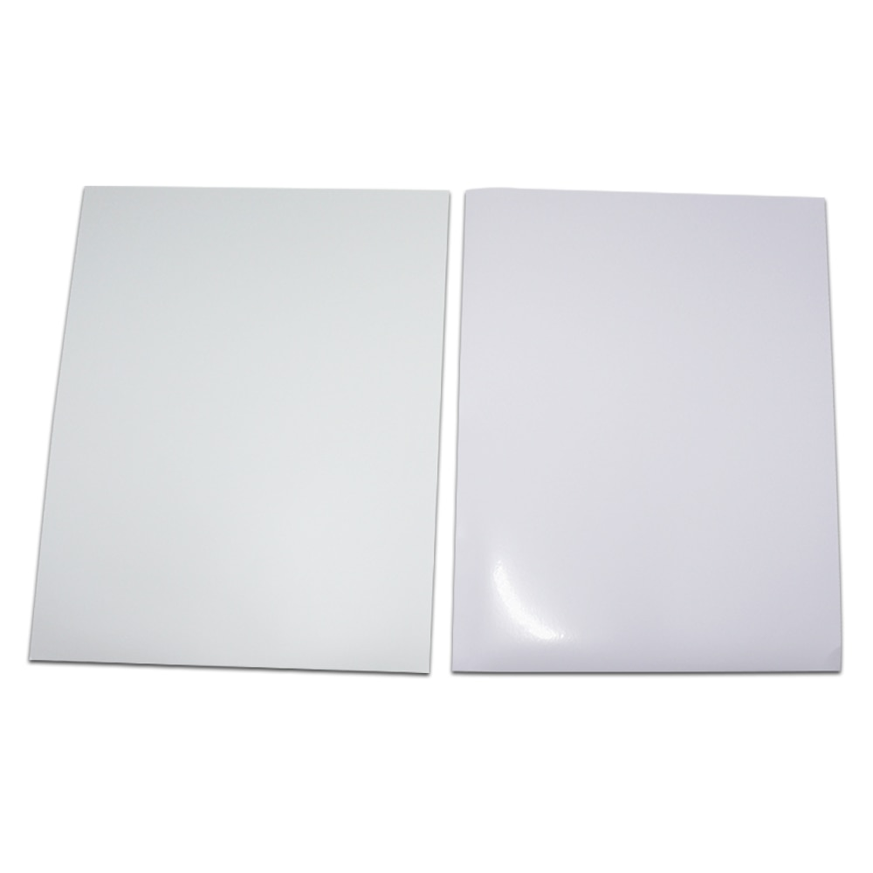

**Fig.9.** Spur Gear. **Fig.10.**Wild mill blade.

﻿Solar strength is power from the Sun. It is renewable, inexhaustible and environmental pollutants unfastened. Solar charged battery structures offer strength supply for entire 24hours an afternoon no matter horrific climate. More so, electricity screw ups or energy fluctuations due to provider a part of restore as the case may be is nonexistent. Wind is a herbal phenomenon related to the motion of air loads caused more often than not by way of the differential solar heating of the earth's floor. Seasonal variations within the energy acquired from the solar have an effect on the energy and course of the wind. The wind turbine captures the winds kinetic electricity in a rotor which include or more blades mechanically coupled to an electrical generator. The turbine is installed on a tall tower to enhance the strength seize. The hybrid energy method something that's made by way of the aggregate of solar.

# RESULTS AND DISCUSSION

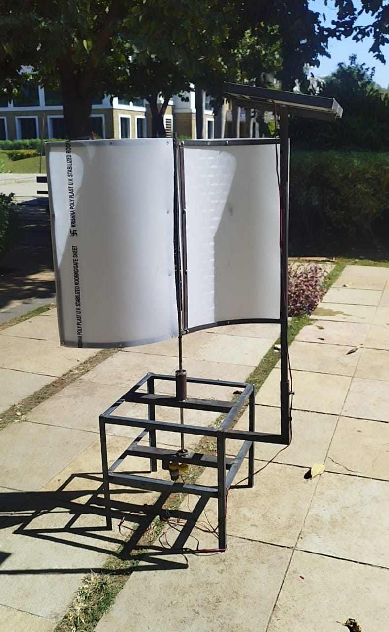

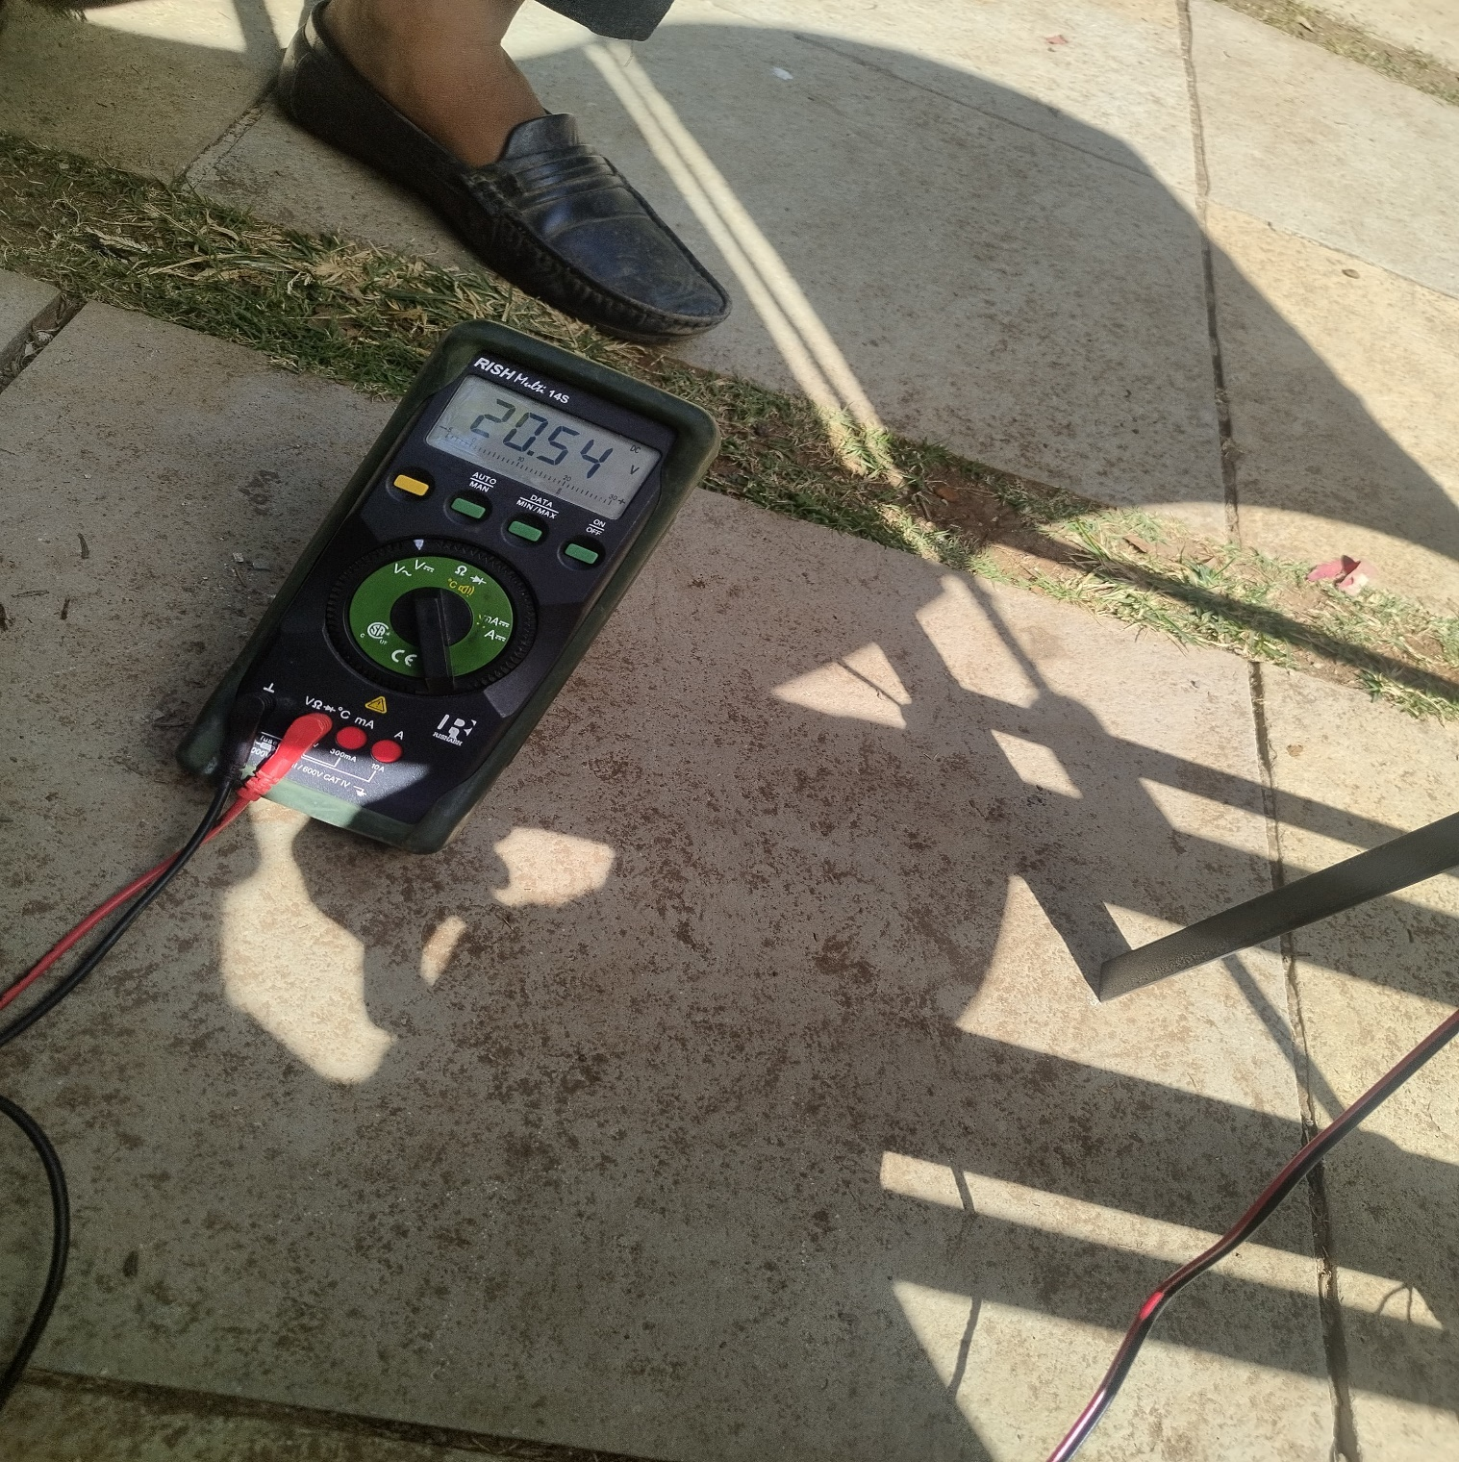 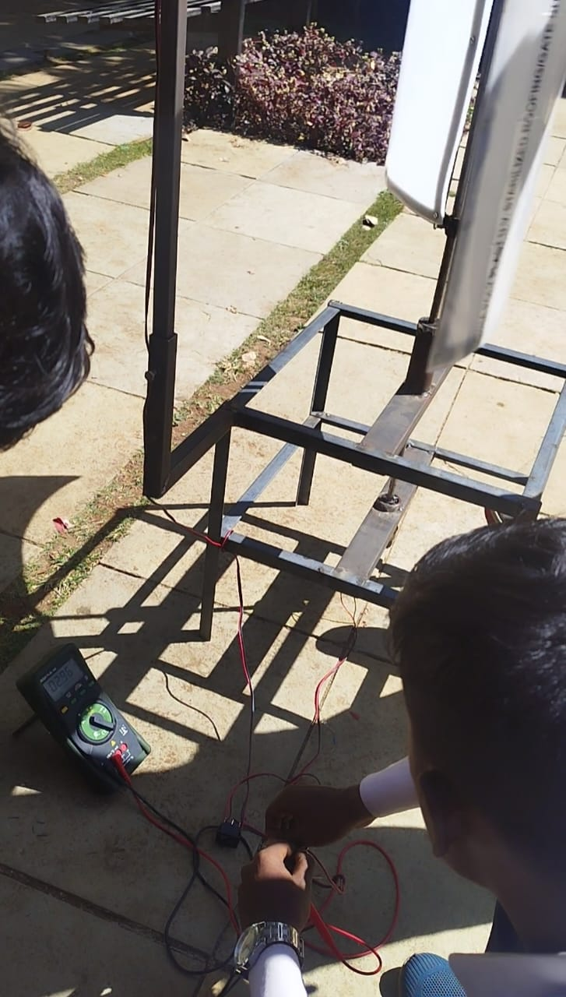

Reading Of Solar Pannel Reading Of Wind Energy

# ADVANTAGES

# ﻿The advantages protected via the endorse device are listed as,

# 1) Overcoming negative aspects of standalone renewable electric power generation device.

# 2) Producing much extra performance as two or greater renewable electricity era device running collectively inside the phrases of electrical energy generation.

# 3) Since, the gadget doesn’t complexity of machine checking out and expertise have become smooth in terms of difficulties.

# 4) System continues is remarkably reduced and will become smooth.

# 5) Renewable energy sources like, sun, wind,. Are applied so, no waste production.

# 6) Producing clean, friendly to surroundings, renewable strength.

# 7) Once the system is designed and evolved or manufactured, the setup of device is simple.

# 8) Within positive time period the installation value receives included.

# 9) If the device gets damaged in case, no need of converting whole device or subsystem. Just, converting a damage factor will training session.

# CONCLUSION

﻿While concluding this file, we feel pretty satisfy in having finished the challenge mission well on time, we had good sized realistic revel in on success of the production schedules of the working mission model. We are therefore, glad to state that the in calculation of mechanical flair proved to be a completely useful cause. Although the design criterions imposed difficult problems which, but have been conquer by way of us because of availability of appropriate reference books. The selection of preference uncooked materials helped us in machining of the various additives to very near tolerance and thereby minimizing the level of balancing trouble. Needless to emphasis here that we had carry no stone unturned in our capacity efforts during machining, fabrication and meeting work of the task version to our whole pleasure. The model develops with the aid of us satisfy the required goals

# REFERENCES

[1] Varad Bagwe, Abhijeet Thoke, Charchit Vatsa, Dibyanshu Pandey, Sangeeta Kotecha, Integration of Solar and Wind Energy System for Hybrid Power Generation, International Conference on Innovative and Advanced Technologies in Engineering (March-2018), Volume 8, pp.11-15.

[2] Dr. Recayi Pecen, Dr. MD Salim, & Dr. Marc Timmerman, A Hybrid Solar-Wind Power Generation System as an Instructional Resource for Industrial Technology Students, Journal of Industrial Technology • Volume 16, Number 3 • May 2000 to July 2000.pp.1-7.

[3] Swapneel kaurav, Prof.P.Yadav, Hybrid Power System Using Wind Energy and Solar Energy, International Journal of Innovative Research in Science, Engineering and Technology,Vol. 5, Issue 1, Januray 2016,pp.54-58. [4] By Medugu, D. W. & Michael, E., Integrated Solar – Wind Hybrid Power Generating System for Residential Application, Global Journal of Researches in Engineering: F Electrical and Electronics Engineering Volume 14 Issue 4 Version 1.0 Year 2014, pp.1-9.

[5] Pritesh P. Shirsath, Anant Pise , Ajit Shinde, Solar-Wind Hybrid Energy Generation System, International Journal of Engineering Research and General Science Volume 4, Issue 2, March-April, 2016,pp. 546-550.

[6] Bartosz Ceran, Qusay Hassan, Marek Jaszczur and Krzysztof Sroka, An analysis of hybrid power generation systems for a residential load, E3S Web of Conferences, Energy and Fuels2016,pp.1-10.