CAR CONTROL USING WIFI MODULE

**D.Prabhakar1, B.Praveen Kumar2, G.Aditya3,G.Vinay kumar4, Dr.S.Sivaganesan5**

1Student, EEE, Holy Mary Institute of Technology & Sciences, Hyderabad, Telangana

2 Student, EEE, Holy Mary Institute of Technology & Sciences, Hyderabad, Telangana

3Student, EEE, Holy Mary Institute of Technology & Sciences, Hyderabad, Telangana

4Student, EEE, Holy Mary Institute of Technology & Sciences, Hyderabad, Telangana

5Professor & HOD, EEE, Holy Mary Institute of Technology & Sciences, Hyderabad, Telangana

**ABSTRACT**

“We built the car employing a variety of transmission methods. But what about a car that can be controlled over WIFI”. WIFI

is the most promising technology right now, and developers are always working to improve it. This technology is prevalent today and will be for many years to come. WIFI with low power consumption has also been developed. We created a car that can be controlled via WIFI. If you host your IP address on a website, you can control it from anywhere in the globe, but we'll stick to local WIFI for now.

**Keywords:** Node MCU, ESP8266, Internet of Things, Wi-Fi, Motor Driver

# INTRODUCTION

Develop a car control system using a WiFi module to enable wireless communication, allowing users to remotely manage and monitor various vehicle functions, such as ignition, door locks, and tracking, fostering increased convenience, security, and real-time data access.

# METHODOLOGY

Method and analysis which is performed in your research work should be written in this section. A simple strategy to follow is to use keywords from your title in first few sentences.

## L298N Motor Driver

We can turn on and off the motor via ENA and ENB. A module usually comes with a jumper on those two pins when those are placed it is in ON state and on maximum speed. After removing the jumpers, by giving PWM signals to ENA and ENB pins we can control the speed of the motors

* + - VCC – voltage supply line for motors and the module (This module has a voltage drop of around 2volts, each channel can handle 2A)
    - GND- Common pin
    - 5V – it outputs 5V when a jumper is placed in 5V-EN (Also provide power for L298N IC through a 7805 5V regulator when the jumper is removed you need to provide 5v externally)

## WiFi Module

Esp8266 has integrated a Tensilica L106 32-bit RISC processor. It got extra-low power consumption which makes this chip very much suitable for small circuits, IOT Projects. This chip reaches a maximum clock speed of 160MHz. Wi-Fi- 2.4GHz receiver & transmitter. User programs are stores in SPI flash. Memory - 32KB instruction RAM. External SPI Flash 512KB to 4MB typically in some cases 16MB supported according to the board you chosen.

# MODELING AND ANALYSIS

Power supply is inter connected with l289N motor driver module and this driver module will be adjustable of power consumption. WiFi module will be acting like a bridge between motor driver and smart devices ,it helps to connect with the total system with our smart device then the l289 driver receive commands and reacts with given command ,they may give outputs from out1,out2,out3 and out4. They consist of In1,In2,In3 and In4 for input commands .Then motor runs on the given command.Here Wifi Module Will Be Integrated With Program for Customisation of Controls

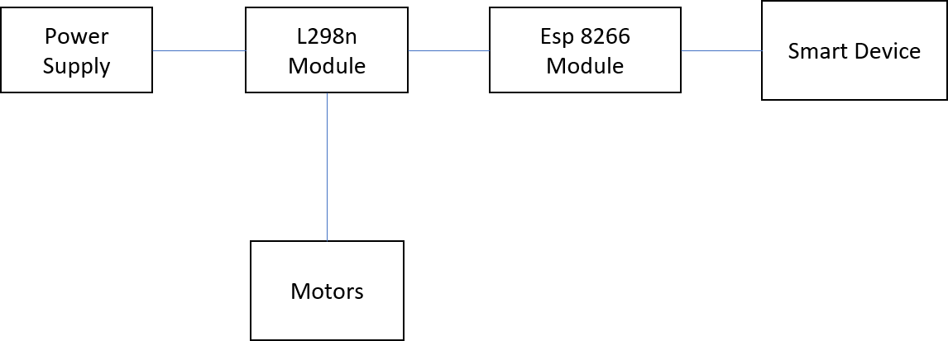

**Figure 1:** Block diagram of Car control using WiFi module.

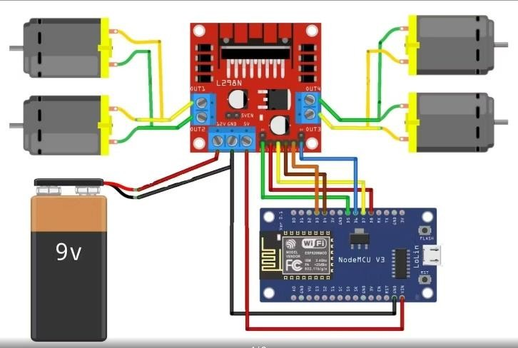

**Figure 2:** Circuit diagram of Car control using WiFi module

## Pulse Width Modulation (PWM)

In the PWM signal, the minimum and maximum voltage are the values that limit the wave’s oscillation. The space between them is called amplitude. A cycle is the interval of the wave where you can find one full repetition. The time that takes a cycle to finish is called a period. Frequency =1/period. Duty Cycle represents how much of the period in which the signal is high. To calculate the duty cycle you need to know how much of the period the signal is high.

## Calculating duty cycle = Take high time as 50ms and low time as 50ms

Period is 100ms 50ms/100mx=50% duty cycle 5v*50%=2.v Output=2.5v

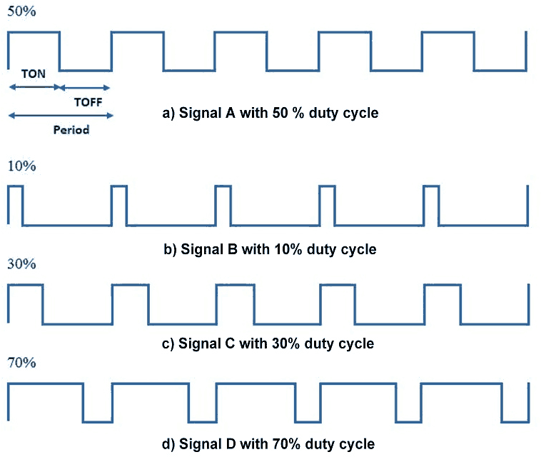

# 3. RESULTS AND DISCUSSION

When this WIFI-controlled car is powered on, the Node MCU board connects to the WIFI connection. Then, when you press the Commands (Forward, Backward, Left, Right) buttons on the interface created with HTML coding and has live hosted the site, those values will be sent to the Node MCU board via the web cloud. Then, the gear motors rotate according to those values. The L298N motor driver board is used for this. Also, the speed of these motors can be controlled by the slider created on the website.

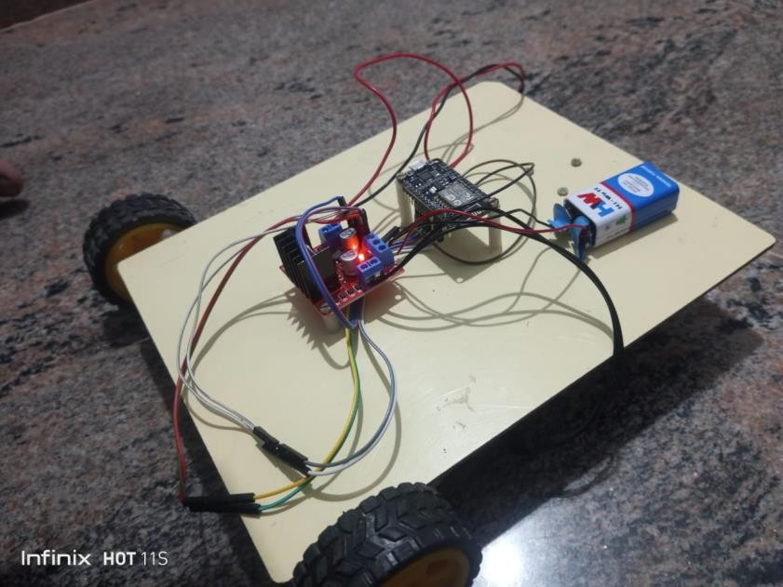

# CONCLUSION

**Figure 3:**Prototype of Car control using WiFi module

Finally, we Conclude That, By Using This Technology We Can Drive Our Vehicle Very Easy And We Can Experience Like Never Before Car Control Using Wifi Opens Up A World Of Possibilities For Customization Convenience And Security.

# REFERENCES

1. Anon., n.d. Sparkfun. [Online] Available at: https:/[/ww](http://www.sparkfun.com/datasheets/Robotics/L298_H_Bridge.pdf)w[.sparkfun.com/datasheets/Robotics/L298_H_Bridge.pdf](http://www.sparkfun.com/datasheets/Robotics/L298_H_Bridge.pdf)
2. Anon., n.d. Tutorial Spoint. [Online] Available at: https:/[/ww](http://www.tutorialspoint.com/microprocessor/microcontrollers_overview.htm)w[.tutorialspoint.com/microprocessor/microcontrollers_overview.htm](http://www.tutorialspoint.com/microprocessor/microcontrollers_overview.htm)
3. arduino-esp8266, n.d. arduino-esp8266. [Online] Available at: https://arduino- esp8266.readthedocs.io/en/latest/esp8266wifi/soft-access-point-class.html
4. Brain, M., n.d. howstuffworks. [Online] Available at: https://electronics.howstuffworks.com/microcontroller1.htm
5. Gudino, M., 2018. Arrow. [Online] Available at: https:/[/ww](http://www.arrow.com/en/research-and-events/articles/engineering-)w[.arrow.com/en/research-and-events/articles/engineering-](http://www.arrow.com/en/research-and-events/articles/engineering-) basics-what-is- [Accessed 26 February 2005].
6. Keim, R., 2019 . allaboutcircuits. [Online] Available at: https://[www.allaboutcircuits.com/technical-articles/what-is-a-](http://www.allaboutcircuits.com/technical-articles/what-is-a-) microcontroller-introductioncomponent-characteristics-component/ [Accessed 25 March 2019].
7. lastminuteengineers, n.d. lastminuteengineers. [Online] Available at: https://lastminuteengineers.com/l298n-dc-stepper- driver-arduino-tutorial/