**FIRE FIGHTING ROBOT**

**T.Rajeswari1,D.Arjuna Narasimha goud2, B.Vasu3, R.Ram Kishore4, S.Bharath kumar5**

1Professor, EEE, Holy Mary Institute of Technology & Sciences, Hyderabad, Telangana

2 Student, EEE, Holy Mary Institute of Technology & Sciences, Hyderabad, Telangana

3 Student, EEE, Holy Mary Institute of Technology & Sciences, Hyderabad, Telangana

4 Student, EEE, Holy Mary Institute of Technology & Sciences, Hyderabad, Telangana

5 Student, EEE, Holy Mary Institute of Technology & Sciences, Hyderabad, Telangana

**ABSTRACT**

This paper aims to address the inherent dangers and limitations of traditional firefighting methods by introducing a robotic vehicle equipped with motors, Arduino, and flame sensors. Targeting high-risk areas such as nuclear power plants, server rooms, and chemical factories, the autonomous robot offers a safer and more effective solution to control fires. By minimizing human intervention, especially in hazardous environments, the project aims to reduce the potential loss of life, property damage, and permanent disability associated with major fire incidents. The robotic vehicle's deployment in critical locations such as hospitals, industries, schools, malls, and function halls enhances its versatility and potential impact on fire emergency response.

**Keywords:** Arduino uno, l298N Motor driver, flame sensor, and DC Motor.

1. **INTRODUCTION**

According to National Crime Records Bureau (NCRB), it is estimated that more than1.2 lakh deaths have been caused because of fire accidents in India from 2010-2014. Even though there are a lot of precautions taken for Fire accidents, these natural/man-made disasters do occur now and then. In the event of a fire breakout, to rescue people and to put out the fire we are forced to use human resources which are not safe. With the advancement of technology especially in [Robotics](https://circuitdigest.com/robotics-projects) it is very much possible to replace humans with robots for Fighting the fire. This would improve the efficiency of fireFighters and would also prevent them from risking human lives.

In this project, we will learn how to build a **simple robot using Arduino** that could move towards the fire and pump out water around it to put down the fire. It is a very simple robot that would teach us the underlying concept of robotics.

**1.1 WORKING PRINCIPLE**

The main brain of this project is the Arduino, but in-order to sense fire we use the **Fire sensor module** (flame sensor)

As you can see these sensors have an **IR Receiver (Photodiode)** which is used to detect the fire. How is this possible? When fire burns it emits a small amount of Infra-red light, this light will be

received by the IR receiver on the sensor module. Then we use an Op- Amp to check for change in voltage across the IR Receiver, so that if a fire is detected the output pin (DO) will give 0V(LOW) and if the is no fire the output pin will be 5V(HIGH).

So, we place three such sensors in three directions of the robot to sense on which direction the fire is burning.

We detect the direction of the fire we can use the motors to move near the fire by driving our motors through the **L293D module**. When near a fire we have to put it out using water. Using a small container, we can carry water, a 5V pump is also placed in the container.

**1.2CIRCUIT DIAGRAM**

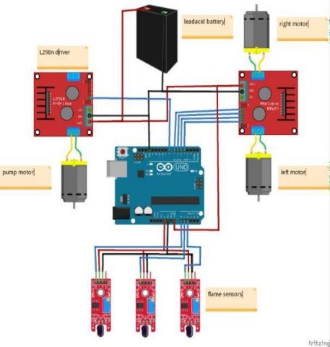

**fig1.Circuit diagram**

**1.3 BLOCK DIAGRAM**

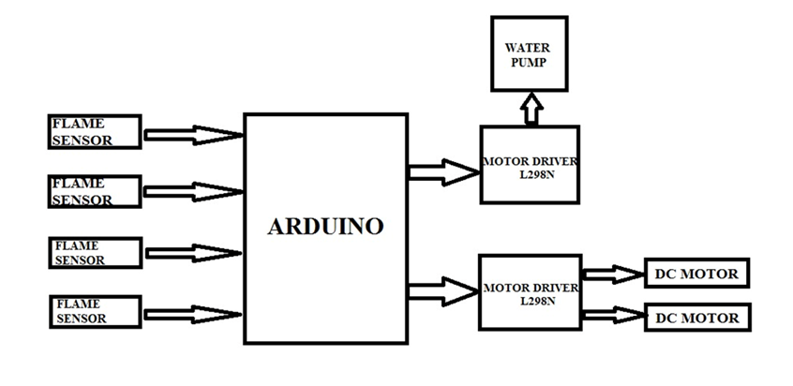

**Fig 2. Block diagram**

**2.HARDWARE REQUIREMENT**

Hardware Components of this project are

1. Arduino NANO with ATmega328P Microcontroller
2. L298N MOTOR DRIVER
3. FLAME SENSOR
4. DC GEAR MOTORS
5. LEAD ACID BATTERY
6. 5V WATER PUMP

**2.1INTRODUCTION TO ARDUINO UNO**

Arduino is an open-source electronics platform based on easy-to-use hardware and software. [Arduino boards](https://www.arduino.cc/en/Main/Products) are able to read inputs - light on a sensor, a finger on a button, or a Twitter message - and turn it into an output - activating a motor, turning on an LED, publishing something online. You can tell your board what to do by sending a set of instructions to the microcontroller on the board. To do so you use the [Arduino programming language](https://www.arduino.cc/en/Reference/HomePage) (based on [Wiring),](http://wiring.org.co/) and [the Arduino Software (IDE),](https://www.arduino.cc/en/Main/Software) based on [Processing.](https://processing.org/)

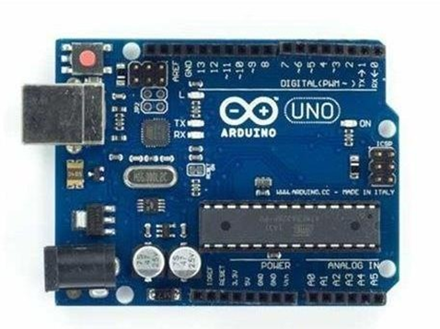

**FIG 3. Arduino**

**2.2 FEATURES OF ARDUINO UNO**

The **Arduino Uno** is a microcontroller board based on the ATmega328. Arduino is an open- source, prototyping platform and its simplicity makes it ideal for hobbyists to use as well as professionals. The Arduino Uno has 14 digital input/output pins (of which 6 can be used as PWM outputs), 6 analog inputs, a 16 MHz crystal oscillator, a USB connection, a power jack, an ICSP header, and a reset button. It contains everything needed to support the microcontroller; simply connect it to a computer with a USB cable or power it with a AC-to- DC adapter or battery to get started.

**Features of the Arduino:**

* Microcontroller: ATmega328
* Operating Voltage: 5V
* Input Voltage (recommended): 7-12V
* Input Voltage (limits): 6-20V
* Digital I/O Pins: 14 (of which 6 provide PWM output)
* Analog Input Pins: 6
* DC Current per I/O Pin: 40 mA
* DC Current for 3.3V Pin: 50 Ma
* Flash Memory: 32 KB of which 0.5 KB used by bootloader
* SRAM: 2 KB (ATmega328)
* EEPROM: 1 KB (ATmega328)

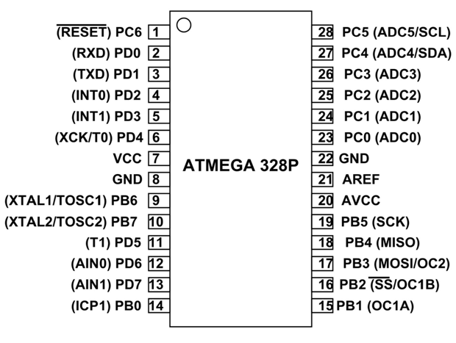

**FIG 4 ATMEGA 328P**

**2.3INTRODUCTION TO L298N MOTOR DRIVER**

[Dual Motor Controller](https://tronixlabs.com.au/robotics/motor-controllers/l298n-dual-motor-controller-module-2a-australia/) Module 2A with Arduino. This allows you to control the speed and direction of two DC motors, or control one bipolar stepper motor with ease. The L298N H-bridge module can be used with motors that have a voltage of between 5 and 35V DC. There is also an onboard 5V regulator, so if your supply voltage is up to 12V you can also source 5V from the board. These L298 H-bridge dual motor controller modules [.](https://tronixlabs.com.au/robotics/motor-controllers/l298n-dual-motor-controller-module-2a-australia/)

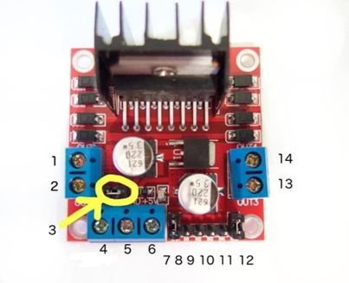

**FIG 5 MOTOR DRIVER**

* 1. **PIN DESCRIPTION**
* DC motor 1 "+" or stepper motor A+
* DC motor 1 "-" or stepper motor A-
* 12V jumper - remove this if using a supply voltage greater than 12V DC. This enables power to the onboard 5V regulator
* Connect your motor supply voltage here, maximum of 35V DC. Remove 12V jumper if

>12V DC

* GND
* 5V output if 12V jumper in place, ideal for powering your Arduino (etc)
* DC motor 1 enable jumper. Leave this in place when using a stepper motor. Connect to PWM output for DC motor speed control.
* IN1
* IN2
* IN3
* IN4
* DC motor 2 enable jumper. Leave this in place when using a stepper motor. Connect to PWM output for DC motor speed control.
* DC motor 2 "+" or stepper motor B+
* DC motor 2 "-" or stepper motor B-
  1. **CONTROLLING DC MOTOR**

To control one or two DC motors is quite easy. First connect each motor to the A and B connections on the L298N [module.](https://tronixlabs.com.au/robotics/motor-controllers/l298n-dual-motor-controller-module-2a-australia/) If you're using two motors for a robot (etc) ensure that the polarity of the motors is the same on both inputs. Otherwise you may need to swap them over when you set both motors to forward and one goes backwards!

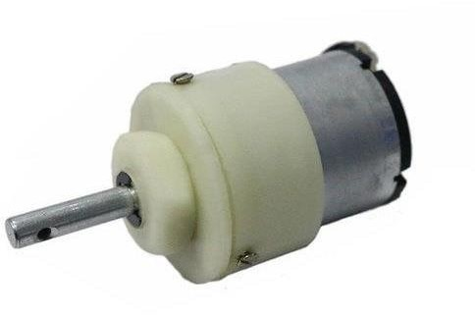 Next, connect your power supply - the positive to pin 4 on the module and negative/GND to pin 5. If you supply is up to 12V you can leave in the 12V jumper (point 3 in the image above) and 5V will be available from pin 6 on the module. This can be fed to your Arduino's 5V pin to power it from the motors' power supply. Don't forget to connect Arduino GND to pin 5 on the module as well to complete the circuit.

**FIG 6 DC MOTOR**

* 1. **INTRODUCTION TO FLAME SENSOR**

A flame detector is a [sensor](https://en.wikipedia.org/wiki/Sensor) designed to detect and respond to the presence of a [flame](https://en.wikipedia.org/wiki/Flame) or [fire,](https://en.wikipedia.org/wiki/Fire) allowing flame detection. Responses to a detected flame depend on the installation, but can include sounding an alarm, deactivating a fuel line (such as a [propane](https://en.wikipedia.org/wiki/Propane) or a [natural gas](https://en.wikipedia.org/wiki/Natural_gas) line), and activating a fire suppression system. When used in applications such as industrial furnaces, their role is to provide confirmation that the furnace is properly; in these cases they take no direct action beyond notifying the operator or control system. A flame detector can often respond faster and more accurately than a [smoke](https://en.wikipedia.org/wiki/Smoke_detector) or [heat detector](https://en.wikipedia.org/wiki/Heat_detector) due to the mechanisms it uses to detect the flame.

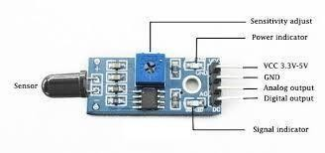

**FIG 7 FLAME SENSOR**

**Specifications**

* This sensor is suitable for the flame wavelength of 760nm to 1100nm.
* It has a high-speed and highly sensitive NPN silicon phototransistor.
* There is a rollover threshold level output. Detection angle of 60 degrees Power supply indicator lamp Comparator output indicator lamp.
* Power supply: 3.3V-5.5V DC
* Used wide range voltage comparator IC LM393,Size: 2.9cm x 1.2cm

**2.7 INTRODUCTION TO DC GEAR MOTOR**

A DC motor is any of a class of rotary electrical machines that converts direct current electrical energy into mechanical energy. The most common types rely on the forces produced by magnetic fields. Nearly all types of DC motors have some internal mechanism, either electromechanical or electronic, to periodically change the direction of current flow in part of the motor.

* 1. **INTRODUCTION TO LITHIUM ION BATTERY**

In this project we are using the rechargeble lithium ion battery. A lithium-ion battery is a type of rechargeable battery that uses lithium ions as the primary component of its electrochemistry. They are commonly used in portable electronics, electric vehicles, and grid energy storage systems. Lithium-ion batteries are known for their high energy density, low self- discharge, and long cycle life. [However, improper handling of a Li-ion cell may result in lose](https://www.ineltro.ch/media/downloads/SAAItem/45/45958/36e3e7f3-2049-4adb-a2a7-79c654d92915.pdf) [of efficiency, heating, ignition, electrolyte leakage or even explosio](https://www.ineltro.ch/media/downloads/SAAItem/45/45958/36e3e7f3-2049-4adb-a2a7-79c654d92915.pdf)n.

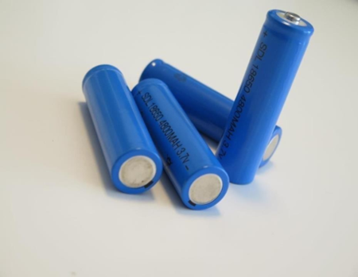

**FIG 8 BATTERY**

**2.9 INTRODUCTION TO WATER PUMP**

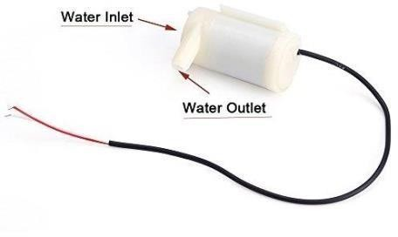 A **pump** is a device that moves fluids ([liquids](https://en.wikipedia.org/wiki/Liquid) or [gases),](https://en.wikipedia.org/wiki/Gas) or sometimes [slurries,](https://en.wikipedia.org/wiki/Slurry) by mechanical action. Pumps can be classified into three major groups according to the method they use to move the fluid: direct lift, displacement, and gravity pumps. Pumps operate by some mechanism (typically [reciprocating](https://en.wikipedia.org/wiki/Reciprocating_motion) or [rotary),](https://en.wikipedia.org/wiki/Rotation) and consume [energy](https://en.wikipedia.org/wiki/Energy) to perform [mechanical work](https://en.wikipedia.org/wiki/Mechanical_work) by moving the fluid. Pumps operate via many energy sources, including manual operation, [electricity,](https://en.wikipedia.org/wiki/Electricity) [engines,](https://en.wikipedia.org/wiki/Engines) or [wind power,](https://en.wikipedia.org/wiki/Wind_power) come in many sizes, from microscopic for use in medical applications to large industrial pumps.

**FIG 9 WATER PUMP**

**3 PROGRAM FLOW CHART**

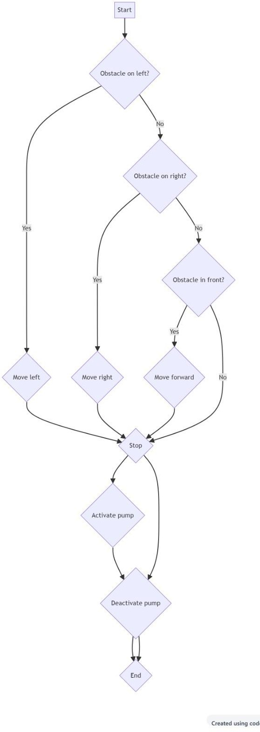

**FIG 10 FLOW CHART**

**4.PROTOTYPE OF THE FIRE FIGHTING ROBOT**

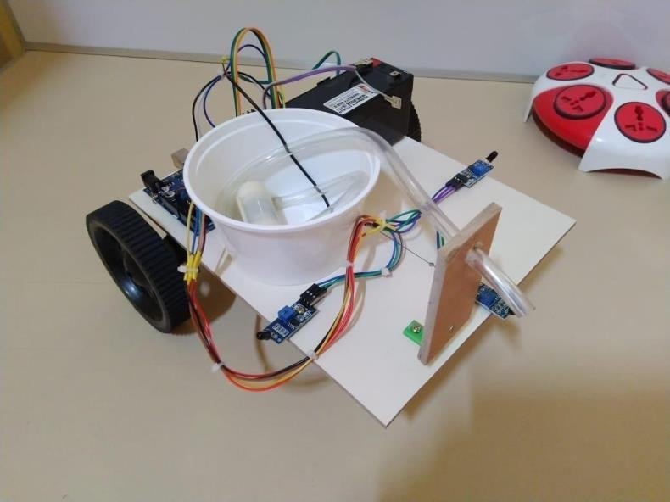

**FIG 11 PROTOTYPE**

**4.1 WORKING OF THE FIRE FIGHTING ROBOT**

The fire fighting robot will work as when the fire is present than the flame sensors of the kit will sense the fire and then the arduino connected to it will command the leg motor driver( motor driver 1) for the movement of kit to reach out to the place of fire with in its range using the dc gear motors than after reaching the ardino will command the pump motor driver( motor driver 2) to start the water pump to dispense the water and put the fire off . after putting off the fire the water pump will stopped and the kit will be at rest position.

**5.CONCLUSION**

In this project, we will learn how to build a simple robot using Arduino that could move towards the fire and pump out water around it to put down the fire. It is a very simple robot that would teach us the underlying concept of robotics We detect the direction of the fire we can use the motors to move near the fire by driving our motors through the **L298N module**. When near a fire we have to put it out using water. Using a small container we can carry water, a 5V pump is also placed in the container

# BIBLIOGRAPHY

1. Ahmad, N.A.N. and Zamri, S.A.S., 2014, September. The cross platform application development adapted Spring framework to support front-end tendering services. In Computer, Communications, and Control Technology (I4CT), 2014 International Conference on (pp. 58-62). IEEE.
2. Alarcon, R. and Wilde, E., 2010, April. Linking data from restful services. In Third Workshop on Linked Data on the Web, Raleigh, North Carolina (April 2010).
3. Al-Fagih, A.E., Al-Turjman, F.M., Alsalih, W.M. and Hassanein, H.S., 2013. A priced public sensing framework for heterogeneous IoT architectures. Emerging Topics in Computing, IEEE Transactions on, 1(1), pp.133-147.
4. Alpaydin, E., 2014. Introduction to machine learning. MIT press.
5. Anthes, G., 2012. HTML5 leads a web revolution. Communications of the ACM, 55(7), pp.16-17.
6. Armando, A., Carbone, R., Chekole, E.G. and Ranise, S., 2014, June. Attribute based access control for APIs in spring security. In Proceedings of the 19th ACM symposium on Access control models and technologies (pp. 85-88). ACM.
7. Atighetchi, M., Soule, N., Pal, P., Loyall, J., Sinclair, A. and Grant, R., 2013, October. Safe conFiguration of TLS connections. In Communications and Network Security (CNS), 2013 IEEE Conference on (pp. 415- 422). IEEE.
8. Bormann, C., Castellani, A.P. and Shelby, Z., 2012. Coap: An application protocol for billions of tiny internet nodes. IEEE Internet Computing, 16(2), p.62.