**1. Information sheet**

**i. Title : Landslide Hotspots in Kokan Sahyadri Ranges in Year 2023-24**

**ii. Author/Authors:** T. K. Talpe 1, Prof.. A.B. Landage 2

**iii. email:** [tej.talpe02@gmail.com](mailto:tej.talpe02@gmail.com) **Phone**: 7588339922

1 PG Student, Department of Civil Engineering, Government College of Engineering, Karad, Maharashtra, India.

2 Professor, Department of Civil Engineering, Government College of Engineering, Karad, Maharashtra, India.

**2. ABSTRACT:**

Landslides pose a significant threat to the ecological and human landscape of mountainous regions, and the Kokan Sahyadri Ranges are no exception. This study aims to identify and analyze landslide hotspots within the Kokan Sahyadri Ranges during the year 2023-24. Utilizing a combination of remote sensing data, geographical information systems (GIS), and field surveys, the research seeks to provide a comprehensive understanding of the factors contributing to landslide susceptibility in this specific region.

**3. Key words:**

Landslide; soil; landslide hotspots; kokan; Sahyadiri ranges;

**4 Introduction:**

The Kokan Sahyadri Ranges, situated along the western coast of India, are facing an increasing threat of landslides during the year 2023-24. This research aims to investigate and analyze landslide hotspots in the region using a multidisciplinary approach involving remote sensing, GIS, and field surveys. The complex topography and susceptibility of the area make understanding landslide dynamics crucial for risk assessment and mitigation. The study addresses the urgent need to unravel the contributing factors, including geological, topographical, and climatic elements, and explores the broader ecological impact of landslides. By bridging the gap between scientific inquiry and practical applications, the research aims to provide valuable insights for effective disaster management, land-use planning, and environmental conservation in the Kokan Sahyadri Ranges.

1. **Study Area**

The study area, is Konkan Sahyadri range (Satara District, Raigad District, Ratnagiri District, and Sindhaurga District) and located at 17°58' N and 73°43'E, 18°30'N and 73°10'E, 17°24' and 73°37', 16°16' and 73°55' respectively. The Sahyadri range, also known as the Western Ghats, has an average elevation of around 1,000 meters. The range's highest point is Kalsubai, which reaches 1,646 meters near Nasik.

The Sahyadri range is located in the western part of India, parallel to the Arabian Sea. It stretches from Gujarat in the north to Karnataka in the south. The range's western flank is characterized by high escarpments alternating with narrow, irregularly tilted terraces.

The Sahyadri range falls in steep cliffs to the Konkan on the west. The area near the foothills of the Sahyadri mountains along the Konkan coast is called Valati. The height of Valati is 200 to 300 meters, and the slope is steep.

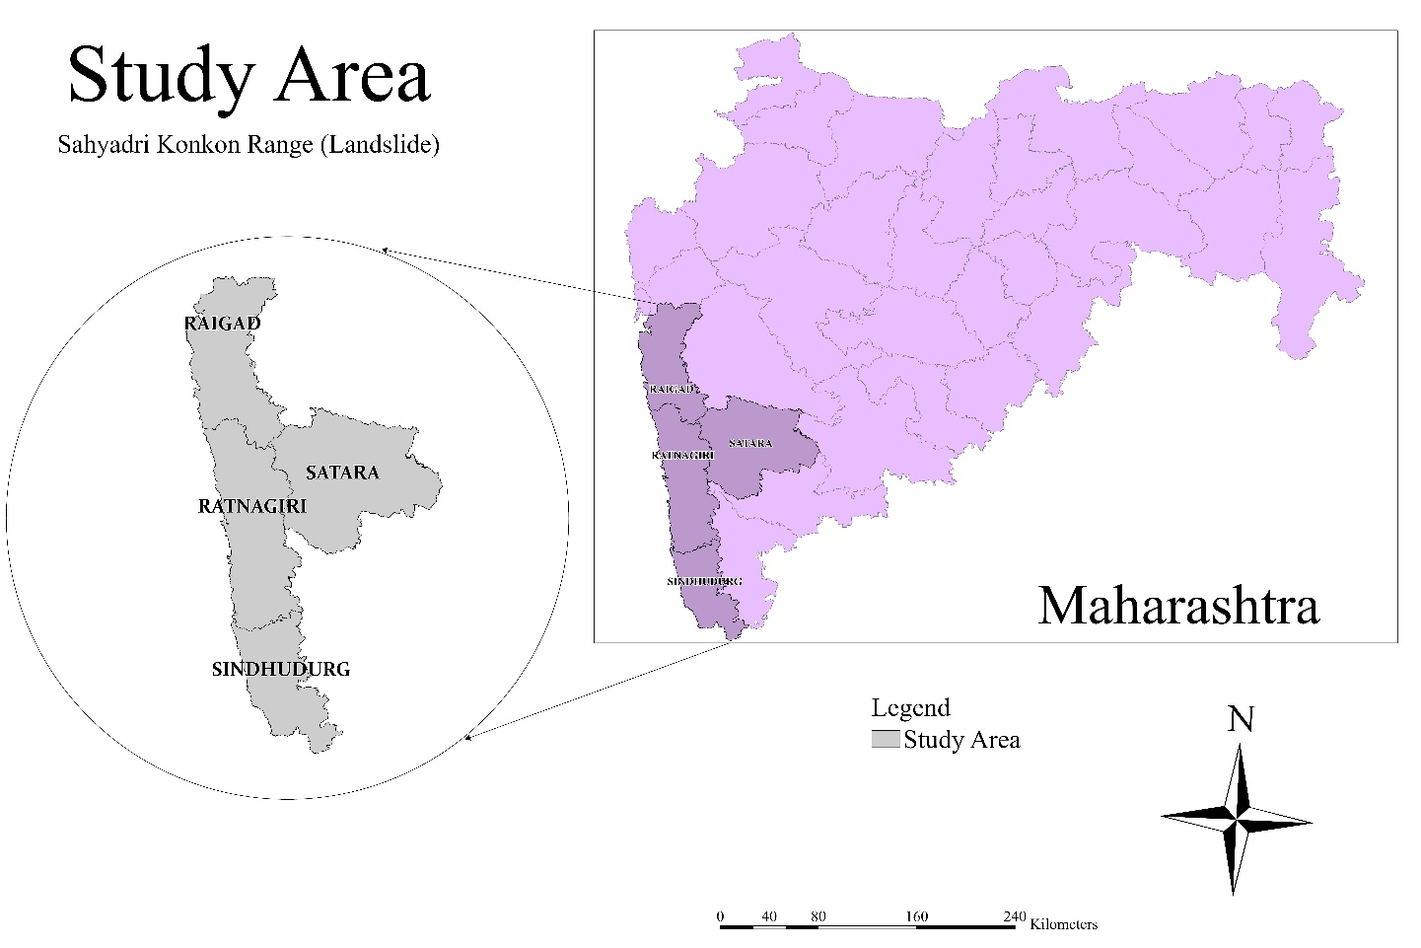

Fig. 1 Study Area

1. **Landslide Hotspots in Satara District**

Landslide hotspots in Satara are typically areas prone to slope instability and erosion, often triggered by heavy rainfall, seismic activity, or human interference. Satara, located in the Western Ghats of Maharashtra, India, features terrain characterized by steep slopes and fragile geological formations, making it susceptible to landslides. Some identified landslide hotspots in Satara include:

1. Ambenali Ghat: Situated on the route to Mahabaleshwar, Ambenali Ghat experiences frequent landslides due to its steep slopes and heavy monsoon rainfall.
2. Koyna Dam Area: The reservoir and surrounding regions of the Koyna Dam are prone to landslides, exacerbated by the construction activities and geological conditions.
3. Tiger's Leap (Tiger Point): A popular tourist spot near Mahabaleshwar, Tiger's Leap is susceptible to landslides during the monsoon season due to its precarious location and soil erosion.
4. Valley Viewpoint (Kate's Point): Another scenic spot near Mahabaleshwar, Valley Viewpoint is prone to landslides owing to its steep cliffs and rainfall-induced soil saturation.
5. Bhairavnath Temple Area: This area, near the hill station of Panchgani, faces landslide risks due to its hilly terrain and monsoon rains.
6. Kaas Plateau: Known for its biodiversity and floral diversity, Kaas Plateau is also susceptible to landslides during heavy rainfall due to its fragile soil structure.
7. Sajjangad Fort: Situated atop a hill near Satara city, Sajjangad Fort is prone to landslides, especially in areas with inadequate slope stabilization measures.

**Table : 1**

**Landslide Hotspots Satara District**

|  |  |  |  |  |
| --- | --- | --- | --- | --- |
| Sr. No. | Name of Taluka | Name | Latitude | Longitude |
| 1 | Satara | Sandavali | 17.62771 | 73.833084 |
| 2 | Bondarwadi | 17.90587 | 73.721734 |
| 3 | Bhairavgad | 17.54607 | 73.961917 |
| 4 | Mahabaleshwar | Achali | 17.86422 | 73.709536 |
| 5 | Bhekavali | 17.90917 | 73.697766 |
| 6 | Dudhoshi | 17.91933 | 73.615354 |
| 7 | Dhawali | 17.87154 | 73.778674 |
| 8 | Yerandal | 17.86991 | 73.72572 |
| 9 | Shindola | 17.90445 | 73.844847 |
| 10 | Yerne kh | 17.86896 | 73.697766 |
| 11 | Navali | 17.894 | 73.705123 |
| 12 | Chaturbet | 17.77515 | 73.999164 |
| 13 | Chikhali | 17.86795 | 73.685995 |
| 14 | Dare | 17.94222 | 73.647734 |
| 15 | Malusar | 17.88468 | 73.680109 |
| 16 | Ghavari | 17.86149 | 73.687173 |
| 17 | Yerne bk | 17.88463 | 73.696295 |
| 18 | Kumthe | 17.90328 | 73.562358 |
| 19 | Jaoli | Bhuteghar | 17.9046 | 73.7287 |
| 20 | Vahite | 17.8934 | 73.7316 |
| 21 | Patan | Dhokawale | 17.5044 | 73.7654 |
| 22 | Mirgaon | 17.4319 | 73.7566 |
| 23 | Humbarli | 17.4075 | 73.739 |
| 24 | Jinti | 17.3221 | 73.8646 |
| 25 | Shindewadi | 17.3136 | 73.9213 |
| 26 | Dhavade | 17.3073 | 73.8448 |
| 27 | Dikshi | 17.2931 | 73.8287 |
| 28 | Davari | 17.2873 | 73.9507 |
| 29 | Ambeghar | 17.2819 | 73.8316 |
| 30 | Kahir | 17.2705 | 73.8154 |
| 31 | Bagalwadi | 17.2693 | 74.0285 |
| 32 | Shidrukwadi | 17.2634 | 74.0094 |
| 33 | Nigade | 17.2054 | 73.8948 |
| 34 | Kalgaon | 17.1649 | 73.9529 |
| 35 | Wai | Kondhavale | 17.9943 | 73.7184 |
| 36 | Jor | 17.9902 | 73.6713 |

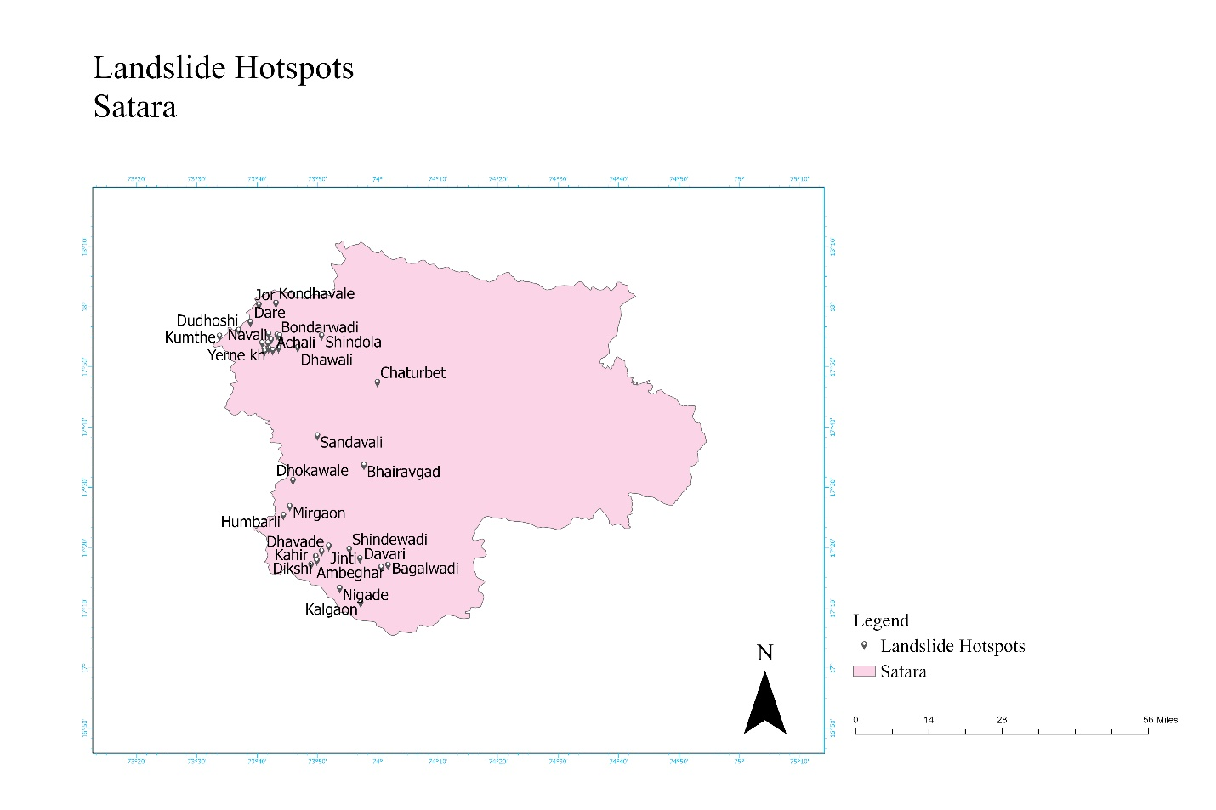

**Fig. 2** **Landslide Hotspots Satara**

1. **Landslide Hotspots in Raigad District**

Landslide hotspots in Raigad District, located in the state of Maharashtra, India, are areas particularly prone to slope instability and erosion, often triggered by heavy rainfall, seismic activity, or human interference. Raigad District, encompassing various terrains ranging from coastal areas to hilly regions of the Western Ghats, faces landslide risks due to its diverse geography. Some identified landslide hotspots in Raigad District include:

1. Tamhini Ghat: Tamhini Ghat, a mountain passage connecting Pune and Raigad Districts, experiences frequent landslides during the monsoon season due to its steep slopes and heavy rainfall.
2. Matheran Hill Station: As a popular hill station located in Raigad District, Matheran is susceptible to landslides, especially in areas with fragile soil structure and inadequate slope stabilization measures.
3. Khandala-Lonavala Region: This hilly area, famous for its scenic beauty and tourist attractions, including Tiger's Point and Bhushi Dam, faces landslide risks during the monsoon season due to its steep terrain and heavy rainfall.
4. Mahad-Mangaon Road: The road network in the Mahad-Mangaon region of Raigad District is prone to landslides, particularly along steep slopes and areas with poor drainage infrastructure.
5. Western Ghats Ranges: Various ranges of the Western Ghats within Raigad District, such as the Sahyadri Range, are susceptible to landslides due to their rugged topography and susceptibility to erosion.
6. Alibaug Coastal Area: While primarily known for its beaches, the coastal areas of Alibaug in Raigad District are also prone to landslides, especially in areas with unstable cliffs and soil erosion.
7. Raigad Fort: Situated atop a hill, Raigad Fort is susceptible to landslides during heavy rainfall, particularly in areas with inadequate slope stabilization measures.

**Table 2**

**Landslide Hotspots Raigad**

|  |  |  |  |  |
| --- | --- | --- | --- | --- |
| Sr. No | Taluka | Hotspot Point | Longitude | Latitude |
| 1 | Karjat | Karjat | 18.9093 | 73.3228 |
| 2 | Mudre | 18.9161 | 73.323 |
| 3 | Ambiwadi T. Kothal Khalati | 19.0134 | 73.4976 |
| 4 | Sangavi | 18.8728 | 73.3606 |
| 5 | Khalapur | Khalapur | 18.8299 | 73.2859 |
| 6 | Subhash Nagar | 18.8046 | 73.3449 |
| 7 | Tondali | 18.7558 | 73.2618 |
| 8 | Narangi | 18.7673 | 73.2618 |
| 9 | Mahad | Lower Tudil | 18.0695 | 73.362 |
| 10 | Shingar Kond | 17.9255 | 73.421 |
| 11 | Kondivate | 18.0721 | 73.4563 |
| 12 | Muthavali | 18.0612 | 73.3974 |
| 13 | Songhar | 18.068 | 73.3443 |
| 14 | Chandhave Kh. | 18.0611 | 73.4622 |
| 15 | Sav | 18.0773 | 73.3856 |
| 16 | Rohan | 18.0749 | 73.3495 |
| 17 | Jangam wadi | 18.0348 | 73.4419 |
| 18 | Mazeri | 18.1262 | 73.5992 |
| 19 | Kosabi | 18.0771 | 73.3664 |
| 20 | Dasgaon | 18.1128 | 73.365 |
| 21 | Mumurshi | 18.0022 | 73.3797 |
| 22 | Parmachi | 18.1408 | 73.6021 |
| 23 | Chimbhave | 18.0455 | 73.3016 |
| 24 | Chochinde | 18.0583 | 73.4136 |
| 25 | Gothe Bk. | 18.0821 | 73.3738 |
| 26 | Nandgaon Bk | 18.1697 | 73.3915 |
| 27 | Adiste | 18.0304 | 73.3414 |
| 28 | Khaire Tarf Tudil | 18.0497 | 73.3488 |
| 29 | Walan Bk | 18.166 | 73.4799 |
| 30 | Revtale | 17.9761 | 73.3768 |
| 31 | Mohot | 18.073 | 73.5329 |
| 32 | Varathi Anganwadi | 18.0575 | 73.3075 |
| 33 | Kurle | 18.035 | 73.4269 |
| 34 | Ambenali ghat | 17.93 | 73.55 |
| 35 | Jui Bk. | 18.0779 | 73.3429 |
| 36 | Waki Bk | 18.1597 | 73.5388 |
| 37 | Mandle | 18.1624 | 73.442 |
| 38 | Sape Wamne | 18.0581 | 73.3716 |
| 39 | Tol Bk. | 18.0993 | 73.3252 |
| 40 | Pimpal Kond | 18.1202 | 73.428 |
| 41 | Walang | 18.056 | 73.3384 |
| 42 | Sheltoli | 18.1122 | 73.494 |
| 43 | Mahad | Chochinde | 18.0583 | 73.4136 |
| 44 | Mumurshi | 18.0022 | 73.3797 |
| 45 | Taloshi | 18.1661 | 73.4151 |
| 46 | Verkhole | 18.1063 | 73.5029 |
| 47 | Karanjkhol | 18.0914 | 73.4232 |
| 48 | Sandoshi | 18.2914 | 73.4357 |
| 49 | Raigad | 18.5158 | 73.1822 |
| 50 | Mahad | 18.0801 | 73.422 |
| 51 | Mangaon | Mangaon | 18.2399 | 73.2809 |
| 52 | Repoli | 18.1865 | 73.3208 |
| 53 | Adghar | 18.2003 | 73.2987 |
| 54 | Pahel | 18.1497 | 73.3348 |
| 55 | Garal | 18.2083 | 73.3042 |
| 56 | tol khurd | 18.104 | 73.3067 |
| 57 | Mahsala | Mahsala | 18.134 | 73.1104 |
| 58 | Amshet | 18.119 | 73.5329 |
| 59 | Khargaon Bk | 18.1497 | 73.1025 |
| 60 | Sakalap | 18.1229 | 73.1069 |
| 61 | Panvel | Maldunge | 19.0346 | 73.2588 |
| 62 | Chinch Wadi | 19.0093 | 73.2553 |
| 63 | Dhodani | 19.0116 | 73.2588 |
| 64 | Poladpur | Poladpur | 17.9825 | 73.4653 |
| 65 | Tutavali Road | 17.9113 | 73.5132 |
| 66 | Tamhane Tarf Kondhavi | 17.9174 | 73.5432 |
| 67 | Charai | 17.988 | 73.4799 |
| 68 | Bhogaon Bk. | 17.915 | 73.4328 |
| 69 | Ombali | 17.8706 | 73.4828 |
| 70 | Kevnale Road | 17.9659 | 73.5462 |
| 71 | Buddha Vihar, Parle | 18.0382 | 73.4627 |
| 72 | Lohare | 18.0167 | 73.4475 |
| 73 | Parsule | 17.9049 | 73.5152 |
| 74 | Roha | Roha | 18.4395 | 73.1186 |
| 75 | Tise | 18.3749 | 73.2441 |
| 76 | Girne | 18.3167 | 73.1084 |
| 77 | Ghosale | 18.373 | 73.0966 |
| 78 | Are Bk. | 18.4564 | 73.0671 |
| 79 | Madhali Kh. | 18.4689 | 73.1246 |
| 80 | Sambhe | 18.393 | 73.191 |
| 81 | Nadawali | 18.4625 | 73.1969 |
| 82 | Wavekhar | 18.4893 | 73.0494 |
| 83 | Pale Bk. | 18.4014 | 73.2043 |
| 84 | Pale Kh. | 18.4103 | 73.191 |
| 85 | Padum | 18.45 | 73.1069 |
| 86 | Mahadev Vadi | 18.4183 | 73.1445 |
| 87 | Sudhagad | Sudhagad | 18.542 | 73.2203 |
| 88 | Bhalgul | 18.6004 | 73.2751 |
| 89 |  | Mangaon Khurd | 18.6753 | 73.3508 |
| 90 | Kanhivali | 18.6046 | 73.2898 |
| 91 | Shrivardan | Vesavi - Bagmandle | 17.9895 | 73.0608 |
| 92 | metkarni devi | 18.0527 | 73.0281 |

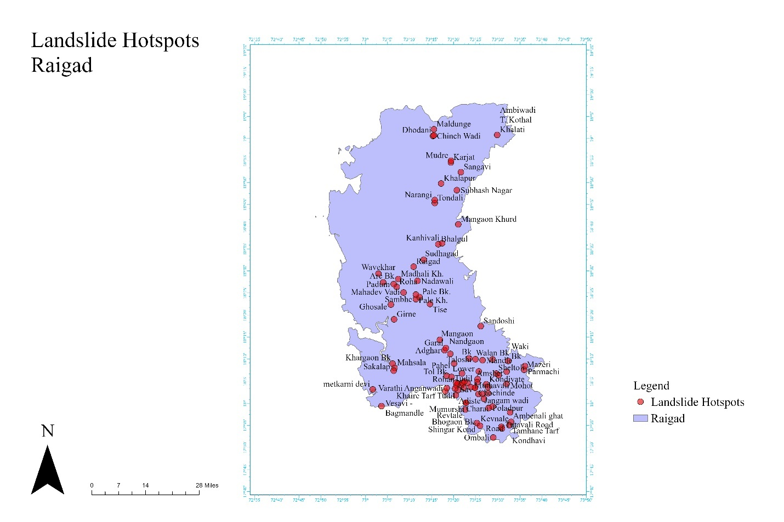

**Fig. 3 Landslide Hotspots Raigad**

1. **Landslide Hotspots in Ratnagiri District**

Landslide hotspots in Ratnagiri District, located in Maharashtra, India, are areas particularly prone to slope instability and erosion, often triggered by heavy rainfall, seismic activity, or human interference. Ratnagiri District, known for its rugged terrain, coastal areas, and Western Ghats ranges, faces significant landslide risks due to its geographical features. Some identified landslide hotspots in Ratnagiri District include:

1. Amba Ghat: Amba Ghat, a mountain pass in the Sahyadri Range, is prone to landslides during the monsoon season due to its steep slopes and heavy rainfall.
2. Ratnagiri-Mumbai Highway: Sections of the Ratnagiri-Mumbai Highway are susceptible to landslides, particularly in areas with steep gradients and inadequate drainage infrastructure.
3. Chiplun-Mahabaleshwar Road: This road passing through Ratnagiri District experiences landslides, especially during the monsoon season, due to its hilly terrain and heavy rainfall.
4. Ganpatipule Coastal Area: While renowned for its beaches, the coastal areas of Ganpatipule are also prone to landslides, particularly in areas with unstable cliffs and soil erosion.
5. Rajapur-Khed Region: The hilly region between Rajapur and Khed in Ratnagiri District faces landslide risks, especially in areas with fragile geological formations and poor land management practices.
6. Western Ghats Ranges: Various ranges of the Western Ghats within Ratnagiri District, such as the Sahyadri Range, are susceptible to landslides due to their rugged topography and susceptibility to erosion.
7. Dapoli Hill Station: Dapoli, a hill station in Ratnagiri District, experiences landslides during heavy rainfall, particularly in areas with steep slopes and inadequate slope stabilization measures.

**Table 3**

**Landslide Hotspots in Ratnagiri**

|  |  |  |  |  |
| --- | --- | --- | --- | --- |
| Sr. No. | Taluka | Name | longitude | latitude |
| 1 | Sangameshwar | Ozare Bk. | 17.00291 | 73.80073 |
| 2 | Ninave | 17.00731 | 73.76691 |
| 3 | Nivdhe | 17.02364 | 73.73896 |
| 4 | Bamnoli | 17.53725 | 73.3414 |
| 5 | Murshi | 16.98357 | 73.73896 |
| 6 | Dakhin | 16.99812 | 73.7419 |
| 7 | Masarang | 17.26824 | 73.62345 |
| 8 | Tiware Ghera Prachitgarh | 17.20477 | 73.66098 |
| 9 | Kolambe | 16.94731 | 73.33407 |
| 10 | Nayari | 17.20952 | 73.64921 |
| 11 | Nive Kh. | 17.062 | 73.68305 |
| 12 | Shringarpur | 17.23341 | 73.66098 |
| 13 | Purye Tarf Devale | 16.9678 | 73.686 |
| 14 | Tamnale School | 17.10296 | 73.68422 |
| 15 | Manjare | 17.19027 | 73.4357 |
| 16 | Kolambe | 16.94731 | 73.33407 |
| 17 | Devale | 17.15919 | 73.66392 |
| 18 | Belari Bk. | 17.08752 | 73.68011 |
| 19 | Manaskond | 17.12195 | 73.474 |
| 20 | Maladewadi | 17.19571 | 73.60358 |
| 21 | Kule | 17.15904 | 73.64479 |
| 22 | Ratnagiri | Dhamanse | 17.12731 | 73.31634 |
| 23 | Chave | 17.19365 | 73.37382 |
| 24 | Golap | 16.89014 | 73.31634 |
| 25 | Valke | 17.00902 | 73.49167 |
| 26 | Pawas | 16.87268 | 73.3296 |
| 27 | Harcheri | 16.95447 | 73.43717 |
| 28 | Purnagad | 16.81149 | 73.31486 |
| 29 | Sathare | 17.00068 | 73.49462 |
| 30 | Agarnaral | 17.21926 | 73.33845 |
| 31 | Jambhari | 17.27147 | 73.27949 |
| 32 | Khalgaon | 17.17486 | 73.38855 |
| 33 | Dewood | 17.19477 | 73.35319 |
| 34 | Ori | 17.14901 | 73.35319 |
| 35 | Ukshi | 17.12521 | 73.44454 |
| 36 | Dhanawade Wadi | 17.0765 | 73.40918 |
| 37 | Nivali | 17.23923 | 73.64479 |
| 38 | Rajapur | Dhopeshwar | 16.65081 | 73.49609 |
| 39 | Parule | 16.74592 | 73.70195 |
| 41 | Khed | Shivane Bk. | 16.75849 | 73.50346 |
| 42 | Dhamnand | 17.6146 | 73.60947 |
| 43 | Dhamnand | 17.6146 | 73.60947 |
| 44 | Posare Bk. | 17.61086 | 73.63302 |
| 45 | Sheldi | 17.63627 | 73.52702 |
| 46 | Shirgaon | 17.45365 | 73.6201 |
| 47 | Kelane | 17.58866 | 73.57414 |
| 48 | Sapirli | 17.6237 | 73.68305 |
| 49 | Khavati | 17.83811 | 73.40944 |
| 50 | Ambavali | 17.7361 | 73.53733 |
| 51 | Sanaghar | 17.74985 | 73.56383 |
| 52 | Khopi | 17.67209 | 73.57708 |
| 53 | Musad | 17.56235 | 73.63596 |
| 54 | Ratnagiri | 17.24776 | 73.37087 |
| 55 | Talvat Khed | 17.65003 | 73.62124 |
| 56 | Choravane | 17.6665 | 73.68011 |
| 57 | Tisangi | 17.70147 | 73.51818 |
| 58 | Posare Bk. | 17.61086 | 73.63302 |
| 59 | Sakhar | 17.63219 | 73.64773 |
| 60 | Jamge | 17.8687 | 73.33771 |
| 61 | Sakharoli | 17.74352 | 73.37382 |
| 62 | Borghar | 17.81018 | 73.41507 |
| 63 | Mandave | 17.79335 | 73.48578 |
| 64 | Talvat Javali | 17.63955 | 73.63302 |
| 65 | Kotwali | 17.6017 | 73.44391 |
| 66 | Chinchavali | 17.81012 | 73.44749 |
| 67 | Dapoli | Panchanadi | 17.63284 | 73.15561 |
| 68 | Kalambat | 17.36062 | 73.38561 |
| 69 | Karde | 17.75209 | 73.12758 |
| 70 | Bhadavale | 17.58098 | 73.35024 |
| 71 | Kolbandre | 17.6869 | 73.25 |
| 72 | Pangari Tarf Haveli | 17.59047 | 73.29423 |
| 73 | Asud | 17.78659 | 73.13948 |
| 74 | Gudaghe | 17.58797 | 73.2323 |
| 75 | Ladghar | 17.72345 | 73.14381 |
| 76 | Asud | 17.76458 | 73.17184 |
| 77 | Harnai | 17.81537 | 73.09808 |
| 78 | Ambavali Kh. | 17.78763 | 73.12282 |
| 79 | Bhopan | 17.59678 | 73.25958 |
| 80 | Aade | 17.89064 | 73.07447 |
| 81 | Chiplun | Chiplun | 17.52341 | 73.53559 |
| 82 | Pedhe | 17.54302 | 73.50935 |
| 83 | Tiware | 17.59012 | 73.6676 |
| 84 | Rictoli | 17.57905 | 73.66652 |
| 85 | Nandivase | 17.54297 | 73.68673 |
| 86 | Chiplun | Kadwad | 17.55386 | 73.67128 |
| 87 | Kolkewadi | 17.54555 | 73.5307 |
| 88 | Tivadi | 17.55683 | 73.70659 |
| 89 | Kalavande | 17.47012 | 73.49462 |
| 90 | Yegaon | 17.32909 | 73.58886 |
| 91 | Parshuram Ghat | 17.55339 | 73.50451 |
| 92 | Mandangad | Panderi | 18.03588 | 73.22493 |
| 93 | Lokarvan | 18.05024 | 73.27359 |
| 94 | Kinjalghar | 18.03455 | 73.16151 |
| 95 | Lang | Hardkhale | 16.8217 | 73.68305 |
| 96 | Musalmanwadi | 16.90254 | 73.32813 |
| 97 | Kurang | 16.78409 | 73.7292 |
| 98 | Indavati | 16.80041 | 73.52702 |
| 99 | Kolhewadi | 16.90819 | 73.65656 |
| 100 | Guhaghar | Kudli | 17.28642 | 73.32076 |
|  |  |  |  |  |

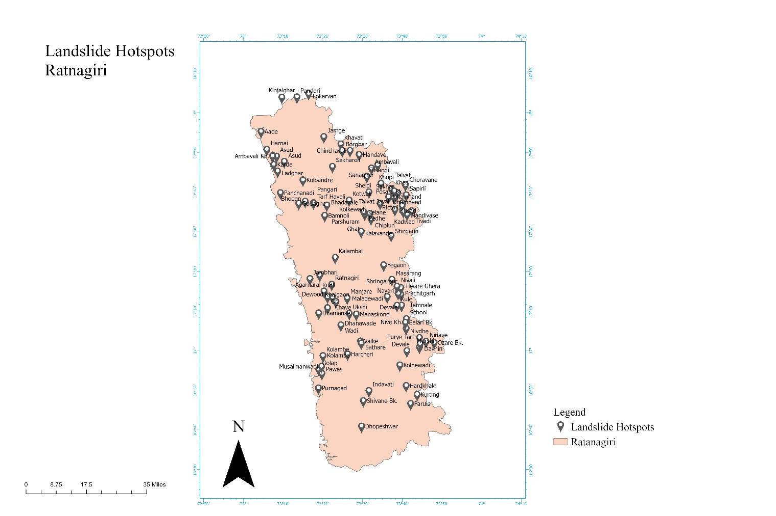

**Fig. 4 Landslide Hotspots in Ratnagiri**

1. **Landslide Hotspots in Sindhadurga District**

Landslide hotspots in Sindhudurg District, situated in Maharashtra, India, are areas particularly prone to slope instability and erosion, often triggered by heavy rainfall, seismic activity, or human interference. Sindhudurg District, known for its coastal stretches, hilly terrain, and Western Ghats ranges, faces significant landslide risks due to its geographical features. Some identified landslide hotspots in Sindhudurg District include:

1. Amboli Ghat: Amboli Ghat, a mountain pass in the Western Ghats, is prone to landslides during the monsoon season due to its steep slopes and heavy rainfall.
2. Sawantwadi-Tilari Road: Sections of the Sawantwadi-Tilari Road are susceptible to landslides, particularly in areas with steep gradients and inadequate drainage infrastructure.
3. Malvan Coastal Area: While famous for its beaches and historic sites, the coastal areas of Malvan are also prone to landslides, especially in areas with unstable cliffs and soil erosion.
4. Vengurla-Maharashtra Coastal Area: The hilly coastal region between Vengurla and Maharashtra faces landslide risks, particularly in areas with fragile geological formations and poor land management practices.
5. Western Ghats Ranges: Various ranges of the Western Ghats within Sindhudurg District are susceptible to landslides due to their rugged topography and susceptibility to erosion.
6. Vijaydurg Fort Area: Situated atop a hill, Vijaydurg Fort is susceptible to landslides during heavy rainfall, particularly in areas with inadequate slope stabilization measures.
7. Kankavli-Devgad Region: The hilly region between Kankavli and Devgad in Sindhudurg District faces landslide risks, especially in areas prone to soil erosion and land degradation.

**Table 4**

**Landslide Hotspots in Sindhudurg**

|  |  |  |  |  |
| --- | --- | --- | --- | --- |
| Sr.No. | Taluka | Name of hotspots | Longitude | Latitude |
| 1 | Vengurla | Tulas | 16.38722 | 73.71002 |
| 2 | Paltad(Tulas),Naikwadi | 15.85066 | 73.68452 |
| 3 | Veshiwadi Bus Stop | 15.86258 | 73.71247 |
| 4 | Pal | 15.83797 | 73.686 |
| 5 | Dabholi | 15.87758 | 73.60947 |
| 6 | Savantwadi | Shirshinge | 16.03397 | 73.97713 |
| 7 | Gotvewadi | 16.04121 | 73.9786 |
| 8 | Asniye | 15.86033 | 73.94186 |
| 9 | Devgav | Pendhari | 16.47615 | 73.5064 |
| 10 | Mutat | 16.48566 | 73.48284 |
| 11 | Pombhurle | 16.50015 | 73.55647 |
| 12 | Manche | 16.5146 | 73.50951 |
| 13 | Malvan | Chindar | 16.21606 | 73.49757 |
| 14 | Kudal | Vetal Bambarde | 16.0486 | 73.7057 |
| 15 | Sarambal | 16.03046 | 73.63596 |
| 16 | Shivapur | 16.06687 | 73.9786 |
| 17 | Nerur | 16.02235 | 73.61867 |
| 18 | Chendawan | 15.99086 | 73.58444 |
| 19 | Naiknagar | 15.99963 | 73.58739 |
| 20 | Dodamarg | Zolambe | 15.83626 | 73.96243 |
| 21 | Mangeli | 15.70095 | 714.09463 |
| 22 | Sasoli | 15.73596 | 73.95362 |

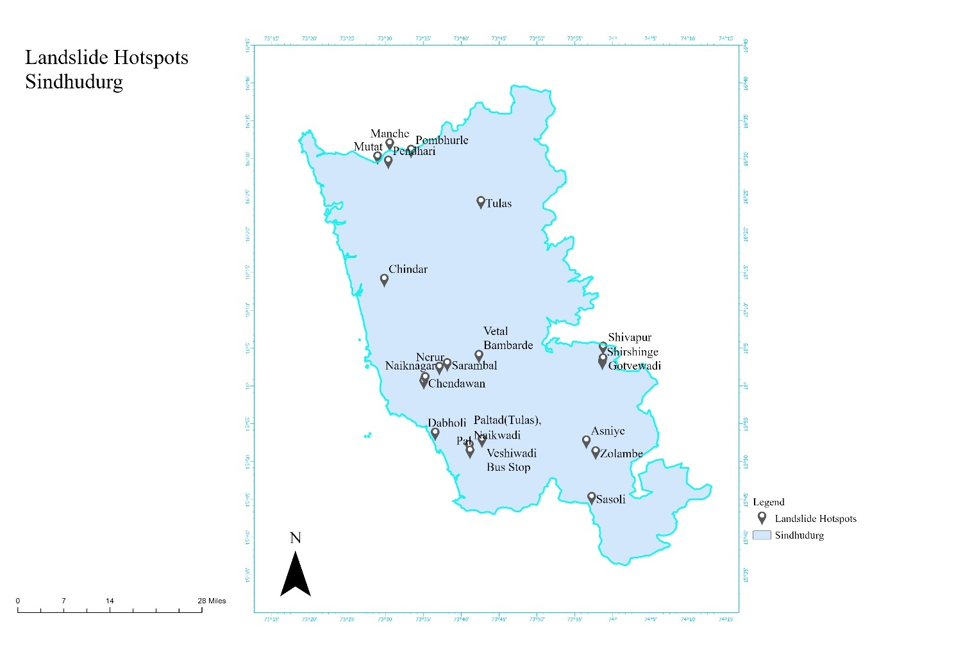

**Fig. 1 Landslide Hotspots in Sindhudurg**

**RESULTS**

There is total 250 landslide hotspots in the kokan Sahyadri ranges in the district Satara, Raigad, Ratnagiri and Sindhudurg.

**Table 5**

**Total number of landslides in kokan Sahyadri Ranges**

|  |  |  |
| --- | --- | --- |
| Sr. No. | Name of District | Number of Landslide Hotspots |
| 1 | Satara | 36 |
| 2 | Ratnagiri | 92 |
| 3 | Raigad | 100 |
| 4 | Sindhudurg | 22 |

**CONCLUSIONS**

In conclusion, the study on landslide hotspots in the Kokan Sahyadri Ranges during 2023-24 reveals a comprehensive understanding of the contributing factors through a multidisciplinary approach. The research underscores the urgency for proactive measures in disaster management and land-use planning, given the increased frequency and intensity of landslides in the specified period. The findings emphasize the interconnectedness of human activities and environmental stability, highlighting the need for collaborative efforts between stakeholders. The study recommends the implementation of early warning systems and sustainable land-use practices to reduce vulnerability, providing valuable insights for similar regions globally.

Overall, the research serves as a foundation for practical strategies towards resilient and sustainable development in the face of landslide risks.

**ACKNOWLEDGEMENTS**

We sincerely thank Nagesh Patil (Sub Divisional Magistrate Satara District) for providing landslide hotspots data of Satara District.

We sincerely thank Chandrakant Survanshi (Sub Divisional Magistrate Ratnagiri District) for providing landslide hotspots data of Ratnagiri District.

We sincerely thank Machindra Sukte (Sub Divisional Magistrate Sindhadurga District) for providing landslide hotspots data of Sindhadurg District.

We sincerely thank Shri. Sandesh Shirke (Sub Divisional Magistrate Raigad District) for providing landslide hotspots data of Raigad District.

**REFERENCES**

1. Gunnell, Y. (1997). Relief and climate in South Asia: the influence of the western ghats on the current climate pattern of peninsular India.
2. Guzzetti, F., Carrara, A., Cardinali, M., & Reichen bach, P.. (1999). Landslide hazard evaluation: a review of current techniques and their application in a multi-scale study, Central Italy.
3. F.C. Dai, C.F. Lee, Y.Y. Ngai (2001) Landslide risk assessment and management: an overview.
4. S. S. Kale (2012) Factors controlling landslide generation in the Deccan Traps region of Maharashtra, India.
5. Jha, C. S., Dutt, C., & Bawa, S. K. (2000). Deforestation and land use changes in Western Ghats, India. 79(2).
6. Landslide Susceptibility Zonation Mapping in the Nilgiris Region: A Literature Review and Research Gap Analysis.
7. John Smith (2023) Interaction of low-level flow with the western ghat mountains and offshore convection in the summer mansoon
8. Dr.Jagannath K.Khemnar (2017) Socio-economic status of Raigad District in Maharashtra
9. Sudhakar D. Pardeshi (2017) Assessment of Lithology and Geomorphic Control on Slope Instability in Raigad District, Maharashtra.
10. Ganesh Jadhav (2019) LANDSLIDE ZONATION MAPPING USING REMOTE SENSING AND GIS
11. Sumant E. Autade (2020) Advances in landslide hazard assessment in India
12. Poman T.S. (2021) Rehabilitation of Taliye GAON in Mahad at Raigad District
13. Subhash Vishnu Karande (2021) Landslide Hazard Zonation along the MH SH-73 at Kelghar Ghat, Satara, Maharashtra
14. Vaibhav Bhagwan Kashyap (2023) Analysis of Landslide Hazard Zones Using GIS and Remote Sensing in Western Ghat Maharashtra (Chandoli Region)
15. Yumin Chen (2016) Landslide susceptibility evaluation based on GIS and information value model
16. Pravat Kumar (2016) Potential landslide susceptibility mapping using weighted overlay model (WOM)
17. Virender Kumar (2019) Effectiveness of Remote Sensing and GIS-Based Landslide Susceptibility Zonation Mapping Using Information Value Method
18. Sujit Mandal (2019) Weighted Overlay Analysis (WOA) Model, Certainty Factor (CF) Model and Analytical Hierarchy Process (AHP) Model in Landslide Susceptibility Studies
19. Pamela (2019) Landslide susceptibility assessment using frequency ratio model in Bogor, West Java, Indonesia
20. Aafaf El Jazouli, Ahmed Barakat (2019) GIS-multicriteria evaluation using AHP for landslide susceptibility mapping in Oum Er Rbia high basin (Morocco)
21. Pamela (2019) Landslide susceptibility assessment using frequency ratio model in Bogor, West Java, Indonesia
22. Sandeep Panchal (2021) Landslide hazard assessment using analytic hierarchy process (AHP): A case study of National Highway 5 in India.
23. Yang Hong (2007) Towards an early-warning system for global landslides triggered by rainfall and earthquake
24. William H. Dutton (2013) The Internet of Things
25. Biswajit Mukhopadhyay, Buddhadev Bhattacherjee (2015) Use of Information Technology in Emergency and Disaster Management
26. Akash Sinha1, Prabhat Kumar (2019) Impact of internet of things (IoT) in disaster management: a task-technology fit perspective
27. Prashant Ahluwalia (2021) Internet of Things Concept and Its Applications