ARTIFICIAL INTELLIGENCE METHODS FOR BUILDING ANALYSIS AND DESIGN IN STRUCTURAL ENGINEERING

A.Paulmakesh1* Dr.A.Arivalagan2

*1M.Tech Structural Engineering, Dr. M.G.R. Educational & Research Institute, Chennai, India*

*2Professor,Department of Civil Engg, Dr. M.G.R. Educational & Research Institute, Chennai, India*

Email id: paulmakesh1986@gmail.com1 arivu357@gmail.com2

|  |  |
| --- | --- |
|  | A B S T R A C T  The study of comprehending and creating computers with intellect that like or surpasses human intelligence is known as artificial intelligence, or AI. Artificial intelligence simulations belong in the category of brain emulation.Artificial intelligence (AI) algorithms may help structural engineers create the best designs by analyzing a variety of factors and limitations. It may investigate a wide range of design options while taking into account elements like structural performance, cost-effectiveness, material utilization, and energy efficiency. This study discusses the use of structural engineer software, such as Robot Structural Analysis, STAAD PRO, and STRAP, for the modeling, analysis, and design of buildings. The article provides examples of how various tools might interpret input as a structural member in modeling, analysis, and design. Three distinct software programs were employed, all of which worked well together. The study shows that, as BIM is not bound to any particular set of tools, software is just a tool for producing excellent results, high efficiency, and correct construction with fewer challenges and errors. Indian Standard IS 456-2000 was utilized to validate the software's design output and for design objectives.In summary, the application of AI to structural engineering has enormous potential for the sector. Artificial intelligence (AI) is boosting productivity and bringing structural engineering into the modern age with its capacity to automate analysis and design processes, enhance accuracy, and provide real-time monitoring. |

Keywords: Artifical Intelligence, Structural Engineering, Beam , Column, Applications, ROBOT Structural Analysis.

1. INTRODUCTION

The technology known as artificial intelligence (AI) simulates human intellect in computers to facilitate learning and problem-solving. Artificial Intelligence facilitates quick, easy, and effective decision-making. In order to improve the building processes and alter the way engineers and builders operate, it integrates a broad range of civil engineering tasks. AI in civil engineering significantly improves engineering design, analysis, and construction management as compared to conventional approaches. Some applications of AI in civil engineering are covered in this article.In the discipline of civil engineering, artificial intelligence, sometimes known as machine intelligence, is a potent tool for solving issues that conventional computing methods are unable to. The accuracy and efficiency of AI can be advantageous to civil engineering projects in a number of areas, including disaster response, optimization in structural design, infrastructure sustainability analysis, structural health monitoring, and construction safety monitoring. However, there are practical obstacles that prevent AI from being applied further in these areas.

This issue of practical application is particularly relevant when applying AI to problems pertaining to the particular characteristics of civil engineering projects, such as their scale, fluctuating nature, multitude of stakeholders, and other elements. These difficulties may result in noisy data, which are records that are insufficient, erroneous, or less relevant to the study being done. Additionally, privacy concerns may prevent certain human-related data from being accessible.Furthermore, rather than being found in other, more readily available resources, a large amount of information about civil engineering is essentially held in the recollections and experiences of specialists in the area. Integrating such sensitive information into AI systems might be challenging.Poor explainability, or the difficulties individuals may have in comprehending how these models generate their judgments or predictions, may also be a hindrance to current AI applications. As a consequence, a lot of individuals don't believe in the outcomes produced by AI. Lastly, the lack of coding expertise among many civil engineering professionals makes it challenging to adopt and disseminate AI-based solutions.

Learning and work is a continuous process. A person needs to learn, work take a break, Update self to be in advance professional practices and survival of jobs. In general, a working capacity of average person serving in the society in any field is around 30 years for which he used to develop nearly equal years since birth to develop set of skills. What if one says that a set of skills can be teach and effectively and nearly error less can be executed by one is possible only be few months or few days.Is it possible? Yes, it is. Artificial intelligence is a way to do so. In the current state of evolution of artificial intelligence, it will soon develop the nearly same set of skills to analysis and design based on the knowledge gather by humans in all the forms of documentation and records.The Civil Engineering is a field where 70% of skills and thumb rules has been taught by a person to person on the execution site. It is one the major unorganized section of society which contributes maximum part in countries GDP and growth. The Job creation and allocation in this sector is the backbone of the Countries body to provide employment. This field consist mainly hard work since 20th century but with the development of time it also advances its nature and make the shoulder to shoulder with other sectors of the industry. Innovations are quite hard to implement on the filed but researchers are developing many ways to reduce the hard work by smart work through the implementation of technology in the field. Technological advancement in the field started with the use of computer to use to remote sensing. The technologies like robotics, Virtual reality, augmented reality, BIM, and many more are quite advance in the field of the Civil Engineering Structure.

***1.1 Importance of AI in Civil Engineering.***

The basic idea behind incorporating AI and automation in civil engineering is to perform a task using algorithms and machines in a more efficient manner than what is expected from humans. AI algorithms have the potential to help the construction sector overcome challenges and improve overall productivity and efficiency.The traditional methods used for modeling and optimizing complex structural systems consume considerable time and computing resources. But AI-based algorithms provide better alternatives to solve problems in civil engineering.The data required to develop AI algorithms are obtained using programmed machines like drones, smart cameras, smart sensors, etc. The data is analyzed to determine all possible construction aberrations and anomalies. AI algorithms also use trial and error methods to identify the best process that needs to be followed depending on the site conditions. Hence, such implementation for project execution improves the quality and productivity of the overall project. A civil Engineering is a one of the oldest branches of Engineering or Mother of the core engineering. The knowledge and data set of this has rootup to the evolution of human who starts to build his shelter from caves. The project of Civil Engineering and challenges with the project are alwaysnew and differ with project to project and place to place.

• Risk mitigation

• Predictive maintenance

• Project management

• Design optimization

• Cost

• Sustainability

• Advanced Structural analysis

• Efficiency

• Cost control

• Intelligence

• Health

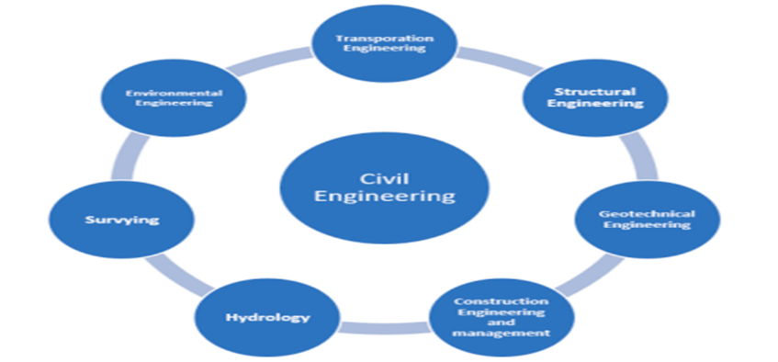• Quality control

• Risk management

• AI for construction safety

• Construction Management

• Construction safety

**Fig -1 Importance of AI in Civil Engineering.**

***1.2 Artificial Intelligence Techniques in Civil Engineering***

***1. Evolutionary Computation (EC)***

Evolutionary computation (EC) is a subcategory of AI being used in civil engineering for several decades. It uses an iterative process and is an effective method to solve complex optimization problems. The standard evolutionary algorithms used in civil engineering are Genetic Algorithms (GAs), Artificial Immune Systems (AIS), and Genetic Programming (GP).

***2. Artificial Neural Networks (ANNs)***

The neural networks collect, memorize, analyze and process massive amounts of data obtained from experiments or numerical analyses to provide basic solutions to complex engineering problems. It has widespread application in studying building materials, structural engineering, geotechnical engineering, construction management, and identifying structural defects.

***3. Fuzzy Systems***

A fuzzy system is a tool for adapting the human way of thinking and problem solving when dealing with uncertain issues faced in construction projects. It considers several aspects like the quality of material, equipment, logistics, and physical risk directly related to administrative and financial capacity.

***4. Expert System***

An expert system is widely used in construction engineering, underground engineering, geotechnical engineering, geological exploration, disaster prevention, material engineering, and the petrochemical industry. This method relies on the existing knowledge of human experts to set up a knowledge system.The system focuses on a particular area and uses all the corresponding knowledge and experience stored in the programming system to solve complex problems.

***1.3 Applications of artificial intelligence in civil engineering:***

* For estimating the percentage of soil moisture content and further classifications.
* In the structural engineering field machine learning can be applied to detect damages using sensory or image data, identifying it’s location and extent.
* Improving productivity by reducing idle time.
* For predicting maximum dry density and optimum moisture content in concrete.
* Using image recognition for proper site monitoring, including aspects of safety and dangerous working conditions.
* Identifying gaps and requirement of materials to cover the tasks without delay.
* For travel time prediction and sign AI optimization in transportation engineering.
* Efficient planning, designing and managing of infrastructure using Building Information Modelling (BIM).
* Utilizing Artificial Neural Network for predicting properties of concrete mix designs.
* To monitor activity in the construction site and predicting changes in the costing based on raw material market rates.
* To analyse settlement of foundation and slope stability.
* For monitor real time structural health of the building, giving warnings on when and where repair is required.
* Helping in tidal forecasting to aid construction in marine environment.
* Reducing errors in the project by automatic analysis of data.
* To develop site layouts and predict risks as part of project management.
* Finding a solution for damage related to pre-stressed concrete pile driving in foundation engineering.
* To solve complicated problems in different stages of the project.
* To make decisions in the design field.
* In the construction waste management domain and handling of smart materials.
* For expert monitoring and optimization if costs in the work system.



**Fig -2 Importance of AI in Civil Engineering.**

***1.3 The Impact of AI on Structural Engineering***

The implementation of AI in structural engineering brings about significant changes, influencing both the profession and project outcomes:

***Improved Safety and Compliance***

By leveraging AI's ability to analyze vast amounts of data, engineers can identify potential structural weaknesses and mitigate safety risks. This enhances structural integrity while ensuring compliance with local construction codes and standards.

***Cost Savings***

AI helps in creating optimized designs, reducing material waste and construction costs. In addition, AI-powered algorithms optimize structural configurations, ensuring efficient resource utilization without compromising safety. These cost-saving measures make projects more economically viable.

***Sustainable Design***

With AI's ability to evaluate different materials, configurations, and environmental factors, structural engineers can prioritize sustainable design solutions. By optimizing energy consumption and reducing environmental impact, AI aids in creating structures that align with the principles of sustainable development.

***Enhanced Collaboration***

AI-powered collaboration platforms allow multiple engineers to work simultaneously on the same project. This promotes efficient communication and coordination, leading to faster project completion and reduced delays.

***Future Opportunities***

The integration of AI in structural engineering paves the way for exciting future possibilities. As AI continues to evolve, the industry can expect advancements such as real-time structural health monitoring, adaptive designs, and automated construction processes.

In conclusion, AI is transforming the field of structural engineering, enhancing accuracy, efficiency, and sustainability. By leveraging AI tools and algorithms, engineers can optimize designs, improve safety, and reduce costs. Embracing AI's potential empowers professionals to push the boundaries of structural engineering, resulting in safer, more efficient, and environmentally friendly structures.

***1.4 The Future of AI in Construction***

Robotics, AI, and the Internet of Things can reduce building costs by up to 20 percent. Engineers can don virtual reality goggles and send mini-robots into buildings under construction. These robots use cameras to track the work as it progresses. AI is being used to plan the routing of electrical and plumbing systems in modern buildings. Companies are using AI to develop safety systems for worksites. AI is being used to track the real-time interactions of workers, machinery, and objects on the site and alert supervisors of potential safety issues, construction errors, and productivity issues. Despite the predictions of massive job losses, AI is unlikely to replace the human workforce. Instead, it will alter business models in the construction industry, reduce expensive errors, reduce worksite injuries, and make building operations more efficient. Leaders at construction companies should prioritize investment based on areas where AI can have the most impact on their company’s unique needs. Early movers will set the direction of the industry and benefit in the short and long term.

**2. LEADING AI STRUCTURAL ANALYSIS AND ENGINEERING SOFTWARE TOOLS**

**2.1 *Autodesk robot structural analysis professional***

Autodesk Robot Structural Analysis Professional offers comprehensive analysis for diverse materials and design codes. Its AI algorithms support the simulation of complex structures, making it a popular choice among structural engineers. Additionally, it integrates well with other Autodesk software, enhancing workflow and productivity.

***2.2. Tekla structural designer***

Tekla Structural Designer is an AI-driven software tool that optimizes steel and concrete structures. It facilitates efficient design processes with automated features and is known for its detailed and accurate modelling capabilities.

***2.3. Sap2000***

SAP2000 provides a wide range of analysis options suitable for various engineering projects. Its AI capabilities are incorporated for advanced modelling and simulation tasks, and its user-friendly interface makes it accessible for both simple and complex projects.

***2.4. Etabs***

ETABS specializes in comprehensive building analysis and design. Its AI integration enhances the modelling of intricate building systems, and it offers integrated analysis, design, and drafting capabilities.

***2.5. Staad.pro***

STAAD.Pro utilizes AI for complex load analysis, including seismic, wind, and gravity. It is versatile in handling various structural engineering projects and is known for its robustness in design and analysis accuracy.

***2.6. Ansys structural analysis***

ANSYS Structural Analysis offers advanced simulation tools that assess structural integrity and dynamics. Its AI capabilities are key in conducting fatigue analysis, making it suitable for complex and large-scale engineering projects.

**2.7. Risa-3D**

RISA-3D is efficient in the 3D design and analysis of structures. Its AI algorithms enhance modelling and optimization processes, and it offers a comprehensive solution for both design and analysis tasks.

***2.8. Skyciv structural 3D***

SkyCiv Structural 3D is a cloud-based software that offers flexibility and accessibility. Its AI-driven analysis and optimization for various structural types make it a popular choice among structural engineers. Additionally, it provides a user-friendly interface with real-time collaboration features.

***9. Dlubal RFEM***

Dlubal RFEM is a powerful software tool for finite element analysis with AI-driven optimization. It is capable of handling complex calculations and structural systems and offers detailed and customizable reporting features.

**10. Bentley systems RAM elements**

Bentley Systems RAM Elements is a versatile software tool suitable for a wide range of structures and materials. Its AI integration enhances design accuracy and efficiency, and it integrates with other Bentley systems, facilitating a seamless workflow.

3.LITERATURE REVIEW

**Shalini Bahukhandi1 , Dr Manju Dominic ( 2021)** concluded term Artificial Intelligence is becoming more and more popular nowadays is due to its ability to process things and learn things in the same as the human brain does and at the same time rectify and learn from its mistakes. Artificial Intelligence gives more benefits like decreasing the chances of error, giving more efficient solutions to problems which humans cannot solve manually as, it can make tasks easier and less time consuming. In field of engineering specially in structural engineering AI can give more accurate design parameters when testing is not possible, will provide more accurate computational and statistical efficiency. The main purpose of this review article is to study different applications of AI in structural or civil engineering, steps involved in the development of these systems, different types of AI methods, AI in structural engineering, and finally their shortcomings and solutions to overcome are discussed.

**Kailas G NathArtificial Intelligence (AI) (2022)** demanstate that branch of computer science that develops machines and software with humanlike intelligence. Artificial Intelligence proves to be the most promising path to more efficient practices in civil engineering. AI can be successfully implemented as a vital game changer in the field of Structural engineering to determine engineering design parameters when testing is not possible. Even with the vast range of adaptability that AI possesses, it is never, at least in the near future that AI is to be considered to perpetually replace human involvement as it can never account for the rationality that is purely human in possession. On the contrary, the essence of it is to be touchwood to assist and help in the field of structural engineering to expand their workflow. The complex and deeplearning algorithms possessed by modern AI systems provide clear cut platforms to the engineers and is something to be put resources into engineering.

**Bilal Manzoor ( 2021)** computed the widespread use of artificial intelligence (AI) in civil engineering has provided civil engineers with various benefits and opportunities, including a rich data collection, sustainable assessment, and productivity. The trend of construction is diverted toward sustainability with the aid of digital technologies. In this regard, this paper presents a systematic literature review (SLR) in order to explore the influence of AI in civil engineering toward sustainable development. In addition, SLR was carried out by using academic publications from Scopus (i.e., 3478 publications). Furthermore, screening is carried out, and eventually, 105 research publications in the field of AI were selected. Keywords were searched through Boolean operation “Artificial Intelligence” OR “Machine intelligence” OR “Machine Learning” OR “Computational intelligence” OR “Computer vision” OR “Expert systems” OR “Neural networks” AND “Civil Engineering” OR “Construction Engineering” OR “Sustainable Development” OR “Sustainability”..

**Christian Málaga-Chuquitaype ( 2022) is evaulated** the prominence gained by Artificial Intelligence (AI) over all aspects of human activity today cannot be overstated. This technology is no newcomer to structural engineering, with logic-based AI systems used to carry out design explorations as early as the 1980s. Nevertheless, the advent of low-cost data collection and processing capabilities have granted new impetus and a degree of ubiquity to AI-based engineering solutions. This review paper ends by posing the question of how long will the human engineer be needed in structural design. However, the paper does not aim to answer this question, not least because all such predictions have a history of going wrong. Instead, the paper assumes throughout as valid the claim that the need for human engineers in conventional design practice has its days numbered. In order to build the case towards the final question, the paper starts with a general description of the currently available AI frameworks and their Machine Learning (ML) sub-classes. The paper then proceeds to review a selected number of studies on the application of AI in structural engineering design. A discussion of specific challenges and future needs is presented with emphasis on the much exalted roles of “engineering intuition” and “creativity”. Finally, the conclusion section of the paper compiles the findings and outlines the challenges and future research directions.

**Rafael Sacks ( 2020)** Adoption of digital information tools in the construction sector provides fertile ground for the birth and growth of companies that specialize in applications of technologies to design and construction. While some of the technologies are new, many implement ideas proposed in construction research decades ago that were impractical without a sound digital building information foundation. Building Information Modelling (BIM) itself can be traced to a landmark paper from 1975; ideas for artificially intelligent design and code checking tools date from the mid-1980s; and construction robots have laboured in research labs for decades. Yet only within the past five years has venture capital actively sought startup companies in the ‘Construction Tech’ sector. Following a set of digital construction innovations through their known past and their uncertain present, we review their increasingly optimistic future, all through the lens of their dependence on digital information. The review identifies new challenges, yielding a set of research topics with the potential to unlock a range of future applications that apply artificial intelligence.

**Hadi Salehi ( 2018)** are computed Artificial intelligence (AI) is proving to be an efficient alternative approach to classical modeling techniques. AI refers to the branch of computer science that develops machines and software with human-like intelligence. Compared to traditional methods, AI offers advantages to deal with problems associated with uncertainties and is an effective aid to solve such complex problems. In addition, AI-based solutions are good alternatives to determine engineering design parameters when testing is not possible, thus resulting in significant savings in terms of human time and effort spent in experiments. AI is also able to make the process of decision making faster, decrease error rates, and increase computational efficiency. Among the different AI techniques, machine learning (ML), pattern recognition (PR), and deep learning (DL) have recently acquired considerable attention and are establishing themselves as a new class of intelligent methods for use in structural engineering. The objective of this review paper is to summarize techniques concerning applications of the noted AI methods in structural engineering developed over the last decade. First, a general introduction to AI is presented and the importance of AI in structural engineering is described. Thereafter, a review of recent applications of ML, PR, and DL in the field is provided, and the capability of such methods to address the restrictions of conventional models are discussed. Further, the advantages of employing such algorithmic methods are discussed in detail. Finally, potential research avenues and emerging trends for employing ML, PR, and DL are presented, and their limitations are discussed.

**Wenjie Liao ( 2024)** are Designing building structures presents various challenges, including inefficient design processes, limited data reuse, and the underutilization of previous design experience. Generative artificial intelligence (AI) has emerged as a powerful tool for learning and creatively using existing data to generate new design ideas. Learning from past experiences, this technique can analyze complex structural drawings, combine requirement texts, integrate mechanical and empirical knowledge, and create fresh designs. In this paper, a comprehensive review of recent research and applications of generative AI in building structural design is provided. The focus is on how data is represented, how intelligent generation algorithms are constructed, methods for evaluating designs, and the integration of generation and optimization. This review reveals the significant progress generative AI has made in building structural design, while also highlighting the key challenges and prospects. The goal is to provide a reference that can help guide the transition towards more intelligent design processes.

4 .MODELLING AND RESULT

*4.1 Robot Structural Analysis*

Autodesk® Robot™ Structural Analysis Professional 2017 (referred to as Robot) is an integrated graphic program for modeling, analyzing and designing various types of structures. It lets you create structures, carry out calculations, and verify results. It also lets you create documentation for the designed and calculated structure. The building has 10 story building. The size of used columns was (250x450, 250x300 and 250x500) mm2 unit, where the size of beams was (250x450 and 230x600) mm2. And the slab thickness was 150 mm. The M25 concrete grade has been assumed for all beams and slabs, while M30 grade for all columns. The steel grade was assumed 415 MPa for main reinforcement, and 250 MPa or 330 MPa for secondary reinforcement. The design code which has been used was I.S 456-2000.

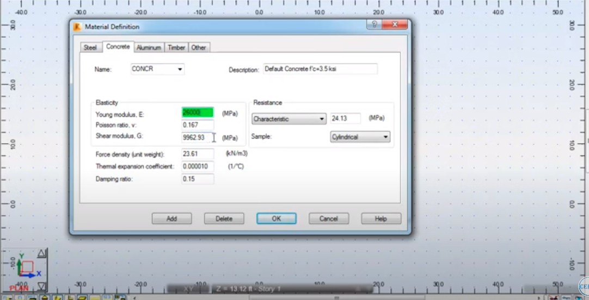

**Fig -3 Creating Axis Using Tools**

 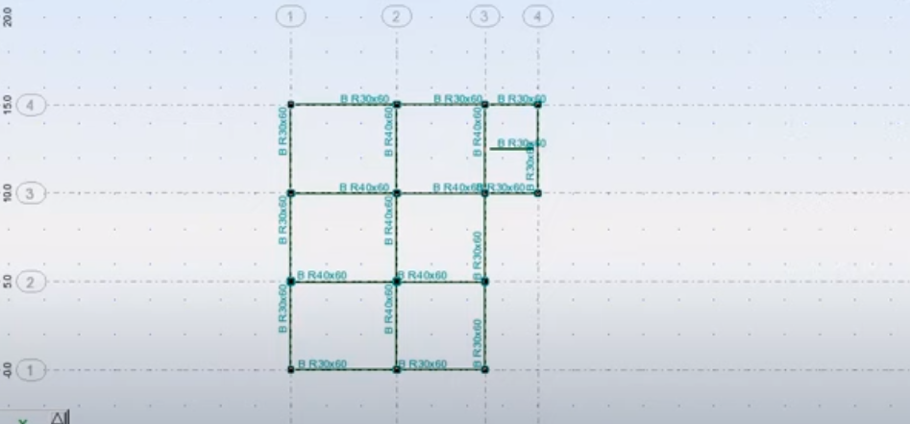

**Fig -4 Draw Grid Lines Fig -2 Create the Beam and Column**

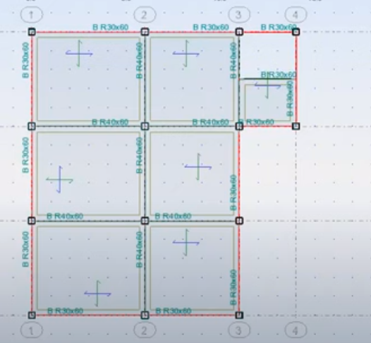 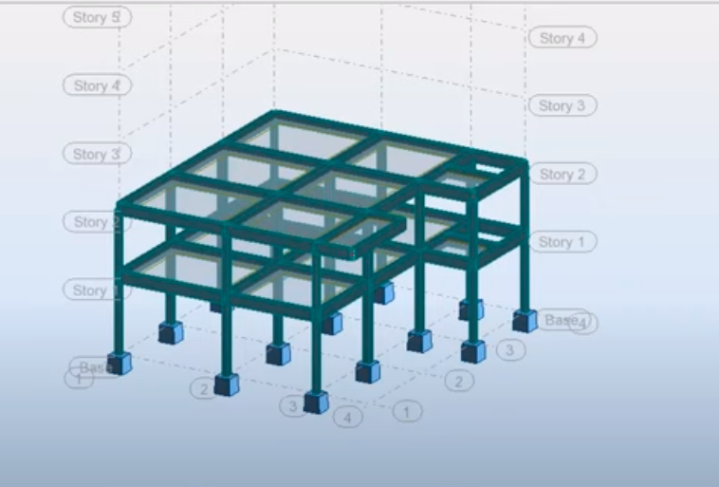

**Fig -3 Assign the two way slab Fig -4 Create the Rendering 3D**

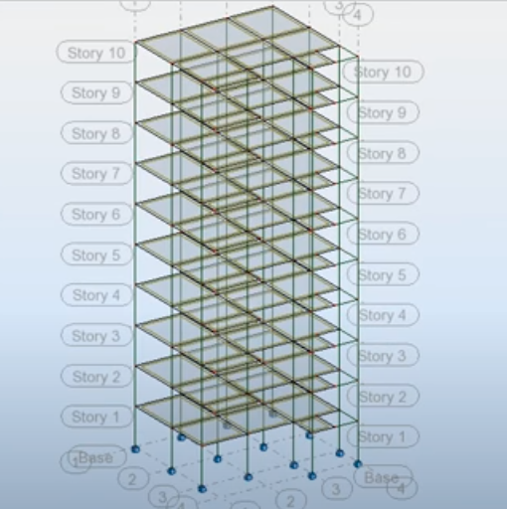 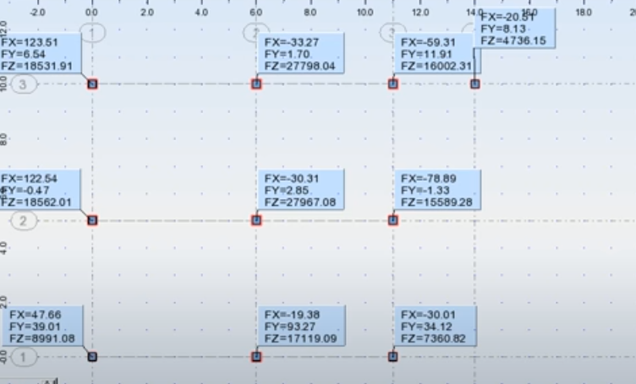

**Fig -5 After Rub Analysis Fig -6 Reaction of FX, FY , FZ**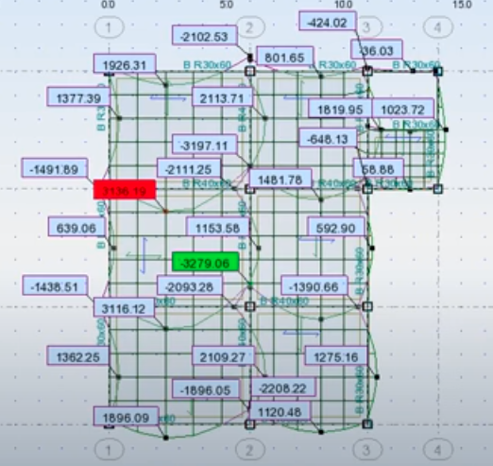

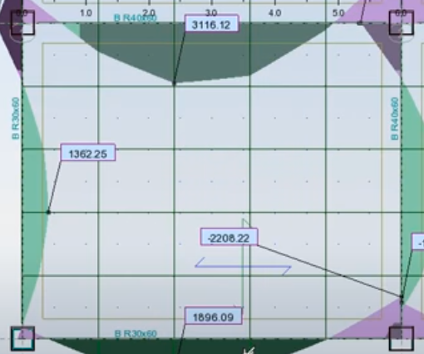

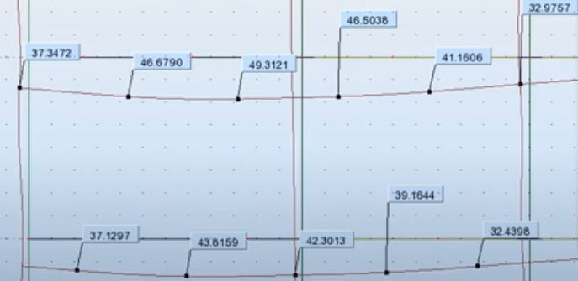

**Fig -7 Bending Moment and Deflection**

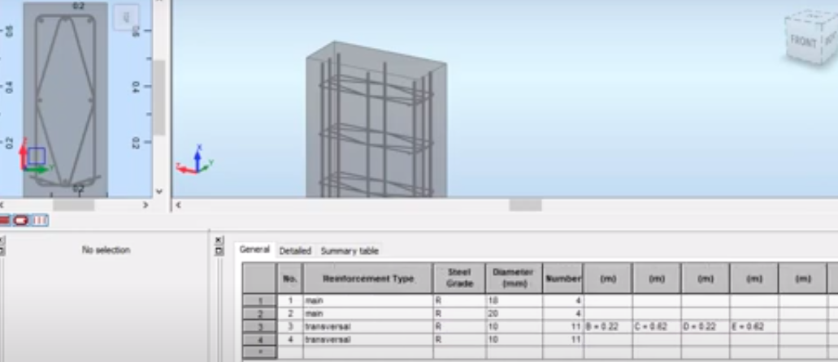

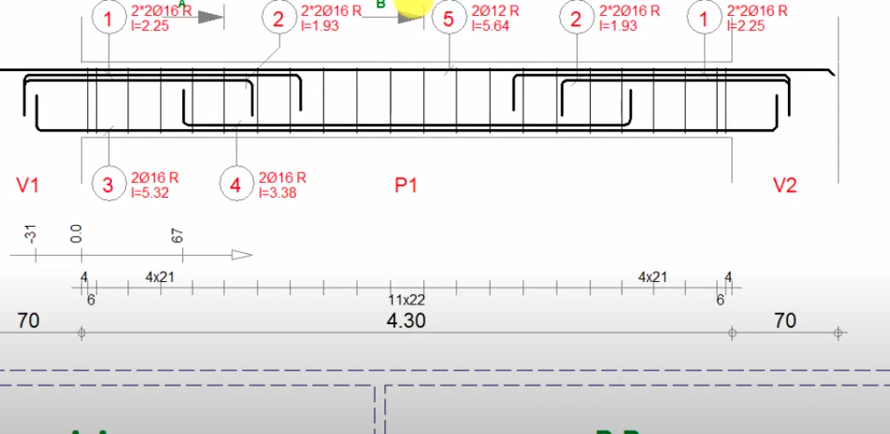

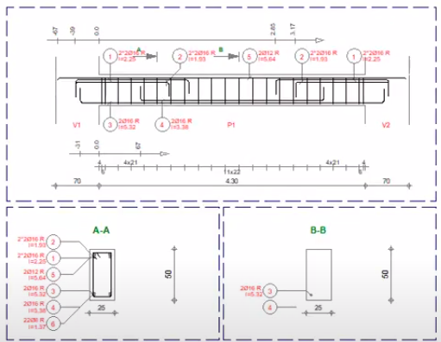

**Fig -8 Column and Beam Design**

***4.2 STAAD PRO***

* 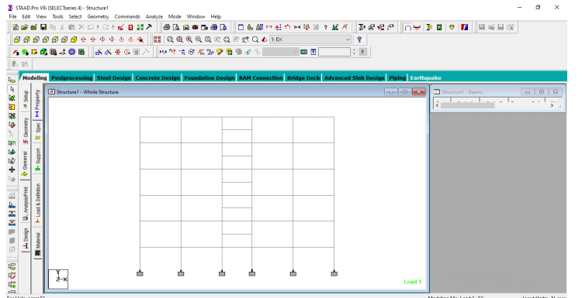
* 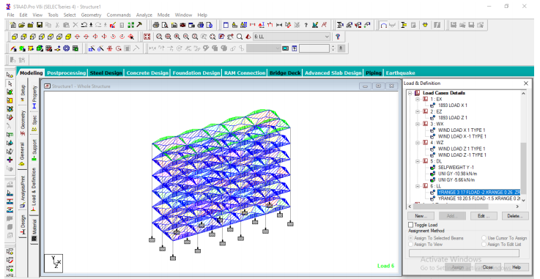

**Fig -9 Modelling and Assign load on slab**

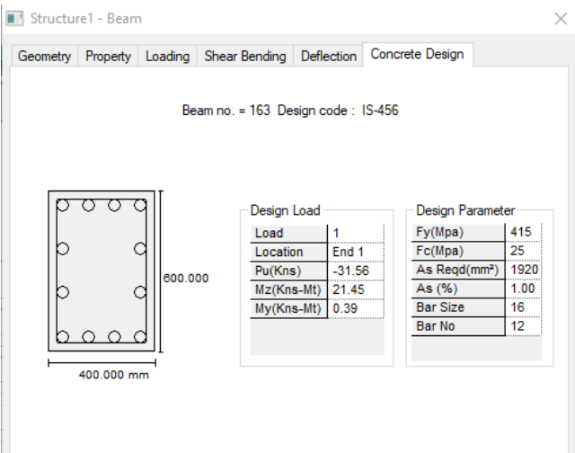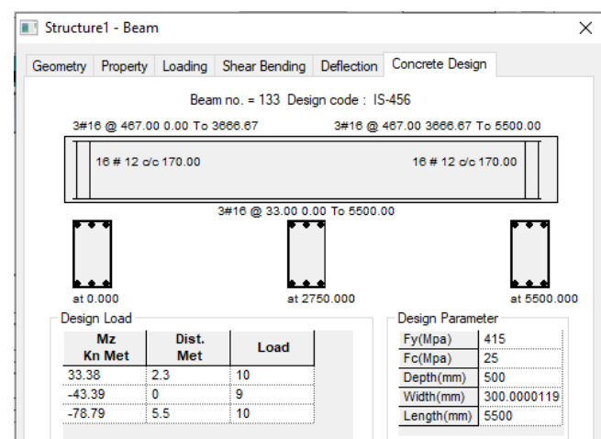

**Fig-10: Reinforcement Details Of Structural Members**

**4.3. STRAP**

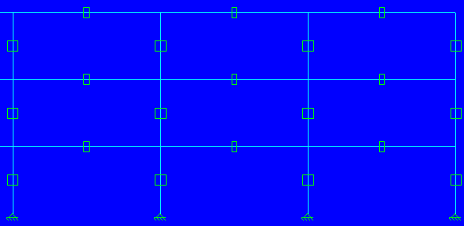

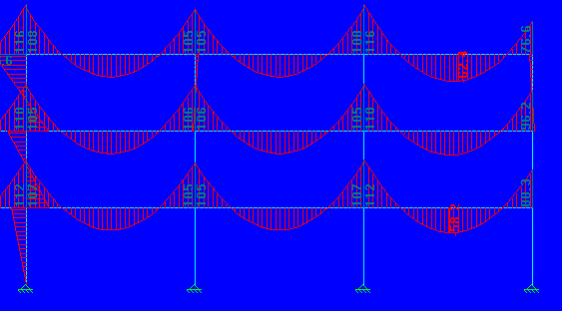

**Fig -11 Modelling Structures with Column Orientation and BMD**

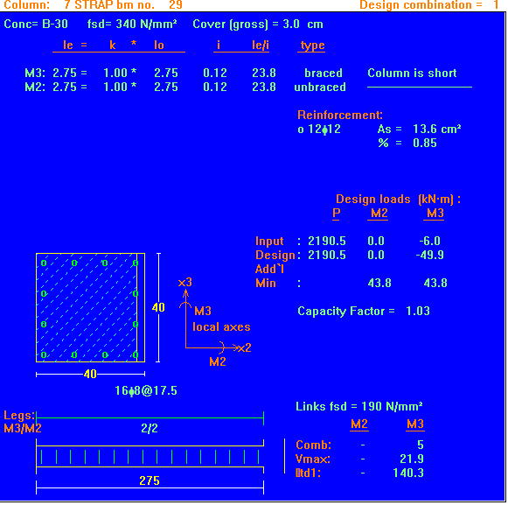

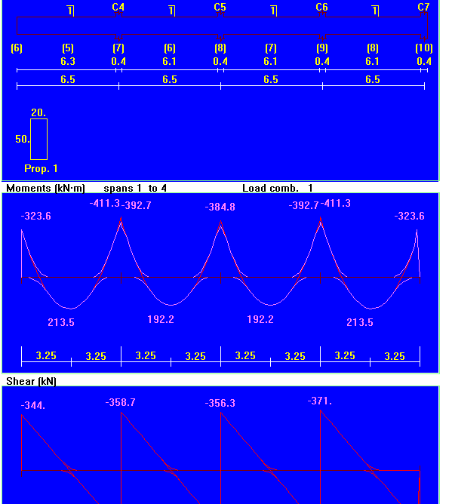

**Fig -11 Analysis of Beam & Column**

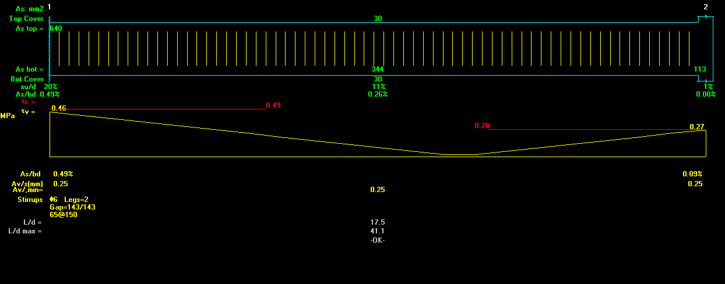





**Fig -12 Structural Detailing Diagram and Scheduling using Strap**

**CONCLUSION**

In conclusion, the integration of AI in structural engineering holds immense promise for the industry. With its ability to automate analysis and design processes, improve accuracy, and enable real-time monitoring, AI is driving efficiency and propelling the field of structural engineering into a new era. Planning, analysis and design building was done. All the structural components weredesigned manually and detailed using AutoCAD. The dimensions of structural members are specified and the loads such as dead load, live load, floor load and earthquake load are applied. Deflection and shear tests are checked for beams, columns and slabs. The tests proved to be safe. Theoretical work has been done. Hence, I conclude that we can gain more knowledge in practical work when compared to theoretical work. ANN’s ability to derive enormous historical data can be coupled with the large data handling capability of the modern computers. ANN can model any functional relationship with reasonable accuracy. Machine Learning algorithms and their application in the field of Civil and Structural engineering are worth exploring. Material model based on ANN helps in explaining and deriving complex, unknown and non-linear functional relationships. This helps to simplify decision making, saves time and helps to reasonably obtain results with accuracy. The paper demonstrates that the software are just tools to come up with a good result, high efficiency and proper construction with lesser difficulties and mistakes, because BIM is not limited in some tools. Indian Standard IS 456-2000 had used for design purposes, and checking the design results of the software.

References

1. Shalini Bahukhandi1 ( 2019) , Dr Manju Dominic2 Artificial Intelligence in Structural Engineering- Review, *International Journal Of Innovative research in Technology* Volume 8 Issue 1 pg 1097-1105

2. Kailas G Nath (2022) delve in the new era: artificial intelligence in structural engineering*, International Journal of Creative Research Thoughts* Volume 10, Issue 5 pg 297-303

3. Bilal Manzoor ( 2021) Influence of Artificial Intelligence in Civil Engineering toward Sustainable Development—*A Systematic Literature Review* 4, 52 pg 1-17

4. Christian Málaga-Chuquitaype ( 2022) Machine Learning in Structural Design: *An Opinionated Review Front. Built Environment* Volume 8 article 815717 pg 1 to 12

5. Rafael Sacks ( 2022) Building Information Modelling, *Artificial Intelligence and Construction Tech* , Developments in the Built Environment, Vol 4, Issue 5, Pg 1 to 10

6. Hadi Salehi ( 2018) Emerging artificial intelligence methods in structural engineering, *Engineering Structures*, Volume 171, Pages 170-189.

7. Wenjie Liao ( 2024) Generative AI design for building structures, *Automation in Construction* Volume 157, pg 1to 12

8. Addanki Manikya Gopichand ( 2020), Analysis And Design Of Multistoried Building (G+6) Using E-Tabs And Slope Deflection Method, *International Research Journal of Engineering and Technology*, Volume: 07 Issue: 08, PG 3657-3663

9. Shubham Borkar ( 2019 ) Analysis And Design Of G+6 Building In Different Seismic Zones By Using Software, *International Research Journal of Engineering and Technology*, Volume: 06 Issue: 05, PG 886-893.

10. Atun Roychoudhury ( 2018), Planning, Analysis & Design of Hospital Building Using Staad Prov8i, *International Journal of Scientific and Engineering Research* vol,8 issue no 04) pg no.1624-1628

11. Guntur S.R.K Dinesh( 2022) modeling and analysis of g+6 Residential building using revit Architecture and staad. Pro”, Volume 9, Issue 3 pg no 1472 - 1476

12. R.H.S Phanindra (2022) Designing, 3d Modeling & Estimation Costing Of G+3 Residential Building Using Revit Architecture & Ms Excel” *Journal of Emerging Technologies and Innovative Research*, Volume 9, Issue 3, pg no 442-454

13. K. Smarsly ( 2007) , Artificial Intelligence in Structural Health Monitoring, *The Third International Conference on Structural Engineering* At: Cape Town pg 1-6

14. Tarun Gehlot ( 2023), Applications Of Artificial Intelligence In Structural Engineering: Review , Journal of Research Administration, Vol. 5 No. 2 pgg 644-649