Mobile Manual Water Purifier (MMWP)
Students : Chavhan Rajesh Dhondibhau 1st Dighe Aniket Shivaji 2nd
Gunjal Pramod Dattatray 3rd Pardeshi Anushka Prasad 4th
Guide: Prof. Fulpagare S.V. Coordinator : Prof. Murhekar N.H
HOD:- Prof Khatate M.B
Diploma Mechanical In Engineering,
Samarth Polytechnic, Belhe.Taluka – Junnar, Dist -Pune.
____________________________________________________________________________

Abstract:- To get available the clean and safe drinking water is an important need for human being. Therefore, in many parts of the world, especially in remote or desert areas, clean water scarcity is there. To overcome this problem, our project aims to develop a Mobile Manual Water Purifier. It is an innovative solution designed to provide clean and potable water through human- powered technology. The Mobile Manual Water Purifier consists of the principles of sustainable energy, water purification, and mobility to create a compact and easily transportable system. This system utilizes a pedal mechanism of a bicycle similar to the normal stationary bicycle, to generate mechanical energy. This energy is then will be used to drive a water purification process that removes contaminants and pathogens, making the water safe for consumption. Mobile Manual Water Purifier (MMWP) is an eco-friendly system. The MMWP works only on mechanical energy without electricity. MMWP provides pure drinking water in remote location. Where no electrical supply is there. As well as it will also help to produce to purified water for the Treckers and the Adiwasi community where no cleaned water supply. For making the given model we have choose Mobile Manual Water Purifier. This model consist of a Bicycle, Centrifugal pump, Additional sprocket wheel, free wheel, Water filters etc. The model will work on the principal of mechanical power and it pressure for water filters. The model will work on Pedal power of the Bicycle. Pedal will be run in two stages first it can move bicycle to forward direction and in second direction or backward direction it will run the motor to make the water pressure. Pressurized water will be enter into the filter and it will get filtered. Then cleaned water will be collected in the Jarican which is fitted to the opposite side of the filter.
Pedal Mechanism: A pedal-driven system is designed to convert human power into mechanical energy efficiently. Water Purification Unit: We involved a water purification unit that employs various filtration methods such as activated sediment water purifier, carbon and membrane filtration to remove impurities from the water. Sustainability: By depending on human power, the Mobile Manual Water Purifier reduces the need for electricity or fossil fuels, making it an environmentally friendly solution. Cost-Effective: The project made for reducing the cost to –

ensure affordability and accessibility for all communities with limited resources. The Mobile Manual Water Purifier project has the potential to provide a sustainable source of clean drinking water to underserved communities, disaster affected areas like flood affected area, earthquake areas, and places where no infrastructure is there. This abstract represents the main concept of our innovative project, which combines technology and human effort to represent the critical international problems. Our project does a positive impression by improving availability of clean water, ultimately contributing to better health and quality of life for those who are living in remote areas.

INTRODUCTION
Project Statement
The project work is prepared by the team of four members Chavhan Rajesh, Dighe Aniket, Gunjal Pramod and Pardeshi Anushka and it is original. This work is referred from other works and it is mentioned in the references. All of the engineering drawings, computer programs, formulations, design work, development and testing reported in this document are also original and prepared by the same team of students. Problem Statement
All developing of the world facing problem for safe and clean drinking water. That sensational issue make us aware to produce such kind of mechanism to create a Mobile Manual Water Purifier (MMWP). The simple mechanism of transporting the dirty water and make it clean by using a bicycle to help for clean water and sanitation of the Adiwasis and also to the trekkers who are going for the trek on forts and hills. This mechanical purifier is not a permanent solution but it will help them little bit.
Motivation
The objective of providing pure drinking water to Adiwasis all over the India is one that has been an ongoing process for the last several decades. Therefore we got the motivation from Maharashtra’s Pani Foundation which is being lead by Mr. Aamir Khan and Gauri Khan. We also thankful to the Mr. Nana Patekar and mr. Sayaji Shinde who also involves in this projects They also do nice job to plant trees in Ahmednagar District and Satara Districts specially.

PEDAL POWER
CHAIN DRIVE MECHANISM
WHEEL SHAFT ROTATING

FILTERED WATER
FILTER
PRESSURIZE WATER
PUMP

Fig: Methodology
One source of energy is human motion, which a machine can use but can only produce so much. A fit and healthy adult can exert up to 900 watts (W) of power, but this is only possible for brief periods of time. It makes sense to pedal for an extended period of time at a continuous power output of 60 W at 50 revolutions per minute (RPM). For many tasks, like pumping water, this output is perfect [8]. A healthy individual can readily produce up to 75 W of mechanical power, and an athlete can produce twice as much [9]. Figure 1 presents the results of the Human Powered Vehicle Association Scientific Symposium and illustrates the maximum amount of time that humans can exert themselves for different steady

DESIGN OF MOBILE MANUAL WATER PURIFIER

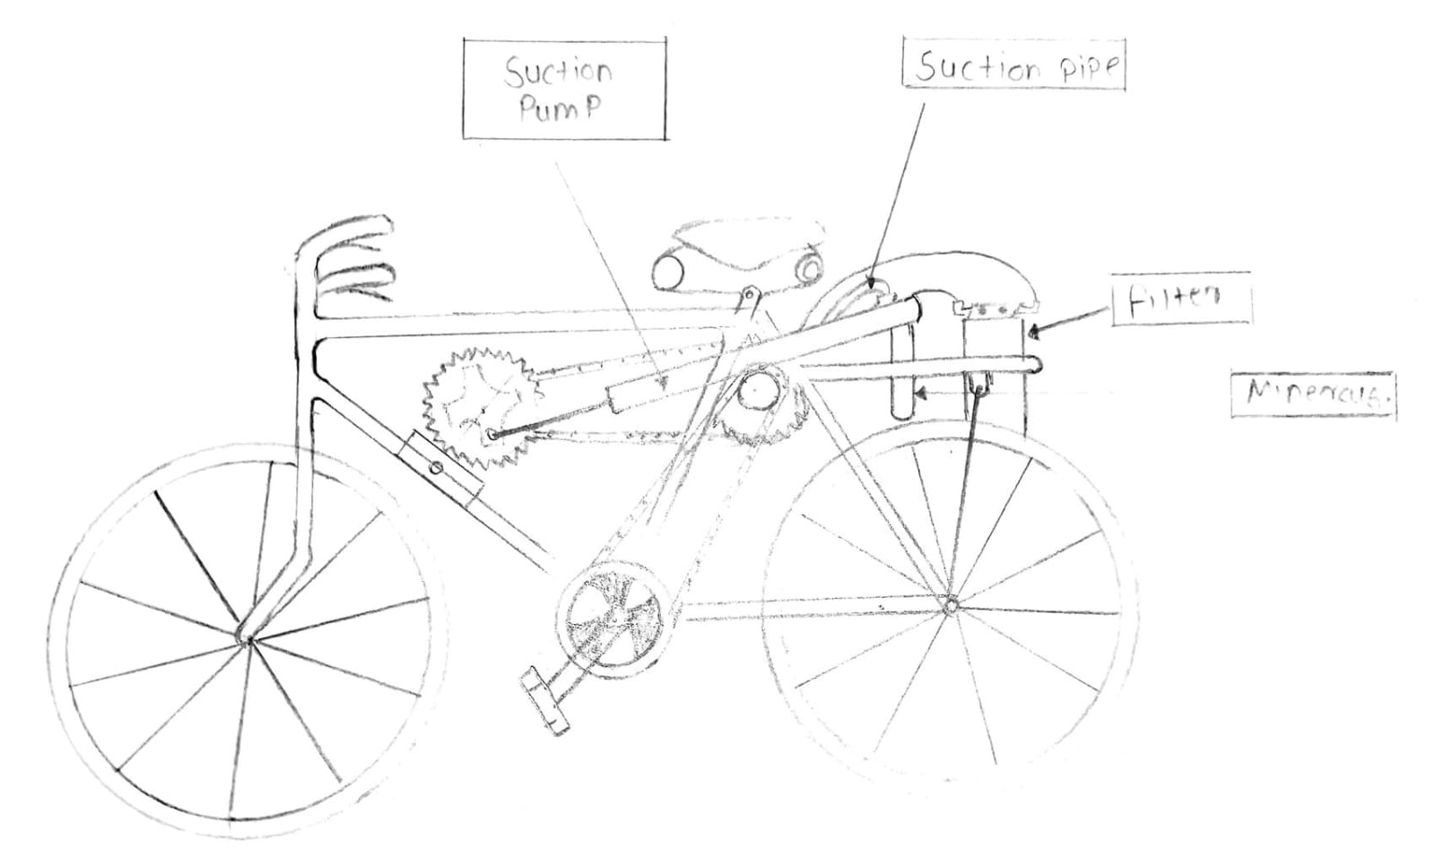

Fig.no Construction of model

MOBILE MANUAL WATER PURIFIER (MMWP) is an eco-friendly system. The MMWP works only on mechanical energy without electricity. For making the given model we have choose Mobile Manual Water Purifier. This model consist of a Bicycle, Centrifugal pump, Additional sprocket wheel, free wheel, Water filters etc. The model will work on the principal of mechanical power and it pressure for water filters. The model will work on Pedal power of the Bicycle. Pedal will be run in two stages first it can move bicycle to forward direction and in second direction or backward direction it will run the motor to make the water pressure. Pressurized water will be enter into the filter and it will get filtered. Then cleaned water will be collected in the Jarican which is fitted to the opposite side of the filter.

ANALYTIC ANALYSIS
A pump is designed to move fluids by mechanical energy. Mechanical Energy takes three basic forms, Kinetic, potential and static.
The general equation for a pump comes from modifying the Bernoulli equation into:

(V₁)² + + 𝑔𝑧₁ + 𝑃₁+ 𝑤_{𝑝𝑢𝑚𝑝 =} (V₂)² + 𝑔𝑧₂ + 𝑃₂+ 𝑤_{𝑙𝑜𝑠𝑠}
2 𝜌 2 𝜌
Where:
V = velocity of the fluid
P = Pressure z = Height
w = work done or lost

Cost Analysis
Cost Analysis for Prototype
Table
Sr. No | Part Name | Cost Per Unit (in Rs) | Quantity | Total (in Rs)
1 | Bicycle | 5000 | 1 | 1600
2 | Pump | 3500 | 1 | 1000
3 | Filters | 1500 | 1 | 1500
4 | Sproket Wheel | 300 | 1 | 300
5 | Free Wheel | 300 | 1 | 300
6 | Chain | 200 | 1 | 200
7 | Jarican or Can | 250 | 1 | 250
8 | Pipes | 500 | 3 | 1500
9 | Additional Fitments | 1000 | - | 1000
 | TOTAL |  |  | 7600/-

CONCLUSION

Therefore in this research project we have prepared the Mobile Manual Water Purifier (MMWP). This purifier is prepared in very reasonable cost and having high efficiency to deliver safe and cleaned drinking water. As well as it is movable so it can be use by transferring it from one location to another without any additional cost. By examining all the projects made on the same basis we have reached to the conclusion that we have made this project with cheaper cost and with minimal components. mobile power water purification systems address a pressing global need for clean water access, and their versatility, reliability, and effectiveness make them indispensable tools for humanitarian efforts, disaster response, outdoor adventures, and beyond. Their ongoing development and deployment contribute to a healthier and more secure future for communities and individuals worldwide

REFERENCES

1. Assistant, Appliance. How Water Filters Work. 2013. 14 March 2014.
<http://applianceassistant.com/Refrigerator-Repair/How-Water-Filters-Work.php>.
2 . B.V, Verder International. The Green Peristaltic Pump . n.d. 16 March 2014.
<http://www.verderflex.com/how-do-peristaltic-pumps-work/>.
3. Flahiff, Daniel. "Aquaduct Bike Purifies Water as you Pedal." 08 November 2008. Inhabitat.com. March 2014. <http://inhabitat.com/aquaduct-bike-purifies-water-as-you- pedal/>.
4. Nippon Basic Co. Water Purification System. 2006. 20 January 2014.
<http://www.nipponbasic.ecnet.jp/eindex.html>.
5. Organization, World Health. Progress on Sanitation And Drinking-Water (2010 Update). New York: UNICEF, 2010.
6. Books and Websites related to Pani foundation.
7. Ademola Samuel Akinwonmi, Stephen Kwasi Adzimah,Fredrick Oppong, “An Experiment on Pedal PoweredCentrifugal Pump for Purified Water Supply Device”ISDE (Vol.3, No.11) (2012).
8. M.Serazul Islam, M.Zakaria Hossai and M.Abdul Khadir,“Design and Development of Pedal Pump for Low LiftIrrigation”, JARD, 5(1&2)116-126 (2007).

9. Atul.P.Ganorkar, K.S.Zakiuddin, H.A.Hussain, “An Experiment on Development of Pedal Operated Water Pump”, IOSR, e-ISSN:2278-1684,(2014).

