AUTOMATED ATTENDENCE MONITORING SYSTEM

# Reshma Nair1, Sonu Thomas2, Thejas Mathew Philip3,Godwinraj D4,Ranjitha Rajan5

## 1,2,3Students, Electronics & Communication Engineering, Amal Jyothi College of Engineering, Kottayam, India.

4Associate Professor,5Assistant Professor, Electronics &Communication Engineering, Amal Jyothi College of Engineering, India.

# ABSTRACT

This project is aimed at developing an interactive “AUTOMATED ATTENDENCE MONITORING SYSTEM”. This paper proposes an innovative approach utilizing AI-powered camera Systems for automated attendance Marking in educational institutions. Drawing upon Insights from renowned journals in the field, the system integrates facial Recognition and attendance tracking algorithms to accurately record student’s attendance. Additionally, it incorporates a parental notification feature, whereby if a student's attendance falls below the threshold of 70%,an automatic message is sent to their parents, altering them to the situation. The utilization of AI technologies enhances the efficiency and accuracy of attendance monitoring, while the parental notification system promotes parental involvement and awareness regarding their child's attendance performance. The implementation of such a system holds significant potential for improving overall attendance rates and fostering a collaborative approach between educational institutions and parents in ensuring students' regular attendance and academic success.

**Keywords:** Artificial intelligence (AI), Deep machine Learning, Contactless Attendance Management System(CAMS), Convolutional Neural Network (CNN), AWS Face Recognition

# INTRODUCTION

The necessity of attendance management in educational institutions is emphasized in the study, along with the difficulty faculty members encounter in controlling growing class sizes, dealing with tardies,and avoiding proxy attendance. Potential answers to the problems are automated systems, such those built on biometric authentication. However, due to concerns, using conventional biometric techniques like fingerprint scanning might not be appropriate during a pandemic. In response to these challenges, the proposed CAMS employ’s facial recognition technology to accurately record attendance without the need for physical contact. High-definition cameras mounted in classrooms capture images of students' faces, which are then processed to identify individuals and record their attendance. This contactless approach not only reduces the risk of infection transmission but also offers a more efficient and accurate method of attendance monitoring compared to traditional manual or biometric systems. The suggested CAMS uses facial recognition technology to precisely record attendance in response to these difficulties without requiring direct physical touch. Classrooms are equipped with high- definition cameras that take pictures of students' faces. These images are processed to identify specific pupils and keep track of their attendance. Compared to manual or biometric systems, this contactless technique of attendance monitoring is more precise and efficient while also lowering the danger of infection transmission. Ultimately, in order to guarantee the security, effectiveness, and precision of attendance tracking in educational settings especially in light of the COVID- 19 pandemic—the study promotes the implementation of contemporary attendance management systems that make use of contactless technology and artificial intelligence.

### PROBLEM STATEMENT

This study underscores the challenges faced by educational institutions in managing attendance amidst increasing class sizes, tardiness, and potential proxy attendance issues. Traditional methods, including manual tracking and conventional biometric techniques, prove inadequate, especially during a pandemic, raising concerns about infection transmission. In response, the proposed Contactless Attendance Management System (CAMS) leverages facial recognition technology as a modern solution. This contactless approach, facilitated by high-definition cameras in classrooms, not only reduces the risk of infection transmission but also provides an efficient and accurate alternative to traditional attendance monitoring systems. By employing facial recognition and artificial intelligence, CAMS address’s the need for secure, effective, and precise attendance tracking, particularly in the context of the ongoing COVID-19 pandemic. The study advocates for the widespread adoption of these advanced attendance management systems to ensure the safety and effectiveness of attendance monitoring in educational settings.

# LITERATURE SURVEY

In the paper [1] that has been referred, “Contactless Attendance Management System using Artificial Intelligence”. This paper was published in 2020.The paper introduces a Contactless Attendance Management System powered by Artificial Intelligence, specifically the InceptionV3 model, for automated student attendance tracking. It addresses challenges like proxy attendance and time constraints faced by faculty, offering high precision and recall in classifying different class labels. The system's touch-free design ensures student safety by eliminating the need for biometric attendance, especially in the context of contagious diseases like COVID-19. Overall, it aims to enhance reliability, accessibility, and security in attendance management within educational settings [2021 e-ISSN: 1742-6596p-ISSN: 1742-6588]. In the paper [2] that has been referred, “Automatic Attendance Monitoring System Using Deep Learning” published in 2021. In this research paper the proposed automatic attendance management system utilizes face recognition technology, specifically employing Deep Convolution Neural Network (DCNN) with the Facenet algorithm for face detection and recognition. Training the model involves using K-Nearest Neighbor (KNN) algorithm. Jetson nano serves as the platform for testing the system. Additionally, the document discusses the RFID-based attendance system as an alternative approach. To enhance face recognition accuracy in challenging environments, the Hybrid Robust Point Set Matching Convolutional Neural Network (HRPSM_CNN) is recommended. Various algorithms and libraries such as OpenFace, Dlib, Numpy, and Sklearn are utilized for implementation. The experimental results demonstrate the effectiveness and efficiency of the proposed system in automating attendance management through face recognition technology. [2020 e-ISSN: 2278- 0181].In the paper [3]that has been referred, “Development of Attendance Monitoring System with Artificial Intelligence Optimization in Cloud”publishedin2021.Inthisresearchthe document outlines a biometric-based automatic attendance management system proposal for educational institutions, integrating RFID, face detection, and temperature measurement for contactless attendance tracking. It emphasizes the utilization of artificial intelligence, machine learning, and neural networks to optimize accuracy and efficiency in attendance monitoring. The system's design includes evolutionary prototyping as a system development life cycle, with software and hardware integration for seamless operation. Positive testing results demonstrate the system's effectiveness in automating attendance processes and providing detailed reports, showcasing its potential to revolutionize attendance tracking in educational environments. [2021 e-ISSN:2686-3251 p-ISSN:2407-7275]. In the paper [4] that has been referred, “Face Detection and Recognition System for Enhancing Security Measures Using Artificial Intelligence System” published in 2020.In this research the document discusses the implementation of a Face Detection and Recognition System using Artificial Intelligence. The system captures facial features, creates templates, and matches them for identification, aiming to enhance security in public areas. It highlights the importance of user-friendly technology and the potential applications in various industries. Future work includes integrating Embed Systems for additional functionalities. The study references different techniques and studies related to face recognition, emphasizing the system's capability to improve security measures.[ 2020 e-ISSN:0974-5645 p-ISSN:0974-6846].In the paper [5] that has been referred, “Facial Recognition Technology-Based Attendance Management System Application in Smart Classroom” published in 2023.In this research the study presents a facial recognition-based automatic attendance system designed for smart classrooms, leveraging advanced algorithms like Viola-Jones, HOG, and YOLOv5 for precise face detection and verification. By automating the attendance process, the system surpasses traditional methods and previous studies in performance metrics. Despite challenges posed by varying environmental conditions, the system can efficiently handle up to 31 students simultaneously and generate detailed attendance reports. The integration of deep neural networks enhances surveillance capabilities, making the system a valuable asset for smart classroom environments. [ 2021 e-ISSN:2521- 5839 p-ISSN:1996-1944]. In the paper [6] that has been referred, “Design of Face Recognition AttendX for Recording Student Attendance Data Based on Artificial Intelligence Technology” published in 2020.In this research The study delves into the technical aspects of the AttendX platform, which leverages advanced face recognition technology for efficient attendance tracking. By employing models such as ResNet and Extended Mobile Net, the system ensures precise face detection and verification, even in scenarios where individuals are wearing masks. The research addresses challenges like anti-spoofing measures in facial recognition to enhance security and accuracy. It also explores the face embedding process and database storage techniques utilized by AttendXNet. Additionally, the study proposes testing methodologies for group attendance monitoring using IP cameras. Overall, the research highlights the technical sophistication of AttendX and Signy Advanced Technologies in enabling reliable and effective student attendance recording, with successful trial outcomes validating the system's efficacy. In the paper[7] that has been referred, “AI- Based Techniques for Real-Time Face Recognition-based Attendance System- A comparative Study” Published in 2020.In this research the technical aspects of face recognition involve intricate processes influenced by factors like lighting conditions and facial pose variations. Various models and techniques, such as Local Ternary Patterns and YOLO face detection, are employed to enhance accuracy. Deep neural networks like ResNet and AlexNet play a crucial role in

achieving high accuracy rates. Histogram models like LBPH are utilized for feature extraction and classification. Leading companies like Amazon and Microsoft leverage deep neural networks for their face recognition services. Additionally, a successful demonstration of a face recognition attendance system using the Flask framework and AWS recognition API showcases the practical application of these technical advancements in real-world scenarios.In the paper[8] that has been referred, “ AI-Based Attendance Monitoring System” published in 2020.In this research the paper discusses various methods of attendance monitoring systems, including fingerprint-based, Radio Frequency Identification (RFID)-based, and Iris-Recognition based systems. It highlights the challenges faced by these systems, such as unauthorized access in RFID-based systems and the need for proper lighting conditions in Iris-Recognition systems. The study also mentions the implementation of AI-enabled attendance systems in educational institutions, emphasizing the benefits of automating attendance processes to reduce errors and ensure accurate monitoring. Additionally, the paper mentions the use of artificial intelligence in face recognition technology for attendance monitoring, aiming to enhance security and efficiency in tracking student attendance.[2020 e-ISSN:2278-3075].In the paper [9] that has been referred, “Fully automated classroom attendance system” published in 2019.In this Research the paper presents a fully automated classroom attendance system that leverages RFID technology, face recognition, and biometric verification. A mobile app called "JIC CMS" was developed for efficient student attendance management. The system uses RFID for marking students present, late, or absent based on entry time, and incorporates advanced algorithms like Open Face with CNNs for face recognition. The implementation aims to enhance competitiveness in the IoT realm and align with college attendance procedures, showcasing a blend of innovative technologies for streamlined classroom control. In the paper [10] that has been referred, “Development of a multi-client student attendance monitoring system” published in 2019.In this research the paper discusses the development of a multi-client student attendance monitoring system with a focus on the technical aspects. The system utilizes technologies such as RFID, face verification, and face recognition to automate attendance recording and monitor student presence in real-time. Client devices are connected to a server via wireless connection, allowing for seamless data exchange. The system architecture includes RFID authentication for initial identification, face-based identification on Raspberry Pi 2 board, and webpage integration for system management. Experimental results showed varying accuracy rates for face verification and recognition due to factors like wearing glasses and lighting conditions. The system also incorporates a database for storing attendance and student information, supported by a web application for viewing, updating, and analyzing attendance data. Overall, the system aims to enhance attendance monitoring efficiency through contactless biometric identification methods. [2021 e-ISSN:2277-3878].

# PROPOSED SYSTEM

An Automated Attendance Monitoring System using Face Recognition combines cutting-edge technology with a programmable camera and Raspberry Pi to revolutionize traditional attendance tracking Fig.1 illustrates the process, beginning with face detection to capture facial images of individuals. It then performs facial feature matching to identify specific facial characteristics. The identified facial data is matched against a database for face recognition and identification of each person methods. Employing advanced face detection and recognition algorithms, the system accurately identifies and records student attendance in real-time. Integrated with a secure database, it maintains comprehensive attendance records for efficient tracking. The system also introduces a proactive approach by monitoring attendance percentages, automatically notifying students and their parents via email if attendance falls below the defined threshold of 70%. This innovative solution not only ensures precise attendance management but also fosters timely communication between educational institutions and parents, promoting a collaborative effort towards student success. The integration of Raspberry Pi enhances the system's versatility and accessibility, making it an effective and scalable solution for modern educational environments.

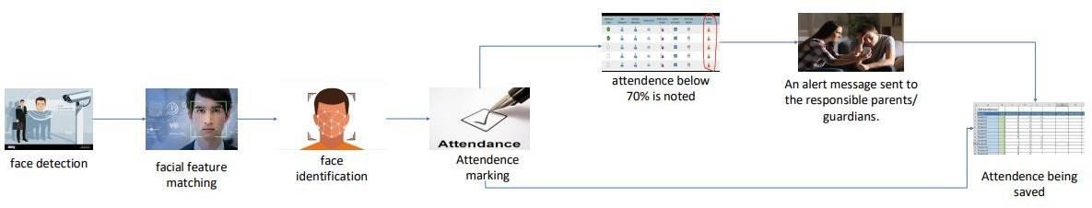

**Fig.1**

### BLOCK DIAGRAM

The Block Diagram in Fig.2 illustrates the systematic architecture of the Automated Attendance Monitoring System using Face Recognition. At its core is the programmable camera capturing live video feed, which is then processed bythe RaspberryPi.Through the implementation of a robust face detection algorithm, the system identifies and locates faces within the video stream. Following this, the face recognition module matches the detected faces with preregistered while the face recognition module matches these faces with pre-registered student profiles stored in the database. The secure database not only holds student information but also serves as a repository for real-time attendance records. An additional layer incorporates attendance monitoring, with a feedback loop that checks attendance percentages against a predefined threshold. If a student's attendance falls below 70%, an automated email notification is triggered, alerting both the student and their parents. Fig.3 shows the circuit diagram, depicting the hardware components and their interconnections, including the Raspberry Pi, camera module, and display interfaces. The integration of these components forms a cohesive and intelligent system, seamlessly automating attendance tracking and promoting effective communication within educational institutions

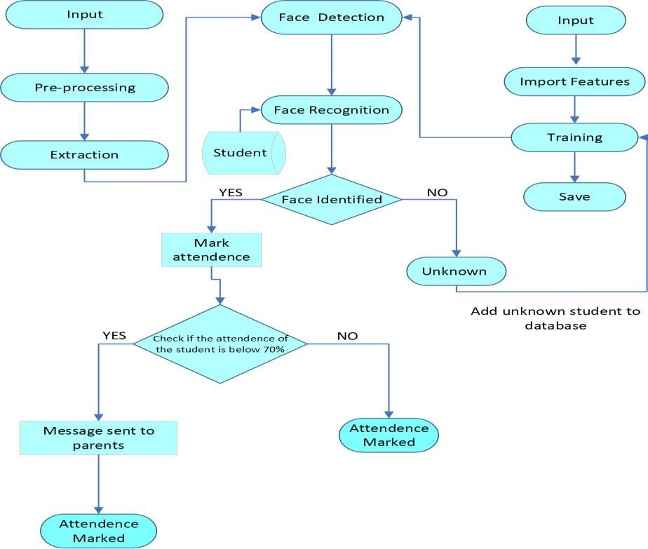

**Fig.2**

### 3.2. CIRCUIT DIAGRAM

**Fig.3**

# EXPECTED RESULT

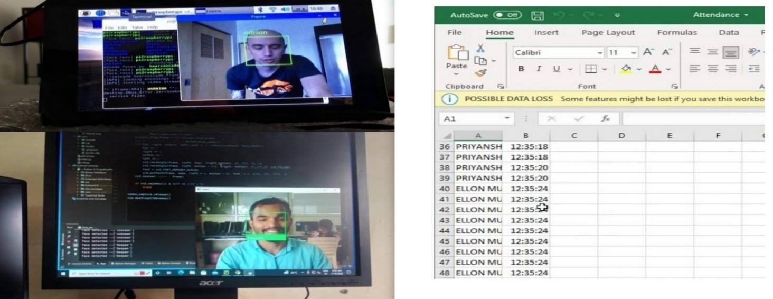

1. **CONCLUSIONS**

### Fig. 4

The development of the Automated Attendance Monitoring System using Face Recognition represents a significant leap forward in the realm of educational technology, offering not only enhanced efficiency but also affordability. The seamless integration of advanced face detection and recognition algorithms with a programmable camera and Raspberry Pi minimizes the need for expensive proprietary hardware, making the system a cost-effective solution for educational institutions with limited resources.

By automating attendance tracking, the system not only reduces manual efforts but also ensures accurate and real-time monitoring, contributing to a more efficient administrative process. The inclusion of a proactive attendance threshold mechanism, combined with automated email notifications, underscores the system's commitment to promoting student accountability and fostering communication, all within an affordable and accessible technological framework. Fig.4 showcases the real-time operation of the system, with facial recognition and attendance marking in progress, along with the attendance records being maintained in a spreadsheet format. As technology continues to reshape education, this project stands as an example of how innovation can be both impactful and economically feasible.

# REFERENCES

1. M Rajamanogaran,SSubha,SBaghavathi Priya and JeevithaSivasamy , "Contactless Attendance Management System using Artificial Intelligence",
2. ShanmuhappriyaM,Dr.SudhaSadhasivam G , "Automatic Attendance Monitoring System Using Deep Learning
3. Mohamad Fakir Naen, Muhamad Hariz Muhamad Adnan, Nurul AdilahYazi,Chee Ken Nee , "Development of Attendance Monitoring System with Artificial Intelligence Optimization in Cloud",
4. Muhammad Farhan Siddiqui, Waqas Ahmed Siddique, Mushtaq Ahmedhand Awais Khan Jumani , "Face Detection and Recognition System for Enhancing Security Measures Using Artificial Intelligence System" ,
5. Ahmad S. Lateef,Mohammed Y. Kamil , "Facial Recognition Technology-Based Attendance Management System Application in Smart Classroom"
6. Ankur Singh Bist,WidyaFebriani,ChandraLukita,SandyKosasi,UntungRahardja , "Design of Face Recognition AttendX for Recording Student Attendance Data Based on Artificial Intelligence Technology" ,
7. Priyanka Pattnaik,Kalyan Kumar Mohanty , "AI-Based Techniques for Real-Time Face Recognition-based Attendance System- A comparative Study"
8. K P Naveen Reddy, Alekhya T, Sushma Manjula T, Rashmi , "AI-Based Attendance Monitoring System"
9. E. Al Hajri, F. Hafeez, and A. A. NV, “Fully automated classroom attendance system.,” Int. J. Interact. Mob.

Technol., vol. 13, no. 8, pp. 95–106, 2019

1. Y. P. Jia, K. Y. Low, and H. L. Wong, “Development of a multi-client student attendance monitoring system,” International Journal of Recent Technology and Engineering, vol. 8, no. 3S, pp. 6–11, 2019.
2. A. Generosi, T. Agostinelli, and M. Mengoni, “Smart retrofitting for human factors: A face recognition-based system proposal,” International Journal on Interactive Design and Manufacturing (IJIDeM), vol. 17, no. 1, pp. 421–433, 2023.
3. M. Karunakar, C. A. Sai, K. Chandra, and K. A. Kumar, “Smart Attendance Monitoring System (SAMS): A Face Recognition Based Attendance System for Classroom Environment,” Int. J. Recent Develop. Sci. Technol., vol. 4, no. 5, pp. 194-201, 2020
4. Akshara Jadhav, Akshay Jadhav Tushar Ladhe, Krishna Yeolekar “Automated Attendance System Using Face Recognition” Irjet Volume: 04 Issue: 01 | Jan -2017
5. ShreyakSawhney ; Karan Kacker ;Samyak Jain ;Shailendra Narayan Singh ;Rakesh Garg “Real-Time Smart Attendance System Using Face Recognition Techniques” Published In Ieee 2019 9th International Conference On Cloud Computing, Data Science & Engineering (Doi: 10.1109/Confluence.2019.8776934)
6. Sajjad, M., Nasir, M., Muhammad, K., Khan, S., Jan, Z., Sangaiah, A. K., ... &Baik, S. W. (2020). Raspberry Pi assisted face recognition framework for enhanced law-enforcement services in smart cities. Future Generation Computer Systems, 108, 995-1007.
7. H. Pranoto and O. Kusumawardani, "Real-time Triplet Loss Embedding Face Recognition for Authentication Student Attendance Records System Framework," JOIV: International Journal on Informatics Visualization, vol. 5, no. 2, pp. 150-155, 2021.
8. F. M. Andiani and B. Soewito, "Face recognition for work attendance using multitask convolutional neural network (MTCNN) and pre-trained facenet," ICIC Express Lett, vol. 15, no. 1, 2021
9. V. Rohini, M. Sobhana, and C. S. Chowdary, "Attendance Monitoring System Design Based on Face Segmentation and Recognition," Recent Patents on Engineering, vol. 17, no. 2, 2023, doi: https://doi.org/ 10.2174/1872212116666220401154639.
10. S. M. Bah and F. Ming, "An improved face recognition algorithm and its application in attendance management system," Array, vol. 5, 2020, doi: https://doi.org/ 10.1016/j.array.2019.100014.
11. M. Gu, X. Liu, and J. Feng, "Classroom face detection algorithm based on improved MTCNN," Signal, Image and Video Processing, vol. 16, no. 5, pp. 1355-1362, 2022, doi: https://doi.org/ 10.1007/s11760-021-02087-x.