Design & Fabricate Advance Agriculture Sprayer Machine.
Students : Lamkhade Suyog Santosh 1st Chore Akshay Nanabhau 2nd
Kadam Shubham Sunil 3rd Ughade Karan Santosh 4th
Guide: Mrs. More A.G. Coordinator : Prof. Murhekar N.H
Diploma Mechanical In Engineering,
Samarth Polytechnic, Belhe.Taluka – Junnar, Dist -Pune.
____________________________________________________________________________

Abstract:-
- Proposes of a device that can be used for spraying applications. The device is designed to overcome the problems faced by farmers while using traditional sprayers, which require more human effort. The device is carried on a vehicle, making it less tiresome than the conventional sprayer. It increases the capacity of spraying and saves human effort in pumping. The device is cost-effective compared to automatic sprayers and can be used in agriculture, floriculture, and agriculture.
The device is based on a sprayer pump that moves forward and backward to give pump action and increase pressure inside the pump, which is further used to spray the pesticide when the valve is opened on the sprayer pipe. The device is an important step towards developing a kit capable of upgrading a conventional sprayer to a fully autonomous robotic sprayer even at an affordable cost in the context of small and medium-size farms The Agricultural Spray Machine Project focuses on the design, development, and evaluation of an advanced mechanized spray system for precision application of agricultural chemicals onto crops.
The project aims to address the need for efficient and targeted spraying techniques in modern farming practices to enhance crop health and yield while minimizing envi ronmental impact. The primary objective of this project is to design a spray machine that can accurately deliver liquid solutions such as pesticides, herbicides, and fertilizers onto crops with precision and consistency. The made in this project will be self-propelled with the help of IC engine and can done work more efficiently.

Problem Statement
- To design and fabricate a proposed model for advanced pesticides sprayer
- One of the difficult task in farming is to prevent the crop without any pests.
- This task simply replaced by a advanced sprayer which reduces the farmer effort.
- Now a days traditional spraying pumps we observing following problems : Costly for farmers having small farming lands, the spraying is traditionally done by labor carrying backpack type sprayer which required more human effort, traditional spraying having more time consuming, efficiency of traditional spraying method is less, and in traditional spraying methods require pressure is not produce

- INTRODUCTION:
India is an agricultural based country, But still now our farmers are doing farming in same traditional ways. They are doing seed sowing, fertilizer and pesticides sprayers, cultivating by conventional methods.
There is need of development in this sector and most commonly on fertilizers pesticides spraying technique, because it required more effort and time to spray by traditional way.

Project Statement
An agricultural crop sprayer is the equipment used for applying liquid substances to plants or crops. These substances could be fertilisers, herbicides, or pesticides – all of which are important for the maintenance of crop health during the crop growth cycle.

Motivation
The motivation is to reduce the amount of pesticides applied in crops, not just for potential savings for the farmers, but also for environment protection issues, as well as for food safety. The system can be used in any crop planted in rows such as onion, soybean, corn, beans, and rice.

ADVANCED AGRICULTURE SPRAYER MACHINE

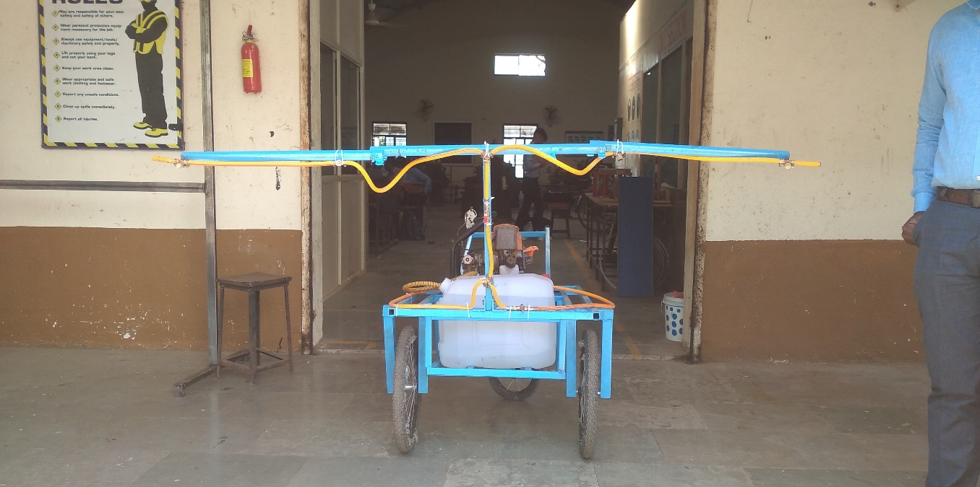

Fig.no 1.1 Construction of model

There are many different types of agricultural sprayers, each with its own advantages and disadvantages. The most common type of sprayer is the knapsack sprayer, which is small, portable sprayer that is carried on the back of the operator. Knapsack sprayers are ideal for small farms and garden, but they can be difficult to use for large areas.

“Advance sprayer machine” is used to apply pesticides, herbicides, and fertilizer to crops. It is fully integrated mechanical system which is composed of various hydraulic equipment's and some newly designed parts that work together to achieve desired effect of projection of spray fluid at any atmospheric condition.

Analytic Analysis
Engine Traction Power Calculation
Velocity = 10km/hr 1 kilometre =1000m
1 hr =3600sec
Velocity in m/s = (10*1000)/3600 =2.778 m/s
Power=Force * Velocity Power =1470.09 KW units - Engine generated
Velocity = 2.778 m/sec
Force = 1470.09/2.778 = 529.51 unit of force
i.e 530 units
Hence required force is so less than that of generated force the design of power is correct.

Cost Analysis
Cost Analysis for Prototype
Table no 1.1
Sr. No | Part Name | Cost Per Unit (in Rs) | Quantity | Total (in Rs)
1 | Tubeless Tyre | 500 | 3 | 1500
2 | Pump | 4700 | 1 | 4700
3 | Pipes | 1200 | 1 | 1200
4 | Chasis Full Frame | 2200 | 1 | 2200
5 | Pipe Jointer | 60 | 12 | 720
6 | Box Pipe M.S. | 550 | 3 | 1650
7 | Paints / Brush | 350 | 1 | 350
8 | Storage Tank | 350 | 1 | 350
9 | Additional Fitments | 2500 | - | 2500
10 | Spray Nozzle | 200 | 4 | 800
 | TOTAL |  |  | 15970/-

CONCLUSION

• The suggested model has removed the problem of back pain, since there is no need to carry the tank (pesticides tank) on the back.
• As suggested model has more number of nozzles which will cover maximum area of spraying in minimum time and at maximum rate.
• Proper adjustment facility is given in the model with respect to crop helps to avoid excessive use of pesticides/fertilizers which result in to less wastage and maximum usage
• The equipment is purposely design for the farmers having small farming land say 2-3 acre.
• It is suitable for spraying as well as weeding at minimum cost for the farmer so that he can afford it.
• Hence, Advance agriculture sprayer machine will cover all the objectives and problem for the farmer and Helping them to work with joy with minimum effort and stress.

REFERENCES

[1] GURURAJ T.R.1 , MALLESH K.U.1 , BASAVARAJ2 AND CHAITANYA Issue 24, 2020 DEVELOPMENT AND PERFORMANCE EVALUATION OF CYCLE MOUNTED BATTERY OPERATED BOOM SPRAYER. .
[2] Rajesh Chandra C1 , Aravinda D1 , Sharath Kumar S N 1 , Jayanth H Issue 12, December 2021 . . “Design and Simulation of Mechanically Operated Fluid Sprayer
[3] 1Laukik P. Raut , 2Smit B. Jaiswal, 3Nitin Y. Mohite . [Issue 11 (Nov - 2013)]. “Design, development and fabrication of agricultural pesticides sprayer with weeder” Sandeep H. Poratkar, 1 Dhanraj R. Raut . [Issue.2, March-April. 2013 pp-864-868 ISSN: 2249-6645 ]. “Development of Multi nozzle Pesticides Sprayer Pump ”
[4] cycle mechanism Agriculture spraying machine. Joseph Redmon, Santosh Divvala, Ross Girshick, Ali Farhad

