# Analysis of T-Beam along with deck slab by Courbon's Theory method and STAAD. Pro

**Gutala Supriya*, Kothakota Sai Tarun*, Kalyanapu Avinash*, Agire Ravindra**

**UG Students – Final Year, Department of Civil Engineering NRI Institute of Technology, Agiripalli, India**

**Abstract: -** This Project Analyze the simple T- Beam Deck Slab. In T-Beam Deck Slab consists Slab wit Longitudinal and Cross Girders. Before Design of Any +Structure we should know what the structural components in the structure, should know the specifications of the components, what are the loads to be considered in the design of structure and should know the analytical concepts. So This thesis gives the brief idea about the meaning of bridge and its classification, loads to be considered and the different methods to be adopted for the analysis of T-Beam deck slab bridge. Girders have analyzed with three different Rational Methods (Courbon’s theory) for four IRC Loadings (Class-AA, Class-A, Class-70R) Also this project Compare the all the loadings and All the Methods which are mentioned above and the same bridge is analyzed as a three dimensional structure using software STAAD ProV8i. Analysis of girders in the Bridge means Calculation of Moments and Shear forces induced in the longitudinal and cross girders at different positions for above mentioned loadings. Also analyzed the Moments induced in the Slab due to IRC Loadings Only. A simple example problem could be taken from the Text book.

**Keywords:** Courbon’s theory- Class-A, Class-AA, Class70R. STAAD ProV8i.

# INTRODUCTION

The design of a deck slab for a bridge involves several factors such as the bridge span, structural loading requirements, material selection, and construction methods. It is a critical element that provides a stable and durable surface for vehicles to travel on. To design a deck slab for a bridge, engineers consider factors such as the type of material used (e.g., reinforced concrete, steel, composite), the load capacity of the bridge, and the expected traffic volume. They also assess the bridge's overall structural system, including support beams, girders, and piers, to ensure proper load distribution. Additionally, the design considers factors like the climate and environmental conditions, as well as construction limitations and available resources. The design process typically involves a detailed analysis of the bridge's geometry, material properties, and structural behaviour to ensure safety and functionality. It's crucial to consult with a qualified structural engineer or bridge design specialist when designing a deck slab for a bridge, as they will have the expertise and knowledge to develop an optimal design solution for your specific project.

# LITERATURE REVIEW

Following are the research works conducted on Analysis of T-Beam along with deck slab

**Mamadapur**, (2012)Bridges designed for class AA should be checked for IRC class A loading also, since under certain conditions, larger stresses may be obtained under class A loading. Sometimes class 70 R loading given in the Appendix - I of IRC: 6 - 1966 - Section II can be used for IRC class AA loading. Class 70R loading is not discussed further.

**Vikas Gandhe(2014)** Bridges are highly investment structures and important landmarks in any country besides being vital links in the transportation system. Strength, safety and economy are the three key features that cannot be neglected before the finalization of types of bridges.

**Hanumant, (2015)** When the live loads are positioned nearer to the kerb the centre of gravity of live load acts eccentrically with the centre of gravity of the girder system. Due to this eccentricity, the loads shared by each girder is increased or decreased depending upon the position of the girders.

**Praful N K(2015)** In this paper studied bridge is a structure providing passage over an obstacle without closing the way beneath. The required passage could also be for a road, a railway, pedestrians, a canal or a pipeline. T-beam bridge decks are one among the principal forms of cast-in-place concrete decks. T-beam bridge decks carry with it a concrete slab integral with girders.

**Sujatha, (2016)** The bridge models are subjected to the IRC class AA and IRC 70R tracked loading system in order to obtain maximum bending moment and shear force. From the analysis it is observed that with the increase in the span, shear force and bending moment in the girder increases. It is also observed that the results of bending moments and shear forces obtained from both courbon’s method

**Verma, S. (2017)** T-beam utilized as a part of construction, is a load bearing structure of reinforced concrete, wood or metal, with a t-formed cross area. The highest point of the t-molded cross segment fills in as a flange or pressure part in opposing compressive stress. The web (vertical area) of the beam beneath the compression flange serves to oppose shear stress and to give more noteworthy detachment to the coupled strengths of bending.

**Abrar Ahmed (2017)** The development of the nation is mainly from agricultural and industrial activities, so, it is required to facilitate the proper transportation by providing the flyovers and Bridges. T-beam and box type are very popular types of section for constructing the flyovers or the bridges. This project looks on the work of analysis, design and also compares the cost of T-Beam and Box girders for respective spans in order to find out the most suitable section. The purpose of this literature is to determine the most economical and proper section for bridges of respective spans.

**Sanjay Tiwari (2017)** Cellular steel section composite with concrete the deck is one in every of the foremost appropriate superstructures in resisting torsional and warp effects elicited by route loading. This type of structure has inherently created new style issues for engineers in estimating its load distribution once subjected to moving vehicles.

**Yogita Gupta (2017)** The shallow foundation is generally provided on non-erodible strata or where scour depth is less. It is conjointly desirable for low perennial flow or standing water condition. In the present case study, the shallow foundation is adopted for box type bridge.

**Neeraj Kumar (2017)** This paper describes the look of 4-lane concrete T-beam bridge considering IRC ClassAA tracked loading with span varied from twenty-five to 40m. After computing manually and STAAD Pro analysis software, it is observed that dead load bending moment with increasing span increases almost square of the span.

**Haymanmyintmaung, (2017)** In this study, the integral bridge with a various span length of 40m, 50m, 60m and 70m non-skew and skews angles of 15°, 30°, 45° and 60° were designed and modelled in SAP2000 software. The parameters investigated in this analytical study were the skew angle, span length and stress reduction methods. The geometric dimensions of the Integral Bridge and the loading used followed AASHTO commonplace specifications.

**Saibabu Sundru (2018)** This work begins with an overview of the condition assessment of the old bridge and explained reasons for demolishing of the bridge. Briefly presented the flexural analysis of two-stage post-tensioned prestressed concrete girder, which will replace the old (new bridge).

**Siva, D. M. (2018)** Courbon's method is observed to give average result on bending moment values for the longitudinal girders than GuyonMassonet method, whereas the GuyonMassonet method gives lower bending moment values than courbon's method of analysis

**Gawatre, D. W., (2018)** Bridge design standards specify the design loads, which are meant to reflect the worst loading that can be caused on the bridge by traffic, permitted and expected to pass over it. In India, the Railway Board specifies the standard design loadings for railway bridges in bridge rules. For the highway bridges, the Indian Road Congress has specified standard design loadings in IRC section II.

**Sharu.E, (2018)** ] The bridge is designed with all the components like Deck, Girders, Bearing, Pier cap, Pier, Pile cap, Pile, Abutment and so on and the configuration by IRC loadings. These components are designed based on IRC loadings and it is being examined with the authentic loading. This bridge has also been checked for its seismic resistance capacity. Finally we are bridge with the overloading currently due to congestion factor on the bridge life span of T-beam Bridge

**Jagdish Chand, Ravikant (2019)**, Three same models are prepared in the STAAD pro and IRC codes, Euro codes and AASHTO loadings are applied. Shear force, bending moment and area of steel is determined from the models according to these different loadings from both longitudinal girder as well as cross girder. The whole analysis is carried out in STAAD Pro and tables and graphs are used to compare the results.

**Hanwate** **(2021)** This paper gives the comparative study of R.C.C.(Reinforced Cement Concrete) Girder and P.S.C.(Prestressed Concrete) Girder, which include the design and estimates of R.C.C. and P.S.C. Girder of various spans. The aim of this work is to study R.C.C .girder well as P.S.C.

**Zain, M**., **(2022)** Courbon's approach was utilized in this research to analyze an RC T beam bridge in terms of moment and shear force under IRC loading. The study analyses the results of analytical modelling of an RC T beam bridge using Courbon's approach and STAAD. Pro software. The scope of this research is limited to right bridges with no skew.

## METHOD OF ANALYSIS OF DECK SLABS

## 3.1. Analysis of Slab Decks:

## • The analysis of deck slabs can be done in two ways depending upon the importance and classification of bridge.

## They are Solid slabs spanning in one direction Slabs spanning in Two directions

## • According to our project we are using slabs spanning in two directions.

## • The moments develop due to wheel loads on the slab both in the longitudinal and transverse directions.

## • These moments are computed by using the design curves developed by “westergard” or “Pigeaud‟s method.

## • Pigeaud‟s method is applicable to rectangular slabs supported freely on all the four sides.

## • The bending moments Can be calculated using the following Formula‟s

## M1=(m1+μm2)W

## M2=(m2+μm1)W

## μ=poission‟s ratio for concrete from IRC-21:2000 = 0.15

## m1,m2=coefficients for moments along short span and long span (from pigeaud‟s curves)

## W= wheel load under consideration

## K=Ratio of short to long span direction= (B/L)

## u and v =Dimensions of the load spread after allowing for dispersion through the wearing coat and structural slab.

## L=Long span length

## B=short span length.

## 3.2. Analysis of Girders:

## A typical Tee beam deck slab generally comprises the longitudinal girder, continuous deck slab between the Tee beams and cross girders to provide lateral rigidity to the bridge deck. The longitudinal girders are spaced at intervals of 2 to 2.5 m and cross girders are provided at 4 to 5 m Intervals. The distribution of live loads among the longitudinal girders can be estimate by any of the following rational methods.

## • Courbon method

## • GuyonMassonet method

## • Hendry Jaegar method

## 3.2.1.Courbon‟s method:

## Among these methods, courbon method is the simplest and is applicable when the following conditions are satisfied:

## a) The ratio of span to width of deck is greater than 2 but less than 4

## b) the longitudinal girders are interconnected by at least five symmetrically spaced cross girders.

## c) The cross girder extends to a depth of at least 0.75 times the depth of the longitudinal girders.

## Courbon method is popular due to the simplicity of computations as detailed below: The center of gravity of live load acts eccentrically with the center of gravity of the girder system. Due to this eccentricity, the loads shared by each girder is increased or decreased depending upon the position of the girders. This is calculated by courbon theory by a reaction factor given by,

## Ri=[ P x Ii / ∑Ii] x [1+(∑Ii / ∑Ii di 2 ) x e x di ]

P= total live load (kN)

Ii=moment of inertial of longitudinal girder (i)e=eccentricity of the live load (m)

di= distance of girder (i) from the axis of the bridge

**II. T-BEAM ANALYSIS USING COURBUN’S THROY:**

**DESIGN EXAMPLE**

Design a R.C.C. Tee beam and slab deck to suit the following data:-

Effective span of girders = 16 m

Clear width of Road way = 7.5 m

Width of Kerbs =600 mm

Thickness of wearing coat = 80 mm

Number of Main Girders = 2.5 m

Spacing of Main Girders = 4

Spacing of Cross Girders = 4 m

Type of loading:- I.R.C. Class 70R tracked vehicle

Materials: M-20 Grade concrete and Fe-415 Grade HYSD bars

Design the deck slab and the exterior girder for flexure only and sketch the details of reinforcements.

**1. Data**

Effective span of Tee beam =16 m

Width of Carriageway = 7.5 m

Thickness of wearing coat = 80mm

M-20 Grade Concrete and Fe-415 Grade HYSD bars.

**2. Permissible Stresses**

m = 10

sigma cb =6.7 N/mm^ 2

j = 0.91

sigma ct =200 N/mm^ 2

underline Q = .762

**3. Cross Section of Deck**

Four main girders are provided at 2.5 m centres

Adopt thickness of deck ab = 250mm Width of main girder = 300 mm

Kerb 600 mm wide by 300 mm deep are provided

Cross girder*, are provided at every 4 m intervals

Width of cross girder = 300 mm

Depth of main girder = 1600 mm at the rate of 100 mm per meter span.

depth of cross girder is taken as equal to that of main girder

-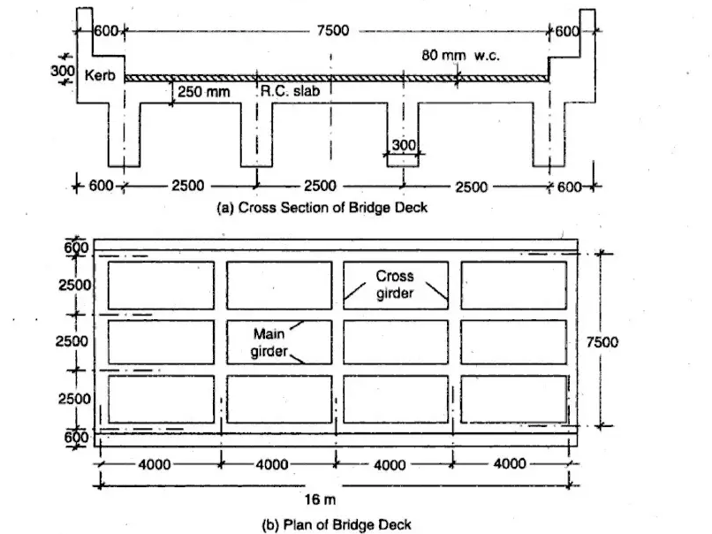

**4. Design of Interior Slab Panel (a)**

Bending Moment

Dead weight of slab = (1 x 1 × 0.25 x 24)

Dead weight of W.C. = (0.08 × 22)

Total dead load

= 6.00 kN/m2

= 1.76 kN/m? = 7.76 kN/mª

Live load is IRC Class 70 R tracked vehicle.

One wheel is placed at the centre of the panel as shown in Fig. 7.28.

и = (0.84 + 2 x 0.08) = 1.00

v = (4.57 + 2 × 0.08) = 4.73 m but limited to 4 m which is the spacing of

cross girders.

(w/B) = (1.00/2.5) = 0.40

(wL) = (4.00/4.00) = 1.00

K = (B/L) = (2.5/4.00) = 0.625

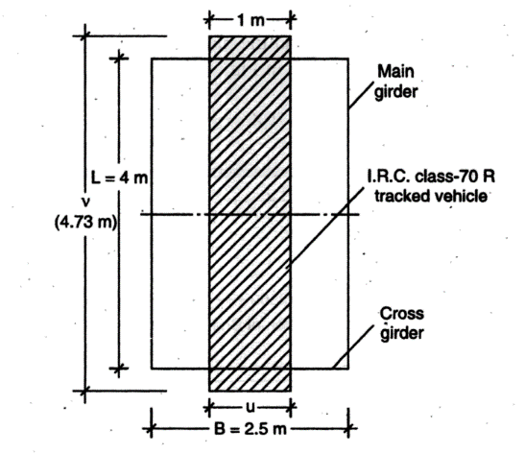

Fig: Position of wheel load for maximum moment

According to IRC:21-1987, minimum nominal cover = 30 mm

Using 12 mm diameter bars,

Effective depth = d = (250 - 30 - 6) = 214 mm

Adopt effective depth = d = 210 mm

For short span, As = [(28.13 × 10°)(200 × 0.91 × 210)] = 736 mm* Spacing of bars = s = (1000 × 113)/736 = 153.5 mm

Adopt 12 mm diameter HYSD bars at 150 mm centres

Мв = (24.95 + 3.18) = 28.13 kN-m

ML. = (10.10 +1.38) = 11.48 kN-m

(spacing of bars in slabs not to exceed 150 mm according to IRC:21 to control cracking).

Effective depth for long span using 10 mm diameter bars

= (210 - 6 - 5) = 199 mm

For long span, 1, = [(11.48 × 106)(200 × 0.91 × 199)] = 317 mm? a Spacing of bars = s = (1000 × 79)(317) = 249 mm

Adopt 10mm diameter bars at the maximum permissible spacing of 150 mm along the long span direction.

5. Design of Longitudinal Girders:

(a) Reaction Factors

Using Courbon's theory, the IRC Class 70 R tracked vehicle loads are arranged for maximum eccentricity as shown in Fig. 7.29. Reaction factor for outer girder A is given by

R, =

2w,

4

41 × 3.75 × 1.1

(21 × 3.75*) + (21 x1.25*)

= 0.764 W

If

W= axle load = 700 kN

W, = 0.5 W

R, = (0.764 × 0.5 M) = 0.382 W

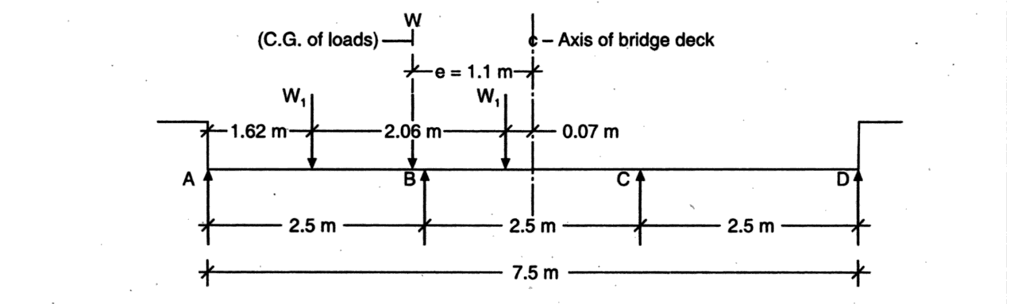

Fig: Transverse position of I.R.C. Class70R Tracked vehicle

(b) Dead Load from Slab per Girder

Dead load of deck slab is calculated with reference to Figure

Weight of

(1) Parapet railing (lumpsum) = 0.700 kN/m

(2) Kerb and Deck slab = (0.55 × 0.6 × 1 × 24) = 7.920 kN/m

Total Load = 8.620 kN/m

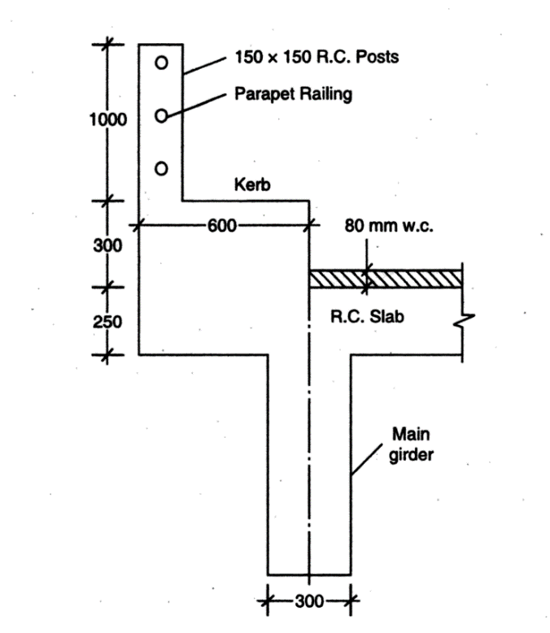

Fig: Details of Deck slab-Kerb and parapet

Total dead load of deck = [2 * 8.62) + (7.5 × 7.76)] = 75.44 KN/m

It is assumed that the dead load of deck is shared equally by all the four girders.

.. Dead load per girder = (75.44/4) = 18.86 kN/m

(c) Live load Bending Moment in Girder

Effective span of girder = 16 m

Impact factor (for Class 70 R loading) =10%

The live load is placed centrally on the span as shown in Fig. 7.31.

Total bending moment = 0.5 (4 + 2.86) 700 = 2401 kN•m

Bending moment including impact and reaction factors in outer girder A is computed as

M= (2401 × 1.01 × 0.382) = 1009 kN-m

(d) Dead Load Bending Moment in Girder-A

Overall depth of girder = 1600 mm

Depth of rib = (1600 - 250) = 1350 mm

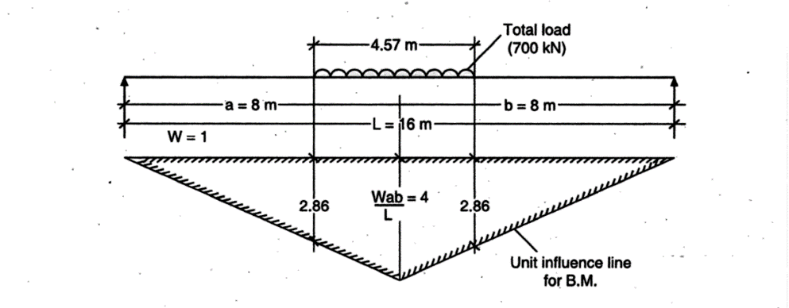

Fig. Influence Line for Bending Moment at Centre of Span of Girder.

Width of rib = 300 mm

Self weight of rib = (1 × 0.3 × 1.35 × 24) = 9.72 kN/m

The cross girder is assumed to have the same cross sectional dimensions of the main girder.

Weight of cross girder = 9.72 kN/m

Reaction on main girder = (9.72 × 2.5) = 24.3 kN

Reaction from deck slab on each girder = 18.86 kN/m

:. Total dead load on girder = (18.86 + 9.72) = 28.58 kN/m

R the maximum bending moment in the exterior girder A is computed as.,

Mmax = [928.58 * 16)/8] + [(24.3 x 16)/4] + [24.3 * 16)/4] = 1109 kN-m

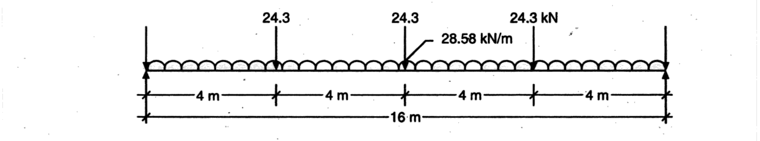

Fig. Dead Loads on Main Girder.

(e) Design Moments in Girder A

Dead load moment

Live load moment

Total design moment

= 1109 kN•m = 1009 kN•m = 2118 kN m

(f) Design of Reinforcements in Girder

The mind span section of girder is designed as a Tee section. Assuming an

effective cover of 150 mm, the effective depth of the main girder = d = 1450 mm

Approximate lever arm = (1450 - 250/2) = 1325 mm

1s = [(2118 x 10°)(200 x 1325)] = 7992 mm?

§rovide 12 bars of 32 mm diameter in 3 rows. (4s provided = 9648 mm₴)

The reinforcement details in the deck slab and the exterior girder 4 are shown in figure

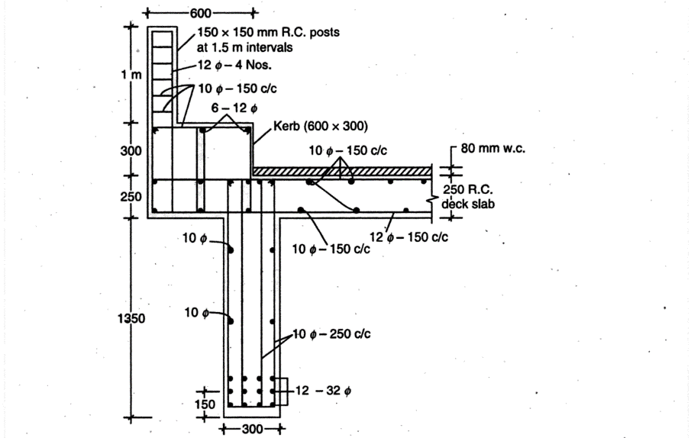

Fig: Cross section of Exterior Tee Beam and Slab

VALIDATION: STAADProVi8

BEAMS AND COLUMNS

BEAMS

COLUMNS

PLATE THICKNESS AND SUPPORTS

LOADS

MAXIMUM ABSOLUTE

BENDING MOMENT AND SHEAR FORCE

BENDING MOMENT

SHEAR FORCE

VEHICLE LOAD

CONCLUSION:

In conclusion, the comprehensive analysis of the T-beam deck slab bridge using both manual calculations and STAAD.Pro software validation has provided robust insights into its structural behavior and performance. The manual calculations allowed for a detailed understanding of the underlying principles and design parameters, while the STAAD.Pro validation ensured accuracy and reliability through computational verification. The synergy between manual and software-based approaches has underscored the bridge's structural integrity, highlighting its capacity to withstand various loading conditions and confirming its suitability for practical applications in transportation infrastructure projects. This combined methodology contributes to a thorough assessment of the T-beam deck slab bridge, facilitating informed decision-making and ensuring the safety and efficiency of the bridge design.

REFERENCES:

* Shreedhar, R., & Mamadapur, S. (2012). Analysis of T-beam bridge using finite element method. International Journal of Engineering and Innovative Technology (IJEIT), 2(3), 340-346.
* Vikas Gandhe, Pawan Patidar “Parametric Studies for Suitability of Steel Bridges, International Journal of Pure and Applied Research in Engineering and Technology, Volume 2 (9): 44-53.
* NK, P., & Hanumant, B. INTERNATIONAL JOURNAL OF ENGINEERING SCIENCES & RESEARCH TECHNOLOGY COMPARATIVE ANALYSIS OF T-BEAM BRIDGE BY RATIONAL METHOD AND STAAD PRO.
* Praful N K & Balaso Hanumant, Comparative Analysis Of T-Beam Bridge By Rational Method and Staad Pro, International Journal of Engineering Sciences & Research Technology, Vol. 4, No. 6, june 2015.
* Priya, Y. Y., & Sujatha, T. Comparative Analysis of Post Tensioned T-Beam Bridge Deck by Rational Method and Finite Element Method. International Journal of Research in IT, Management and Engineering, ISSN, 2249-1619.
* Verma, S., & Singh, G. J. (2017). Analysis and Design of Concrete T-beam Girder Bridge and Box Girder Bridge a Comparative Study.
* Prof. R.B. Lokhande ,Abrar Ahmed, “comparative analysis and design of t-beam and box girders,” International Research Journal of Engineering and Technology (IRJET) Volume: 04 Issue: 07 , eISSN: 2395-0056 | July -2017.
* Sanjay Tiwari & Pradeep Bhargava “Load Distribution Factors for Composite Multicell Box Girder Bridges” J. Inst. Eng. India Ser. A (December 2017) 98(4):483–492.
* Yogita Gupta, Suneet Kaur & Nitin Dindorkar “Bridge Failure Due to Inadequate Design of Bed Protection” J. Inst. Eng. India Ser. A (December 2017) 98(4):555–560.
* Neeraj Kumar “The effect of varying span on Design of Medium span Reinforced Concrete T-beam Bridge Deck”The International Journal of Engineering and Science Volume || 6 || Issue || 5 || Pages || PP 53- 56|| 2017 ||ISSN (e): 2319 – 1813 ISSN (p): 2319 – 1805.
* Haymanmyintmaung, kyawlinnhtat “Investigation of Integral Bridge Effect under Dynamic Loading” International Journal of Scientific and Research Publications, Volume 7, Issue 5, May 2017, ISSN 2250-315.
* Saibabu Sundru “Assessment of Replacement Bridge using Proof Load Test” J. Inst. Eng. India Ser. A (March 2018) 99(1):155–163.
* Siva, D. M. (2018). A Computational Approach of Prestressed Concrete Bridge Deck Slab Analysis for various IRC Classes of loadings using Pigeaud Charts. SSRG International Journal of Civil Engineering (SSRG-IJCE)–Volume, 5..
* Gawatre, D. W. (2018). Case Study on Design and Analysis of Simply Supported and Continuous Bridge-A Review.
* Sharu.E ,Nivedhitha M and Gowtham Raja M , “design of RCC t-beam bridge considering overloading due to congestion,” Indian J.Sci.Res. 17(2): 211 - 216, 2018.
* Jagdish Chand, Ravikant, “Design and Analysis of Bridge Girders using Different Codes”, International Journal of Engineering and Innovative Technology (IJEIT), ISSN: 2278-0181, Vol 8 Issue 07, July-2019.
* Hanwate, T., Gupta, S., Jain, S., & Scholar, P. G. (2021). Study on Interfacial Shear Properties of Concrete Reinforced Stone Arch Bridges Using Staad. pro A Review.
* Zain, M., Pandey, A. K., Varma, R., & Srivastava, R. K. (2022). Comparative analysis of T-Beam along with deck slab by Courbon’s method and STAAD. Pro. Materials Today: Proceedings, 56, 2261-2267.