**SMART MIRROR USING RASPBERRY PI**

Aseel Mukaddam (1), Kundan Jha (2), Harish Lodh (3), Anand Battula(4)

MRS NAMRATA KULKARNI

*1,2,3,4 Students, Electronics & TeleCommunication Engineering, Shree L.R. Tiwari College Of Engineering*

*5 Assistant Professor, Electronics & TeleCommunication Engineering, Shree L.R. Tiwari College Of Engineering*

**ABSTRACT**

Internet and mobile phones connect us more easily in the virtual world. Smart phones with the concept of Internet of things connect us to everyday objects. Intelligent mirrors with computations using microcontrollers and computer provides the information on the places located on the mirror. Smart mirror uses microcontroller cards and association with web for retrieving information from the web. This will be displayed on the mirror. The proposed smart mirror displays the information such as weather, date and time, calendar, captures picture from camera, multimedia information such as music, voice control and local news from the web. Rasberry pi 3 microcontroller is used as hardware to control the sensors and the smart mirror. This will act as brain of the interactive system and it is powered by python scripts for mirror software. Google assistant Application Programmable Interface is used as personal assistant for interacting with web. IFTTT – a free web service to access open source API’s for customizing Google assistant. The device looks like an ordinary mirror. It has screen inside that is capable to interact using voice commands and smart phone.

# INTRODUCTION

In today’s world, everyone needs comfort of life with the help of Technology. This acts as a motivation behind evolution of new advance technologies. Now a day, people want to be connected to each other ,require easy and fast access of information, keep themselves updated about the current affairs happening around the world. Internet of Things plays a major role for it. Internet of Things (IOT) describes the network of physical objects “things” that are embedded with sensors, software, and other technologies for connecting and exchanging data with other devices and systems over the internet. Enormous growth in the field of IOT in last few decades has transformed the human life and converted home to a smart home. Basic idea behind development of this work is to make our home a smart home by utilizing the most common thing in the home i.e. the mirror. Mirror is available in every home and everyone looks at it while going out. So, along with performing normal function of mirror of showing the image, if it can update the person with all basic information and latest news at a glance then the person will never lag behind the world.

The project looks like a ordinary mirror with a screen inside which is capable of interacting using voice commands and smart phone. It makes use of Rasberry pi 3 microcontroller. Rsapberry pi runs with raspbian Jessie pixel operating system. The proposed smart mirror displays date and time, current weather condition, reminders.

The smart mirror both in offline and online mode so the user will not be disconnected even if server goes down.

The limitation of the existing mirror is user must have an android mobile phone with application installed.

# PROBLEM STATEMENT

In a rapidly advancing technological landscape, people are increasingly seeking innovative ways to access and interact with real-time information in a seamless and personalized manner. Traditional mirrors offer only a reflective surface, lacking the capability to provide useful, dynamic, and customized information. The problem is the absence of a versatile, cost-effective, and aesthetically pleasing solution that integrates modern technology into a common household item, the mirror, to cater to various information and entertainment needs. This project aims to develop a smart mirror using a Raspberry Pi to address this issue. The smart mirror will serve as a multi-functional, interactive, and customizable platform that displays essential information, such as the time, date, weather, news, calendar events, and other user-defined content, while maintaining the primary function of a mirror. The challenge is to design and build a smart mirror that seamlessly integrates hardware, software, and aesthetics, allowing users to conveniently access information and entertainment in a user-friendly and appealing manner. Additionally, privacy and security concerns have been addressed, ensuring that sensitive information remains protected and private. The project's objectives include creating a smart mirror that is easy to set up, highly customizable, and capable of providing real-time data and user interactivity. It should be an innovative addition to daily life, offering both utility and entertainment while maintaining a sense of aesthetics and privacy. The project is cost-effective, accessible, and educational, inspiring others to explore the possibilities of combining technology and everyday objects. Ultimately, this smart mirror should enhance the way people interact with information, transforming a simple mirror into a modern and intelligent piece of home technology

# LITERATURE SURVEY

The literature survey for this project includes review many articles on smart mirror applications and classified based on their fields of application. The fields are General, Medical, Fashion, Academic and Sports fields. In papers [1] and [2], the authors have developed a smart mirror that acts as a personal assistant to solve the problem of lack of time that is faced by many people. It displays some general information like time, weather, news, etc. The users can read and reply emails, also view and edit daily schedules for multiple users. Users can also interact with the mirror using a graphical keyboard within the mirror. Whereas many features were added such as the Arduino Uno micro-controller with a Global System Module (GSM) to send emergency calls. The system also uses energy-saving sensors if there is no object near the device. As a result many tasks can be performed at the same time In[3], the authors have provided an interactive smart mirror using Ambient Intelligence (AMI) services encompass interactivity through multimodal user interfaces. The interface can understand and recognize surroundings in connect with IoT. The result of this system is an interactive mirror which is easy to use and adapt while performing daily tasks. In [4], the authors have designed a small low-cost smart mirror using a simple operating system with wide application range. The mirror is useful especially for us and it suits our needs. The users can display the weather, road traffic, news and their schedules. The system was developed using a Raspberry Pi. In [5], the authors have proposed a smart mirror that displays a calendar, weather, synchronized reminders and social media notifications. In addition, it detects if someone in front of it by using passive InfraRed (PIR) sensors and it supports a Wi-Fi to connect to the Internet. The users can interact with the mirror by using voice commands. In general, the mirror interaction method is useful for old and disabled people. In [6], the authors have focused on the problem of the user’s social emotion especially the negative emotions to improve it through the magic mirror. To analyze the user’s feeling, the mirror has four modes: mirror mode, alleviation mode, reminder mode and silent mode. Moreover, it supports identity recognition, facial expression and social emotion. Furthermore, in case of negative emotions appearance, the mirror displays positive words on the screen and runs the user’s favourite music to cheer them up. In general, the results showed that the system helped to improve and treat the bad mood of many users.

1. **PROPOSED SYSTEM**

We used Hardware Components like Raspberry pi, monitor, two way mirror, frame and Power supply and we used software components like Raspbian os, magic mirror software and different modules for weather, news, calendar etc. To setup the whole project we mounted monitor behind the two way mirror and attach the raspberry pi behind the mirror and secure it in frame. For configuration connect and power on and add sensors, microphone, camera. Then we tested different features and troubleshoot.

A smart mirror circuit using a Raspberry Pi typically involves connecting various components to the Raspberry Pi board. Here's a simplified overview:

1.Raspberry Pi: The central component that controls the smart mirror. It's usually powered by a micro USB cable.

2.Mirror: A regular mirror with a semi-transparent mirror film or a two-way mirror glass placed over a display.

3.Display: A monitor or a screen placed behind the mirror to show the digital content. It's connected to the Raspberry Pi via HDMI.

4.WiFi Dongle/Ethernet Cable: Provides internet connectivity to the Raspberry Pi for accessing online data, weather updates, news, etc.

5.Power Supply: Provides power to the Raspberry Pi and other components. Can be connected directly or via a power strip.

6. USB Peripherals: Keyboard, mouse, or any other USB devices for interaction with the Raspberry Pi.

* 1. **BLOCK DIAGRAM**

Figure shows the block diagram of proposed smart mirror. The mirror is an interaction device. This mirror displays the location based services such date, time, calendar, weather etc . The setup of home automations using Raspberry Pi 3 interacts with the user using voice enabled based assistant system It also displays the headlines of the news or weather forecast. It looks like a regular mirror but it has screen inside. Transmitted data managed in a centralized data base. A flat monitor is used for the displaying the information. The Smart Mirror contains several information; It is a simple webpage that contains an embedded browser in it. Once the mirror is invoked It automatically displays the information to the user like date, time and newsfeed etc., 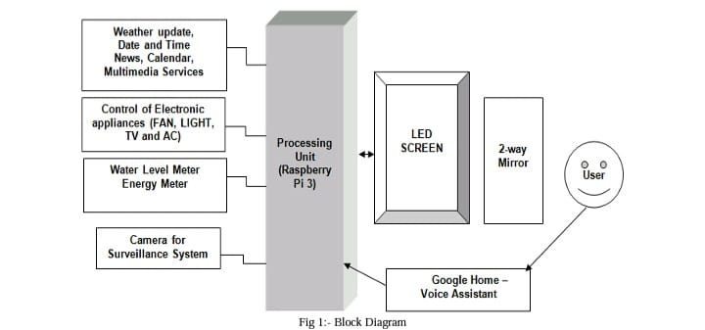Secondly mirror is triggered as per the

command to control the sensors and electronic appliances such as fan, light, AC and TV.DIY skills.

* 1. **CIRCUIT DIAGRAM**

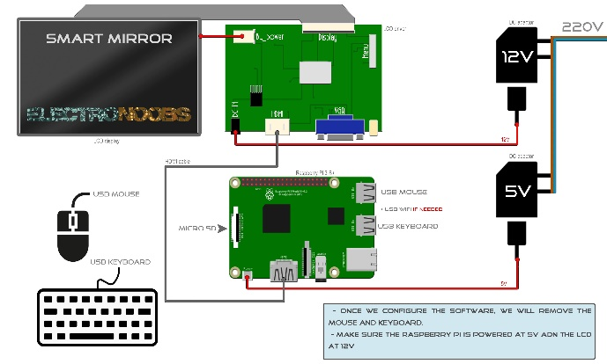

Connect the Raspberry Pi to the display:

Connect the HDMI output of the Raspberry Pi to the HDMI input of the display.

Connect the power source for the display to ensure it receives power.

Connect power sources.

Provide a power source to the Raspberry Pi. You can use a micro USB power supply.

Install the Raspberry Pi inside the frame or housing, ensuring it's secure and well-ventilated for cooling.

Mount the two-way mirror in front of the display, ensuring it fits properly within the frame.

Power on the Raspberry Pi and configure the software to display the desired information on the mirror's surface.

Connect the Raspberry Pi to the internet (via Ethernet or Wi-Fi) to keep the information up to date and access additional data for display.

1. **EXPECTED RESULT**

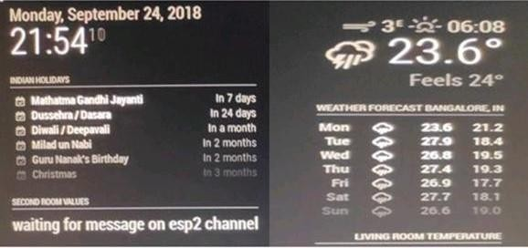

The above result shows that the smart mirror has many different features like Date, Time, Temperature, Upcoming Holidays, Weather Forecast, Mobile notification. Many more such different features can be added on the mirror with the help of different modules that we can download on Raspbian OS.

1. **CONCLUSION**

The proposed mirror provides home automation with IOT enabled. It has surveillance system for monitoring. It uses raspberry pi b+ for automation and displays the additional information such as weather, time, date, calendar, news update etc. During the development, few limitations are identified: if the Internet connection is down, the system won’t be able to continue the connectivity and the data won’t be stored in the database. Data transaction may disconnect when the server goes down. It’s an open source, security is needed. In order to provide security the proposed system may be implemented using microchip AVR Microchip Technology. AC164160 AVR-IoT WG Evaluation Board is to provide IoT with sensor node solutions. It can interface with smart modules to reduce the complex algorithm. It consists of cryptographic coprocessor chip to store private keys, validate the firmware, and offer a secure boot process for the device. It establishes a secure connection to the Google Cloud IoT. This secure connection is achieved by using JSON Web Token to authenticate the device.

1. **REFRENCES**

[1]. Prakash Prasad , Mansi Nimie, Smart Mirror Using Raspberry Pi, May 2021.

[2]. Mrs. V. Jyothi, Mr .Kota Shiva Kumar ,Design and implementation of smart mirror, 2021.

[3]. Bhuvaneswari T, Aishwarya C, Aishwarya H A, Smart Mirror using Raspberry Pi 2020.

[4]. Lakshmi NM ,Ishwarya P ,IoT based Smart Mirror, 2018.

.[5]. K. S. M. Vinay Sagar KN ,Home Automation Using Internet of Things, International Research Journal of Engineering and Technology, 2(3), 2015,1965-1970.