**Versatility of Curry Leaves: From Kitchen to Medicine**

**Raut Vaishnavi V.1, Tandale Prashant S.2, Garje Sanjay Y.2, Sayyed Gaffar A.3**

1. Student, SAJVPM’s College of Pharmaceutical Science and Research Center Kada, Maharashtra, India.

2. Professor, SAJVPM’s College of Pharmaceutical Science and Research Center Kada, Maharashtra, India.

3. Principle, SAJVPM’s College of Pharmaceutical Science and Research Center Kada, Maharashtra, India.

(prof.tandale@gmail.com)

**ABSTRACT:**

This review explores the pharmacognostical, phytochemical, and pharmacological studies of Murraya koenigii, also known as curry leaf, an Indian plant with diverse medicinal, culinary, and industrial uses. The study focuses on its leaves, stem, bark, and oil, identifying various phytochemical components in curry leaf powder. Murraya koenigii, a member of the Rutaceae family, is significant in traditional Indian medicine, particularly in Ayurveda, due to its abundant carbazole alkaloids. Despite its significance, curry leaves are often discarded from dishes without tasting them. The ritual of adding chopped onion and curry leaf to sizzling mustard seeds in hot oil is a quintessential step in South Indian cuisine. Despite their significance, their health benefits remain largely unrecognized. This article delves into the numerous health benefits of curry leaves and their significance beyond taste in daily life.

**Keywords:-**

Murraya koenigii, Curry leaf, Pharmacological Studies

**Introduction:**

Currently, a significant portion of individuals in developing nations rely on botanical resources for healthcare, skincare, economic gains, and cultural enrichment. Traditional medicinal plants have been integral to healing practices across various regions, including India, China, Germany, Thailand, among others. The World Health Organization (WHO) estimates that 80% of the global population utilizes traditional medicine, evident from the $19.4 billion global revenue generated by herbal remedies in 2010. Furthermore, there is a growing demand for traditional medicinal plants, with India experiencing a 20% annual market expansion and China attributing 30% to 50% of its medicinal consumption to traditional medicine. In Thailand, approximately 76.7% of the populace primarily resort to traditional herbal medicine for healthcare needs, while in Germany, natural remedies are preferred by 90% of the population for specific health concerns. Thus, the significance of medicinal plants in traditional medicine is evident across both developing and industrialized nations, as underscored by the expanding global market for traditional medicine.

Murraya koenigii, commonly known as Curry Leaves/Kadhi Patta/Mitha Nimba/Giri Nimba, is a highly valued medicinal herb extensively used as a spice and condiment in India. It holds a significant place in Indian cuisine due to its distinct flavor and is a staple in everyday cooking. Curry leaves are rich in essential nutrients such as carbohydrates, proteins, fibers, calcium, phosphorus, iron, magnesium, copper, as well as vitamins like nicotinic acid, B, C, A, and E, along with antioxidants, plant sterols, glycosides, and flavonoids. The oil derived from curry leaves is applied externally for treating bruises and skin eruptions and is also utilized in the soap and perfume industries. Various alkaloids and phytoconstituents, including mahanine, koenine, koenigine, girinimbiol, and others, have been isolated from the leaves, contributing to its medicinal properties.

In traditional medicine, M. koenigii is revered for its tonic and stomachic attributes. The bark and roots are employed as stimulants and for treating skin eruptions and bites from venomous animals. Consumption of raw curry leaves aids in managing conditions like dysentery, diarrhea, and vomiting. Additionally, the leaves and roots are traditionally used as bitter tonics, anthelmintics, and analgesics, addressing ailments such as piles, inflammation, itching, leucoderma, and blood disorders.

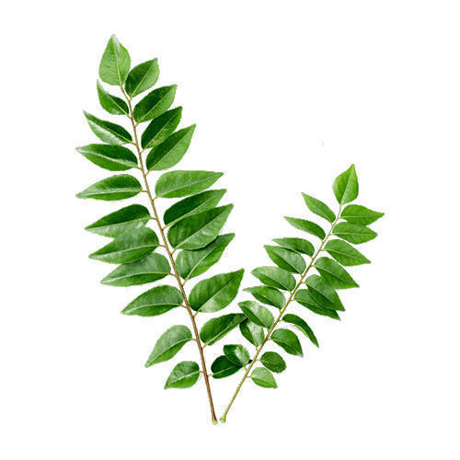

**Fig.1: Curry leaves**

**Taxonomical**

**Classification:-**

Kingdom: Plantae

Subkingdom: Tracheobionta

Division: Magnoliophyta

Class: Magnoliopsida

Subclass: Rosidae

Order: Sapindales

Family: Rutaceae

Genus: Murraya

Species: koenigii

**Synonyms for curry leaves:-**

1. English: Curry leaves

2. Hindi: कढ़ी पत्ता (Kadhi patta)

3. French: Feuilles de curry

4. Spanish: Hojas de curry

5. German: Curryblätter

6. Italian: Foglie di curry

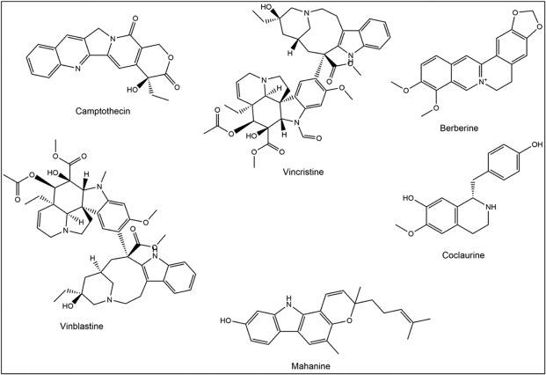**Fig.2:** Structure of chemicals in curry leaves

**Table1: Chemical constituents in curry leaves with their uses:-**

|  |  |  |  |
| --- | --- | --- | --- |
| Sr.no. | Chemical constituents | Examples | Uses |
| 1 | Carbazole Alkaloids | murrayanine, mahanine, koenine, and girinimbin | Antioxidant, anti-inflammatory, and anti-cancer properties. |
| 2 | Flavonoids | quercetin, kaempferol, and rutin | Antioxidant and anti-inflammatory effects, and may help in managing diabetes and cardiovascular diseases. |
| 3 | Essential Oils | limonene, β-caryophyllene, α-pinene, and β-pinene | Give curry leaves their characteristic aroma and flavor, and may have antimicrobial and anti-inflammatory properties. |
| 4 | Tannins | ellagitannins, gallic acid, corilagin | Treating diarrhea and dysentery. |
| 5 | Phenolic Compounds | caffeic acid | Antioxidant and anti-inflammatory properties. |

**Traditional Uses:**

As a member of the citrus family, curry leaves boast a potent, aromatic flavour reminiscent of lemongrass. Utilized as an herb, curry leaves offer a nuanced taste profile distinct from curry powder, imparting a rich complexity to culinary creations. Historically, the bark and roots have been employed externally to remedy bites from venomous creatures, while the consumption of raw leaves was believed to alleviate dysentery and diarrhoea. Additionally, infusions of roasted leaves were administered to curb vomiting. Moreover, Murraya koenigii served as a blood purifier, tonic, and remedy for stomachaches, doubling as a flavour enhancer in curries and chutneys.

**Plant Description and Habitat:**

This plant thrives throughout India and can be found in the wild from the Himalayas to regions such as Uttarakhand, Sikkim, Garhwal, Bengal, Assam, Western Ghats, and Travancore-Cochin. Propagation occurs primarily through seeds, which readily germinate under partial shade. It is also present in other parts of the Asian region, including moist forests ranging from 500 to 1600 meters in height in Guangdong, South Hainan, South Yunnan (Xishuangbanna), Bhutan, Laos, Nepal, Pakistan, Sri Lanka, Thailand, and Vietnam. Introduced to Malaysia, South Africa, and Réunion Island alongside South Indian immigrants, curry leaves remain scarce outside the Indian cultural sphere. Murraya koenigii manifests as an unarmed, semi-deciduous aromatic shrub or small tree with a slender yet sturdy woody stem and branches enveloped in dark grey bark. Its imparipinnate, glabrous leaves, composed of 9-25 or more short-stalked leaflets, are arranged alternately, dotted with glands, and exude a potent aroma.

**Morphological Characteristics:**

Murraya koenigii presents as a small, spreading shrub reaching approximately 2.5 meters in height, with a stem ranging from dark green to brownish in color. When the bark is peeled longitudinally, the white wood beneath becomes visible. The main stem boasts a diameter of around 16cm. Each leaf spans about 30cm in length and bears 24 leaflets, exhibiting reticulate venation. The flowers, characterized by their white, funnel-shaped appearance, emit a sweet aroma and have an average fully opened diameter of 1.12cm. They are bisexual in nature. The fruits, which vary in shape from round to oblong, measure between 1.4 to 1.6cm in length and 1 to 1.2cm in diameter. Upon ripening, the fruits turn black with a shiny surface, while the pulp adopts a wisteria blue hue. The seeds are spinach green, measuring approximately 11mm in 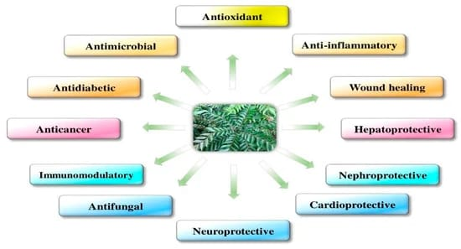length and weighing about 445mg**.**

**Fig.3: Pharmacological activities of curry leaves**

**Pharmacological Activity of Murraya koenigii:**

Antimicrobial Activity:

The hexane, methanol, and chloroform extracts from Murraya koenigii root were evaluated against various bacterial strains including Bacillus subtilis, Staphylococcus aureus, Escherichia coli, Salmonella typhi, as well as fungal strains like Aspergillus niger, Candida albicans, and Trichophyton rubrum. All three extracts demonstrated effectiveness against the tested strains, with the methanol extract exhibiting the most significant antimicrobial activity. Notably, it displayed maximum inhibitory effects against Staphylococcus aureus and Trichophyton rubrum. Staphylococcus aureus was susceptible to all three extracts, whereas the aqueous extract showed limited efficacy against the tested microorganisms.

Antipyretic Activity:

In fevered rats induced by the parenteral administration of 10mg/kg of brewer's yeast, the ethanol extract of Murraya koenigii leaves demonstrated antipyretic activity compared to the petroleum ether and chloroform extracts, with efficacy comparable to that of a paracetamol dose.

Hypoglycemic Effects:

Treatment with aqueous and methanolic extracts of Murraya koenigii leaves led to a decrease in plasma glucose levels in alloxon-induced rats.

Anti-inflammatory Activity:

Ethanol, petroleum ether, and chloroform extracts from Murraya koenigii leaves were evaluated for their anti-inflammatory effects. The ethanolic extract, administered orally at a dose of 250mg/kg, demonstrated significant reduction in carrageenan-induced paw edema in Albino rats of the Wistar strain compared to the other solvent extracts**.**

**Side Effects:**

1. Potential Allergic Reactions:

Individuals with allergies to curry leaves should refrain from using them altogether. Symptoms such as itching, redness, or swelling after using curry leaves warrant immediate medical attention.

2. Risk of Digestive Issues:

While the high fiber content in curry leaves can be beneficial for digestion, excessive consumption may lead to digestive upset. Symptoms such as bloating, diarrhea, stomach cramps, and constipation may occur.

3. Possible Hypotension:

Overconsumption of curry leaves may result in low blood pressure due to their active iron compound. While iron is essential for the body, excessive intake can have adverse effects in the long term. It is advisable to consume curry leaves in moderation to avoid this potential side effect.

4. Risk of Water Retention:

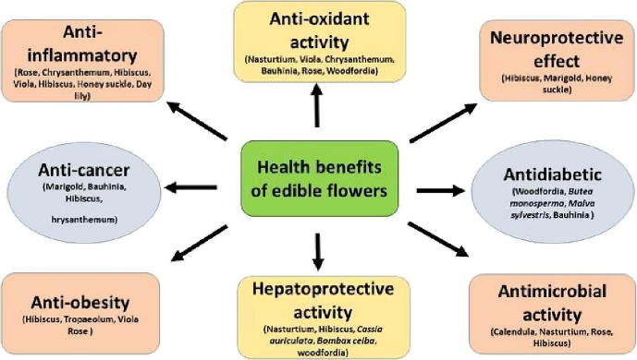Curry leaves are rich in sodium, and excessive sodium intake can lead to bloating and water retention, potentially causing weight gain. To mitigate this risk, it is advisable to consume curry leaves in moderation.

**Fig.4: Beneficial activities of curry leaves**

**Benefits:-**

**Antifungal Activity:**

Numerous studies have reported the antifungal properties of M. koenigii. For instance, research has shown that the essential oil extracted from the leaves exhibits significant antifungal activity. This activity is attributed to the presence of various phytochemicals, such as alkaloids, terpenoids, flavonoids, phenolics, tannins, and saponins, known for their antimicrobial properties. Traditional use of curry leaves as an antifungal agent finds support in these investigations. In vitro studies have demonstrated the effectiveness of M. koenigii against a range of pathogenic fungi, including Penicillium notatum, Aspergillus flavus, Aspergillus niger, and others.

**Antibacterial Activity:**

Amid concerns about antibiotic resistance, interest in alternative antimicrobial agents, including herbal medicines like M. koenigii extracts, is growing. Methanol and ethanol extracts from M. koenigii leaves have shown effectiveness against bacterial strains such as Escherichia coli, Staphylococcus, Streptococcus, and Proteus. Additionally, compounds isolated from M. koenigii, such as pyranocarbazoles and green-synthesized silver nanoparticles, demonstrate antibacterial properties against multidrug-resistant bacteria. Moreover, M. koenigii essential oil exhibits antibiofilm activity against Pseudomonas aeruginosa, a common pathogen in biofilm-related infections.

**Hepatoprotective Effect:**

Liver diseases pose significant challenges, and herbal medicines like M. koenigii are being explored for their hepatoprotective properties. Studies have shown that M. koenigii extracts can protect against ethanol-induced hepatotoxicity by maintaining enzymatic antioxidant levels and cellular integrity. Additionally, carbazole alkaloids and tannins from M. koenigii have demonstrated hepatoprotective activity against ethanol-induced liver damage.

**Immunomodulatory Activity:**

The immunomodulatory potential of M. koenigii extracts has been investigated, showing promise in stimulating humoral immunity and enhancing phagocytic function. These extracts also exhibit effects on oxidative stress metabolism, further highlighting their potential as immunomodulatory agents.

**Nephroprotective Activity:**

M. koenigii has shown nephroprotective properties in experimental models, maintaining normal levels of renal markers and antioxidant activity. Additionally, it demonstrates efficacy against nephrotoxicity induced by agents like cyclophosphamide, highlighting its potential in kidney disorder management.

**Antidiabetic Activity:**

In the management of diabetes mellitus, M. koenigii has demonstrated inhibitory effects on enzymes like aldose reductase and α-glucosidase, contributing to its antidiabetic properties. Moreover, its antioxidant and insulin mimetic effects help reduce blood glucose levels, indicating its potential in diabetes management.

**Anticancer Activity (In Vivo and In Vitro):**

M. koenigii contains secondary metabolites with potential anticancer properties, as evidenced by studies showing cytotoxic activity against various cancer cell lines. Compounds like mahanine and girinimbine demonstrate growth inhibitory effects on cancer cells, suggesting their potential as anticancer agents. Additionally, leaf extracts of M. koenigii contain compounds like rutin, quercetin, kaempferol, and apigenin, which inhibit endogenous proteasome activity in cancer cells

**Neuroprotective Effects:**

Supplementation with extracts from M. koenigii leaves has been shown to assist in managing various neurodegenerative conditions, including Alzheimer's disease (AD), Parkinson's disease (PD), and others. M. koenigii exhibits potential neuroprotective properties against orofacial dyskinesia induced by reserpine. Moreover, it stabilizes levels of protective antioxidant enzymes like SOD, catalase (CAT), and GSH, while inhibiting lipid peroxidation (LPO) in the forebrain regions of reserpine-treated animals. Additionally, it has been demonstrated to significantly alleviate reserpine-induced behavioral abnormalities. ILF attenuated cytotoxicity, oxidative stress, and mitochondrial dysfunction in SH-SY5Y cells, downregulating the expression of Bax and caspases-3, -6, -8, and -9, while upregulating Bcl-2 expression. ILF was also found to regulate expressions of p-P13K, p-AKT, and p-GSK-3 beta. Preclinical studies have indicated that M. koenigii leaves could enhance memory in rats. The potential neuroprotective effects of the methanolic extract of M. koenigii leaves were demonstrated in a rat model of partial global cerebral ischemia induced by two-vessel occlusion. Test findings indicated that M. koenigii leaves positively impacted memory and learning impairments. M. koenigii leaf extracts also modestly improved memory in rats with chronic partial global cerebral ischemia.

**Radioprotective and Chemoprotective Effects:**

A methanolic extract of M. koenigii has shown protective effects against chromosomal damage caused by radiation and cyclophosphamide in vivo. Radiation leads to an increase in various aberrations, such as chromatid fragmentation and chromosomal breakages, rings, and dicentrics. Treatment with a methanolic extract of M. koenigii before radiation significantly reduced these aberrations. M. koenigii can significantly protect bone marrow against radiation and cyclophosphamide.

**Wound Healing Properties:**

Wound healing involves numerous biochemical and cellular processes that aid in the restoration of functional and anatomical continuity. M. koenigii leaves promote wound healing in male albino rats by significantly enhancing wound contraction and reducing epithelialization, supporting collagen synthesis as evidenced in histopathological studies.

**Conclusion:-**

The review paper highlights the multifaceted benefits and applications of curry leaves (Murraya koenigii) across various fields including culinary, traditional medicine, and industrial sectors. Through a comprehensive examination of scientific literature and traditional knowledge, it is evident that curry leaves possess a rich phytochemical profile consisting of antioxidants, flavonoids, alkaloids, and essential oils, which contribute to their diverse pharmacological activities.

From a culinary perspective, curry leaves add a unique flavor and aroma to dishes, while their traditional medicinal uses range from digestive aid to diabetes management and skincare. Moreover, the industrial applications of curry leaves, including essential oil production, pharmaceutical research, and cosmetic formulations, underscore their potential as valuable ingredients in diverse products.

While further research is warranted to explore the full therapeutic potential of curry leaves and their constituents, the existing evidence supports their inclusion in dietary, medicinal, and industrial contexts. Overall, curry leaves emerge as a versatile botanical with promising prospects for enhancing health, flavor, and fragrance across various domains.

**References:-**

1. Kumar S.R, Loveleena D, Godwin S., Medicinal property of Murraya koenigii- a review, International Research Journal of Biological Sciences., 2013, 2(9), 80-83.

2. Saini S.C, Reddy G.B.S., Murraya koenigii, Journal of Pharmacy and Biological Sciences., 2013, 7(6), 15-18

3. Sindhu R.K, Arora S., Evaluation of phenolic contents and antioxidant potential of Murraya koenigii (L) spreng roots, Journal of Applied Pharmaceutical Science., 2012, 2(11), 120-122.

4. An update on Murraya koenigii S: a multifunctional Ayurvedic herb. Journal of Chinese integrative medicine. 2012; 9(8):824- 833.

5. Raghunathan K, Mitra R, Pharmacognosy of Indigenous Drugs, Central Council for Research in Ayurveda and Siddha, New Delhi, Vol. I: 433.

6. Jain V, Momin M, Laddha K., Murraya Koenigii: An Updated Review, International Journal of Ayurvedic and Herbal Medicine, 2012, 2(4), 607-627.

7. Singh S, More PK, Mohan SM., Curry leaves (Murraya koenigii Linn. Sprengal)-a mircale plant, Indian Journal of Scientific Research., 2014, 4(1), 46-52.

8. Ganesan P, Phaiphan A, Murugan Y, Baharin B.S., Comparative study of bioactive compounds in curry and coriander leaves: An update, Journal of Chemical and Pharmaceutical Research., 2013, 5(11), 590- 594

9. Tan S.P, Nafiah M.A, Ahmad K., C23- carbazole alkaloids from Malayan Murraya koenigii (L.) spreng. Journal of Chemical and Pharmaceutical Research. 2014, 6(4), 1093-1098.

10. Malwal M, Sarin R., Antimicrobial efficacy of Murraya koenigii (Linn.)Spreng.root extracts, Indian Journal of Natural Products and Resources. 2011, 2(1), 48-51.

11.   Kluytmans J, van Belkum A, Verbrugh H (July 1997). Nasal carriage of Staphylococcus aureus: epidemiology, underlying mechanisms, and associated risks. Clinical Microbiology Reviews. 10 (3): 505–520.

12.   Tong SY, Davis JS, Eichenberger E, Holland TL, Fowler VG (July 2015). Staphylococcus aureus infections: epidemiology, pathophysiology, clinical manifestations, and management. Clinical Microbiology Reviews. 28 (3): 603–661

13.   Cole AM, Tahk S, Oren A, Yoshioka D, Kim YH, Park A, Ganz T (November 2001). Determinants of *Staphylococcus aureus* nasal carriage. Clinical and Diagnostic Laboratory Immunology. 8 (6): 1064–1069.

14.   Senok AC, Verstraelen H, Temmerman M, Botta GA. Probiotics for the treatment of bacterial vaginosis". The Cochrane Database of Systematic Reviews. 2009; 10(4): CD006289.

15.   Hoffman B. Williams Gynecology (2nd Ed.). New York: McGraw-Hill Medical. 2012; 65

16.   MedlinePlus [Internet]. Bethesda, MD: National Library of Medicine, US. Skin infections are the most common. They can look like pimples or boils.

17.   Bowersox J (27 May 1999). Experimental Staph Vaccine Broadly Protective in Animal Studies. NIH. Archived from the original on 5 May 2007. Retrieved 28 July 2007.

18.   Schlecht LM, Peters BM, Krom BP, Freiberg JA, Hänsch GM, Filler SG, et al. Systemic Staphylococcus aureus infection mediated by Candida albicans hyphal invasion of mucosal tissue. Microbiology. 2015; 161 (Pt 1): 168–181.

19.   Curran JP, Al-Salihi FL. Neonatal staphylococcal scalded skin syndrome: massive outbreak due to an unusual phage type". Pediatrics. 1980; 66 (2): 285–290

20.   Sing a, Tuschak C, Hörmansdorfer S. Methicillin-resistant *Staphylococcus aureus* in a family and its pet cat. The New England Journal of Medicine. 2008; 358 (11): 1200–1201

21. Jain V., Momin M., Laddha K. Murraya koenigii: an updated review. International Journal of Ayurvedic and Herbal Medicine*.*2012; 2:607–627. [[Google Scholar](https://scholar.google.com/scholar_lookup?journal=International+Journal+of+Ayurvedic+and+Herbal+Medicine&title=Murraya+koenigii:+an+updated+review&author=V.+Jain&author=M.+Momin&author=K.+Laddha&volume=2&publication_year=2012&pages=607-627&)]

22. Saha C., Chowdhury B. K. Carbazoloquinones from murraya koenigii. Phytochemistry*.*1998; 48(2):363–366. doi: 10.1016/s0031-9422(97)01135-7.

23. Fiebig M., Pezzuto J. M., Soejarto D. D., Kinghorn A. D. Koenoline, a further cytotoxic carbazole alkaloid from Murraya koenigii. Phytochemistry*.*1985; 24(12):3041–3043. doi: 10.1016/0031-9422(85)80052-2.

24. Tachibana Y., Kikuzaki H., Lajis N. H., Nakatani N. Comparison of antioxidative properties of carbazole alkaloids from Murraya koenigii leaves. Journal of Agricultural and Food Chemistry*.*2003; 51(22):6461–6467. doi: 10.1021/jf034700+.

25. Rajendran M. P., Pallaiyan B. B., Selvaraj N. Chemical composition, antibacterial and antioxidant profile of essential oil from Murraya koenigii (L.) leaves. International Journal of Pharmacy and Pharmaceutical Sciences*.*2014; 4:200–214.

26. Ghasemzadeh A., Jaafar H. Z. E., Rahmat A., Devarajan T. Evaluation of bioactive compounds, pharmaceutical quality, and anticancer activity of curry leaf (murraya koenigii L.) Evidence-Based Complementary and Alternative Medicine*.*2014; 2014:8. doi: 10.1155/2014/873803.873803.

27. Sakunpak A., Matsunami K., Otsuka H., et al. Isolation of new monoterpene coumarins from Micromelum minutum leaves and their cytotoxic activity against leishmania major and cancer cells. Food Chemistry*.*2013; 139(1–4):458–463.

28. Lekphrom R., Kanokmedhakul K., Sangsopha W., Kanokmedhakul S. A new coumarin from the roots of Micromelum minutum. Natural Product Research*.*2016; 30(21):2383–2388.

29. Lekphrom R., Kanokmedhakul S., Kukongviriyapan V., Kanokmedhakul K. C-7 oxygenated coumarins from the fruits of micromelum minutum. Archives of Pharmacal Research*.*2011; 34(4):527–531. doi: 10.1007/s12272-011-0402-y.

30. Kamkaen N., Ruangrangsi N. Chemical compositions and antimicrobial activities of essential oils from Micromelum minutum. Thailand Journal of Health Research*.*2003; 17:148–153.