**E-Commerce Website**

**Bhargi Patel1, Kevin Shah2**

1Dept. Of Computer Science & Engineering, Parul University, India.

**ABSTRACT**

In the realm of digital commerce, an e-commerce website serves as a virtual marketplace where businesses can effectively showcase and vend their products and services. The proliferation of the internet has given rise to a multitude of e-commerce websites, as enterprises increasingly recognize the significance of establishing an online presence to extend their reach to a wider audience. These websites encompass a diverse range of features, encompassing comprehensive product catalogs, user-friendly shopping carts, secure payment gateways, and streamlined order management systems. Additionally, they empower customers by providing them with the ability to search for and compare products, peruse product reviews, and make well-informed purchasing decisions. E-commerce websites have become an indispensable tool for businesses aiming to expand their customer base and enhance sales, offering unparalleled convenience, accessibility, and a tailored shopping experience.

**Keywords:** E-commerce, Marketplace, Features , Business Growth , Shopping

1. **INTRODUCTION**

The purpose of this project is to develop a web-based shopping system for an existing shop. The main objective is to create an online shopping application using HTML, CSS, JavaScript, and PHP. The aim is to offer the benefits of online shopping to customers who usually visit the physical store. By utilizing a website, customers will be able to purchase products from the shop conveniently through the internet. This system can be implemented in any local shop or even in multinational branded shops with retail outlet chains. By providing an online portal, shops can prevent losing customers to popular online platforms like Amazon, Flipkart or eBay.

1. **METHODOLOGY**

**Software Development Life Cycle (SDLC): -**

A software development life cycle (SDLC) model serves as a conceptual framework that outlines the various activities involved in a software development project, starting from the planning phase and extending to maintenance. This approach encompasses multiple models, each encompassing a range of tasks and activities.

**Type of SDLC: -**

1. Waterfall Model

2. RAD Model

3. Spiral Model

4. Incremental Model

5. Iterative Model

6. Agile Model

7. V-Model

* Iterative Model

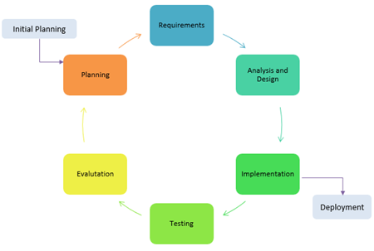

* In the Iterative model, the iterative process starts with a simple implementation of a small set of the software requirements and iteratively enhances the evolving versions until the complete system is implemented and ready to be deployed. An iterative life cycle model does not attempt to start with a full specification of requirements. Instead, development begins by specifying and implementing just part of the software, which is then reviewed to identify further requirements. This process is then repeated, producing a new version of the software at the end of each iteration of the model.

**SDLC framework includes the following steps: -**

**SCOPING AND PLANNING:**

* **Scoping:**
* Business goals: Identify the business goals for the e-commerce website, such as increasing sales, expanding customer reach, improving customer experience, or launching a new product line.
* Target audience: Define the target audience for the website, including demographics, psychographics, and buyer personas.
* Competitor analysis: Conduct a competitive analysis to identify the strengths and weaknesses of your competitors' e-commerce websites.
* Functional requirements: Identify the functional requirements of the e-commerce website, such as product catalog, shopping cart, payment gateway, shipping options, and customer service.
* Technical requirements: Determine the technical requirements of the website, such as platform, hosting, security, and performance.
* Content strategy: Create a content strategy that aligns with the business goals and target audience, including product descriptions, blog posts, social media content, and email marketing.
* **Planning:**
* **Website structure:** Develop a website structure that is user-friendly and easy to navigate. This should include a homepage, product pages, category pages, shopping cart, checkout page, and contact page.
* **Design:** Create a visually appealing design that reflects the brand's identity and resonates with the target audience.
* **Platform:** Select an e-commerce platform that meets the technical requirements and supports the functional requirements of the website.
* **Hosting:** Choose a reliable hosting provider that ensures website uptime and fast loading speed.
* **Security:** Implement security measures to protect customer data, such as SSL certificate, two-factor authentication, and encryption.
* **Payment gateway:** Integrate a secure and reliable payment gateway that supports multiple payment options and is compliant with PCI DSS standards.
* **Shipping options:** Offer a range of shipping options, such as standard, express, and international shipping, and provide real-time tracking information. Customer service: Provide excellent customer service, including a help desk, live chat, and email support.
* **Marketing:** Develop a marketing plan that includes SEO, social media, email marketing, and paid advertising to attract and retain customers.
* **Analytics:** Set up website analytics to track key performance indicators, such as website traffic and many more.

**CONCEPTUAL DESIGN AND RESEARCH: -**

* **User Experience:** The success of an e-commerce website relies heavily on the user experience (UX). To ensure a positive UX, it is important to have a website that is easy to navigate, with clear categories and product pages that provide all the necessary information for customers to make informed decisions. Consider incorporating search and filtering functionality to help customers quickly find what they are looking for.
* **Visual Design:** The visual design of your website plays a crucial role as it is the first thing customers see when they visit your site. Choose a visually appealing design that reflects your brand, while still being easy to read and navigate.
* **Product Catalog:** Organize your product catalog in a user-friendly manner, making it easy for customers to browse. Each product listing should include clear images, detailed descriptions, pricing information, and any other relevant details. Consider including customer reviews and ratings to build trust with potential customers.
* **Shopping Cart and Checkout:** Streamline the shopping cart and checkout process to make it as user-friendly as possible. Enable customers to easily add items to their cart, view their cart, and complete the checkout process. Additionally, consider offering a guest checkout option for customers who prefer not to create an account.
* **Payment and Security:** Ensure that your e-commerce website has a secure payment gateway that supports various payment options and is easy to use. It is essential to have SSL certification and encrypt customer information to protect against fraud and data breaches.
* **Shipping and Returns:** Clearly communicate your shipping and return policies, providing detailed information about shipping options and costs. Consider offering free shipping for larger orders or for customers who subscribe to your newsletter.
* **Customer Service:** Provide excellent customer service by offering multiple channels for customers to contact you, such as email, phone, or live chat. Consider including an FAQ section on your website to address common customer questions.

**Development Of Methodology**

1. **Research and Analysis**

* Identify the target audience and their preferences.
* Analyze competitors' e-commerce platforms to understand industry trends and best practices.
* Conduct market research to identify niche opportunities and customer pain points.

1. **Planning and Strategy**

* Define project scope, objectives, and success criteria.
* Create a project plan with clear timelines, milestones, and resource allocation.
* Establish a budget and allocate resources for design, development, and marketing.

1. **User Experience (**UX**) Design**

* Develop user personas to understand the needs and behaviors of potential customers.
* Create wireframes and prototypes to visualize the website's layout, navigation, and user flow.
* Design the user interface (UI) to ensure a seamless and intuitive shopping experience across devices.

1. **Technology and Platform Selection**

* Choose an appropriate e-commerce platform (e.g., Shopify, WooCommerce, Magento) based on the project requirements and scalability.
* Select suitable technologies for front-end and back-end development, ensuring security and performance.

1. **Website Development**

* Develop the front-end of the website, focusing on responsive design, fast loading times, and intuitive navigation.
* Implement the back-end infrastructure for secure transactions, user account management, and inventory management.
* Integrate essential e-commerce features such as payment gateways, shipping options, and inventory tracking.

1. **Testing and Quality Assurance**

* Conduct rigorous testing for functionality, usability, and security.
* Perform user acceptance testing to gather feedback and identify areas for improvement.
* Ensure compatibility across various devices, browsers, and operating systems.

1. **Launch and Deployment**

* Prepare the website for launch by ensuring all components are ready and operational.
* Set up hosting, domain registration, and SSL certification for secure transactions.
* Create a marketing strategy to generate initial traffic and attract potential customers.

1. **Maintenance and Optimization**

* Implement a system for monitoring website performance, user behavior, and sales metrics.
* Provide ongoing support, maintenance, and updates to address any issues and keep the website up to date.
* Use analytics tools to gather insights and optimize the website for improved conversion rates and user satisfaction.

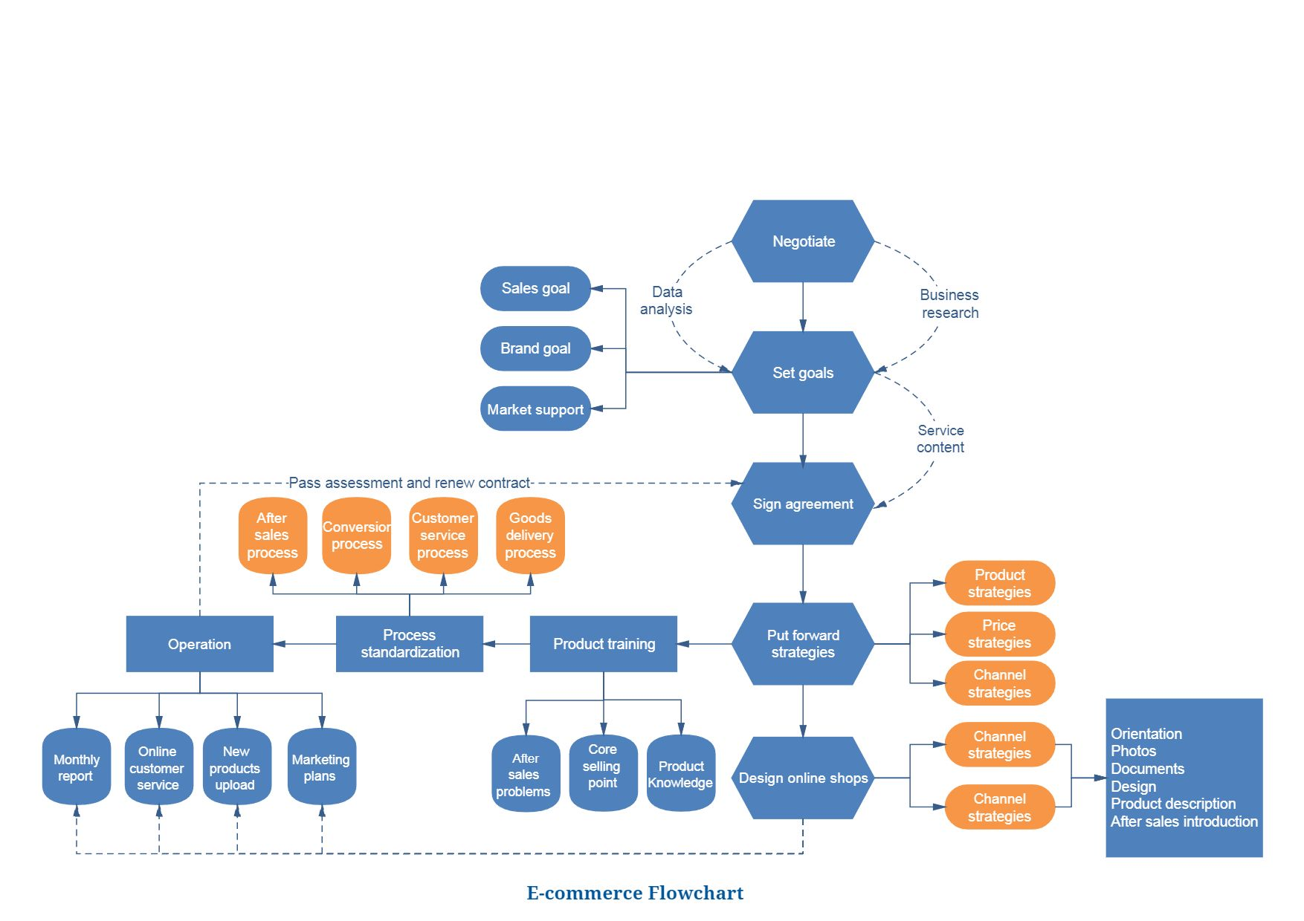

**Figure 1:** E-commerce Flowchart.

1. **RESULTS AND DISCUSSION**

The e-commerce website is operational and error-free; it is operational online and its domain is functioning as intended.



1.NewsLetter

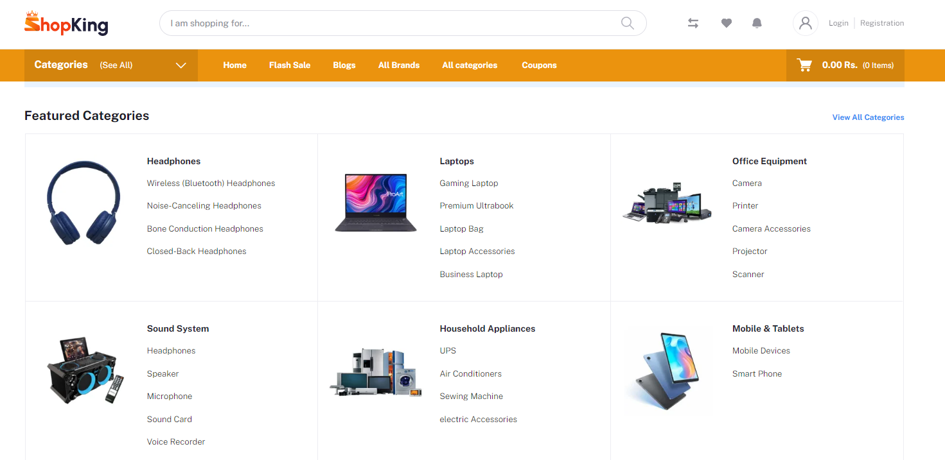

2.Featured Categories / Homepage

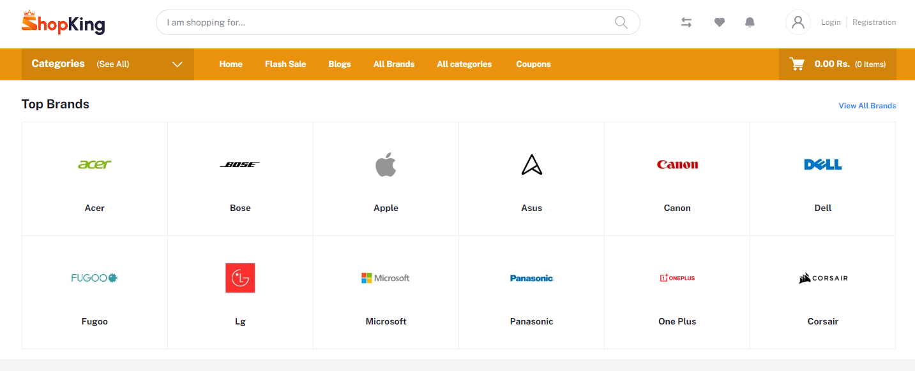

3.Top Brands

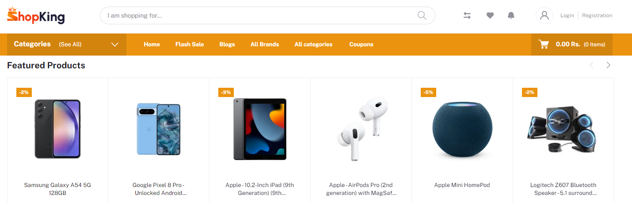

4.Featured Products

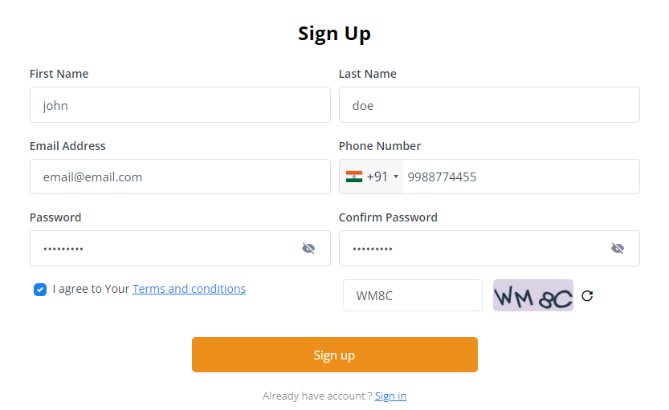

5.Sign up Page

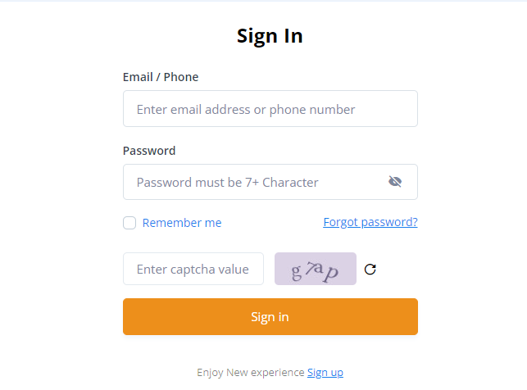

6.Sign In

1. **CONCLUSION**

To sum up, e-commerce websites have become an indispensable aspect of the modern business landscape, granting businesses the opportunity to expand their reach, conduct online transactions, and generate revenue. E-commerce websites offer several advantages over traditional brick-and-mortar stores, including reduced overhead costs, round-the-clock availability, and a wider customer base. The success of an e-commerce website hinges on various factors, such as its design, functionality, product offerings, customer service, and marketing efforts. By providing a well-designed and user-friendly website that offers top-quality products and exceptional customer service, businesses can witness a boost in sales revenue, a higher conversion rate, customer acquisition and retention.

1. **REFERENCES**
2. [www.w3schools.com](http://www.w3schools.com)
3. [www.geeksforgeeks.com](http://www.geeksforgeeks.com)
4. [www.djangoproject.com](http://www.djangoproject.com)
5. [www.tutorialspoints.com](http://www.tutorialspoints.com)
6. [www.learnigpoints.com](http://www.learnigpoints.com)
7. [www.tutorialshub.com](http://www.tutorialshub.com)
8. [www.pythonconcept.com](http://www.pythonconcept.com)
9. [www.google.com](http://www.google.com)
10. [www.pythonlean.org](http://www.pythonlean.org)
11. [www.javatpoint.com](http://www.javatpoint.com)
12. John Duckett, HTML and CSS: Design and Build Websites,2015
13. Mastering HTML, CSS & JavaScript Web Publishing Paperback,2016.
14. Software Engineering Book By Chandramouli Subramanian, Saikat Dutt, Chandramouli Seetharaman, B. G Geetha.
15. Software Engineering with UML - Book By Bhuvan Unhelkar.