[www.ijprems.com](http://www.ijprems.com/) Factor :

# Vol. 04, Issue 01, January 2024, pp : xx-xx 5.725

[editor@ijprems.com](mailto:editor@ijprems.com)

Mobile Tracker For Site Engineer’s

Fariya Baig, Aishwarya Laherwani, Samiksha Desai, Himanshi Rai, Sangita Bhoyar Final year student, Computer Engineering, VES Polytechnic, Mumbai, Maharashtra, India Final year student, Computer Engineering, VES Polytechnic, Mumbai, Maharashtra, India Final year student, Computer Engineering, VES Polytechnic, Mumbai, Maharashtra, India Departmental Head, Computer Engineering,VES Polytechnic,Mumbai, Maharashtra, India

# ABSTRACT

The Mobile Tracker for Site Engineer application is a comprehensive tool designed to enhance the efficiency and effectiveness of site engineers by leveraging advanced analysis, investigation, and research capabilities. This innovative mobile solution enables site engineers to track their movements and activities in real-time, providing valuable insights into their daily operations. By integrating GPS technology, the application accurately records the engineer's location throughout the day, facilitating efficient route planning and resource allocation. Furthermore, the app offers detailed analytics and reports, allowing engineers to conduct in-depth analysis of their productivity, identify areas for improvement, and make data-driven decisions. With features such as task management, time tracking, and expense reporting, the Mobile Tracker for Site Engineer application empowers engineers to streamline their workflow, optimize resource utilization, and deliver projects on time and within budget.

# INTRODUCTION

Mobile Tracker for Site Engineers, is the ultimate tool for tracking and managing your site activities with ease and efficiency. Whether you're overseeing construction projects, conducting inspections, or managing resources on-site, our app is tailored to streamline your workflow and enhance productivity.

With Mobile Tracker, you can log daily activities, track progress, and maintain detailed records right from your mobile device. One can easily create and assign tasks, schedule meetings, and communicate with your team in real-time, ensuring everyone stays informed and connected.

Our app also offers robust reporting features, allowing you to generate comprehensive reports on project status, resource allocation, and more, empowering you to make informed decisions and drive success on-site. As organizations seek to enhance operational efficiency and decision-making, the development and implementation of our application could play a pivotal role in streamlining data collection and management workflows.

# METHODOLOGY

* 1. Requirement Analysis:

In the requirement analysis phase of developing the Mobile Tracker for Site Engineer application, it is imperative to engage with various stakeholders, primarily site engineers, project managers, and other pertinent personnel. This engagement facilitates a comprehensive understanding of the intricacies involved in the day-to-day operations of site engineers. Through interviews, surveys, and workshops, the specific needs and challenges encountered by site engineers are meticulously explored and documented. These requirements could range from the need for accurate tracking of work hours and activities to the necessity for real-time communication with project managers and team members. Additionally, factors such as the types of projects typically undertaken, the environments in which engineers operate, and any regulatory or safety considerations are also taken into account. By involving stakeholders from the outset, the development team can ensure that the resulting application is tailored precisely to address the unique requirements and challenges faced by site engineers, thereby maximizing its utility and effectiveness in improving their workflow and productivity.

* 1. Market Research:

In the market research phase for the Mobile Tracker for Site Engineer application, a comprehensive analysis of existing solutions, competitor offerings, and emerging trends in mobile tracking and productivity tools for field engineers is conducted.

[www.ijprems.com](http://www.ijprems.com/) Factor :

# Vol. 04, Issue 01, January 2024, pp : xx-xx 5.725

[editor@ijprems.com](mailto:editor@ijprems.com)

This involves exploring various sources such as industry reports, online forums, competitor websites, and user reviews to gather insights into the current landscape of similar applications. By examining the features, functionalities, strengths, and weaknesses of existing solutions, the development team can gain a clear understanding of the market demands and expectations. Furthermore, identifying emerging trends in mobile tracking technology and productivity tools allows for the integration of innovative features that meet the evolving needs of the target audience. Through this research, the team can pinpoint gaps in the market and opportunities for differentiation, enabling them to develop a unique value proposition for the Mobile Tracker for Site Engineer application. This thorough understanding of the market landscape and customer preferences guides the development process, ensuring that the application delivers essential features while offering distinct advantages over existing solutions.

* 1. technology Selection:

In the technology selection phase for the Mobile Tracker for Site Engineer application, careful consideration is given to choosing the most suitable technology stack to meet the project requirements effectively. This involves evaluating various factors such as platform compatibility, scalability, and ease of integration with GPS and other relevant technologies. Firstly, platform compatibility is crucial, as the application needs to be accessible across different mobile platforms such as iOS and Android to reach a broader audience of site engineers. Scalability is also a key consideration, as the application should be able to handle increasing user loads and data volumes as the user base grows over time. Additionally, seamless integration with GPS technology is essential for accurate tracking of engineer movements and activities. This involves selecting technologies and frameworks that support GPS functionality and provide robust location tracking capabilities. Furthermore, compatibility with other relevant technologies such as API for data storage. By carefully evaluating these factors, the development team can choose the most appropriate technology stack that aligns with the project requirements and ensures the successful implementation of the Mobile Tracker for Site Engineer application.

* 1. Prototyping and Design:

In the prototyping and design phase for the Mobile Tracker for Site Engineer application, the focus is on creating wireframes and prototypes to conceptualize and refine the user interface (UI) and user experience (UX). This process begins with brainstorming sessions to outline the key features and functionalities of the application based on the requirements gathered from stakeholders. Wireframes are then developed to outline the layout and structure of the application's screens, focusing on usability and functionality rather than visual design. These wireframes serve as a foundation for creating prototypes, which are interactive mockups that simulate the user flow and interactions within the application.

During these design sessions, various aspects of the application's design are considered, including navigation, information architecture, visual design elements, and interaction patterns. The goal is to create a user-friendly and intuitive interface that enhances the overall user experience and facilitates efficient navigation and interaction with the application. By involving stakeholders in the design process and incorporating their feedback iteratively, the development team can ensure that the final design of the Mobile Tracker for Site Engineer application effectively addresses the needs and preferences of its target users.

* 1. Development:

In the development phase of the Mobile Tracker for Site Engineer application, the focus is on transforming the finalized design and requirements into a functional and robust software solution. This process involves several key tasks across frontend and back-end development, as well as integration with external services.

Front-end Development: Front-end development involves the creation of the user interface (UI) and user experience (UX) elements that users interact with. This includes implementing the visual design elements, navigation components, and interactive features outlined in the design phase. Front-end developers use programming languages such as HTML, CSS, and JavaScript to build responsive and intuitive interfaces that are compatible with various mobile devices and screen sizes.

Back-end Development: Back-end development focuses on building the server-side components of the application that handle data processing, storage, and business logic. This includes setting up databases to store user data, implementing authentication and authorization mechanisms to secure user information, and developing APIs (Application Programming Interfaces) to

[www.ijprems.com](http://www.ijprems.com/) Factor :

# Vol. 04, Issue 01, January 2024, pp : xx-xx 5.725

[editor@ijprems.com](mailto:editor@ijprems.com)

facilitate communication between the front-end and back-end components of the application. Back-end developers typically use programming languages such as Java & Kotlin along with frameworks like Android Studio.

Integration with External Services: The Mobile Tracker for Site Engineer application may require integration with external services such as GPS tracking services and reporting tools. Integration with GPS tracking services enables real-time tracking of engineer movements and activities, while integration with reporting tools facilitates the generation of analytics and reports based on tracked data. Developers use APIs provided by these external services to integrate them seamlessly into the application, ensuring that they work cohesively with the rest of the functionality.

Throughout the development process, developers follow best practices such as code reviews, testing, and version control to ensure the quality, reliability, and maintainability of the codebase. Collaboration between front-end and back-end developers, as well as with stakeholders, ensures that the final application meets the intended requirements and delivers a seamless user experience for site engineers.

* 1. Testing:

In the testing phase of the Mobile Tracker for Site Engineer application, a series of rigorous evaluations are conducted to ensure the software's functionality, usability, and compatibility across various devices and operating systems. This process involves several types of testing to comprehensively assess different aspects of the application:

1. Functional Testing: Functional testing verifies that each feature and functionality of the application works as intendedaccording to the specified requirements. Test cases are designed to cover various scenarios and user interactions, ensuring that all features perform as expected without any errors or unexpected behavior.
2. Usability Testing: Usability testing focuses on evaluating the user interface (UI) and user experience (UX) of theapplication from the perspective of end-users. Testers, representing the target audience of site engineers, interact with the application to assess its intuitiveness, ease of use, and overall user satisfaction. Feedback is collected to identify any usability issues or areas for improvement.
3. Compatibility Testing: Compatibility testing ensures that the application functions correctly across different devices,browsers, and operating systems. Testers verify that the application performs consistently and displays correctly on various screen sizes and resolutions, as well as across different web browsers and mobile platforms (iOS, Android). This testing helps identify any compatibility issues that may arise due to differences in hardware or software environments.
4. Performance Testing: Performance testing evaluates the responsiveness, speed, and scalability of the application underdifferent conditions and user loads. Testers simulate real-world usage scenarios to measure the application's performance metrics such as response times, resource utilization, and throughput. This testing helps identify any bottlenecks or performance issues that may impact the user experience, especially during peak usage periods.
5. Security Testing: Security testing assesses the application's resilience against potential security threats and vulnerabilities. Testers examine the application for common security issues such as authentication flaws, data breaches, and injection attacks. Vulnerability scanning tools and penetration testing techniques may be used to identify and mitigate security risks.

By conducting comprehensive testing across these various dimensions, the development team can identify and resolve any bugs, errors, or usability issues before releasing the Mobile Tracker for Site Engineer application to end-users. This ensures that the application meets quality standards and delivers a seamless and reliable experience for site engineers, enhancing their productivity and effectiveness in the field.

[www.ijprems.com](http://www.ijprems.com/) Factor :

# Vol. 04, Issue 01, January 2024, pp : xx-xx 5.725

[editor@ijprems.com](mailto:editor@ijprems.com)

* 1. Maintenance and Support:

In the maintenance and support phase of the Mobile Tracker for Site Engineer application, the focus shifts to ensuring the ongoing functionality, reliability, and relevance of the software over its lifecycle. This phase involves several key activities aimed at addressing issues, enhancing features, and providing assistance to users:

1. Regular Updates: As technology evolves and user needs change, it is essential to keep the application up-to-date with thelatest advancements and improvements. Regular updates are released to introduce new features, enhance existing functionality, and address any vulnerabilities or bugs discovered after deployment. These updates may also include performance optimizations and compatibility enhancements to ensure the application runs smoothly on different devices and platforms.
2. Bug Fixes: Despite thorough testing during development, bugs and issues may still arise after the application is deployed toproduction. The maintenance phase involves promptly identifying and addressing any reported bugs or errors to maintain the application's reliability and usability. Bug fixes are prioritized based on severity and impact, with urgent issues addressed promptly to minimize disruptions for users.
3. Technical Support: Providing technical support to users is crucial for resolving issues, answering questions, and assistingwith troubleshooting. This may involve setting up a helpdesk or support ticket system to handle user inquiries efficiently. Technical support staff are trained to assist users with various issues, such as installation problems, login issues, or feature usage questions. Clear communication channels, such as email, phone support, or online chat, are established to facilitate timely assistance for users.
4. User Feedback and Continuous Improvement: User feedback plays a vital role in guiding the ongoing development andimprovement of the application. Feedback channels are established to gather input from users regarding their experiences, suggestions for enhancements, and any issues encountered while using the application. This feedback is carefully analyzed and considered when prioritizing future updates and improvements to ensure that the application continues to meet the evolving needs and preferences of its users.
5. Performance Monitoring and Optimization: Monitoring the performance of the application in production environmentsallows for proactive identification of performance issues or bottlenecks. Performance monitoring tools are used to track key metrics such as response times, resource utilization, and error rates. Optimization efforts are then undertaken to address any performance issues and improve the overall efficiency and responsiveness of the application.

By providing ongoing maintenance and support for the Mobile Tracker for Site Engineer application, the development team can ensure that the software remains functional, reliable, and aligned with user needs and expectations over time. This proactive approach to maintenance helps maximize the value of the application for its users and supports their continued success in the field.

# MODELING AND ANALYSIS

Flowchart:-

[www.ijprems.com](http://www.ijprems.com/) Factor :

# Vol. 04, Issue 01, January 2024, pp : xx-xx 5.725

[editor@ijprems.com](mailto:editor@ijprems.com)

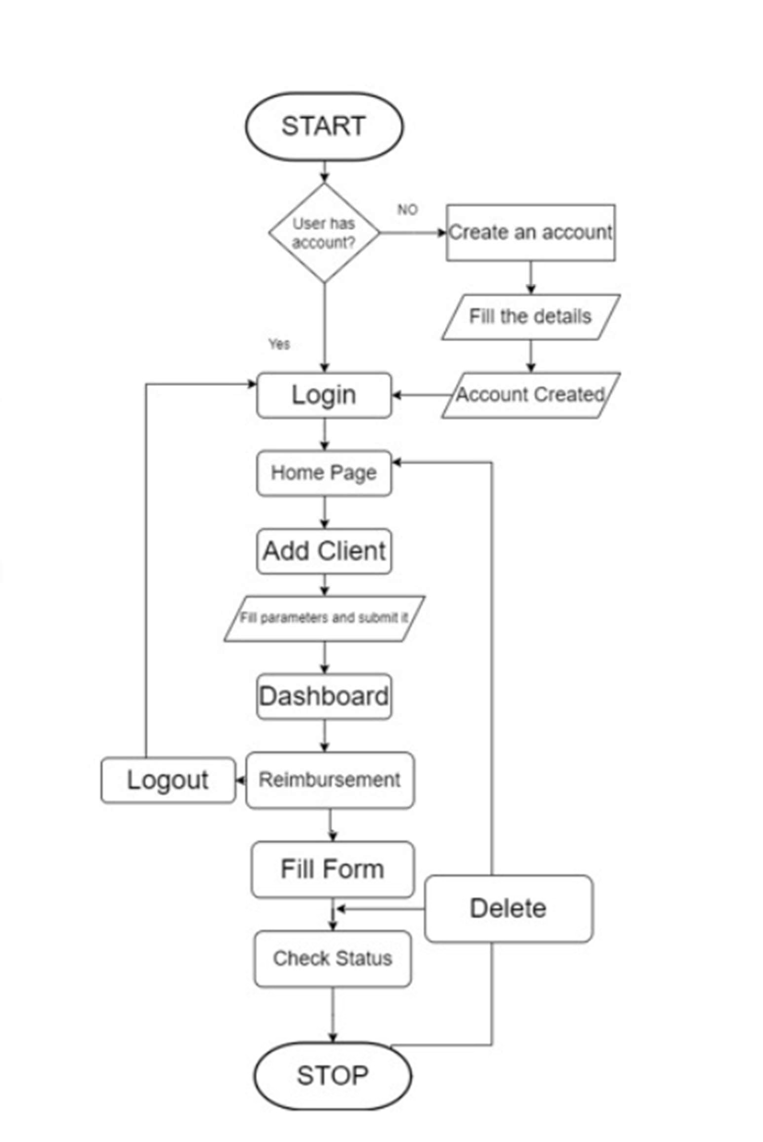

[www.ijprems.com](http://www.ijprems.com/) Factor :

# Vol. 04, Issue 01, January 2024, pp : xx-xx 5.725

[editor@ijprems.com](mailto:editor@ijprems.com)

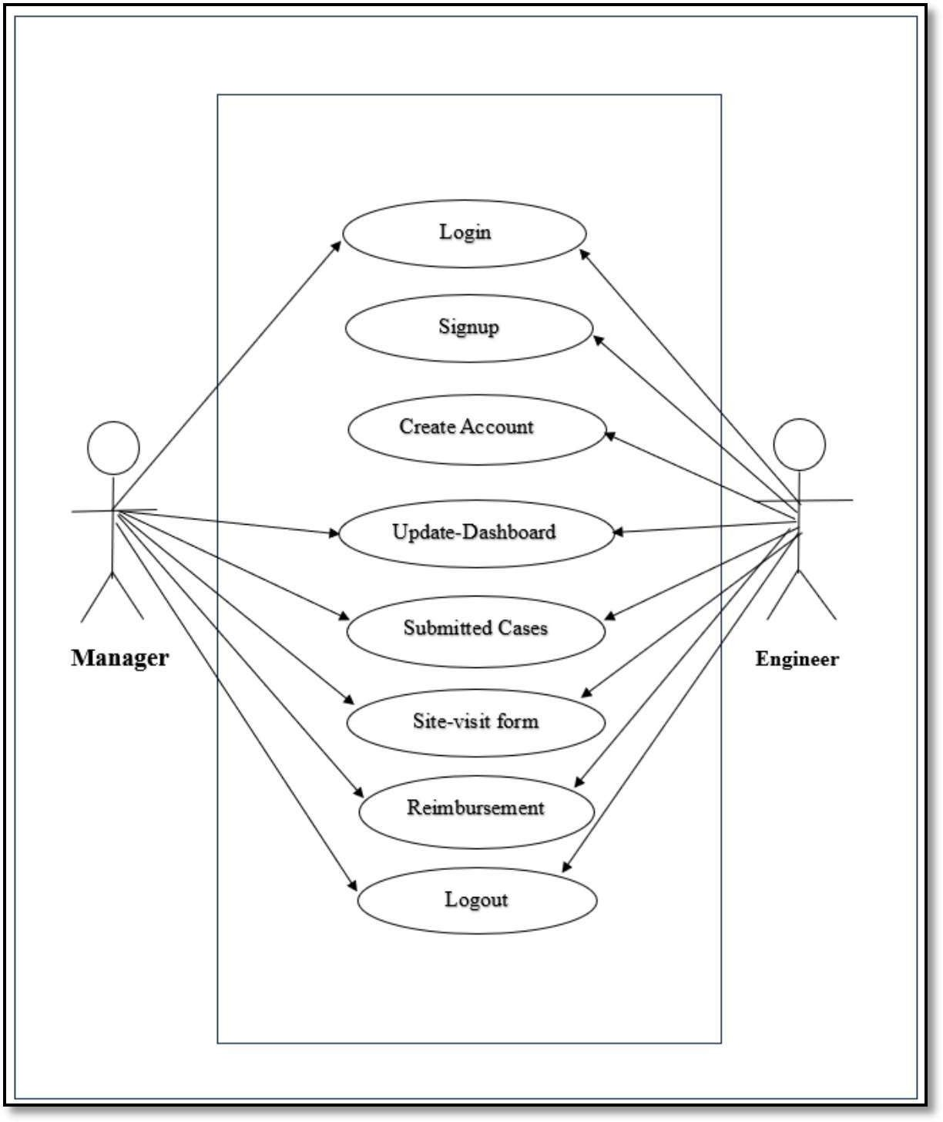

Fig3.1. Use Case Diagram

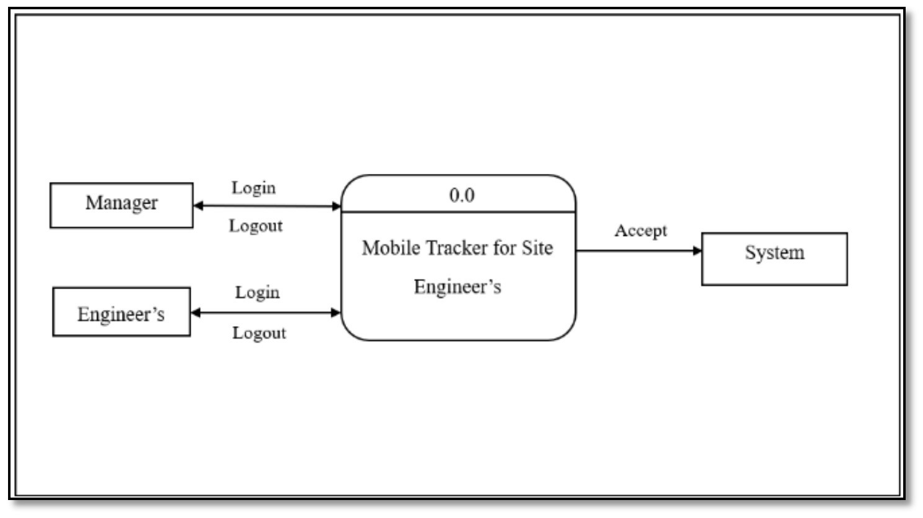

Fig 3.2. Zero-Level DFD

[www.ijprems.com](http://www.ijprems.com/) Factor :

# Vol. 04, Issue 01, January 2024, pp : xx-xx 5.725

[editor@ijprems.com](mailto:editor@ijprems.com)

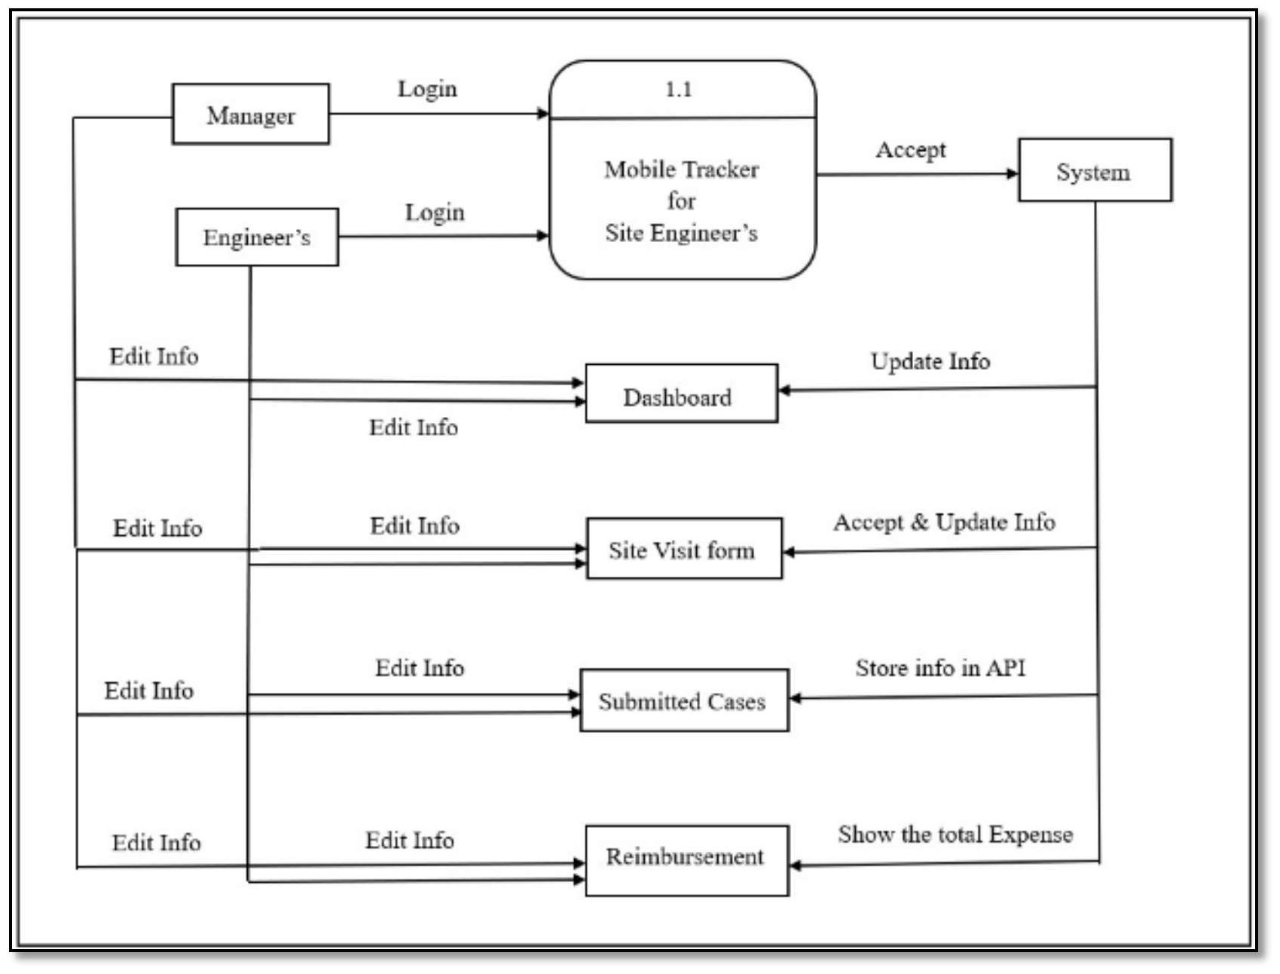

Fig3.2. Data Flow Diagram

# RESULTS AND DISCUSSION

[www.ijprems.com](http://www.ijprems.com/) Factor :

# Vol. 04, Issue 01, January 2024, pp : xx-xx 5.725

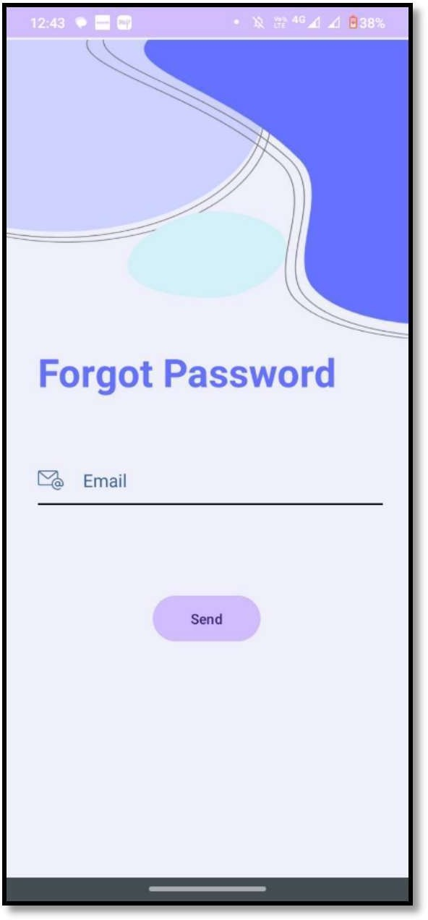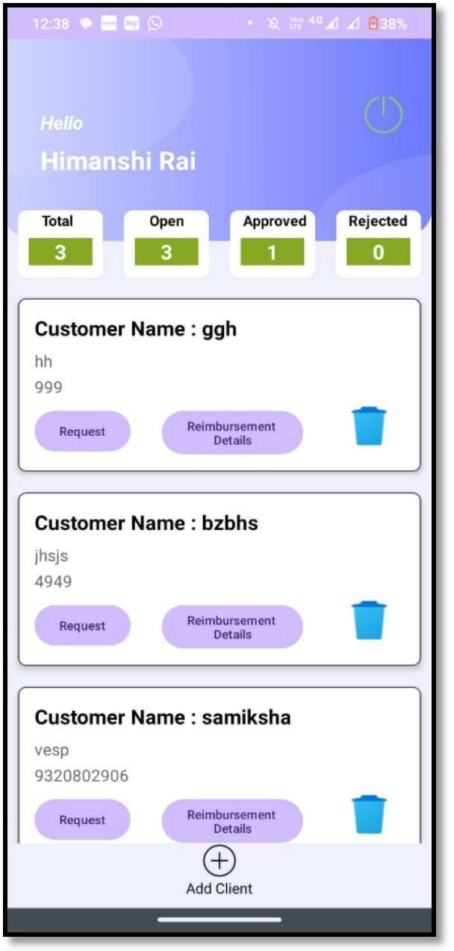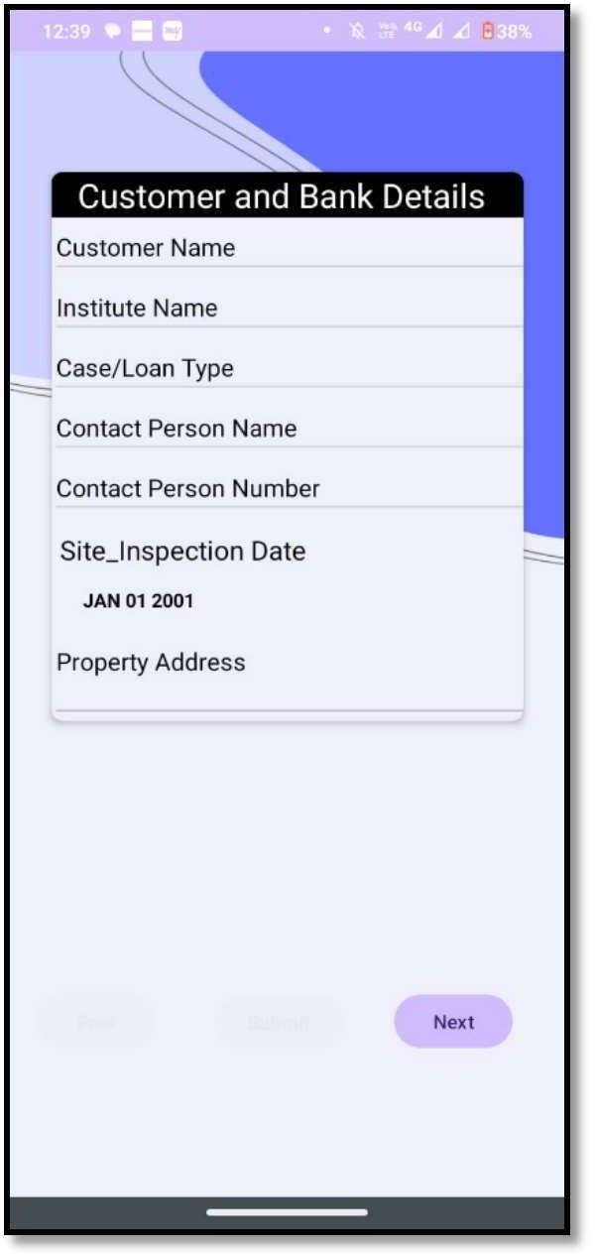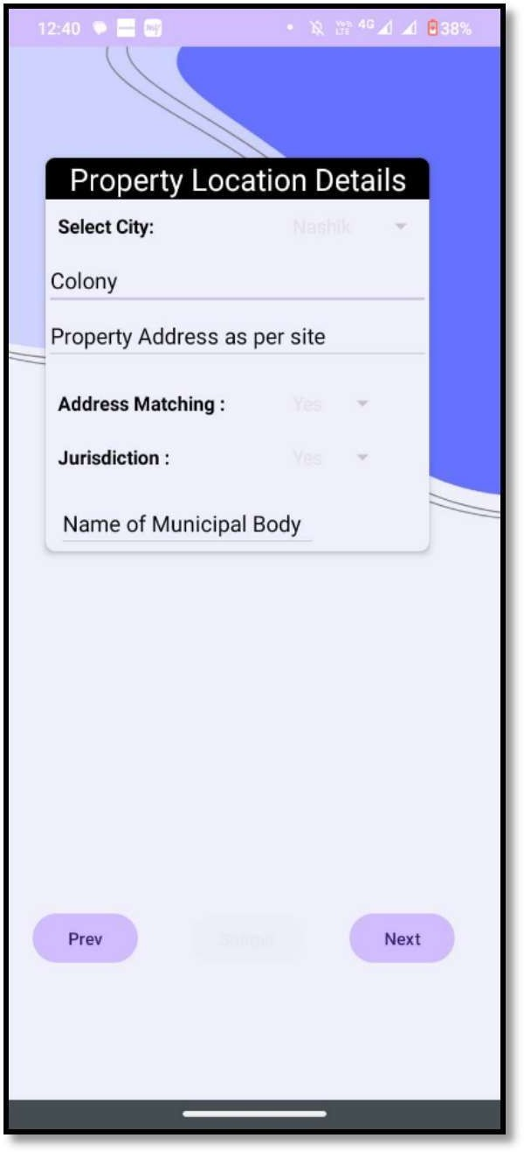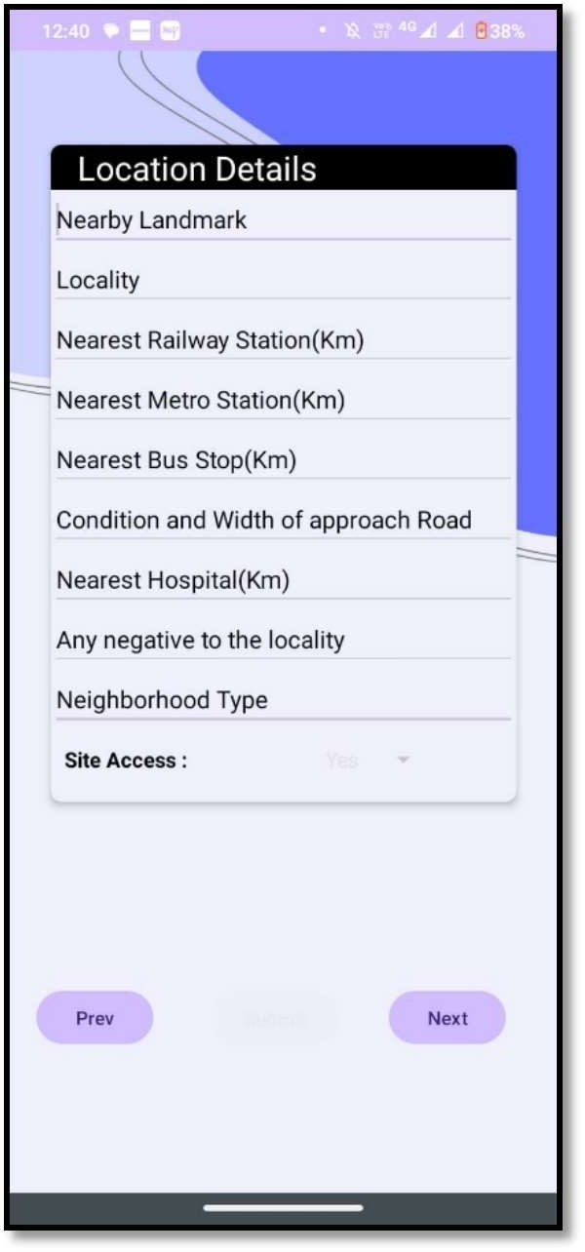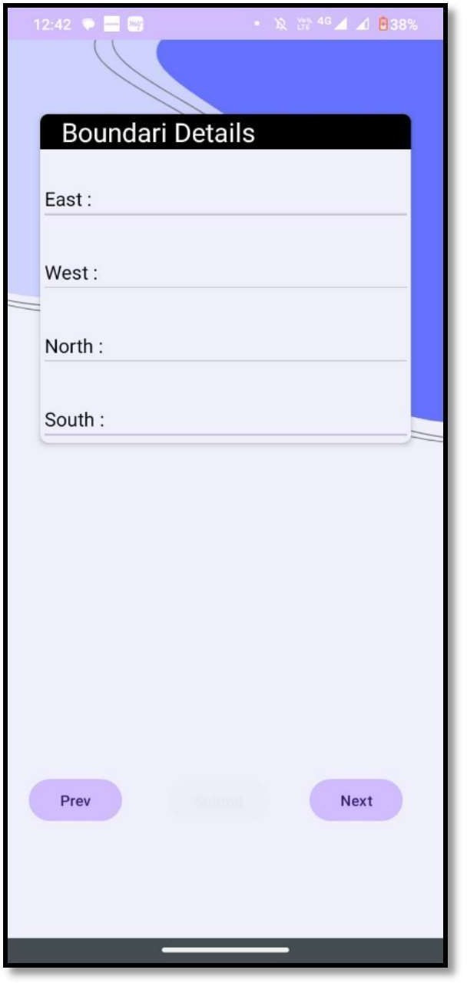[editor@ijprems.com](mailto:editor@ijprems.com)

[www.ijprems.com](http://www.ijprems.com/) Factor :

# Vol. 04, Issue 01, January 2024, pp : xx-xx 5.725

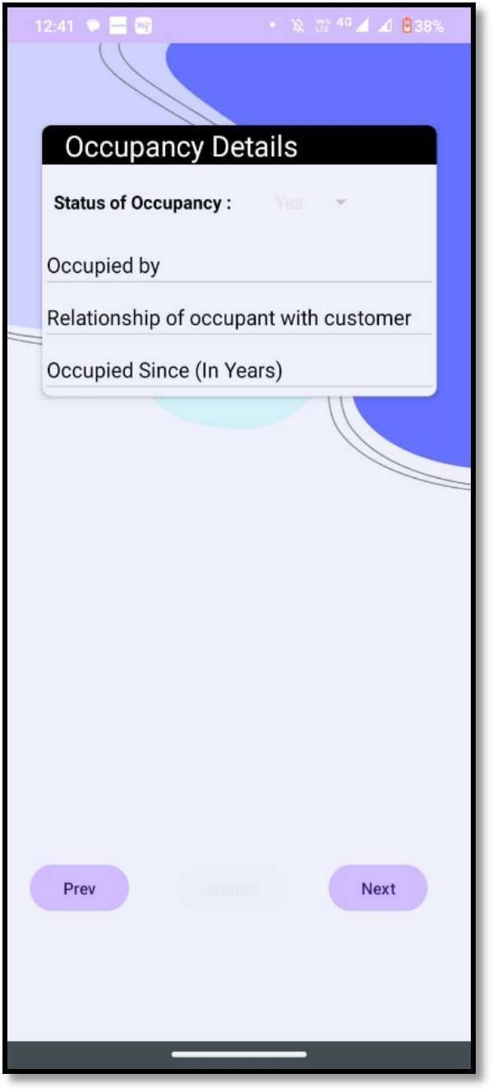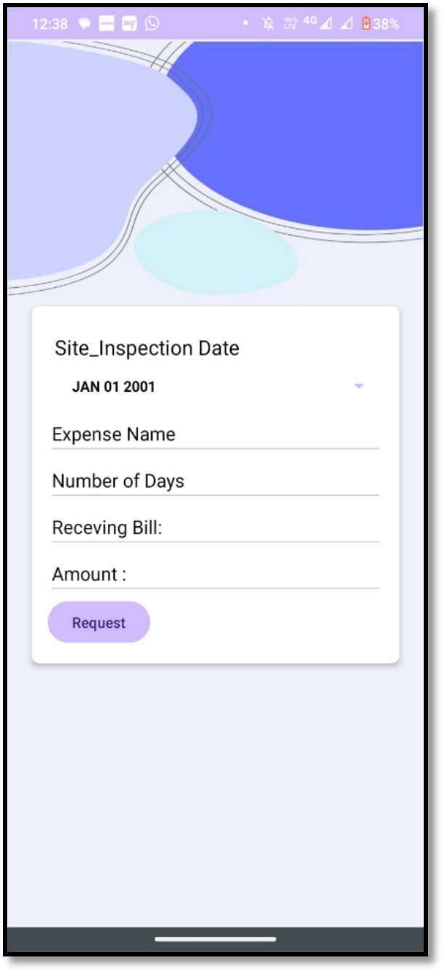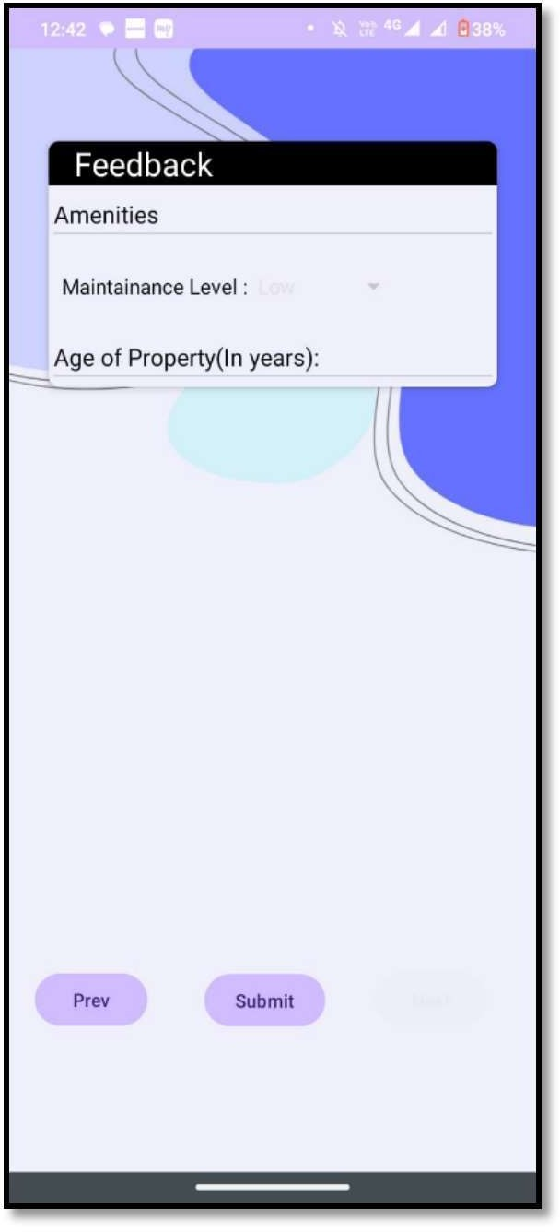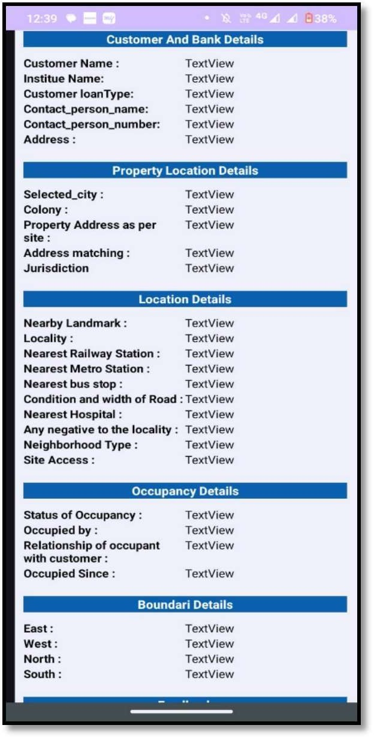[editor@ijprems.com](mailto:editor@ijprems.com)

[www.ijprems.com](http://www.ijprems.com/) Factor :

# Vol. 04, Issue 01, January 2024, pp : xx-xx 5.725

[editor@ijprems.com](mailto:editor@ijprems.com)

# CONCLUSION

In conclusion, the implementation of a mobile tracker for site engineers offers a transformative solution to enhance productivity, streamline communication, and ensure efficient project management. By leveraging the capabilities of mobile technology, such a tracker provides real-time monitoring of site activities, facilitates seamless coordination among team members, and enables prompt decision-making. The ability to track engineer movements, monitor task progress, and receive instant updates empowers project managers to optimize resource allocation and address potential issues proactively. Moreover, the integration of GPS technology enhances safety measures by ensuring the whereabouts of engineers in hazardous environments. Overall, the adoption of a mobile tracker for site engineers not only improves operational efficiency but also contributes to the overall success of construction projects.

# REFERENCES

1. National Institute of Standards and Technology (NIST) - Construction Site Management Guidelines. You could adapt thecontent of the NIST guidelines to focus on best practices and standards for mobile tracker implementation in construction site management.
2. Software Engineering Institute - Best Practices for Mobile Site Engineering Applications - This resource could provide insights into effective strategies and techniques for developing and deploying mobile tracker applications tailored to the needs of site engineers in construction projects.
3. Construction Technology Insights - Innovations in Construction Site Management: A Comprehensive Guide to MobileTracker Development. - This publication could offer a comprehensive overview of innovative technologies and approaches for developing mobile tracker applications specifically designed for construction site management.
4. EEE Transactions on Construction Engineering - Evaluating Security Measures in Mobile Tracker Applications forConstruction Site Management. - You could refer to this research paper to understand the importance of security considerations and best practices in developing secure mobile tracker solutions for construction site management.