A STUDY ON THE EFFECTIVENESS OF WORK LIFE BALANCE AND THEIR IMPACT ON EMPLOYEE SATISFACTION

**Bala Murugan N 1, Dr.S. Muthumani2**

1MBA student, Jerusalem College of Engineering, Chennai

2Professor and Head MBA, Jerusalem College of Engineering, Chennai

**ABSTRACT**

**This research aimed to evaluate the influence of work-life balance on employee satisfaction, employing a descriptive analytical approach. A tailored survey questionnaire was distributed among a sample of participants from the organization to gather the requisite data. The collected data underwent analysis utilizing the SPSS V27 software. The study centered on the employees of Celebrity Fashions Limited as both the study population and sampling unit. Findings indicated a positive level of work-life balance among employees, correlating with high levels of employee satisfaction within the company. The study emphasizes the significance of comprehending work-life balance and its association with improving employee satisfaction. Moreover, it suggests further exploration into the impact of work-life balance on employee satisfaction across diverse sectors for future research.**

**Keywords:** Work-life balance, Employee satisfaction, Descriptive analytical approach, Organizational research.

1. **INTRODUCTION**

Work-life balance has become an increasingly important aspect of the modern workplace, with organizations recognizing its profound impact on employee satisfaction, productivity, and overall well-being. As the boundaries between work and personal life continue to blur, achieving a harmonious equilibrium between professional responsibilities and personal commitments has emerged as a significant challenge for employees across various industries. This introduction will delve into the intricate relationship between work-life balance and employee satisfaction, exploring its multifaceted impact on individuals and organizations alike.

1. Evolution of Work-Life Balance:

Over the years, societal changes, technological advancements, and shifting cultural norms have reshaped the concept of work-life balance. Historically, work was predominantly confined to the office, with clear delineations between work hours and personal time. However, the advent of digital communication and remote work has blurred these boundaries, leading to a more fluid and interconnected approach to balancing work and life responsibilities.

2. Definition and Significance:

Work-life balance refers to the ability of individuals to effectively manage their professional commitments alongside personal and familial obligations, leisure pursuits, and overall well-being. Achieving a satisfactory work-life balance is crucial as it enables individuals to lead fulfilling lives, maintain optimal health, and nurture meaningful relationships outside of work. Moreover, organizations recognize the importance of supporting their employees in achieving work-life balance as it directly impacts employee satisfaction, retention rates, and organizational success.

3. Impact on Employee Satisfaction:

A harmonious work-life balance is intrinsically linked to employee satisfaction and engagement. When employees feel empowered to prioritize their personal well-being and spend quality time with loved ones, they experience greater job satisfaction, morale, and motivation. Conversely, a lack of balance between work and personal life can lead to burnout, stress, and disengagement, ultimately eroding employee morale and productivity. Therefore, organizations that prioritize and support work-life balance initiatives are more likely to cultivate a positive and fulfilling work environment, resulting in higher levels of employee satisfaction and retention.

4. Organizational Benefits:

Beyond individual well-being, fostering a culture of work-life balance yields numerous benefits for organizations. By prioritizing employee satisfaction and well-being, organizations can enhance employee morale, loyalty, and commitment. This, in turn, translates into higher levels of productivity, creativity, and innovation. Moreover, organizations that promote work-life balance are better positioned to attract and retain top talent, ultimately gaining a competitive advantage in the marketplace.

In conclusion, achieving a healthy work-life balance is essential for both individuals and organizations. By recognizing the importance of work-life balance and implementing supportive policies and practices, organizations can foster a culture of well-being, satisfaction, and success for their employees. Throughout this exploration, we will delve deeper into the various dimensions of work-life balance and its profound impact on employee satisfaction in the workplace.

1. **METHODOLOGY**

This study combines both primary and secondary data sources. Primary data were collected through a well-structured questionnaire, employing a simple random sampling method to select 110 respondents. Secondary data were gathered from various reference materials, including books, journals, research articles, magazines, and websites. The research is classified under a descriptive research design, which focuses on describing the characteristics or behaviors of a phenomenon without manipulation or control. Descriptive research aims to provide an accurate representation of the subject under investigation and is commonly used to address questions such as "what," "who," "where," "when," or "how" about a specific topic.

Objectives:

1. To assess the current work-life balance perceptions among employees.

2. To investigate the impact of work-life balance on overall employee satisfaction within the organization.

3. To identify and analyze specific factors affecting work-life balance.

4. To evaluate existing organizational policies and practices related to work-life balance and their effectiveness.

1. **LITERATURE REVIEW**

Murthy, (2022) Work Life Balance at Hyundai Motors, in his paper compared the working experience of the employees with their work-life balance. The paper concluded that the impact of work pressure on work-life is varying for different work-experience groups. Goyal & Agarwal, (2021) WORK LIFE BALANCE, reviewed and reported that the investment in the different schemes of Work-Life balance helps the organization in increasing the efficiency, lower turnover, attaining better customer services, good health, adaptable working with a satisfied workforce in the banking industry. Edison & Julius, (2021) The Impact Work-Life Balance toward Job Satisfaction and Employee Retention in their study on has concluded that the participants below 2 years of working experience do not have any perception on their existing work life balance, and those who have the experience between two to eight years stated that they are able to manage their work-life balance. M.SridharKumar (2019) The Importance of Work-Life-Balance the study concludes that the employees have high working arrangements, flexible working hours; they also have a good support from their managers and their team members. The complicatedness and commitment of the employees to the company is very high. Delecta, P. (April, 2018) Importance of Work Life Balance: A Review in this study work –life balance is analysed from organizational context. This study has the potential to enable the working people to consider their stand point in terms of work life balance and executives to gain new perspectives in order to cope with such a problem. This subject interests almost everyone with a professional career. This widespread interest is partly due to its reflection on all aspects of life. For those who think the objective in life is to work, their career becomes the core of life. However, people have limited time and therefore have to perform many other activities other than their jobs. Aycan (2018) Impact of Work-Life Balance on Job Satisfaction a Case of Health Care Services in Pakistan the study only with work and family and put forward the concept of “life balance” with a more whole perspective. The study defined life balance as fulfilling the demands satisfactorily in the three basic areas of life; namely, work, family and private. Work demands work hours, work intensity and proportion of working hours spent in work. Additional work hours subtract from home time, while high work intensity or work pressure may result in fatigue, anxiety or over adverse physiological consequences that affect the quality of home and family life.

1. **DATA ANALYSIS AND INTERPRETATION**

**Percentage analysis**

Percentage analysis for to what extent do you feel supported by your supervisor/manager in achieving a healthy work-life balance

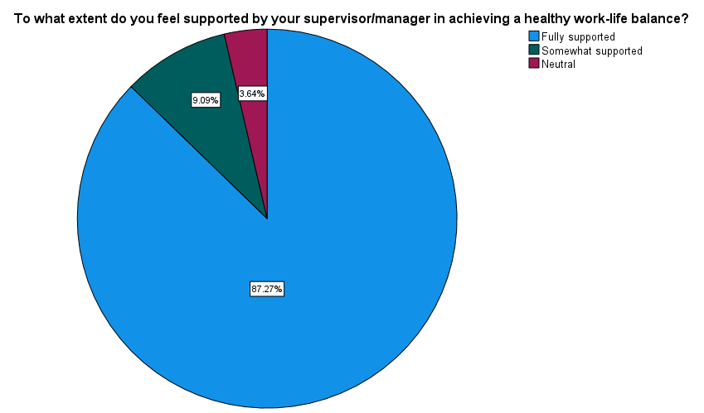TABLE 1

|  |  |  |  |  |  |
| --- | --- | --- | --- | --- | --- |
| **To what extent do you feel supported by your supervisor/manager in achieving a healthy work-life balance?** | | | | | |
|  | | Frequency | Percent | Valid Percent | Cumulative Percent |
| Valid | Fully supported | 96 | 87.3 | 87.3 | 87.3 |
| Somewhat supported | 10 | 9.1 | 9.1 | 96.4 |
| Neutral | 4 | 3.6 | 3.6 | 100.0 |
| Total | 110 | 100.0 | 100.0 |  |

INFERENCE

As the data shows nearly 87% of the respondents have received full support from the supervisor/manager in achieving a healthy work-life balance.

Percentage analysis for do you feel that you have sufficient leisure time while balancing your work responsibilities.

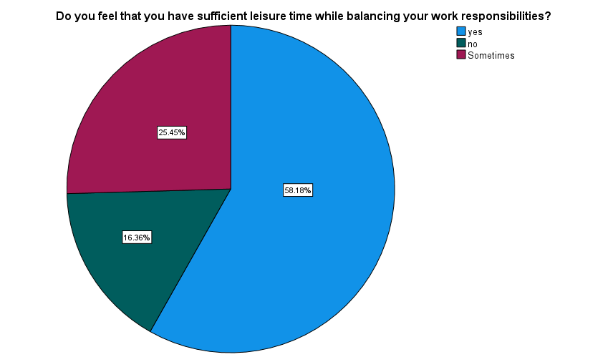TABLE 2

|  |  |  |  |  |  |
| --- | --- | --- | --- | --- | --- |
| **Do you feel that you have sufficient leisure time while balancing your work responsibilities?** | | | | | |
|  | | Frequency | Percent | Valid Percent | Cumulative Percent |
| Valid | yes | 64 | 58.2 | 58.2 | 58.2 |
| no | 18 | 16.4 | 16.4 | 74.5 |
| Sometimes | 28 | 25.5 | 25.5 | 100.0 |
| Total | 110 | 100.0 | 100.0 |  |

INFERENCE

As the data shows nearly 58% of the respondents have sufficient leisure time while balancing their work responsibilities.

Percentage analysis for do you feel that you have enough time to fulfill your personal responsibilities outside of work

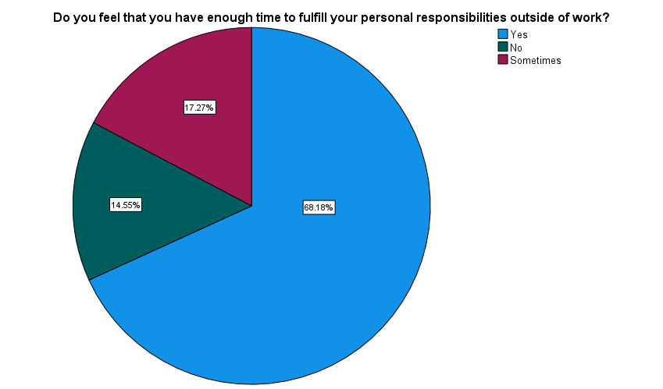TABLE 3

|  |  |  |  |  |  |
| --- | --- | --- | --- | --- | --- |
| **Do you feel that you have enough time to fulfil your personal responsibilities outside of work?** | | | | | |
|  | | Frequency | Percent | Valid Percent | Cumulative Percent |
| Valid | Yes | 75 | 68.2 | 68.2 | 68.2 |
| No | 16 | 14.5 | 14.5 | 82.7 |
| Sometimes | 19 | 17.3 | 17.3 | 100.0 |
| Total | 110 | 100.0 | 100.0 |  |

INFERENCE

As the data shows nearly 68% of the respondents have enough time to fulfill your personal responsibilities outside of work.

Percentage analysis for how effectively do you believe the existing work-life balance policies and practices are implemented and enforced within the organization.

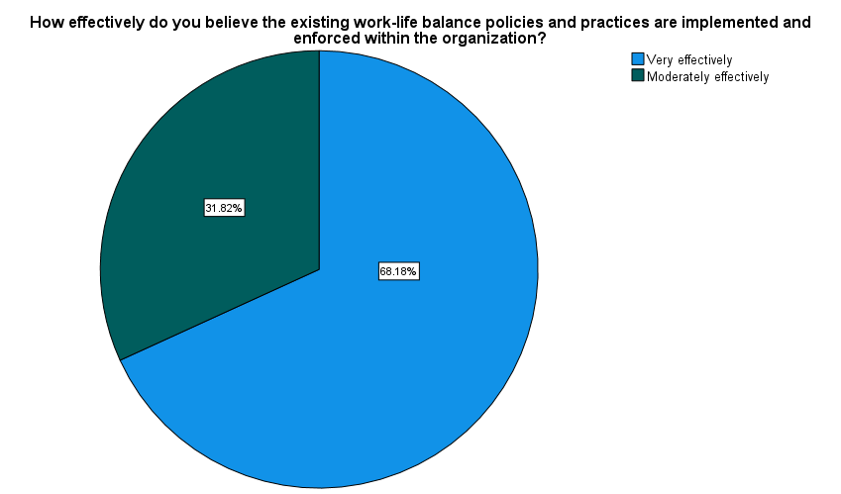TABLE 4

|  |  |  |  |  |  |
| --- | --- | --- | --- | --- | --- |
| **How effectively do you believe the existing work-life balance policies and practices are implemented and enforced within the organization?** | | | | | |
|  | | Frequency | Percent | Valid Percent | Cumulative Percent |
| Valid | Very effectively | 75 | 68.2 | 68.2 | 68.2 |
| Moderately effectively | 35 | 31.8 | 31.8 | 100.0 |
| Total | 110 | 100.0 | 100.0 |  |

INFERENCE

As the data shows nearly 68% of the respondents have felt the existing work-life balance policies and practices are implemented and enforced within the organization very effective.

**CORRELATION ANALYSIS**

To find out the significance relationship between the experience with the current organization and How would you rate your current level of satisfaction with your work-life balance.

**Ho:** There is no significance relationship between experience with the current organization and the current level of satisfaction with work-life balance.

**H1:** There is a significance relationship between experience with the current organization and the current level of satisfaction with work-life balance.

|  |  |  |  |
| --- | --- | --- | --- |
| **Correlations** | | | |
|  | | Experience with your current organization | How would you rate your current level of satisfaction with your work-life balance? |
| Experience with your current organization | Pearson Correlation | 1 | .183 |
| Sig. (2-tailed) |  | .056 |
| N | 110 | 110 |
| How would you rate your current level of satisfaction with your work-life balance? | Pearson Correlation | .183 | 1 |
| Sig. (2-tailed) | .056 |  |
| N | 110 | 110 |

Inference:

From the above table, we find that the significant value is 0.056, which is greater than table value 0.05, so the Null hypothesis is accepted and Alternative hypothesis is rejected.

Therefore, there is no significance relationship between experience with the current organization and the current level of satisfaction with work-life balance.

**CHI-SQUARE ANALYSIS**

To find out the association between the number of dependents and to what extent do personal obligations affects ability to maintain a healthy work-life balance.

Ho: There is no significance association between the number of dependents and to what extent do personal obligations affects ability to maintain a healthy work-life balance.

H1: There is a significance association between the number of dependents and to what extent do personal obligations affects ability to maintain a healthy work-life balance.

|  |  |  |
| --- | --- | --- |
| **Test Statistics** | | |
|  | Number of dependents (e.g., children, elderly relatives) | To what extent do personal obligations (e.g., family, caregiving responsibilities) affect your ability to maintain a healthy work-life balance? |
| Chi-Square | 24.618a | 45.491a |
| df | 3 | 3 |
| Asymp. Sig. | .000 | .000 |

Inference:

From the above table, we find that the significant value is 0.000, which is less than table value 0.05, so the Null hypothesis is rejected and Alternative hypothesis is accepted.

Therefore, there is a significance association between the number of dependents and to what extent do personal obligations affects ability to maintain a healthy work-life balance.

**REGRESSION ANALYSIS**

To find out the relationship between effectiveness of existing work-life balance policies and practices are implemented and enforced within the organization and perception of company culture.

Ho: There is no significant relationship between effectiveness of existing work-life balance policies and practices are implemented and enforced within the organization and perception of company culture.

H1: There is a significant relationship between effectiveness of existing work-life balance policies and practices are implemented and enforced within the organization and perception of company culture.

|  |  |  |  |  |  |  |
| --- | --- | --- | --- | --- | --- | --- |
| **Coefficientsa** | | | | | | |
| Model | | Unstandardized Coefficients | | Standardized Coefficients | t | Sig. |
| B | Std. Error | Beta |
| 1 | (Constant) | .728 | .071 |  | 10.208 | .000 |
| What is your perception of the company culture regarding work-life balance? | .373 | .040 | .669 | 9.356 | .000 |

Inference:

From the above table, we find that the significant value is 0.000, which is less than table value 0.05, so the Null hypothesis is rejected and Alternative hypothesis is accepted.

Therefore, there is a significant relationship between effectiveness of existing work-life balance policies and practices are implemented and enforced within the organization and perception of company culture.

1. **FINDINDS**

The study findings reveal several key insights regarding the demographic composition and work-life balance perceptions of the respondents. A significant proportion, over 60%, falls within the age range of 35-54, with approximately 52% being male. Regarding educational attainment, 30% hold a bachelor's degree. The majority, nearly 66%, are married, and around 51% have three or more dependents. In terms of income, more than 75% earn a monthly income between 15000 – 39999. Work experience within the organization is substantial, as over 60% have more than 5 years of experience. The majority, nearly 79%, work in the factory setting. Notably, close to 50% have never felt overwhelmed by their workload affecting personal life, while approximately 35% always have the flexibility to adjust their work schedule for personal commitments or emergencies. The overwhelming majority, almost 87%, receive full support from supervisors/managers in achieving a healthy work-life balance. Leisure time is deemed sufficient by around 58% of respondents, and nearly 44% are satisfied with their current work-life balance. Additionally, approximately 68% have enough time to fulfill personal responsibilities outside of work.

A notable proportion, 42%, strongly agree that their job allows them to effectively manage both work and personal life. Furthermore, almost 56% always feel their workload is manageable within regular working hours, while nearly 47% have never experienced difficulty falling asleep due to work-related stress. Additionally, about 65% report no impact on personal obligations affecting their ability to maintain a healthy work-life balance. In terms of organizational support, approximately 58% feel the company culture. regarding work-life balance is very supportive, and almost 68% perceive existing work-life balance policies and practices to be implemented and enforced very effectively. However, about 49% believe that the company could improve its existing work-life balance policies and practices by increasing awareness and communication about them.

1. **CONCLUSION**

In conclusion, this study on the effectiveness of work-life balance and its impact on employee satisfaction has provided valuable insights into the dynamics between work-life balance initiatives and overall employee well-being. Through comprehensive analysis, it has become evident that maintaining a healthy balance between professional responsibilities and personal life significantly contributes to employee satisfaction. The findings of this study indicate that employees who perceive their organization's work-life balance initiatives positively tend to report higher levels of satisfaction. Factors such as support from supervisors/managers, flexibility in work arrangements, and company culture play crucial roles in shaping employees' perceptions of work-life balance effectiveness. Moreover, the study highlights the importance of effective implementation and enforcement of work-life balance policies and practices within organizations. When employees feel that these policies are adequately implemented and enforced, they are more likely to experience higher satisfaction levels and overall well-being.

1. **REFERENCES**
2. A study on work life balance and its impact on employee job satisfaction - Dr. Jigisha Naidu - The Online Journal of Distance Education and e-Learning.
3. Work-life balance and its impact on employee satisfaction on five star hotels - Ghassan Issa Al Omari – Research gate.
4. Work-Life Balance, Job Satisfaction, and Job Performance of SMEs Employees: The Moderating Role of Family-Supportive Supervisor Behaviors - Perengki Susanto – National library of medicine.
5. Impact of Work-Life Balance on Job Satisfaction a Case of Health Care Services - Muhammad Shadab - Developing Country Studies.
6. The impact of work-life balance on employees' job satisfaction and turnover intention – Aslani – Zeitschriftenartikel.
7. The Impact Work-Life Balance toward Job Satisfaction and Employee Retention - Hana Silaban - International Journal of Innovation and Economic Development.