**A STUDY ON COMPETENCY MAPPING ON EMPLOYEES AT TAGORE MEDICAL COLLEGE AND HOSPITAL (TMCH)**

1Aravindha Raj R and 2Muthumani S

1MBA student Jerusalem College of Engineering, Chennai

2Professor and Head MBA, Jerusalem College of Engineering, Chennai

**ABSTRACT**

The study deals with **"A STUDY ON COMPETENCY MAPPING ON EMPLOYEES AT TAGORE MEDICAL COLLEGE AND HOSPITAL (TMCH)"**. The main objective of this study is to know about the skills available with the employees of TMCH to enhance their career and the management goals. Through this project, I came to know about the importance of theoretical knowledge of HR practices viz training and development programs, job up gradation, job positioning, effective management of resources etc, thereby bringing about conceptual clarity. This research study is Descriptive & Hypothesis research in nature. The size of the sample is 150 and the sampling technique used is Stratified sampling (Probability sampling), through the questionnaire method, Both the sources of data collection via, primary and secondary have been used in this report. The questionnaire has been conducted with many questions concerning the skills available at Tagore Medical College and Hospital for the development of the career of the employees and to achieve management goals. The tools which used are chi-square, one way ANOVA and Regression. A thorough analysis has also been done on the responses given by the respondents based upon which conclusions have been drawn. The research reveals that the skills available at TMCH are more than handful to enhance the career of the employees and even for organization. The research also exposes that there is relationship between skills of the employees and maximum utilization of man power that makes success rate in achieving management objective. The study also shows that there is significant improvement in the efficiency of the employees because of the training programmes, job positioning, and performance appraisal and even for promotion.

**INTRODUCTION**

Human Resource Management performs the function of Recruitment, selection, training, development and remuneration. In addition, among these recruitment and selection functions seem to be the most difficult one as they deal with selection and appointment of employees. It is the efficiency of HRM in performing these two functions, which leads to overall efficiency in an organization. Different assessment approaches were developed and adopted including personality tests, thematic tests, psychometric tests etc... These tests have improved assessment of candidate but still the reliability of the test result is not adequate to forecast effectiveness of the candidate for the job. It was found by the research conducted by Industrial and Organizational Psychologists that 'effectiveness of a person to carry out a job depends not only on a single or isolated factor but on "set of many different factors". Such set of factors that help the possessor to be proficient in a particular job is termed as Competency for the particular job.

**REVIEW OF LITERATURE**

**Unido & Rankin (International Journal of Scientific & Engineering Research, Volume 2, Issue 8, Your Of Publication: August-2011)** “A. Competency set of Skills, related knowledge and attributes that allow an individual to sccessfully perform a task or an activity within a specific function or a job. "Competencies are definition of skills and behavior that organization expects their staff to practice in work". A capacity that exists in a person that leads to behavior that meets the job demands within parameters of organizational environment, and that, in turn brings about desired results.”

**lanlen Holder - Strategic Competency Management Gulf New (United Arab Emirates) March 5, 2008** “Competency is the capability to apply a set of related knowledge, skills and abilities requited to perform "Critical Work Functions" in a defined work setting strategic competency management enable organizations to identify exemplary employees and discover their secrets to success, and competency models spotlight stellar individual performance and use it as a yardstick against which all performance is evaluated”

**R.C.Kiran Chandy - Competency Management, Edition: Hr Wishma Publication (March 04, 2010) “**The competency framework serves as the bed rock for all HR processes like talent induction, management development appraisal and training yield much better results". A HR consultant point out that the competency movement has caught on much better in the non IT sector than the IT sector that the IT sector. Only a few IT organization which are at the higher end of the HR value chain are known to be doing some work in this area; most are busy handling recruitment and compensation related matters.”

**RESEARCH METHODOLOGY**

The research is also med to describe an entire collection of information about a particular subject & finding solution. Descriptive research, as their same implies are designed to describe something. Descriptive research studies see those studies which are concerned with describing the characteristics of a particular individual or of a group. The study is carried out with the help of the following methods of collection. Primary Data Collection Method, Secondary Data Collection Method. A pilot study is a "small scale replica" of the main study. It is the rehearsal of the main study. For this study sample size chosen are 150. If a population from which a sample is to be drawn does not constitute a homogeneous group, stratified sampling technique is generally applied in order to obtain a representative sample. Under stratified sampling the population is divided into several sub-population that are individually more homogeneous than the total population and then we select stems from each stratum to constitute a sample Since each stratum is more homogeneous than the total population.

**OBJECTIVES OF THE STUDY**

* To analyze the behavior mindset of the employees.
* To identify areas in which employees would like to develop further.
* To find out the steps taken by the management to increase the competency of the employees.
* To find out the effectiveness of competency development program offered by the organization.
* To measure skill gap on employees.

**SCOPE OF THE STUDY**

* This study explores to the career development that prospect in the company and also helps to bring about the best career development
* The study helps to understand the employee's attitude and to understand the career requirement of the employees.
* It is used to find the competency level of the employees after the training program.

**NEED OF THE STUDY**

* It helps to realize the talent potential of the employees and enabling them to give their best by providing appropriate results effectiveness of training and development program.
* It helps in empowering the vision and mission of the organization and main advantages of carrying out the study is to figure out the “Right person for the Right job”.
* This study also helps in identifying the behavior aspect of the employees to thus helping him to change himself as per his job designation.

**LIMITATION OF THE STUDY**

* The data collection was difficult from few employees
* The study in conducted considering the change in future.
* The responses given by the respondents may n't be relied upon completely

**PERCENTAGE ANALYSIS**

**PERCENTAGE ANALYSIS FOR EMPLOYEE ACCEPTS CHALLENGING JOB.**

|  |  |  |  |  |  |
| --- | --- | --- | --- | --- | --- |
| **Table No.1 Employee Accepts Challenging Job** | | | | | |
|  | | Frequency | Percent | Valid Percent | Cumulative Percent |
| Valid | Strongly Agree. | 30 | 20.0 | 20.0 | 20.0 |
| Agree | 76 | 50.7 | 50.7 | 70.7 |
| Neutral | 14 | 9.3 | 9.3 | 80.0 |
| Disagree | 21 | 14.0 | 14.0 | 94.0 |
| Strongly Disagree | 9 | 6.0 | 6.0 | 100.0 |
| Total | 150 | 100.0 | 100.0 |  |

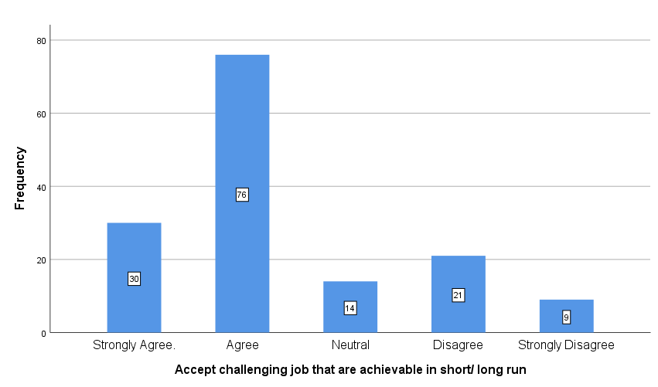

**Chart No.2. Employee Accepts Challenging Job.**

**INTERPRETATION:**

From the above table, it is inferred that highest 50.7% of the respondents says agree to accepts challenging job that are achievable in short and long run, 20% of the respondents says strongly agree, 9.3% of the respondents are neither agree nor disagree, 14% of the respondents says disagree and lowest 8% of the respondents says strongly disagree to accepts challenging job that are achievable in short and long run.

**PERCENTAGE ANALYSIS ON PERSONALLY ENCOURAGE INNOVATION AND CREATIVITY.**

|  |  |  |  |  |  |
| --- | --- | --- | --- | --- | --- |
| **Table No.2 Personally Encourage Innovation And Creativity.** | | | | | |
|  | | Frequency | Percent | Valid Percent | Cumulative Percent |
| Valid | Strongly Agree | 18 | 12.0 | 12.0 | 12.0 |
| Agree | 27 | 18.0 | 18.0 | 30.0 |
| Neutral | 45 | 30.0 | 30.0 | 60.0 |
| Disagree | 30 | 20.0 | 20.0 | 80.0 |
| Strongly Disagree | 30 | 20.0 | 20.0 | 100.0 |
| Total | 150 | 100.0 | 100.0 |  |

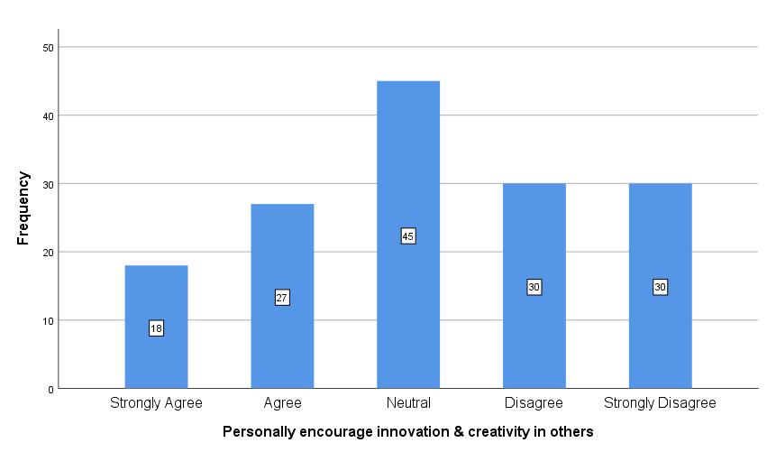

**Chart No.2 Personally Encourage Innovation And Creativity.**

**INTERPRETATION:**

From the above table, it is inferred that highest 30% of the respondents says neither agree nor disagree to personally encourage innovation and creativity, both 20% of the respondents says disagree and strongly disagree, 18% of the respondents says agree and lowest 12% of the respondents says strongly agree to personally encourage innovation and creativity.

**PERCENTAGE ANALYSIS ON COUNSELING SESSIONS HELP TO SOLVE THE PROBLEMS**

|  |  |  |  |  |  |
| --- | --- | --- | --- | --- | --- |
| **TableNo.3. Counseling Sessions Help to Solve the Problems** | | | | | |
|  | | | | | |
|  | | Frequency | Percent | Valid Percent | Cumulative Percent |
| Valid | Highly Satisfied | 32 | 21.3 | 21.3 | 21.3 |
| Satisfied | 52 | 34.7 | 34.7 | 56.0 |
| Moderate | 40 | 26.7 | 26.7 | 82.7 |
| Dissatisfied | 15 | 10.0 | 10.0 | 92.7 |
| Highly Dissatisfied | 11 | 7.3 | 7.3 | 100.0 |
| Total | 150 | 100.0 | 100.0 |  |

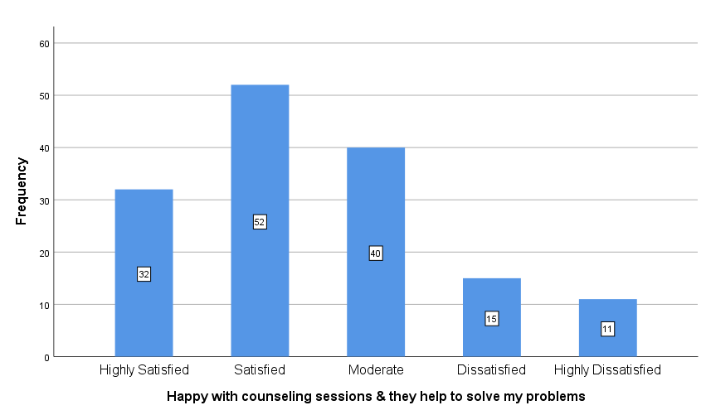

**Chart No.3 Counseling Sessions Help to Solve the Problems**

**INTERPRETATION:**

From the above table, it is inferred but highest 34.7% of the respondents says satisfied for counseling sessions help to solve the problems in the organization, 26.7% of the respondents says medium, 21.3% of the respondents says highly satisfied, 10% of the respondents says dissatisfied and 7.3% of the respondents says highly dissatisfied for counseling sessions help to solve the problems in the organization.

**PERCENTAGE ANALYSIS ON TRAINING PROGRAM IS IMPORTANT AND USEFUL FOR CAREER DEVELOPMENT.**

**Table No.4. Training Program is Important and Useful For Career Development**

|  |  |  |  |  |  |
| --- | --- | --- | --- | --- | --- |
|  | | | | | |
|  | | Frequency | Percent | Valid Percent | Cumulative Percent |
| Valid | Professional Training | 32 | 21.3 | 21.3 | 21.3 |
| Time Management Training | 36 | 24.0 | 24.0 | 45.3 |
| Leadership Training | 27 | 18.0 | 18.0 | 63.3 |
| Personality Development | 45 | 30.0 | 30.0 | 93.3 |
| Motivational Training | 10 | 6.7 | 6.7 | 100.0 |
| Total | 150 | 100.0 | 100.0 |  |

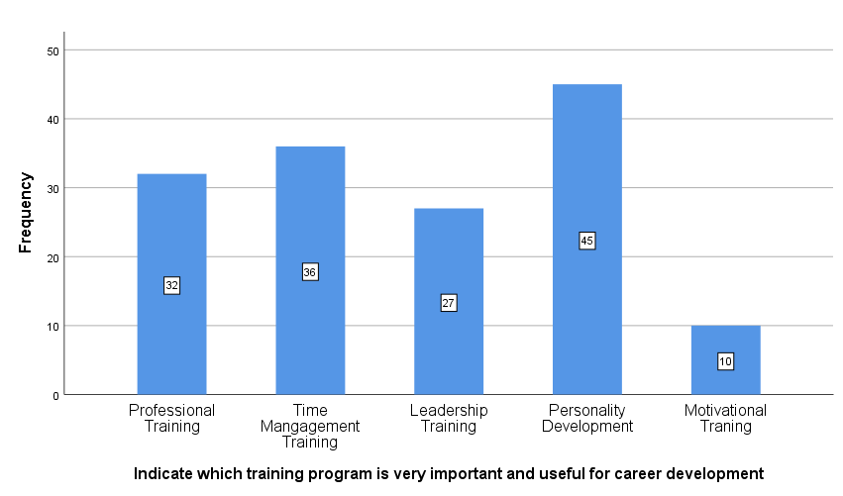

**Chart No.4. Training Program is Important and Useful For Career Development**

**INTERPRETATION:**

From the above table, it is inferred that highest 30% of the respondents says Personality development training is important and useful training program for career development. 24% of the respondents says time management training, 21.3% of the respondents says Professional training, 18% of the respondents says leadership training and lowest 6.7% of the respondents says motivational training is important and useful training program for career development.

**PERCENTAGE ANALYSIS ON MEASUREMENT OF SKILLS DONE PERIODICALLY / REGULARLY IN THE ORGANIZATION.**

**Table No.5. Measurement of Skills Done Periodically / Regularly In the Organization.**

|  |  |  |  |  |  |
| --- | --- | --- | --- | --- | --- |
|  | | | | | |
|  | | Frequency | Percent | Valid Percent | Cumulative Percent |
| Valid | Yes | 135 | 90.0 | 90.0 | 90.0 |
| No | 15 | 10.0 | 10.0 | 100.0 |
| Total | 150 | 100.0 | 100.0 |  |

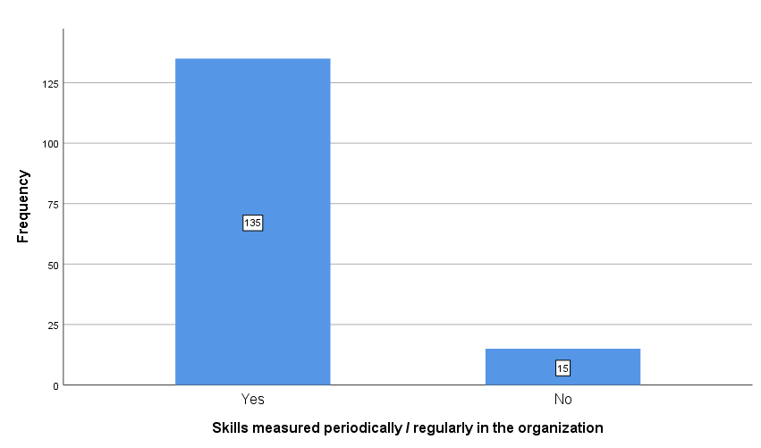

**Chart No.5. Measurement of Skills Done Periodically / Regularly In the Organization**

**INTERPRETATION:**

From the above table, it is inferred that maximum 90% of the respondents says yes for skills measurement done periodically/regularly in the organization and 10% of the respondents says no for skills measurement done periodically/regularly in the organization.

**PERCENTAGE ANALYSIS ON PERFORMANCE APPRAISAL ARE EVALUATED FROM TIME TO TIME**

**TableNo.6. Performance Appraisal are Evaluated From Time To Time.**

|  |  |  |  |  |  |
| --- | --- | --- | --- | --- | --- |
|  | | | | | |
|  | | Frequency | Percent | Valid Percent | Cumulative Percent |
| Valid | Highly Satisfied | 41 | 27.3 | 27.3 | 27.3 |
| Satisfied | 36 | 24.0 | 24.0 | 51.3 |
| Moderate | 45 | 30.0 | 30.0 | 81.3 |
| Dissatisfied | 15 | 10.0 | 10.0 | 91.3 |
| Highly Dissatisfied | 13 | 8.7 | 8.7 | 100.0 |
| Total | 150 | 100.0 | 100.0 |  |

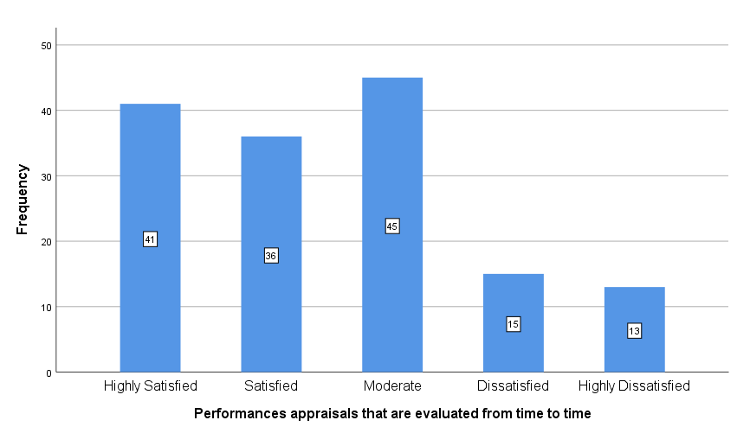

**Chart No.6. Performance Appraisal are Evaluated From Time To Time**

**INTERPRETATION:**

From the above table, it is inferred that highest 30% of the respondents says medium for performance appraisals are evaluated from time to time, 27.3% of the respondents says highly satisfied, 24% of the respondents says satisfied, 10% of the respondents says dissatisfied and lowest 8.7% of the respondents says highly dissatisfied for performance appraisals are evaluated from time to time.

**ANOVA**

ANOVA is used to compare means among two or more groups to determine if there are statistically significant differences between them. Here Anova is used to compare organization provides career growth for employee competency & Performance appraisal are evaluated time to time.

**Null Hypothesis:** There is no significant difference between organization provides career growth for employee competency & Performance appraisal are evaluated time to time.

**Alternative Hypothesis:** There is significance difference between organization provides career growth for employee competency & Performance appraisal are evaluated time to time.

|  |  |  |  |  |  |
| --- | --- | --- | --- | --- | --- |
| **ANOVA** | | | | | |
|  | | | | | |
|  | Sum of Squares | df | Mean Square | F | Sig. |
| Between Groups | 134.640 | 1 | 134.640 | 214.651 | .000 |
| Within Groups | 92.833 | 148 | .627 |  |  |
| Total | 227.473 | 149 |  |  |  |

**INFERENCE:**

From the above table, we find that the significant value is 0.000, which is Lesser than table value 0.05, so the Null hypothesis is rejected and Alternative hypothesis is Accepted

Therefore there is significant difference between the organization provides career growth for employee competency & Performance appraisal are evaluated time to time.

**CORRELATIONS:**

A correlation hypothesis typically predicts the direction and strength of the relationship between the variables. Here Correlation is used to give the relationship on Seize opportunities and challenges as they arise & can maintain high performance even under enormous level.

**Null Hypothesis:** There is no Correlation between Seize opportunities and challenges as they arise & can maintain high performance even under enormous level.

**Alternative Hypothesis:** There is Correlation between Seize opportunities and challenges as they arise & can maintain high performance even under enormous level.

|  |  |  |  |
| --- | --- | --- | --- |
| **Correlations** | | | |
|  | | Seize opportunities and challenges as they arise | Can maintain high performance even under enormous level |
| Seize opportunities and challenges as they arise | Pearson Correlation | 1 | .926** |
| Sig. (2-tailed) |  | .000 |
| N | 150 | 150 |
| Can maintain high performance even under enormous level | Pearson Correlation | .926** | 1 |
| Sig. (2-tailed) | .000 |  |
| N | 150 | 150 |
| **. Correlation is significant at the 0.01 level (2-tailed). | | | |

**INFERENCE:**

From the above table, we find that the significant value is 0.000, which is Lesser than table value 0.05, so the Null hypothesis is Rejected and Alternative hypothesis is Accepted.

Therefore there is relationship between Seize opportunities and challenges as they arise & can maintain high performance even under enormous level.

**CHI – SQUARE TEST**

The chi-square test is used to determine if there is a significant association or difference between categorical variables. Here Chi-Square Analysis is done between Department & Which training program is very important and useful for career development

**Null Hypothesis:** There is no significant association between Department in TMCH & Which training program is very important and useful for career development

**Alternative Hypothesis:** There is significant association between Departments in TMCH & Which training program is very important and useful for career development

|  |  |  |
| --- | --- | --- |
| **Test Statistics** | | |
|  | Department | Which training program is very important and useful for career development |
| Chi-Square | 48.267a | 22.467a |
| df | 4 | 4 |
| Asymp. Sig. | .000 | .000 |
| a. 0 cells (0.0%) have expected frequencies less than 5. The minimum expected cell frequency is 30.0. | | |

**INFERENCE:**

From the above table, we find that the significant value is 0.000, which is less than table value 0.05, so the Null hypothesis is rejected and Alternative hypothesis is accepted.

There is significant association between the factors considered before Investing and monitoring the Investments.

**FINDINGS:**

* It is inferred that highest 50.7% of the respondents says agree to accepts challenging job that are achievable in short and long run.
* The study shows that highest 30% of the respondents says neither agree nor disagree to personally encourage innovation and creativity.
* It is inferred but highest 34.7% of the respondents says satisfied for counseling sessions help to solve the problems in the organization.
* It is inferred that highest 30% of the respondents says Personality development training is important and useful training program for career development.
* The Researcher identifies that maximum 90% of the respondents says yes for skills measurement done periodically/regularly in the organization.
* The Researcher identifies that highest 30% of the respondents says medium for performance appraisals are evaluated from time to time.

**SUGGESTIONS:**

* The management should encourage & boost the employed productivity and their forecasting skills must be honed.
* Workshops must be conducted from time to time based on new technologies & platforms which will be useful for the employees. The employees must be encouraged to work together in group which helps them to get job done faster.
* New innovation ideas and creativity of the employees must be encouraged at they ought to bring success to the company and they must he suitability appreciated and rewarded.
* I like to suggest that the management should induce the change factor very slowly in the organization. Since the change in something that can't be implemented all of sudden enough time must be gives to the employees for best results.
* If the employees have any problem and issues at hand, he must be provided with expert and useful counseling separately and appropriate steps be taken to correct that way the concentration on the job will increase, as well as loyalty to the organization

**CONCLUSION:**

This research was carried out to provide a clear picture to identify the skills, knowledge. competency of the employees and to match & map them as necessary with their respective job designation. Considering all the tools, techniques method & procedures, which are used to map the competency of the employee of TMCH. Since competency mapping is the vital process in the current scenario of management Researcher started research work in the particular area of the organization, considering almost all the factors that were found to be relevant to my topic. This competency mapping is very useful for the workers and also for the management. It is useful for evaluation the job, Performance Appraisal and training requirement to improve the skills and knowledge of workers. It is found that the entire process is a huge success & researcher hope that research analysis will helpful for the implementation and growth process of the organization. Carefully taking into account all the theoretical, practical calculations and analysis. Researcher concludes that TMCH is very effective and efficient in all its operations and also the employees are quite capable of handling any kind of situation.

**REFERENCE**

* Unido & Rankin, International Journal of Scienntic & Engineering Research, Volume 2.Issue 8, August-2011.
* lanken Holder, Gulf New (United Arab Emirates), March 5, 2008, Damodar Suar and Abhik Dun, Cambridge Review Jeumal, 2000
* Boyatzis, Contemporary Management Research, Pages 45-70, Vol.3, No. 1, March 2007.
* Fotis Draganidis, Gregoris Mentzas, Information Management & Computer Security, Vol. 14 Iss: 1, pp.51-64, 2006