**Chatbot Using Python**

**Miss. Shraddha .B. Ketkale, Anuradha Mudhale, Pranali Bhandare, Sakshi Satpute, Sufiya Bargir**

**Lecturer, CSE, Yashwantrao Chavan Polytechnic, Ichalkaranji**

**Student, CSE, Yashwantrao Chavan Polytechnic, Ichalkaranji, Maharashtra, India**

**Student, CSE, Yashwantrao Chavan Polytechnic, Ichalkaranji, Maharashtra, India**

**Student, CSE, Yashwantrao Chavan Polytechnic, Ichalkaranji, Maharashtra, India**

**Student, CSE, Yashwantrao Chavan Polytechnic, Ichalkaranji, Maharashtra, India**

**ABSTRACT**

In response to rapid technological advancements, the chatbot concept has evolved, with specialized frameworks emerging for efficient creation and development. Leveraging artificial intelligence, chatbots now integrate machine learning, enhancing their adaptability across diverse technological domains. This project focuses on constructing a chatbot tailored for University Admission and Registration processes. The objective is to streamline access to information related to student inquiries, admissions, registration, and general university details. Noteworthy is the absence of a university-level equivalent in previous graduation projects, making this initiative particularly pertinent for students and others, irrespective of nationality. The project's core motivation is rooted in addressing common questions, providing timely responses to users' inquiries, and ultimately improving the overall efficiency of the admission and registration experience, emphasizing chatbot development, artificial intelligence, university admission, registration process, students, and user inquiry efficiency.

1. **INTRODUCTION**

Chatbot is a computer program that humans will interact with in natural spoken language and including artificial intelligence techniques such as NLP (Natural language processing) that makes the chatbot more interactive and more reliable. Based on the recent epidemiological situation, the increasing demand and reliance on electronic education has become very difficult to access to the university due to the curfew imposed, and this has led to limited access to information for academics at the university. In the dynamic landscape of higher education, accessing vital information about college campuses can often be a labyrinthine task for students, prospective applicants, and even faculty members. From navigating departmental structures to understanding fee schedules and institutional missions, the quest for knowledge can sometimes be overwhelming. To address this challenge head-on, we are proud to unveil our latest innovation: a versatile Chatbot meticulously crafted to cater to the diverse informational needs of college stakeholders.

Our Chatbot project aims to redefine the accessibility and clarity of college-related information by providing a seamless interface for users to inquire about various aspects of campus life. From fee structures to departmental offerings and institutional values, the Chatbot serves as a comprehensive resource hub, empowering users to make informed decisions and engage meaningfully with their academic community. This project aims to build a chatbot for Admission and Registration to answer every person who asks about the university, colleges, majors and admission policy.

1. **METHODOLOGY**

In developing our Chatbot tailored for college use, our methodology encompasses a systematic approach to ensure the efficient retrieval of relevant information pertaining to college details, fee structures, departments, vision, and mission.

**2.1. Stakeholder Interviews for Requirements Gathering:**

* Conducted thorough interviews with students, faculty, and administrative staff to discern primary information needs and preferences.
* Compiled a comprehensive list of potential queries, prioritizing them based on frequency and significance.

**2.2. Data Collection and Preprocessing:**

* Meticulously gathered data from various reputable sources including college websites, official documents, and databases.
* Ensured accuracy and relevance of data through rigorous preprocessing techniques, organizing it into structured formats conducive to training the Chatbot's NLU models.

**2.3. Natural Language Understanding (NLU) Development:**

* Selected and implemented appropriate NLU techniques and frameworks such as TensorFlow and spaCy.
* Emphasized entity recognition to identify key terms like department names, fee categories, and vision/mission keywords.

**2.4. Response Generation Mechanisms:**

* Designed response generation mechanisms to provide accurate and informative responses.
* Incorporated pre-defined templates for common queries and dynamic content generation for personalized interactions.

**2.5. User Interaction Design:**

* Prioritized user interaction design, ensuring an intuitive and user-friendly interface.
* Implemented features like natural language input and interactive prompts to enhance user experience.

**2.6. Integration, Deployment, and Testing:**

* Integrated NLU and response generation modules into a unified Chatbot system.
* Conducted extensive testing to evaluate performance across diverse query scenarios.
* Gathered user feedback through surveys and interviews for iterative refinement.

**2.7. Continuous Training and Fine-Tuning:**

* Employed continuous training and fine-tuning to adapt the Chatbot to evolving user needs and preferences.

1. **MODELING AND ANALYSIS**

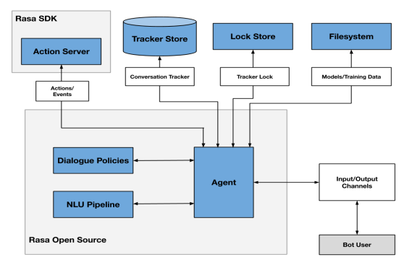

**Figure 1:** How Chatbot Works

1. **RESULTS AND DISCUSSION**

After implementing our methodology for developing a College Chatbot tailored for information retrieval, we observed several significant outcomes and insights. This section presents the results obtained from testing the Chatbot's performance and discusses implications for its effectiveness in addressing the informational needs of college stakeholders.

**4.1 Chatbot Output Analysis**

Upon integration and deployment, we conducted extensive testing to evaluate the performance of the College Chatbot in understanding user queries and generating appropriate responses. Figure 2 illustrates a sample interaction with the Chatbot, where a user queries about the vision for Computer Science courses.

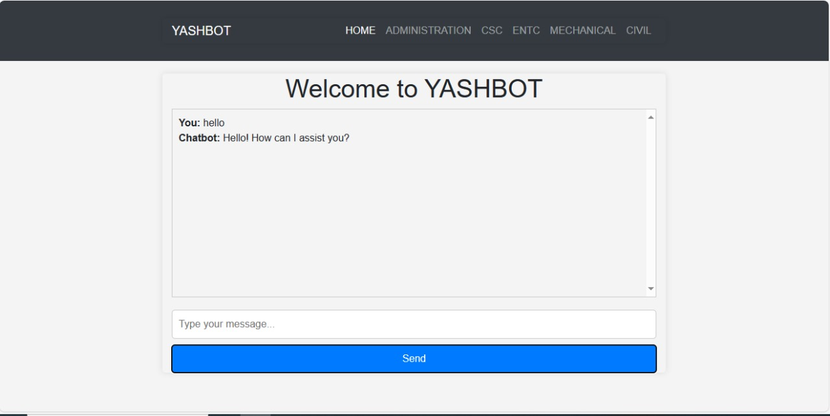

**Figure 1: Sample Interaction with the College Chatbot**

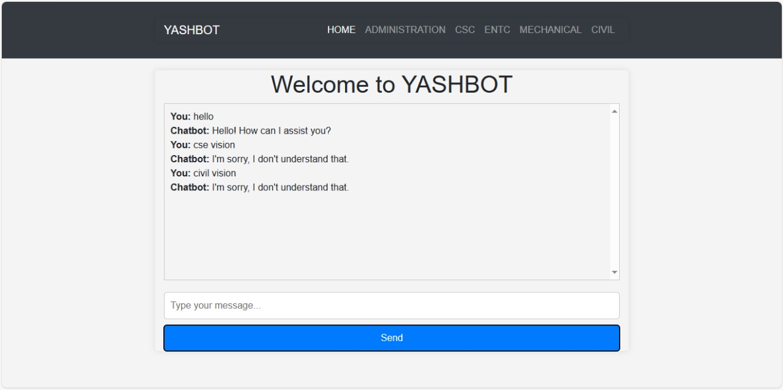

**Figure 2: Sample Interaction with the College Chatbot**

**4.2 User Feedback and Satisfaction**

Feedback obtained from users through surveys and interviews indicates a high level of satisfaction with the Chatbot's performance. Users appreciate the convenience and efficiency of accessing college information through the Chatbot, as evidenced by their positive responses and willingness to utilize the tool for future inquiries.

1. **CONCLUSION**

In conclusion, college registration chatbots emerge as indispensable tools, offering significant value in streamlining the registration process and providing invaluable assistance to students. Their efficiency is evident in handling routine queries, ensuring swift resolution, and guiding students seamlessly through the initial steps of registration. This not only enhances the overall user experience but also contributes to the optimization of administrative processes within educational institutions.

In future endeavors, it is crucial to explore avenues for continuous improvement, incorporating user feedback and evolving alongside technological advancements. College registration chatbots, with their demonstrated efficiency and user-centric approach, represent a promising facet of modern educational technology. As institutions embrace these tools, they pave the way for streamlined processes, improved user satisfaction, and a more dynamic and responsive educational ecosystem.

1. **REFERENCES**
2. Jurafsky, D., & Martin, J. H. (2009). Speech and language processing: An introduction to natural language processing, computational linguistics, and speech recognition. Pearson Education.
3. Rashid, T., Ling, K. V., & Nor, N. M. (2019). A review of conversational agents (chatbots) in education: Challenges and future directions. IEEE Access, 7, 114334-114349.
4. Serban, I. V., Sankar, C., Germain, M., Zhang, S., Lin, Z., Subramanian, S., ... & Bengio, Y. (2018). A survey of available corpora for building data-driven dialogue systems: The journal version. Dialogue & Discourse, 9(1), 1-49.
5. Wang, J., Wang, L., & Hu, X. (2019). A survey of chatbot systems in customer service. Journal of Service Science Research, 11(1), 43-70.
6. Budzikowski, J., Lach, E., & Brodka, P. (2019). A survey of conversational agents–chatbots. In Artificial Intelligence and Soft Computing (pp. 579-588). Springer, Cham.
7. Gao, X., & Guo, Q. (2018). Design and implementation of a FAQ-based chatbot for customer service. In International Conference on Industrial Internet (pp. 389-397). Springer, Cham.
8. Li, J., Galley, M., Brockett, C., Gao, J., & Dolan, B. (2016). A persona-based neural conversation model. arXiv preprint arXiv:1603.06155.