**A STUDY ON INVESTORS PERCEPTION TOWARDS MUTUAL FUNDS AT UTI MUTUAL FUNDS**

***Hareesh S1 and S.V. Praveen 2***

**1 MBA Student, Jerusalem College of Engineering, Chennai**

**2 Professor, Jerusalem College of Engineering, Chennai**

**ABSTRACT**

The study investigates **the investors perception within UTI Mutual Funds**, Chennai, focuses on understanding the **factors influencing investor’s attitudes, decisions and satisfaction**. Through a comprehensive analysis of data, the study aims to uncover the key elements shaping investor’s perceptions. The findings will provide valuable insights improving investors relation, enhancing communication strategies and fostering trust. The study contributes to the broader understanding of investor behavior and assists organizations in tailoring their approaches to meet investor expectations effectively.

**INTRODUCTION**

The study aims to understand the perception of mutual funds among investors in India. The research will involve surveying investors from various age groups and income levels to gather their opinions on mutual funds. The study will also explore factors such as the level of awareness about mutual funds, the perceived benefits and risks of investing in mutual funds, and the factors that influencing investment decisions.

**OBJECTIVES OF THE STUDY**

**PRIMARY OBJECTIVE:**

* To study on investors perception towards mutual funds

**SECONDARY OBJECTIVES:**

* To study the factors influencing mutual fund investments.
* To identify the awareness level and usage of mutual funds among investors.
* To identify and analyze the investor preference towards mutual fund investments.

**NEED FOR THE STUDY**

* To identify the different perception that each individual had on mutual funds.
* To analyse the different preferences of investors on mutual funds.
* To identify what are the common factors that influence the people towards mutual funds.
* To enhance the level of communication among investors.

**SCOPE OF THE STUDY**

* The research work focuses on studying the investors different perception towards mutual funds.
* The study explores how different demographic factors influence investor perceptions and preferences regarding mutual funds.
* The study explores factors influencing investor loyalty and retention, identifying strategies to enhance long-term relationships with clients.
* The research will provide insights into the future outlook of investor perceptions, anticipating shifts in preferences and potential areas for innovation in offerings.

**LIMITATIONS OF THE STUDY**

* The study’s findings may be limited by the size and represention of the sample, potentially making it challenging to generalize results to the entire population of the firm.
* There is a possibility of response bias.
* The study may be limited by time constraints, affecting the depth of data collection and analysis.
* External factors such as economic conditions, regulatory changes, or global events can influence investor perceptions.

**REVIEW OF LITERATURE**

**Martin Mysa (2021)** a mutual fund is an investment instrument that brings funds from different buyers and facilitates in investing the funds in bonds, short-term money-market instruments, stocks and other securities or assets are few combinations of investments. The primary goal behind investment in mutual fund is to earn goods return with comparatively low risk. The main objective of this research is to identify buyers’ preference towards mutual fund in Secunderabad metropolitan city. By using in structured questionnaire, description statistical tools like chi-square test have been used for analyzing the data. The findings from this research are that the most of the buyers are doubtful to invest the new age investment like mutual funds.

**K.Sasikumar, Dr.K.Krishnamurthy (2020)** This research aims to study retail investors’ preferences towards mutual funds. India is one of the fastest growing economies in the world with rising incomes, but also savings and investments. The main sector of emerging financial markets is investment in mutual funds. The mutual fund sector plays a key role in the development of financial markets, business sector and growth of financial intermediaries. The regulatory measures to develop mutual fund industry and to protect the interests of mf investors are also important. This study required to examine theoretical aspects of Indian mutual fund industry and retail investor’s preferences towards investment.

**S. Sudha Christy Joy and V. Ganeshkumar (2020)** Mutual funds play an important role in mobilizing savings of millions of investors across the country. In mutual funds, savings of small investors are mobilized, invested and returns are distributed in the same proportion to the unit holders. Now-adays bank rates have become very low so, keeping large amount of money in bank does not give higher returns. People can invest in stock market. But a common investor is not well informed about the complexities involved in stock market movements.

**Raja, Jagadeeswaran B (2020**) Mutual fund is a trust that pools the small savings of a number of small and medium investors. The fund collected through the various schemes is invested in different types of securities under the supervision of expert fund manager. Small and medium investors are participating in the capital market without assuming a very high degree of risk. **T**he findings of the study proved that the mutual fund companies should disclose the important information’s like return performance of the scheme, risk of the scheme, number of assets in the funds and reputation brand name of the fund on their prospectors.

**V.Sridevi (2019)** a mutual fund is an investment medium that pools funds from various investors and invests the funds in stocks, bonds, short-term money-market instruments, other securities or assets or some combination of these investments. The primary goal behind investment in mutual fund is to earn goods return with comparatively low risk. **T**he main objective of the study is to examine the investor’s behavior towards mutual fund investment. A sample of 150 individual investors has been selected for this purpose. Statistical tools like percentage analysis, chi-square test and garret ranking technique were used to analysis the collected data. It can be concluded that the Indian mutual fund industry is growing at a good pace.

**Meenakshi Bindal, Bhuwan Gupta, Sweety Dubey (2019)** This examination on investor’s acknowledgment towards and late improvement and headway of mutual fund premiums in Alwar city goes under the board an area of organization publicizing. In the wide thought of organization publicizing, it exclusively centers on the exhibiting of cash related organization specifically basic resources. Well-ordered Indian budgetary market is getting the chance to be engaged and the supply of various fiscal instruments ought to be in parity to the premium perspectives of the monetary .

**PERCENTAGE ANALYSIS**

**1. GENDER OF THE RESPONDENTS**

|  |  |  |  |  |  |
| --- | --- | --- | --- | --- | --- |
| **Gender** | | | | | |
|  | | Frequency | Percent | Valid Percent | Cumulative Percent |
| Valid | male | 78 | 68.4 | 68.4 | 68.4 |
| female | 36 | 31.6 | 31.6 | 100.0 |
| Total | 114 | 100.0 | 100.0 |  |

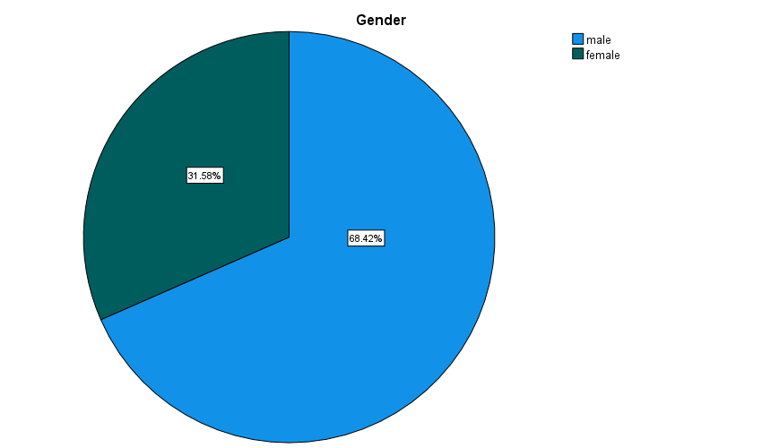

**INFERENCE:**

From the above chart it is found that out of 114 respondents, 68.4 % are male and 31.6% are female.

**TABLE 2. AGE CATEGORIES OF THE RESPONDENTS**

|  |  |  |  |  |  |
| --- | --- | --- | --- | --- | --- |
| **Age** | | | | | |
|  | | Frequency | Percent | Valid Percent | Cumulative Percent |
| Valid | 15-20 | 6 | 5.3 | 5.3 | 5.3 |
| 21-30 | 44 | 38.6 | 38.6 | 43.9 |
| 31-40 | 38 | 33.3 | 33.3 | 77.2 |
| 41-50 | 16 | 14.0 | 14.0 | 91.2 |
| above 50 | 10 | 8.8 | 8.8 | 100.0 |
| Total | 114 | 100.0 | 100.0 |  |

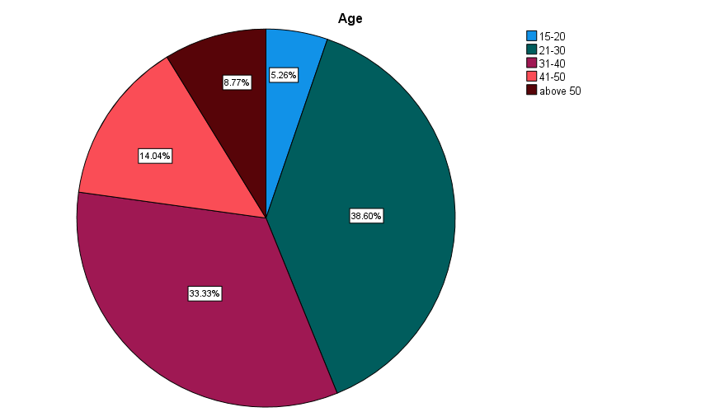

**INFERENCE:**

From the above chart it is found that out of 114 respondents 5.3% are from age category 15-20, 38.6% are from 21-30, 33.3% are from 31-40%, 14% are from 41-50, 8.8% are from above 50 years category.

**TABLE 3 PERCENTAGE ANALYSIS FOR FACTORS TO BE CONSIDERED BEFORE INVESTING IN MUTUAL FUNDS**

|  |  |  |  |  |  |
| --- | --- | --- | --- | --- | --- |
| **What factors do you consider before investing in mutual funds?** | | | | | |
|  | | Frequency | Percent | Valid Percent | Cumulative Percent |
| Valid | past performance of the fund | 36 | 31.6 | 31.6 | 31.6 |
| fund managers experience and track record | 22 | 19.3 | 19.3 | 50.9 |
| expense ratio | 46 | 40.4 | 40.4 | 91.2 |
| risk profile of the fund | 10 | 8.8 | 8.8 | 100.0 |
| Total | 114 | 100.0 | 100.0 |  |

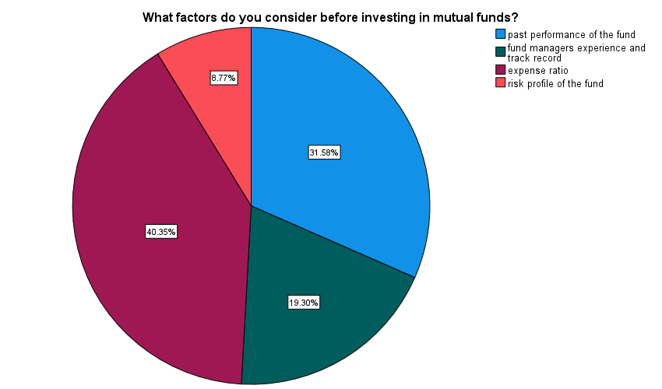

**INFERENCE:**

From the above chart it is found that out of 114 respondents, 40.4% considers expense ratio, 31.6% considers past performance of the fund, 19.3% considers fund managers experience and 8.8% considers the risk profile of the fund.

**TABLE 4 AWARENESS OF TAX BENEFITS ASSOCIATED WITH MUTUAL FUNDS**

|  |  |  |  |  |  |
| --- | --- | --- | --- | --- | --- |
| **Are you aware of the tax benefits associated with investing in mutual funds?** | | | | | |
|  | | Frequency | Percent | Valid Percent | Cumulative Percent |
| Valid | yes | 86 | 75.4 | 75.4 | 75.4 |
| no | 28 | 24.6 | 24.6 | 100.0 |
| Total | 114 | 100.0 | 100.0 |  |

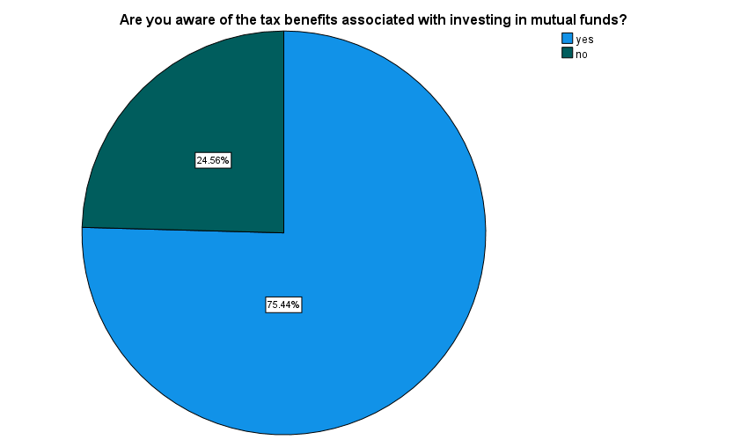

**Inference:**

From the above chart it is found that out of 114 respondents, 75.4% are aware of tax benefits associated with mutual funds.

**CORRELATION**

To identify the awareness level and usage of mutual funds among investors.

**NULL HYPOTHESIS(HO):** There is no relationship between understanding the workings of mutual fund with the investment goal.

**ALTERNATE HYPOTHESIS(H1):** There is a relationship between understanding the workings of mutual fund with the investment goal.

|  |  |  |  |
| --- | --- | --- | --- |
| **Correlations** | | | |
|  | | **How important is it for you to understand the workings of a mutual fund before investing in it?** | **What are your investment goal for investing in mutual funds?** |
| **How important is it for you to understand the workings of a mutual fund before investing in it?** | **Pearson Correlation** | **1** | **.288\*\*** |
| **Sig. (2-tailed)** |  | **.002** |
| **N** | **114** | **114** |
| **What are your investment goal for investing in mutual funds?** | **Pearson Correlation** | **.288\*\*** | **1** |
| **Sig. (2-tailed)** | **.002** |  |
| **N** | **114** | **114** |
| **\*\*. Correlation is significant at the 0.01 level (2-tailed).** | | | |

The significant value 0.002 is less than the table value i.e, 0.05 (0.002 < 0.05)

**H0 is rejecting and H1 is accepted**

Therefore, there is a relationship between understanding the workings of mutual fund with investment goal.

**CHI SQUARE**

To study the factors influencing mutual fund investments using Chi Square.

**NULL HYPOTHESIS(H0):** There is no association between gender and consideration of factors for investing in mutual funds.

**ALTERNATE HYPOTHESIS(H1):** There is association between gender and consideration of factors for investing in mutual funds.

|  |  |  |
| --- | --- | --- |
| **Test Statistics** | | |
|  | **Gender** | **What factors do you consider before investing in mutual funds?** |
| **Chi-Square** | **15.474a** | **26.211b** |
| **df** | **1** | **3** |
| **Asymp. Sig.** | **.000** | **.000** |
| **a. 0 cells (0.0%) have expected frequencies less than 5. The minimum expected cell frequency is 57.0.** | | |
| **b. 0 cells (0.0%) have expected frequencies less than 5. The minimum expected cell frequency is 28.5.** | | |

The significant value is 0.000 which is lesser than the table value (0.000 < 0.05)

**H0 is rejected and H1 is accepted.**

Therefore there is association between gender and consideration of factors for investing in mutual funds.

**ANOVA**

To identify the awareness level and usage of mutual funds among investors using ANOVA.

**NULL HYPOTHESIS (H0):** There is no significance difference between age factor and tax benefits associated with mutual funds.

**ALTERNATIVE HYPOTHESIS (H1):**There is significance difference between age factor and tax benefits associated with mutual funds.

|  |  |  |  |  |  |
| --- | --- | --- | --- | --- | --- |
| **ANOVA** | | | | | |
| **Age** | | | | | |
|  | **Sum of Squares** | **df** | **Mean Square** | **F** | **Sig.** |
| **Between Groups** | **10.528** | **1** | **10.528** | **10.723** | **.001** |
| **Within Groups** | **109.963** | **112** | **.982** |  |  |
| **Total** | **120.491** | **113** |  |  |  |

The significant value is 0.001 which is lesser than the table value (0.001 < 0.05)

**H0 is rejected and H1 is accepted.**

Therefore, there is significance difference between age factor and tax benefits associated with mutual funds.

**FINDINGS**

* It is found that out of 114 respondents, **68.4 %** are male and **31.6%** are female.
* It is found that out of 114 respondents **5.3%** are from age category 15-20, **38.6%** are from 21-30, **33.3%** are from 31-40%, **14%** are from 41-50, **8.8%** are from above 50 years category.
* It is found that out of 114 respondents, **40.4%** consideres expense ratio, **31.6%** considers past performance of the fund, **19.3%** considers fund managers experience and **8.8%** considers the risk profile of the fund.
* It is found that out of 114 respondents, **75.4%** are aware of tax benefits associated with mutual funds.
* While using **CORRELATION** we found that, there is a relationship between understanding the workings of mutual fund with investment goal.
* While using **CHI SQUARE** we found that, there is association between gender and consideration of factors for investing in mutual funds.
* While using **ANOVA** we found that, there is significance difference between age factor and tax benefits associated with mutual funds.

**SUGGESTIONS**

* Financial goals depends on a variety of factors, including the age of investors, lifestyle, financial independence, family dedication, income and spending levels. Therefore, it is necessary for investment trust companies to assess the needs of investors.
* Investors should clearly mention their investment objectives, based on that financial advisor will choose the right scheme.
* Awareness about mutual funds has to be increased among everyone.
* Investors must review their portfolio occasionally to get to know about the schemes in which their money is invested.

**CONCLUSION**

In conclusion, the study provides a foundation for Sivasri Premier Investments to refine its investor engagement strategies, fostering a more inclusive and informed investor community. By leveraging the insights gained, the company can contribute to the overall growth and sustainability of mutual fund investments in alignment with investor expectations.

**REFERENCES**

* **Sharma D. P. C (2019),** Identification of factors influencing investors perception towards investment in Mutual fund. **Sharma C Pooja(2019),** Identification of factors influencing investors perception towards investment in Mutual funds, Journal of Commerce and Accounting Research, 8(3), 2277-2146.
* **Trivedi R Swamin, P.K., Dash(2017),** A study of investor’s perception towards mutual fund decision; an Indian perspective, International Journal of Economic Research, 14(9).
* **Singh B.K. (2012),** A study on investors attitude towards mutual funds as an investment option. International Journal of Research in Management, 2(2), 61-70.
* **Saha S & Dev M (2011),** Analysis of Factors affecting Investors Perception of Mutual Fund Investment, IUP Journal of Management Research 10(2).
* **Walia N & Kiran R (2009),** An analysis of investor’s risk perception towards mutual fund services, Inernational Journal of business and Management, 4(5), 106-120.