**VERTICAL HYDROPONICS**

**Sijin Sajeev1, Sidharth M Nair2, Shwetha B Pillai3 , Dr. Godwinraj D4, Ranjitha Rajan5**

1Student, Electronics and Communications, Amal Jyothi College Of Engineering, Kanjirappally, Kerala, India

2 Student, Electronics and Communications, Amal Jyothi College Of Engineering, Kanjirappally, Kerala, India

3 Student, Electronics and Communications, Amal Jyothi College Of Engineering, Kanjirappally, Kerala, India

4Associate Professor, Electronics and Communications, Amal Jyothi College Of Engineering, Kanjirappally, Kerala, India

5Assistant Professor, Electronics and Communications, Amal Jyothi College Of Engineering, Kanjirappally, Kerala, India

**ABSTRACT**

Vertical hydroponics is an excellent method of farming that increases space efficiency by arranging plants in vertical order in indoor environment. This innovative approach to agriculture, delivers essential nutrients to plant roots, eliminating the need for soil. Irrespective of weather conditions, artificial lighting and other technologies can be used to get a year around cultivation. this farming is pesticide free and completely environment friendly. Vertical hydroponics is a promising method for future agricultural practices. Vertical hydroponics presents a promising solution to address the sustainability issues plaguing traditional agriculture. However, despite its potential benefits, the widespread adoption and successful implementation of vertical hydroponics face several significant challenges that need to be addressed.

**Keywords:** Farming, Hydroponics, efficiency, sustainability.

**INTRODUCTION**

Vertical hydroponics provides innovative solutions to challenges faced in modern agriculture. In the current scenario where rapid urbanization and land usage are taking place maximizing space utilization and resource efficiency is attained using this farming. Hydroponics uses advanced technologies such as LED lighting, climate control, resource utilization, no pesticides etc. These sets the stage for exploring how vertical farming is revolutionary.

Traditional agriculture faces numerous challenges ranging from limited arable land to the depletion of natural resources and the impacts of climate change. In response to these challenges, innovative farming techniques have emerged, and among them, vertical hydroponics stands out as a promising solution. Vertical hydroponics represents a paradigm shift in agriculture, offering a sustainable alternative to conventional farming methods. Unlike traditional soil-based farming, which relies on vast expanses of land and is susceptible to environmental constraints, vertical hydroponics leverages advanced technologies to cultivate crops in vertical structures, using nutrient-rich water solutions instead of soil. This method enables crops to be grown in a controlled environment, making it suitable for urban areas with limited space and adverse climatic conditions. The principles of vertical hydroponics are grounded in the efficient use of resources. By stacking plants vertically, this approach maximizes the use of available space, significantly increasing crop yields per square meter compared to conventional farming. Moreover, the closed-loop system of hydroponics conserves water by recirculating it through the system, addressing the issue of water scarcity—a critical concern in many regions worldwide. Furthermore, vertical hydroponics offers unparalleled versatility in crop production. It enables year-round cultivation, independent of seasonal variations, making it possible to grow a wide range of crops regardless of geographical location or climate. This versatility not only enhances food security but also promotes agricultural diversity and resilience. In addition to its practical benefits, vertical hydroponics aligns with the growing demand for sustainable food production systems. By minimizing the use of chemical fertilizers and pesticides, it reduces environmental pollution and promotes healthier produce. Furthermore, its integration with renewable energy sources and innovative technologies contributes to the overall sustainability of the agricultural sector. As the global population continues to increase, and urbanization accelerates, the demand for efficient and sustainable food production methods becomes increasingly urgent. In this context, vertical hydroponics emerges as a transformative force in agriculture, offering a scalable and environmentally friendly approach to meet the growing food demand of urban populations while minimizing the ecological footprint of farming practices. This article provides a comprehensive survey of vertical hydroponics, exploring its principles, technologies, applications, benefits, and challenges. By examining recent research findings and real-world examples, it aims to shed light on the potential of vertical hydroponics to revolutionize food production and contribute to a more sustainable future.

**LITERATURE SURVEY**

* Dickson Despommier's book "The Vertical Farm: Feeding the World in the 21st Century" (2010)   
  Hydroponics and other forms of vertical farming have become increasingly popular thanks in large part to Despommier's book. It talks about how vertical farming could provide sustainable solutions for the food demands of cities.
* "Plant Factory: An Indoor Vertical Farming System for Efficient Quality Food Production" by Toyoki Kozai, Genhua Niu, and Michiko Takagaki (Eds.) (2015)

This book provides comprehensive insights into the technical and economic aspects of indoor vertical farming

systems, offering a scientific foundation for crop production optimization.

* Title: Maximizing Yield and Efficiency: A Survey of Vertical Hydroponics

Vertical hydroponics is a burgeoning agricultural practice that holds promise for addressing the challenges of conventional farming while maximizing resource efficiency. This article provides a comprehensive summary of the state-of- the-art in vertical hydroponics, examining its principles, technologies, applications, benefits, and challenges. By synthesizing recent research findings and real-world applications, this publication offers valuable insights for researchers, practitioners,

and policymakers seeking to harness the potential of vertical hydroponics for sustainable food production.

* Title: A Comprehensive Analysis of Vertical Farming Technology: A Manual for Putting Building-Integrated Agriculture into Practice in Cities  
  Writers: Thomaier, Susanne; Henckel, Dietrich; Walk, Helmut; Freisinger, Ursula B.; Sawicka, Marta; Werner, Alexandra; Specht, Kathrin; Siebert, Rosemarie; Hartmann, Ingrid;  
  2014's Advances in Building Energy Research  
  This research provides an in-depth analysis of urban building integration of vertical farming technology, such as hydroponic systems. It talks about the possible advantages of vertical farming.
* Title: Pros and Cons of Vertical Hydroponic Farming Systems  
  K. V. Ramana and Vikas Chandel are the authors.  
  2017 saw the publication of the International Journal of Environmental Sciences.  
  In summary, the benefits and drawbacks of vertical hydroponic farming systems are assessed in this study. It talks about things like agricultural production potential, nitrogen management, water conservation, and space efficiency. The difficulties with initial setup expenses, energy usage, and technological complexity are all covered in the article.  
  Title: An Examination of Vertical Hydroponics Systems in Urban Agriculture: Methods, Procedures, and Difficulties

**PROBLEM STATEMENT**

Because vertical hydroponics systems maximize space usage and resource efficiency, they present a possible solution to the problems associated with urban agriculture. To maximise the efficiency and sustainability of these systems, a number of crucial concerns must be resolved.  
Energy Consumption: Artificial lighting and climate control are essential components of many vertical hydroponics systems, which results in considerable energy consumption. This raises operating expenses and adds to carbon emissions at the same time. Long-term sustainability depends on finding ways to reduce energy use while preserving ideal growing conditions.  
Water Usage: Compared to conventional soil-based agriculture, hydroponic systems usually use water more efficiently. But in vertical systems, water distribution and recirculation mechanisms must be thoughtfully planned to reduce waste and provide sufficient moisture for every plant all the way through the pipe.

Nutrient management: For plants to grow and thrive, the hydroponic solution's nutrients must be kept in the right proportions. Uneven growth and yield can result from problems with the consistent delivery of nutrients throughout the many levels in vertical systems. Creating plans for dynamically monitoring and adjusting nutrient levels can enhance system performance as a whole.  
Structural Stability: Maintaining structural stability is crucial as vertical hydroponics systems get bigger in scale. The weight of water, plants, and equipment can strain the supporting structure to the point of collapse, posing a concern to public safety. It is crucial to design sturdy structures that can support enormous weights without sacrificing space economy.

Addressing these challenges requires collaborative efforts from various stakeholders, including researchers, policymakers, industry leaders, and agricultural practitioners. Strategies such as technology innovation, knowledge dissemination, financial incentives, and policy reforms are essential to overcome barriers and promote the adoption of vertical hydroponics as a sustainable agricultural practice. By addressing these challenges, vertical hydroponics has the potential to revolutionize food production, enhance agricultural sustainability, and contribute to global food security in the face of mounting environmental pressures.

**MODELING AND ANALYSIS**

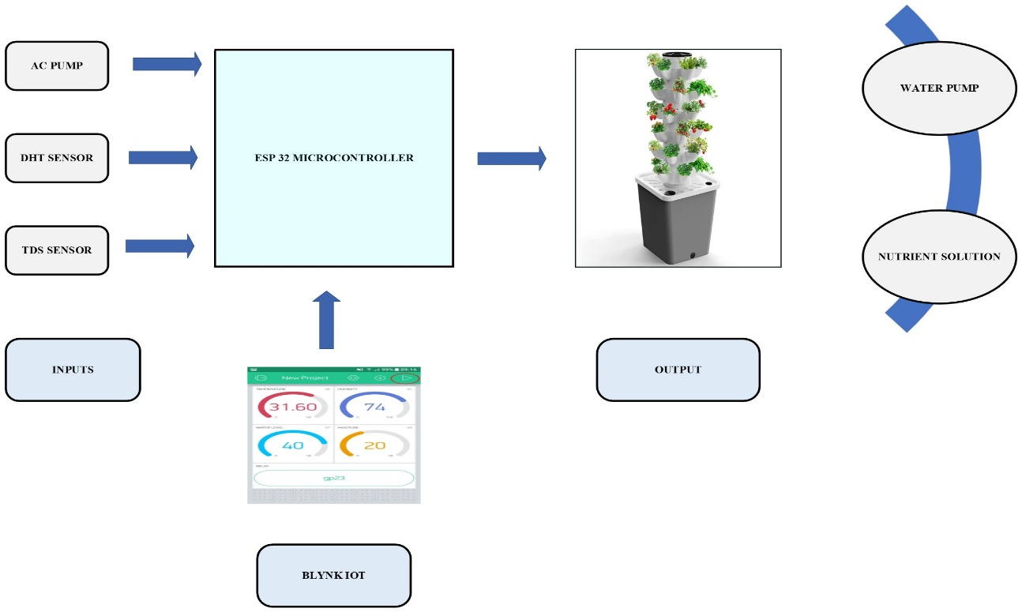

**Figure 1:** Graphical Abstract of Vertical Hydroponics

**CIRCUIT DIAGRAM**

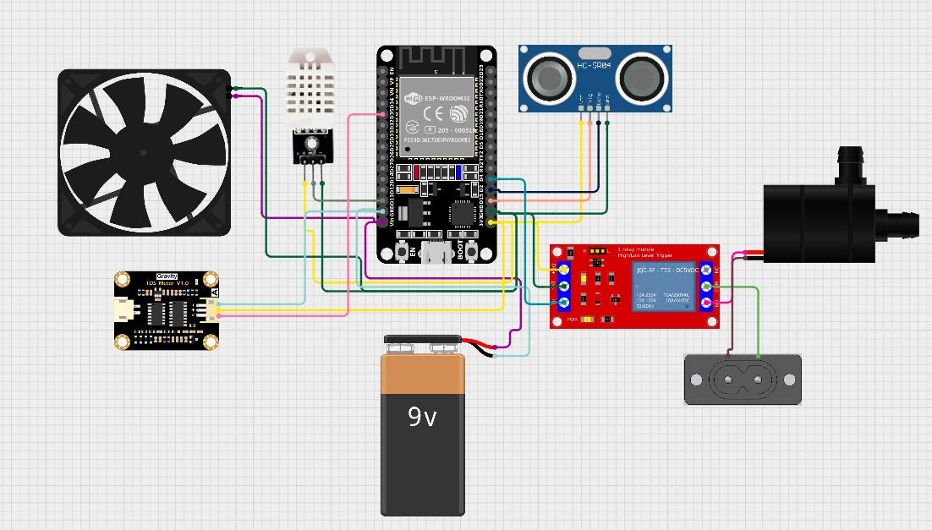

**Figure 2:** Simulated diagram

**COMPONENTS REQUIRED**

**Table 1.** Components

|  |  |  |
| --- | --- | --- |
| SN. | Sample | Quantity (Liter) |
| 1 | ESP32 | 1 |
| 2 | Ultrasonic Sensor | 1 |
| 3 | Relay Module | 1 |
| 4 | Pump | 1 |
| 5 | Cooling Fan | 1 |
| 6 | TDS Sensor | 1 |
| 7 | DHT Sensor | 1 |

**CONCLUSION**

Vertical Hydroponics involves or employs water based nutrient solution instead of soil.Hydroponics offer promising solutions to pressing agricultural challenges like soil erosion ,water scarcity.Also by incorporating hydroponics with IOT provides efficient use of nutrient solution,limits the water usage and provides optimum growth for the plants potentially revolutionizing resource efficiency in farming practices. Vertical hydroponics offers a promising avenue for sustainable food production, with the potential to mitigate environmental impact and enhance food security.

vertical hydroponics stands at the forefront of agricultural innovation, offering a pathway to sustainable food production in an increasingly resource-constrained world. By harnessing its potential and overcoming the associated challenges, we can pave the way for a more resilient, efficient, and environmentally conscious food system—one that nourishes both people and the planet for generations to come. The journey towards agricultural sustainability through vertical hydroponics is not merely an aspiration but an imperative for the future of humanity and the health of our planet.

**NOVELTY**

Using a nutrient-rich water solution, hydroponics is a crop technique that grows plants without the need for soil. Moreover, the nutrients can be obtained from a variety of sources, including fish waste (a technique known as aquaponics), and the water utilized can be recovered and repurposed. Permits a high yield density per unit area when compared to horizontal farming.

**REFERENCES**

1. Elias T. Nerantzis, Tilemachos K. Kolipoulous, Sanjay K. Sharma, Urban Vertical Hydroponics, ISSN 2623-4874 e-ISSN 2623-4882,2018[1]
2. Chow Kheong Keat and Chithrameenal Kannan, Development of a Cylindrical Hydroponics System for Vertical Farming, 10.17265/2161-6264/2015.02.003
3. Dionysios Touliatos, Ian C. Dodd, Martin McAinsh, Vertical farming increases lettuce yield per unit area compared to conventional horizontal hydroponics,6 June 2016
4. Muhammad E. H. Chowdhury, Amith Khandakar, Saba Ahmed, Fatima Al-Khuzaei, Jalaa Hamdalla, Fahmida Haque, Mamun Bin Ibne Reaz, Ahmed Al Shafei, Nasser Al-Emadi, Design ,Construction and testing of IoT based automated indoor vertical Hydroponics farming test bed in Qatar, 2 October 2020
5. G W Michael, F S Tay and Y L Then, Development of Automated Monitoring System For Hydroponics Vertical Farming 10.1088/1742-6596/1844/1/012024
6. Despommier, D (2009) The Rise of vertical farms. Scientific American, 301(5).
7. Fischetti, M (2008) Growing vertical ,Scientific American, 3, 0,74.
8. Kryzanowski, M, Kuna-Dibbert, B, Schneider, J, (2005) Health effects of transport- related air pollution, WHO, Denmark.
9. Kurasek , B, (2009) The Living Skyscrapper. Farming the Urban Skyline, Vertical Farm Project and living space in Lake Michigian.
10. Ross, J(2010)The Nebraska grout study, Water Well Journal, November, pp25-31.
11. Abdullah, N.-O. Vertical-horizontal regulated soilless farming via advanced hydroponics for domestic food production in Doha, Qatar. Res. Ideas Outcomes2016,2,e8134.
12. Bugbee B. 2019, “284 Towards Efficient Nutrient Management in Recirculating Hydroponic Culture, ”Hortscience, vol.34, no 3, pp. 491C-491.
13. Fischetti, M. (2008) Growing vertical, Scientific American, 3.0,74
14. Polikarakis, J. (2003) Environmental Agriculture, Psichallou publications Greece
15. Computer Aided Optimum Design in Engineering, X, WIT Press, pp. Koliopoulos, T., and Koliopoulou, G. (2007) Evaluation of optimum landfill design: Mid Auchencarroch experimental landfill emissions .
16. Malek Al Chalebi (2015) Vertical farming: Skyscrapper sustainability? Sustainable Cities and society, 18, pp. 74-77.
17. Paulsen, S. Chemigation Safety Devices: Approved Alternative Equipment and Pesticide Label Requirements (2001). Sacramento, California's Department of Pesticide Regulation Web availability as of May 8, 2018:
18. In Alberta Soil Phosphorus Limits Project, Volume 5, 82, Riemersma, S., Little, J., Ontkean, G., and Moskal-Hébert, T. (2006), "Phosphorus sources and sinks in watersheds: A review. Alberta Agriculture, Food and Rural Development, Lethbridge, Alberta, Canada, provides information and evaluations.
19. United Nations. (2007) By 2050, there will be a 2.5 billion rise in the global population. This information may be found online at http://www.un.org/News/Press/docs//2007/pop952.doc.htm. (web access as of May 8, 2018).
20. Grower Training Manual for Backflow Prevention in Pesticide Chemigation, Zoldoske, Jacobsen, and Norum, 2004. The California State University Center for Irrigation Technology http://www.cdpr.ca.gov/docs/emon/grndwtr/chem/grower_manual.pdf University, Fresno, Fresno, CA (web access 8 May 2018).