**EXPERIMENTAL ANALYSIS ON CONCRETE BY PARTIAL REPLACEMENT OF COARSE AGGREGATE BY CERAMIC TILES AND FINE AGGREGATE BY STEEL SLAG**

Rizi Afrin Khan1 , Pawan Dubey2

Student1, Department of Civil Engineering, School of Research and Technology, People’s University, Bhopal M.P.

Associate professor2, Department of Civil Engineering, School of Research and Technology, People’s University, Bhopal M.P.

**ABSTRAT**

This study presents an experimental analysis of concrete incorporating steel slag and crushed ceramic tiles as partial replacements for fine and coarse aggregates, respectively. The research aims to assess the mechanical properties, durability, and sustainability aspects of such concrete mixes. In this study, samples were made with varying percentages of crushed ceramic tile waste and steel slag, including 0%, 20%, 30%, 40%, 60%, 80%, and 100%. After 7 and 28 days of curing, the compressive strength of the steel slag ceramic tile concrete (SSCTC) was measured. The strength of steel slag ceramic tile concrete (SSCTC) is increased by adding steel slag and crushed ceramic tile waste up to 40% for all curing ages up to a certain point. After replacing 40% of the aggregates, the steel slag ceramic tile concrete's strength abruptly drops. With a 40% substitution of steel slag and crushed ceramic tiles, the compressive strength of Steel Slag Ceramic Tile Concrete (SSCTC) improves by 1.22 times. The findings contribute to understanding the feasibility and effectiveness of using steel slag and crushed ceramic tiles as sustainable alternatives in concrete production, offering insights for engineers and researchers seeking to enhance the environmental performance of concrete structures.

Keywords: Steel Slag, Crushed Ceramic Tiles, Eco-friendly Concrete, Workability, Mix Design, Compressive Strength

**INTRODUCTION:**

The primary goal of this study is to replace all or a portion of the coarse and fine aggregate with broken ceramic tiles and steel slag, as the utilisation of natural resources is increasing in the modern day. Because of the increased volume of construction and the daily growth in raw materials needed to make concrete, natural resources are becoming less and less available. As a result, we should employ the waste materials that are produced by the various sectors in the construction sector. This will allow us to use the waste materials while also making them more environmentally friendly and lowering the cost of building. Various mix proportions are investigated to determine the optimal combination that enhances both mechanical strength and environmental benefits. The experimental program includes tests such as compressive strength, flexural strength, split tensile strength, and durability tests to evaluate the performance of the concrete mixes. The findings contribute to understanding the feasibility and effectiveness of using steel slag and crushed ceramic tiles as sustainable alternatives in concrete production, offering insights for engineers and researchers seeking to enhance the environmental performance of concrete structures. In the current project, coarse aggregate will be made of shattered ceramic tiles, while fine aggregate will be replaced with steel slag. In this work, we look at M30 concrete that has shattered ceramic tiles used as coarse aggregate and steel slag substituted for fine aggregate. Compressive strength of material is determined by its characteristics. The outcomes were contrasted with typical concrete properties.

**LITERATURE REVIEW:**

The use of alternative materials as partial replacements for conventional aggregates in concrete has gained significant attention in recent years due to environmental concerns and the need for sustainable construction practices. Steel slag and crushed ceramic tiles are two such alternative aggregates that have been investigated for their potential to enhance the performance and sustainability of concrete mixes.

**Vijay (2018),** The physical, chemical, and mechanical qualities of the object namely, their strength, durability, great angular form, and high resistance to abrasion and impact—are examined in the report. Concrete is tested for strength and durability using split tensile strength and compressive strength tests, which are conducted after adding steel slag in different percentages (10% & 20%) to replace sand for seven and twenty-eight days, respectively. Results indicate that adding steel slag in place of some of the sand improves concrete's strength qualities. The proportion of steel slag in the mixture tends to enhance the compressive strength. If steel slag is substituted for 20% of the fine aggregate, the strength improvement at early ages is greater than that at later ages. In comparison to the control mix, there is an increase of 12% after 7 days and 7% after 28 days when 10% steel slag was added to the mix. 20% steel slag adds a significant amount to the proportion, increasing it to 16% and 27% after 7 and 28 days, respectively.

**Akshay Bhavsar et al (2018),** presented the work relates the use of steel slag, an inexpensive waste material that was used as fine aggregate in M20 grade concrete is recommended to be approved for use in concrete as a substitute for fine aggregates. A preliminary investigation is conducted to examine the impact of partially substituting steel slag for fine aggregate in concrete on its qualities. The properties of M20 conventional concrete include its compressive strength, split tensile strength, and flexural strengths. To replace the 0%, 10%, 20%, and 30% of steel slag added, tests were carried out on concrete cubes, cylinders, and beams to examine these properties. Concrete with steel slag aggregates had comparable compressive, flexural, and splitting tensile strengths to regular concrete. More research is needed to determine the long-term impacts of concrete's hardened qualities, as the strength may change over time.

**Sherin Khan (2019),** studied the effect of shattered ceramic tiles on concrete might result in a 30% increase in the proportion of coarse ceramic tile aggregate. Comparing the specimens to standard concrete, the specimens' compressive strength increases, and then the strength progressively decreases. If waste ceramic tile aggregate is used in place of the natural coarse aggregate, the cube, beam, and cylinder may all reach a maximum strength of 30%. Therefore, waste ceramic may be utilised in rigid pavement design in addition to partially replacing natural coarse aggregate in concrete. To make 1 m3 of M30 grade concrete, the overall savings in rupees when ceramic waste material is substituted for natural coarse aggregate is 16.60%.

**Priyanka Kusum (2021)** highlighted that there is a large potential of future study in the use of recycled aggregate in concrete, namely ceramic tile waste. With greater tile aggregate substitution, concrete becomes more workable. The use of ceramic tile aggregate up to 30% in lieu of coarse aggregate at first boosts the compressive strength of concrete. However, as the mix becomes less cohesive and workable, the compressive strength of concrete declines with subsequent replacements of coarse aggregate. With a ceramic aggregate substitution of up to 30%, the characteristics of concrete rose linearly; after that, they dropped linearly.

**MATERIAL USED:**

1. CEMENT: Cement is a binder in construction; it is a substance that adheres to and sets other materials together. Cement is primarily used to bond materials, like as sand, together.
2. SAND: Sand is the fundamental building ingredient used to make mortar and concrete. A combination that hardens on setting is created when sand, cement, and water are combined. The cement gel formed during cement hydration is what holds the sand particles together.
3. CRUSHED STONE: Concrete's coarse aggregates provide the mixture body and strength and serve as a filler to ensure that the concrete's mass is uniform. Every construction project, whether it be for a building, railway track, road, etc., uses coarse materials. In concrete, coarse aggregate was thought to be purely filler material and chemically inert.
4. STEEL SLAG: A byproduct of the oxidation of impurities in pig iron during the steel-making process is steel slag. Grey is the steel slag with lower alkalinity and brown grey or off-white with greater alkalinity. There are fewer holes and a hard, thick texture with loose, unbonded slag. Steel slag may be used in civil engineering applications to minimise natural resource use and the demand for their disposal.
5. CRUSHED CERAMIC TILES: Ceramic items are an important component of the basic building materials that are utilised in practically all buildings. Ceramics are most frequently used for wall and floor tiles, home ceramics, and sanitary goods. The tile industry accounts for the greatest portion (39%) of the ceramic industry among these sources. Ceramics are useful for ornamentation, but their wastes really pose a hazard to the environment. Tile debris from the ceramics industry, building construction, and building demolition may be utilised to make concrete.

**PREPARATION OF CONCRETE MIX**

In this investigation, hand mixing with a mix percentage of 0.44 w/c was employed. To mix concrete with and without SS and crushed ceramic tiles, calculate the mixing materials based on the mix design and weigh them on a weighing machine. The components, which comprise crushed stone, crushed ceramic tiles, steel slag, sand, and cement, are then put in and well mixed with a trowel for around 2 minutes. To ensure that all of the ingredients are properly combined, water is put onto the plate and blended again. The consistency of the mixture is monitored throughout the process.

SS and crushed ceramic tiles are added to the following concrete mix in quantities ranging from 0% to 100% of the FA and CA respectively. First, prepare the dry mix by mixing for about 2 minutes. Afterward, water is incrementally introduced into the mixture and mixed for an additional two minutes. When SS and crushed ceramic tiles are incorporated together, the mixing duration progressively increases.

1. Top of Form

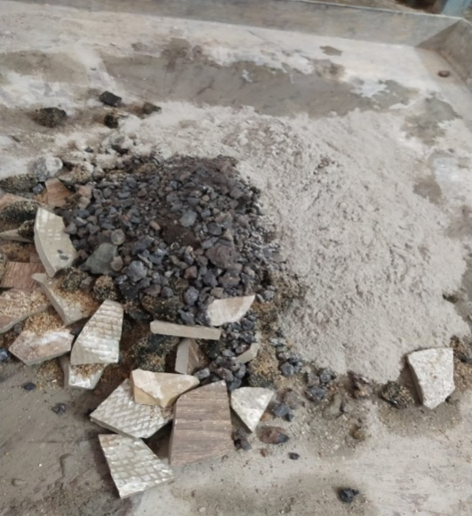 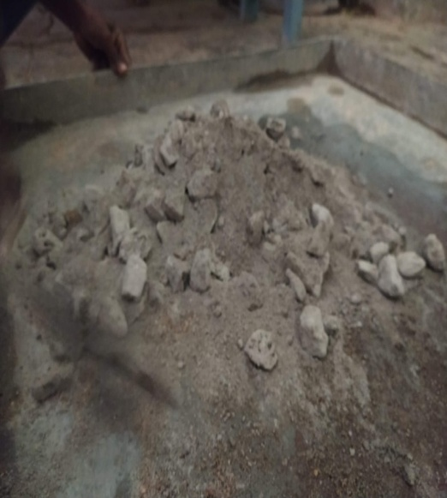

**Fig. 1 Mixing of Ingredients Fig. 2 Dry mixing of concrete**

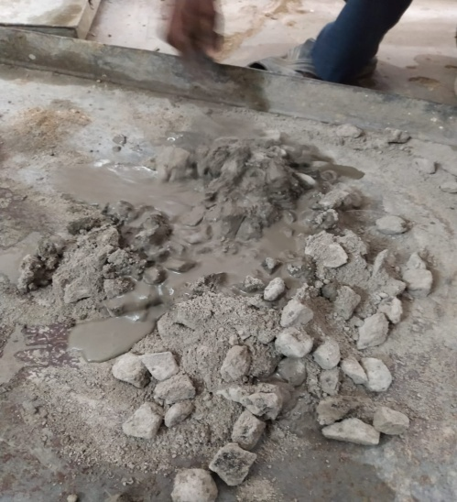

**Fig. 3 Mixing with adding water gradually**

**EXPERIMENTAL SETUP AND RESULTS:**

This study aimed to assess the strength of concrete with steel slag and crushed ceramic tiles as a partial replacement for fine aggregate and coarse aggregate respectively, addressing a research need. Various tests were performed on materials which were used in this concrete , workability and compressive strength after 28 days on a 150 x 150 x 150 mm cubes.

**Table 1: TEST RESULTS ON CEMENT:**

|  |  |  |
| --- | --- | --- |
| **S.No.** | **Properties** | **Test Result** |
| 1. | Fineness Modulus | 1% |
| 2. | Specific Gravity | 3.15 |
| 3. | Standard Consistency | 28% |
| 4. | Initial Setting Time | 40 min |
| 5. | Final Setting Time | 480 min |
| 6. | Compressive Strength |  |
| 3 days strength | 16.25 N/mm2 |
| 7 days strength | 19.27 N/mm2 |
| 28 days strength | * 1. N/mm2 |

**Table 2 :TEST RESULTS ON SAND**

|  |  |  |
| --- | --- | --- |
| **S.No.** | **Properties** | **Test Result** |
| 1. | Grading of Sand | Zone II as per IS 383 |
| 2. | Specific Gravity | 2.68 |
| 3. | Density | 1682 kg/m3 |
| 4. | Water Absorption | 1.73 % |
| 5. | Fineness Modulus | 2.84 |

**Table 3 : TEST RESULTS ON STEEL SLAG AGGREGATE**

|  |  |  |
| --- | --- | --- |
| **S.No.** | **Properties** | **Test Result** |
| 1. | Specific Gravity | 3.28 |
| 2. | Water Absorption | 2.87% |
| 3. | Fineness Modulus | 2.96 |

**Table 4 : TEST RESULTS ON CRUSHED STONE AGGREGATE**

|  |  |  |
| --- | --- | --- |
| **S.No.** | **Properties** | **Test Result** |
| 1. | Fineness Modulus |  |
| 10 mm | 4.67 |
| 20mm | 5.31 |
| 2. | Specific Gravity |  |
| 10mm | 2.56 |
| 20mm | 2.72 |
| 3. | Water Absorption | 1.516 % |
| 4. | Impact Strength | 15.6 % |
| 5. | Fakiness Index | 25.86 % |
| 6. | Elongation Index | 36.04% |

**Table 5: TEST RESULTS ON CRUSHED CERAMIC TILES AAGREGATE**

|  |  |  |
| --- | --- | --- |
| S.No. | PROPERTIES | TEST RESULT |
| 1. | Water Absorption | 4.133 % |
| 2. | Impact Strength | 12.13 % |
| 3. | Flakiness Index | 7.02 % |
| 4. | Elongation Index | 35.38 % |

Table 6: M-30 concrete grade’s workability with and without steel slag and crushed ceramic tiles

|  |  |
| --- | --- |
| **Percentages of steel slag and crushed ceramic tiles** | **Slump value (mm)** |
| 0 % | 78 |
| 20 % | 73 |
| 30% | 71 |
| 40 % | 70 |
| 60 % | 67 |
| 80 % | 63 |
| 100 % | 58 |

**Fig. 4: slump value of different percentage of steel slag and crushed stone**

**Table 7 : COMBINE TABLE FOR COMPRESSIVE STRENGTH OF SSCTC**

|  |  |  |  |
| --- | --- | --- | --- |
| **S.No.** | **Steel Slag and Crushed Ceramic Tiles**  **(%)** | **Average Compressive Strength at 7 Days (N/mm2)** | **Average Compressive Strength at 28 Days (N/mm2)** |
| 1. | 0% | 23.27 | 40.78 |
| 2. | 20% | 23.67 | 40.92 |
| 3. | 30% | 25.25 | 42.68 |
| 4. | 40% | 26.19 | 46.67 |
| 5. | 60% | 23.93 | 38.21 |
| 6. | 80% | 23.78 | 36.24 |
| 7. | 100% | 21.87 | 33.51 |

**Fig. 5 Average Compressive Strength of Concrete with different percentage of Steel Slag and Crushed Ceramic tiles**

**CONCLUSION:**

Based on the given data and approach, the following conclusions were formed .

1. Compared to ordinary concrete, the compressive strength of the concrete mix increases in the percentages of waste ceramic tiles and steel slag 28 days after curing, whereas the percentage of regular concrete decreases.
2. In comparison to ordinary concrete, the workability of the concrete mix declines as the ratio of discarded steel slag and ceramic tiles increases.
3. Since leftover steel slag and ceramic tiles are byproducts of the building industry, they can both be used to make concrete, which makes it an environmentally beneficial building material.
4. Compared to the other mixes, the concrete generated by the M4 mix had a higher compressive strength. Yet, mixtures including up to 40% steel slag and ceramic coarse aggregate can be employed.
5. The usage of ceramic coarse aggregate and steel slag has an effect on the properties of concrete in increment manner.
6. The mechanical properties of concrete are enhanced by the use of ceramic coarse aggregate.
7. Concrete that is formed by substituting coarse and fine aggregate is significantly more stable and long-lasting than ordinary concrete.
8. Concrete that contains up to 40% replacement meets M30 grade design mix requirements for compressive strength; nevertheless, typical concrete loses strength when more steel slag and ceramic waste are added.
9. Accordingly, substituting 40% of the steel slag aggregate and waste ceramic tiles provides the necessary strength and is regarded as the ideal proportion.

**REFERENCE:**

1. Akshay Bhavsar, et al , IJEDR 2018 | Volume 6, Issue 2 | ISSN: 2321-9939 IJEDR1802135 International Journal of Engineering Development and Research (www.ijedr.org) 730 Partial Replacement Of Fine Aggregate Using Steel Slag
2. Priyanka Kusum, International Research Journal of Engineering and Technology (IRJET) e-ISSN: 2395-0056 Volume: 08 Issue: 11 | Nov 2021 “Partial Replacement of Coarse Aggregate by Waste Ceramic Tiles”
3. Sherin Khan, Use of Ceramic Tile Waste in Concrete Mix by Partial Replacement of Coarse Aggregate: An Experimental Study © 2019 JETIR March 2019, Volume 6, Issue 3 www.jetir.org (ISSN-2349-5162)
4. Vijay Department of civil engineering , Shree Baba Mastnath Engineering College, Rohtak © 2018 JETIR July 2018, Volume 5, Issue 7 www.jetir.org (ISSN-2349-5162) JETIR1807672 Journal of Emerging Technologies and Innovative Research (JETIR) www.jetir.org 484 Effect Of Partial Replacement [20%] of Sand by Steel Slag on Strength Characteristics of Pavement
5. IS 10262:2019, Recommended Guidelines For Concrete Mix Design, Bureau of Indian Standard, New Delhi.
6. IS 2386 (Part-1) 1963, Methods of test for aggregates for concrete, Bureau of Indian standard, New Delhi.
7. IS 2386 (Part-3) 1963, Methods of test for aggregates for concrete, Bureau of Indian standard, New Delhi.
8. IS 456-2000 Specifications For Plain And Reinforced Concrete.
9. IS 4031 (Part-1) 1988, Methods of physical tests for hydraulic cement, Bureau of Indian Standard, New Delhi.
10. IS 4031 (Part-2) 1988, Methods of physical tests for hydraulic cement, Bureau of Indian Standard, New Delhi.
11. BIS: 2386 (Part I)-1963 (Reaffirmed 2021): Methods of Test for Aggregates for Concrete, Bureau of Indian Standard, New Delhi-1963.
12. IS 2386:1963 Part-3, Methods of test for aggregates for concrete: Part 3 Specific gravity, density, voids, absorption, and bulking