**A STUDY ON EFFECTIVENESS OF REWARD SYSTEM ON MOTIVATIONAL LEVEL OF IT EMPLOYEES**

1Lavanya K and 2Manoj Kumar M

1MBA student Jerusalem College of Engineering, Chennai

2 Assistant Professor MBA, Jerusalem College of Engineering, Chennai

**ABSTRACT**

The aim of this study was to look at the importance of organization rewards system as a Motivation tool for employee’s performance. More and more organizations are realizing That they have to find a good balance between workers contribution to the organization and the organizations contribution to workers. Therefore, the objective of this study was to investigate what types of rewards motives Employees. Likewise, identifying whether there is a comprehensive total rewards System, and if there is much awareness of total rewards amongst employees. In order to investigate this research firstly looked at the literature around total rewards system and how it can relate to employee motivation and performance. After conducting various Perspectives and studies carried out on rewards systems and employee motivation. These were then outlined for a practical perspective as well as theoretical perspective. The study aims to assess the impact of a reward system on the motivation of IT employees. Through a comprehensive analysis, it will explore how various types of rewards influence employee engagement and productivity within the IT sector. The findings aim to provide valuable insights for organizations seeking to enhance their motivational strategies and foster a more productive work environment for IT professionals. It is concluded that totally rewards system is vital in every industry and since employer’s are looking for talented people. They must produce the types of rewards that will meet Employees needs in order to retain them for long term.

**INTRODUCTION:**

The introduction of a study on the effectiveness of a reward system on the motivational levels of IT employees should begin by outlining the significance of employee motivation in the technology sector. Discuss the pivotal role IT professionals play in organizational success and the challenges they face. Highlight the link between motivated employees and increased productivity, innovation, and job satisfaction. Next, introduce the concept of reward systems and their potential impact on motivation. Explore various types of rewards, such as monetary incentives, recognition, and professional development opportunities. Emphasize the relevance of tailoring rewards to the unique needs and preferences of IT employees. Discuss existing research on motivation and rewards within the IT industry, identifying gaps or inconsistencies that your study aims to address. Clearly state the research objectives and hypothesis, providing a roadmap for the study’s contributions to both academia and practical implications for IT organizations. A reward system is an important tool that managers can use to move employees’ Motivation the way you want. In other words, reward programs seek to attract people to Join the organization to keep them coming to work and to motivate them to work at Higher levels. In different words, reward system attract people to join the organization and also helps to reduce turnover intention of employees. It will encourage them to Work, and motivate them to perform good. The factors that motivates and affect Employee performance are rewards which can be monetary, job security, working Conditions, employer-employee relationship, autonomy, relationship with colleagues, Training and development opportunities, employee recognition and company’s rules and Policies for rewarding employees. Among all these factors, motivation that comes with Rewards becomes important factor which increases the exceptional contribution by Employees. For an organization to meet its obligations to its shareholders, employees, and the public, its senior management must create a relationship between the organization and the employees that will meet the changing needs of both parties.

**REVIEW OF LITERATURE**

**Nirma Sadamali Jayawardena and Darshana Jayawardena (2020)** Studied on the Extrinsic and intrinsic rewarding system on employee motivation. The study contributed to identify the employee motivational factors in the selected company and to reduce Current labour turnover ratio by identifying the factors which motivate the current Workforce.

**Walters T. Nagwa (2019)** conducted a study on the effect of reward system on Employee performance. The study assesses the degree to which profit sharing affects Employee commitment. Firstly, because reward systems are not a one size fit for every Firm, it will be interesting to investigate the effect of reward system on employee Performance in service firms. Employee task are more routine with a relatively lower Level of creativity and innovation. There is a lower probability for group work and a higher level of specialization and task distinction. It is very important for research to be Done in this direction with the focus of identifying the most appropriate reward system for service firms. Secondly, wages and salaries constitute a significant part of expenses Made by firms. Considering that reward is an important tool that can be used to attract the right employee, keep them and constantly motivate them to perform at optimum Level, reward systems are expected to deliver attractive packages.

**Belachew Kassahun (2019),**identified that employee motivation is a very important Issue that affects every business organization. To provide an excellent service for their customers and to foster development of tourism in the region one and two star rated Hotels as vital place should consider the issue of motivation to satisfy its employees and Grasp success. The rewards that one and two star rated hotels provides for its employee’s payment, promotion, recognition, benefit, work content, and work condition. But the reward system of the one and two star rated hotels is poor and employees were Not treated well by the hotels. This means, the one and two star rated hotels did provide Adequate rewards which incorporates intrinsic and extrinsic for their staff that motivates Them for higher performance. The perception of the hotel employees towards the reward System of the one and two star rated hotels is negative. They believe that the reward System of the one and two star rated hotels is not properly communicated, transparent and fairness. They also felt that the reward system is not externally competitive and Appropriate for hotel employees

**RESEARCH METHODOLOGY:**

The study will utilize a quantitative design, using survey questionnaires to gather data on Employees satisfaction with the effectiveness of reward system on motivational level of its employees. The framework of market research methods and procedures chosen by a researcher is referred to as research Design. The researchers’ design allows to use the most appropriate methodologies for the study and to set up Their investigations successfully in the future as well. This research aimed to explore the effect of using Rewards as motivation and the kinds of rewards employees deem most effective. Quantitative research is typically used to test hypothesis, measure the prevalence or frequency of a particular phenomenon, evaluate the effectiveness off interventions or treatments, and make generalizations about a population based on a sample.

**DATA ANALYSIS**

**1.Gender**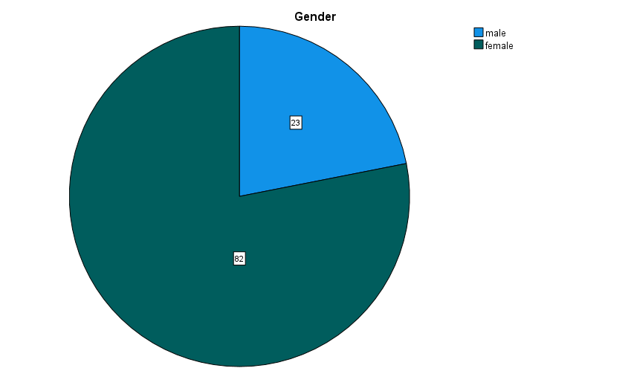

|  |  |  |  |  |  |
| --- | --- | --- | --- | --- | --- |
| **Gender** | | | | | |
|  | | Frequency | Percent | Valid Percent | Cumulative Percent |
| Valid | male | 23 | 2.3 | 21.9 | 21.9 |
| female | 82 | 8.2 | 78.1 | 100.0 |
| Total | 105 | 10.5 | 100.0 |  |
| Missing | System | 893 | 89.5 |  |  |
| Total | | 998 | 100.0 |  |  |

**INTERPRETATION:** From the study it is found that out of 105 responses, 2.3% is from male, 8.2% is from female.

**2. How does your organisation currently recognize and acknowledge your performance?**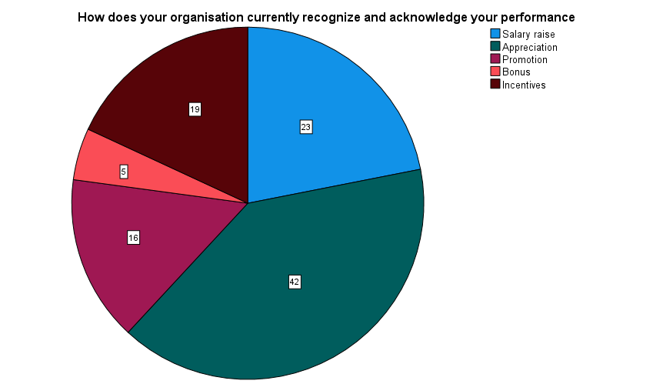

|  |  |  |  |  |  |
| --- | --- | --- | --- | --- | --- |
|  | | Frequency | Percent | Valid Percent | Cumulative Percent |
| Valid | Salary raise | 23 | 2.3 | 21.9 | 21.9 |
| Appreciation | 42 | 4.2 | 40.0 | 61.9 |
| Promotion | 16 | 1.6 | 15.2 | 77.1 |
| Bonus | 5 | .5 | 4.8 | 81.9 |
| Incentives | 19 | 1.9 | 18.1 | 100.0 |
| Total | 105 | 10.5 | 100.0 |  |
| Missing | System | 893 | 89.5 |  |  |
| Total | | 998 | 100.0 |  |  |

**INTERPRETATION:** From the study it is found that out of 105 responses, 2.3% is from Salary raise, 4.2% is from Appreciation, 1.6% is from Promotion, 5% is from Bonus, 1.9% is from Incentives.

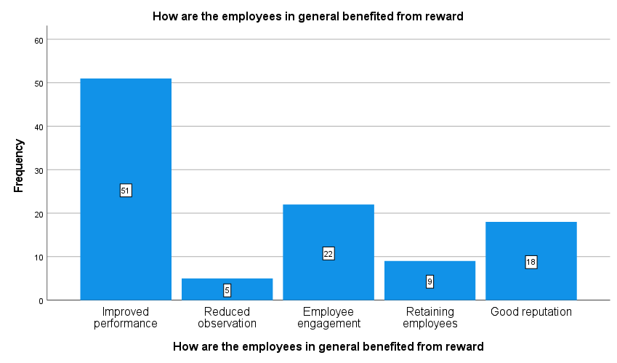**3.How are the employees in general benefited from reward?**

|  |  |  |  |  |  |
| --- | --- | --- | --- | --- | --- |
|  | | Frequency | Percent | Valid Percent | Cumulative Percent |
| Valid | Improved performance | 51 | 5.1 | 48.6 | 48.6 |
| Reduced observation | 5 | .5 | 4.8 | 53.3 |
| Employee engagement | 22 | 2.2 | 21.0 | 74.3 |
| Retaining employees | 9 | .9 | 8.6 | 82.9 |
| Good reputation | 18 | 1.8 | 17.1 | 100.0 |
| Total | 105 | 10.5 | 100.0 |  |
| Missing | System | 893 | 89.5 |  |  |
| Total | | 998 | 100.0 |  |  |

**INTERPRETATION****:** From the study it is found that out of 105 responses, 5.1% is from improved performance, 5% is from reduced observation, 2.2% is from Employee engagement, 9% is from Retaining employees, 1.8% is from good reputation.

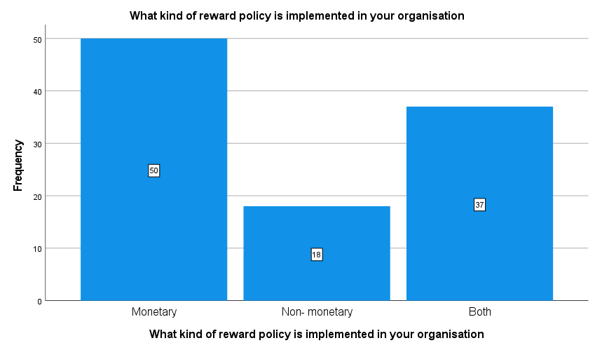**4.What kind of reward policy is implemented in your organisation?**

|  |  |  |  |  |  |
| --- | --- | --- | --- | --- | --- |
|  | | Frequency | Percent | Valid Percent | Cumulative Percent |
| Valid | Monetary | 50 | 5.0 | 47.6 | 47.6 |
| Non- monetary | 18 | 1.8 | 17.1 | 64.8 |
| Both | 37 | 3.7 | 35.2 | 100.0 |
| Total | 105 | 10.5 | 100.0 |  |
| Missing | System | 893 | 89.5 |  |  |
| Total | | 998 | 100.0 |  |  |

**INTERPRETATION**

From the study it is found that 5.0% is from monetary, 1.8% is from non- monetary, 3.7% is from both.

**5.ANOVA TEST**

Analysis of Variance (ANOVA) is a statistical formula used to compare variances across the means (or average) of different groups. A range of scenarios use it to determine if there is any difference between the means of different groups.

**NULL HYPOTHESIS:** There is no significance difference between experience and reward system in our company.

**ALTERNATIVE HYPOTHESIS:** There is significance difference between experience and reward system in our company.

|  |  |  |  |  |  |
| --- | --- | --- | --- | --- | --- |
| **ANOVA** | | | | | |
| How many years have you been working in your company | | | | | |
|  | Sum of Squares | df | Mean Square | F | Sig. |
| Between Groups | 7.345 | 3 | 2.448 | 3.469 | .019 |
| Within Groups | 71.284 | 101 | .706 |  |  |
| Total | 78.629 | 104 |  |  |  |

**INFERENCE**

From the above table, we find that the significant value is 0.019, which is less than the table value 0.05, so the null hypothesis is rejected and alternative hypothesis is accepted.

Therefore, there is relationship between experience and reward system in our company improved by performance.

**6.CORRELATION**

Correlation is a statistical measure that expresses the extent to which two variables are linearly related (meaning they change together at a constant rate). It’s a common tool for describing simple relationships without making a statement about cause and effect.

**Null hypothesis:** There is no correlation between experience and reward system in our company improved by performance.

**Alternative hypothesis:** There is correlation between experience and reward system in our company improved by performance.

|  |  |  |  |
| --- | --- | --- | --- |
| **Correlations** | | | |
|  | | Reward system in our organisation improved by performance | How many years have you been working in your company |
| Reward system in our organisation improved by performance | Pearson Correlation | 1 | -.076 |
| Sig. (2-tailed) |  | .442 |
| N | 105 | 105 |
| How many years have you been working in your company | Pearson Correlation | -.076 | 1 |
| Sig. (2-tailed) | .442 |  |
| N | 105 | 105 |

**INFERENCE**

From the above table, we find that significant value is 0.442, which is greater than table value 0.05, so the null hypothesis is accepted and alternative hypothesis is rejected.

Therefore, there is no relationship between experience and reward system in our company improved by performance.

**7. CHI-SQUARE TEST**

Chi-square is a statistical test used to examine the differences between categorical variables from a random sample in order to judge the goodness of fit between expected and observed results.

**Null hypothesis:** There is no significance association between gender and do you agree that reward system is fair and equitable among employees with varied experience in the organisation.

**Alternative hypothesis:** There is significance association between gender and do you agree that reward system is fair and equitable among employees with varied experience in the organisation.

|  |  |  |  |  |  |
| --- | --- | --- | --- | --- | --- |
| **Chi-Square Tests** | | | | | |
|  | Value | df | Asymptotic Significance (2-sided) | Exact Sig. (2-sided) | Exact Sig. (1-sided) |
| Pearson Chi-Square | 8.013a | 1 | .005 |  |  |
| Continuity Correctionb | 6.479 | 1 | .011 |  |  |
| Likelihood Ratio | 7.198 | 1 | .007 |  |  |
| Fisher's Exact Test |  |  |  | .009 | .007 |
| Linear-by-Linear Association | 7.936 | 1 | .005 |  |  |
| N of Valid Cases | 105 |  |  |  |  |
| a. 0 cells (.0%) have expected count less than 5. The minimum expected count is 5.04. | | | | | |
| b. Computed only for a 2x2 table | | | | | |

**INFERENCE:**

From the above table, we find that the significant value is .007, which is less than table value 0.05, so the null hypothesis is rejected and alternative hypothesis is accepted.

There is no significant association between gender and do you agree that reward system is fair and equitable among employees with varied experience in the organisation.

**FINDINGS**

According to the study, from the above table, it is found that out of 105 responses, 2.3% is from male, 8.2% is from female. According to the study, from the above table, it is found that out of 105 responses, 2.3% is from Salary raise, 4.2% is from Appreciation, 1.6% is from Promotion, 5% is from Bonus, 1.9% is from Incentives. According to the study, from the above table, it is found that out of 105 responses, 5.1% is from improved performance, 5% is from reduced observation, 2.2% is from Employee engagement, 9% is from Retaining employees, 1.8% is from good reputation. According to the study, from the above table, it is found that out of 105 responses, 1.8% is from non- monetary, 3.7% is from both. According to the study, from the above table, we find that the significant value is 0.019, which is less than the table value 0.05, so the null hypothesis is rejected and alternative hypothesis is accepted. Therefore, there is relationship between experience and reward system in our company improved by performance. According to the study, from the above table, we find that significant value is 0.442, which is greater than table value 0.05, so the null hypothesis is accepted and alternative hypothesis is rejected. Therefore, there is no relationship between experience and reward system in our company improved by performance. According to the study, from the above table, we find that the significant value is .007, which is less than table value 0.05, so the null hypothesis is rejected and alternative hypothesis is accepted. There is no significant association between gender and do you agree that reward system is fair and equitable among employees with varied experience in the organisation.

**SUGGESTIONS FOR IMPROVEMENT**

* Many rewards system have been used and developed for the past few years, all the decision about the Reward system have come from upper managers, the Employees have not had any possibility to influence the development process.
* Therefore, I suggest that the company should include the employees in the Decision-making process. This could be done by giving the employees an Opportunity to frequently give feedback on the reward system.
* The respondents felt that it was unfair in the company-based rewards the people Don’t work hard get rewarded by the hard work of others.
* Therefore, I suggest that larger percentage of profit sharing could be paid out According to their individual performance.

**CONCLUSION**

Employee’s motivation is one of the most essential parts in the company’s Development and success. It is hence vital for an employer to understand what Motivates the employees and how to maximize their overall job performance. Employee reward and recognition by programs that acknowledge employee Contribution to the company’s goal and show appreciation for that efforts are Necessary for a high-performing workplace, happier employee. The purpose of Rewards is to motivate employees thereby increasing the result of the organization.

**BIBLIOGRAPHY:**

1.Nirma Sadamali Jayawardena and Darshana Jayawardena, The impact of Extrinsic and intrinsic rewarding system on employee motivation in the context of Sri Lankan apparel sector, International Journal of Business Excellence, Volume 20, Issue 1, 2020

2. Walters T. Ngwa, Effect of Reward System on Employee Performance Among Selected Manufacturing Firms in the Littoral Region of Cameroon, Academy of Strategic Management Journal, Volume 18, Issue 3, 2019

3. Belachew Kassahun, Reward System and its Effect on Employees Work Motivation in One and Two Star Rated Hotels in Amhara Region, Ethiopia, Journal of Tourism, Hospitality and Sports, Vol.40, 2019

4. Zhen Zhang, Lianying Zhang, Aibin Li, Investigating the Effects of Reward Interdependence and Nonfinancial Incentives on NPD Collaboration in Diverse Project Teams, Vol 50, Issue 6, 2019

5. Yoko Kitakaji, Susumu Ohnuma, The Detrimental Effects of Punishment and Reward on

Cooperation in the Industrial Waste Illegal Dumping Game, Vol 50, Issue 5, 2018

6. Said Juma Al Darmak, Driving Innovation: Reviewing the Role of Rewards, Journal of Human Resource and Sustainability Studies, 2017, 7, 406-415

7. Ofelia Robescu and Alina-Georgiana Iancu, The Effects of Motivation on Employees Performance in Organizations, Valahian Journal of Economic Studies, Volume:7 Issue: 2 Date: 2016

8. Abdifatah Abdilahi Ali, Analysis of Extrinsic Rewards and Employee Satisfaction: Case of Somtel Company in Somaliland, International Journal of Business Management and Economic Research (IJBMER), Vol 6(6),2015, 417- 435

9. Ayesha Binte Safiullah, Impact of Rewards on Employee Motivation of the Telecommunication Industry of Bangladesh: An Empirical Study, Volume 16, Issue 12. Ver. II (Dec. 2014)

10. Dr. Baskar, Prakash Rajkumar. K. R, A Study on the Impact of Rewards and Recognition on Employee Motivation, International Journal of Science and Research (IJSR), Index Copernicus Value (2014)