**ANALYSIS AND DESIGN OF G+5 RESIDENTIAL BUILDINGS BY USING ETABS**

**Thota Badrinath*, Shaik Adam Sharief *, Shaik Nayab Rasool *, Ratnavathu Kalyan Nayak *, Pasupuleti Devi Venkata Anu Vara prasad * and**

**P. Narendra Babu1**

*UG Students – Final year, 1Associative professor and HOD

Department of Civil Engineering,NRI Institute of Technology, Agiripalli, India

**Abstract –** Due to growing population and less available land, multi – storied building is constructed to provide accommodation for many families in limited area. In this project, we have drafted G+5 building plan in AutoCAD and Analysis and Design of structure is done by using Etabs and then Scheduling and controlling is done by using Primavera software. Management of a construction project mission entails the multi directional interaction of dynamic forces represented by its scope, time, resources, costs, and quality. There is a dynamic link on how to manage scope, resources, product quality and how to stay within time and budget limits. Here we are use primavera p6 to defined in terms of quality specifications, completion time, budgeted costs.

**Key Words:** AUTOCAD, ETABS, Analysis and design

## INTRODUCTION

## Now a days, the people from village are coming to towns for employment and educational facilities hence with the limited land available so as to proposed the apartment building and individual houses are feasible with each other. The main objective of this project is to analysis and to construction scheduling of an apartment building (G+5) using Etabs and Primavera P6 software. First of all, the planning is done using AutoCAD and code refers for this project is IS 456-2000. The first and foremost thing which we can get by effectively planning in primavera is start date and finishing date of the project. Primavera P6 helps in effectively scheduling the project by assigning two relationships at a time to each activity and considerably reduces the float. All the important steps like creating an EPS, creating a WBS, linking of activities according to their interdependence and availability of resources and determination of critical path are clearly exhibited in this report.

## LITERATURE REVIEW

Following are the research works conducted on analysis and design of structures by using different softwares.

**Sarah (2016)** – ETABS demonstrated proficiency in modeling nonlinear behavior, providing accurate predictions of structural performance under extreme conditions.

**David** **(2017)** – Parametric studies revealed significant variations in structural behavior, emphasizing the importance of parameter selection in design.

**Chen (2017)** – High user satisfaction with features – Requests for enhanced customization options – Performance issues with large datasets.

**Jhonson et al. (2018) –** Resistance to change among stakeholders – Lack of IT infrastructure in some agencies – Positive impact on project transparency.

**Smith** **et al. (2018)** -Improved project scheduling – Enhanced communication among teams – Challenges in initial setup and training.

**Rachel (2018)** – ETABS offered comprehensive tools for concrete design, facilitating efficient and accurate structural analysis and detailing.

**John et al. (2018)** – ETABS showed faster analysis and design iterations compared to SAP2000, while both yielded similar results in structural analysis.

**Williams et al. (2019)** – Limited support for Agile methodologies in Primavera – Workarounds to adapt Agile practices – Potential for future software updates to address Agile needs.

**Pate et al. (2019) –** Significant reduction in project delays – better resource allocation – Complex learning curve for users.

**Mark et al. (2019)** – ETABS accurately predicted wind-induced structural responses, aiding in the design of resilient structures against wind loads.

**Jane (2019)** – ETABS demonstrated high accuracy in predicting structural behavior under different loading conditions, with minimal computational time.

**Garcia et al. (2020)** – Improved resource allocation efficiency – Challenges in tracking resource utilization accurately – Need for more robust reporting capabilities.

**Michael** **(2020)** – ETABS provided robust seismic analysis capabilities, accurately predicting structural responses to seismic forces.

**Brown et al. (2020)** – Improved cost estimation accuracy – Better tracking of project expenses – Integration challenges with other software.

**Nguyen et al. (2021)** – Streamlined data exchange between BIM and Primavera – Improved project visualization and coordination – Technical challenges in software integration.

**Emily (2021)** – ETABS integration with BIM streamlined the design process, facilitating seamless data exchange and collaboration among stakeholders.

1. **OBJECTIVES**

* To understand basic principles of the structure using IS codes.
* To analysis the structural details of the structure.
* To understand the design parameter of the beams, slab, column and other structural entities.
* To prepare the 3D model of the structure by use of the software for detailed design and analysis.
* To design G +5 residential building using ETABS software in order to design and analyse the building.

1. **METHODOLOGY**

The seminar topic “Design of an RCC structure using ETABS”, starts with drafting a plan of building in AUTO CADD software. After completion of the drafting process, the designing of the slab, beam, and column is to be done. The design of the columns, beams, slabs (Two-way and one-way slab) have been done according to IS 456 norms. The procedure as follows, starting with the data collection for the designing of the particular building. In which the information like type of the building, building plan, floor to floor height, plinth height, depth of foundation, BCS of soil, wall thickness, and assumed loading factors including floor finish, roof finish, live load and dead load. The material to be used in the structure is to be defined too. Additionally, structural planning of the purposed project for deciding the position of columns, followed by positioning of beams and spanning of slabs. The numbering and nomenclature for members are then done in order to facilitate the easy in the practice of designing of the member. Sizing of beams and column is to be done according to the specific need of the building. Ultimate load which is also called as factored load for the given member. These comprise of a load of the roof, floor, and bath –WC, loft and balconies. Then comes on of the very important designing procedure, design of the beam. In which the designing of roof beam, floor beams, and plinth beams are done. After the designing of the beams, designing of the column section is done, which comprises of columns in top storey, in an intermediate storey and in the first storey. This all comprises of end columns, intermediate columns and a number of columns on each floor. The design of footing is then done. All the footings are to be designed according to the bearing capacity of the soil below the foundation level of the soil, for example, the bearing capacity of the soil is reasonably low then all the footings are to be designed for axial loads. Finally, the designing of the slabs is carried out using the IS 456, depending upon the type of the slab.

* 1. **PLAN DETAILS**
* Super Built-up area – 3880Sq.ft
* Build up area {4 plots} – 3066Sq.ft
* Single plot area – 766.500 Sq. ft
* Outer wall to compound wall distance {Setbacks} – 6ft
* Each story height: 12ft or 3m.

**4.2 PLAN OF G+5 RESIDENTIAL BUILDING**

**Figure 1 Plan of a floor**

**Figure 2 Line diagram of a floor**

**4.3 IMPORTED PLAN FROM AUTOCAD TO ETABS**

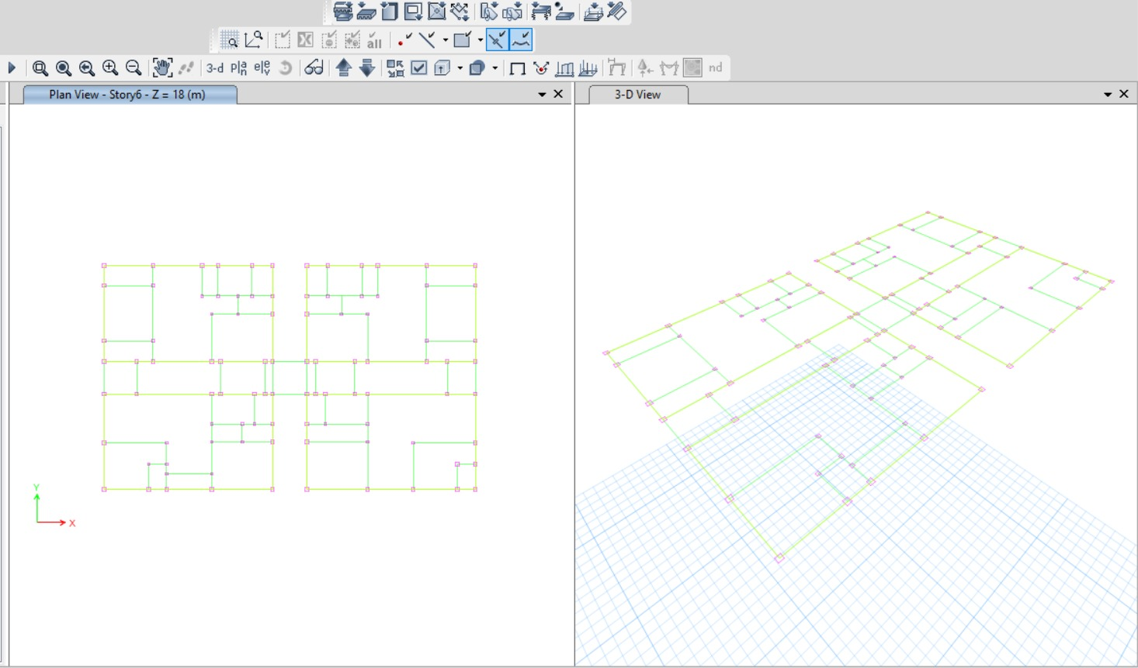

**Figure 3 Plan imported from Autocad to Etabs**

**4.4 LOADS & LOAD COMBINATIONS**

* Dead Load (IS 875-Part-1:1987) Unit Weight of Building Materials.
* Live Load (IS 875- Part-2:1987)
* Wind Load (IS 875-Part-3:1987)
* Seismic Load (IS 1893-Part-1:2002
  1. **LOAD COMBINATIONS**
* 1.5(Dead Load + Live Load)
* 1.2 (Dead Load + Live Load + Wind X)
* 1.2 (Dead Load + Live Load + Wind Y)
* 1.2 (Dead Load + Live Load + Seismic X)
* 1.2 (Dead Load + Live Load + Seismic Y)
  1. **DEAD LOAD**

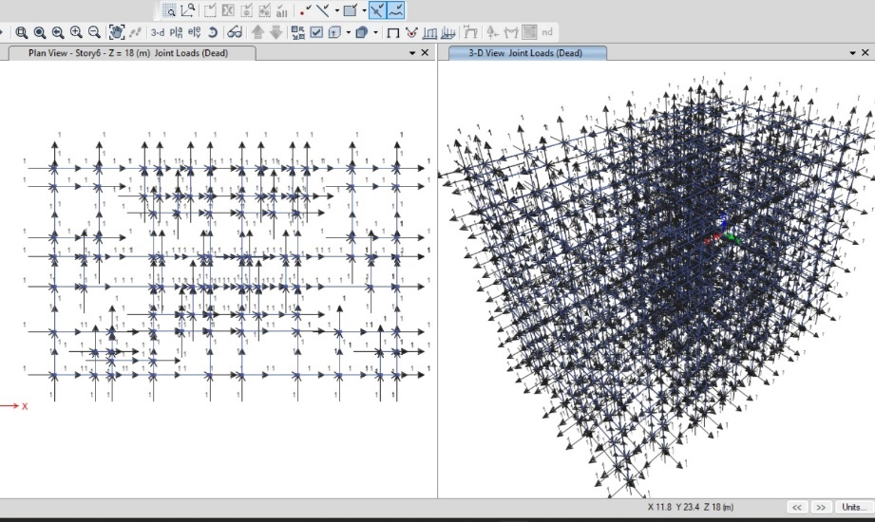

**Figure 4 Dead load on structure**

**4.7 LIVE LOAD**

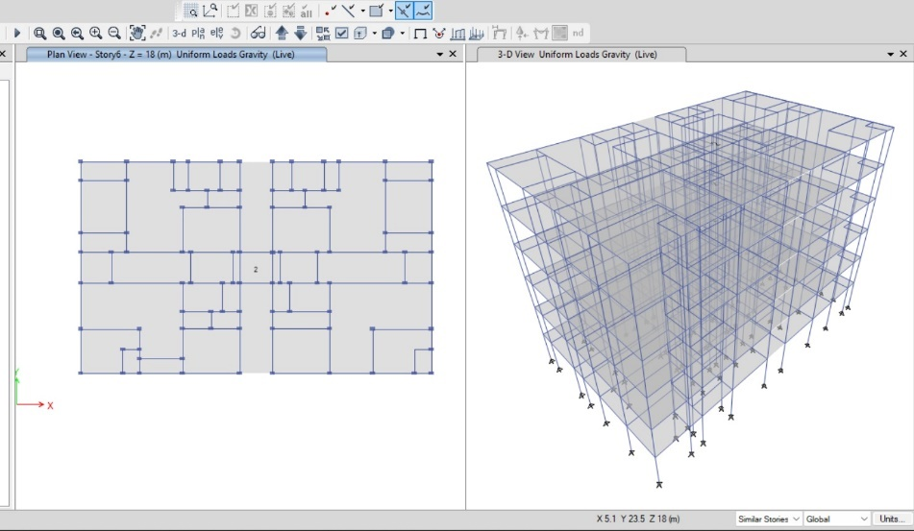

**Figure 5 Live load on structure**

**4.8** SEISMIC LOAD

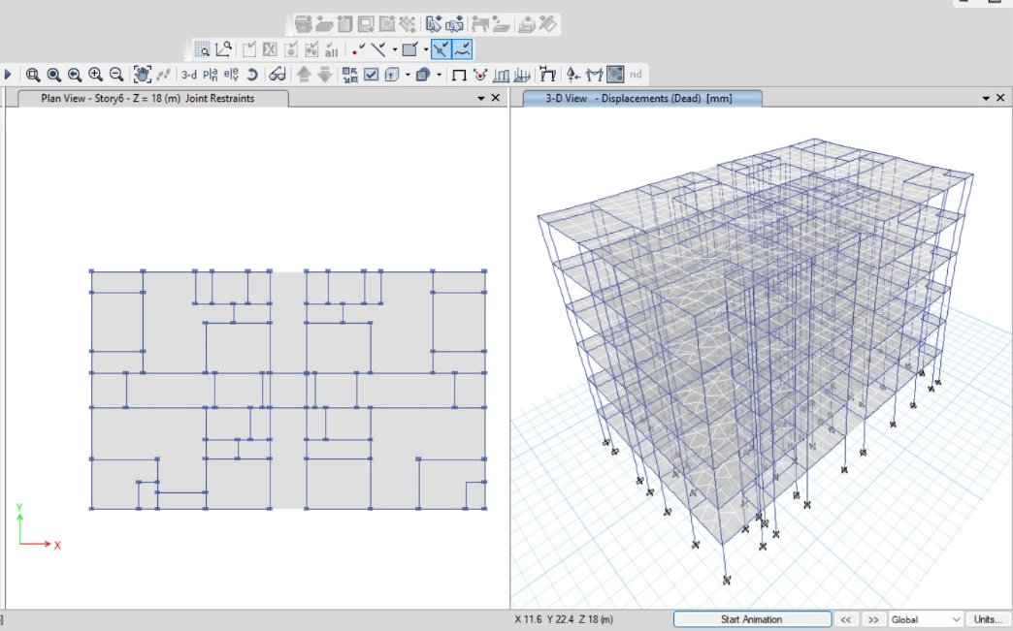

1. **BEAMS AND COLUMNS**

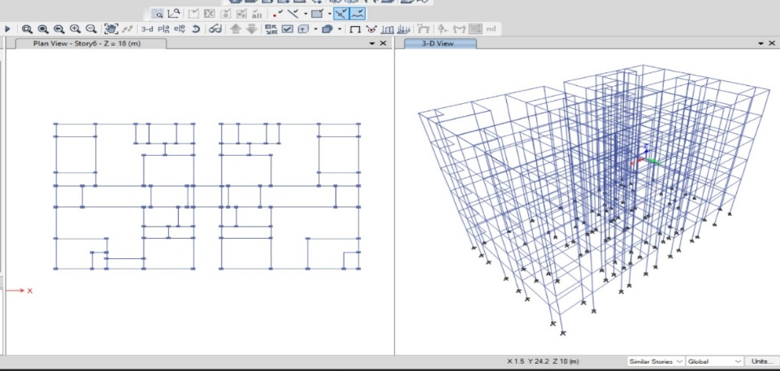

**Figure 6 Applying properties to beams and columns**

1. **SHEAR FORCE AND BENDING MOMENT DIAGRAMS**

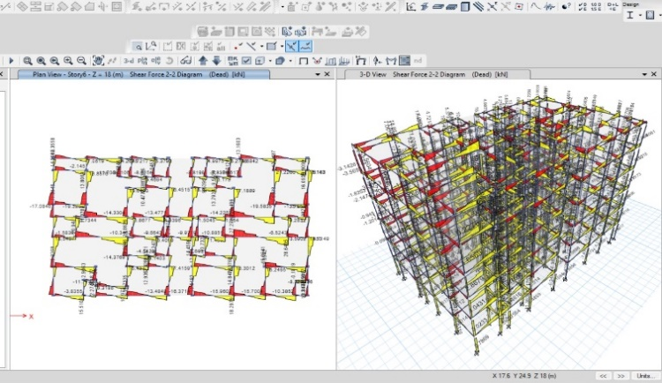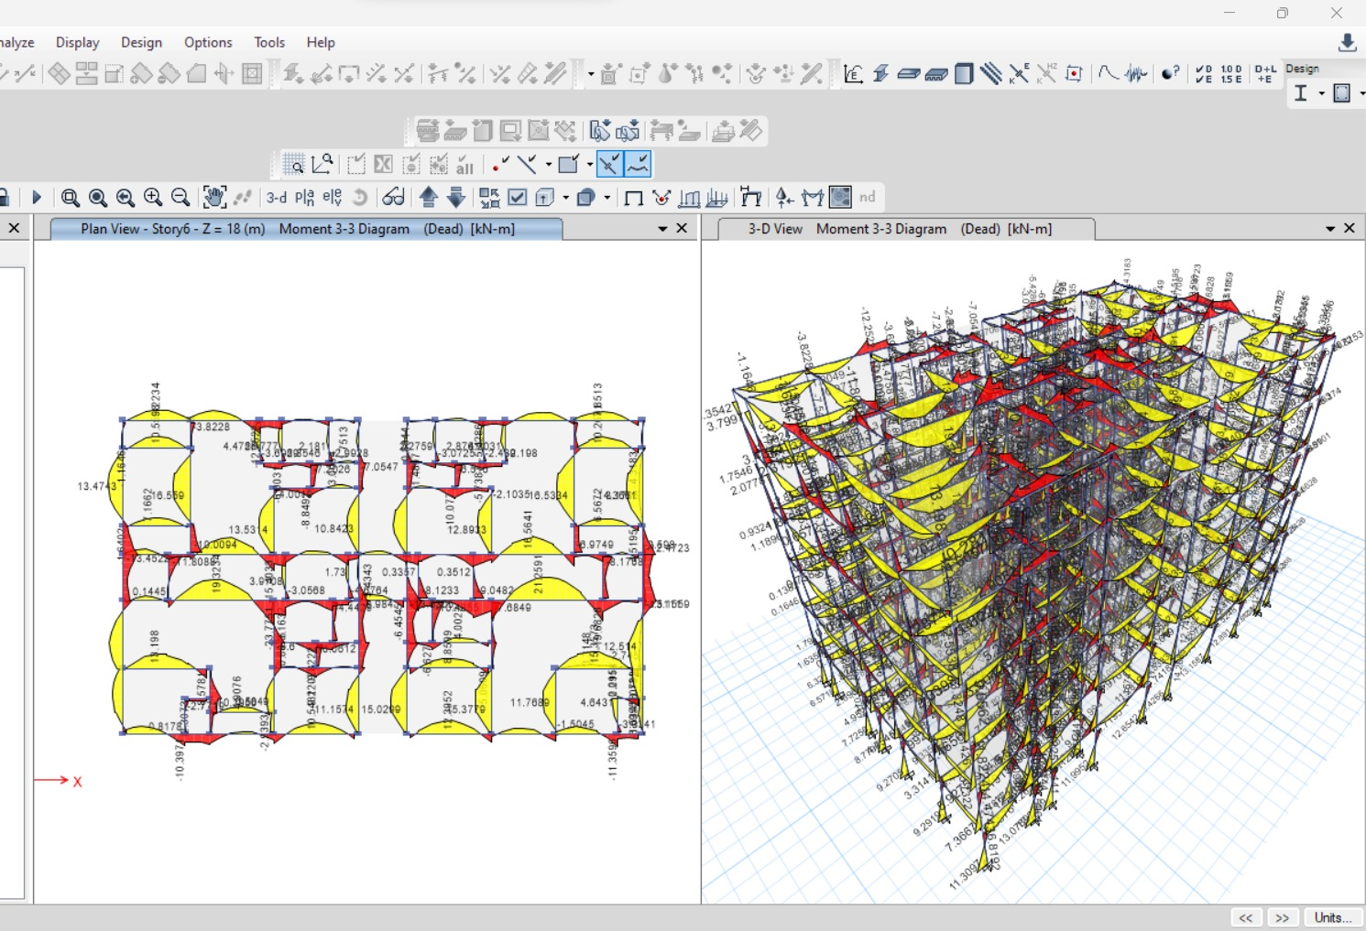

**Figure 7 Shear force and Bending moment of the structure**

1. **TOP AND BOTTOM REINFORCEMENT OF THE BEAMS AND COLUMNS**

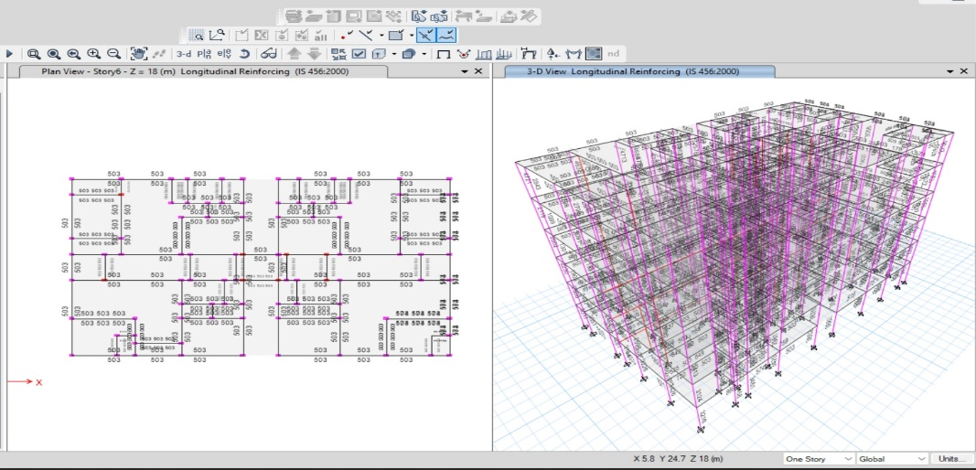

**Figure 8 Top and Bottom reinforcement of beams and columns with value**s

|  |  |  |  |
| --- | --- | --- | --- |
| **TYPE OF COLUMN** | **DIMENSIONS (b.h)**  **mm** | **REINFORCEMENT**  **mm2** | **NO. OF BARS** |
| Column 1 | 230 x 350 | 3481 | 12 bars with 14mm dia |
| Column 2 | 450 x 450 | 3162 | 12 bars with 12mm dia |
| Column 3 | 500 x 500 | 3674 | 12 bars with 14mm dia |

**8 COLUMN DETAIL**

|  |  |  |  |
| --- | --- | --- | --- |
| **TYPE OF BEAM** | **DIMENSIONS (b.h)**  **mm** | **REINFORCEMENT mm2/m** | **NO. OF BARS** |
| Beam 1 | 230 x 350 | 548.55 | 10 bars with 14mm dia |
| Beam 2 | 300 x 450 | 340.66 | 8 bars with 12mm dia |
| Beam 3 | 300 x 600 | 608.28 | 12 bars with 14mm dia |

1. **BEAM DETAIL**
2. **CONCLUSION**

Based on the analysis and design of multi-storied building, the following conclusions are made:

1. Our project deals with provision of earthquake resistant structure which is also economic.
2. Minimum sizes of the beams and columns were provided as B 230mmX450mm and C 350mm x 450 mm, after analysis only the failed column axes and dimensions were changed to C 500 x 500 mm which comes under economic.
3. Seismic analysis was done by using ETABS software and successfully verified manually as per IS 1893-2002
4. There is a gradual increase in the value of lateral forces from bottom floor to top floor in software analysis.
5. Maximum Shear force is 93.8KN and Maximum Bending Moment values is 79.5KN, which is acted at top floor of the building

**11 REFERENCES**

* Lavanya, C. V., Pailey, E. P., Sabreen, M., & Sekhar, U. P. B. C. (2017). Analysis and design of g+5 residential building using ETABS. *International Journal of Civil Engineering and Technology*, *8*(4), 1845-1850.
* Yadav, J. C., & Reddy, L. R. (2017). Dynamic Analysis of G+5 Residential Building in zone2 and zone5 by using ETABS. *Volume VIII*, (3), 333-346.
* Mai, K. K., Amer, M., Ali, M. S., Ahmed, M. F., Omair, M., & Tanveer, A. (2018). Analysis And Design of Residential Building G+5 using E-Tabs. *International Journals of Innovative Technologies ISSN*, 2321-8665.
* Ahamad, S. A., & Pratap, K. V. (2021). Dynamic analysis of G+5 multi storied building by using shear walls in various locations for different seismic zones by using Etabs. *Materials Today: Proceedings*, *43*, 1043-1048.
* Pawar, N. V., Patel, N. S., Maya ram, R., & Verma, Q. M. N. Design and Analysis of G+5 Residential Building Using ETABS.
* Padole, C., Bansod, S., Sukhdeve, T., Dhomne, A., Nagose, M., Hanwate, P., & Varghese, V. (2021). Analysis and Design of G+ 5 Residential Building Using ETABS. *International Journal of Engineering Applied Sciences and Technology*, *5*(12), 254-267.
* KARTEEK, G. S., & POTHULA, M. Analysis and Design of a G+ 10 Residential Building using ETABS for Different Plane Configurations.
* Abdullah, F., Islam, Z., & Sabnam, M. (2021). Comparative Study of Multistoried (G+ 5) Residential Building using ETABS Software and Manual Calculation. *Journal of Structural Technology*, *6*(2), 1-7.
* Mehta, N., & Butala, A. Comparative Study of G+ 7 Storey Residential Building in Seismic Zone 5.Saibabu, J., Asadi, S. S., & Prakash, S. B. (2017). Relability of Implementing Primavera P6 in Fast-Track Planning of Residential Building. *International Journal of Civil Engineering and Technology*, *8*(1), 245-56.
* Naji, S., Çelik, O. C., Alengaram, U. J., Jumaat, M. Z., & Shamshirband, S. (2014). Structure, energy and cost efficiency evaluation of three different lightweight construction systems used in low-rise residential buildings. Energy and buildings, 84, 727-739.
* Mahesh, S., & Rao, M. D. B. P. (2014). Comparison of analysis and design of regular and irregular configuration of multi Story building in various seismic zones and various types of soils using ETABS and STAAD. IOSR Journal of Mechanical and Civil Engineering, 11(6), 45-52.
* Gaikwad, S. S., & Kushwah, R. S. PLANNING, SCHEDULING AND CONTROLLING OF RESIDENTIAL BUILDINGS USING PRIMAVERA & MS EXCEL.