**A STUDY ON EMPLOYEE MOVITATION AT KHIVARAJ TECH PARK PVT LTD**

S Divya and Praveen S V

MBA student Jerusalem College of Engineering, Chennai

Assistant Professor and Department of MBA, Jerusalem College of Engineering, Chennai

**ABSTRACT**

Employee motivation is the creativity, the energy levels, and the commitment that the employees bring to their job. Even though employees’ motivation doesn’t directly influence organization’s growth, it is like a necessary pre-condition as a result of lack of motivation among the employees can have a harmful impact on their performance. Motivation plays an important role to meet the company’s goals. In an Organization the motivated employees can lead to increased productivity and allow to achieve higher levels of output. Therefore, in today’s world each organization tries to manage their human resource department to stay their employees motivated. This qualitative study aims to explore the factors influencing employee motivation within Khivaraj Tech Park Pvt Ltd, a leading organization in the sector. By delving into the perspectives of employees, managers, and human resources personnel, this research seeks to identify the key drivers of motivation, as well as potential barriers and challenges faced by employees in maintaining high levels of engagement and commitment. A sample size of 101 was taken in order to conduct research. Chi Square and correlation were employed to analyze the data. The data amassed was meticulously organized, coded, and subsequently subjected to thorough analysis using statistical and frequency tabulations, all facilitated by SPSS software.

**Keywords**: Employee motivation, organization, productivity**.**

**INTRODUCTION**

The efficiency of a person depends on two factors, firstly, the level of ability to do a certain work, secondly, the willingness to do the work. So for as the first factor is concerned it can be acquired by education and training, but the second factor can be created by motivation. A person may have several needs and desires. It is only strongly felt needs which becomes motives. Thus motives are a product of needs and desires motives are many and keep on changing with time motives are invisible and directed towards certain goals. Motivation means that process which creates on inspiration in a person to motivation is derived from the word ‘motive’ which means the latest power in a person which impels him to do a work. Motivation is the process of steering a person’s inner drives and actions towards certain goals and committing his energies to achieve these goals. It involve a chain reaction starting with felt needs, resulting in motives which give rise to tension which census action towards goals. It is the process of stimulating people to strive willingly towards the achievement of organizational goals motivation may be defined as the work a manager performs an order to Induce Subordinates to act on the desired manner by satisfying their needs and desires.

Thus motivations is concerned with how behaviour gets started, is energized, sustained and directed. Motivation results from the interaction of both conscious and unconscious factors such as the intensity of desire or need, incentive or reward value of the goal, and expectations of the individual and of his or her peers. These factors are the reasons one has for behaving a certain way.

**REVIEW OF LITERATURE**

Ismajli et al.(2015) identified that the factors that motivate employees as human resources in local government serve as a basis for increasing the service quality. He found that salary of workers, professional advancement and opportunity for promotion appear to be among the most important factors of motivation. The other important factorthat the study revealed are work conditions, as well as the evaluation and the objective assessment of performance measurement.

Ioan Moise Achim, Larisa Dragolea, George Balan (2013) said that the financial side of motivation is widely preferred and known by the both parts –employer and employee.In the present study we shall insist and plead for the possibilities of application and the results of the efficient non - financial motivation plan to the internal climate and the lasting performance of the firm.

Muogbo U.S (2013) found that there existed relationship between employee motivation and the organizational performance. The study reveals that extrinsic motivation given to workers in an organization has a significant influence on the workers performance.

Hafiza et al. (2011) found that there are several factors that can affect employee performance like training and development opportunities, working conditions, worker-employer relationship, job security and company over all policies and procedures for rewarding employees. Among the factors that affect employee performance, motivation that comes with rewards is of utmost importance.

**METHODOLOGY**

The primary objective of this To study the Employee Motivation at Khivaraj Tech Park Pvt Ltd. By delving into the perspectives of employees, managers, and human resources personnel, this research seeks to identify the key drivers of motivation, as well as potential barriers and challenges faced by employees in maintaining high levels of engagement and commitment Descriptive research design is used in the study. Descriptive research includes surveys, finding and enquires. Descriptive research methods can be used in multiple ways and for various reasons. The limitations of the study is respondents are reluctant to response in all cases and since small size of 102 respondents are taken so it is difficult of draw inferences about the population from this sample size. Primary data is collected by providing questionnaire to employees through emails, WhatsApp, etc. Secondary data is collected by analyzing through websites, vlogs, etc.

**ANALYSIS**

1. **PERCENTAGE ANALYSIS FOR AGE VARIABLE**

**TABLE 1 CHART 1**

|  |  |  |
| --- | --- | --- |
| **PARTICULARS** | **FREQUENCY** | **PERCENTAGE** |
| 21-30 | 28 | 27.7 |
| 31-40 | 37 | 36 |
| 41-50 | 26 | 25.7 |
| 51 and ABOVE | 11 | 10.8 |
| TOTAL | 102 | 100% |

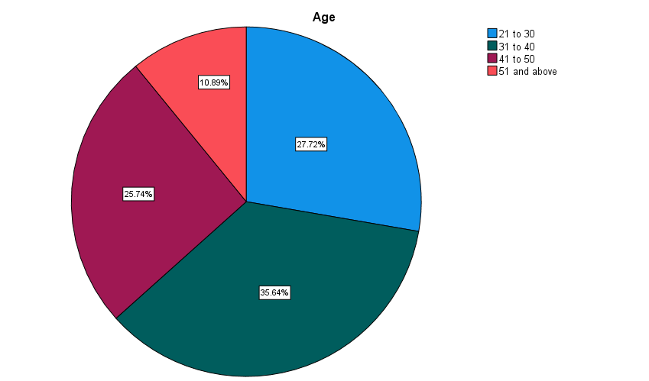

**INFERENCE**

From the above result it is observed that out of 101 respondents 28% are 21-30, , 36% are 31-40, 25.74% are 41-50 and 10.89% are 51 and above.

**2. PERCENTAGE ANALYSIS FOR GENDER VARIABLE**

**TABLE 2 CHART 2**

|  |  |  |
| --- | --- | --- |
| **PARTICULARS** | **FREQUENCY** | **PERCENTAGE** |
| MALE | 54 | 54% |
| FEMALE | 46 | 46% |
| TOTAL | 102 | 100% |

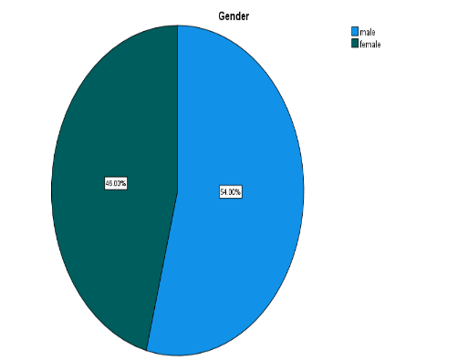

**INFERENCE**

From the above data it is found that out of 101 respondents 54% are male and 46% are females.

**3. PERCENTAGE ANALYSIS FOR EDUCATION QUALIFICATION VARIABLE**

**TABLE 3 CHART 3**

|  |  |  |
| --- | --- | --- |
| **PARTICULARS** | **FREQUENCY** | **PERCENTAGE** |
| BACHELOR | 46 | 45.54% |
| MASTER | 45 | 44.55% |
| DIPLOMA | 10 | 9.90% |
| **TOTAL** | **102** | **100%** |

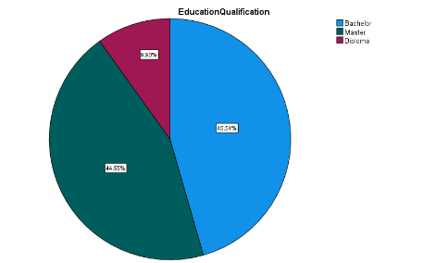

**INFERENCE**

From the above result it is found that out of 102 respondents Bachelor-45.54% , Master-44.55% and Diploma - 9.90%.

**4. PERCENTAGE ANALYSIS FOR THE OPINON OF YOUR PREFERABLE MOTIVATION METHOD**

**TABLE 4 CHART 4**

|  |  |  |
| --- | --- | --- |
| **PARTICULARS** | **FREQUENCY** | **PERCENTAGE** |
| MONETARY | 38 | 37.62% |
| NON- MONETARY | 10 | 9.80% |
| BOTH | 53 | 52.48% |
| TOTAL | 102 | 100% |

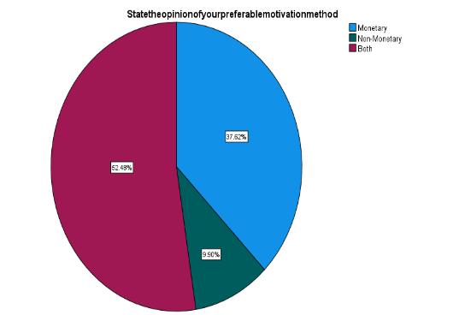

**INFERENCE**

From the above table and chart it is analyzed that out of 102 respondents Monetary- 37.62%, Non-Monetary - 9.80% and Both 52.48%.

**5. PERCENTAGE ANALYSIS FOR THE FOLLOWING MOTIVATION FACTOR**

**THAT MOTIVATES YOU MOST**

**TABLE 5 CHART 5**

|  |  |  |
| --- | --- | --- |
| **PARTICULARS** | **FREQUENCY** | **PERCENTAGE** |
| SALARY INCREASE | 34 | 33.66% |
| PROMOTION | 14 | 13.86% |
| LEAVE | 11 | 10% |
| MOTIVATIONAL TALKS | 19 | 18.81% |
| RECOGNITION | 24 | 23.76% |
| TOTAL | 102 | 100 |

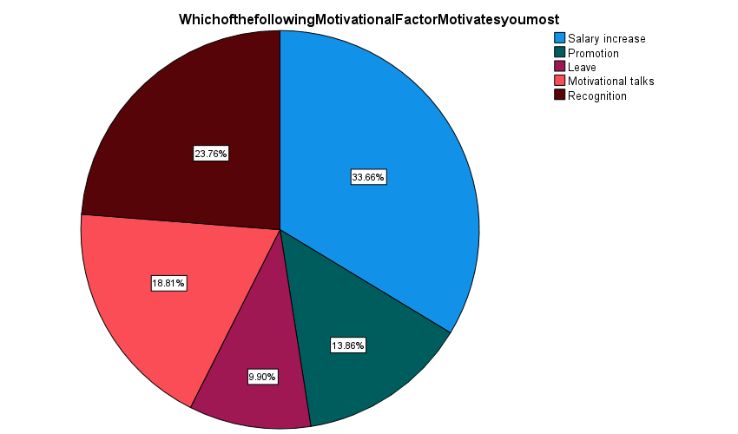

**INFERENCE**

From the above table and chart it is analyzed that out of 102 respondents Salary Increase -33.66%, Promotion - 13.86%, Leave -10%, Motivational- 18.81% and Recognitions – 23.26%.

**CHI SQUARE**

Chi-square test is used to compare relationship between the tew variables. This test allows us to do lot more than test for the quality of several proportions. Chi-square is used to determine whether the two attributes are independent of each other.

**NULL HYPOTHESIS:**

**H0:** There is no association between the opinion of employee preferrable motivation method and the motivation helps to improve employee performance.

**ALTERNATIVE HYPOTHESIS:**

**H1:** There is association between the opinion of employee preferrable motivation method and the motivation helps to improve employee performance.

**TABLE 6**

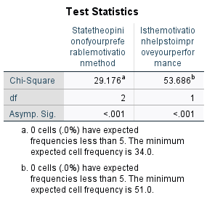

**INFERENCE**

From the above result it is found that the significance have expected frequencies less than 5. The minimum expected cell frequency is 34.0 for State the opinion of your preferable motivation method . Is the motivation helps to improve your performance have expected frequencies less than 5. The minimum expected cell frequency is 51.0.

**CORRELATION ANALYSIS**

To find the relationship between the Relation with superiors as the Motivational Factor to Employees Performance and  How satisfied are you with the level of communication within the company .

**NULL HYPOTHESIS:**

**H0:** There is no relationship Relation with superiors as the Motivational Factor to Employees Performance and  How satisfied are you with the level of communication within the company.

**ALTERNATIVE HYPOTHESIS:**

**H1:** There is a relationship between Relation with superiors as the Motivational Factor to Employees Performance and  How satisfied are you with the level of communication within the company.

|  |  |  |  |
| --- | --- | --- | --- |
| **Correlations** | | | |
|  | | Relation with superiors as Motivational Factor on Employees Performance | How satisfied are you with the level of communication within the company |
| Relation with superiors as Motivational Factor on Employees Performance | Pearson Correlation | 1 | 0.780 |
| Sig. (2-tailed) |  | <.001 |
| N | 102 | 102 |
| How satisfied are you with the level of communication within the company | Pearson Correlation | .780* | 1 |
| Sig. (2-tailed) | <.001 |  |
| N | 102 | 102 |
| *. Correlation is significant at the 0.01 level (2-tailed). | | | |

**INFERENCE**

From the test it is found that the significance value is .001 is less than table significant value (0.000<0.05). H0 is rejected and H1 is accepted.

**FINDINGS**

According to the study the majority of respondent 36% from the age of 31 to 40.According to the study the majority of respondent and 54% are males and 46% are females . According to the study, the majority of respondent Monetary- 37.62%, Non-Monetary - 9.80% and Both 52.48%. According to the study the majority of respondent Salary Increase -33.66%, Promotion - 13.86%, Leave -10%, Motivational- 18.81% and Recognitions – 23.26%. According to the study the value of significance have expected frequencies less than 5. The minimum expected cell frequency is 34.0. According to the study the value of significance have expected frequencies less than 5. The minimum expected cell frequency is 51.0. According to the study of the significant value 0.001 is less than the table significant value (0.000<0.05). H0 is rejected and H1 is accepted. Therefore there is a relationship between the relation with superiors as the Motivational Factor and the level of communication within the company,

**SUGGESTION**

The first thing organization need to understand is that motivation is a process which is effective if continuous in nature and the same is to be made known to the top and middle level management . The organization will have to understand and clear any thoughts otherwise could hinder the process of motivation like; Money is only thing that can motivate employees, fear could be used to achieve results, at the same time organizations need to understand that increased Job satisfaction does not means increased job performance. Organizations will have to design strategies in alignment with corporate goals and objectives and the same to be conveyed to the employees and allow them to know their contribution in achievement of the same. The key to motivating employees is to have a clear understanding of employee expectation and also understand what motivate the employees individually and collective groups. Organizations will have to involve employees in goal setting and decision making; this will increase employee participation and give a sense of responsibility in achievement of organizational goals and objective.Organizations have to develop performance management system which effectively rewards, recognizing and appreciating positively and consistently. Organization will have to create career development and advancement opportunities to the employees. An environment promoting team spirit, knowledge sharing and employee engagement to allow employees identify themselves with the organization. Organization has to design and frame organizational structure and processes such as training and development, performance management, compensation and rewards etc which supports and facilitate work and helps creating a motivated and committed environment in the organization. Organization has to design and frame organizational structure and processes such as training and development, performance management, compensation and rewards etc which supports and facilitate work and helps creating a motivated and committed environment in the organization.

**CONCLUSION**

On the basis of the data analysis and interpretations the research come to know that following points :

▪ Respondents get opportunity to express their views.

▪ There is a cooperative relationship between workers and management. Motivation is abstract quality, for which measurement become to difficult task because of the non-availability of standardized test for it.

▪ Attitude of workers towards supervisor and co-workers is also extremely favorable.

▪ Attitude of workers towards organization is extremely favorable.

**REFERENCES**

1. Naim Ismajli, Jusuf Zekiri, Ermira Qosja and Ibrahim Krasniqi. (2015), “The importance of motivational factors on Employee performance at Kosovo Municipalities”, Journal of Political Sciences Public Affairs, DOI: 10.4172/2332-0761.1000152..

2. Ioan Moise Achim, Larisa Dragolea and George Balan (2013), “The importance of employee motivation to increase organisational performance”, Annales Universitatis Apulensis Series Oeconomica, vol.15, no: 2, Pg: 685 – 691.

3. Hackman, J.R., & Oldham, G.R. (1980). Work redesign. Readings, MA: AddisonWesley.

4. Muogbo U.S (2013), “The influence of motivation on employee’s performance: A study on selected firms in Anambra state”, The International Journal of Engineering and Science, Vol. 2 no. 7, Pg: 70 – 80, ISSN (p): 2319 – 1805

5. Rajeswari Devadass (2011), “Employee motivation in organizations: An integrative literature review”, International Conference on Sociality and Economics Development IACSIT Press, Singapore IPEDR, Vol.10, no.2, Pg: 560 – 570..

6. Elizabeth Boye Kuranchie-Mensah and Kwesi Amponsah-Tawiah (2016), “Employee motivation and work performance: A comparative study of Minning companies in Ghana”, Journal of Industrial Engineering and Management, vol. 9, no: 2, Pg: 255-309. [Navaneetha et. al., Vol.5 (Iss.5): May 2018] ISSN: 2454-1907 DOI: 10.5281/zenodo.1255343 Http://www.ijetmr.com©International Journal of Engineering Technologies and Management Research [25]