**SCHEMES OFFERED BY THE UNORGANIZED LABOUR WELFARE BOARDS OF THE GOVERNMENT OF TAMIL NADU**

**Varunprasath.D1,Jayashree.J2, Kesavamoorthy.S3, Vedamuthu.N4, Dr. A.Rajesh Kumar5**

1,2,3,4Research Student, Computer Science and Engineering, N.S.N. College of Engineering & Technology, Karur, Tamil Nadu, India.

5Associate Professor, Computer Science and Engineering, N.S.N. College of Engineering & Technology.

**ABSTRACT**

In the ever-changing landscape of digital services and government initiatives, our project embarks on a mission to empower citizens with a revolutionary chatbot known as SchemeSetu. The intelligent chatbot serves as a central information hub, consolidating crucial details on government sponsored loans and insurance schemes from various sources. Harnessing cutting-edge technologies and natural language processing, SchemeSetu acts as a unified gateway to essential financial assistance programs. Drawing information from reputable institutions like NABARD and RBI, our innovation not only simplifies access but also enriches the user experience. Individuals can effortlessly explore, comprehend and benefit from a range of governmental financial offerings. With SchemeSetu, our aim is to transform how individuals interact with access government services, fostering financial literacy and promoting inclusivity in financial matters. **Keywords:** Chatbot, Government schemes.

**1. INTRODUCTION**

The Government of Tamil Nadu, like many other state governments in India, has established Unorganized Labour Welfare Boards to address the needs and welfare of workers in the unorganized sector. These boards typically introduce various schemes aimed at providing social security, healthcare, education, and other benefits to workers who are not covered by formal employment structures. These schemes are typically administered at the district or regional level through various welfare boards or agencies established by the government. They play a crucial role in improving the living standards and socio-economic conditions of workers in the unorganized sector, contributing to their overall well-being and empowerment.

**2. METHODOLOY**

**2.1 EXISTING SYSTEM**

In the government provides many schemes for everyone. However, knowledgeable individuals can easily find information about these schemes. While uneducated people struggle to access it. This presents a significant challenge for them to apply for and benefit from these schemes. Schemes can be provided from different websites through different strategies and without having Tamil language guide. The website's interface looks old-fashioned and doesn't meet today's standards.

**2.2 DISADVANTAGES**

* Limited Access to Technology
* Data Privacy and Security Concerns
* Accuracy and Reliability of Information

**2.3 PROPOSED SYSTEM**

The proposal entails the development of a user-friendly web portal integrated with a chatbot to aid individuals, especially those with limited education or resources, in accessing government schemes. To begin, thorough research and surveys will be conducted to understand the specific needs and challenges faced by the target demographic. Collaborating with web developers and UX/UI designers, the portal will be designed for simplicity with intuitive navigation and clear instructions, accommodating both Tamil and English languages. The chatbot, utilizing natural language processing, will provide personalized assistance regarding scheme details, eligibility criteria, and application procedures. Continuous content updates and outreach efforts will ensure accessibility and awareness. Feedback mechanisms and regular evaluations will drive ongoing improvements, ultimately creating an effective tool for enhancing access to vital government support for all users.

**2.4 ADVANTAGES**

* Online Accessibility and Convenience.
* Efficiency and Time Savings.
* Improved Accuracy and Data Management.

**3. MODELING AND ANALYSIS**

A system architecture or systems architecture is the conceptual model that defines the structure, behavior, and views of a system. An architecture description is a formal description and representation of a system organized in a way that supports reasoning about the structures and behaviors of the system. A system architecture can comprise system components, the externally visible properties of those components, and the relationships (e.g., the behavior) between them. It can provide a plan from which products can be procured and systems developed that will work together to implement the overall system. There have been efforts to formalize languages to describe system architecture; collectively these are called architecture description languages (ADLs).Conducting such modeling and analysis would require collecting relevant data on the implementation and outcomes of the schemes, employing appropriate statistical and analytical techniques, and engaging stakeholders for feedback and insights. The findings from the modeling and analysis can then inform policy decisions, resource allocation, and program improvements to enhance the welfare of unorganized laborers in Tamil Nadu.

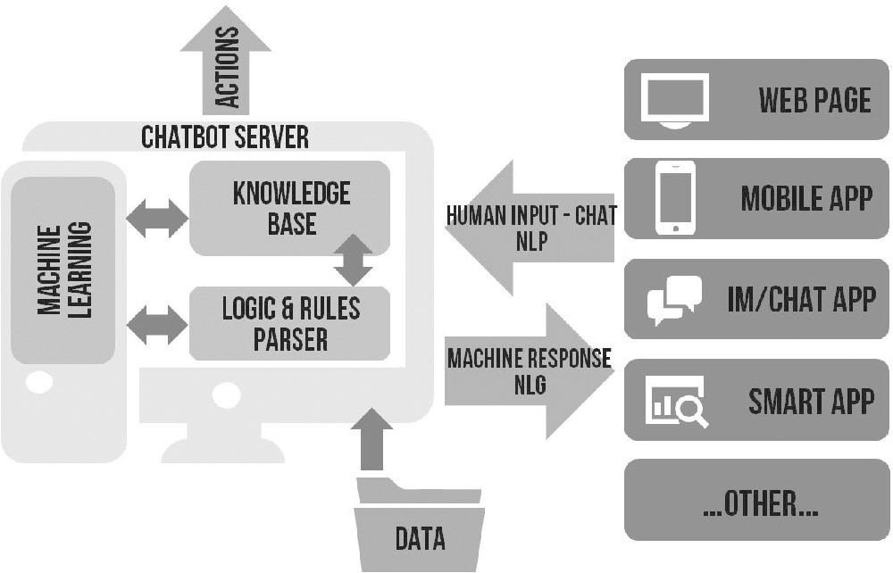**Existing System Architecture**

**Chatbot Server:** A chatbot server can be deployed to provide instant responses to queries related to the welfare schemes. It can offer information about eligibility criteria, application procedures, and benefits of the schemes.

**Machine Learning:** Machine learning algorithms can be applied to predict demand for welfare services, detect fraudulent activities, and automate routine tasks such as document verification and eligibility assessment.

**Knowledge Base:** A knowledge base can be maintained to store information about the welfare schemes, including FAQs, case studies, success stories, and best practices. This resource can be accessed by workers, administrators, and support staff to enhance their understanding and effectiveness.

**Logic & Rules Parser:** A logic and rules parser can be employed to ensure compliance with regulations and guidelines governing the welfare schemes. It can automate decision-making processes and enforce consistency in the application of eligibility criteria and benefits.

**Human Input-Chat NLP:** Human input through chat NLP (Natural Language Processing) can help in understanding the queries and concerns of workers better. This input can be used to improve the responses provided by chatbots and other automated systems.

**Machine Response NLG:** Natural Language Generation (NLG) techniques can be utilized to generate personalized messages, notifications, and alerts for workers. This can enhance engagement and improve the overall user experience.

**Web Page:** A dedicated web page can serve as a comprehensive resource hub for information related to the welfare schemes. Workers can visit the web page to access forms, guidelines, updates, and other relevant details.

**Mobile App:** A mobile app can be developed to provide easy access to information about the welfare schemes. Workers can use the app to apply for schemes, track the status of their applications, receive notifications, and access support services.

**IM/Chat App:** An instant messaging or chat application can be integrated with the welfare scheme infrastructure to facilitate communication between workers and authorities. This can streamline the process of seeking assistance or clarifications regarding the schemes.

**Smart App:** A smart app can leverage technologies like GPS, biometrics, and push notifications to enhance the user experience and ensure efficient delivery of welfare services. It can provide personalized recommendations and reminders based on the user's profile and preferences.

**Data:** Data analytics can be employed to analyze demographic trends, scheme utilization patterns, and effectiveness metrics. This data-driven approach can help in identifying areas for improvement and optimizing resource allocation.

**4. RESULTS**

# Analysis of the schemes offered by the Unorganized Labour Welfare Boards of the Government of Tamil Nadu reveals significant participation among eligible unorganized laborers. Across the state, participation rates vary, with certain regions exhibiting higher engagement than others. Demographic analysis indicates a diverse beneficiary profile, with participation spanning various age groups, genders, occupations, and geographical locations. While challenges persist, including logistical hurdles and awareness gaps, the overall impact of the welfare schemes on the lives of unorganized laborers underscores the importance of continued support and strategic interventions to foster inclusive growth and socio-economic development across Tamil Nadu. Collaborative efforts involving government agencies, non-governmental organizations, and community stakeholders are essential to sustain the momentum and maximize the impact of welfare schemes on the lives of unorganized laborers in Tamil Nadu.

# 5.CONCLUSION

The analysis has revealed commendable participation rates and positive impacts on various indicators, including income levels, employment opportunities, access to healthcare, and financial stability. However, disparities in scheme utilization and persistent challenges such as gender imbalances and logistical hurdles highlight the need for targeted interventions and collaborative efforts.By fostering a supportive environment and promoting equitable access to opportunities, we can strive towards creating a more inclusive and prosperous society for all unorganized laborers in Tamil Nadu. In conclusion, an agricultural scheme chatbot holds significant potential to revolutionize the way farmers access information, navigate government programs, and make informed decisions to enhance their agricultural practices. Through the integration of artificial intelligence (AI) technologies, such as natural language processing (NLP), machine learning (ML), and voice recognition, agricultural scheme chatbots can provide personalized, accessible, and efficient support to farmers and stakeholders across the agricultural sector.

# 6. REFERENCES

1. Abu Shawar, B., & Atwell, E. (2019). Chatbots: Are they really useful? LDV-Forum: Zeitschrift Fur Computer linguistic Und Sprach technologies, 22(1), 29–49 10.1.1.106. 1099.

2. Athey .S, The Impact of Machine Learning on Economics. Economics of Artificial Intelligence. University of Chicago Press. Atkinson. K, Baroni. P, Giacomin. M, Hunter. A, Prakken. H, Reed.C, Villata. S (2020). Toward Artificial Argumentation. AI Magazine, 38(3), 25–36.

3. Augenstein, I., Derczynski, L., & Bontcheva, K. Generalization in named entity recognition: A quantitative analysis. Computer Speech & Language, 44, 2020, 61–83.

4. Baskerville, R. L. (2023). Investigating Information Systems with Action Research. Communications of the Association for Information Systems, 2(3), 1–32. <http://www.cis>. gsu.edu/~rbaskerv/CAIS_2_19/CAIS_2_19.html.

5. Baskerville, R. L., & Myers, M. D. (2023). Special issue on Action Research in Information Systems: Making IS Research Relevant to Practice: Foreword. MIS Quarterly, 28(3), 329–335.