**A STUDY ON EMPLOYEES ABSENTEEISM AT OLYMPIA TECKPARK PRIVATE LIMITED**

Buvaneshwari K and Praveen S V

MBA student Jerusalem College of Engineering, Chennai

Assistant Professor and Department of MBA, Jerusalem College of Engineering, Chennai

**ABSTRACT**

Absenteeism in Indian industries has become usual phenomenon. It is a vital issue that requires immediate attention by both employers and employees. Absenteeism is a habitual pattern of absence from a duty or obligation. It’s a mistake to think that absenteeism is always a product of laziness or employees who try to get out of work whenever they can. This paper attempts to spotlight various causes of absenteeism ranging from personal issues to poor work environment, occupational diseases, work overtime , bad working conditions and inadequate welfare conditions, lack of trained laborers, insecurity in employment, collective bargaining process, rigid control system, lack of supervisory support, lack of interest, lack of cohesive and cordial culture and so on. This research also highlights the ways to reduce the absenteeism of the employees in the organization.

**INTRODUCTION**

Employee Absenteeism is referred to herein as failure of employees to report for work when they are scheduled to work. Employees who are away from work on recognized holidays, vacations, approved leaves of absence, or leaves of absence allowed for under the collective agreement provisions would not be included. Employee Absenteeism is a habitual pattern of absence from a duty or obligation.Traditionally, Employee absenteeism has been viewed as an indicator of poor individual performance, as well as a breach of an implicit contract between employee and employer; it was seen as a management problem. More recent scholarship seeks to understand Employee absenteeism as an indicator of psychological, medical, or social adjustment to work.

High absenteeism in the workplace may be indicative of poor morale but absence can also be caused by workplace hazards or sick building syndrome. Many employees use statistics such as the Bradford factor that do not distinguish between genuine illness and absence for inappropriate reasons.

**REVIEW OF LITERATURE**

**K.A. Hari Kumar(2012)** stated that the rate of absenteeism in madura coats In very high.

**Ruchi Sinha (2010)** in her study reveals that there only 4% employees remain away from their work and that too due to personal reasons. There is very high Level of job satisfaction among the employees.

**Nisam(2010)** stated that stress among employees, health problems, loneliness at Workplace, non-cooperation of colleagues causes absenteeism at workplace.

**Wolter H.J. Hassink & Pierre Koning (2009)** find statistically significant difference in patterns across group of workers with different eligibility statuses depending on their attendance records and whether they had previously won.One finding is that absenteeism rose among workers, who having won already, were ineligible for further participation. Nevertheless, and although the reduction in firm-wide absence with the lottery drifted from 2.4%points to 1.1%points after seven months,the authors conclude that the lottery was of net benefit to the firm.

**Giber. et(1992)** Studied if continuous exposure to air conditioning during working hours has an observable effect on health. Absenteeism from ill health recorded by company doctors was compared in two groups of employees of the frence national Electric and gas company in western Frances working in similar jobs and spending most of their time in either air- conditioned offices or a natural atmosphere.

**Knowles (1979)** opined that although absence from work may be due to any of a large number of factors empirical evidence supporting the view that causal factors can be organizational in nature is scant. Absence may be regarded as one facet of a wider  behavioral problem pervading entire organizational sub-units.

**The labour bureau (1962)**defines absenteeism as the total shifts lost because of absence as percentage of the total number of man shifts scheduled to work.

**METHODOLOGY**

Research methodology is defined as a more systematic activity directed towards discovery and the development of an organized body of knowledge.The primary objective of this to study the employees absenteeism in olympia teckpark (chennai) private limited. Descriptive research design is used in the study. Descriptive research includes surveys, finding and inquires. Descriptive research methods can be used in multiple ways and for various reasons. The limitations of the study is respondents are reluctant to response in all cases and since small size of 108 respondents are taken so it is difficult of draw inferences about the population from this sample size. Primary data is collected by providing questionnaire to organization employees, through emails, WhatsApp, etc. Secondary data is collected by analyzing through websites, vlogs, etc.

**ANALYSIS**

1. **PERCENTAGE ANALYSIS FOR AGE VARIABLE**

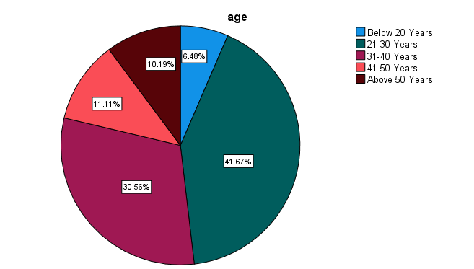 **TABLE 1** **CHART 1**

|  |  |  |
| --- | --- | --- |
| **PARTICULARS** | **FREQUENCY** | **PERCENTAGE** |
| Below 20 | **7** | 6.5% |
| 21-30 | 45 | 41.7% |
| 31-40 | 33 | 30.6% |
| 41-50 | 12 | 11.1% |
| ABOVE 50 | 11 | 10.2% |
| TOTAL | 108 | 100% |

**INFERENCE**

From the above result it is observed that out of 108 respondents 7% are Below 20, 45% are 21-30, 33% are 31-40, 12% are 41-50 , and 11% are above 50.

1. **PERCENTAGE ANALYSIS FOR GENDER VARIABLE**

**TABLE 2 CHAT 2**

|  |  |  |
| --- | --- | --- |
| **PARTICULARS** | **FREQUENCY** | **PERCENTAGE** |
| MALE | 61 | 56.5% |
| FEMALE | 47 | 43.5% |
| TOTAL | 108 | 100% |

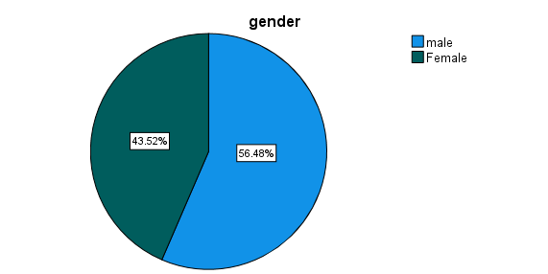

**INFERENCE**

From the above data it is found that out of 108 respondents 61% are Male and 47% are Female.

**3.PERCENTAGE ANALYSIS FOR EDUCATION QUALIFICATION VARIABLE**

**TABLE 3 CHART 3**

|  |  |  |
| --- | --- | --- |
| **PARTICULARS** | **FREQUENCY** | **PERCENTAGE** |
| BACHELOR | 27 | 25.0% |
| MASTER | 36 | 33.3% |
| DIPLOMA | 28 | 25.9% |
| OTHERS | 17 | 15.7% |
| TOTAL | 108 | 100% |

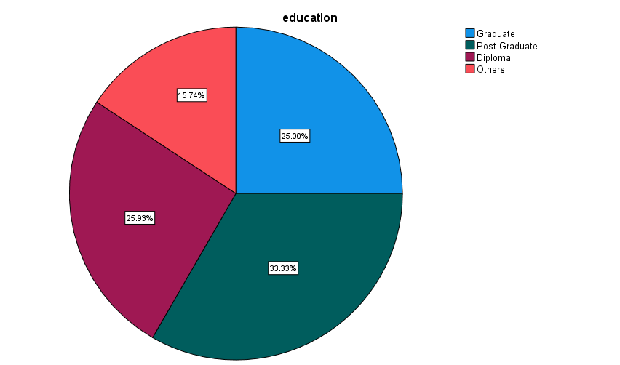

**INFERENCE**

From the above result it is found that out of 108 respondents Bachelor-27% ,Master-36%,

Diploma 28 & Others 17.

**4.THE MAIN REASON FOR EMPLOYEES ABSENTEEISM**

**TABLE 4 CHAT 4**

|  |  |  |
| --- | --- | --- |
| **PARTICULARS** | **FREQUENCY** | **PERCENTAGE** |
| HEALTH PROBLEM | 23 | 21.3% |
| STRESS | 40 | 37.0% |
| WORK DISSATISFIED | 13 | 12.0% |
| WORK RESPONSIBLE | 10 | 9.3% |
| FUNCTIONS | 22 | 20.4% |
| TOTAL | 108 | 100% |

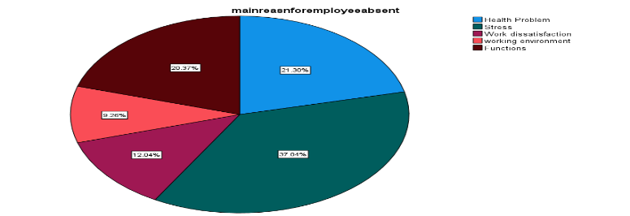

**INFERENCE**

From the above result it is found that out of 108 respondents 23% Health problem, 40% Stress,13% Work dissatisfied, 10% Work responsible, 22% Function.

**5.HOW SATISFIED ARE YOU WITH YOUR WORK**

**TABLE 5 CHAT 5**

|  |  |  |
| --- | --- | --- |
| **PARTICULARS** | **FREQUENCY** | **PERCENTAGE** |
| HIGHLY SATISFIED |  |  |
| SATISFIED | 23 | 21.3% |
| NEUTRAL | 57 | 52.8% |
| DISSATISFIED | 13 | 12.0 |
| HIGHLY DISSATISFIED | 8 | 7.4% |
| TOTAL | 108 | 100% |

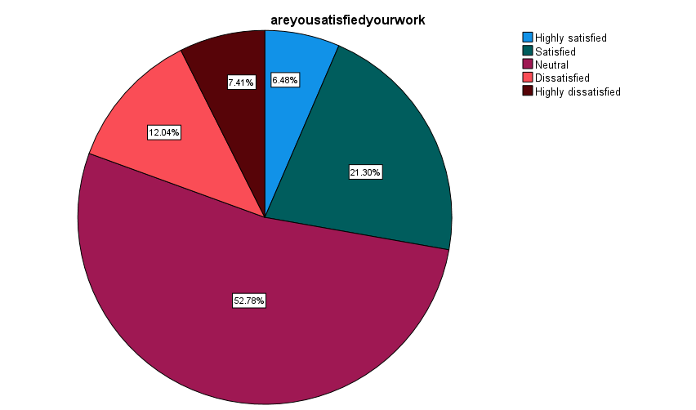

**INFERENCE**

From the above table and chart it is analyzed that out of 108 respondents Highly satisfied-7%,Satisfied-23% , Neutral 57%, Dissatisfied 13%, & Highly dissatisfied 8% .

**ONE-WAY (ANOVA) TEST**

To find out the difference between the do you work overtime, satisfy your work overtime in your organization, adequate facilities provided in you organization.

**NULL HYPOTHESIS:**

**H0:** There is no significant difference between the do you work overtime, satisfy your work overtime in your organization, adequate facilities provided in you organization.

**ALTERNATIVE HYPOTHESIS:**

**H1:** There is significant difference between the do you work overtime, satisfy your work overtime in your organization, adequate facilities provided in you organization.

**TABLE 6**

|  |  |  |  |  |  |  |
| --- | --- | --- | --- | --- | --- | --- |
| ANOVA | | | | | | |
|  | | Sum of Squares | df | Mean Square | F | Sig. |
| Do you have work overtime | Between Groups | 1.152 | 4 | .288 | 1.881 | <.001 |
| Within Groups | 15.765 | 103 | .153 |  |  |
| Total | 16.917 | 107 |  |  |  |
| Satisfy working hour in your organization | Between Groups | 21.942 | 4 | 5.485 | 5.649 | <.001 |
| Within Groups | 100.021 | 103 | .971 |  |  |
| Total | 121.963 | 107 |  |  |  |
| Are you adequate facilities provided in your organization | Between Groups | 3.081 | 4 | .770 | 3.925 | <.001 |
| Within Groups | 20.215 | 103 | .196 |  |  |
| Total | 23.296 | 107 |  |  |  |

**INFERENCE:**

From the one-way ANOVA test it is found that the significant value of .001 is more than table value of 0.5, the null hypothesis is accepted. That is,there is no significant difference between the work overtime are satisfied work environment & facilities provided.

**CHI-SQUARE TEST:**

To find the relationship between do you work overtime and facilities provided in you organization.

**NULL HYPOTHESIS:**

**H0:** There is no relationship between do you work overtime and facilities provided in you organization.

**H1:** There is relationship between do you work overtime and facilities provided in you organization.

**TABLE 7**

|  |  |  |
| --- | --- | --- |
|  | Do you work overtime | Facilities provided in your company |
| Chi-Square | 40.333 a | 80.148b |
| df | 1 | 4 |
| Asymp. Sig. | .000 | .000 |

**Test Statistics**

**INFERENCE:**

From the above result it is found that the significance have expected frequencies less than 5. The minimum expected cell frequency is 21.6

**FINDINGS**

According to the study, 108respondents 7% are Below 20, 45% are 21-30, 33% are 31-40, 12% are 41-50 , and 11% are above 50. According to the study61% are male and 47% are females. According to the study, Bachelor-27% ,Master-36%,Diploma 28 & Others 17. According to the study,23% Health problem, 40% Stress,13% Work dissatisfied, 10% Work responsible, 22% Function. According to the study Highly satisfied -7%, Satisfied-23% , Neutral 57%, Dissatisfied 13%, & Highly dissatisfied 8% . According to from the test it is found that the significance value is 0.119 which is higher than the table value 0.5, the Null hypothesis was accepted. That is There is relationship between work overtime and facilities provided. According to the study value the significance value is <.001 which is higher than the table value 21.6, the Null hypothesis was accepted. That is There is relationship between factors of work overtime, management support, from the above result it is found that the significance value (.005) is less than the table value (0.5). Therefore, the null hypothesis was rejected. That is, there is an association between. That is, there is no significant difference between the significance value is 288 which is higher than table value 0.1, the null hypothesis was rejected.,that there is no significant between do you feel motivated when completely your daily task & are you been rewarded for tasking risk at work.

**SUGGESTIONS AND CONCLUSION**

More experienced staff are generally less likely to be absent. So hire more experienced people. Offer an attractive salary package. Because highly paid employees are less likely to be absent, so offering an attractive compensation package can build loyalty and reduce absenteeism. Small things that can have a big effect and ensure that your employees are happy to come into office. So provide a pleasant work environment. Consider introducing more predictable working hours and limiting overtime as these measures can help to reduce employees absenteeism

Absenteeism can be controlled and reduced to a great extent if the workers are committed and are supported by all levels of management. An effective attendance record keeping system, consultation and open communication by the management can create the healthy productive work environment in the company. This would reduce grievances and give greater employee satisfaction. Further it throws light to the fact that absenteeism can’t be reduced by providing better Medical facilities and salary. Absenteeism is universal problem and every organization should strive to tackle this problem in the possible way.

## REFERENCE

1. **Ernest B. Akyeampong,** Trends and seasonality in Absenteeism.
2. **Mariajosé Romero** and **Young-Su Lee,** A National Portrait of Chronic Absenteeism in the Early Grades.
3. M**orten Nordberg** and **Knut Røed**, Absenteeism, Health Insurance, and Business Cycles.
4. **K Ashwathappa,** (1997) Human Resource and Personnel Management,Tata Mc Graw- Hill 131-176
5. **Chris Dukes**, (2001) Recruiting the Right Staff
6. **John M**. Ivancevich, Human Resource Management, Tata McGraw- Hill, 2004
7. **Steve Kneeland**, (1999) Hiring People, discover an effective interviewing system; avoid Hiring the wrong person, recruit outstanding performers
8. **Stone, Harold C and Kendell,** W.E Effective Personnel Selection Procedures, 1956
9. **Mikalachki et Jeffrey Gandz,** (1979), "Measuring Absenteeism" Relations industrial / Industrial Relations, vol. 34, no.3 p. 516-545.
10. **Arnold B. Bakker,Evangelia Demerouti,Elpine** de Boer, and Wilmar B. Schaufeli(2001), “Job demands and job resources as predictors of absence duration and frequency”, Journal of Vocational Behavior.
11. **B. Anderson & D.J. Geldenhuys** (2011), "The relationship between absenteeism and employer-sponsored child care" Southern African Business Review, Volume 15, No. 3
12. **Banks, J., Patel, C.J., & Moola, M.A.** (2012).”Perceptions of inequity in the workplace: Exploring the link with unauthorized absenteeism.” SA Journal of Human Resource management.
13. **Brian Francis Redmond**, (2010), "Lateness Absenteeism Turnover And Burnout"
14. **C.S.Chethan Kumar NVR Naidu**, (2012), "Minimizing The Eighth Waste Of Lean- Absenteeism through Six Sigma Methodology" International Journal for Quality research,Vol.6, No. 2,
15. **David A. Harrison and Joseph J. Martocchio** (1998), “Time for Absenteeism”, Journal of Management Vol. 24, No. 3, 305-350
16. **Dr. Bilgin SENEL and Dr. Mine,** (2012), “Senelthe Cost Of Absenteeism And The Effect Of Demographic Characteristics And Tenure On Absenteeism”, Vol. 4
17. **Dr. N. Santhi, Mrs. D. Maria Angelin Jayanthi,** (2011), “A Study On Absenteeism Of Employees In Retailing Industry,”volume No:2