**A STUDY ON RELATIONSHIP BETWEEN MANAGEMENT AND EMPLOYEES**

1Malini P and 2Manoj Kumar M

1MBA student Jerusalem College of Engineering, Chennai

2 Assistant Professor MBA, Jerusalem College of Engineering, Chennai

**ABSTRACT**

Employee Relationship Management is the important factor that lies in the current competitive organization. This relationship stands on organization communication among all the workers and the management which is the essential part to build a good working community. In this study graphic plan and basic irregular testing was utilized . The essential information was taken with the assistance of survey for the review .it is found out the greater part of the respondents are concur that they are glad to work in the association. Employee relationship management has focused on enabling to collaborate on typical

managerial tasks with their employers. By engaging inputs from both sides of the employment relationship, ERM platforms aim to align the interests of both parties, worker and employer, and inform day-to-day business functions under a streamlined workflow. The equation that we are considering has the elements of scientific management, industrial welfare, human relations as the causative factors affecting good employment relation.

**Keywords:** Employee satisfaction, Employee relation, Employee benefits, Customer relationship, internal employee relationship management.

**INTRODUCTION**

The term “Employee relations” refers to a company's efforts to manage relationships between employers and employees. An organization with a good employee relations program provides fair and consistent treatment to all employees so they will be committed to their jobs and loyal to the company. The important information must be discussed with the presence of all employees so that they will give their opinions freely. The important information should be put in notice boards also. So that all will read and know the information. Employee relationship management includes different activities which a organization can adopt by superiors or the management to develop an healthy and friendly relationship between the employees and extracts the best out of each team member.

**REVIEW OF LITERATURE**

**Bajaj (2022)** Employee relation is defined as the relationship between employees and managers to enhance moral, commitment and trust of employees and to create suitable working environment which enables them to put much effort for the achievement of organizational goals. An effective employee relation involves creating and cultivating a motivated and productive workforce. Creating healthy employee relation in an organization is a prerequisite for the achievement of organizational goals. For this to happen, organizations have to develop strong employee relationship which involves motivating employees, making them to participate in decision making activity and create an opportunity for free flow of information in the organization and resolve conflicts or disagreements when they arise in the work place. This scenario makes employees to develop a sense of ownership in the organization and this in return initiated them to work hard. **Lagergren and Anderson (2022)** Healthy employee relation leads to more efficient, effective and productive employees which further leads to the increment of production level in the organization. Employee relationship management is relatively a recent term defined as a strategy to effectively manage employees in a way they can attain organizational objectives. Employee relationship management includes various activities on which an organization implemented by the management so as to develop friendly cooperative relationship with its employees. It helps to create cohesive work environment in which all employees work together in collaboration to ensure the realization of its goals. Besides, it promotes commitment, facilitates employees in achievement of organizational objectives minimizes workplace conflict and increases trust. **Md. Sahedur Rahman (2021)**, “Effect of Employee Relationship Management (ERM) on Employee Performance”. The objective of the research is to examine the effects of ERM on employee performance at banking sectors and to provide suggestions on how to implement ERM in the organization. The organization has to implicate in the right way for the effective performance. **Ali, B. J., & Anwar, G. (2021)**, “an Empirical Study of Employees’ Motivation and Its Influence Job Satisfaction”. The study examines the relationship between the balance scorecard perspectives and job satisfaction at banking sector. An Empirical Study of Employees’ Motivation and its Influence Job Satisfaction - The results show that non reward incentives have a better impact on employee success because they encourage them to be more environmentally conscious.

**RESEARCH METHODOLOGY**

A research is a scientist investigational art form. In other words, research is systematic and scientific search for information about a certain subject. The arguments behind taking research methodology into account is that one can get understanding of the approach and procedure used to fulfill the project’s goals. The use of analytical methodology in research has become a persuasive component in evaluating results.

**DESCRIPTIVE RESEARCH**

Descriptive research is defined as a research method a company studies the behavior of its customers to identify its target market before it launches a new product. This is another use case of how brands use descriptive research by observing the customer’s reactions and behavior toward a competitor’s product.

**ANALYSIS**

1. How would you rate the overall relationship between employees and management in your organization?

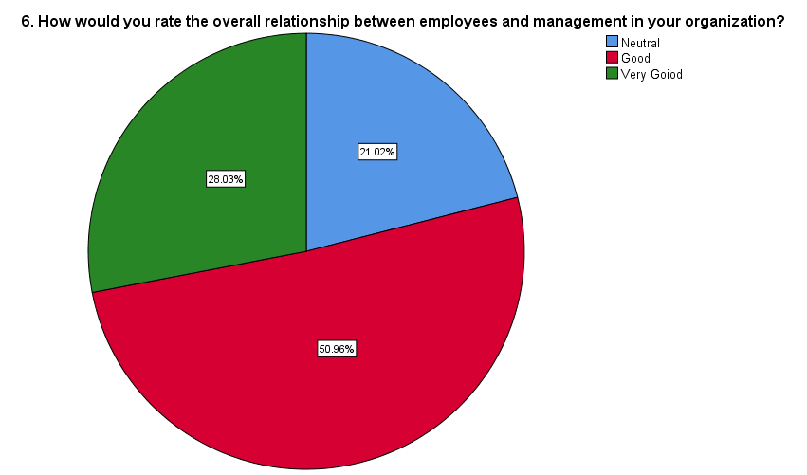Table.1 **Chart.1**

|  |  |  |  |  |  |
| --- | --- | --- | --- | --- | --- |
| **How would you rate the overall relationship between employees and management in your organization?** | | | | | |
|  | | Frequency | Percent | Valid Percent | Cumulative Percent |
| Valid | Neutral | 33 | 21 | 21 | 21 |
| Good | 80 | 51 | 51 | 72 |
| Very Good | 44 | 28 | 28 | 100 |
| Total | 157 | 100 | 100 |  |

**INTERPRETATION:** From the above table it is interpreted the overall relationship between employees and management 50.96% responded for Good and 28.03% respond for Very Good and 21.02% respond of Natural.

1. How often does your employer provide opportunities for open communication and feedback sessions with employees?

**Table.2 Chart.2**

|  |  |  |  |  |  |
| --- | --- | --- | --- | --- | --- |
| **How often does your employer provide opportunities for open communication and feedback sessions with employees?** | | | | | |
|  | | Frequency | Percent | Valid Percent | Cumulative Percent |
| Valid | Rarely | 30 | 19.1 | 19.1 | 19.1 |
|  | Occasionally | 5 | 3.2 | 3.2 | 22.3 |
| Regularly | 71 | 45.2 | 45.2 | 67.5 |
| Frequently | 12 | 7.6 | 7.6 | 75.2 |
| Always | 39 | 24.8 | 24.8 | 100 |
| Total | 157 | 100 | 100 |  |

**INTERPRETATION:** From the above table it is interpreted employer provide opportunities for open communication and feedback 45.22% respond of Regularly and 24.84% respond of always and 19.11% respond of Rarely and 7.64% responds of Frequently and 3.18% respond of Occasionally.

3.In your opinion, how does the transparency of decision-making processes within the organization affect the employer-employee relationship?

**Table.3 Chart.3**

|  |  |  |  |  |  |
| --- | --- | --- | --- | --- | --- |
| **In your opinion, how does the transparency of decision-making processes within the organization affect the employer-employee relationship?** | | | | | |
|  | | Frequency | Percent | Valid Percent | Cumulative Percent |
| Valid | Enhances Trust | 117 | 74.5 | 74.5 | 74.5 |
|  | No Impact | 38 | 24.2 | 24.2 | 98.7 |
|  | Decreases Trust | 2 | 1.3 | 1.3 | 100 |
|  | Total | 157 | 100 | 100 |  |

**INTERPRETATION:** From the above table it is interpreted decision-making processes within the organization affect the employer-employee relationship 74.52% respond of Enhance Trust and 24.20% respond of No impact and 1.27% respond of Decrease Trust.

4.Does your supervisor actively listen to your suggestions and enables you to perform at your best?

**Table.4 Chart.4**

|  |  |  |  |  |  |
| --- | --- | --- | --- | --- | --- |
| **Does your supervisor actively listen to your suggestions and& enables you to perform at your best** | | | | | |
|  | | Frequency | Percent | Valid Percent | Cumulative Percent |
| Valid | Strongly Agree | 19 | 12.1 | 12.1 | 12.1 |
| Agree | 37 | 23.6 | 23.6 | 35.7 |
| Neutral | 101 | 64.3 | 64.3 | 100.0 |
| Total | 157 | 100.0 | 100.0 |  |

**INTERPRETATION:** From the above table supervisor actively listen to your suggestions and& enables you to perform at your best 64.33% respond of Natural and 23.57%respond of Agree and 12.10% respond of Strongly agree.

**CHI-SQUARE TEST:** A chi-square test is a statistical test that is used to compare observed and expected results.

**Null hypothesis (Ho):**There is no healthy relationship within organization will be & more effective and successful.

**Alternate hypothesis (H1):**There is healthy relationship within organization will be & more effective and successful.

|  |  |  |
| --- | --- | --- |
| **Test Statistics** | | |
|  | 3. Gender | 17. Do you think that healthy relationship within organization will be& more effective and successful? |
| Chi-Square | 10.073a | 46.642b |
| df | 1 | 3 |
| Asymp. Sig. | .002 | .000 |

**INTERPRETATION:**

Since the calculated value is lesser than the tabulated value, we accept the null hypothesis and hence, there is no relationship gender respondents and healthy relationship within organization will be & more effective and successful.

**Correlation:** To find the relationship between overall relationship between employees and management in your organization.

**NULL HYPOTHESIS:H0:** There is no relationship between overall relationship between employees and management in your organization.

**ALTERNATIVE HYPOTHESIS: H1:** There is a relationship between overall relationship between employees and management in your organization.

|  |  |  |  |
| --- | --- | --- | --- |
| **Correlations** | | | |
|  | | 6. How would you rate the overall relationship between employees and management in your organization? | 8.In your opinion, how does a positive employer-employee relationship impact employee morale and job satisfaction? |
| 6. How would you rate the overall relationship between employees and management in your organization? | Pearson Correlation | 1 | -.164* |
| Sig. (2-tailed) |  | .040 |
| N | 157 | 157 |
| 8.In your opinion, how does a positive employer-employee relationship impact employee morale and job satisfaction? | Pearson Correlation | -.164* | 1 |
| Sig. (2-tailed) | .040 |  |
| N | 157 | 157 |
| *. Correlation is significant at the 0.05 level (2-tailed). | | | |

**INFERENCE**

From the test it is found that the significance value is 0.040 which is higher than table value 0.1,the null hypothesis was rejected that there is no significance between overall relationship between employees and management in your organization.

**FINDINGS**

According to the study 61.78% of respondents for female. Relationship between employees and management 50.96% responded for Good. Employer provide opportunities for open communication and feedback 45.22% respond of Regularly. Positive employer-employee relationship impact employee morale and job satisfaction 62.42% respond of Positively. level of trust between employees and management in your organization 94.27% respond of Strong. communication from management plays a significant role in fostering a positive employer-employee relationship 85.99% respond of Agree. Decision-making processes within the organization affect the employer-employee relationship 74.52% respond of Enhance Trust. Role of leadership in setting a positive tone for the employer-employee relationship within the organization 52.56% respond of Neutral. Correlation between employee satisfaction and their productivity level 89.17% respond of yes**.** Supportive work environment impacts employee morale and job satisfaction 67.52% respond of Positively. Since the calculated value is lesser than the tabulated value, we accept the null hypothesis and hence, there is no relationship gender respondents and healthy relationship within Organization will be & more effective and successful. From the test it is found that the significance value is 0.040 which is higher than table value 0.1,the null hypothesis was rejected that there is no significance between overall relationship between employees and management in your organization.

**SUGGESTION**

* Employers should fix counseling session, meetings and communication to each of the individual employees to know the satisfaction level of the employees.
* Some of the employees are not satisfied with the treating employees in the organization so company have to improve the treating an employees without discriminations
* Some employees do not have a good relationship with the co-worker. Therefore, company have to clear grievance and disputes among employees to enhance relationship with co-workers
* The company should accept worthy suggestions from the employees for better output.
* Organization should take necessary measures to make employees have good relationship.
* Employers must collect regular feedback from employees.

**BIBLIOGRAPHY**

1.Bal, P. M., Kooij, D. T., & Rousseau, D. M. (Eds.). (2015). Aging workers and the employee-employer relationship (pp. 129-144). Amsterdam: Springer.

2. Bashir, I., Ismat, S., & Mahmood, B. (2012). " Employee-employer relationship" Empowerment and Interpersonal Trust in Private Educational Institutions and Its Impact on Overall Profitability of an Organizations. International Journal of Asian Social Science, 2(3), 262 270.

3.Tanwar, K., & Prasad, A. (2016). Exploring the relationship between employer branding and employee retention. Global Business Review, 17(3_suppl), 186S-206S.

4.Supanti, D., Butcher, K., & Fredline, L. (2015). Enhancing the employer-employee relationship through corporate social responsibility (CSR) engagement. International Journal of Contemporary Hospitality Management.

5. White, L., Lockett, A., & Currie, G. (2019). How does the availability and use of flexible leave influence the employer–employee relationship?. Human Resource Management.