**FLEXURAL BEHAVIOUR OF GLASS FIBRE REINFORCED BEAMS WITH PARTIAL REPLACEMENT OF FINE AGGREGATE BY FOUNDRY SAND**

M.Petchiyammal1, P.Vinoth Kumar2 , S.Seathupathi3

*1Assistant Professor, Department of Civil Engineering, Sree Sowdambika College of Engineering, Aruppukottai, Tamilnadu E-Mail: petchi36@gmail.com*

*2 Assistant Professor, Department of Civil Engineering, Sree Sowdambika College of Engineering, Aruppukottai, Tamilnadu E-Mail: vinothk539@gmail.com*

*3UG student, Department of Civil Engineering, Sree Sowdambika College of Engineering, Aruppukottai, Tamilnadu E-Mail: sethupathi412001@gmail.com*

**Abstract**

Metal foundries use large amount of sand as part of the metal casting process. Foundries successfully recycle and reuse the sand many times in-casting process. When the sand can no longer be reused in the foundry, it is removed from the foundry and is termed as “foundry waste sand”. Foundry sand can be used in concrete to improve its strength and other durability factors. Due to industrialization there is huge amount of foundry waste sand created. So to reduce the cost of the construction also to make structure more durable, reduce problem of this material the project has been undertaken so that it can be used for construction fashion. Glass fibres improve the strength of the material by increasing the force required for deformation and improve the toughness by increasing the energy required for crack propagation. Foundry sand and Glass fibre powder can be used as a partial replacement of fine aggregates or total replacement of fine aggregate and as supplementary addition to achieve different properties of concrete. This experimental investigation was performed to evaluate the strength of concrete, in which natural sand was partially replaced with waste foundry sand (WFS) and Glass fibre (GFRP). Natural sand was replaced with various percentages (10%, 20% and 30% by adding 0.5% of glass fiber to the concrete) of WFS by weight. Compressive strength test were performed for all replacement levels of foundry sand and Glass fibre for M20 grade concrete.

**Keywords:-** Foundry sand, Glass fibre, Compressive Strength, Flexural Strength, Split Tensile Strength

1. **INTRODUCTION**

In the view of the global sustainable developments, it is imperative that fibres like glass, carbon, polypropylene and aramid fibres provide improvements in tensile strength, fatigue characteristics, durability, shrinkage characteristics, impact, cavitation, erosion resistance and serviceability of concrete. Glass fibre is a material consisting of numerous extremely fine fibres of glass. Glass fibre is commonly used as an insulating material. It is also used as a reinforcing agent for many polymer products. Glass fibres are useful thermal insulators because of their high ratio of surface area to weight. It act as a good chemical resistance. Fibre reinforced concrete (FRC) is a concrete made primarily of hydraulic cements, aggregates and discrete reinforcing fibres. FRC is a relatively new material. Results of tensile tests done on concretes with glass, polypropylene and steel fibres, indicate that with such large volume of aligned fibres in concrete, there is substantial enhancement of the tensile load carrying capacity of the matrix. Glass fibres improve the strength of the material by increasing the force required for deformation and improve the toughness by increasing the energy required for crack propagation.

**2.1. MATERIALS**

**2.1.1. FOUNDRY SAND**

Foundry sand consists primarily of silica sand, coated with a thin film of burnt carbon, residual binder (bentonite, sea coal, resins) and dust. Foundry sand can be used in concrete to improve its strength and other durability factors. Foundry Sand can be used as a partial replacement of cement or as a partial replacement of fine aggregates or total replacement of fine aggregate and as supplementary addition to achieve different properties of concrete.

***Table 1****:* ***Physical Properties of Fly Ash***

|  |  |  |
| --- | --- | --- |
| **S.NO** | **FOUNDRY SAND** | |
| 1 | Specific gravity | 2.10 |
| 2 | Fineness modulus | 1.25 |
| 3 | Unit weight (kg/m3) | 1520 |

**2.1.2. GLASS-FIBRE**

Glass-fibre reinforced concrete (GRC) is a material made of a cementations matrix composed of cement, sand, water and admixtures, in which short length glass fibres are dispersed. Glass fibre is consists of A-glass, C-glass, E-glass, and AE-glass fibre. It has been widely used in the construction industry for non-structural elements, like façade panels, piping and channels

|  |  |  |
| --- | --- | --- |
| ***Table.2 Properties of Glass fibre*** | | |
| **S.NO** | **GLASS FIBRE** | |
| 1 | Type | E glass fibre |
| 2 | Length | 6mm |
| 3 | Tensile strength (Gpa) | 3.5 |
| 4 | Modulus (Gpa) | 73.5 |
| 5 | Density (kg/m3) | 2720 |

**2.1.3 Cement**

The cement used is OPC 43 grade cement. The Ordinary Portland Cement of 43 grade conforming to IS: 8112-1989 is be used. Tests were conducted on the cement like Specific gravity, consistency test, setting time tests and Compressive strength N/mm2at 28 days.

***Table.3: Properties of cement***

|  |  |  |
| --- | --- | --- |
| **S.NO** | **CEMENT** | |
| 1 | Compressive strength | 43 Mpa |
| 2 | Specific gravity | 3.15 |
| 3 | Standard consistency | 31% |
| 4 | Initial setting time | 30 mins |
| 5 | Final setting time | 600 mins |

**2.1.4 Fine aggregate**

Locally available river sand was used as a fine aggregate. The properties of the fine aggregate as shown in the Table. (IS sieve 383-1970).

**2.1.5 Coarse aggregate**

Crushed stone or gravel used in concrete, will not when dry, pass through a sieve with 11.6 mm and 13.2mm diameter holes. In this project 12.5 mm size coarse aggregates are used.

***Table.4 Properties of Fine and Coarse Aggregate***

|  |  |  |  |
| --- | --- | --- | --- |
| **S.NO** | **PROPERTIES** | **FINE AGGREGATE** | **COARSE AGGREGATE** |
| 1. | Size | 4.75 | 12.5mm |
| 2. | Bulk density | 1721 kg/m3 | 1650kg/m3 |
| 3. | Fineness modulus | 2.8 | 6.8 |
| 4. | Specific gravity | 2.55 | 2.70 |

**2.1.6 Water**

Water is an important ingredient of concrete as it actively participates in the chemical reactions with cement. The strength of cement concrete comes mainly from the binding action of the hydration of cement get the requirement of water should be reduced to that required chemical reaction of un hydrated cement as the excess water would end up in only formation undesirable voids or capillaries in the hardened cement paste in concrete.

**3. PREPARATION OF CONCRETE MIX**

The concrete mixtures were prepared by Ordinary Portland cement, natural sand, coarse aggregate, Foundry sand and Glass fibre. Among the four series of mixtures, one was the control mixture and the remaining three mixtures were containing foundry sand with glass fibre in various proportions such as 10%, 20%, and 30%. For all the mixtures, aggregates were weighed in dry condition and the mixtures were mixed together for 4 to 5min in a laboratory counter current mixer shown figure 3.

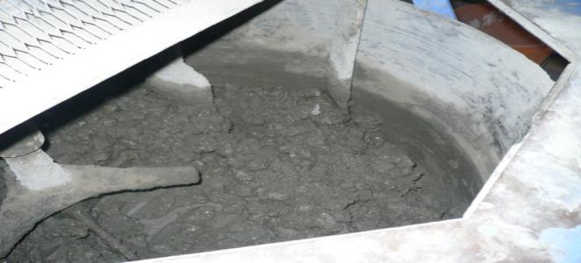

**Figure3. Mixing of concrete**

Workability of the fresh concrete was verified by slump test apparatus. Compressive and splitting tensile strength of the concrete measured using 150mmx150mmx150mm cubes and 150mmx300mm cylinders. In addition prisms and R.C.C beams were prepared to determine the flexural strength of the concrete.

**3.1 MIX DESIGN**

***Table .5 Mix Ratio for M20 grade concrete in kg/m3***

|  |  |  |  |  |
| --- | --- | --- | --- | --- |
| **DESCRIPTION** | **CEMENT** | **FINE AGGREGATE** | **COARSE AGGREGATE** | **WATER-CEMENT RATIO** |
| **WEIGHT** | 417.15 | 629.85 | 1088.1 | 208.5 |
| **RATIO** | 1 | 1.5 | 2.6 | 0.50 |

**3.2 CASTED SPECIMENS:**

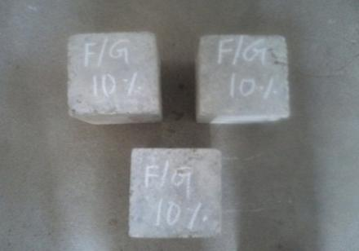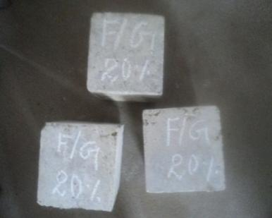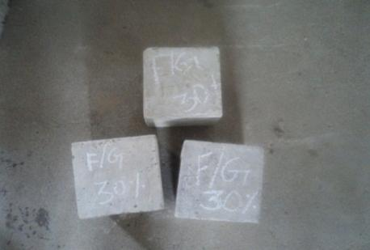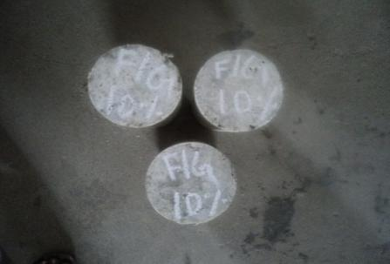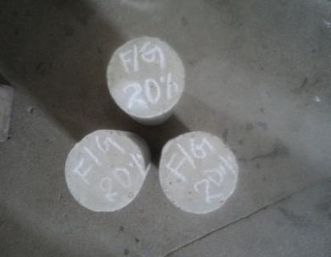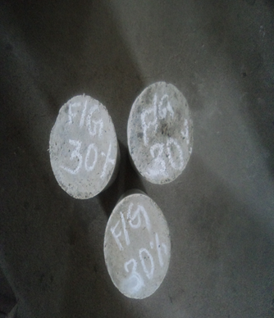

***Figure 9. Cubes and cylinders after 28 days curing (Foundry sand with glass fibre)***

**3.3 TESTING OF BRICKS**

Specimen should be passes through the following tests after 7&14 days from curing:

* Compressive Strength Test As Per IS: 3495 (Part 1)-1992.
* Water Absorption Test As Per IS: 3495 (Part 2)-1992.
* Durability

**4. RESULTS AND DISCUSSION**

**4.1 COMPRESSIVE STRENGTH**

Compressive strength is the most important property of the hardened concrete. The concrete cubes were tested accordance with the IS standards at the 28 days. Compressive strength results are shown in Table 6.The compressive strength was increased up to 15% , 28% and48% when compared to control specimen.

***Table 6: compressive strength of concrete at 28 days***

|  |  |  |
| --- | --- | --- |
| **S.no** | **Designation** | **Average compressive strength (N/mm2) at 28 days** |
| **1** | Control | 22.6 |
| **2** | 10% F.S + G.F | 26.10 |
| **3** | 20% F.S + G.F | 28.96 |
| **4** | 30% F.S + G.F | 33.53 |

***Figure15. Average compressive strength of concrete at 28 days***

**4.2 SPILT TENSILE STRENGTH**

The split tensile strength of the concrete measured at the age of 28days and the strength values are listed in Table 7.Spilting tensile strength of concrete mixtures increased with the increase in foundry sand content by adding glass fibre.The spilt tensile strength was increased upto 8.4%, 22.6% and 26.9% when compared to control specimen.

***Table 7: Spilt tensile strength of concrete at 28 days***

|  |  |  |
| --- | --- | --- |
| **S.no** | **Designation** | **Average spilt tensile strength (N/mm2) at 28 days** |
| **1** | Control | 2.6 |
| **2** | 10% F.S + G.F | 2.82 |
| **3** | 20% F.S + G.F | 3.19 |
| **4** | 30% F.S + G.F | 3.30 |

***Figure16. Spilt tensile strength of concrete N/mm2 at 28 days***

**4.3 FLEXURAL STRENGTH**

The Flexural strength of the concrete measured at the age of 28days and the strength values are listed in Table 8.Flexural strength of concrete mixtures increased with the increase in foundry sand content by adding glass fibre. The flexural strength was increased up to 7.6%, 26.9% and 35.5% when compared to control specimen.

***Table 8: flexural strength of concrete at 28 days***

|  |  |  |
| --- | --- | --- |
| **S.NO** | **Description** | **Average flexural strength (N/mm2) at 28 days** |
| **1** | Control | 6.5 |
| **2** | 10% F.S + G.F | 7 |
| **3** | 20% F.S + G.F | 8.25 |
| **4** | 30% F.S + G.F | 9.1 |

***Figure.17 Flexural strength of concrete at 28 days***

**5. CONCLUSION**

From this study the following conclusions can be drawn:

* Compressive strength, splitting-tensile strength and flexural strength test results of concrete mixtures increased with foundry sand and glass fibre mixes.
* For 10%FS+GF system, the compressive, spilt tensile, flexural strength was increasedupto 15%, 8.4% ,7.6% and 9.2% with the control mix.
* For 20%FS+GF system, the compressive, spilt tensile, flexural strength was increased up to 28%, 22.6% 26.9% and 15.1%with the control mix.
* For 30%FS+GF system, the compressive, spilt tensile, flexural strength was increased up to 48%, 26.9% ,35.5% and 23.8%with the control mix.
* Environmental effects from wastes and disposal problems of waste can be reduced through this research.
* A better measure by an innovative Construction Material is formed through this research.

**REFERENCES**

1. Gurpreet Singh and RafatSiddique***“****Abrasion resistance and strength properties of concrete containing waste foundry sand (WFS)****”***, Construction and Building Materials, Vol. 28, pg. 421–426, (2012).
2. GurdeepKaur, and RafatSiddique, Anita Rajor***“*** *Properties of concrete containing fungal treated waste foundry sand* ***”***, Construction and Building Materials, Vol.29, (2012) 82-87.
3. GurdeepKaur and RafatSiddique***“****Micro-structural and metal leachate analysis of concrete made with fungal treated waste foundry sand* ***’’***,Construction and Building Materials, 38 (2013) .94–100.
4. Kraus andNaik, ***“****Use of foundry silica-dust in manufacturing economical self-consolidating concrete****”***,Construction and Building Materials 23 (2009) 3439–3442.
5. Khatib, B.A.Herki, S. Kenai***“****Capillarity of concrete incorporating waste foundry sand* ***’’***, Construction and Building Materials 47 (2013) 867–871.