**“A STUDY ON HR POLICIES AND IMPLEMENTATION AT BPO”**

**Veronica A1, Muthumani S2and Bethel Erastus-0bilo3**

1MBA Student, Jerusalem College of Engineering, Chennai, Tamil Nadu, India

2Professor And Head MBA, Jerusalem College of Engineering, Chennai, Tamil Nadu, India

Vice President of Academic Affairs & Professor of Criminal Justice, University of Atlanta, Atlanta, GA

**ABSTRACT**

The Business Process Outsourcing (BPO) industry plays a vital role in the global economy, providing cost-effective solutions for businesses to outsource non-core functions. With its rapid growth, the BPO industry faces unique challenges related to human resources management. This article discusses the importance of HR policies in the BPO sector and how their effective implementation can contribute to the industry's success. In the fast-paced and dynamic world of Business Process Outsourcing (BPO), the significance of well-crafted Human Resources (HR) policies and their effective implementation cannot be overstated. The BPO industry, which plays a pivotal role in global business operations, relies on its Crimia workforce to deliver exceptional services.

**Keywords:** HR policies, BPO industry, promotion, Job satisfaction.

**1.** **INTRODUCTION**

A policy is a guide for repetitive action in major areas of business. It is a statement of commonly accepted understanding of decision-making criteria. Policies are set up to achieve several benefits. By taking policy decisions on frequently recurring problems, the top management provides the guidelines to lower level managers. It will permit decisions to be made in similar situations without repeating the reasons and expensive analysis required initially to state the policy. Policies help managers at various levels to act with confidence without the need of consulting the superiors every time. This will also ensure promptness of action. On the basis of such policies, programs are developed by the management to pursue the objectives. Carrying out the programs result in certain practices. Policies declare what is intended; they describe what is proposed. Practices describe how policies are being implemented. A company may have adopted a policy of providing training for all employees as a means of preparing them for promotion.

**2. REVIEW OF LITERATURE**

**"Effective HR Policies in the BPO Sector: A Study on Employee Motivation and Retention" by S. Agarwal and M. Dasgupta (2019).** This study examines the impact of HR policies on employee motivation and retention in the BPO sector. The study finds that effective HR policies can improve employee motivation and retention, leading to higher job satisfaction and better performance.

**"HR Challenges in the BPO Industry: A Study of Implementation and Best Practices" by S. Gupta and A. Singh (2020).** This study explores the challenges faced by BPO companies in implementing HR policies and identifies best practices for successful implementation. The study suggests that effective communication, training, and monitoring are critical for successful implementation.

**"Employee Engagement and HR Policies in the BPO Industry" by R. Singh and M. Chakraborty (2021).** This study examines the relationship between HR policies and employee engagement in the BPO industry. The study finds that effective HR policies can improve employee engagement, leading to higher job satisfaction, better performance, and lower turnover rates.

**3. METHODOLOGY**

The study will utilize a quantitative design, using survey questionnaires to gather data on Employees satisfaction with the effectiveness of reward system on motivational level of its employees. The framework of market research methods and procedures chosen by a researcher is referred to as research Design. The researchers’ design allows to use the most appropriate methodologies for the study and to set up Their investigations successfully in the future as well. This research aimed to explore the effect of using Rewards as motivation and the kinds of rewards employees deem most effective. Quantitative research is typically used to test hypothesis, measure the prevalence or frequency of a particular phenomenon, evaluate the effectiveness off interventions or treatments, and make generalizations about a population based on a sample.

**4. ANALYSIS**

* **PERCENTAGE ANALYSIS:**

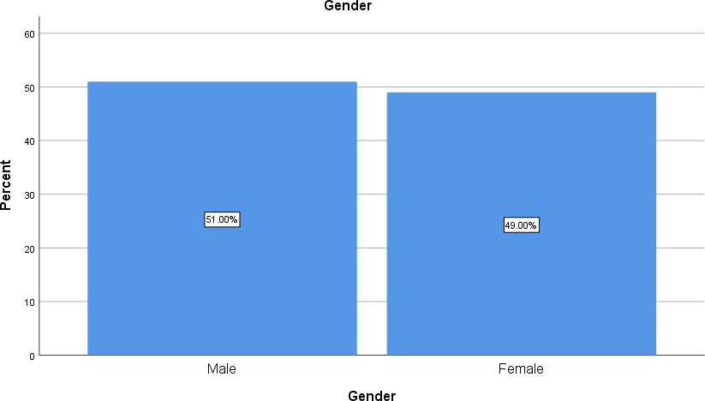**1. GENDER OF THE RESPONDENT:**

|  |  |  |  |  |  |
| --- | --- | --- | --- | --- | --- |
| Valid | Male | 51 | 49.0 | 51.0 | 51.0 |
| Female | 49 | 47.1 | 49.0 | 100.0 |
| Total | 100 | 96.2 | 100.0 |  |
| Missing | System | 4 | +3.8 |  |  |
| Total | | 104 | 100.0 |  |  |

### **INTERPRETATION:**

From the above table it is interpreted that 49% are male and 51% of respondents are female. Majority (51%) are female.

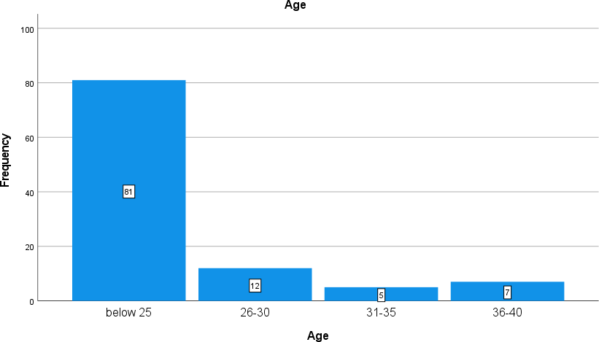**2. AGE OF THE RESPONDENT**

|  |  |  |  |  |  |
| --- | --- | --- | --- | --- | --- |
| * **Age** | | | | | |
|  | | Frequenc y | Percent | Valid Percent | Cumulative Percent |
| Valid | Below 25 | 81 | 8.1 | 77.1 | 77.1 |
|  | 26-30 | 12 | 1.2 | 11.4 | 88.6 |
|  | 31-35 | 5 | .5 | 4.8 | 93.3 |
|  | 36-40 | 7 | .7 | 6.7 | 100.0 |
|  | Total | 105 | 10.5 | 100.0 |  |
| Missing | System | 893 | 89.5 |  |  |
| Total | | 998 | 100.0 |  |  |

## **INTERPRETATION**

From the study it is found that out of 105 responses, 8.1% is from below 25, 1.2% is from 26-30, 5% is from 31-35, 7% is from 36-40.

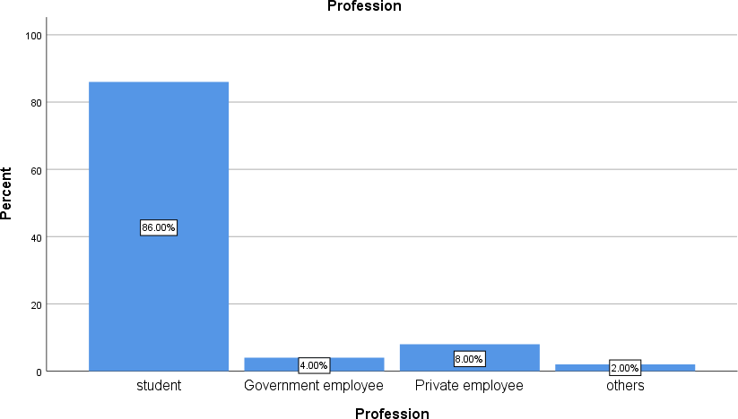 **3. EMPLOYEMENT STATUS**

|  |  |  |  |  |  |
| --- | --- | --- | --- | --- | --- |
| **Profession** | | | | | |
|  | | Frequency | Percent | Valid Percent | Cumulative Percent |
| Valid | Private Employee | 86 | 82.7 | 86.0 | 86.0 |
| Intern | 4 | 3.8 | 4.0 | 90.0 |
| Business or Profession | 8 | 7.7 | 8.0 | 98.0 |
| others | 2 | 1.9 | 2.0 | 100.0 |
| Total | 105 | 10.5 | 100.0 |  |
| Missing | System | 4 | 3.8 |  |  |
| Total | | 105 | 100.0 |  |  |

**INTERPRETATION**

From the study it is found that out of 105 responses, 82.7% is from private employee, 3.8% is from intern, 7.7% is from business or profession, 1.9% is from others.

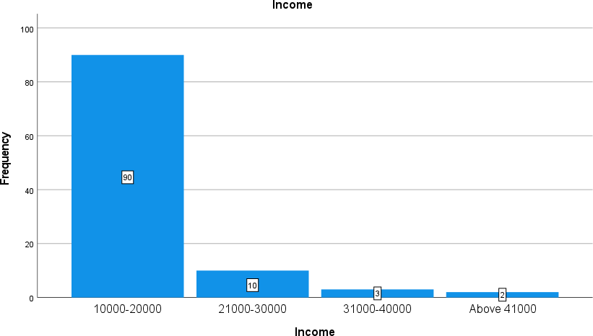**4. INCOME**

|  |  |  |  |  |  |
| --- | --- | --- | --- | --- | --- |
| Frequency | | | Percent | Valid Percent | Cumulative Percent |
| Valid | 10000-20000 | 90 | 9.0 | 85.7 | 85.7 |
| 21000-30000 | 10 | 1.0 | 9.5 | 95.2 |
| 31000-40000 | 3 | .3 | 2.9 | 98.1 |
| Above 41000 | 2 | .2 | 1.9 | 100.0 |
| Total | 105 | 10.5 | 100.0 |  |
| Missing | System | 893 | 89.5 |  |  |
| Total | | 998 | 100.0 |  |  |

**INTERPRETATION**

From the study it is found that out of 105 responses, 9.0% is from 10000-20000, 1.0% is from 21000-30000, 3% is from 31000-40000, 2% is from above 41000.

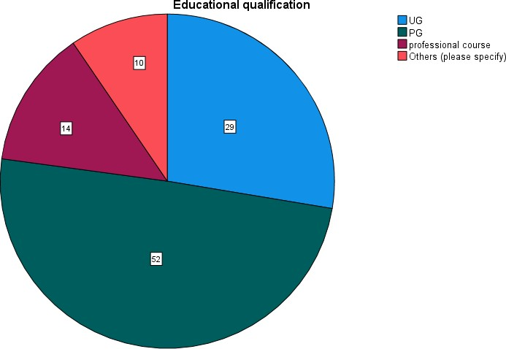 **5. EDUCATINAL QUALIFICATION**

|  |  |  |  |  |
| --- | --- | --- | --- | --- |
| Frequency | | Percent | Valid Percent | Cumulative Percent |
| UG | 29 | 2.9 | 27.6 | 27.6 |
| PG | 52 | 5.2 | 49.5 | 77.1 |
| professional course | 14 | 1.4 | 13.3 | 90.5 |
| Others (please specify) | 10 | 1.0 | 9.5 | 100.0 |
| Total | 105 | 10.5 | 100.0 |  |
| System | 893 | 89.5 |  |  |
| Total | 998 | 100.0 |  |  |

**INTERPRETATION**

From the study it is found that out of 105 responses, 2.9% is from UG, 5.2% is from PG, 1.4% is from professional course, 1.0% is from others.

**6. ONEWAY-ANOVA**

Analysis of Variance (ANOVA) is a statistical formula used to compare variances across the means (or average) of different groups. A range of scenarios use it to determine if there is any difference between the means of different groups.

**Null hypothesis:** There is no significance difference between experience and employee performance in our company.

**Alternative hypothesis:** There is significance difference between experience and employee performance in our company.

**ANOVA**

How many years have you been working in your company

|  |  |  |  |  |  |
| --- | --- | --- | --- | --- | --- |
| Sum of Squares | | df | Mean Square | F | Sig. |
| Between Groups | 7.345 | 3 | 2.448 | 3.469 | .019 |
| Within Groups | 71.284 | 101 | .706 |  |  |
| Total | 78.629 | 104 |  |  |  |

## **INFERENCE**

From the above table, we find that the significant value is 0.019, which is less than the table value 0.05, so the null hypothesis is rejected and alternative hypothesis is accepted.

Therefore, there is relationship between experience and employee performance in our company

**7. ONEWAY-ANOVA**

Analysis of Variance (ANOVA) is a statistical formula used to compare variances across the means (or average) of different groups. A range of scenarios use it to determine if there is any difference between the means of different groups.

**Null hypothesis:** There is no significance difference between analyzation of employee performance and reward policy in our company improved by performance.

**Alternative hypothesis:** There is significance difference between analyzation of employee performance and reward policy in our company improved by performance.

**ANOVA**

Reward policy in our organisation improved by performance

|  |  |  |  |  |  |
| --- | --- | --- | --- | --- | --- |
| Sum of Squares | | df | Mean Square | F | Sig. |
| Between Groups | 14.202 | 4 | 3.550 | 5.885 | .000 |
| Within Groups | 60.332 | 100 | .603 |  |  |
| Total | 74.533 | 104 |  |  |  |

## **INFERENCE**

From the above table, we find that the significant value is 0.000, which is lesser than the table value 0.05, so the null hypothesis is rejected and alternative hypothesis is accepted. Therefore, there is relationship between the analyzation of employee performance, and reward policy in our company improved by performance.

## **8. CHI-SQUARE TEST**

Chi-square is a statistical test used to examine the differences between categorical variables from a random sample in order to judge the goodness of fit between expected and observed results.

**Null hypothesis:** There is no significance association between age and do you agree that the policies are covered and equitable among employees with varied experience in the organization.

**Alternative hypothesis:** There is significance association between age and do you agree that the policies are covered and equitable among employees with varied experience in the organization.

**Chi-Square Tests**

|  |  |  |  |  |  |
| --- | --- | --- | --- | --- | --- |
| Value | | df | Asymptotic  Significance (2- sided) | Exact Sig. (2- sided) | Exact Sig. (1- sided) |
| Pearson Chi-Square | 8.013a | 1 | .005 |  |  |
| Continuity Correctionb | 6.479 | 1 | .011 |  |  |
| Likelihood Ratio | 7.198 | 1 | .007 |  |  |
| Fisher's Exact Test |  |  |  | .009 | .007 |
| Linear-by-Linear Association | 7.936 | 1 | .005 |  |  |
| N of Valid Cases | 105 |  |  |  |  |

1. 0 cells (.0%) have expected count less than 5. The minimum expected count is 5.04.
2. Computed only for a 2x2 table

## **INFERENCE:**

From the above table, we find that the significant value is .007, which is less than table value 0.05, so the null hypothesis is rejected and alternative hypothesis is accepted.

There is no significant association between age and do you agree that the policies are covered and equitable among employees with varied experience in the organization.

**5. FINDINGS:**

From the above table it is interpreted that 49% are male and 51% of respondents are female. Majority (51%) are female.

From the study it is found that out of 105 responses, 8.1% is from below 25, 1.2% is from 26-30, 5% is from 31-35, 7% is from 36-40.

From the study it is found that out of 105 responses, 82.7% is from private employee, 3.8% is from intern, 7.7% is from business or profession, 1.9% is from others.

From the study it is found that out of 105 responses, 2.9% is from UG, 5.2% is from PG, 1.4% is from professional course, 1.0% is from others.

**6. SUGGESTIONS:**

Based on the findings of the report these are a few recommendations for the implementation of the HR policies for BPO sector:

1] Adjust HR strategies to the organization's objectives and values: HR strategies ought to be planned so that they line up with the organization's vision, mission, and values. This will guarantee that the representatives are making progress toward accomplishing the organization's objectives.

2] Guarantee consistence with work regulations: While making HR approaches, guaranteeing consistence with all pertinent work regulations in India is fundamental. This will assist with staying away from legitimate issues and questions with workers.

**7. CONCLUSION:**

All in all, the undertaking report features the significance of HR approaches and their execution in the BPO area in India. The BPO area has been a huge supporter of the Indian economy, and the progress of this area to a great extent relies upon the proficient administration of HR.

The report observed that HR approaches are basic for the viable administration of HR in the BPO area. They help to make a positive work culture, draw in and hold skilled representatives, guarantee consistence with work regulations, and adjust worker conduct to the organization's objectives and values. Nonetheless, compelling execution of HR approaches is similarly significant for accomplishing these targets.

**8. REFERENCES**

1. Human resource management practices in Indian business process outsourcing industry: A review. Journal of Management and Strategy, 8(3), 11-21” (Das, P., & Baruah, T. D. (2017)

Retrieved from: <https://www.brookings.edu/>

2. Managing human resources in business process outsourcing (BPO): A study of Dhaka, Bangladesh. Journal of Business and Management, 21(3), 97-115(Sultana, N., Azim, M. T., & Khan, M. A. (2019)

Retrieved from: https://www.researchgate.net/

3. Implementation of human resource policies in Indian BPO industry: A case study. Journal of Management and Strategy, 7(3), 17-26(Barua, N., & Baruah, T. D. (2016)

Retrieved from: <https://www.proquest.com>

4. Human resource management in business process outsourcing: A conceptual framework. Journal of Business and Management, 19(2), 55-67 (Li, Y., & Lu, J. (2015)

The Dynamics of HRM Systems in Indian BPO Firms(PAWAN S. BUDHWAR HARSH K. LUTHAR JYOTSNA BHATNAGAR)

5. Economic development strategies and macro and micro-level human resource policies: The case study of India’s outsourcing industry (SAROSH KURUVILLA and ARUNA RANGANATHAN)

Retrieved from: <https://www.ebsco.com/>

6. Globalization and outsourcing: confronting new human resource challenges in India’s business process outsourcing industry” (Sarosh Kuruvilla and Aruna Ranganathan)

Trade unionism in Indian BPO-ITes Industry: Insights from literature”(Santanu Sarkar)

Retrieved from: <https://www.researchgate.com>