**Remote Control Spray Painting Machine**

Students :- 1) Mhaske Aditya Revannath. 2) Kandalkar Rameshwar Subhash

3) Sarode Adesh Babaji. 4) Butte Prathamesh Somnath.

Guide:Mr.Momin.H.S. Coordinator : Prof. Murhekar N.H

Diploma Mechanical In Engineering,

Samarth Polytechnic, Belhe.Taluka – Junnar, Dist -Pune.

**Abstract:-**

Wall painting is a repetitive, exhausting and hazardous process which makes it an ideal case for automation. Painting had been automated in automotive industry but not yet for the construction industry. There is a strong need for a mobile robot that can move to paint interior walls of residential buildings. The primary aim of the project is to design, develop and implement Wall Spray Painting which helps to achieve low cost painting equipment. Despite the advances and its wide spreading applications, interior wall painting has share’ little in research activities. The painting chemicals can cause hazards to the human painters such as eye and respiratory system problems. Also the nature of painting procedure that requires repeated work and hand rising makes it boring, time and effort consuming.

When construction workers and robots are properly integrated in building tasks, the whole construction process can be better managed and savings in human labour and timing are obtained as a consequence. The project is based on wall remote spray painting, controlled through wired remote. Here we are going to develop a mechanism, which will run powered by gear motor, we can start our painting automatically. In addition, it would offer the opportunity to reduce or eliminate human exposure to difficult and hazardous environments, which would solve most of the problems connected with safety when many activities occur at the same time.

The automation for painting the exterior wall In buildings has been proposed. Above all these the interior wall painting has shared little in research activities. The painting chemicals can cause hazards to the painters such as eye and respiratory system problems. Also, the nature of painting procedure that requires repeated work and hand rising makes it boring, time and effort consuming. These factors motivate the development of an automated robotic painting system. This project aims to develop the interior wall painting robot. This automatic wall painting robot is not designed using complicated components.

**Problem Statement**

Painting work (commercial or residential dwellings), is physically quite intensive, requires consistent vigilance, and yet boring, due to the repeating actions of painting procedures; the work could be uncomfortable or unsettling because of harmful chemicals present in the paint or other solvents, which can be nauseating or cause respiratory problems to the workers. With its numerous benefits like quality control, repeatability, waste reduction, faster cycle times - automated painting could very well provide a way out. Concurrent upsides of automation include reduced labor costs and lower probability of blunders. These factors inspired the concept of an automated robotic painting system. Building and construction is one of the major industries around the world. In this fast moving life construction industry is also growing rapidly. But the labour’s in the construction industry are not sufficient. This insufficient labor in the construction industry is because of the difficulty in the work. In construction industry, during the work in tall buildings or in the sites where there is riskier situation like interior area in the city.

**1. INTRODUCTION:**

Building and construction is one of the major industries around the world. In this fast- moving life construction industry is also growing rapidly. But the labors in the construction industry are not sufficient. This insufficient labor in the construction industry is because of the difficulty in the work. In construction industry, during the work in tall buildings or in the sites where there is riskier situation like interior area in the city. There are some other reasons for the insufficient labor which may be because of the improvement the education level which cause the people to think that these types of work are not as prestigious as the other jobs. Despite the advances in the Spray Painting and its wide spreading applications, painting is also considered to be the difficult process as it also has to paint the whole building. To make this work easier and safer and also to reduce the number of labors automation in painting was introduced. The automation for painting the exterior wall in buildings has been proposed. Above all these the interior wall painting has shared little in research activities. The painting chemicals can cause hazards to the painters such as eye and respiratory system problems. Also, the nature of painting procedure that requires repeated work and hand rising makes it boring, time and effort consuming. These factors motivate the development of an Remote Control Spray Painting system. This project aims to develop the interior wall painting Spray Painting This automatic wall painting robot is not designed using complicated components. This Spray Painting is simple and portable. Is designed using few steels, conveyor shaft, spray gun and a wire controller unit to control the entire operation.

**Project Statement**

In this technical world, there is a strong requirement of automatic

execution of all work. Humans avoid etting actually involved in the task; rather find

machines to carry out our designated work. The definite targets for improvement of

the wall painting robot, in order to solve the antecedent situation, were set as follows:

1. To minimize human efforts the machine is operated by remote control.
2. To reduce time requirement for painting, spray gun is used.
3. To improve safety by eliminating work on scaffolds.
4. To control the wastage of paints
5. To make machine structure simple to enable easy mounting.

**REMOTE CONTROL SPRAY PAINTING MACHINE**

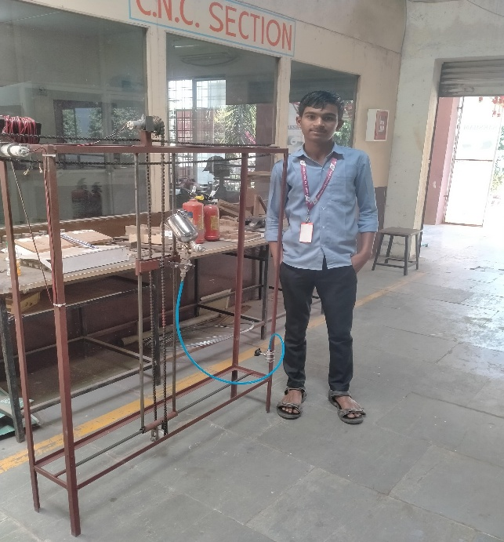

Fig.no 1.1 Construction of model

In the Remote Operated Spray Painting Machine, to start the system switch ON the power supply with the help of 35v charger which connected to the de machines to drive the robot. When the robot is stared, system gets initialize. Now the system can move in x-axis with the help of basement wheel mechanism system. After performing this operation, The 3pray gun in can adjust to spray on surface of the wall and it can execute with the use of Colour barrel and threaded steel rod. One best feature is that a IR sensor, it will detect the perfect position of wall where machine can paint, it means it will detect the particular distance of paint. In this way, the whole operation can perform easily and safely.

**Analytic Analysis**

For calculating horizontal painting speed

Speed of horizontal motor is 30 rpm

V=3.142 x D pulley x N motor/60

V=3.142×0.06×30/60

V=0.094m/s

V=0.33km/hr

For calculating Vertical painting speed

Speed of Vertical motor is 10 rpm

V=3.142 x D pulley x N motor /60

V=3.142×0.06×10/60

V=0.0314m/s

V=0.11km/hr

Hence horizontal painting will be preferred.

**Cost Analysis**

**Cost Analysis for Prototype**

|  |  |  |  |  |
| --- | --- | --- | --- | --- |
| **Sr.No** | **Part Name** | **Cost Per Unit(inRs)** | **Quantity** | **Total (In Rs)** |
| 1 | Spray Gun | 2200 | 1 | 2200 |
| 2 | Frame | 3000 | 1 | 3000 |
| 3 | Welding Rod | 40 | 10 | 400 |
| 4 | Remote | 1500 | 1 | 1500 |
| 5 | Battery | 1250 | 1 | 1250 |
| 6 | Bearing | 300 | 2 | 600 |
| 7 | Pipe | 50 | 3 | 150 |
| 8 | Connecting Wires | - | - | 500 |
| 9 | Other Equipment | - | - | 2000 |
|  | **Total** | | | 11600 |

**CONCLUSION**

We have designed and fabricated the prototype model for testing purpose which is limited to a certain height, but it can be developed and the limit can be increased. Also, our model requires an external compressor for the compressed air this can be eliminated by using an in-built compressor. The automatic wall painting machine has been design fabricated for painting walls easily. This machine can be used in interior work in industries and houses. It saves human power and time as well as labor cost. It gives the opportunity to reduce human exposure to difficult and hazardous environment.

**REFERENCES**

[1]. Mohamed Abdellatif “Design of An Autonomous Wall Painting Robot Mechatronic and Robotic Dept. EgyptJapan Univercity of Science and Technology, Alexandria, Egypt, 7 February 2016.

[2]. Dhaval Thakar, Chetan P. Vora “A Review on Design and Development of Semi Automatic Painting Machine”

Int. Journal of Engineering Research and Applications, ISSN: 2248-9622, Vol. 4, Issue 4

Version 7), April 2014.

[3]. P.Keerthanaal, K.Jeevitha2, V.Navina3, G.Indira4, S.Jayamanis “Automatic Wall Painting Robot” International

Journal of Innovative Research in Science, Engineering and Technology Vol. 2, Issue 7, July

2013

[4]. Berardo Naticchia, Alberto Giretti and Alessandro Carbonari “Set Up of an Automated

Multicolour System for Interior Wall Painting” International Journal of Advanced Robotic Systems, Vol. 4, No. 4 (2007)

ISSN 1729-8806, pp. 407-416

[5]. Takuya Gokyu, Masayuki Takasu, Sumio Fukuda “Development of Wall Painting Robot”

Tokyu Construction

Co. Ltd. 1-16-14 Shibuya-ku, Tokyo, Japan.

[6]. Pål Johan & Jan Tommy Gravdahl “A Real-Time Algorithm for Determining the Optimal

Paint Gun Orientation

in Spray Paint Applications” IEEE transactions on automation science and engineering, vol. 7,No 4, October 2010

[7]. Praneet Singh, Deepanshu Suneja, Prachi, Jitendra Kumar “Android Based, Arduino

Powered Automated wall”

Praneet Singh et al, / (IJCSIT) International Journal of Computer Science and Information Technologies, Vol. 5 (3),

2014, 4490-4491