A study on investor awareness about investment of mutual fund.

¹Akash S and ²Muthumani S
¹MBA student Jerusalem College of Engineering, Chennai
²Professor and Head MBA, Jerusalem College of Engineering, Chennai

ABSTRACT

Investment is done with the motive of earning a regular return, risk-free. In our country, a number of investment measures can be seen ranging from insurance policies to shares or debentures. The type of investment chosen depends upon the income level and the risk taking ability of the investor. Mutual Funds are an emerging mode of investment with great potential as it’s got diverging investing modes with regular return and minimized risk. But the awareness level it has with respect to the citizens of our country is really low. This study has been adopted with the aim to study the awareness level mutual funds have among the investing population in India and to suggest better remedies to familiarize them among the population.

KEYWORDS: Mutual fund, investors’ perception, investors’ behavior, objectives, Investment, Risk, Return, Awareness.

INTRODUCTION
A mutual fund is a pool of money managed by a professional Fund Manager. It is an investment vehicle that pools money from multiple investors to invest in diversified portfolio of stocks, bonds, or other securities.

A Mutual fund is type of Investment Company that gathers assets form investors and collectively invests in stocks, bonds, or money market instruments.The money thus collect is then invested in capital market instruments such as shares, debenture, and foreign market. The main aim of the fund manager is to taking the scrip that have under value and future will rising, then fund manager sell out the stock.

Fund manager concentration on risk- return trade off, where minimize the risk and maximize the return through diversification of the portfolio. The most common feature of the mutual fund unit are low cost.

A mutual fund is a professionally managed investment product that sells shares to investor and pools the capital it raises to purchase investments a fund typically buys a diversified portfolio of stocks, bonds and money market securities, or a combination of stocks and bonds, depending on the investment objectives of the fund.

- ONE TIME INVESTMENT: The amount that has to be invested in onetime is known as Onetime Investment. The investors has to pay the whole amount at once. The minimum amount is Rs.5000 and maximum is as per the investor’s choice. This investment is generally preferred for the business man who is able to pay at one time.
- SYSTEMATIC INVESTMENT PLAN (SIP): The amount that has to be invested through same monthly installment is known as Systematic Investment Plan. The investor has to pay the minimum amount Rs.1000 monthly for all equity and balanced schemes like that for 6 months. And Rs.500 monthly for Tax Saver scheme like that for 12 months. This type of investment is generally preferred for the salaried people.
- SYSTEMATIC WITHDRAWAL PLAN (SWP): The SWP meaning in mutual funds is an extended facility that enables you to withdraw money from your mutual funds in a systematic manner. In an SWP, you can choose your withdrawal amount, frequency and duration according to your needs. The systematic withdrawal plan (SWP) provides a steady income stream. The main advantage of the best SWP plans in India is it is especially useful for people who want to get a steady stream of income such as retirees.

REVIEW OF LITERATURE

O.V.A. M.Sridevi (2018), “Performance Analysis of Mutual Funds-A Study on Selected Mid Cap and Small Cap Funds”, Results of the study have showed that out of the two schemes of both mid cap and small cap funds have evidences of outperforming the benchmark return. Not all the funds have represented positive values. However from the above study it can be said that the schemes have diversified results.
Shivangi Agarwal, Nawaz’s Mishra (2017), “A study of the risk adjusted performance of mutual funds industry in India”, the study found that 90% of the schemes performed better than 24 their benchmark. It indicates that at the time of research, the funds performed in a better way, hence the investors who are interested in consistent returns may choose investment in these schemes.

Dr. R.Perumal (2016), Investment decision making towards mutual funds by using statistical tools and ratio analysis of mutual fund schemes. The objective of this research work is to exploits the use of statistical tools and ratio analysis in terms of financial performance. The study result are helpful to the Mutual Fund firms in terms of realize their recital among the mutual fund companies in the marketplace.
Shefali Gupta (2015), “A comparative study on performance evaluation of sectorial mutual fund schemes of Indian companies.” All five sector funds had positive return during 2008 to 2012. Banking and finance, FMCG and healthcare and technology funds have performed well as compared to SENSEX returns.

RESEARCH METHODOLOGY

This research draws upon a combination of primary and secondary data. The primary data collection was accomplished through a well-structured questionnaire, employing a snowball sampling method to select 105 respondents for the study. The secondary data were sourced from a variety of reference materials, including books, journals, research articles, magazines, and websites. The second set of data used for the study is the secondary data. The secondary data relating to net resources mobilized by banks and financial institution sponsored mutual funds, assets under management, investors mix etc. This type of data is collected from different investment periodicals, magazines, various newspapers, RBI reports, AMFI reports, SEBI annual reports; securities market reviews, study of existing literature of different authors in the related field etc. The sample size was relatively modest, comprising 105 participants, which potentially affects the research's overall reliability. To carry out the research work different statistical tools are used in order to derive certain meaningful information and results. In case of primary data Chi-Square tests has been applied and in case of categories where respondents are required to provide ranks to different factors, the relative importance of the respective factor is calculated by assigning scores to them. In case of secondary data exponential growth rates has been calculated.

ANALYSIS
Percentage analysis
Table 1 Awareness of mutual funds

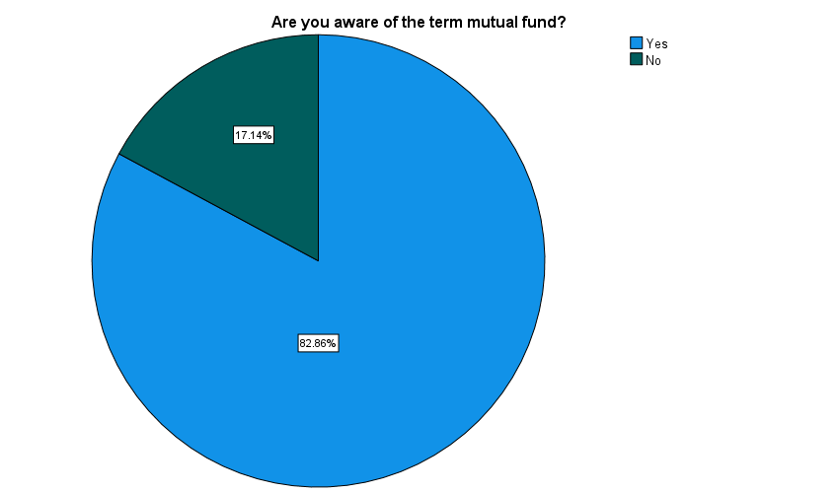
Particular | Frequency | Percent
Yes | 87 | 82.9
No | 18 | 17.1
Total | 105 | 100.0

Inference: As the data shows nearly of 83% of respondents are aware of mutual funds.

Table 2 AWARENESS OF TAX BENEFITS ASSOCIATED WITH MUTUAL FUNDS
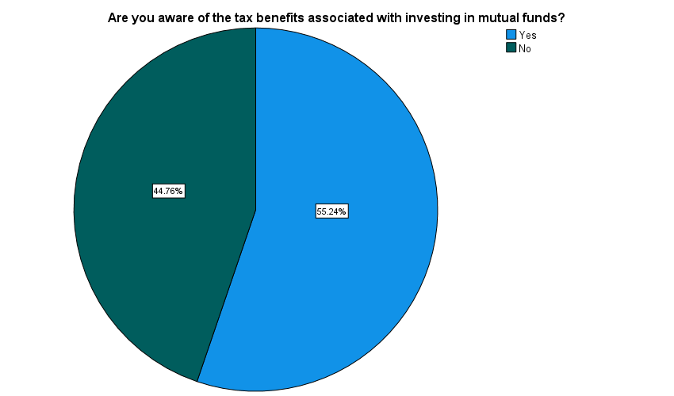

Particular | Frequency | Percent
Yes | 58 | 55.2
No | 47 | 44.8
Total | 105 | 100.0

Inference:
As the data shows nearly of 55% of respondents were aware of the tax benefits associated with investing in mutual funds.

TABLE 3 FACTORS THAT CONSIDERED BEFORE INVESTING IN MUTUAL FUNDS
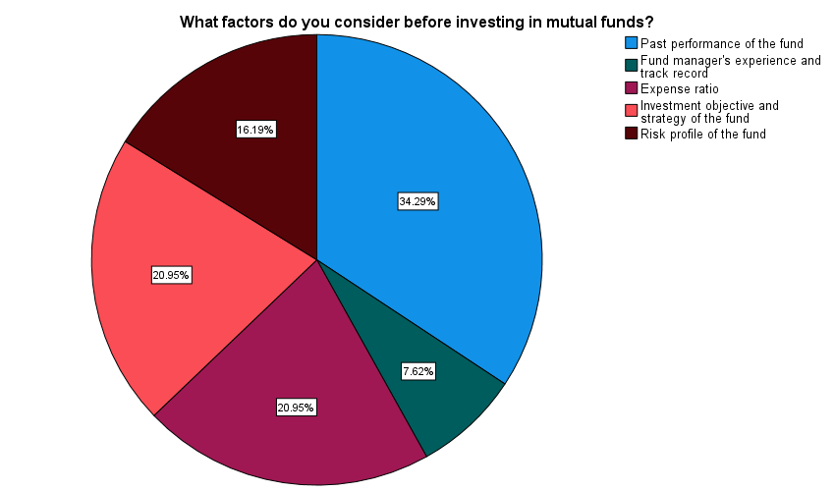
Particular | Frequeny | Percent
Past performance of the fund | 36 | 34.3
Fund manager's experience and track record | 8 | 7.6
Expense ratio | 22 | 21.0
Investment objective and strategy of the fund | 22 | 21.0
Risk profile of the fund | 17 | 16.2
Total | 105 | 100.0

Inference: As the data shows nearly of 34% the respondents are past performance of the fund are considered before investing in mutual funds.

TABLE 4 MODE OF PURCHASE OF MUTUAL FUNDS
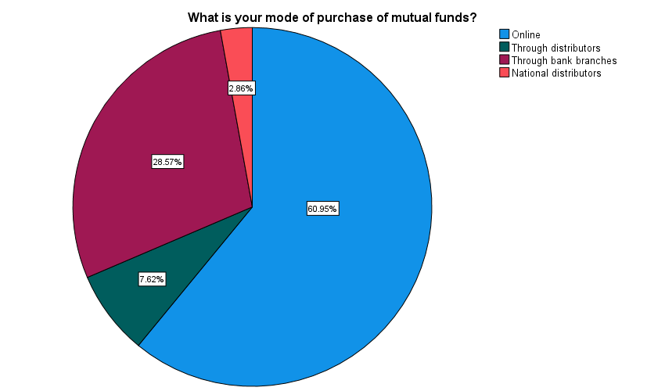

Particular | Frequency | Percent
Online | 64 | 61.0
Through distributors | 8 | 7.6
Through bank branches | 30 | 28.6
National distributors | 3 | 2.9
Total | 105 | 100.0

Inference: As the data shows nearly of 61% the respondents are purchase of mutual funds in online.

Correlation analysis

To find the relationship between awareness level and usage of mutual funds among investors.

Ho: There is no relationship between understanding the workings of mutual fund with the investment goal
H1: There is a relationship between understanding the workings of mutual fund with the investment goal.

Correlations
 |  | What are your investment goal for investing in mutual funds? | How important is it for you to understand the workings of a mutual fund before investing in it?
What are your investment goal for investing in mutual funds? | Pearson Correlation | 1 | .272**
 | Sig. (1-tailed) |  | .003
 | N | 105 | 105
How important is it for you to understand the workings of a mutual fund before investing in it? | Pearson Correlation | .272** | 1
 | Sig. (1-tailed) | .003
 | N | 105 | 105
**. Correlation is significant at the 0.01 level (1-tailed).

The significant value 0.003 is less than the table significant value (0.003<0.05).

Inference:
From the above table, we find that the significant value is 0.003, which is lesser than table value 0.05, so the Null hypothesis is rejected and Alternative hypothesis is accepted.
Therefore, there is a relationship between understanding the workings of mutual fund with the investment goal.

CHI-SQUARE
To find the association between gender and factors do you consider before investing in mutual funds.

Ho: There is no association between age and factors considering before investing in mutual funds.
H1: There is a association between age and factors considering before investing in mutual funds.

Test Statistics
 | Gender | What factors do you consider before investing in mutual funds?
Chi-Square | 5.038ª | 19.619^{b}
df | 1 | 4
Asymp. Sig. | .025 | .001
a. 0 cells (0.0%) have expected frequencies less than 5. The minimum expected cell frequency is 52.5.
b. 0 cells (0.0%) have expected frequencies less than 5. The minimum expected cell frequency is 21.0.

Inference:

From the above table, the significant value is 0.025 which is lesser than table value (0.0025<0.05). Thus, H0 is rejected and H1 is accepted. There is a relationship between gender and factors do you consider before investing in mutual funds.

ANOVA
To find the difference between age and the awareness of tax benefits associated with investing in mutual funds
NULL HYPOTHESIS (HO): There is no significance difference between age and the awareness of tax benefits associated with investing in mutual funds.
ALTERNATIVE HYPOTHESIS (H1): There is a significance difference between age and the awareness of tax benefits associated with investing in mutual funds.

ANOVA
Age
 | Sum of Squares | df | Mean Square | F | Sig.
Between Groups | 2.055 | 1 | 2.055 | 1.660 | .000
Within Groups | 127.507 | 103 | 1.238
Total | 129.562 | 104

Inference:
The significant value 0.000 is less than the table significant value (0.000<0.05). H0 is rejected and H1 is accepted. Therefore, there is a significance difference between age and the awareness of tax benefits associated with mutual funds.

Findings

The data reveals that approximately of 83% of respondents are aware of mutual funds 83% of respondents are aware of mutual funds in the data of the surveyed participants. Notably, the tabulated results illustrate that as the data shows nearly of 61% the respondents are purchase of mutual funds in online. A significant data shows nearly of 34% the respondents are past performance of the fund are considered before investing in mutual funds. Moreover, data shows nearly of 55% of respondents were aware of the tax benefits associated with investing in mutual funds.

Suggestions

The company should give the knowledge regarding Mutual Fund through various sources like more advertisements, T.V. programmes, etc.

The company should also attract the medium level Income people by showing them the benefits of the liquidity funds for the short Term to attract them.

The company should also attract the customer through different schemes who having knowledge about the Mutual Funds but not investing in Mutual Funds.

The company should organize seminar to give information about Mutual Fund and should distribute brochures having detail of schemes of Mutual Fund.

Conclusion
Today a lot of investment opportunities are available to the investors in the financial markets. Investors can invest in corporate bonds, debentures, bank deposits, post office schemes etc. But nowadays investors opt for portfolio managers to invest money on their behalf. These portfolio managers are experts in stock market operations and invest the money in such a way that the investors would get minimum assured returns. Today many institutions are busy in providing wealth management services to the investors. But these services are very costly. Thus in order to help the investor’s mutual funds provide a protective shed to the small and big investors. Today the main task before mutual fund industry is to convert the potential investors into the reality investors. New and more innovative schemes should be launched from time to time so that investor’s confidence should be maintained. All this will lead to the overall growth and development of the mutual fund industry.

Reference

Bansal, L.K (1996), “Mutual Funds Management and Working” Deep and Deep publications, New Delhi. pp 34-39.

Gupta, A (2000)," Investment Performance of Indian Mutual Funds: An Empirical Study", Finance India, Vol.XIV, No.3, pp.833-866.

Aggarwal, N and Gupta, M (2007) “Performance of Mutual Funds in India: An Empirical Study”, The Icfai Journal of Applied Finance, Vol.13, No.9, pp.5-16.

Bodla, B S and Bishnoi, S (2008), “Emerging Trends of Mutual Funds in India: A Study across Category and type of schemes, “Journal of Indian Management and Strategy, Vol.13, p-15.

Bhowal A and Paul T (2013), ‘Gaps in Customer Solution – A Case Study of Mutual Funds in India’, the SAMs Journal, 7(1), 33-41.

