**SOIL STABILIZATION USING WASTE FLY ASH**

1B.Muthumari, 2C.Ravikumar, 3S.S.Pradheepan

1Assistant Professor, 2Assistant Professor, 3UG Student

1Department of Civil Engineering,

1Sree Sowdambika College of Engineering, Aruppukottai, Tamilnadu, India

***Abstract*:** Metal foundries use large amount of sand as part of the metal casting process. Foundries successfully recycle and reuse the sand many times in-casting process. When the sand can no longer be reused in the foundry, it is removed from the foundry and is termed as “foundry waste sand”. Foundry sand can be used in concrete to improve its strength and other durability factors. Due to industrialization, there is huge amount of foundry waste sand created. So, to reduce the cost of the construction also to make structure more durable, reduce problem of this material the project has been undertaken so that it can be used for construction fashion. Glass fibres improve the strength of the material by increasing the force required for deformation and improve the toughness by increasing the energy required for crack propagation. Foundry sand and Glass fibre powder can be used as a partial replacement of fine aggregates or total replacement of fine aggregate and as supplementary addition to achieve different properties of concrete. This experimental investigation was performed to evaluate the strength of concrete, in which natural sand was partially replaced with waste foundry sand (WFS) and Glass fibre (GFRP). Natural sand was replaced with various percentages (10%, 20% and 30% by adding 0.5% of glass fiber to the concrete) of WFS by weight. Compressive strength test were performed for all replacement levels of foundry sand and Glass fibre for M20 grade concrete.

***Keywords*: -** Foundry sand, Glass fibre, Compressive Strength, Flexural Strength, Split Tensile Strength

**1.INTRODUCTION**

The world witnesses a trend nowadays, i.e. “Utilizing the waste material for the improvement/strengthening of the poor soils”. The main reason following the trend is the production of a large quantity of wastes like plastics, rice husk ash, fly ash and other industrial and agricultural wastes. These wastes cause the deposition problem and serious environmental concerns also. In order to resolve these problems one of the venues is to use these materials in different civil engineering projects. A good auspicious technology regarding to utilize these wastes regarding the civil engineering projects is the soil stabilization. Since decades, industrial products like lime and Portland cement are in use to attain good quality of the civil works, although these have proven to be very costly. The area was being used for cultivation and during summer extensive shrinkage cracks exceeding 10mm width where noticed on the surface. The soil was not suitable in the present form construction of ash dyke due to poor workability.instead of borrowing a suitable soil form a long distance it is better to stabilize the soil with fly ash that was available in the power plant.For many years admixtures such as lime, cement and cement kiln dust are used to improve the quality of readily available local soil. Laboratory and field experiment have confirmed that the addition of these admixture can increases the strength and stability of such soil. However the cost of introducing these admixtures such as plastic, fibre etc. In view of this a lot of researchers working on utilization of fly ash in different construction operation. Fly ash is one of the residues generated in combustion of coal.

**2. MATERIALS**

**2.1 Clayey Soil**

Soil used in this study was a clayey soil. The soil was obtained by making pits of about one meter deep below the ground.

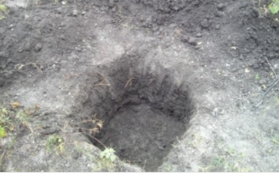

Fig 1 Sample Collection

**2.2 Fly ash**

Coal fly ash, a burnt residue of pulverized coal is hazardous and its disposal is a problem. The power requirement of the country is rapidly increasing with increase in growth of the industrial sectors. India depends on thermal power as its main source (around 65% of power produced is thermal power); as a result the quantity of ash produced shall also increase. Indian coal on an average has 30% to 40% ash and this is one of the prime factors which shall lead to increased ash production and hence ash utilization problems for the country.

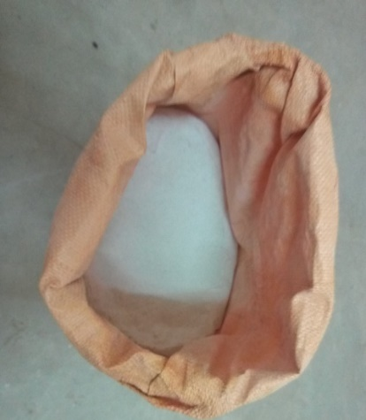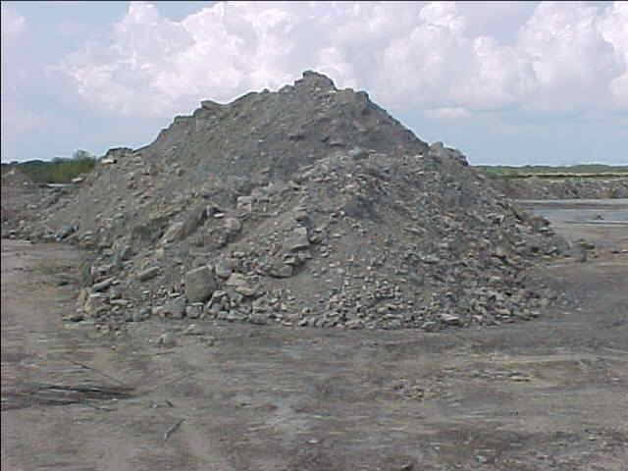

Fig 2 Fly ash

**3. TEST CONDUCTED**

The experimental work consists of the following steps

1. Determination of soil index properties (Atterberg‟s limits)

a. Liquid limit

b. Plastic limit

c. Shrinkage limit

2. Unconfined Compression Test

3. Standard Proctor Compaction Test

4. California Bearing Ratio Test

**4.TEST RESULTS AND OBSERVATION**

**4.1.1 Liquid Limit**

Table 1 Liquid Limit

|  |  |  |  |  |  |
| --- | --- | --- | --- | --- | --- |
| Determination Numbers | **1** | **2** | **3** | **4** | **5** |
| Number of blows | 112 | 88 | 64 | 42 | 22 |
| Weight of Container W0 g | 13.45 | 13.5 | 12.9 | 12.86 | 12.15 |
| Weight of container+ Wet soil W1 g | 22.4 | 22.4 | 22.12 | 22.2 | 21.45 |
| Weight of container+ oven dry soil W2 g | 20.21 | 20.15 | 19.76 | 19.72 | 18.9 |
| Weight if water (W1/W2)g | 2.19 | 2.25 | 2.36 | 2.48 | 2.55 |
| Weight of ovendry soil (W2-W0)g | 6.76 | 6.65 | 6.86 | 6.86 | 6.75 |
| water content W = {[(W1 - W2)/ (W2-W0)]x100} % | 32.39 | 33.83 | 34.40 | 36.15 | 37.77 |

Fig 3 Liquid Limit Graph Liquid Limit of Soil = 37.5 %

**4.1.2 Plastic Limit**

Table 2 Plastic Limit

|  |  |
| --- | --- |
| Container number | 1 |
| Weight of Container W0 g | 14.88 |
| Weight of container+ Wet soil W1 g | 19.27 |
| Weight of container+ oven dry soil W2 g | 17.76 |
| Weight if water (W1 - W2)g | 1.51 |
| Weight of ovendry soil (W2-w0)g | 2.88 |
| water content W = {[(W1 - W2)/ (W2-w0)]x100} % | 52.43 |

Plastic Limit of Soil = 52.43 %

Plasticity Index = Liquid Limit – Plastic Limit

= 37.5-52 = 14.93

**4.1.3 Shrinkage Limit**

Table 3 Shrinkage Limit

|  |  |
| --- | --- |
| Determination Numbers | **1** |
| Weight of tareContainer g | 36 |
| Weight of tare container+ Wet soil g | 75 |
| Weight of oven dried soil pat W0g | 62.24 |
| % of water Content | 0.5 |
| Volume of Container Vcm3 | 22.26 |
| Volume of dry soil pot Vocm3 | 13.1 |
| Shrinkage Limit Ws= (W-(V-Vd)/WO)X100 % | 43.12 |
| Shrinkage Ratio Wo/Vo g/cm3 | 4.75 |

Shrinkage limit of a given soil:43.12

**4.2 Unconfined Compression Test**

Table 4 Unconfined Compression Test

|  |  |  |  |  |  |  |  |
| --- | --- | --- | --- | --- | --- | --- | --- |
| Deflection Dial Reading | Priving ring reading | ∆l | e=∆l/l | load (kn) | 1-e | area, | stress,S=P/A |
| 0 | 0 | 0 | 0 | 0 | 1 | 11.34 | 0 |
| 0.5 | 0 | 0.5 | 0.051020408 | 0 | 0.948979592 | 11.9496774 | 0 |
| 1 | 1.2 | 1 | 0.102040816 | 2.4 | 0.897959184 | 12.6286364 | 0.1900443 |
| 1.5 | 2 | 1.5 | 0.153061224 | 4 | 0.846938776 | 13.3893976 | 0.2987438 |
| 2 | 2.9 | 2 | 0.204081633 | 5.8 | 0.795918367 | 14.2476923 | 0.4070835 |
| 2.5 | 3.2 | 2.5 | 0.255102041 | 6.4 | 0.744897959 | 15.2235616 | 0.420401 |
| 3 | 3.8 | 3 | 0.306122449 | 7.6 | 0.693877551 | 16.3429412 | 0.4650326 |
| 3.5 | 4 | 3.5 | 0.357142857 | 8 | 0.642857143 | 17.64 | 0.4535147 |
| 4 | 4.2 | 4 | 0.408163265 | 8.4 | 0.591836735 | 19.1606897 | 0.4383976 |
| 4.5 | 4.4 | 4.5 | 0.459183673 | 8.8 | 0.540816327 | 20.9683019 | 0.4196811 |
| 5 | 4.4 | 5 | 0.510204082 | 8.8 | 0.489795918 | 23.1525 | 0.3800885 |

Fig 4 Unconfined Compression Test Graph

Unconfined Compression strength of Soil = 0.46 KN/cm2

**4.3 Standard Proctor Compaction Test**

Table 5 Proctor Compaction Test

|  |  |  |  |  |  |
| --- | --- | --- | --- | --- | --- |
| **Water content** | **weight of mould** | **Weight of mould+base plate +soil** | **Weight of soi**l | **Bulk density** | **Dry density** |
| 8 | 5.04 | 7.285 | 2.245 | 2.18172983 | 0.61 |
| 10 | 5.04 | 7.297 | 2.257 | 2.19339164 | 0.63 |
| 12 | 5.04 | 7.01 | 1.97 | 1.91448008 | 0.65 |
| 14 | 5.04 | 6.98 | 1.94 | 1.88532556 | 0.63 |

Fig 5 Proctor Compaction test Graph

Max Dry Density of Soil = 0.65 g/cc

Optimum Moisture Content = 11%

**4.4 California Bearing Ratio Test**

Table 6 California Bearing Ratio Test

|  |  |  |  |  |
| --- | --- | --- | --- | --- |
| s.no | Proving ring reading | Penetration depth | Actual load | Standard load (Kg) |
| 1 | 10 | 0.5 | 11.76 | 274 |
| 2 | 36 | 1 | 42.34 | 548 |
| 3 | 65 | 1.5 | 76.44 | 822 |
| 4 | 94 | 2 | 110.54 | 1096 |
| 5 | 120 | 2.5 | 141.1 | 1370 |
| 6 | 143 | 3 | 168.17 | 1644 |
| 7 | 175 | 4 | 205.8 | 1849.5 |
| 8 | 196 | 5 | 230.49 | 2055 |
| 9 | 229 | 7.5 | 269.3 | 2630 |
| 10 | 243 | 10 | 285.77 | 3180 |
| 11 | 247 | 12.5 | 290.47 | 3600 |

California Bearing Ratio of Soil = 13.65 %

**5. CONCLUSION**

The suitability of fly ash as stabilizer to improve physical properties and strength of weak natural clayey soil has been investigated with the help of a series of the laboratory tests. The soil samples were taken from many town were tested to determine the properties such as particle size distribution, optimum moisture content, dry density, swelling ratio and bearing capacity. The properties of clay samples were determined without and with the addition of 15, 20 and 25% fly ash by total weight of the samples. The results obtained from the tests are summarized as follows.

* Particle size distribution of the soils remained unchanged due to the addition of fly ash because of almost similar gradation of the clayey soil and flyash used during this study.
* The liquid limit and plastic limit decrease with the addition of flyash, thereby decreasing the plasticity index also.
* The addition of flyash resulted in a remarkable increase in the maximum dry density and a decrease in optimum moisture content to those of the natural clayey soil respectively. The soil expansivity, which was „moderate‟ for the clayey soil, was also improved to „negligible‟ with 20% proportion of the flyash when clayey soil was tested for free swelling ratio
* The bearing capacity of the clayey soil significantly enhanced due to the addition of the flyash and was increased for the samples with 20% proportion of the marble powder.

The results of the experimental study conducted and discussions made herein inferred that the addition of flyash to weak natural clayey soil has shown remarkable improvement in the physical properties and bearing capacity of the soil. It may be concluded that the flyash may be considered a potential stabilizing component to strengthen the weak clayey soils.

**6. REFERENCES**

[1] Use of class C Fly Ashes for the Stabilization of an Expansive Soil, Journal Geotechnical and Geoenvironmental Engineering. Vol. 127, No. 7, pp.568-573.

[2] IS: 2720 (Part 1,2,4,5,7& 15): “Methods for test of soils”.

[3] Mishra A.K. Dhawan S., Rao, S.M. (2008), Analysis of Swelling and Shrinkage Behavior of CompactedClays, Geotechnical and Geological Engineering, Vol. 26, No. 3 pp. 289 – 298.

[4] Prakash, K. and Shidhara, A.(2004), Free Swell Ratio and Clay mineralogy of Fine-Grained Soils,Geotechnical Testing Journal, Vol. 27, No.2, pp.1 – 6.

[5] I Pollution Control Board (CPCB). Report on management of Municipal solid WASTES, Delhi. India, 2000.

[6] Stabilisation of Black Cotton Soils Using Fly Ash, Hubballi-

Dharwad Municipal Corporation Area, Karnataka, India

By UdayashankarD.Hakari, S.C.Puranik

[7] Asokan P. Application of coal combustion resides for hazardous Waste management. Third Annual PHD,progress report. Indian

[8] Institute of Technology, Bombay, India. 2004

[9] JyotiS.Trivedi, Sandeep Nair, ChakradharIyyunni. “Optimum Utilization of Fly Ash for Stabilization of Sub- Grade Soil Using Genetic Algorithm” Procedia Engineering 51: 250 – 258(2013).

[10] DimitrisDermatas, XiaoguangMeng. “Utilization of fly ash for stabilizing consoliding metal contaminatedsoils” Engineering Geology 70(3-4): 377–394(2003).

[11] Sherwood PT. “Soil stabilization with cement and lime“stateof the artreview.HNSO Publication; 1993.

[12] Petry TM, Little DN. “Review of stabilization of clays and expansive soils in pavements and lightly loaded structures “history, practice, and future. Journal of Materials in Civil Engineering 14(6):447–60(2002).

[13] Consoli NC, Foppa D, Festugato L, HeineckKS.”Key parameters for strength control of artificially cemented soils.” Journal of Geotechnical and Geoenvironmental Engineering 133(2):197–205(2007).