**All about 'Blue green algae'**

Author:- Himanshu Mishra .

**Key words**

Blue green algae, cyanobacteria, Agriculture, biofertilizer .

**Abstract**

Blue-green algae form a self-sufficient system which Is capable of fixing atmospheric nitrogen in organic forms And which grows upon a free water surface. Blue-green algae (BGA) are among the most interesting life forms on earth and have been consumed as food or medicine by humans . BGA contain various bioactive components, such as phycocyanin, carotenoids, γ-linolenic acid, fibers, and plant sterols, which can also be beneficial to humans. The several BGA species or their active components have plasma total cholesterol and triglyceride-lowering properties due to their modulation of intestinal cholesterol absorption and hepatic lipogenic gene expression. BGA also helps in reducing inflammation by inhibiting the nuclear activity, and also helps in reducing the production of proinflammatory cytokines. BGA inhibit lipid peroxidation and have free radical clearance activity, which is also beneficial for the protection against oxidative stress. The effects of BGA can contribute to the prevention of metabolic and inflammatory diseases. Blue green algae (BGA) has more morphological and metabolic diversity and it is used in economic development and environment management like wastewater treatment, land reclamation, production of fine chemicals, atmospheric fixation of nitrogen, production of methane fuel, conversion of solar energy, therapeutic functions .BGA fix atmospheric nitrogen and supply it to plants thereby having the capacity to reduce the consumption of urea.

**Introduction**

Blue green algae is also known as cyanobacteria in scientific term . Blue green algae is a group of gram negative photosynthetic bacteria that have colonized earth surface and are considered as the predecessors of modern day chloroplast. BGA possess a great deal of morphological and metabolic diversity . BGA are nutritious natural products rich in essential amino acids, γ-linolenic acid (GLA), fibers, B vitamins, calcium, phosphorous, iron, pigments such as β-carotene, xanthophyll’s, and chlorophyll, and other bioactive compounds. Blue green algae also helps us making chemical products with applications in the feed, food, nutritional, cosmetic, pharmaceutical and even fuel industry. Blue green algae is used from the centuries. The purposeful cultivation of blue green algae started only a few decades ago. During 20th century, several cultivation technologies have been developed and are in use to produce CB biomass as a source of valuable product .Factors promoting Blue green algae l growth include sunlight, warm weather, low turbulence, and nutrient sources Such as phosphorus and nitrogen, some types of algae prefer turbid, or cloudy, water with low levels Of light. Water containing high levels of blue-green algae may appear greenish in color and, occasionally, some Shades of blues, browns and even white. Cyanobacteria have gained importance because of their importance and uses in various areas of research. This diverse group has application in different fields like biotechnology, pharmacology, agriculture etc. Due to presence of large number of bioactive compounds cyanobacteria has possesses antiviral, antibacterial, antifungal and anticancer

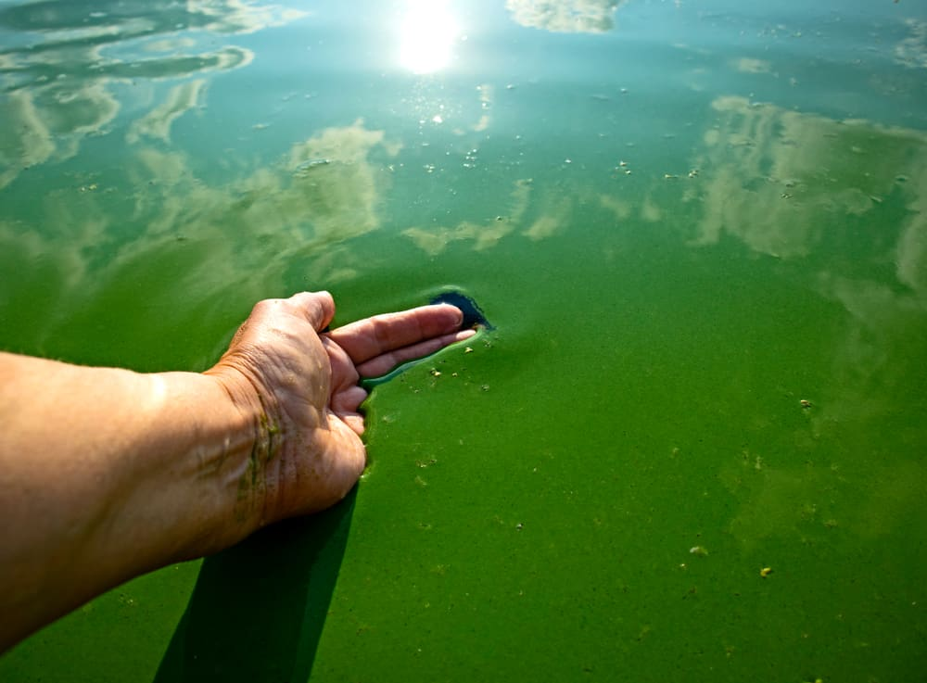

activities. Several strains of cyanobacteria are also rich in food supplements. The Nitrogen fixing capacity of cyanobacteria has attracted agriculturists and researchers and they used blue green algae media of biofertilizers to improve both the fertility of soil as well as growth of plants. Some studies have also shown that cyanobacteria have capacity to degrade environmental pollutants and are also being used as a source of alternative energy.

**Nitrogen fixation**

In some cyanobacteria nitrogen fixation occurs in heterocyst. It is an enlarged cell and may be present terminally or intercalary in filamentous cyanophycean algae. These special cell wall layers permit the atmospheric N2 (g) to diffuse inside, whereas on they stop the atmospheric O2 to come inside. This is a damage- control mechanism for the enzyme nitrogenize, as the nitrogenize is sensitive to O2 and cold, and cannot function in the presence of O2 .BGA fix approximately 25Kg N/ha/year. It is suitable nitrogen fixer for paddy field.

**Occurrence and agronomic significance**

The Importance of blue-green algae in rice fields has been reported in numerous papers. Culture studies were introduced by Banerjee in 1935 and the importance of blue-green algal nitrogen fixation in helping to maintain Fertility of the rice fields . Many rice fields show the positive growths of blue-green algae, although eukaryotic green algae may be More abundant where high quantities of nitrogenous fertilizer have been added. The best known effect of blue-green algal growth on rice increased nitrogen .The extent to which the blue-green algae may contribute to the nitrogen requirements Of the rice crop is determined by a number of factors, the most obvious of which are The standing crop, rate of nitrogen fixation per unit area, turnover of the nitrogen fixed And the extent to which any nitrogen released becomes available to the rice plant .Availability resulting from nitrogen fixation

**Nutritional Benefits**

The blue green algae spirulina is a good source of protein. Its protein content includes all the essential amino acids . It is a complete source of the important nutrients. A 100-gram serving also contains about 2 grams of carbohydrates and 0 fat. With only 26 calories in each serving, spirulina is a naturally low-calorie food. It also provides moderate amounts of several important minerals, including calcium, iron, potassium and magnesium, as well as small amounts of zinc and phosphorus. The algae also contain vitamins A, C, E and several of the B vitamins, including thiamin, riboflavin, vitamin B-6 and folate. The Blue green algae is Rich in many nutrient and it is packed with nutrients. A single tablespoon (tbsp), or 7 grams (g), of dried powder

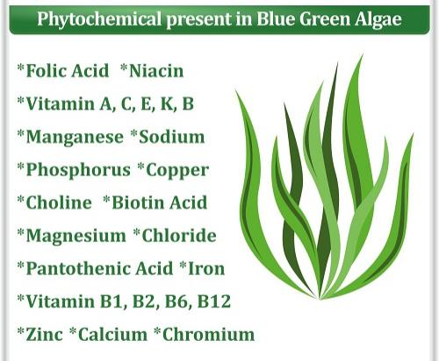

Protein: 4 g

Thiamin: 14% of the Daily Value (DV)

Riboflavin: 20% of the DV

Niacin: 6% of the DV

Copper: 47% of the DV

Iron: 11% of the DV

It also contains small amounts of magnesium, potassium, and manganese. the same amount contains only 20 calories and less than 2 g of carbohydrates. Spirulina also provides a small amount of fat — around 1 g per tbsp. (7 g) — including both omega-6 and omega-3 fatty acids in an approximately 1.5 to 1 ratio. And the quality of the protein in blue green algae is considered excellent and provides Trusted Source all of the essential amino acids that your body needs.

**Health Benefits.**

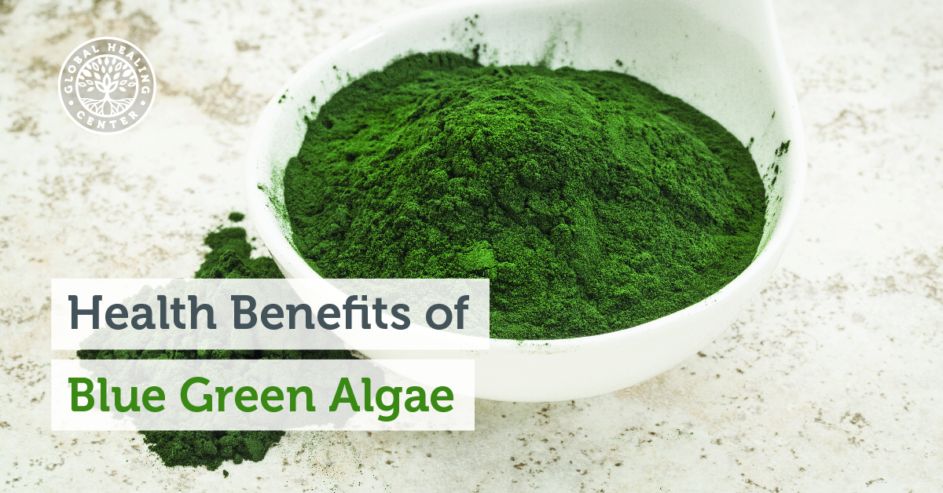

The blue green algae also boost immune system and have natural anti-viral properties, helping suppress growth of HIV and other viruses. Consuming blue green algae may also help relieve fatigue and improve your tolerance of exercise. A clinical study published in “Medicine and Science in Sports and Exercise” found that male subjects who consumed spirulina for four weeks were able to exercise longer and had changes in their blood that indicated better usage of nutrients compared to a placebo group. Blue green algae may also lower blood cholesterol levels and reduce blood pressure. BGA contain bioactive components, namely, carotenoids, GLA, PC, fibers, and plant sterols, which can be beneficial for preventing CVD and NAFLD. BGA inhibit intestinal cholesterol absorption and decrease hepatic lipids, lowering plasma total cholesterol, and triglyceride concentrations. The anti-inflammatory function of BGA is mediated, at least in part, by inhibiting the NF-κB pathway to decrease the production of proinflammatory mediators. BGA can also decrease oxidative stress due to their free radical scavenging activity and inhibition of lipid peroxidation. In conclusion, BGA can be consumed as a dietary supplement or a food component to obtain health benefits against CVD and NAFLD. However, safety assessments of any BGA species should precede recommendations for the BGA consumption in humans because contamination of toxin-producing BGA has been reported in some naturally harvested BGA products .

**Useful for Digestive System**

Blue-green algae are rich in oxygen and contain high levels of chlorophyll that inhibits anaerobic bacteria. Blue-green algae, which activate the automatic muscular system in the gastrointestinal tract, create an oxygen-rich environment that feeds probiotics. Therefore, it can play an essential role in the regulation of the digestive system

**Detox Effect**

Blue-green algae are rapidly absorbed in the body and act as a detoxifying agent by balancing the intestinal tract. Blue-green algae, which also helps to maintain the necessary minerals, vitamins, and nutrient balance, can also be said to have superior capabilities in detoxification, which means purification of the body from harmful toxicities.

**Strengthens the Immune System**

Blue-green algae contain abundant beta carotene, the precursor of vitamin A. This miraculous supplement that provides vitamin A support, which we know as one of the vital vitamins for our body, makes a significant contribution to the strengthening of the immune system .

**Weight Loss**

Blue-green algae, which are very low in calories, are also included in the diet lists. They have an extremely high nutritional value and are an excellent fat burner! With a rate of 60%, only 10 grams of spirulina, which is a protein store, is enough to meet the daily iron need. With regular consumption, A, B, D, and K vitamin needs are met.

**Cosmetic Industry**

Blue-green algae toner is highly moisturizing anti-inflammatory and antibacterial and good for all skin types and treatment and prevention of acne. It’s 7.8 fluid and it’s actually a decent amount of toner for a pretty good price too. The blue-green algae and organic helps in combination with the hyaluronic acid to penetrate deeply and promote cellular renewal naturally and nourished and re-mineralize the skin .And it has a anti-inflammatory effects. Its has anti-acne properties ,antibacterial it’s a more organic With a remarkable anti-aging ability, spirulina nourishes the skin and gives antioxidant effects. It also contains beta carotene in it, and also provides a good quality of vision for healthy eyes.

**Radioactive Protection**

Blue-green algae fight radiation, especially during the cancer treatment process, when the algae remove the radioactive particles to which the patients are exposed to. It can have a positive effect on the course of the treatment; however, in this case, it is necessary to follow the doctor's recommendations

**Blue Green Algae Supplement**

Blue-Green Algae contain dietary supplements and are rich in minerals, proteins, vitamins, amino acids. These supplements are very beneficial to improve your mental ability and concentration. The dietary supplements of blue-green algae give a positive effect on algae products. There are some commercialized products which are based on blue-green algae such as Aphanizomenon flos-aquae, Spirulina, and Chlorella.

**Usage and Recommendations**

Blue green algae supplements are available in capsules from many health-food stores. The supplements usually contain spirulina, sometimes in combination with other algae called Aphanizomeron flos aquae. Choose only products certified free of contamination by microcystins, potentially harmful toxins that the algae sometimes produce. Contaminant-free supplements are generally considered safe, although you should avoid them if you take immunosuppressive medication or if you are pregnant or breast-feeding. Discuss use of blue green algae with your doctor to decide if consuming them might be helpful for you.

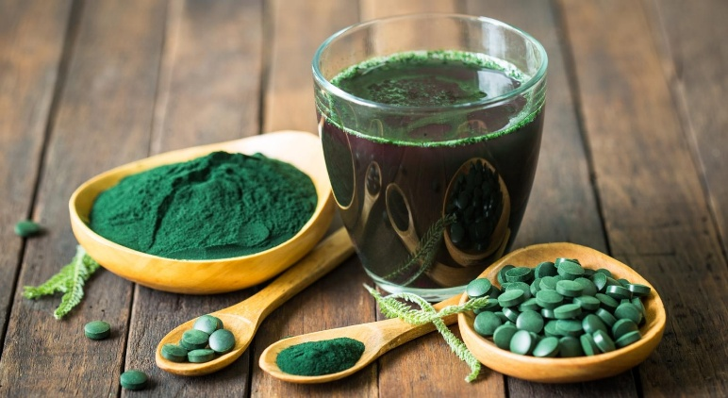

**Biofertilizer Production**: Blue-green algae is also used to produce biofertilizers, and it is environmental friendly alternatives to chemical fertilizers. These biofertilizers can enhance plant growth and productivity.

**Drought Resistance**: Some species of blue-green algae produce substances that can help plants to adapt drought stress by enhancing their water intake and water holding capacity.

**Soil Stabilization:** Blue-green algae also helps in prevent of soil erosion by binding soil particles together and forming a protective layer on the soil surface.

**References**:

1. Draisci R, et al. Identification of anatoxins in blue-green algae food supplements using liquid chromatography-tandem mass spectrometry. Food Addit Contam 2001;18:525-31.
2. Patocka J. The toxins of Cyanobacteria. Acta Medica 2001;44:69-75.
3. Paerl, H. W., & Otten, T. G. (2013). Harmful cyanobacterial blooms: causes, consequences, and controls. Microbial Ecology, 65(4), 995-1010.
4. Carmichael, W. W. (2001). Health effects of toxin-producing cyanobacteria: “The CyanoHABs”. Human and Ecological Risk Assessment: An International Journal, 7(5), 1393-1407.
5. Hudnell, H. K. (2008). The state of US freshwater harmful algal blooms assessments, policy and legislation. Toxicon, 51(1), 152-163.
6. World Health Organization. (2019). Cyanobacterial toxins: Microcystin-LR in drinking-water (No. WHO/SDE/WSH/03.04/14/Rev/1). World Health Organization.
7. Selmi C, Leung PS, Fischer L, et al. The effects of Spirulina on anemia and immune function in senior citizens. Cell Mol Immunol. 2011 Jan 31.
8. Kalafati M, Jamurtas AZ, Nikolaidis MG, et al. Ergogenic and antioxidant effects of spirulina supplementation in humans. Med Sci Sports Exerc. 2010 Jan;42(1):142-51.
9. Lee EH, Park JE, Choi YJ, Huh KB, Kim WY. A randomized study to establish the effects of spirulina in type 2 diabetes mellitus patients. Nutr Res Pract. 2008 Winter;2(4):295-300.
10. Samuels R, Mani UV, Iyer UM, Nayak US. Hypocholesterolemic effect of spirulina in patients with hyperlipidemic nephrotic syndrome. J Med.Food 2002;5:91-6.
11. Huisman, J., Codd, G. A., Paerl, H. W., Ibelings, B. W., Verspagen, J. M., & Visser, P. M. (2018). Cyanobacterial blooms. Nature Reviews Microbiology, 16(8), 471-483.
12. Otten, T. G., & Paerl, H. W. (2015). Health effects of toxic cyanobacteria in US drinking and recreational waters: our current understanding and proposed direction. Current Environmental Health Reports, 2(1), 75-84.
13. Smith, V. H., & Schindler, D. W. (2009). Eutrophication science: where do we go from here?. Trends in Ecology & Evolution, 24(4), 201-207.
14. Paerl, H. W., & Huisman, J. (2009). Climate change: a catalyst for global expansion of harmful cyanobacterial blooms. Environmental Microbiology Reports, 1(1), 27-37.
15. Suikkanen, S., Pulina, S., Engström-Öst, J., & Lehtiniemi, M. (2020). Climate change and eutrophication-induced shifts in northern summer plankton communities. Scientific Reports, 10(1), 1-10.
16. Health Benefits of Eating Red, Green, & Blue Green algae . July 19, 2020 by SeaVegetables
17. <https://www.weekand.com/healthy-living/article/health-benefits-blue-green-algae-18011839.php>
18. Brian ALAN Whitton., Pierre Armand Roger. Use of blue-green algae and Azolla in rice culture . Journal of Applied Phycology
19. B.A.WHITTON and P.A.ROGER’ ., Use of blue-green algae and azola in rice Culture . Pages 89-100 in Society for General Microbiology. 1989. Microbial inoculation Of crop plants. Vol. 25. R. Campbell and R. M. Macdonald, editors. IRL Press at Oxford University Press, Oxford.
20. Alina Petre, MS, RD (NL) ., Supplements You Need on a Vegan Diet . October 15, 2019 healthline
21. Joanne Marie ., Health Benefits of Blue Green Algae . Dec 17, 2018
22. https://www.weekand.com/healthy-living/article/health-benefits-blue-green-algae-18011839.php
23. Aisha Kamal ., Iffat Ahmad ., Cyanobacteria “the blue green algae” and its novel applications: A brief Review . International Journal of Innovation and Applied Studies ISSN 2028-9324 Vol. 7 No. 1 July 2014, pp. 251-261.
24. Rishi Raj and Mrinalini Kumari ., Blue green algae (BGA) and its application . Journal of Pharmacognosy and Phytochemistry 2020; 9(2): 287-296 .