**A Study on Effectiveness of organizational culture on employee performance**

1Hari Haran M and 2S.V Praveen

1MBA student Jerusalem College of Engineering, Chennai

2Professor and Head MBA, Jerusalem College of Engineering, Chennai

**ABSTRACT**

This study aims to investigate the influence of organizational culture on employee performance within the organization. The research will explore various dimensions of organizational culture, such as leadership styles, communication patterns, and employee engagement, and their correlation with individual and team performance. The study will employ a mixed methods approach, including surveys, interviews, and performance metrics analysis, to gather comprehensive data from employees at different hierarchical levels. The findings of this study will contribute to a deeper understanding of the role of organizational culture in shaping employee behaviour and productivity, and provide valuable insights for organizations seeking to enhance their performance through cultural interventions. The results are expected to offer practical implications for HR professionals, managers, and organizational leaders to develop strategies that foster a positive and productive work environment.

**INTRODUCTIONS**

Organizational culture plays a significant role in shaping the behaviour, attitudes, and performance of employees within a company. It encompasses the shared values, beliefs, norms, and practices that define the work environment and guide employee interactions. A strong organizational culture can enhance employee engagement, job satisfaction, and overall performance, while a toxic or dysfunctional culture can have detrimental effects on employee morale and productivity.

This study aims to explore the impact of organizational culture on employee performance. By examining the relationship between various aspects of organizational culture, such as leadership style, communication practices, and teamwork, and employee performance metrics like productivity, job satisfaction, and retention rates, we can gain insights into how organizations can create a positive and supportive work environment that fosters high performance.

**REVIEW OF LITERATURE**

Armstrong and Baron, (2019) “Performance management is a strategic and integrated approach to delivering sustained success to organizations by improving the performance of the people who work in them and by developing the capabilities of teams and individual contributors.

Kandula (2015), the key to good performance is a strong culture. He further maintains that due to differences in organizational culture, the same strategies do not yield the same results for two organizations in the same industry and the same location. A positive and strong culture can make an average individual perform and achieve brilliantly whereas a negative and weak culture may demotivate an outstanding employee to underperform and end up with no achievement. Therefore, organizational culture has an active and direct role in performance management.

Mannion, R., & Davies, H. (2018) Hospitals, are a dynamic cultural mosaic made up of multiple, complex and overlapping subgroups with variably shared assumptions, values, beliefs, and behaviours. Two of the major professional groupings concerned with quality improvement doctors- managers- may differ in several important ways.

Thoreson, Bono, and Patton (2018) discovered that after correcting the sampling and measurement errors of 301studies, the correlation between job satisfaction and job performance increased to It is important to note that the connection between job satisfaction and job performance.

(Manguennandongo, 2002) An organization survives if it is performing well in the environment by being profitable but if it fails to do so the organization may not survive. And worse is the decay of both human and physical structures.

Casse and Banahan (2007), the different approaches to training and development need to be explored. It has come to their attention by their own preferred model and through experience with large Organizations. The current traditional training continuously facing the challenges in the selection of the employees, in maintaining the uncertainty related to the purpose and in introducing new tactics for the environment of work and by recognizing this, they advising on all the problems, which reiterates the requirement for flexible approach.

**ANALYSIS**

**PERCENTAGE ANALYSIS**

TABLE 1

|  |  |  |  |  |  |
| --- | --- | --- | --- | --- | --- |
| **Do you believe that your level of job satisfaction affects your performance at work?** | | | | | |
|  | | Frequency | Percent | Valid Percent | Cumulative Percent |
| Valid | agree | 61 | 59.2 | 59.2 | 59.2 |
| neutral | 31 | 30.1 | 30.1 | 89.3 |
| disagree | 11 | 10.7 | 10.7 | 100.0 |
| Total | 103 | 100.0 | 100.0 |  |

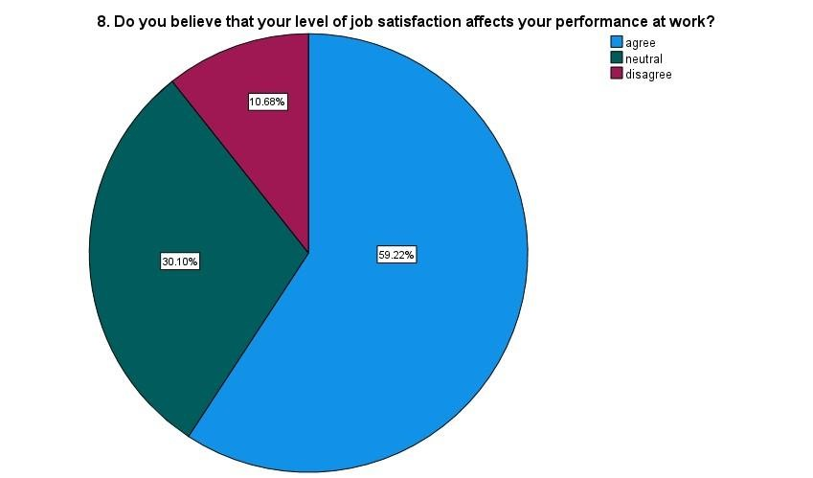FIG 1

**Inference:**

As the table shows that most of the respondents are agree with the job satisfaction affect the performance at work with the percentage of 59.22 as shown in the pie chart.

TABLE 2

|  |  |  |  |  |  |
| --- | --- | --- | --- | --- | --- |
| **Does organizational culture influence employee job satisfaction and engagement?** | | | | | |
|  | | Frequency | Percent | Valid Percent | Cumulative Percent |
| Valid | yes | 48 | 46.6 | 46.6 | 46.6 |
| no | 28 | 27.2 | 27.2 | 73.8 |
| maybe | 27 | 26.2 | 26.2 | 100.0 |
| Total | 103 | 100.0 | 100.0 |  |

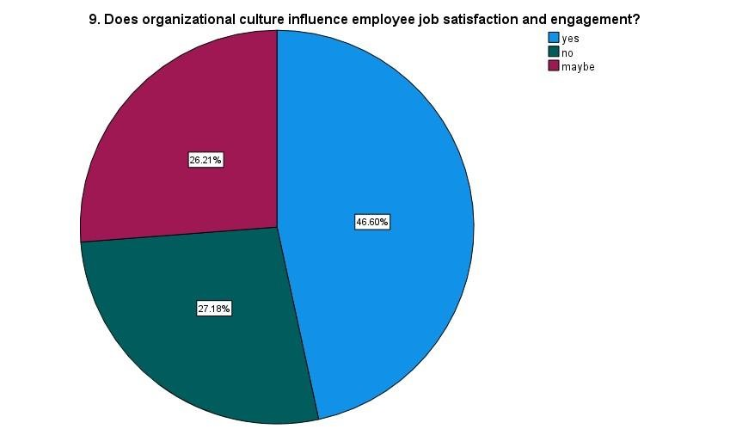FIG 2

**Inference:**

As the table shows that most of the respondents says yes for organizational culture influence the job satisfaction with the percentage of 46.60 as shown in the pie chart.

TABLE 3

|  |  |  |  |  |  |
| --- | --- | --- | --- | --- | --- |
| **Do employees in organizations with strong cultures tend to report higher levels of job satisfaction?** | | | | | |
|  | | Frequency | Percent | Valid Percent | Cumulative Percent |
| Valid | yes | 57 | 55.3 | 55.3 | 55.3 |
| no | 25 | 24.3 | 24.3 | 79.6 |
| maybe | 21 | 20.4 | 20.4 | 100.0 |
| Total | 103 | 100.0 | 100.0 |  |

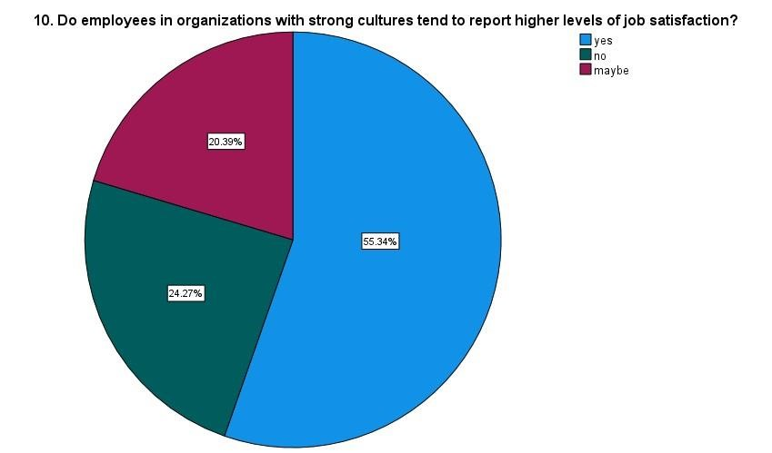FIG 3

**Inference:**

As the table shows that most of the respondents say yes for the strong culture tend to report higher level of job satisfaction with the percentage of 55.34 as shown in the pie chart.

TABLE 4

|  |  |  |  |  |  |
| --- | --- | --- | --- | --- | --- |
| **12. Does organizational culture have a positive impact on employee work-life balance and well-being?** | | | | | |
|  | | Frequency | Percent | Valid Percent | Cumulative Percent |
| Valid | yes | 44 | 42.7 | 42.7 | 42.7 |
| no | 8 | 7.8 | 7.8 | 50.5 |
| sometimes | 34 | 33.0 | 33.0 | 83.5 |
| depends | 13 | 12.6 | 12.6 | 96.1 |
| unsure | 4 | 3.9 | 3.9 | 100.0 |
| Total | 103 | 100.0 | 100.0 |  |

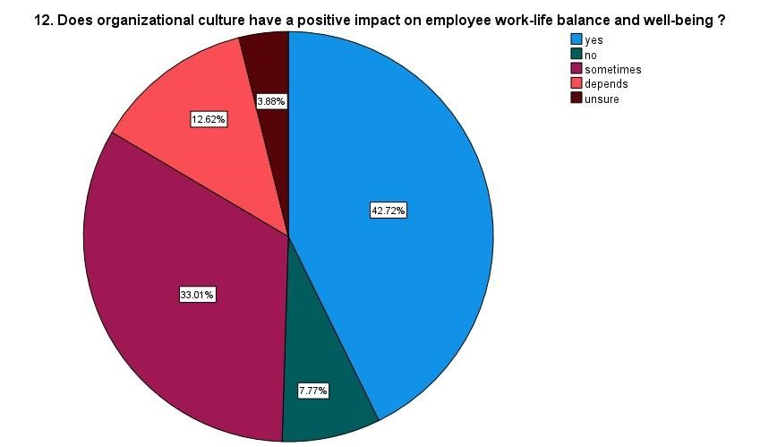FIG 4

**Inference:**

As the table shows that most of the respondents are says yes for organisational culture have a positive impact on employee work-life balance with the percentage of 42.72 as shown in the pie chart

TABLE 5

|  |  |  |  |  |  |
| --- | --- | --- | --- | --- | --- |
| **14. Can a supportive organizational culture improve employee well-being?** | | | | | |
|  | | Frequency | Percent | Valid Percent | Cumulative Percent |
| Valid | yes | 41 | 39.8 | 39.8 | 39.8 |
| no | 22 | 21.4 | 21.4 | 61.2 |
| maybe | 38 | 36.9 | 36.9 | 98.1 |
| rarely | 1 | 1.0 | 1.0 | 99.0 |
| unsure | 1 | 1.0 | 1.0 | 100.0 |
| Total | 103 | 100.0 | 100.0 |  |

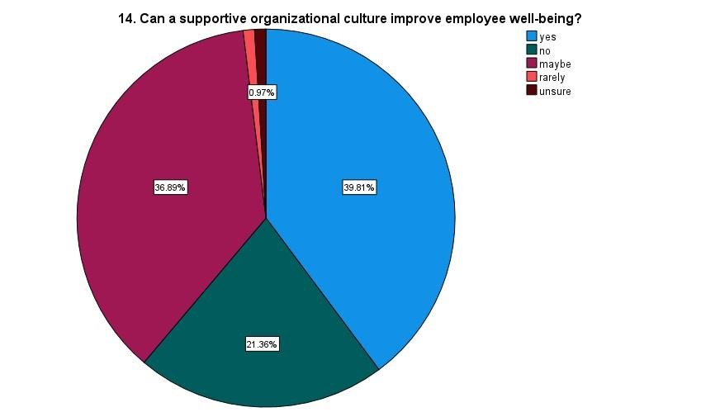FIG 5

**Inference:**

As the table shows that most of the respondents are says yes for supportive organisational culture improve employee well-being with the percentage of 39.81 as shown in the pie chart.

**CORRELATION**

To find out the relationship between Does organizational culture have a positive impact on employee work-life balance and well-being and organizational culture impact employee mental health.

**H0:** There is no significance relationship between organizational culture have a positive impact on employee work-life balance and well-being and organizational culture impact employee mental health.

**H1:** There is a significance relationship between organizational culture have a positive impact on employee work-life balance and well-being and organizational culture impact employee mental health.

|  |  |  |  |
| --- | --- | --- | --- |
| **Correlations** | |  | |
|  | | 12. Does organizational  culture have a positive impact on employee worklife balance and wellbeing? | 13. Can organizationally  culture impact employee mental health? |
| 12. Does organizational culture have a positive impact on employee work-life balance and well-being? | Pearson Correlation | 1 | .595** |
| Sig. (2-tailed) |  | .000 |
| N | 103 | 103 |
| 13. Can organizationally culture impact employee mental health? | Pearson Correlation | .595** | 1 |
| Sig. (2-tailed) | .000 |  |
| N | 103 | 103 |
| **. Correlation is significant at the 0.01 level (2-tailed). | |  | |

**Inference:**

From the above table, we find the significant value is .000, which is less than the table value 0.05, so null hypothesis is rejected and alternative hypothesis is accepted.

Therefore, there is a significance relationship between organizational culture have a positive impact on employee work-life balance and well-being and organizational culture impact employee mental health.

**REGREESION ANALYSIS**

To find out the relationship between Do you believe that your level of job satisfaction affects your performance at work and does organizational culture influence employee job satisfaction and engagement.

**H0:** There is no significance relationship between job satisfaction affects your performance at work and organizational culture influence employee job satisfaction and engagement.

**H1:** There is a significance relationship between job satisfaction affects your performance at work and organizational culture influence employee job satisfaction and engagement.

|  |  |  |  |  |  |  |
| --- | --- | --- | --- | --- | --- | --- |
| **Coefficientsa** | | | |  |  |  |
| Model | | Unstandardized Coefficients | | Standardized Coefficients | t | Sig. |
| B | Std. Error | Beta |
| 1 | (Constant) | 1.062 | .154 |  | 6.902 | .000 |
| 9. Does organizational culture influence employee job satisfaction and engagement? | .252 | .078 | .306 | 3.236 | .002 |

a. Dependent Variable: 8. Do you believe that your level of job satisfaction affects your performance at work?

**Inference:**

From the above table, we find the significant value is .002, which is less than table value 0.05, so the null hypothesis is rejected and alternative hypothesis is accepted.

Therefore, there is a significant relationship between job satisfaction affects your performance at work and organizational culture influence employee job satisfaction and engagement.

**FINDINGS**

The table shows that most of the respondents are somewhat satisfied with their current job with the percentage of 36.89 as shown in the pie chart.

The table shows that most of the respondents are agree with the job satisfaction affect the performance at work with the percentage of 59.22 as shown in the pie chart.

The table shows that most of the respondents says yes for organizational culture influence the job satisfaction with the percentage of 46.60 as shown in the pie chart.

The table shows that most of the respondents say yes for the strong culture tend to report higher level of job satisfaction with the percentage of 55.34 as shown in the pie chart.

The table shows that most of the respondents are says yes for recommend the work place with others with the percentage of 48.54 as shown in the pie chart.

organizational culture has a positive impact on employee work-life balance and well-being and organizational culture impact employee mental health.

**SUGGESTIONS**

The data presented in the tables and pie charts highlight several key insights regarding the respondents' demographics, attitudes towards organizational culture, and its impact on various aspects of their work experience. To enhance the clarity and coherence of the report, it is advisable to organize the information systematically and provide clear headings for each section, such as "Demographic Profile of Respondents" and "Perceptions of Organizational Culture." Additionally, incorporating descriptive statistics or visual aids, such as bar graphs or histograms, can further elucidate the distribution of responses across different categories. Furthermore, it would be beneficial to include a brief discussion or interpretation of the findings, emphasizing the implications for organizational management and suggesting potential strategies for leveraging organizational culture to improve employee satisfaction, performance, and retention

**REFERENCE**

Mannion, R., & Davies, H. (2018) Hospitals, are a dynamic cultural mosaic made up of multiple, complex and overlapping subgroups with variably shared assumptions, values, beliefs, and behaviours.

Iaffaldano and Muchinsky (2020) have found a weak connection, approximately 0.17, between job satisfaction and job performance.

Kandula (2015), the key to good performance is a strong culture. He further maintains that due to differences in organizational culture, the same strategies do not yield the same results for two organizations in the same industry and the same location.