**THE INFLUENCE OF WORK ENVIRONMENT, WORK DISCIPLINE AND COOPERATION ON THE PERFORMANCE OF DISNAKER EMPLOYEES, PM-PTSP MALANG CITY-INDONESIA**

**Priyo Sudibyo1, Edi Sugiarto2**

1Lecturer at Management Undergraduate Study Program, Faculty of Economics and Business, University of Merdeka Malang, Indonesia. Email: priyo.sudibyo11@gmail.com

gmail.com2Lecturee at Accounting Undergraduate Study Program, Faculty of Economics and Business, University of Merdeka Malang, Indonesia. Email: edi.sugiarto1@unmer.ac.id

**ABSTRACT**

The Department of Manpower, Investment and One Stop Integrated Services (DISNAKER, PM-PTSP) needs employees who can provide excellent service for all types of services. Among them are the work environment, work discipline and cooperation. The main problem in this research is whether the process of work environment, work discipline and cooperation influences employee performance at DISNAKER, PM-PTSP Malang City. The aim of this research is to determine the influence of the work environment, work discipline and cooperation on the performance of DISNAKER, PM-PTSP Malang City employees. The data obtained in this research is primary data by distributing questionnaires to respondents. The population in this research is 55 employees of DISNAKER, PM-PTSP Malang City. Data were analyzed using t test calculations. The work environment has a significance level of 0.030 which is <0.05, indicating that H0 is rejected where the work environment has a significant influence on employee performance at DISNAKER, PMPTSP Malang City. Work discipline has a significance level of 0.034, where the result is <0.05, this shows that H0 is rejected where work discipline has a significant influence on employee performance at DISNAKER, PM-PTSP Malang City. Cooperation has a significance level of 0.004 which is <0.05, this indicates that H0 is rejected where cooperation has a significant influence on employee performance at DISNAKER, PM-PTSP Malang City. Work environment, Work Discipline and Cooperation have a significant effect on employee performance at DISNAKER, PM-PTSP Malang City. In the process of collecting data, the information provided by respondents through questionnaires sometimes does not show the respondents' true opinions, however, from this research, suggestions can be taken to the parties studied to maintain the level of service quality.

**Keywords:** Work Environment, Work Discipline, Cooperation, Performance, Disnaker Employees.

1. **INTRODUCTION**

In this era of globalization, human resources are a very important factor. Hanafi (2018), Therefore, Human Resources are resources that must be improved effectively and efficiently for optimal performance. To achieve optimal performance, agencies must create conditions that enable this. Good employees naturally know how to optimally utilize existing opportunities to achieve effectiveness and efficiency at work. Staff who function optimally are expected to be able to influence the agency well so that it can achieve the stated goals.

Reviews related to human resources of course include employee performance. According to Wirawan (2018), performance is an activity carried out by employees when carrying out work assigned by the agency. According to Armstrong, (2017), performance is the result of work that has a strong relationship with the organization's strategic goals, customer satisfaction and economic promotion. It is hoped that the agency's desired goals can be achieved with good and optimal employee performance. On the other hand, it is difficult for an agency to achieve its goals when its employees do not get good results, so they cannot do their work well. (Yudiningsih, 2016).

Performance has a broader meaning than just expressing it as the result of work, but rather becomes an ongoing work process. Performance is about work and the results achieved in work. Performance is a work result that has a strong relationship with the organization's strategic goals, customer satisfaction and financial contribution. (Armstrong, 2015). Employee performance is always related to several factors that influence it. Knowing the factors that influence performance makes it easier for leaders to identify what makes employees perform optimally. Factors that influence an employee's performance according to Mahmudi, (2010), performance is a multidimensional construct that includes many factors that influence it, including: personal factors, leadership factors, team factors, system factors, contextual factors and other factors. This research examines the influence of the work environment, work discipline and cooperation as important factors for both long-established and established agencies. A good work environment makes employees comfortable at work, this comfort has an effect on improving employee work results (Novyanti, 2015).

The work environment in an agency is very important for management. Therefore, a conducive work environment provides a sense of security and comfort. Employees can achieve maximum results if they have high achievement motivation. This form of achievement must be embedded in oneself and the work environment. A good working atmosphere defines success in achieving common goals. On the other hand, if the work environment is not good, motivation will also weaken morale and ultimately reduce employee performance. Apart from work environment issues, work discipline is also very important, especially if it encourages employees to be disciplined both as individuals and when working in groups. Apart from that, discipline also functions to train employees to follow and enjoy existing rules, procedures and practices to achieve good performance. Good discipline describes a person's responsibility for the tasks given by their superiors. Can increase work morale and create a perfect company. Maintaining and improving good discipline is quite difficult because many factors can influence it. Work discipline is an employee's awareness and willingness to comply with all organizational regulations and applicable standards. Thus, work discipline is a tool that leaders use to communicate with their employees so that they are willing to correct their behavior according to the rules that have been set. Discipline is followed in the organization. This means that without good work discipline from employees, it will be difficult for the organization to realize its goals. Therefore, discipline is the key to an organization's success in achieving its goals (Sinambela, 2017).

Cooperation, relatively small groups working on well-defined tasks, challenging tasks are most effectively achieved by groups working together rather than individuals working alone and success is achieved after working environmental conditions and work discipline. Agency goals cannot be separated from cooperation (West, 2014). The definition of teamwork means that cooperation is a group of people working together to achieve a common goal, and this goal is easier to achieve if they work in a group than if they work alone. Cooperation facilitates communication between employees and leaders. So the most important thing is that cooperation facilitates decision making by employees or leaders. Positive synergy will emerge by itself if cooperation is carried out and coordinated well.

The Department of Manpower, Investment and One-Stop Integrated Services (DISNAKER, PM-PTSP) is an agency that is engaged in carrying out government affairs in the field of Manpower, Investment, and licensing and non-licensing services in an integrated One-Stop manner in accordance with the delegated authority. The basis for establishing the One Stop Investment and Integrated Services Service (DPMPTSP) is Malang City Regional Regulation Number 7 of 2016.

Based on the description above, the Department of Manpower, Investment and One Stop Integrated Services (DISNAKER, PM-PTSP) needs employees who can provide excellent service for all types of services. Of course, agencies must implement various important things so that their employees' work performance is better and more excellent. Among them are the work environment, work discipline and cooperation. Apart from that, in the era of rapidly developing digital or online industries, something related to services is really needed. Therefore, employee performance must be seen and improved. With employee performance getting better and better, it will have a positive impact on better service. With the background of the problems above, the author is interested in researching the title The Influence of the Work Environment, Discipline and Cooperation on the Performance of ASN Employees at the Manpower Office, PM-PTSP Malang City 2023.

1. **METHODOLOGY**

This quantitative research has independent variables. First is Work environment (X1) with indicators of Work atmosphere, Relationships with coworkers, Relationship Between Subordinates and Leaders, and also Availability of work facilities. Next independent variable is Work Discipline (X2). There are several indicators of work discipline: Attendance, Execution of work orders, Compliance with labor standards, High level of vigilance, and ethics at work. Last independent variable is Cooperation (X3), whose indicators are Willingness to work together (cooperativeness), conveying positive expectations, respecting other people's opinions, and providing encouragement. The dependent variable in this research is Employee Performance (Y). This variable has indicators: Sense of responsibility, reliability in doing work (staff can be trusted), ability to take initiative, quality of work, and finally cooperation.

**2.1 Research Scope**

The scope of this research is directly related to human resource management. The unifying object (unit) of this research is the individual, namely the employee of DISNAKER PM-PTSP Malang City.

**2.2 Research Site**

This research was conducted at the Department of Manpower, Investment and One Stop Integrated Services, Malang City, Jalan Mayjen Sungkono No. 2, Arjowinangun, Kedungkandang District, Malang City.

**2.2 Population**

The population of this study was only 55 employees at the Department of Manpower, Investment and One-Stop Integrated Services in Malang City,

**2.2 Sampling technique**

These are Manpower Office employees, PM-PTSP employs 55 workers. Because there are so many parts of the office, the entire population as a sample is 55 employees. The sampling technique uses a census.

**2.2** **Data collection technique**

This research data collection technique uses a questionnaire.,

1. **TECHNIQUE OF DATA ANALYSIS**

Sugiyono (2017), shows how accurate the data that appears on the objects and data collected by researchers is. With the validity test, the measuring instrument used (questionnaire) is used to measure whether the data obtained after the research is valid or not. The criteria set to measure whether something is valid or not is that the calculated r is greater than the r-table at a significance rate of 5% or 0.05. If the r-count is greater than the r-table then the measuring instrument does not meet the valid criteria (Ghozali, 2011). According to Sugiyono (2018), reliability testing is the degree of coherence and stability of data or findings. Data that is not reliable cannot be processed further because it gives rise to ordinary conclusions. A measuring instrument is considered reliable if the measurement results are consistent over time. The reliability test is carried out after a validity test is carried out and the test is in the form of a valid statement or question. Cronbach's alpha ranged from 0.50 to 0.60. In this study the researcher chose a reliability coefficient of 0.60. Using linear regression analysis, the influence of the work environment (X1), work discipline (X2) and cooperation (X3) on employee performance (Y) is often studied. To determine the accuracy of the model, according to Ghozali (2018), several classical assumptions must be tested, namely the normality test, multicollinearity test, heteroscedasticity test and autocorrelation test.

Normality test to check whether the regression model in this study has normally distributed residuals or not. Scattered data is usually an indicator of a good regression model. The non-parametric Kolmogorov-Smirnov (K-S) statistical test included in the SPSS program can be used to identify whether the residuals are normally distributed or not. A data distribution can be considered normal if the value is > 0.05 (Ghozali, 2018). Whether it is normally distributed or not can also be done in a more reliable way, namely by looking at the normal probability plot. A good regression model usually has sparse data, that is, observing and seeing the distribution of data (points) on the diagonal axis of the graph. Ghozali (2017) stated that the purpose of the multicollinearity test is to test whether there is a high or perfect correlation between independent variables in a regression model. A good regression model is one where there is no correlation between independent variables and there are no symptoms of multicollinearity. We can determine the presence of symptoms of multicollinearity by looking at the size of the VIF (variance inflation factor) value and also by looking at the tolerance value, which can measure variations in a selected variable that cannot be explained by other independent variables. The value used to show symptoms of multicollinearity is VIF < 10.00 and tolerance value > 0.10 (Ghozali, 2018). The heteroscedasticity test is to test whether there is an inequality in the residual variance of an observation with other observations in the regression model (Ghozali, 2018). Heteroskedasticity can be tested by looking at the dispersion between SRESID and ZPRED, that is, whether a certain pattern exists or not. This decision is based on the following things: 1) If there is a certain pattern, for example the points form a certain regular pattern (wavy, widening and tapering), it means that heteroscedasticity has occurred. 2) If there is no clear pattern and the points are above and below 0 on the Y axis, then heteroscedasticity does not occur (Ghozali, 2018). There is another way to validate the variant test, namely the park test. This means that if the significance level value of the independent variable exceeds 0.05, it can be concluded that the regression model in this research does not contain symptoms of heteroscedasticity.

Hypothesis testing, namely carrying out simultaneous tests (f), partial tests (t) and the coefficient of determination tests (R-squared). The F test (simultaneous test) is carried out to determine the effect of the independent variable on the dependent variable as a whole or together. This means that the independent variable has an influence on the dependent variable. According to Ghozali (2016), partial hypothesis testing can be proven using the t test formula. The purpose of the t-statistical test is to check whether each independent variable (X) has an influence on the variable or is independent (Y). By using a significance level of 5% and degree of freedom (df) to test the effect of df = n – 2, you will see a t table value of 2 (two) followed by a calculated t value for a two-sided test. According to Ghozali (2016), the coefficient of determination test is used to find out how much influence the independent variable has on the dependent variable. The coefficient of determination is a measure used to determine whether or not the suitability or accuracy of a value or regression line with sample data. If the correlation coefficient value is known, then the coefficient of determination is obtained by squaring it.

**4. RESULTS AND DISCUSSION**

**4.1 Validity Test**

In determining whether or not an item is appropriate to use, a significant test is usually carried out, meaning it is considered valid if it correlates significantly with the total, or if you carry out a direct assessment if the minimum correlation limit is 0.30. In connection with the values mentioned above, it is necessary to carry out validity tests for each variable that will be used in hypothesis testing. For this reason, a validity test will be presented for the Employee Performance variable which can be presented in the following table:

Table 1 Validity Test Results for Employee Performance Variable

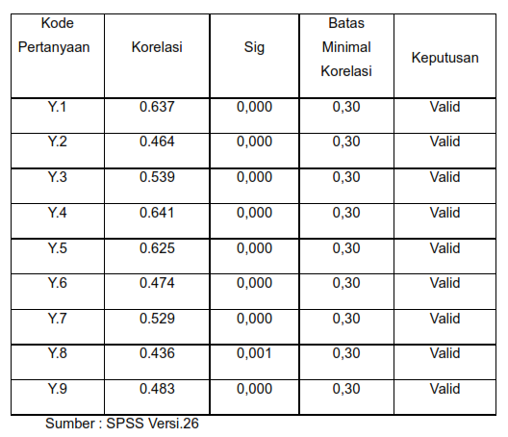

.

In table 1, namely the results of the validity test for the Employee Performance variable with 9 question items, it turns out that the correlation value is above 0.30, where the correlation value for the four question items is between 0.637 - 0.483 because the correlation value is above 0.30 with each question having a significant correlation ( α < 0.05) means that it can be said that all question items can be said to be valid.

Then a validity test will be presented for the Work Environment variable which can be seen in the following table:

Table 2 Validity Test Results for Work Environment Variable

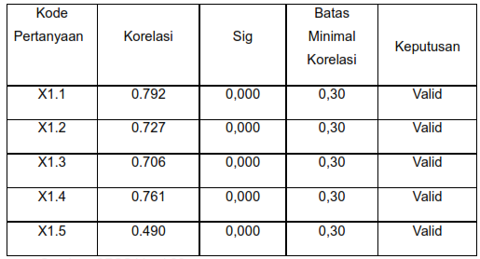

In table 2, namely the results of the validity test for the work environment variable with 5 question items, it turns out that the correlation value is above 0.30, where the correlation value for the four question items is between 0.792 - 0.490 because the correlation value is above 0.30 with each question having a significant correlation (α < 0.05) means that it can be said that all question items can be said to be valid.

Then a validity test will be presented for the Work Discipline variable which can be seen in the following table:

Table 3 Validity Test Results for the Work Discipline variable

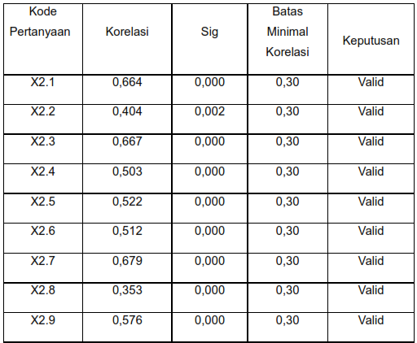

In table 14, namely the results of the validity test for the Work Discipline variable with 9 question items, it turns out that the correlation value is above 0.30, where the correlation value for the four question items is between 0.664 - 0.576 because the correlation value is above 0.30 with each question having a significant correlation (α < 0.05) means that it can be said that all question items can be said to be valid.

Then a validity test will be presented for the Cooperation variable which can be seen in the following table:

Table 4 Validity Test Results for the Cooperation variable

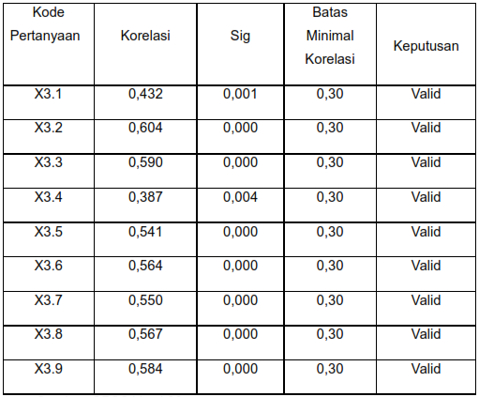

In table 15, namely the results of the validity test for the Cooperation variable with 9 question items, it turns out that the correlation value is above 0.30, where the correlation value for the four question items is between 0.432 - 0.584 because the correlation value is above 0.30 with each question having a significant correlation (α < 0.05) means that it can be said that all question items can be said to be valid.

**4.2 Reliability Test**

The reliability test is carried out after a validity test is carried out and the test is in the form of a valid statement or question. Cronbach's alpha ranged from 0.50 to 0.60. In this study the researcher chose a reliability coefficient of 0.60. The reliability testing criteria are as follows:

Table 5 Reliability Test results

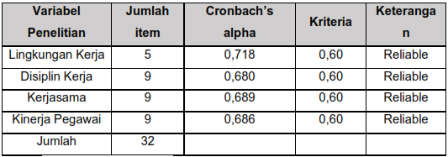

Table 16, namely the results of the reliability test with 4 variables and 32 question items, turns out to have Cronbach's alpha for the three variables between 0.718 – 0.686. It can be said that of the 32 question items that will be used, all question items can be categorized as reliable because they have Cronbach's alpha above 0.60. Thus, it can be said that all question items that have been processed have a high level of reliability in the hypothesis testing process.

**4.3 Classical Assumptions Test**

**4.3.1 Normality Test**

The purpose of the data normality test is to test whether the confounding variables or residuals in the regression are normally distributed or not.

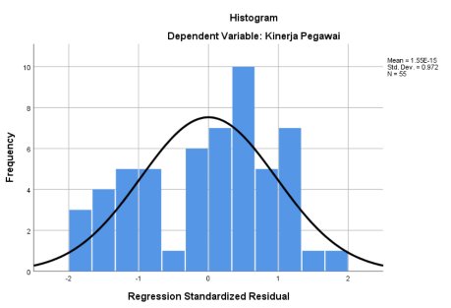

Figure 1 Normality Test Histogram

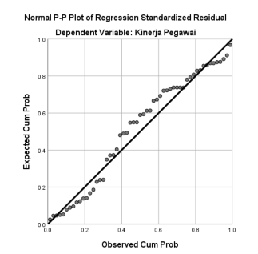From Figure 1 above, it can be seen that the results of the data normality test are normally distributed, because the histogram image above has a line that forms a bell and has a balanced convexity in the middle.

Figure 2 PP-Plot Normality Test

Based on Figure 2 above, the results of data normality testing using the PP-Plot image show that the data points are spread around the diagonal line so it can be said that this data is normally distributed.

From Figure 1 and Figure 2 above, it can be concluded that after testing the data for normality, the employee performance variables are normally distributed.

To check whether the diagonal line data is normally distributed or not, the Kolmogorov Smirnov test (1 KS sample) is carried out, namely by looking at the residual data whether it is normally distributed or not. If the Asymp.sig (2-tailed) value is > significant level (α = 0.05), the residual is normally distributed.

Table 6 One-sample Kolmogorov-Smirnov Normality Test

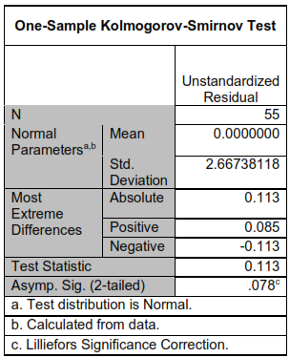

From table 6 of the SPSS results above, it is known that the significance value of the normality test variable Asiymp.Sig (2-tailed) is 0.078, which is greater than 0.05. Based on the assessment of the Kolmogorov-Smirnov normality test above, it can be concluded that the data is normally distributed.

Thus, overall it can be concluded that the data observation values are normally distributed and can be continued with other classical assumption tests.

**4.3.2 Multicollinearity Test**

The purpose of the multicollinearity test is to test whether there is a correlation between independent variables in a regression model. This test was carried out by looking at the Tolerance and Variance Inflation Factor (VIF) values from the analysis results using SPSS. If the tolerance value is greater than 0.10 or the VIF is smaller than 10, it can be concluded that multicollinearity does not occur.

The multicollinearity test of the questionnaire results that have been distributed to respondents can be seen in the following table.

Table 7 Multicolinearity Test Results

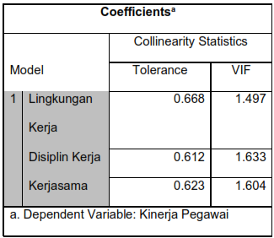

Based on table 17 above, it can be seen that the variance inflation factor (VIF) number is smaller than 10, including work environment 1,497 < 10, 1,633 < 10 and 1,604 < 10 and work environment tolerance values 0.668 > 0.10, work discipline 0.612 > 0.10 and Work equals 0.623 > 0.10 so it can be said to be free from multicollinearity.

**4.3.3 Heteroscedasticity Test**

Heteroskedasticity can be tested by looking at the dispersion between SRESID and ZPRED, i.e. whether a particular pattern exists or not. The decision is based on the following: 1) If there is a certain pattern, for example the dots form a certain regular pattern (wavy, widening and tapering), it means that heteroscedasticity has occurred. 2) If there is no clear pattern and the points are above and below 0 on the Y axis, then heteroscedasticity does not occur (Ghozali, 2018).

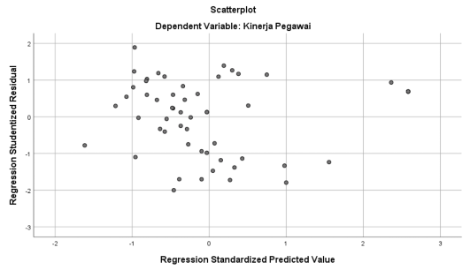A good regression model is one where heteroscedasticity does not occur.

Figure 3 Scatterplot of Heteroscedasticity test

From the graph above, it can be seen that the test graph meets the requirements for heteroscedasticity, where (Ghozali, 2018) says that if it does not form a clear pattern and the points are spread above and below zero on the Y axis, then it indicates that heteroscedasticity does not occur. The graph above can be said to be free from heteroscedasticity.

**4.4 Multiple Linear Regression**

Linear regression analysis is an exploratory hypothesis analysis method or technique that tests whether there is an influence (regression) between one variable and another variable expressed in a mathematical equation. Multiple linear regression analysis functions to test the influence of two or more independent variables (X) on a dependent variable (Y).

Table 8 Multiple Linear Regression

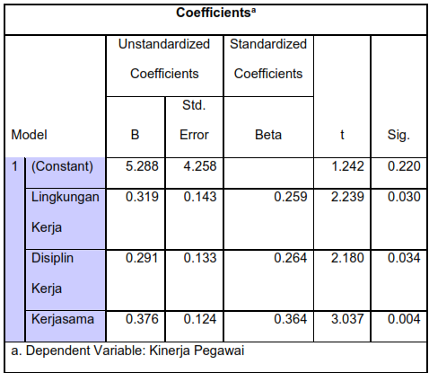

The table above provides information regarding the regression equation, namely how much the work environment variable (X1), work discipline variable (X2) and cooperation variable (X3) predict on the employee performance variable (Y). The regression equation formula for this analysis or research is: Y = a + b1X1 + b2X2 + b3X3 + e or Y = 5.288 + 0.312 X1 + 0.291 X2 + 0.376 X3 + e. Thus, that can be concluded:

a. If everything in the independent variables is considered zero then the employee performance value (Y) is 5,288 units

b. The work environment regression coefficient X1 = 0.312, meaning that if the work environment increases by 1, it will increase employee performance by 0.312. A positive coefficient means that there is a positive relationship between the work environment variable (X1) and employee performance (Y), where the higher the work environment variable (X1), the more employee performance (Y) will improve.

c. Work discipline regression coefficient X2 = 0.291, meaning that if work discipline increases by 1, employee performance will increase by 0.291. The coefficient is positive, meaning that there is a positive relationship between the work discipline variable (X2) and employee performance (Y), where the higher the work discipline variable (X2), the more employee performance (Y) will improve.

d. The cooperation regression coefficient X3 = 0.376, meaning that if cooperation increases by 1, it will increase employee performance by 0.376. The coefficient is positive, meaning that there is a positive relationship between the cooperation variable (X3) and employee performance (Y), where the higher the cooperation variable (X3), the more employee performance (Y) will improve.

**4.5 Hypothesis testing**

**4.5.1 Simultaneous Test**

Table 9 Simultaneous Test Results

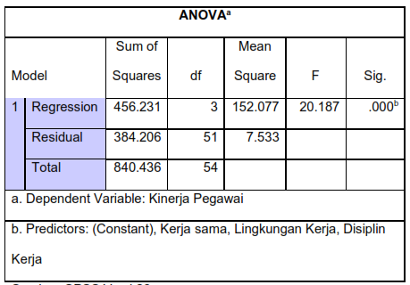

It can be seen from table 9 above that F-count is 20,187 while F-table is 2.79 which can be seen at α = 0.05 (see attached table F). The probability of being significant is much smaller than 0.05, namely 0.000 <0.05, so the regression model can be said that in this study the work environment, work discipline and cooperation simultaneously have a positive and significant effect on employee performance.

**4.5.2 Partial Test**

Table 10 Partial Test Results

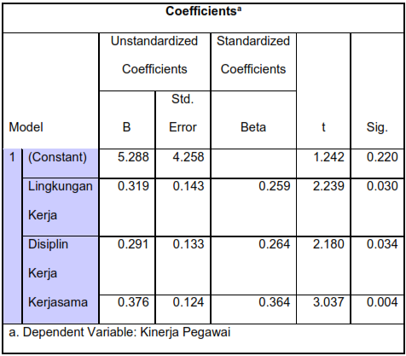

Based on table 10 above it can be seen that:

1. The influence of the work environment on employee performance - The results of the t test show that the Work Environment variable has a t value of 2.239 with a significance level of 0.030 which is smaller than 0.05 (sig 0.030 < 0.05), this indicates that H0 is rejected and Ha accepted. Based on this analysis, it can be concluded that the work environment has a positive and significant effect on employee performance.
2. The influence of work discipline on employee performance - The results of the t test show that the Work Discipline variable has a t value of 2,180 with a significance level of 0.034 which is smaller than 0.05 (sig 0.034 < 0.05), this indicates that H0 is rejected and Ha accepted. Based on this analysis, it can be concluded that work discipline has a positive and significant effect on employee performance.
3. The effect of cooperation on employee performance - The results of the t test show that the recruitment variable has a t value of 3.037 with a significance level of 0.004 which is smaller than 0.05 (sig 0.004 < 0.05), this indicates that Ho is rejected and Ha accepted. Based on this analysis, it can be concluded that cooperation has a positive and significant effect on employee performance.

**4.5.3 Coefficient of Determination Test**

Table 11 Coefficient of Determination Results

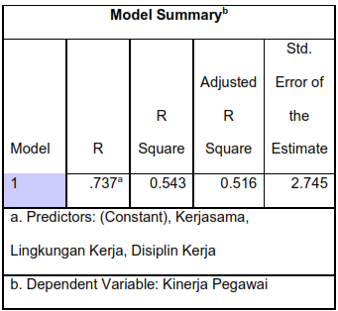

Based on table 11 above it can be explained as follows:

a. The Adjusted R² Square figure is 0.516 which can be called the coefficient of determination, which in this case means that 51.6% of employee performance can be obtained and explained by the work environment, work discipline and cooperation. Meanwhile, the remaining 100% - 51.6% = 48.4% is explained by other factors or variables outside the model, such as leadership style, wages and work motivation and others.

b. The R Square value of 0.543s shows that there is a close relationship between the work environment, work discipline and cooperation.

1. **CONCLUSIONS & SUGGESTIONS**

**5.1 Conclusions**

Based on data analysis and discussion of research results, the following conclusions can be drawn:

1. The work environment has a positive and significant effect on employee performance at the Department of Manpower, Investment and One-Stop Integrated Services (DISNAKER, PM-PTSP) Malang City.

2. Work discipline has a positive and significant effect on employee performance at the Department of Manpower, Investment and One-Stop Integrated Services (DISNAKER, PM-PTSP) Malang City.

3. Collaboration has a positive and significant effect on employee performance at the Department of Manpower, Investment and One-Stop Integrated Services (DISNAKER, PM-PTSP) Malang City.

4. The work environment, work discipline and cooperation have a positive and significant effect on employee performance at the Department of Manpower, Investment and One Stop Integrated Services (DISNAKER, PM-PTSP) Malang City.

**5.2 Suggestions**

The suggestions that can be given through the results of this research are as follows:

1. Employees must continue to improve their level of discipline, such as arriving on time at the specified time, and when leaving work they must comply with what is set by the agency.

2. It is recommended that employees maintain an ethical level of service to the community.

3. To improve employee performance, it is necessary to pay attention to teamwork so that employee loyalty will increase.

4. DISNAKER, PM-PTSP Malang City also needs to pay attention to a healthy work environment and away from commotion or noise so that employees can work comfortably and safely, so that their performance will increase.

5. For further research, it is recommended to conduct research in other, larger agencies or companies so that you can compare the collaboration that occurs within agencies or companies.

**6. LIMITATIONS**

Several limitations in this research: In the process of collecting data, the information provided by respondents through questionnaires sometimes does not show the respondents' true opinions, this happens because sometimes there are differences in thoughts, assumptions and different understandings for each respondent, as well as other factors such as the honesty factor in filling in respondents' opinions in their questionnaires.

1. **REFERENCES**
2. Ananda, R. H. (2019). Pengaruh Disiplin Kerja Dan Lingkungan Kerja Terhadap Kinerja Karyawan Dinas Pekerjaan Umum, Perumahan Dan Energi Sumber Daya Mineral.Yogyakarta.
3. Andy, F.B. (2023). Pengaruh Lingkungan Kerja dan Kerjasama Tim Terhadap Produktivitas Kerja Karyawan.
4. Armstrong, (2009). Pengaruh Disiplin Kerja Dan Lingkungan Kerja Terhadap Kinerja Karyawan Dinas Pekerjaan Umum, Perumahan Dan Energi Sumber Daya Mineral. Hal.2-3.
5. Armstrong. (2017). Pengaruh Lingkungan Kerja, Disiplin Kerja, Kerjasama Tim Terhadap Kinerja Karyawan PT POS INDONESIA PUSAT SURAKARTA. Hal.2
6. Arisanti, (2019). Pengaruh Motivasi Kerja Dan Disiplin Kerja Terhadap Kinerja Karyawan Pada PT Pegadaian (Persero) Cabang Nganjuk. Jurnal Ilmiah Mahasiswa Ekonom.
7. Budi. (2021). Pengaruh lingkungan kerja, motivasi kerja, komunikasi internal dan kerjasama tim terhadap produktivitas kerja karyawan sekolah swasta. Bunga Matahari Kota Banda Aceh. Vol. 11, No. 2: 171-173.
8. Eva Silvani Lawasi, Boge Triatmanto. Pengaruh Komunikasi, Motivasi dan Kerjasama Tim terhadap Peningkatan Kinerja Karyawan. Vol. 5, No. 1, 2017, hal. 2.
9. Ferawati, A. (2017). Pengaruh Lingkungan Kerja Dan Disiplin Kerja Terhadap Kinerja Karyawan. Agora. 5(1).
10. Hanafi. (2018). Pengaruh Lingkungan Kerja, Disiplin Kerja, Kerjasama Tim Terhadap Kinerja Karyawan PT POS INDONESIA PUSAT SURAKARTA. Hal.1-2.
11. Hidayat, Z. (2012). Pengaruh Lingkungan Kerja dan Disiplin Kerja Serta Motivasi Kerja Terhadap Kinerja Karyawan Perusahaan Daerah Air Minum (PDAM) Kabupaten Lumajang. Jurnal Penelitan Ilmu Ekonomi (WIGA), vol. (2)1
12. Laela Eka, S. (2023). Pengaruh Lingkungan Kerja Dan Disiplin Kerja Terhadap Kinerja Karyawan Pt. Bank Rakyat Indonesia (Persero) Tbk Kantor Cabang Jember. 42-48.
13. Lawasi, Eva S. & Triatmanto, Boge. (2017). Pengaruh Komunikasi, Motivasi dan Kerjasama Tim Terhadap Peningkatan Kinerja Karyawan. Jurnal Manajemen dan Kewirausahaan (JMDK, vol (5) no 1
14. Lawasi, E. S., & Triatmanto, B. (2017). Pengaruh komunikasi, motivasi dan kerjasama tim terhadap peningkatan kinerja karyawan. Jurnal Manajemen Dan Kewirausahaan (JMDK). 47–57.
15. Noor Rika, D.I. (2018). Pengaruh Lingkungan Kerja Terhadap Disiplin Kerja Dan Semangat Kerja Karyawan (Studi Pada Karyawan PDAM Kota Malang). 58-59.
16. Nugroho, Arief P. (2020). Analisis Pengaruh Lingkungan kerja, Kerjasama Tim dan Disiplin Kerja Terhadap Kinerja Karyawan.
17. Oktabintoro, A.S. (2021). Pengaruh Lingkungan Kerja, Disiplin Kerja, Kerjasama Tim Terhadap Kinerja Karyawan PT POS INDONESIA PUSAT SURAKARTA. Surakarta.
18. Putri, D.A. (2020). Pengaruh Lingkungan Kerja, Disiplin Kerja Dan Kerjasama Tim Terhadap Kinerja Karyawan Petugas Keamanan Pada Universitas Surabaya (Ubaya). Diploma Thesis, STIE Mahardhika Surabaya.
19. Siagian, (2003). Pengaruh Lingkungan Kerja, Disiplin Kerja, Kerjasama Tim Terhadap Kinerja Karyawan PT POS INDONESIA PUSAT SURAKARTA. Hal.2-3.
20. Suwanto, S. (2019). Pengaruh Disiplin Kerja Dan Motivasi Kerja Terhadap Kinerja Karyawan Pada Rumah Sakit Umum Tangerang Selatan. JENIUS (Jurnal Ilmiah Manajemen Sumber Daya Manusia), 3(1), 16-23.
21. Wirawan. (2009). Pengaruh Lingkungan Kerja, Disiplin Kerja, Kerjasama Tim Terhadap Kinerja Karyawan PT POS INDONESIA PUSAT SURAKARTA. Hal.2
22. Widya, S. (2021). Pengaruh Disiplin Kerja Dan Lingkungan Kerja Terhadap Kinerja Karyawan Rumah Sakit Awal Bros Ujung Batu. Batusangkar.
23. Wuri, N.S. (2022). Pengaruh Kerjasama Tim, Lingkungan Kerja, Kesehatan Dan Keselamatan Kerja Terhadap Kinerja Karyawan (Studi Khasus Pada Klinik Pratama Rawat Inap Prisdhy). Vol 1, No 3.
24. Yudiningsih, et.al. (2016). Pengaruh Lingkungan Kerja, Disiplin Kerja, Kerjasama Terhadap Kinerja Karyawan PT POS INDONESIA PUSAT SURAKARTA. Hal.2.