MobileNet Architecture for Improved Diabetic Retinopathy Detection

|  |  |
| --- | --- |
| Madhavi T  Assistant Professor  Department of Artificial Intelligence  Shri Vishnu Engineering College For Women  Bhimavaram, India  Madhavi.v@svecw.edu.in  Sneha Gowri K  Department of Artificial Intelligence  Shri Vishnu Engineering College For Women  Bhimavaram, India kollisnehagowri@gmail.com  Akshaya P  Department of Artificial Intelligence  Shri Vishnu Engineering College For Women  Bhimavaram, India palleakshaya9@gmail.com | Ramya D  Department of Artificial Intelligence  Shri Vishnu Engineering College For Women  Bhimavaram, India ramyadubbala99@gmail.com  Aiswarya T  Department of Artificial Intelligence  Shri Vishnu Engineering College For Women  Bhimavaram, India aiswaryathavva@gmail.com  Supriya K  Department of Artificial Intelligence  Shri Vishnu Engineering College For Women  Bhimavaram, India kantipudisupriya2003@gmail.com |

*Abstract*—Background: Diabetic retinopathy, a common complication of Type II diabetes, poses a serious threat to vision, particularly among individuals aged 20 to 64. Early detection is crucial for effective management, yet current screening methods are resource-intensive.

Methods: This study employs deep learning, specifically the MobileNet architecture, to automate and enhance the accuracy of diabetic retinopathy diagnosis. Utilizing retinal fundus images from the Aptos 2019 challenge dataset, the classifier is trained to predict diabetic retinopathy.

Results: The MobileNet-based classifier achieves remarkable performance, with f-1 scores of 0.97, 0.98, and 0.95, along with recall, precision, and accuracy rates of 96%.

Concluding Remarks: These results underscore the efficacy of the proposed approach, positioning it as a valuable tool for early detection and clinical assessment of diabetic retinopathy, complementing ophthalmologists’ expertise and improving accessibility to screenings.

Keywords: Diabetic Retinopathy; MobileNet; Deep Learning; Early Detection; Medical Image Analysis.

# TABLE I

|  |  |  |  |
| --- | --- | --- | --- |
| DIABETIC RETINOPATHY (DR) BY AGE [1] | | | |
| Type | Age (years) |
| Normal | 32 ± 8 |
| Mild DR | 48 ± 14 |
| Moderate DR | 58 ± 13 |
| Severe DR | 45 ± 12 |
| PDR | 70 ± 10 |

# INTRODUCTION

DR is a major challenge to global eye health, especially for those with diabetes. DR is the most serious form of diabetic eye disease and causes significant damage to the retina, often resulting in permanent vision loss or blindness. Although DR is largely preventable, it is still one of the leading causes of blindness worldwide. Current methods for detecting DR rely heavily on manual examinations performed by trained medical professionals, which can be laborious and subjective. Diabetic retinopathy primarily affects the retina, causing damage to retinal blood vessels, fluid leakage, and distortion of vision. The disease progresses through five distinct stages, each presenting unique challenges for diagnosis and treatment. Early detection and intervention are crucial for preventing the progression of DR and preserving vision. However, existing diagnostic procedures face limitations in accurately distinguishing between the stages of DR, leading to delays in appropriate treatment [ [2], [7]].The diagnosis of DR is complicated by the variability of symptoms and the absence of outward signs in its initial stages. Even experienced medical professionals find it challenging to reliably classify DR images, which can result in misdiagnoses and delays in initiating treatment. The reliance on manual examinations and fundus imaging contributes to inefficiencies in the diagnostic process and underscores the need for more efficient and accurate diagnostic tools [3]. The motivation behind this research stems from the urgent need to address the challenges posed by diabetic retinopathy

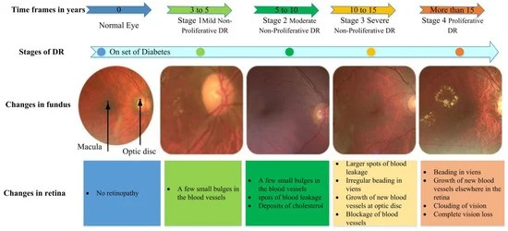

# Fig. 1. Stages of diabetic retinopathy [5]

(DR), a leading cause of blindness globally. Current diagnostic methods for DR rely heavily on manual examinations and fundus imaging, which are time-consuming and subject to interpretation. Therefore, the primary objective of this research is to develop a deep learning algorithm capable of automating the detection of DR from fundus images. By leveraging advanced deep learning techniques, the goal is to create a faster, more accurate, and user-friendly diagnostic tool that can assist medical professionals in diagnosing and managing DR more effectively. [4]Specifically, the objectives include developing the algorithm, validating its performance using real-world datasets, and comparing it against existing diagnostic methods. Ultimately, this research aims to improve patient outcomes by providing timely and accurate diagnosis of DR, thereby facilitating early intervention and treatment.The primary contribution of this research lies in the development and validation of a robust deep learning algorithm for the automatic detection of diabetic retinopathy. By leveraging a large dataset of fundus

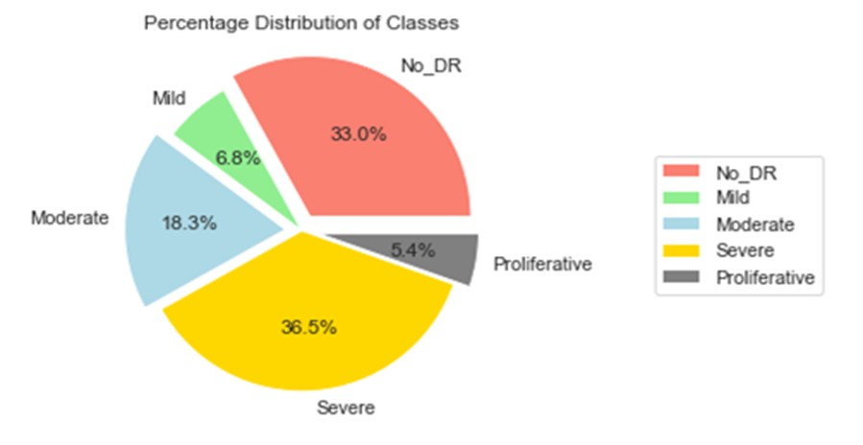

# Fig. 2. Distribution of Classes

images, the algorithm achieves high accuracy in identifying different stages of DR. This contribution has significant implications for clinical practice, as it can expedite the diagnostic process, reduce the burden on medical personnel, and improve patient care.

# RELATED WORKS

The related work in the field of diabetic retinopathy (DR) detection using deep learning techniques encompasses several significant studies. Gulshan et al. (2016) pioneered the development and validation of a deep learning algorithm specifically designed for the detection of DR in retinal fundus photographs. Their work demonstrated the potential of deep learning in automating the detection process, thereby improving efficiency and accuracy in diagnosing DR.

Following Gulshan et al.’s groundbreaking work, Xu et al. (2017) proposed a deep convolutional neural network (CNN) approach for the early automated detection of DR using fundus images. Their study contributed to the advancement of early detection methods, which are crucial for timely intervention and treatment to prevent vision loss in diabetic patients.

Similarly, Islam et al. (2018) introduced a deep learningbased method for the early detection and grading of DR using retinal fundus images. By leveraging deep learning techniques, their approach aimed to enhance the accuracy and efficiency of DR diagnosis, particularly in identifying the severity of the condition at an early stage.

In another study, Lam et al. (2018) explored automated DR detection using deep learning methods, further highlighting the potential of machine learning algorithms in improving the diagnostic process for DR. Their research provided insights into the development of robust and reliable automated systems for DR screening.

Moreover, Hosseinzadeh Kassani et al. (2019) introduced a modified Xception architecture specifically tailored for DR classification. Their study contributed to the ongoing efforts to refine deep learning models for accurate and efficient DR diagnosis, showcasing the adaptability of deep learning architectures in addressing medical imaging challenges. In addition to these primary studies, reviews by Revathy et al. (2020) and Nadeem et al. (2022) provided comprehensive insights into the application of deep learning for DR analysis. These reviews highlighted the challenges and opportunities in the field, offering valuable guidance for future research directions and innovation in DR detection methodologies. Collectively, the related work underscores the transformative potential of deep learning models, transfer learning techniques, multi-scale perspective guidelines, and multi-task learning methodologies in the diagnosis and management of diabetic retinopathy. These studies lay the foundation for continued advancements in the field, fostering collaboration and exploration of novel approaches to enhance DR detection and patient care.

# EXISTING SYSTEM

The existing model utilizes machine learning algorithms [8], specifically artificial neural networks (ANN), for diabetic retinopathy detection. While ANN is a form of transfer learning, it has limitations in achieving high accuracy rates.The system relies on ANN to process retinal fundus images for diabetic retinopathy diagnosis. However, due to the complexity of the disease and the variability in image characteristics, the accuracy of the model is not optimal.Despite employing transfer learning methods such as ANN [6], the existing system struggles to achieve the desired level of accuracy in diabetic retinopathy detection.The limitations of the existing system highlight the need for more advanced techniques and models in diabetic retinopathy diagnosis, particularly those based on deep learning architectures and multi-modal data integration.The challenges faced by the existing system underscore the importance of continuous research and development efforts to improve the accuracy and reliability of diabetic retinopathy detection methods.

# PROPOSED SYSTEM

The proposed solution represents an innovative approach to diabetic retinopathy detection by combining MobileNet, a powerful deep learning architecture, with machine learning methods. Diabetic retinopathy poses a significant challenge in healthcare due to its potential to cause vision impairment if left untreated. Therefore, accurately classifying diabetic retinopathy based on retinal fundus images is paramount for effective disease management. By leveraging MobileNet’s advanced capabilities in image classification tasks, the proposed method aims to enhance the accuracy and efficiency of diabetic retinopathy identification. MobileNet’s deep learning framework enables the system to analyze retinal images with high precision, facilitating the early detection and classification of diabetic retinopathy stages. Integrating machine learning techniques further enhances the classification process, ensuring reliable and consistent results. This novel approach addresses the critical need for precise diabetic retinopathy classification, empowering healthcare professionals with a valuable tool to diagnose and manage the disease effectively. MobileNet is a convolutional neural network architecture specially designed for efficient mobile and embedded vision applications. It introduces depthwise separable convolutions to reduce computational complexity while maintaining high accuracy. The algorithm begins with an input image *I* of dimensions *W* ×*H* ×*C*, where *W* represents width, *H* is height, and *C* denotes the number of channels (e.g., RGB channels). Pre-trained MobileNet model weights, learned from datasets like ImageNet, are loaded as initial parameters. Depthwise separable convolutions are then applied, comprising depthwise convolution to each input channel followed by pointwise convolution to combine output channels. Batch normalization is applied after each convolution operation for normalization and improved training stability. In some layers, a linear bottleneck increases the network’s non-linearity with additional depthwise and pointwise convolutions. Global average pooling follows to reduce spatial dimensions of feature maps, computing the average value of each feature map across its spatial extent. Finally, a fully connected layer with softmax activation classifies the input image into different categories. MobileNet’s lightweight design, achieved through depthwise separable convolutions, makes it ideal for resource-constrained devices while maintaining competitive performance in image classification tasks.

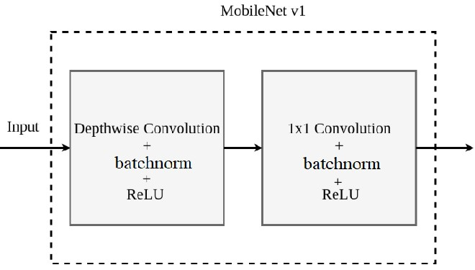

Fig. 3. MobileNet Architecture [9]

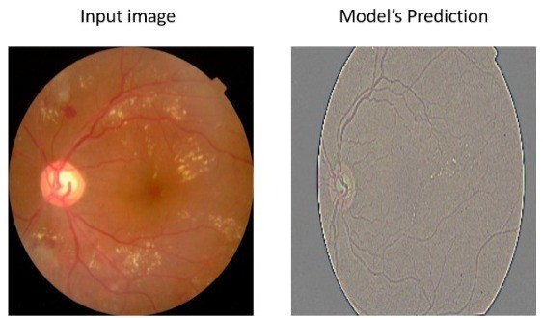

# RESULTS AND DISCUSSION

Integrated Development Environments (IDEs) play a crucial role in the development and deployment of machine learning applications. Among the widely used IDEs are PyCharm, renowned for its comprehensive features such as code completion, debugging, and version control integration, and Jupyter Notebook, which provides an interactive environment for data exploration, visualization, and prototyping of machine learning algorithms.

# Fig. 4. Input Image and Model Prediction

|  |
| --- |
| on the original images; previous to superimposition, values were regularized to a range of 0 to 255. This thorough system highlights the MobileNet model’s efficacity and trustability in the identification of diabetic retinopathy.  applications in various domains. The rate of true cons to  true negatives divided by the total number of compliances  was used to calculate delicacy, which was used as a hand  for overall prophetic delicacy.The calculation of perceptivity  involved dividing the total number of true negatives by the  total number of false positives and negatives.This measure of  perceptivity shows how well the model can identify positive  cases among all factual cons. The proportion of true negatives  to the aggregate of true and false cons was used to calcu-  late particularity, which indicates the model’s capability to  discern nature of the problems among all factual negatives.  The model’s performance was examined using the Receiver  Fig. 7. Accuracies of Different Models  Accuracy:  0.9644  Loss:  0.1216  VI. C  ONCLUSION AND  F  UTURE  E  NHANCEMENT  In summary, the development of deep learning models for identifying diabetic retinopathy represents a significant advancement in clinical imaging. This innovative approach has demonstrated promising results in automating the early detec- |

Deep learning frameworks like TensorFlow and PyTorch serve as foundational tools for building and training neural network models, particularly for image classification tasks. Complementing these frameworks are essential libraries and frameworks like NumPy, which offers support for multidimensional arrays and mathematical functions, and Keras, a high-level neural networks API simplifying the development of deep learning models. Additionally, libraries such as pandas facilitate data manipulation, exploration, and visualization, while scikit-learn provides tools for data preprocessing, model selection, evaluation, and deployment. Matplotlib stands out as a comprehensive plotting library for creating diverse visualizations, and Pillow offers support for various image file formats. For database connectivity, Django Connector enables seamless interaction with backend databases by defining models for storing patient data, images, and diagnostic results. Lastly, beautifulsoup4 proves valuable for parsing HTML and XML documents, facilitating web scraping and data extraction tasks. Together, these tools and libraries form the foundation for efficient development and deployment of machine learning Fig. 5. Confusion Matrix

Operating Characteristic wind analysis, the area under the wind was a vital metric.

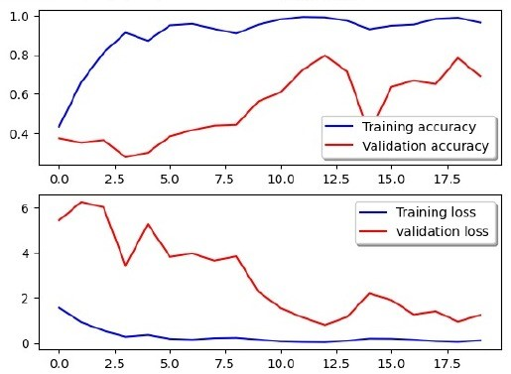

Fig. 6. Simple visual evaluation the models reliability,recall,and loss in training and validation samples

Also, the operation of heat maps that appear from the last convolutional layers made it easier to see model interpretations tion of diabetic retinopathy, facilitating timely interventions and reducing the risk of vision loss among diabetic patients. With further refinement and integration into healthcare systems, deep learning models have the potential to contribute to more effective and accessible screening, ultimately improving the quality of life for individuals with diabetes.

Looking ahead, several enhancements could significantly improve the project for detecting diabetic retinopathy using deep learning. Firstly, the integration of more advanced deep learning architectures, such as ensemble methods and transfer learning, could enhance diagnostic accuracy. Additionally, extending data augmentation techniques with Generative Adversarial Networks (GANs) could enable more nuanced data generation. Incorporating features like patient medical history and localized disease prediction could lead to more personalized diagnostics. Integrating real-time analysis capabilities into a streamlined graphical user interface (GUI) or a mobile application could enable immediate diagnoses. To scale the solution, developing a cloud-based architecture and an API for integration with existing healthcare systems would be beneficial. Furthermore, incorporating multi-modal inputs, including other types of retinal scans and patient lifestyle factors, could enrich the diagnostic framework. Lastly, ongoing efforts should focus on assessing and mitigating any biases in the model and maintaining transparency in its diagnostic criteria and results.

# REFERENCES

1. U. Rajendra Acharya, Choo Min Lim, Eddie Yin Kwee Ng, Caroline Chee, T. Tamura, “Computer-based detection of diabetes retinopathy stages using digital fundus images,” *Proceedings of the Institution of Mechanical Engineers, Part H: Journal of Engineering in Medicine*, vol. 223, pp. 545–553, 2009. [https://api.semanticscholar.org/CorpusID: 18728857](https://api.semanticscholar.org/CorpusID:18728857)
2. M. W. Nadeem, H. G. Goh, M. Hussain, S. Y. Liew, I. Andonovic, and M. A. Khan, ”Deep Learning for Diabetic Retinopathy Analysis: A Review, Research Challenges, and Future Directions,” Sensors (Basel), vol. 22, no. 18, p. 6780, Sep. 2022. doi: 10.3390/s22186780. PMID: 36146130; PMCID: PMC9505428.
3. J. Amin, M. Sharif, and M. Yasmin, ”A Review on Recent Developments for Detection of Diabetic Retinopathy,” Scientifica (Cairo), vol. 2016, article ID 6838976, 2016. doi: 10.1155/2016/6838976. Epub 2016 Sep 29. PMID: 27777811; PMCID: PMC5061953.
4. Awais Bajwa, Neeam Nosheen, Khalid Iqbal Talpur, Sheeraz Akram,

“A Prospective Study on Diabetic Retinopathy Detection Based on Modify Convolutional Neural Network Using Fundus Images at Sindh Institute of Ophthalmology & Visual Sciences,” Diagnostics, vol. 13, no. 3, p. 393, Jan. 20, 2023. doi: 10.3390/diagnostics13030393. PMCID: PMC9914220, PMID: 36766498.

1. A. Al-Omaisi, C.-Z. Zhu, S. A. Althubiti, D. Al-Alimi, Y.-L. Xiao, P.-B. Ouyang, and M. A. A. Al-Qaness, ”Detection of Diabetic Retinopathy in Retinal Fundus Images Using CNN Classification Models,” Electronics, vol. 11, no. 17, article 2740, 2022. Available online: [https://www.mdpi. com/2079-9292/11/17/2740.](https://www.mdpi.com/2079-9292/11/17/2740)
2. Kshirsagar, P. R., Manoharan, H., Meshram, P., Alqahtani, J., Naveed,

Q. N., Islam, S., Abebe, T. G. (2022). Recognition of Diabetic Retinopathy with Ground Truth Segmentation Using Fundus Images and Neural Network Algorithm. Comput Intell Neurosci, 2022, 8356081.

doi: 10.1155/2022/8356081. PMID: 36211022; PMCID: PMC9536961.

1. Gulshan, Varun, Lily Peng, Marc Coram, Martin C. Stumpe, Derek Wu, Arunachalam Narayanaswamy, Subhashini Venugopalan, Kasumi

Widner, Tom Madams, Jorge Cuadros, Ramasamy Kim, Rajiv Raman, Philip C. Nelson, Jessica L. Mega, and Dale R. Webster. ”Development and Validation of a Deep Learning Algorithm for Detection of Diabetic Retinopathy in Retinal Fundus Photographs.” JAMA 316, no. 22 (2016): 2402-2410.

1. Gayathri S, Gopi VP, Palanisamy P. Diabetic retinopathy classification based on multipath CNN and machine learning classifiers. Phys Eng Sci Med. 2021 Sep;44(3):639-653. doi: 10.1007/s13246-021-01012-3. Epub 2021 May 25. PMID: 34033015.
2. Shekofa,Ghoury, Cemil ,Sungur, Akif Durdu, ”Real-Time Diseases Detection of Grape and Grape Leaves using Faster R-CNN and SSD MobileNet Architectures,” in Proceedings, 2019.