Accident Mitigation-Empowering Safety with Machine Learning

Dr.G.Yedukondalu yedukondalu.ds@anurag.edu.in
Anurag University,
Hyderabad

Sai Priyatham Reddy
21eg510102@anurag.edu.in Anurag University Hyderabad

Akhil Reddy
20eg110124@anurag.edu.in Anurag University Hyderabad

Sravya Reddy
20eg110125@anurag.edu.in Anurag University Hyderabad

Abstract— The occurrence of road accidents remains a prominent cause of deaths, disabilities, and hospitalizations in our country this makes accident mitigation important in order to minimise it and save lives. Accidents pose a significant threat to public safety, resulting in loss of life, injuries, and property damage. The urgent issue of road accidents by proposing a predictive model for accident severity. Traditional mitigation methods often lack real-time hazard identification, necessitating advanced solutions. Leveraging machine learning and data from the Road Traffic Accident (RTA) dataset, the proposed model employs the Random Forest algorithm to achieve an 83% accuracy rate in predicting accident severity. Factors such as vehicle type, age, sex, time of day, and weather conditions are analyzed to provide accurate predictions. The web application developed as part of this initiative allows users to input data, enabling personalized severity predictions. Ultimately, this research aims to significantly enhance road safety, reduce accidents, and safeguard lives and public well-being.
Keywords— Road accidents, accident severity prediction, machine learning, Random Forest algorithm, real-time hazard identification, road safety, data analysis, web application, RTA dataset, public well-being, accident mitigation, predictive modeling.
- Introduction
In response to the persistent concern of road safety and the significant toll of accidents on lives and society, there is a growing shift towards proactive measures to prevent accidents before they occur. The project "Accident Mitigation" aims to redefine road safety by leveraging predictive analytics to anticipate accident severity. Instead of reactive responses, the project focuses on proactive risk assessment to mitigate potential hazards. Central to this endeavor is the utilization of the Random Forest algorithm, known for its precision and adaptability in analyzing vast datasets. By harnessing a comprehensive dataset encompassing factors such as time of travel, weather conditions, driver demographics, vehicle type, and road conditions, the project aims to discern patterns and correlations to predict injury severity accurately. The project adopts a meticulous data splitting strategy, allocating 70% of the dataset for training the Random Forest algorithm and reserving 30% for testing and validation. This approach ensures rigorous model fine-tuning, performance evaluation, and generalization to unseen data. Categorizing accidents into different severity levels is fundamental, achieved through holistic assessment of contributing factors. Understanding the intricate interplay of these variables enables the identification of high-risk scenarios and facilitates proactive measures to prevent accidents .Ultimately, the project aims to enhance road safety by offering a proactive mechanism for predicting injury severity, equipping road users, authorities, and transportation agencies with the insights needed to avert accidents. The innovative web application developed provides drivers with proactive traffic accident risk predictions, enabling informed decision-making and precautionary measures while on the road. Through user-friendly interfaces and real-time alerts, the project fosters collaborative efforts in road safety, engaging individual drivers, city planners, and transportation agencies alike. By embracing predictive analytics and proactive risk assessment, the project endeavors to reduce the overall number of accidents, injuries, and fatalities on roadways, contributing towards safer and more efficient transportation systems .effectiveness
II. Literature Review
In the context of literature on road safety and accident mitigation encompasses various studies and approaches aimed at understanding and addressing the challenges posed by road accidents. Reactive measures, such as emergency response and post-accident investigations, have historically dominated efforts to mitigate accidents. However, there is a growing recognition of the limitations of these approaches and the need for proactive measures to prevent accidents before they occur.

[1] Shristi Sonal and Saumya Suman “A Framework for Analysis of Road Accidents”Proceedings of International Conference on Emerging Trends and Innovations in Engineering and Technological Research (ICETIETR).Published 1 July 2018: In their paper Shristi Sonal and Saumya Suman emphasize the substantial influence of external factors, specifically weather conditions, on road accidents. Their research underscores the critical role of weather elements like fog, rain, and snow in contributing to accidents.
[2]Gupta, Meenu, Vijender Kumar Solanki, and Vijay Kumar Singh. "A Novel Framework to Use Association Rule Mining for classification of traffic accident severity." Ingeniería Solidaria 13, no. 21 (January 1, 2017): They highlight key studies examining traffic accident data globally, emphasizing the prevalence of regression-based techniques. Notably, one study using logistic regression found higher accident risks in residential and shopping areas than in rural ones, while anotherexplored neural networks, revealing elevated pedestrian accident risks at non-signalized intersections, especially at night. This overview provides essential insights into the field

- Pedregosa, F., Varoquaux, G., Gramfort, A., Michel, V., Thirion, B., Grisel, O., ... & Duchesnay, É. (2011). Scikit-learn: Machine learning in Python. Journal of Machine Learning Research, 12, 2825-2830.:In their 2011 paper "Scikit-learn: Machine learning in Python," Pedregosa et al. highlight Python's growing role in scientific computing. Scikit-learn leverages Python's interactive, library-rich environment to offer state-of-the-art machine learning algorithms, bridging disciplines like computer science, biology, and physics. Notably open-source, efficient with compiled code, and emphasizing imperative programming, Scikit-learn distinguishes itself from other Python ML toolkits.

III. Proposed Method
The proposed method for accident mitigation involves utilizing predictive analytics, specifically the Random Forest algorithm, to anticipate accident severity and identify potential hazards before they occur. This method consists of several key steps:

1.Data Acquisition: Comprehensive datasets containing information on factors such as weather conditions, road conditions, driver demographics, vehicle characteristics, and accident severity are collected from various sources, including police reports, hospital records, and traffic cameras.

2. Data Preprocessing: The acquired data undergoes preprocessing to clean and prepare it for analysis. This may involve handling missing values, encoding categorical variables, and scaling numerical features.

3. Feature Selection: Relevant features that have a significant impact on accident severity are identified and selected for analysis. This step helps reduce dimensionality and improve the efficiency of the predictive model.

4. Model Training: The Random Forest algorithm is trained on a portion of the dataset, with the goal of learning patterns and relationships between input features and accident severity outcomes. The algorithm constructs multiple decision trees based on random subsets of the data and combines their predictions to produce more accurate results.

5. Model Evaluation: The trained model is evaluated using the remaining portion of the dataset reserved for testing and validation. Performance metrics such as accuracy, precision, recall, and F1-score are computed to assess the model's effectiveness in predicting accident severity.

6. Model Deployment: Once the model demonstrates satisfactory performance, it is deployed within a web application interface accessible to road users, authorities, and transportation agencies. The application allows users to input relevant data, such as current driving conditions, and receive proactive predictions of traffic accident risk.

IV. Implementation
The implementation of the project has been carried out in a step-by-step manner. A detailed description of each module is given below and it is followed by an introduction to the technologies used in implementing the project.
1.Training: We utilize 70% of the data to train the model. During this training stage, we will develop and train machine learning model. This includes setting up hyperparameters, and feeding the preprocessed data into the model. The model will learn from the training data to make predictions about accident severity based on input features
2.Testing: After training your model, you'll need to evaluate its performance . We use 30% of remaining data for testing. The testing phase assess how well the model generalizes to new, unseen data. You'll calculate various performance metrics to gauge the model's accuracy and reliability. This stage helps you fine-tune the model and ensure it meets the desired accuracy and reliability criteria.

3.Web App Integration: In the final stage, you'll integrate your trained machine learning model into a application. This integration allows users to input relevant information through a web interface, and the model will provide predictions for accident severity. You'll need to design the user interface, set up the backend infrastructure using Flask framework and ensure seamless communication between the web app and the model. This stage aims to make your accident severity prediction system accessible and user-friendly.
The web page features three main sections: Accident Severity Prediction, Safety and Precautions, and Help and About. In the Accident Severity Prediction section, users can utilize a real-time prediction tool to assess the severity of accidents in their specified locations, drawing upon various factors like weather conditions and time of day. The Safety and Precautions section is dedicated to promoting road safety, offering educational resources, articles, and practical tips to reduce accidents and enhance safety awareness. Meanwhile, the Help and About section serves as a user support and information repository, assisting users in navigating the application and providing insights into its purpose and development team. Together, these sections create a holistic user interface, empowering users to make informed decisions about road safety and accident prevention while efficiently accessing the accident severity prediction tool.
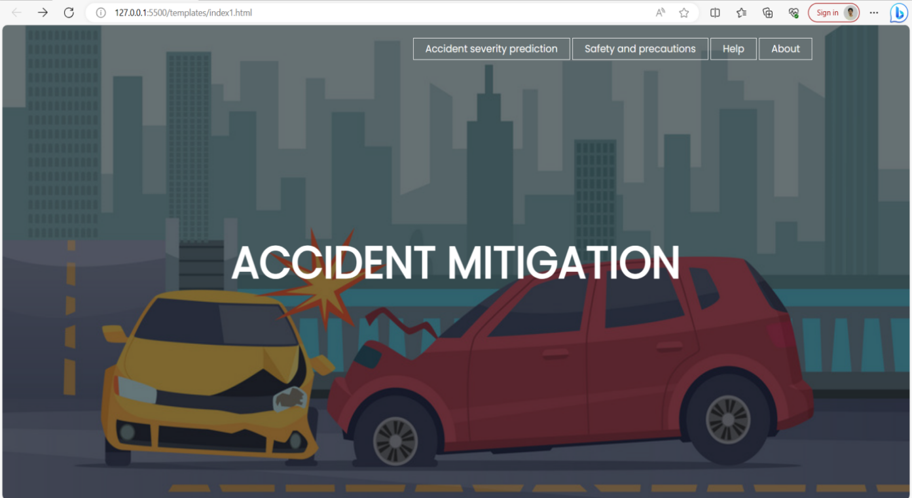
Figure 4.1 Index Page
The webpage presents an accident severity prediction application, users are prompted to input specific details and data. By entering relevant information, such as road conditions, weather, traffic density, and other variables, users actively contribute to the prediction model.. It fosters a sense of engagement and personal involvement in enhancing road safety and accident prevention.

Figure 4.2 Accident Severity Prediction Page
Upon clicking "Predict," user-submitted data is sent to the backend, where it's analyzed by a predictive model. After processing, the app displays the estimated accident severity for the current location, aiding users in making safer driving decisions
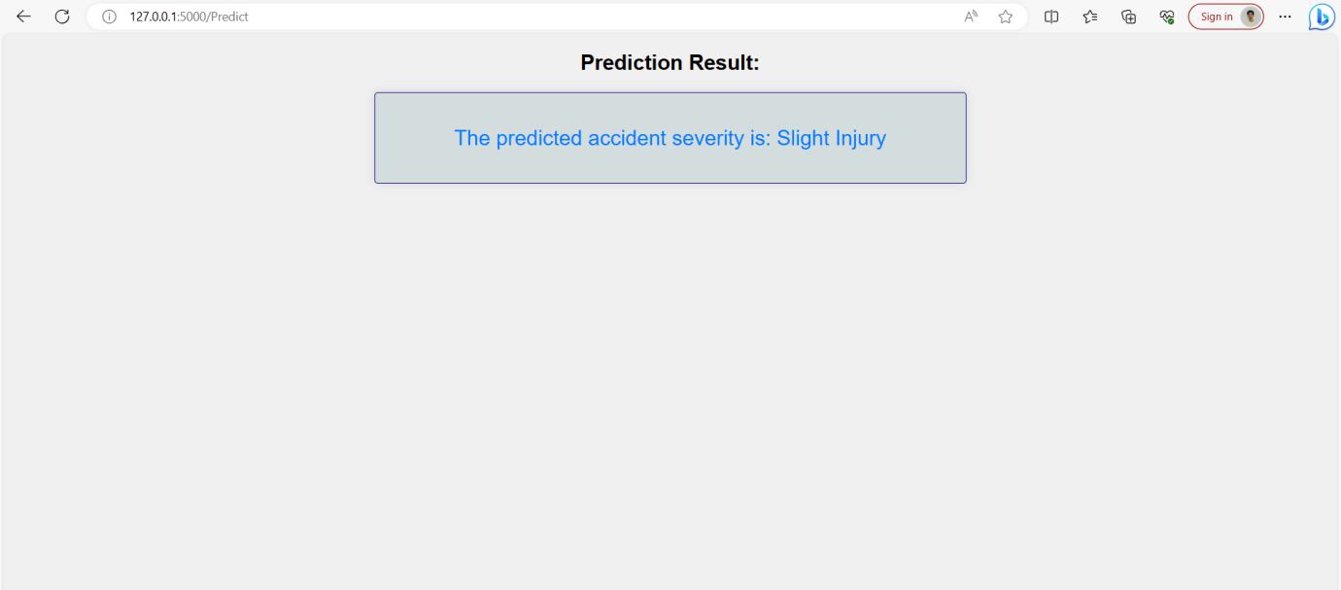
Figure 4.3 Prediction Result Page
The page provides essential safety guidelines and precautions to educate users on accident prevention. By offering valuable insights and safety measures, it aims to enhance awareness on accidents.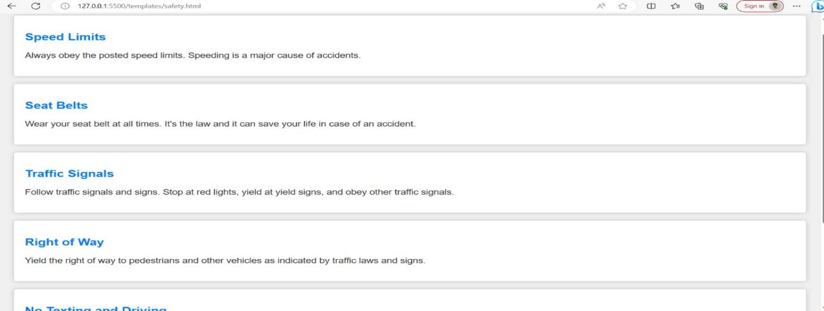
Figure 4.4 Safety and Precautions Page

V. Conclusion
The Accident Severity Prediction App represents a valuable tool for enhancing road safety and emergency response. By leveraging advanced machine learning techniques and real-time data, this app empowers users with the ability to predict and assess the severity of accidents. Analysis is done for the identification of factors involved in the accident that occur together. This shares a lot in understanding the circumstances and causes of accident. And this ultimately helps the Government to adapt the traffic safety policies with different types of accidents and situations. Our relentless pursuit of accuracy enhancement in the Accident Severity Prediction Project has been guided by our commitment to bolster road safety and emergency response. Through meticulous data refinement, exploration of advanced machine learning techniques, and thoughtful model parameter optimization, we have made remarkable progress, attaining an impressive 83% accuracy rate using Random forest algorithm. However, our journey toward greater precision remains unceasing, with ongoing efforts encompassing robust cross-validation, class imbalance mitigation, user feedback integration, and the utilization of external data sources. Our dedication to this cause persists, as we firmly believe that our project will continue to evolve into a vital tool, fostering safer roads and more effective accident response protocols within our communities.

- Acknowledgment:
We extend our sincere gratitude to all those who contributed to the development and implemention of Mock interview evaluator . We would like to express our appreciation to Dr. G. Yedukondalu , Assosciate Professor at the Department of Data Science, for his valuable guidance and support throughout the project. We also acknowledge the efforts of our team members Sravya Reddy, Akhil Reddy and Sai Priyatham Reddy for their dedication and hardwork in bringing this project to fruition. Additionally, we would like to thank the faculty and participated in testing and refining the application. Finally, we are grateful for the support and resources provided by Anurag University, which made this project possible.

- References
[1]Shristi Sonal and Saumya Suman “A Framework for Analysis of Road Accidents”Proceedings of International Conference on Emerging Trends and Innovations in Engineering and Technological Research (ICETIETR).Published 1 July 2018

[2]SArmin Ronacher Flask was first released in 2010. “Flask is an open-source project and does not have a traditional publisher.” It is maintained and developed by a community of contributors.(2010)

[3]Gupta, Meenu, Vijender Kumar Solanki, and Vijay Kumar Singh. "A Novel Framework to Use Association Rule Mining for classification of traffic accident severity." Ingeniería Solidaria 13, no. 21 (January 1, 2017)

[4]Pedregosa, F., Varoquaux, G., Gramfort, A., Michel, V., Thirion, B., Grisel, O., ... & Duchesnay, É. (2011). Scikit-learn: Machine learning in Python. Journal of Machine Learning Research, 12, 2825-2830.

[5]Li, Bing, and Jia Xin Liu. "Research on Preventive Management of Freeway Traffic Accident." Advanced Materials Research 779-780 (September 2013): 763–68.

[6]Nidhi. R, Ms, and Ms Kanchana V. "Analysis of Road Accidents Using Data Mining Techniques." International Journal of Engineering & Technology 7, no. 3.10 (July 15, 2018)

[7] Volchatova, I. V. "ACCIDENT RATE AND VICTIMS OF ROAD TRAFFIC IN A BIG CITY." World of Transport and Transportation 15, no. 4 (August 28, 2017): 202–13.

[8]Soni, N., Patel, M., & Mistry, K. (2022). An Automation to Reduce Road Traffic Accidents Using Machine Learning Techniques.

[9]Tirumuru Ketha. "Analysis of Road Accidents to Identify Major Causes and Influencing Factors of Accidents – A Machine Learning Approach" (December 2019 )

[10]Juan Martín Fernández-Berni, Roberto López-Molinero, and Miguel A. Sotelo. “Accident prediction through combination of traffic monitoring data and machine learning techniques” (2013). https://doi.org/10.3390/computers10120157

[11]Liaw, A., & Wiener, M. "Classification and regression by randomForest." 2002

[12]Priyanka A. Nandurge, Nagraj dharwadkar. "Analyzing road accident data using machine learning paradigms"(February 2017).

[13]Kumar. S., & Toshniwa.D “ A data mining approach to characterize road accident locations”(2016).

[14]Ponnaluri, R. “Road traffic crashes and risk groups in India: Analysis, interpretations, and prevention strategies.” (March 2012)

[15]Rao, S. R. Ritchie’s” Predictive Model of Accidents using Machine Learning Algorithm” (2020).

