**A STUDY ON EFFECTIVENESS OF EMPLOYEE ENGAGEMNET PRACTICES IN TELEAPPS**

1shruthi D and 2madhiarsi S

1MBA student Jerusalem College of Engineering, Chennai

2Professor and Head MBA, Jerusalem College of Engineering, Chennai

# **ABSTRACT**

# The study examines the effectiveness of employee engagement practices in Teleapps India Pvt Ltd and enhancing organizational performance and employee well-being. The research aims to identify key engagement practices and their impact on employee motivation, job satisfaction, and overall productivity. Ultimately, the research highlights the importance of employee engagement in driving organizational success and fostering a culture of high performance and employee satisfaction.

# **KEYWORDS:** Employee engagement, satisfaction, employee motivation

**INTRODUCTION**

The aim of the paper is to research about the evaluation of employee engagement practices in the Teleapps India Pvt Ltd and to identify the effectiveness of the engagement activities among its employees. Here's an introduction for your study on the effectiveness of employee engagement practices. In the landscape of organizational management. Effective engagement activities serve as guiding principles that govern various aspects of employers-organisation relationships, and their benefits.

The aim of this study is to examine the effectiveness of employee engagement practices within Teleapps. By conducting a analysis, we seek to gain insights into the strengths and weaknesses of existing engagement activities, identify areas for improvement, and ultimately enhance the employee motivation to increase their performance. Through combined of quantitative surveys and qualitative interviews, we will adapt into employees' perceptions, experiences, and suggestions regarding engagement practices. This study will not only provide treasured feedback to employees and organizations but also contribute to the longer scope into the improvement in employee engagement practices.

**REVIEW OF LITERATURE**

* Dr. Rohit Verma (2019) - This review paper explores how digital technologies are shaping employee engagement practices in Indian organizations, discussing the opportunities and challenges associated with leveraging digital platforms for enhancing employee motivation and commitment**.**
* Hadi Teimouri (2016)- The aim this study is to investigate the relationship between employee engagement and organisational effectiveness. Two questionnaires in relation to employee engagement and organisational effectiveness using Parsons model were designed and distributed among 184 experts and managers of Damavand Power Generation Management located in Damavand, Iran. The participants were selected using a stratified sampling method. The finding proves that there is a meaningful relationship between each of the six dimensions of internal marketing, including organisational justice, rewarding, training, employee participation, information sharing, job security and organisational effectiveness.
* Vipul Saxena & Rachana Srivastava, (2015) This study proves that Employee engagement is the level of involvement and commitment an employee has towards his/her organization and its values. It is a measure of an employee's positive or negative attitude towards their job, colleagues and organization which influences their willingness to learn and perform at work. Employee engagement has a direct impact on the employee's productivity, loyalty, commitment and less attrition.
* **Bijaya Kumar Sundaray, (2011)** This study focuses on various factors which lead to employee engagement and what should company do to make the employees engaged. Proper attention on engagement strategies will increase the organizational effectiveness in terms of higher productivity, profits, quality, customer satisfaction, employee retention and increased adaptability.

# **METHODOLOGY**

In this study based on both primary and secondary data. Primary data were collected from the employees of Teleapps PVT LTD, thousand lights, chennai-600064 using well-framed questionnaire. Snowball sampling method was used for selecting sample respondents. 61 respondents were selected for the present study. The secondary data were collected from various books, journals, research articles, magazines, and websites. Primary Objectives to study on effectiveness of employee engagement practices in Teleapps. Secondary objectives is to find out the impact of employee engagement on employee performance. To analyze the relationship between employee well-being, mental health and engagement practices. To identify best practices for measuring and tracking employee engagement levels.

Need of study is to understand employee perception on engagement activities. To improve employee retention in company and increase productivity and performance.Scope of study is to understand the framework of employee engagement activities. To increase the output level of employees. Limitation of study the size of the sample was relatively small-61 participants. A larger sample would likely upgrade the reliability of the research.

**ANALYSIS**

**DESCRIPTIVE STATISTICS:**

1. PERCENTAGE ANALYSIS:

|  |  |  |  |
| --- | --- | --- | --- |
| factor |  | frequency | Percentage |
| 1.gender | Male | 30 | 49.18% |
|  | Female | 31 | 50.82% |
|  |  |  |  |
| 2.Educational qualification | UG | 9 | 14.75% |
|  | PG | 52 | 85.25% |
|  |  |  |  |
| 1. Age | 20-25 | 38 | 62.30% |
|  | 26-30 | 13 | 21.31% |
|  | 31-35 | 9 | 14.75% |
|  | Above 40 | 1 | 1.64% |
|  |  |  |  |
| 4. Rating of your overall level of engagement at work | Highly engaged | 8 | 12.5% |
|  | Moderately engaged | 46 | 71.9% |
|  | Not very engaged | 10 | 15.6% |
|  | Not engaged at all | 1 | 1.64% |
|  |  |  |  |
| 1. Methods that organizations use to measure employee engagement | Employee surveys | 29 | 47.54% |
|  | One-on-one interviews | 20 | 32.79% |
|  | Focus groups | 9 | 14.75% |
|  | Engagement pulse checks | 3 | 4.92% |
|  |  |  |  |
| 6.Rating of current work life balance | Excellent | 22 | 36.07% |
|  | Good | 28 | 45.90% |
|  | Fair | 7 | 11.48% |
|  | Poor | 3 | 4.92% |
|  | Very poor | 1 | 1.64% |

**CORRELATION**

**To find the relationship between effectiveness of how satisfied are you with current roles and responsibilities and overall well being currently.**

H0(null hypothesis): there is no relationship between satisfaction level with your current roles and responsibilities and overall wellbeing currently

H1(alternative hypothesis) there is a relationship between satisfaction level with your current roles and responsibilities and overall wellbeing currently.

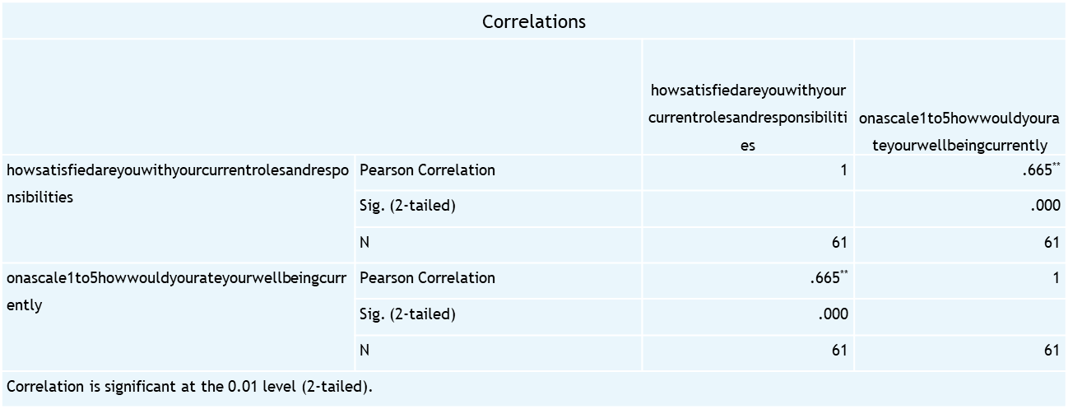

The significant value 0.000 is less than the table significant value (0.000<0.05).

H0 is rejected and H1 is accepted

Therefore, there is a relationship between satisfaction level with your current roles and responsibilities and overall well-being currently.

**ANOVA**

**To find the difference between experience and stress related work**

H0(null hypothesis): there is no significance difference between experience and stress related work

H1(alternative hypothesis): there is a significance difference between experience and stress related work

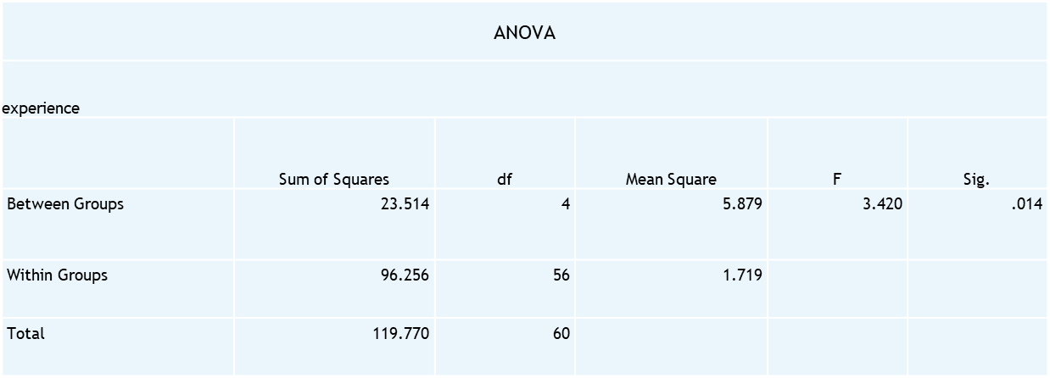

The significant value 0.014 is less than the table significant value (0.014<0.05).

H0 is rejected and H1 is accepted.

Therefore, there is a significance difference between experience and stress related work

**FINDINGS**

From the above table that it is interpreted that 50.82% are female and 49.18% are male. Majority are female with 50 respondents. This is interpreted that 85.25% are PG and 14.75% are UG. Majority are Pg with 85 respondents. It is interpreted that 62.30% are an age of 20-25 and 21.31% are an age of 26-30 and 14.75% are an age of 31-35 and 1.64% are an age of above 40.Thus the majority of the people are an age of 20-25.it is interpreted that 12.5% are highly engaged with engagement level, 71.9% are moderately engaged, 15.6% are not very engaged, 1.64% are not engaged at all. Thus majority of the people are moderately engaged. It is interpreted that 47.54% is based on employee surveys method, 32.79% use one-on-one interviews method, 14.75% use focus group method, 4.92% use engagement pulse checks to measure employee engagement. Thus the majority are employee surveys with 49%.It is interpreted that 36.07% are excellent with their current work life balance,45.90% are good,11.48%are fair, 4.92% are poor, 1.64% are very poor. Majority are with good work life balance. According to the correlation analysis we found that there is a relationship between satisfaction level with your current roles and responsibilities and overall well being currently. According to the Anova analysis we found that there is a significance difference between experience and stress related work.

**CONCLUSION**

This study on the effectiveness of employee engagement practices has demonstrated significant positive impacts on various organizational metrics, including productivity, employee satisfaction, and retention rates. By implementing strategic engagement initiatives, the company has not only fostered a more vibrant and motivated workforce but also cultivated a culture of collaboration and innovation.

**REFERENCE**

* Joubert, M., & Roodt, G. (2011). Identifying enabling management practices for employee engagement. *Acta Commercii*, *11*(1), 88-110.
* Chandani, A., Mehta, M., Mall, A., & Khokhar, V. (2016). Employee engagement: A review paper on factors affecting employee engagement. *Indian Journal of Science and Technology*.
* Byrne, Z. S. (2022). *Understanding employee engagement: Theory, research, and practice*. Routledge.
* Swarnalatha, C., & Prasanna, T. S. (2013). Employee engagement: The concept. *International Journal of Management Research and Reviews*, *3*(12), 3872.
* Truss, C., Shantz, A., Soane, E., Alfes, K., & Delbridge, R. (2013). Employee engagement, organisational performance and individual well-being: exploring the evidence, developing the theory. *The international journal of human resource management*, *24*(14), 2657-2669.
* Markos, S., & Sridevi, M. S. (2010). Employee engagement: The key to improving performance. *International journal of business and management*, *5*(12), 89.