**ADVANCEMENTS AND CHALLENGES IN FEEDING TECHNIQUES FOR MICROSTRIP PATCH ANTENNAS: A COMPREHENSIVE REVIEW**

**Sudarshan Kumar Jain1, Girraj Sharma2, Honey Agarwal3, Devendra Sharma4**

1,3,4Assistant Professor, ECE Department, JECRC, Jaipur, Rajasthan, India

2Associate Professor, ECE Department, JECRC, Jaipur, Rajasthan, India

**ABSTRACT**

Modern wireless communication systems frequently employ microstrip patch antennas because of their low profile, lightweight, and simplicity of construction. However, the feeding method employed significantly impacts these antennas' performance. This study thoroughly analyzes the many feeding methods used in microstrip patch antennas, such as inset feed, coaxial feed, aperture coupling feed, proximity coupling feed, and microstrip line feed. Every feeding method is covered, along with its benefits, drawbacks, and uses. The intention is to offer guidance on choosing the best feeding method for a given set of design specifications.

**Keywords:** Microstrip patch antennas, Feeding techniques, Bandwidth, Radiation pattern, Impedance matching, Efficiency.

1. **INTRODUCTION**

Microstrip patch antennas have become essential for wireless communication systems because of their various merits. They are at the leading edge of antenna design owing to their discrete and lightweight nature, affordability, and compatibility with integrated circuit technology. These antennas are preferred because they blend well with various gadgets and setups without significantly increasing size or weight. The performance of microstrip patch antennas is highly dependent on the feeding mechanism selected, even with their widespread use. The feeding mechanism influences the bandwidth, radiation pattern, impedance matching, and the antenna system's overall efficiency.

For example, bandwidth specifies the range of frequencies that the antenna may operate across it. By affecting the coupling efficiency and impedance matching between the feeding network and the radiating element, the feeding approach directly affects the bandwidth. A larger bandwidth may be achieved via a well-designed feeding method that allows the antenna to handle more frequency bands and communication protocols [1]. The radiation pattern describes the distribution of electromagnetic energy in space, which is another important factor in antenna performance. By establishing the current distribution along the radiating element, the feeding strategy has a major impact on the radiation pattern. Depending on the application's particular needs, various feeding mechanisms might result in different radiation patterns, such as omnidirectional, directed, or sectorized [2].

Impedance matching is necessary to maximize power transmission between the antenna element and the feeding network and maximize antenna efficiency. The impedance seen at the antenna's feed point is directly impacted by the selected feeding method, which affects the antenna's efficiency in emitting and receiving electromagnetic radiation. An optimal feeding strategy reduces reflection losses and guarantees maximum power transmission, improving the antenna system's overall performance. Efficiency is a crucial parameter for evaluating an antenna's performance, as it can be measured as the ratio of radiated power to input power. The efficiency mostly depends on the feeding strategy, which affects things like radiation losses, conductor losses, and impedance mismatch losses. An efficient feeding technique maximizes converting electrical energy into radiated electromagnetic waves, improving the antenna's performance and range.

Choosing the right feeding strategy becomes crucial because of the significant influence feeding approaches have on the performance of microstrip patch antennas. To guarantee the best possible performance for certain applications, designers must carefully consider the trade-offs and features of various feeding strategies. Factors including size restrictions, bandwidth limitations, frequency requirements, and integration issues must be considered when choosing the feeding strategy. Designers may maximize the benefits of microstrip patch antennas and optimize their performance for various wireless communication systems by selecting the best feeding mechanism.

1. **FEEDING TECHNIQUES FOR MICROSTRIP PATCH ANTENNA**

**2.1 Microstrip feeding**

Due to its simplicity and ease of integration, the microstrip line feed technique is extensively used to feed microstrip patch antennas. Using this method, the patch antenna is directly connected to a microstrip transmission line, usually found on the same substrate as the patch. Its direct connection makes it appropriate for various applications by streamlining the overall design and facilitating integration into other systems. The simplicity of the design of microstrip line feed is one of its main benefits. Designers may achieve a simple arrangement by simply connecting the patch antenna to a microstrip transmission line, which reduces complexity in the fabrication and assembly procedures. Furthermore, system configurations may be flexible by readily tailoring the integration of microstrip line feed to match individual design needs [3].

Microstrip line feed has several drawbacks despite its simplicity and ease of integration. Radiation loss potential is one significant downside, particularly at higher frequencies. The overall effectiveness and performance of the antenna system can be impacted by radiation losses in the microstrip transmission line, which can rise with frequency.

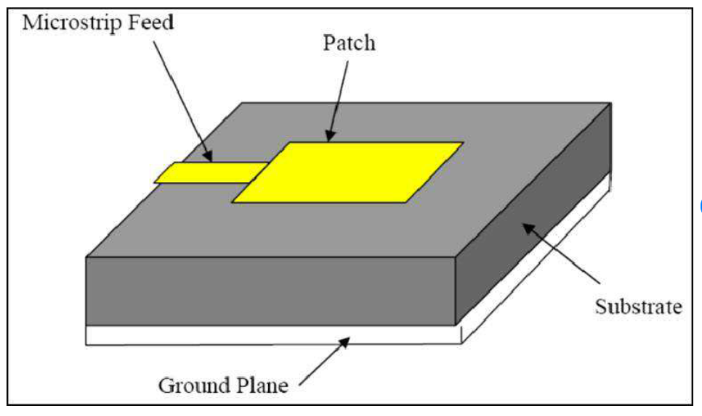

**Figure.1** Microstrip Line Feed [7]

Moreover, microstrip line feed can cause problems with impedance mismatch, especially when switching between various impedance levels along the transmission line. These impedance mismatches can cause standing wave effects and reflections, which can alter the antenna's bandwidth characteristics and impedance matching. Designers frequently use impedance-matching networks, impedance transformers, and meticulous layout optimization to alleviate these difficulties. Reducing radiation losses and optimizing impedance matching help microstrip patch antennas with microstrip line feed operate better overall.

**2.2 Coaxial feed**

Another popular method of feeding microstrip patch antennas is coaxial feed, which has benefits and drawbacks. The coaxial feed enables effective energy transfer between the transmission line and the antenna element by connecting the patch antenna to a coaxial cable via a probe [4]. The outstanding impedance-matching ability of coaxial feed is one of its main benefits. A clearly defined characteristic impedance, usually 50 or 75 ohms, is intrinsic to the coaxial construction and may be readily matched to the impedance of the microstrip patch antenna. Impedance matching maximizes power transmission and reduces reflection losses, improving the antenna system's overall performance and efficiency.

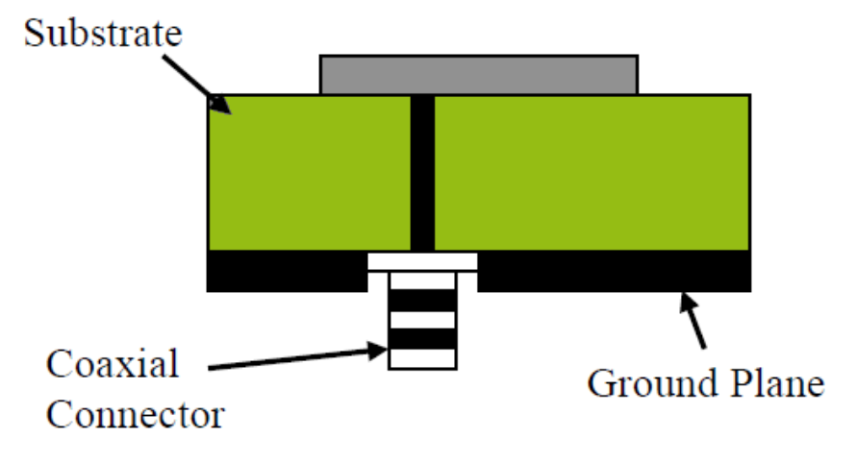

**Figure 2** Coaxial line Feed [8]

Low radiation losses are a well-known feature of coaxial feed, especially at high frequencies. Coaxial cables are a useful tool for directing electromagnetic waves, reducing loss in the transmission line, and maintaining the signal's integrity as it moves toward the antenna element. Because of this property, coaxial feed is especially well suited for high-frequency applications where signal attenuation is a major worry. Coaxial feed does have certain benefits, but it also has certain drawbacks. Adjusting probe length, location, and diameter precisely may be necessary to achieve the best coaxial feed results. It is necessary to carefully modify some parameters throughout the design and manufacturing process since small deviations impact the antenna's radiation characteristics and impedance matching.

Furthermore, because coaxial cables and connections are substantial, incorporating coaxial feed into small antenna designs might be difficult. In some applications, it may be difficult to fulfill size limits due to the physical dimensions of coaxial components, which might limit the antenna system's potential for downsizing. Designers frequently use sophisticated modeling and optimization approaches to overcome these obstacles and optimize the coaxial feed configuration. To address the size and integration limitations related to coaxial feed in microstrip patch antennas, novel techniques, including low-loss coaxial cables and downsized coaxial connections, are constantly being developed.

**2.3 Aperture Coupling**

In microstrip patch antennas, aperture coupling feed is a frequently employed technique that has distinct benefits and difficulties compared to alternative approaches. This method transfers electromagnetic energy while keeping the feed line and radiating element isolated. A ground plane aperture links energy from a microstrip transmission line to the patch antenna.

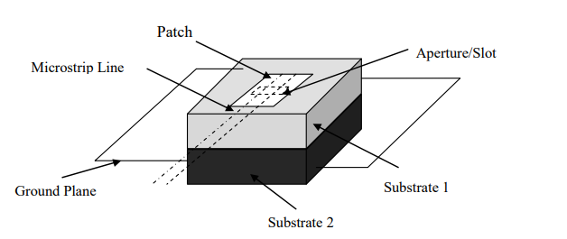

**Figure.3** Aperture Coupled Feed [6]

The ability of aperture coupling feed to produce high isolation between the radiating element and the feed line is one of its main advantages. Through the ground plane aperture, the transmission line and patch antenna are physically separated, allowing electromagnetic coupling without direct electrical contact. In phased array and MIMO (Multiple Input Multiple Output) systems, in particular, this separation serves to limit mutual coupling effects and reduce electromagnetic interference, resulting in enhanced radiation efficiency and less cross-polarization.

Additionally, because the feed structure and radiating element may be optimized independently, aperture coupling feed provides design flexibility. The total performance of the antenna system may be optimized by designers by adjusting factors like the aperture size, shape, and location to suit the coupling characteristics and impedance matching requirements.

**2.4 Proximity coupling**

In microstrip patch antennas, proximity coupling feed is a frequently employed technique that has both distinct benefits and difficulties in comparison to alternative approaches. Using just the proximity effect between the two pieces, electromagnetic coupling between the feed line and the patch antenna is accomplished in this manner without the need for any physical connection [5]. The ease of design of proximity coupling feed is one of its main benefits. An antenna construction that is simple and small may be achieved by designers by doing away with the requirement for physical connections between the patch antenna and the feed line. Because of its simplicity, proximity coupling feed may be easily fabricated and integrated into a variety of applications where weight and space are important factors.

factors.

Furthermore, proximity coupling feed is ideally suited for broadband communication systems due to its large bandwidth performance. The antenna may function across a large bandwidth without the need for intricate matching networks or tuning components thanks to the electromagnetic coupling that occurs between the feed line and the patch antenna. This coupling makes effective energy transfer possible over a wide range of frequencies.

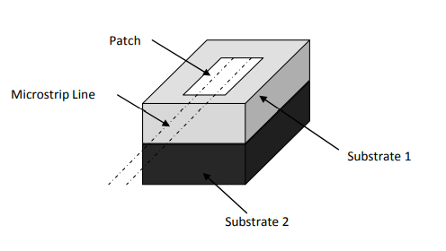

**Figure.4** Proximity Coupled Feeding [6]

When compared to alternative feeding methods, proximity coupling feed may have lower power transfer efficiency despite its benefits. Higher losses and decreased efficiency may arise from the feed line and patch antenna not being physically connected, especially at higher frequencies or over longer distances. This restriction could have an effect on the antenna system's overall performance, influencing elements like efficiency, gain, and radiation pattern.

Furthermore, the surroundings and items in the immediate vicinity may impact the proximity coupling feed. Variations in antenna performance might result from interference with the coupling process caused by nearby metallic structures or electromagnetic interference sources. Furthermore, the electromagnetic field distribution and coupling efficiency can be affected by modifications to the antenna's surroundings, such as adjacent materials or objects, which further complicates antenna deployment and design in real-world situations.

In order to overcome these difficulties, designers frequently use optimization techniques to optimize the proximity coupling feed structure. The coupling characteristics may be analyzed, and possible sources of inefficiency or interference can be found using sophisticated electromagnetic modeling techniques. Additional techniques can be used to lessen the impact of nearby objects and enhance the antenna system's overall performance, including shielding, isolation, and impedance matching.

**2.5 Inset feed**

The inset feed approach is frequently utilized in microstrip patch antennas and has several benefits and significant difficulties. A short-circuited or open-circuited stub on the patch surface allows the patch antenna to be fed straight through, giving the radiating element a direct connection.

The ability of inset feed to provide excellent radiation efficiency and impedance matching is one of its main features. The feed point impedance may be efficiently controlled, and mismatch losses can be reduced by designers feeding the antenna straight via a stub on the patch surface. This raises the overall performance of the antenna by increasing power transfer efficiency and improving radiation characteristics. Moreover, inset feed makes it simple to tune antenna characteristics by modifying the feed stub's length and location. By adjusting these parameters, designers can adjust the bandwidth, resonant frequency, and other antenna performance metrics to satisfy particular design specifications. This tuning flexibility allows antenna designs to be tailored for different operating frequencies and applications.

Notwithstanding its benefits, inset feed may provide fabrication and production issues. Precise manufacturing processes are typically necessary to ensure proper dimensions and positioning of the feed stub on the patch surface in order to achieve the best performance with inset feed. Stub length or position variations of even a small degree might affect the radiation characteristics and impedance matching of the antenna, hence strict quality control and tight tolerances are required during manufacture.

Furthermore, compared to alternative feeding methods, constructing inset feed structures can need extra processing steps, which could raise production costs and complexity. In high-volume production settings, specialized equipment and knowledge may be required to achieve the required precision and reproducibility in manufacturing.

To address these challenges, designers often utilize advanced fabrication techniques such as photolithography, laser machining, or computer-controlled milling to achieve precise dimensions and placement of the feed stub. Additionally, rigorous testing and validation processes are employed to ensure the consistency and reliability of antenna performance across production batches. So, inset feed offers advantages such as good impedance matching, radiation efficiency, and tunability for microstrip patch antennas. However, achieving optimal performance may require precise fabrication techniques and attention to detail.

1. **Conclusion:**

In summary, microstrip line feed is straightforward and easy to integrate, but it can also result in radiation losses and impedance mismatch, particularly at higher frequencies. Low radiation losses and excellent impedance matching are two areas where coaxial feed shines, although accurate tuning and integration remain difficult in small devices. The careful tuning of aperture size and position is necessary to decrease cross-polarization and improve isolation and radiation efficiency through aperture coupling feed. The simplicity and large bandwidth of proximity coupling feed are counterbalanced by its low power transfer efficiency and sensitivity to nearby objects.

Although inset feed produces high radiation efficiency, impedance matching, and tunability, its best performance necessitates careful manufacturing. Choosing the best feeding approach ultimately comes down to certain design criteria, including bandwidth, size limitations, frequency, and integration considerations, which enable designers to maximize microstrip patch antennas for various applications.

**4. REFERENCES**

[1] Constantine A. Balanis, Antenna Theory, Analysis and Design,3rd edition, A John Wiley & Sons, Inc., Publication, 2005.

[2] Jain, Sudarshan Kumar. "Design and Analysis of Multilayer Substrate Structure Microstrip Patch Antenna." SSRG International Journal of Electronics and Communication Engineering (SSRG-IJECE)–Volume 2 (2015).

[3] Chang, Ming-Hsuan, and Bo-Yu Chen. "Microstrip-fed ring slot antenna design with wideband harmonic suppression." IEEE Transactions on Antennas and Propagation 62.9 (2014): 4828-4832.

[4] Upender, P., and PA Harsha Vardhini. "Design Analysis of Rectangular and Circular Microstrip Patch Antenna with coaxial feed at S-Band for wireless applications." 2020 Fourth International Conference on I-SMAC (IoT in Social, Mobile, Analytics and Cloud) (I-SMAC). IEEE, 2020.

[5] Yadav, Rohit, et al. "Graphene-based multiband stack patch THz antenna with proximity feed." 2021 IEEE Indian Conference on Antennas and Propagation (InCAP). IEEE, 2021.

[6] Rhazi, Youssef, Seddik Bri, and Rajaa Touahani. "Effect of Microstrip Antenna Feeding in the K-band." International Journal of Engineering and Technology (IJET) 4.6 (2013): 515-522.

[7] Khaleel, Aymen Dheyaa. "Design tri-band single and dual patch array antenna with band suppression." Research Gate 10 (2012).

[8] Abdulkareem, Seevan Fahmi. Design and Fabrication of Printed Fractal Slot Antennas for Dual-Band Communication Applications. Diss. M. Sc Thesis, University of Technology, Iraq, 2013.