**A STUDY ON STRESS LEVEL OF EMPLOYEES IN VEDGE SOFTWARE LABS**

Jacob martin. A and Surendher R

MBA student Jerusalem College of Engineering, Chennai

Professor and Head MBA, Jerusalem College of Engineering, Chennai

**ABSTRACT**

This study aims to investigate the stress levels of employees in various industries and sectors. The research will focus on identifying common stressors in the workplace, exploring coping mechanisms used by employees, and assessing the impact of stress on job performance and overall well-being. Data will be collected through surveys and interviews with employees from different organizations to gain a comprehensive understanding of the factors contributing to stress in the workplace. The findings of this study will provide valuable insights for employers and policymakers to develop strategies and interventions to support employees in managing their stress levels effectively.The study will also examine the role of organizational culture, leadership styles, workload, work-life balance, and job satisfaction in contributing to employee stress. By analyzing these factors, the research aims to provide recommendations for creating a healthier and more supportive work environment that promotes employee well-being and productivity.

**1. INTRODUCTION**

The project titled level stress on employees of VEDGE SOFTWARE LABS is done with a view to analysis the effective operation of stress management by the management by the manufacturing as well as satisfactory level of employees satisfaction level survey was developed to gain the base of information of the employee attitudes about the stress management working in the VEDGE SOFTWARE LABS and to deduct the areas where improvement and development is requiring to survey assess the employess & management perception towards the successful working of stress management.

Stress has been called “the invisible”,It is a disease that may affect you, your organization, and any of the people in it, so you cannot afford to ignore it. Stress is a part of day-to-day living of every individual. The college students may experience stress in meeting in academic demands, people on the job, business men maysuffer stress to reach office time and to complete the projects on time and even the house hole ladies may experience stress in managing the home affairs and to look for the maid servan

The reasons for the stress differ from person to person.

But a high level of stress can be serious threat to the personality trails of the individual and can cause physiological and social problems.

**OBJECTIVES OF THE STUDY**  
 **PRIMARY OBJECTIVES**To study the stress level of the employees at VEDGE SOFTWARE LABS.  
  
**SECONDARY OBJECTIVES**

* To identify the impacts of stress on employees productivity and meet organization goals.
* To know various causes of stress and to know the impact of work stress on personal life.
* To study the stress level and to manage stress for the betterment of the organization.
* To identify emotional, physical and mental effects of stress.
* To identify various factors that influences the stress level of the employees.

**NEED OF THE STUDY**  
To produce change on these types of measures, stress interventions will need to alter or modify the sources of stress in the work environment.

* The purpose of the study is to understand that the stress management in work setting can be effective in enhancing worker physical and psychological health.
* The choice of which stress management techniques to use should be based on the specific health outcomes that are targeted for change.
* The quality of the methodology varied substantially among studies. None of the stress interventions was consistently effective in producing effects on job/ organizational-relevant outcomes such as absenteeism or job satisfaction.

**SCOPE OF THE STUDY**

* To learn the way of organization deals to handle the kind of stress the employees face.
* To know how the organization get affected due to the stress faced by the employee.
* Gain knowledge to follow tatics to get relief from stress level during work hours.
* To get an idea to keep the employee satisfaction & motivated by lowering the stress level.
* Knowledge earning and gaining pratical exposure to overcome stress during work time.

**LIMITATIONS OF THE STUDY**

* The research was carried out in a short span of time, where the researcher could not widen the study.  
  The study could not generated due to the fact that researcher adapted personal interview method.  
  There is no measure to check out whether the information provided by the employees is correct or not.  
  The tools used to measure stress levels may not be valid or reliable, leading to inaccurate results.
* The survey is subjected to the bias and prejudices of the respondents. Hence 100% accuracy can’t is assured.

**2.REVIEW OF LITERATURE:**

Review of related literature is an important step in undertaking research. It helps in clarifying and defining the problem stating objectives, formulating hypothesis, Selecting appropriate design and methodology of research as well as interpreting the results the light of the research work already undertaken. In this chapter,an endeavor has been made to provide an overview of various qaspects of this study throughout the review of existing literview. The sources referred include various journals, books, articles, internet, sites, etc.

* **Dr.K.Gunasekaran (2020)** A study on stress management of its employees. International Journal of Advanced Science and Technology, Issn-1129-1137, vol-29, (Mar 11 2020), the study Stress management may be regarded as an important technique and measurement which enhances the overall performances of the employee and improves his productivity and quality of work. Stress is a feeling that creates physiological and psychological imbalance with in a person it’s a body response any demand of changes in internal and external environment.
* **Dr Jolly Sahni** **(2020)**“Stress and Coping Mechanism during WFH (Work from Home) Among Service Industry Employees” Volume 1, Issue 1, October 2020 International Journal of Operations Management The continuing crisis of Coronavirus-19 disease (COVID-19) has changed our lives considerably; imposing the need for various modifications for organizations and individuals to cope up in this testing time.
* **Ms. Neetu Pareek (2020)** Managing Stress is the biggest challenge especially if we are talking about the current scenario of Covid-19 outbreak; this is very strenuous for each any every individual to overcome by it. In this article we can get an overview about the stress and its management techniques, which can work in this pandemic situation. Stress is very common concept in today’s era. Stress can differ for any person or any situation. Stress management includes different techniques like proper planning, listening body needs.

**3. RESEARCH METHODOLOGY**

|  |  |  |  |  |  |
| --- | --- | --- | --- | --- | --- |
| **AGE OF THE RESPONDENT** | | | | | |
|  | | Frequency | Percent | Valid Percent | Cumulative Percent |
| Valid | LESS THAN 20 YEARS | 32 | 29.9 | 29.9 | 29.9 |
| 21-24 YEARS | 42 | 39.3 | 39.3 | 69.2 |
| 25-28 YEARS | 22 | 20.6 | 20.6 | 89.7 |
| ABOVE 28 YEARS | 11 | 10.3 | 10.3 | 100.0 |
| Total | 107 | 100.0 | 100.0 |  |

This chapter discusses the methodology used to conduct the fieldwork of this research to propose identify the research’s problems and present the structure to how solve these problems in stages; each stage depend on rules and directions. According to Adam & Healy (2000), research methodology is the total approach used to investigate the issue of concern, and within that, the specific research methods and tools used to meet the declared research objectives. Adam & Healy (2000) consider methodology to be the procedures used for collecting and analysing the required data. In order to select an appropriate research methodology and decide on data collection techniques, a clear and explicit statement of the research aim and objectives is necessary. Research is the process of systematic and in-depth study or search for any particular topic, subjects or area of investigation, backed by collection, compilation, presentation and interpretation of relevant details or data.

**4.DATA ANALYSIS AND INTERPRETATION**

4.1.1 CLASSIFICATION BASED ON THE AGE OF THE RESPONDENTS

CHART-4.1.1

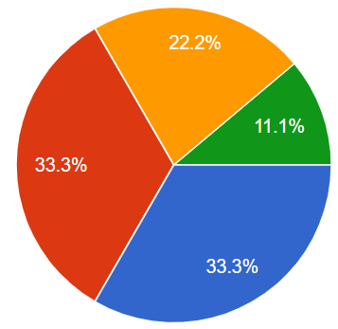

TABLE NO: 4.1.1

**INTERPRETATION:**

AS THE TABLE SHOWS THE MAJORITY OF THE RESPONDENT ARE THE AGE BETWEEN 21-24 YEARS.

**4.1.2 CLASSIFICATION BASED ON THE GENDER OF THE RESPONDENTS**

**CHART-4.1.2**

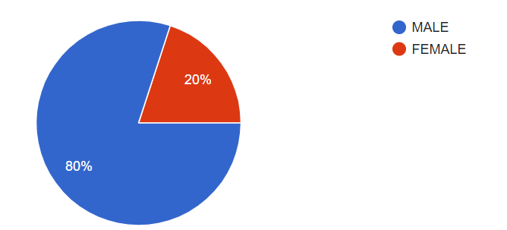

TABLE NO: 4.1.2

|  |  |  |  |  |  |
| --- | --- | --- | --- | --- | --- |
| **GENDER OF THE RESPONDENT** | | | | | |
|  | | Frequency | Percent | Valid Percent | Cumulative Percent |
| Valid | MALE | 85 | 79.4 | 79.4 | 79.4 |
| FEMALE | 22 | 20.6 | 20.6 | 100.0 |
| Total | 107 | 100.0 | 100.0 |  |

**INTERPRETATION:**

AS THE TABLE SHOWS THE MAJORITY OF THE RESPONDENT ARE MALE WITH PERCENTAGE OF 80% AS SHOWN IN THE PIE CHART.

**4.1.3 CLASSIFICATION BASED ON THE YEARS OF EXPERIENCE IN THE ORGANIZATION**

**CHART-4.1.3**

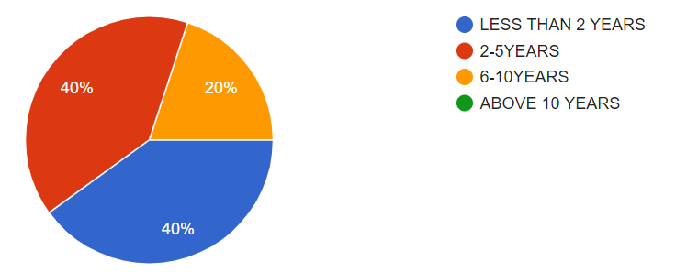

TABLE NO: 4.1.3

|  |  |  |  |  |  |
| --- | --- | --- | --- | --- | --- |
| **YEARS OF EXPERIENCE IN THE ORGANIZATION** | | | | | |
|  | | Frequency | Percent | Valid Percent | Cumulative Percent |
| Valid | LESS THAN 2 YEARS | 43 | 40.2 | 40.2 | 40.2 |
| 2-5 YEARS | 42 | 39.3 | 39.3 | 79.4 |
| 6-10 YEARS | 22 | 20.6 | 20.6 | 100.0 |
| Total | 107 | 100.0 | 100.0 |  |

**INTERPRETATION:**

AS THE TABLE SHOWS THE MAJORITY OF THE RESPONDENT ARE LESS THAN 2 YEARS WITH PERCENTAGE OF 40% AS SHOWN IN THE PIE CHART.

**CHI- SQUARE TEST**

to find out the any differences in the gender compared to stress management techniques more effective to the respondents.

**NULL HYPOTHESIS (H0):**

There is no significance difference between gender compared to stress management techniques is more effective.

**ALTERNATIVE HYPOTHESIS (H1):**

There is significance difference between gender compared to stress management techniques is more effective.

|  |  |  |  |  |  |
| --- | --- | --- | --- | --- | --- |
| **GENDER OF THE RESPONDENT * WHICH OF THE FOLLOWING STRESS MANAGEMENT TECHNIQUES IS MORE EFFECTIVE Crosstabulation** | | | | | |
| Count | | | | | |
|  | | WHICH OF THE FOLLOWING STRESS MANAGEMENT TECHNIQUES IS MORE EFFECTIVE | | | Total |
| EXERCISE | MEDITATION | TALKING TO A FRIEND |
| GENDER OF THE RESPONDENT | MALE | 11 | 20 | 54 | 85 |
| FEMALE | 0 | 22 | 0 | 22 |
| Total | | 11 | 42 | 54 | 107 |

|  |  |  |  |
| --- | --- | --- | --- |
| **Chi-Square Tests** | | | |
|  | Value | df | Asymptotic Significance (2-sided) |
| Pearson Chi-Square | 42.860a | 2 | .000 |
| Likelihood Ratio | 50.600 | 2 | .000 |
| Linear-by-Linear Association | 9.935 | 1 | .002 |
| N of Valid Cases | 107 |  |  |
| a. 1 cells (16.7%) have expected count less than 5. The minimum expected count is 2.26. | | | |

**INFERENCE:**

The significance value is 0.05 is lesser than the table value of 0.002 (0.05>0.002). hence H0 is rejected and H1 is accepted.

Therefore, there is a significant difference between gender and stress management techniques is more effective.

**CORRELATION:**

TO FIND OUT THE RELATIONSHIP BETWEEN STRESS LEVELS IMPACT YOUR JOB PERFORMANCE AND SPECIFIC EFFORTS TAKES TO REDUCE OR PREVENT STRESS.

**NULL HYPOTHESIS:**

There is no relationship between stress levels impact your job performance and specific efforts takes to reduce or prevent stress.

**ALTERNATIVE HYPOTHESIS:**

There is relationship between stress levels impact your job performance and specific efforts takes to reduce or prevent stress.

|  |  |  |  |
| --- | --- | --- | --- |
| **Correlations** | | | |
|  | | DO YOU FEEL THAT YOUR STRESS LEVELS IMPACT YOUR JOB PERFORMANCE | THE SPECIFIC EFFORTS TAKES TO REDUCE OR PREVENT STRESS |
| DO YOU FEEL THAT YOUR STRESS LEVELS IMPACT YOUR JOB PERFORMANCE | Pearson Correlation | 1 | -.181 |
| Sig. (2-tailed) |  | .076 |
| N | 107 | 97 |
| THE SPECIFIC EFFORTS TAKES TO REDUCE OR PREVENT STRESS | Pearson Correlation | -.181 | 1 |
| Sig. (2-tailed) | .076 |  |
| N | 97 | 97 |

**INFERENCE:**

The significance value is 0.05 is lesser than the table value of 0.76 (0.05<0.76). hence H1 is rejected and H0 is accepted.

Therefore, there is a no significant difference between stress levels impact your job performance and specific efforts takes to reduce or prevent stress.

**ANOVA**

To find the Monthly salary of the respondents and stress is affects more effectively.

**NULL HYPOTHESIS (H0):**

There is no significant difference between the monthly salary of the respondents and stress is affects more effectively.

**ALTERNATIVE HYPOTHESIS (H1):**

There is a significant difference between the monthly salary of the respondents and stress is affects more effectively.

|  |  |  |  |  |  |
| --- | --- | --- | --- | --- | --- |
| **ANOVA** | | | | | |
| IF STRESS IS AFFECTS MORE EFFIECTIVELY | | | | | |
|  | Sum of Squares | df | Mean Square | F | Sig. |
| Between Groups | 14.508 | 2 | 7.254 | 10.432 | .000 |
| Within Groups | 72.314 | 104 | .695 |  |  |
| Total | 86.822 | 106 |  |  |  |

**INFERENCE:**

The significance value is 0.05 is lesser than the table value of 0.000 (0.05>0.000). Hence H0 is rejected and H1 is accepted.

Therefore, there is a significant difference between the Monthly salary of the respondents and stress is affects more effectively.

**5.FINDINGS**

**PERCENTAGE ANALYSIS**

According to the survey, there are 107 respondents, from that 30% are less than 20 years old, 40% are 21-24 years old , 20 are 25-28 years old and 10% are above 28 years old.According to the survey, there are 107 respondents, from that 80% are male and 20% are female.According to the survey, there are 107 respondents, from the 40% are less than 2 years, 40% are 2-5 years, 20% are 6-10 years and 0% are above 10 years.According to the survey, there are 107 respondents, from that 40% are post graduate and 60% are under graduate.According to the survey, there are 107 respondents, from that 60% are unmarried and 40% are married.According to the survey, there are 107 respondents, from that 20% are software developer, 60% are business developer and 20% are human resources.According to the survey, there are 107 respondents, from that 30% are below 12000, 20% are 12001-15000, 50% are 15001-20000 and 0% are above 20001.According to the survey, there are 107 respondents, from that 30% are high workload, 20% are tight deadline, 40% are poor work life balance and 10% are lack of support from colleagues or supervisor.According to the survey, there are 107 respondents, from that 20% are yes, definitely, 50% are yes, somewhat and 30% are no, not really.According to the survey, there are 107 respondents, from that 40% are satisfied, 50% are neutral, 10% are dissatisfied.

**6. SUGGESTIONS**  
Organization balance support between stress level and personal life can be made more effectIve by following suggestions. Organizations should provide facilities like yoga, library etc. to relieve the stress. Employee should be given awareness about healthy food habits and also seen they are accessible to healthy food in the organizational round the clock.  
Many tasks can be delegated to subordinates without losing effectiveness so that we can reduce the overload of work. Employees should have positive attitude about work, about life and forget the stress. Employees should be provided training in time management techniques so as to avoid last minute rush in accomplishing the given targets which induces stress.

**7.CONCLUSION**

A study on work stress of employee conducted in VEDGE SOFTWARE LABS , Chennai is consist of the information about the employees undergoing from stress who working in the VEDGE SOFTWARE LABS . So considering this facter this topic become one of the most important part of the project as it consists of the opininion of the employees who work in the VEDGE Software Labs. In short it ws a direct interview of the employee who gave their opinion about how to reduce stress. The response of employees in the polaris was marvelous and they have given their valuable opinion about reducing stress.  
  
This study has provided suggestion for the improvement of the organization which seemed to be valuable and effective. It is one of the positive things that the organization cares for their employees. This will help the organization to boost up the productivity.