**AQUA VISION – A Drowning Detection Incident Monitoring and Alerting System**

**Mallamma CG1, Sanjay GT2, Shashank M3, Sreenidhi D4, Yeshwanth K5**

1Asst Professor, Dept. Of CSE, Sambhram Institute of Technology, Bengaluru Urban, Karnataka, India

2,3,4,5 Final Year Students, Dept. Of CSE, Sambhram Institute of Technology, Bengaluru Urban, Karnataka, India

**ABSTRACT**

When it comes to safety of Human beings, we lag with lack of Response Time with respect to Action and sometimes with lack of accurate data causing False Alaram. Despite Modern technologies and Safety tools, yet there’s always a causality left behind. This Paper discusses about a robust way to overcome this problem by using Superlative method of addressing the issue. The Sole Purpose of the Solution lies in Striving to provide Live Real Time Video Streams making way for Immediate Response Period. Aims to Enhance Water Safety providing Rapid means of recognizing Critical situations and alerting Health Care Centre’s. Along with Snaps captured in the Frame Pixels for Faster identification. Providing a wide spread in Environments such as Amusement Parks, Public Swimming Pools, Ponds and Lakes.

**Keywords:** Causality, Superlative, Response Period, Alarm, Amusement Park.

1. **INTRODUCTION**

A Coherent and Visual Striking Drowning Detection System that is multi-functional in various forms such as Detecting a person if he/she is or around the vicinity meaning Inside the Swimming Pool Area and outside the premises is identified and including Actions such as swimming or drowning is displayed over the Plasma. The question what arises is How the input source is fed into System. The System comprises of numerous ways for providing Input via an Image which accepts JPEG and PNG format of pictures, Video format that includes MP4 setup, another dominant and unique method is the Live Feed Option where Video footage is accepted widely either through the Computer Systems’ (Laptop) Web Camera or an additional personalized Web Camera that could be placed at a distinct corner over the pool premises, it also includes RTSP that facilitates the transportation of live audio and video content across the internet and finally a definitive mode of input shall also include YouTube where Video could be processed by just pasting the Link of an Online Video that is housed under YouTube Platform and the System shall detect actions performed and trigger appropriate functions timely.

1. **METHODOLOGY**

The Working Mechanism includes a delay in the System to detect or precisely the waiting time as to what we could even refer to as, which ideally is the Time it takes to cross-examine if the person is drowning and eventually follows a post-delay which is half of the delay time to re-examine if the Person is actually drowning or whether was it an Instrumental error, followed by which if found true that the Person seems to be drowning it stimulates an alarm which acts a Code for Signal of Stress and triggers an SOS Signal by activating an Audio tape that is connected to the Speaker and gives an admonition which alerts the surrounding environment know that there is a Victim around, Not only does the System rise an Alarm but also captures a Picture from the Frame while Drowning for scrutinization and under stores them under the Images section securely.

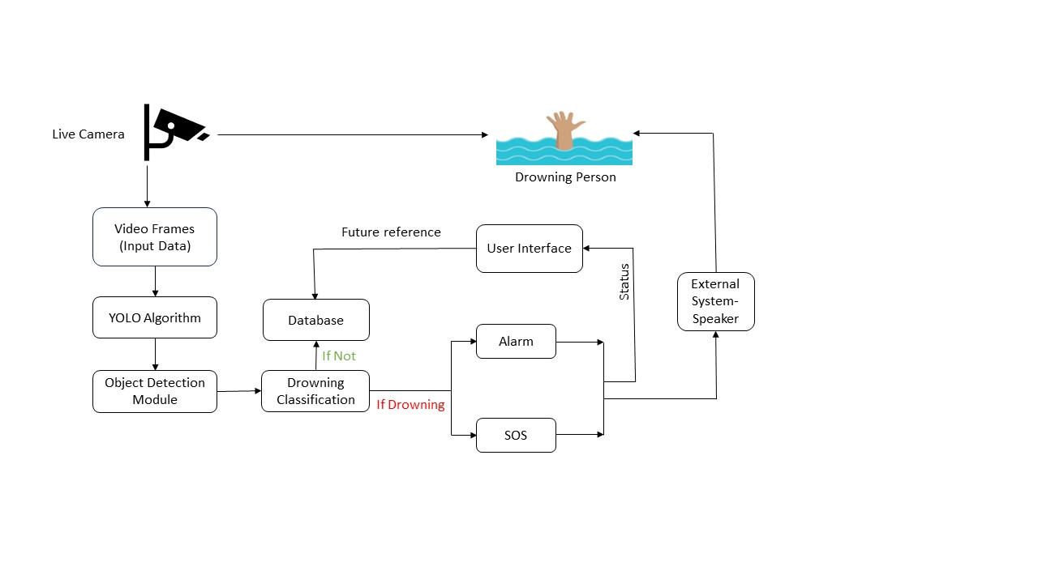

**Figure 2.1 Working Mechanism**

1. **MODELING AND ANALYSIS**

**3.1 Integration of OpenCV and YOLOv8**

The drowning detection system leverages the integration of OpenCV and YOLOv8 to achieve accurate and real-time detection of potential drowning incidents. OpenCV provides essential functionalities for image preprocessing, including contrast enhancement, noise reduction, and feature extraction. These preprocessing steps are crucial for improving the quality of input data before feeding it into the YOLOv8 model. YOLO v8, on the other hand, serves as the core object detection framework, responsible for identifying and localizing potential drowning incidents within the input images or video frames. The model has been pretrained on a large-scale dataset, enabling it to recognize a wide range of objects with high accuracy and efficiency. The seamless integration of OpenCV and YOLOv8 allows for efficient processing of input data in real-time, making the drowning detection system suitable for deployment in various environments, including Swimming pools, Amusement parks.

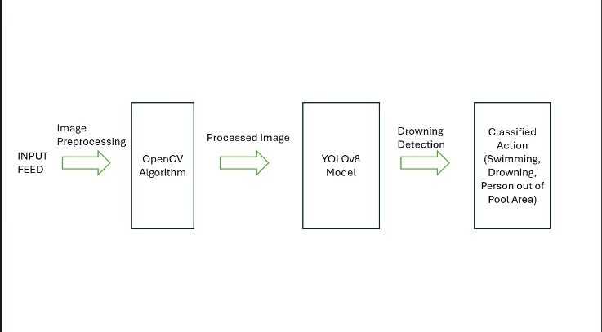

**Figure 3.1:** **Control-Flow Diagram**

**3.2 Insights and Observations**

Based on the analysis of results, several insights and observations are gleaned regarding the performance and effectiveness of the drowning detection system. Factors influencing the system's performance, such as lighting conditions, image quality, and the presence of occlusions, are identified and discussed. The impact of different parameters or configurations on detection accuracy and false positive rates is explored, providing valuable insights for system optimization and refinement.

1. **RESULTS AND DISCUSSION**

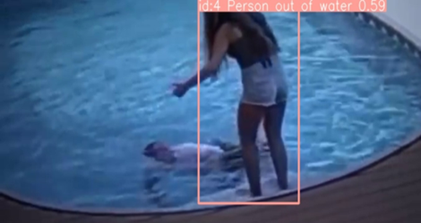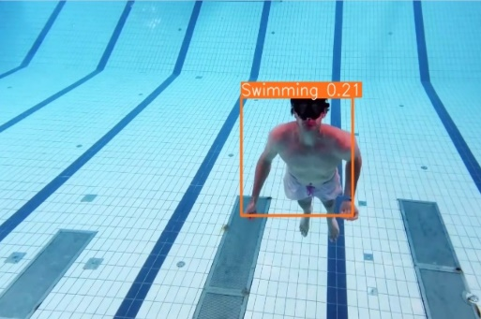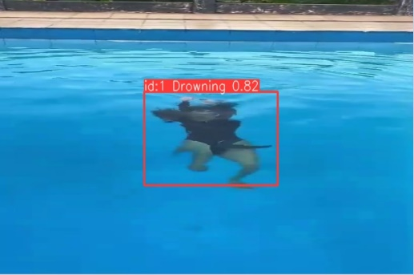

**Figure 4.1 Drowning Action Detected** **Figure 4.2 Swimming Action Detected Figure 4.3 Detection of Person Out**

**of Pool**

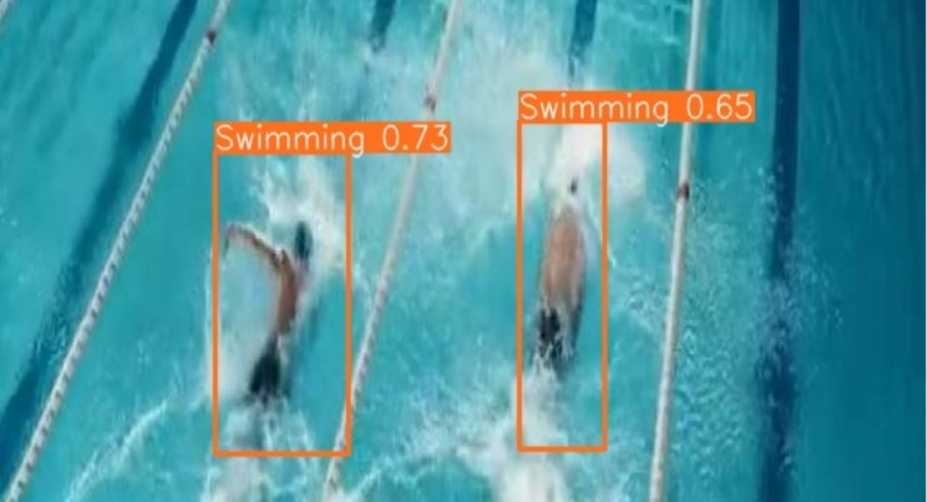

**Figure 4.4 Detects Multiple Swimmers in an Instance**

The results obtained from the drowning detection system using OpenCV and YOLOv8 demonstrate its effectiveness in accurately detecting and localizing potential drowning incidents in real-time. The system achieves high accuracy across different environmental conditions and scenarios, with minimal false positives. Qualitative evaluation further confirms the system's robustness, with drowning incidents consistently identified and localized with precision. Comparative analysis with existing methods underscores the superiority of the proposed approach, emphasizing the importance of integrating advanced computer vision techniques and deep learning models for enhancing public safety in aquatic environments.

1. **CONCLUSION**

The Drowning Detector project involves creating a computer vision system using OpenCV and deep learning to identify drowning incidents in videos. The project includes steps such as collecting annotated datasets, preprocessing video frames, selecting and training a deep learning model, integrating with OpenCV for real-time analysis, implementing an alert system, testing for accuracy, optimizing for efficiency, and documenting for deployment. The goal is to enhance water safety by providing a reliable and automated means of detecting potential drowning situations.

1. **REFERENCES**

[1] Organization, W.H Bloomberg, L.P: Global Report on Drowning Preventing a Leading Killer [2014]

[2] UNICEF Bank, W. Division, U.P: Levels and Trends in Child Mortality 2017. Lancet 243

[3] IEEE/CVF Conference on Computer Vision and Pattern Recognition (CVPR) 658-699 [2019]

[4] Educator Resources - Facts & Stats about Drowning, An Assessment of Statistical count of Causalities proclaimed by

Stop-drowning-now under their section of drowning statistics.

<https://www.stopdrowningnow.org/drowning-statistics/>

[5] Alotaibi, A. Automated and Intelligent System for Monitoring Swimming Pool Safety Based on the IoT and Transfer

Learning. Electronics 2020, 9, 2082. [Google Scholar]

[6] Mohtasham-Amiri, Z. Traumatic injuries in drowning. J. Inj. Violence Res. 2022, 14, 6, PMCID: PMC9115828.

[Google Scholar]

[7] Zaara, M.; Belhaj, A.; Naceur, Y.; Makni, C.; Gharbaoui, M.; Bellali, M.; Zhioua, M.; Allouche, M. Patterns of unintentional

fatal drowning among children in North Tunisia: A 10-year study. Rev. Dépidémiologie St. Publique 2022, 70, 31–37.

[Google Scholar]

[8] IJRTI-Lifeguard for Drowning Detection Saranya R, Bharath R, Gopinath SB, Deebak Raaj VPS, Gajapati VES Vol 8,

Issue 5 [2023]

[9] A. Roy and K. Srinivasan, "A Novel Drowning Detection Method for Safety of Swimmers," in Proc. Natl. Power Syst.

Conf. (NPSC), Dec. 14-16, 2018, NIT Tiruchirappalli, India, IEEE, pp. 1-6, 2018.

[10] N. Salehi, M. Keyvanara, and S. A. Monadjemmi, "An Automatic Video-based Drowning Detection System for Swimming

Pools Using Active Contours," I.J. Image, Graphics and Signal Processing, vol. 8, no. 8, pp. 1-8, Aug. 2016, doi:

10.5815/ijigsp.2016.08.01.

[11] H. Kam, W. Lu, and W.-Y. Yau, "A Video-Based Drowning Detection System," Centre for Signal Processing, School of

Electrical and Electronic Engineering, Nanyang Technological University, 50 Nanyang Avenue, Singapore 639798, IEEE,

2002.

[12] Kaviya K, Kavitha R, Ajitha R, Jothika S, "Drowning Detection System", IJRTI. International Journal for Research Trends

and Innovation, vol.8, no.5, pp.747-751, IJRTI. 2018.

[13] Tingzhuang Liu, Xinyu He ,Linglu He ,Fei Yuan: A video drowning detection device based on underwater computer

vision. IET Image Process. 17 1905–1918 (2023)

[14] Balaji Hariharan, Riji N Das, Arjun S, " WiEyeTNB : A Wireless Sensor Based Drowning Detection System for Enhanced

Parental Care", ICSSITE. Institute for Computer Sciences, Social Informatics and Telecommunications Engineering, pp.

511-520, 2012.

[15] Nasrin Salehi, Maryam Keyvanara, Seyed Amirhassan Monadjemmi, " An Automatic Video-based Drowning Detection

System for Swimming Pools Using Active Contours", IJIGSP. I.J.Image, Graphics and Signal Processing, vol.8, pp.1-8,

doi:10.5815/IJIGSP.2016.08.01

[16] Bapardekar Yukta, Berde Rinku, Valvi Priyanka, "Drowning Detection System Using CNN", IJCRT. International Journal

of Creative Research Thoughts, vol.10, no.3, pp.80-82, IJCRT. April, 2022.