**A STUDY ON PERFORMANCE APPRAISAL AT TAGORE HOSPITAL**

1Nithin sai.S and 2Sivakanni.

1MBA student Jerusalem College of Engineering, Chennai

2Ass Professor MBA, Jerusalem College of Engineering, Chennai

**ABSTRACT**

Performance appraisal is a critical aspect of human resource management, particularly within the healthcare sector, where the quality of service directly impacts patient outcomes. This study aims to evaluate and enhance the performance appraisal systems at Tagore Medical Hospitals, a leading healthcare institution renowned for its commitment to patient care and employee development.The main objective of this study was to determine the effects of performance appraisal on employee performance in the healthcare sector in Kenya a case study of Tagore medical hospital, with the objectives being to determine how performance appraisal feedback affects employee performance at Tagore medical hospital; to establish. how performance appraisal process affects employee performance at Tagore medical hospital; to determine how performance appraisal goals affects employee performance at Tagore medical hospital; To find out how performance appraisal methods affects the employee performance at Tagore medical hospital. The results obtained from this study will generate insight that will assist organizations in developing effective performance measurement strategies for it will enable the organization to identify and develop guidelines that will enhance effective staff appraisal that will improve staff performance and for academicians and scholars, the study findings was beneficial to forming the basis for future research on the subject, providing a critical examination of the field. Statistical tool used for analysing and interpreting the opinions of the users and the tools includes simple percentage analysis Correlation, oneway anova and chi square. The results were presented with the help of different charts and diagrams were drawn from the analysing of data's, suggestions and conclusion have been made based on the findings.

**INTRODUCTION**

Performance appraisal is a crucial aspect of human resource management in any organization, including healthcare institutions like Tagore Medical Hospital. It is a systematic process that evaluates the performance of employees against predetermined goals and objectives. The healthcare sector, in particular, relies heavily on the competence and dedication of its workforce to deliver quality patient care and achieve organizational objectives.Tagore Medical Hospital, being a prominent healthcare facility, recognizes the importance of effectively evaluating the performance of its staff to ensure optimal service delivery, patient satisfaction, and overall organizational success. Performance appraisal at Tagore Medical Hospital serves as a tool for assessing individual performance, identifying areas of improvement, recognizing achievements, and making informed decisions regarding training, promotion, and reward allocation.This study aims to delve into the performance appraisal practices at Tagore Medical Hospital, examining its effectiveness, strengths, weaknesses, and potential areas for enhancement. By conducting a comprehensive analysis of the existing appraisal system, this research seeks to provide valuable insights and recommendations to optimize the performance appraisal process at Tagore Medical Hospital.

**REVIEW OF LITERATURE**

**Yang sankari (2008)** conducted a study on individual performance and his findings were that individuals performance are had to verify, he asserts that organization can use rewards based on rewards and direct bonuses on individual performance if employee performance is noticeable. With agreement with Yang (2008) Bishop (2011) carried an investigation of employee performance and he revealed that recognition, acknowledgment and reward of performance of employees direct discrimination between employee productivity. Asim (2013) also carried a study on effects of employee motivation on employee performance, and the findings and conclusion were if staff are more motivated their performace will definately increase.

**Robinson and Fink (2009)** established that there are a number of flaws in the evaluation process. However, formal performance appraisal programmes have often yielded disappointing and unsatisfactory results. According to Robinson and Fink (2009) performance appraisal should be abandoned as the last hope as they outline pitfalls and problems as evidence and at the same time consider the potentials of performance appraisal programes. The issues should not dwell on whether to scrap but rather it should be to make them better. The irony is that time becomes an enemy when performance appraisal feedback are not dealt with openly. In order to prevent the larger problem continuous feedback and documentation are very important. One reason for failure is that firms often select extensively from the wide battery of available performance appraisal techniques without really thinking about which particular technique is best suited to a particular appraisal objective.

**Kirushick yadhv (2011)** carried a research on the interactive role of performance appraisal reactions and regular feedback and his intentions were to test the relationship between performance appraisal reactions and staff outcomes in terms of affective organizational commitment and workplace performance. The study adopted a cross sectional survey of 803 from three organizations located in Norway. His study established that perceived helpfulness of performance appraisal was directly related to affective commitment and the relations between performance appraisal and work performance was significant only for employees reporting higher levels of perceived regular feedback. At the same time the relationship between performance appraisal reactions and work performance was moderated by regular feedback that’s suggest formal performance appraisal cannot compensate for low levels of regular feedback.

**MOHAN KUMAR S (2012)**, conducted a study on performance appraisal process and organizational citizenship behaviour. The objective of their study was examine how performance appraisal process is associated with organizational citizenship behaviour, the study was anchored on two theories namely impression management theory and social exchange theory, the study used commitment as mediator and rating reward as moderator. The researchers used a multi-source sample of 777 and examined the mediating role of affective commitment with structural equation modeling and Sobel tests and the moderating role of rating – reward linkage with ordinary least squares regression model. The relationship between performance appraisal process and organizational citizenship behaviour mediated by affective commitment and perceived rating reward linkage strengthened the direct association between organizational citizenship and performance appraisal process whereas it weakened the relationship between affective commitment and appraisal.

**SECONDARY OBJECTIVE:**

i. To establish how performance appraisal process affects employee performance at Tagore hospital.

ii. To determine how performance appraisal goals affects employee performance at Tagore hospital.

iii. To find out how performance appraisal methods affects employee performance at Tagore hospitas.

**NEED OF STUDY:**

* To ensures that healthcare professionals, including doctors, nurses, and support staff, are meeting standards of care and delivering high-quality services to patients.
* To provides an opportunity for healthcare professionals to receive feedback on their performance, recognize their strengths, and identify areas for skill enhancement or further training.
* To provides a mechanism for aligning individual performance goals with the broader objectives of the hospital

**SCOPE OF THE STUDY:**

´ The study has been conducted on Analyzing the Concept of Performance Appraisal System on Employees Development.

´ The study is confined to the Chennai city.

´ The study covers about the performance appraisal system on employee development.

´ The scope of the study is to find out the Concept of Performance Appraisal System on Employees Development.

**CHAPTER-3 RESEARCH METHODOLOGY**

**3.1 DEFINITION OF RESEARCH:**

According to john w best "research may be defined as the systematic and objective analysisandrecording of controlled observations that may lead to the development of generalizations principlesor theories resulting in prediction and possibly ultimate control of event

**3.2 RESEARCH DESIGN:**

A research design is a systematic plan to study a scientific problem the design of a study defines the study type (descriptive, correlation, semi-experimental, experimental, review, meta-analytic) and subtype (e.g., descriptive longitudinal case study), research question hypothesis, independent, experimental design and if applicable data, collection methods and a statistical analysis plan

**3.3 TYPES OF RESEARCH DESIGN:**

**DESCRIPTIVE DESIGN**:

Descriptive research designs help provide answers to the questions of who what when where and how associated with a particular research problem a descriptive study cannot conclusively as certain answer to why descriptive research is used to obtain information concerning the current status of the phenomena and to describe "what exists "with respect to variables or condition in a situation.

**RESEARCH DESIGN :** DESCRIPTIVE RESEARCH

**SAMPLING METHOD:** SNOWBALL SAMPLING

3.**4 COLLECTION OF DATA**

Data refers to information or facts. Often researchers understand data only by numerical figures. Italso includes descriptive facts on numerical information, qualitative and quantitative information １３Collection of data is done by two methods

• Primary data

• Secondary data

PRIMARY DATA

Primary data are those which are collected fresh and for the first time and thus happentobeoriginal in character. In descriptive research, primary data was obtained through a structuredquestionnaire with the respondents.

SECONDARY DATA

Secondary data are those which have been collected by someone else which have alreadybeenpassed through the statistical process. The data may either be published or an unpublisheddata. Researchers must be very careful in using secondary data, as the existing data availablemaysometimes be inappropriate or unsuitable for the study.

**SAMPLE SIZE:**

100 respondents were identified randomly for the purpose of the study.

# ANALYSIS

**Percentage analysis**

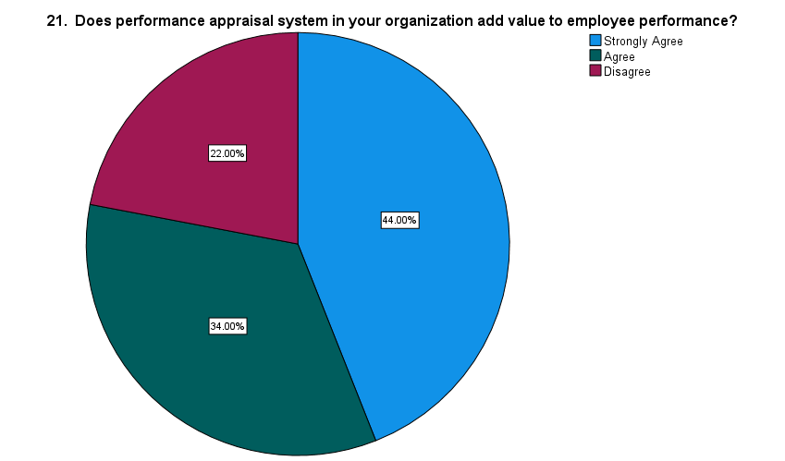

|  |  |  |  |  |  |
| --- | --- | --- | --- | --- | --- |
| **21. Does performance appraisal system in your organization add value to employee performance?** | | | | | |
|  | | Frequency | Percent | Valid Percent | Cumulative Percent |
| Valid | Strongly Agree | 44 | 44.0 | 44.0 | 44.0 |
| Agree | 34 | 34.0 | 34.0 | 78.0 |
| Disagree | 22 | 22.0 | 22.0 | 100.0 |
| Total | 100 | 100.0 | 100.0 |  |

**Inference:**

**The above table and chart states that, 59% of respondents Strongly Agree performance appraisal system in your organization add value to employee performance ,29% of respondents Agree and 12% of respondents Disagree and none of them would Strongly disagree.**

|  |  |  |  |  |
| --- | --- | --- | --- | --- |
| **22. Do you think Performance appraisal method used in my organization is easily understood by staff?** | | | | |
| Frequency | Percent | Valid Percent | Cumulative Percent |
| 59 | 59.0 | 59.0 | 59.0 |
| 29 | 29.0 | 29.0 | 88.0 |
| 12 | 12.0 | 12.0 | 100.0 |
| 100 | 100.0 | 100.0 |  |

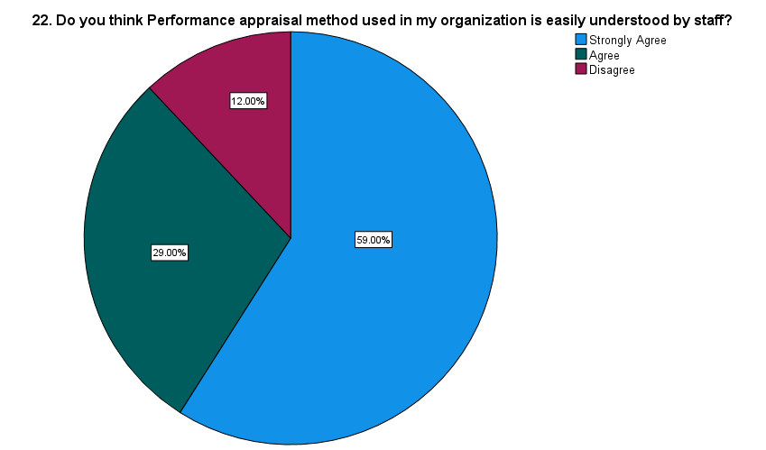

**Inference:**

**The above table and chart states that, 59% of respondents Strongly Agree that performance appraisal method used in my organization is easily understood by staff ,29% of respondents Agree and 12% of respondents Disagree and none of then would Strongly disagree.**

|  |  |  |  |  |  |
| --- | --- | --- | --- | --- | --- |
| **23. Do you think that performance appraisal system adopted in your organization is effective ?** | | | | | |
|  | | Frequency | Percent | Valid Percent | Cumulative Percent |
| Valid | Strongly Agree | 53 | 53.0 | 53.0 | 53.0 |
| Agree | 28 | 28.0 | 28.0 | 81.0 |
| Disagree | 18 | 18.0 | 18.0 | 99.0 |
| Strongly Disagree | 1 | 1.0 | 1.0 | 100.0 |
| Total | 100 | 100.0 | 100.0 |  |

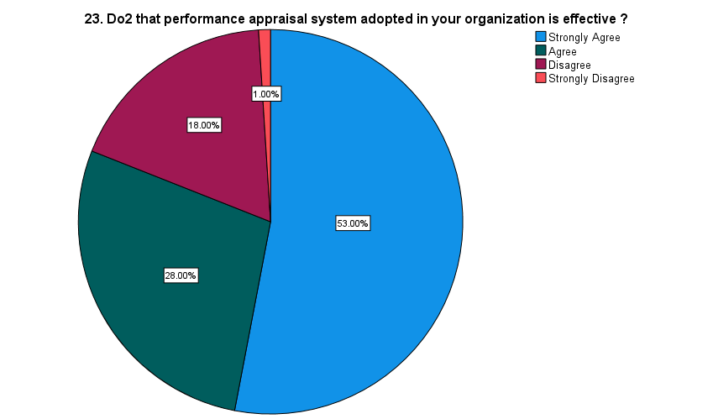

**Inference:**

**The above table and chart states that, 53% of respondents Strongly Agree that performance appraisal system adopted in your organization is effective ,28% of respondents Agree and 18% of respondents Disagree and only 1% of respondents strongly Disagree.**

|  |  |  |  |  |  |
| --- | --- | --- | --- | --- | --- |
| **12. Are staff able to express their grievances in the process of performance appraisal in the organization?** | | | | | |
|  | | Frequency | Percent | Valid Percent | Cumulative Percent |
| Valid | Strongly Agree | 52 | 52.0 | 52.0 | 52.0 |
| Agree | 32 | 32.0 | 32.0 | 84.0 |
| Disagree | 16 | 16.0 | 16.0 | 100.0 |
| Total | 100 | 100.0 | 100.0 |  |

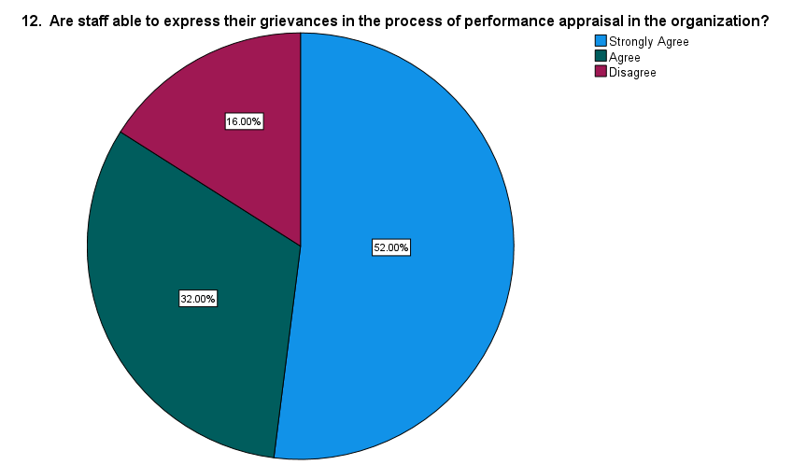

**Inference:**

**The above table and chart states that, 52% of respondents Strongly Agree that the staff able to express their grievances in the process of performance appraisal in the organization ,32% of respondents Agree and 16% of respondents Disagree and none of them would Strongly disagree.**

|  |  |  |  |  |  |
| --- | --- | --- | --- | --- | --- |
| **13. Do you agree that staff promotion is associated with performance appraisal process in the organization?** | | | | | |
|  | | Frequency | Percent | Valid Percent | Cumulative Percent |
| Valid | Strongly Agree | 60 | 60.0 | 60.0 | 60.0 |
| Agree | 31 | 31.0 | 31.0 | 91.0 |
| Disagree | 9 | 9.0 | 9.0 | 100.0 |
| Total | 100 | 100.0 | 100.0 |  |

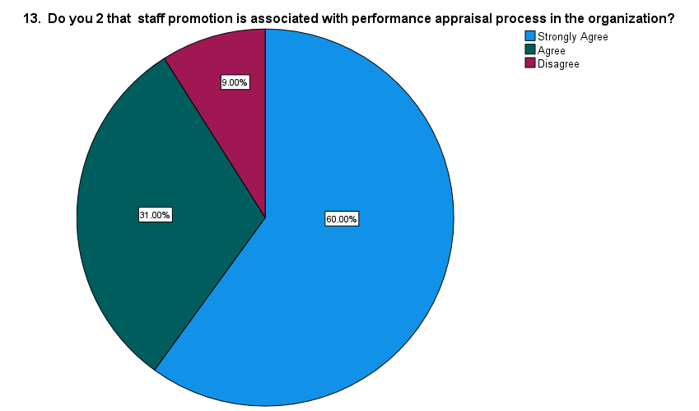

**Inference:**

**The above table and chart states that, 60% of respondents Strongly Agree that staff promotion is associated with performance appraisal process in the organization,31% of respondents Agree and 9% of respondents Disagree and none of then would Strongly disagree.**

**CHI-SQUARE :**

|  |  |  |
| --- | --- | --- |
| **Test Statistics** | | |
|  | 7. To what extent does performance appraisal feedback affect employee performance in the organization ? | 10. Does staff in your organization look forward to performance appraisal feedback ? |
| Chi-Square | 29.040a | 45.200a |
| df | 3 | 3 |
| Asymp. Sig. | .001 | .001 |
| a. 0 cells (0.0%) have expected frequencies less than 5. The minimum expected cell frequency is 25.0. | | |

**Inference:**

From the above table we find the significant value as .000 which is less than 0.05. hence, Ho is rejected and H1 is accepted.

**Therefore,** here is a significance difference between the major problems and actions took by the company.

**Correlation analysis**

Correlation analysis in research is a statistical method used to measure the strength of the linear relationship between two variables and compute their association. Simply put - correlation analysis calculates the level of change in one variable due to the change in the other.

To find out the significance relation between the organization achieve performance appraisal goals after the process and the performance appraisal method used in my organization is easily understood by staff.

Ho: There is no significance difference between frequency between the organization achieve performance appraisal goals after the process and the performance appraisal method used in my organization is easily understood by staff.

H1: There is a significance difference between between the organization achieve performance appraisal goals after the process and the performance appraisal method used in my organization is easily understood by staff.

|  |  |  |  |
| --- | --- | --- | --- |
| **Correlations** | | | |
|  | | 19. Do you 2 that the organization achieve performance appraisal goals after the process ? | 22. Do you think Performance appraisal method used in my organization is easily understood by staff? |
| 19. Do you 2 that the organization achieve performance appraisal goals after the process ? | Pearson Correlation | 1 | .268** |
| Sig. (2-tailed) |  | .007 |
| N | 100 | 100 |
| 22. Do you think Performance appraisal method used in my organization is easily understood by staff? | Pearson Correlation | .268** | 1 |
| Sig. (2-tailed) | .007 |  |
| N | 100 | 100 |
| **. Correlation is significant at the 0.01 level (2-tailed). | | | |

**Inference:**

From the above table, we find that the significant value is 1.268, which is greater than table value 0.05, so the Null hypothesis is rejected and Alternative hypothesis is accepted. Therefore, There’s a significance difference between the organization achieve performance appraisal goals after the process and the performance appraisal method used in my organization is easily understood by staff.

**ONE WAY ANNOVA**

|  |  |  |  |  |  |  |
| --- | --- | --- | --- | --- | --- | --- |
| **ANOVA** | | | | | | |
|  | | Sum of Squares | df | Mean Square | F | Sig. |
| 13. Do you 2 that staff promotion is associated with performance appraisal process in the organization? | Between Groups | .629 | 2 | .315 | .721 | .489 |
| Within Groups | 42.361 | 97 | .437 |  |  |
| Total | 42.990 | 99 |  |  |  |
| 15.Do you 2 that the organization training policy linked to performance appraisal goal? | Between Groups | 2.526 | 2 | 1.263 | 2.160 | .121 |
| Within Groups | 56.714 | 97 | .585 |  |  |
| Total | 59.240 | 99 |  |  |  |
| 18. Does Performance appraisal goals are well documented in HR Policies ? | Between Groups | 1.575 | 2 | .787 | 1.172 | .314 |
| Within Groups | 65.175 | 97 | .672 |  |  |
| Total | 66.750 | 99 |  |  |  |

**INFERENCE :**

**From the anova analysis it is found that the difference value of .489 is greater the table value 0.5, the null hypothesis is accepted. Therefore, there is no significance difference between the staff able to express their grievances in the process of performance appraisal in the organization and that staff promotion is associated with performance appraisal process in the organization.**

**From the anova analysis it is found that the difference value of .121 is greater the table value 0.5, the null hypothesis is accepted. Therefore, there is no significance difference between staff able to express their grievances in the process of performance appraisal in the organization and the organization training policy linked to performance appraisal goal.**

**From the anova analysis it is found that the difference value of .314 is greater the table value 0.5, the null hypothesis is accepted. Therefore, there is no significance difference between staff able to express their grievances in the process of performance appraisal in the organization and Performance appraisal goals are well documented in HR Policies.**

**FINDINGS:**

According to this survey, Majority of the respondents are Male. Majority of the respondent is in the age group of 30 to 40.Majority respondents income Belongs to above 40,000.Majority respondents belongs to Doctors .Majority respondents Educational qualification Belongs to Post Graduate and the least respondents Belongs to PHD’s.Majority respondents say that performance appraisal feedback affect employee performance in the organization and none of them say it is at a Very Great extent.Majority respondents Strongly Agree that performance appraisal have impact on employee performance in your organization. Majority respondents Strongly Agree Performance appraisal feedback is used for improving staff performance.Majority of respondents Strongly Agree that staff in our organization look forward to performance appraisal feedback.Majority the respondents Says YES that they think the current appraisal method affect employee performance at the Organization.Majority respondents Strongly Agree that the staff able to express their grievances in the process of performance appraisal in the organization.Majority respondents Strongly Agree that staff promotion is associated with performance appraisal process in the organization.Majority respondents say that performance appraisal goal affect employee performance at the organization Very Great extent.Majority of respondents Strongly Agree performance appraisal goal identify staff training needs in your organization.Majority of respondents Strongly Agree performance appraisal goal identify staff training needs in your organization.Majority of respondents Strongly Agree performance appraisal goal identify staff training needs in your organization.Majority respondents Strongly Agree Performance appraisal goals are well documented in HR Policies.Majority respondents Strongly Agree that the organization achieve performance appraisal goals after the process.Majority respondents Strongly Agree that the organization achieve performance appraisal goals after the process.Majority respondents Strongly Agree performance appraisal system in your organization add value to employee performance.Majority of respondents Strongly Agree that performance appraisal method used in my organization is easily understood by staff.Majority of respondents Strongly Agree that performance appraisal system adopted in your organization is effective.

**SUGGESSIONS:**

1. The majority of respondents fall within the age group of 30 to 40. Future studies could consider targeting a wider range of age groups to gain insights into how different age demographics perceive performance appraisal. Although the majority of respondents have an income above 40,000, it would be valuable to also include respondents from diverse income brackets to understand how income levels may influence perceptions of performance appraisal.While it's noted that the majority of respondents are doctors, future studies could include a broader range of occupations within the healthcare sector to capture varied perspectives on performance appraisal.Although the majority of respondents have post-graduate qualifications, ensuring representation from respondents with different educational backgrounds, including PhDs, can provide a more comprehensive understanding of how education levels may impact perceptions of performance appraisal.While it's noted that the majority of respondents believe performance appraisal feedback affects employee performance, further qualitative exploration could provide insights into specific ways in which feedback influences behavior and performance.While it's stated that the majority of respondents strongly agree that performance appraisal goals are well-documented in HR policies, it would be beneficial to ensure clear and accessible documentation to enhance transparency and understanding among employees.

Conclusion:

The findings of this study indicate a strong consensus among respondents regarding the importance and effectiveness of performance appraisal at Tagore Medical Hospital. The majority of respondents perceive performance appraisal feedback to have a significant impact on employee performance and believe that the appraisal process contributes positively to staff development and organizational goals. Overall, the results of this study underscore the significance of performance appraisal in fostering employee development, improving organizational performance, and maintaining a culture of accountability and transparency within Tagore Medical Hospital. Moving forward, recommendations for enhancing diversity in respondent demographics and further qualitative exploration of feedback impact can enrich future studies on performance appraisal practices in healthcare settings.

Top of Form