Strength characteristics of recycled concrete aggregate with addition of steel fibres

**Raman1,Tinku Biswas2, Kirokul Kikhi3**

1 (M.tech Scholar) 2nd year, Department of Civil Engineering, Ganga Institute of Technology and Managements, Jhajjar Haryana (India)

2Associate Professor, Department of Civil Engineering, Ganga Institute of Technology and Managements, Jhajjar Haryana (India)

3(M.tech Scholar) 2nd year, Department of Civil Engineering, Ganga Institute of Technology and Managements, Jhajjar Haryana (India)

# ABSTRACT

***We know development exercises request a lot of regular materials to deliver concrete and total. Acquisition of these normal materials essentially alters the regular sources and makes major ecological issues. Moreover, maintainable waste administration is one more significant issue looked by nations from one side of the planet to the other. To limit the natural effect and energy consistency of cement utilized for development offices, reuse of development and destruction squanders can be a valuable way which prompts manageable designing ways to deal with substantial blend plan. The reused substantial total has a few properties like the normal totals yet the strength is not exactly the regular totals. So the strength of cement made, reused substantial totals is improved by the expansion of certain added substances. In this study steel filaments are included cement with reused cement to build the functionality of the substantial at a similar water-concrete proportion, furthermore, to increment in compressive, pliable and flexural strength of the substantial.***

***Keywords—*** *Recycle concrete aggregate, Steel fibre, Compressive strength, Split tensile strength, Flexural strength*

## INTRODUCTION

Concrete is the most well-known and helpful material in the development business and has added to the progression of civilizations over the past hundred years. In any case, development exercises request a lot of regular materials to deliver concrete and total. Obtainment of these regular materials altogether changes the normal sources and makes major ecological issues. Besides, economical waste administration is one more significant issue looked by nations everywhere. To limit the natural effect and energy consistency of cement utilized for development offices, reuse of development and destruction squanders can be a gainful way which prompts economical designing ways to deal with substantial blend plan. As many agricultural nations all around the world are reusing and reuse region choices to limit the effect of energy and natural substance utilization on the climate, one more waste that can be possibly utilized for substantial creation is reused substantial total acquired by means of development and destruction squander.

Economical advancement of the concrete and substantial industry requires the usage of modern waste parts. As of now, for various reasons, the substantial development industry isn't maintainable. First and foremost, it consumes colossal amounts of virgin materials which can stay for next ages. Besides, the vital fastener in concrete is Portland concrete, the development of which is a significant supporter of ozone harming substance emanations that are ensnared in an Earth-wide temperature boost and environmental change. Thirdly, many substantial designs experience the ill effects of an absence of solidness which might squander the regular assets. In this way, tracking down an answer for substitute a viable reused item for a piece of the concrete is by all accounts alluring for supportable turn of events. The use as a mineral admixture to somewhat supplant concrete could protect the non-inexhaustible assets expected for the development of concrete, and could some way or another add to practical development.

The reused substantial total has a few properties like the regular totals yet the strength is not exactly the normal totals. We can utilize the modern side-effect somewhat, which doesn't influence the new and solidified properties of the substantial and gives the comparative outcome as ordinary cement.

An enormous number of investigates have been coordinated toward the use of waste materials. To build the solidness of the substantial made with reused substantial totals, admixture and fiber can be utilized, the admixture expands the functionality of the substantial at a similar water-concrete proportion, though the fiber increment compressive, ductile and flexural strength of the substantial. The necessary sturdiness qualities are more hard to characterize than the strength qualities, determination frequently utilizes a blend of execution and prescriptive necessities, like usefulness, compressive strength, Split elasticity, flexural strength, and water-concrete material proportion to accomplish a solid cement. The outcome might be a high strength concrete, however this main comes as a development and destruction misuse of requiring a sturdy cement.

### Objectives

The fundamental goal is to concentrate on the impacts of fractional supplanting of normal totals with reused totals and expansion of steel fiber, and to look at its compressive, elasticity flexural strength with standard M30 concrete. This exploratory concentrate likewise finds the ideal level of normal totals that can be somewhat supplanted with reused totals relating to least cost. Reused totals are gotten from old wrecked cement and make them of the size of 20mm utilizing a sledge. To some extent supplanting of normal totals with reused totals and adding an alternate level of steel fiber were finished. It additionally brings about minimal expense of cement.

The objectives of the study are:

* To study the influence of partial replacement of coarse aggregates with recycled aggregates and addition of a different percentage of steel fiber on the compressive strength, tensile strength & flexural strength of grade M30 concrete.
* Determines the optimum percentage replacement of coarse aggregates with recycled aggregates corresponding to minimum cost.
* To develop environment-friendly concrete.
* Durability analysis of concrete i.e. standard grade M30 concrete and concrete having a partial replacement of coarse aggregates with recycled aggregates and steel fibers.

## MATERIAL AND METHODOLOGY

### Material used

* + 1. **Cement:** Ordinary Portland cement of grade 43 is adopted for this work. The brand of cement used was Shree ultra-tech OPC with grade 43. The cement was gray and free from lumps.
    2. **Aggregates:** In this research work fine aggregates used was river sand, coarse aggregates used were crushed stones (natural and recycled course aggregate according to concrete mix. design). These materials were easily available from the local market.
    3. **Fine Aggregates:** In this research the fine aggregates that are used is the river sand.
    4. **Coarse Aggregates:-**Locally available crushed stone aggregates of 20 mm nominal maximum size were used as coarse aggregate.
    5. **Recycle Concrete Aggregates (RCA):** For my experimental program, I have used old demolished concrete and make its size to 20mm using a hammer. The recycled concrete aggregate has similar properties as that of natural aggregates, but water absorption is more in case of recycled aggregates. The specific gravity of recycled aggregates is found to be less than the specific gravity of natural aggregates.
    6. **Corrugated Steel Fibres:** For increasing the strength of the recycled concrete I have used corrugated steel fibers which I purchased from STEWOLS INDIA (P) LTD.5-8B, Nagpur. As the workability of concrete decreases with the addition of long length fiber, I have used 25 mm length corrugated steel fiber and having 1mm dia. in section.
    7. **Admixture:** For my experimental program I have used Master Glenium SKY 8630, it is an admixture based on modified polycarboxylic ether. This admixture has been developed for applications in high-performance concrete where the more durability and performance is required. Master Glenium SKY 8630 is free of chloride & low alkali. It can be used with all types of cement.
    8. **Water:** The water used was the potable water as supplied in the Concrete technology laboratory of our Institute. Water used for mixing should be clean and free from injurious amounts of acids, oil, alkalis’, salts and sugar, organic materials or other substances that may be deleterious for the concrete. As per IS: 456-2000 potable water should be used for curing and mixing of concrete. So potable water was used for the preparation of all concrete specimens.

### Concrete Mix Design Material Details

Cement Used = OPC 43 Grade Specific Gravity of Cement = 3.24 Fineness (Specific Surface %) = 9

Fineness Modulus Fine Aggregate = 2.57

Fineness Modulus Course Aggregate = 6.55 Specific Gravity of Coarse Aggregate = 2.64 Water absorption Course Aggregate % = 0.81

Bulk density (loose) Course Aggregate Kg/m3 = 2.7 Fineness Modulus Recycle Aggregate = 6.41 Specific Gravity Recycle Aggregate = 2.7

Water absorption (%) Recycle Aggregate = 4.5

### Properties of Fibre

Length of Fiber = 25mm Diameter = 1mm Aspect ratio = 25 Shape = Corrugated Corrugated = Fe-415

### Mix Proportion

**Table 1: Design mix. Concrete use replacement in RCA and Steel fibres are below percentage.**

|  |  |  |  |
| --- | --- | --- | --- |
| **RCA\Steel fibre** | **0%** | **0.5%** | **1%** |
| **0%** | M 1 | M 2 | M 3 |
| **50%** | M 4 | M 5 | M 6 |
| **100%** | M 7 | M 8 | M 9 |

### Concrete Mix Design (M30)

Design Stipulations

(1) Characteristic comp. strength required

Test Data for Materials

1. Specific Gravity of Cement = 3.15

In the field at 28 days = 30 MPa Level of quality control = Good

1. Comp. Strength of Cement at 7 days satisfies the requirement of Indian standard

Assume standard Deviation = 5

Mean Target strength = 30+1.65 X 5=38.25 MPa

## RESULT AND DISCUSSION

* 1. The **compressive strength** test was conducted at curing ages of 7 and 28 days. The average compressive strength test results of all the mixes at different curing ages are shown in Table 2.

### Table 2: Average compressive strength at 7 and 28 Days

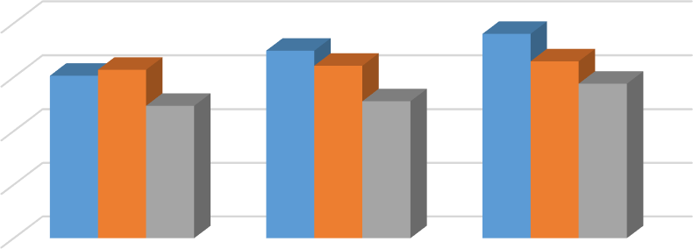

40

30.26

31.36

30

24.68

34.9

32.11

25.52

38.02

32.93

28.77

20

10

0

0% Steel Fibre

0.5% Steel Fibre

1.0% Steel Fibre

RECYCLE AGGREGATE (%AGE)

0% RCA 50%RCA 100%RCA

|  |  |  |  |
| --- | --- | --- | --- |
| **S. no** | **Mix ID** | **Compressive strength** | |
| **7 days** | **28 days** |
| 1 | M 1 | 30.26 | 40.25 |
| 2 | M 2 | 34.9 | 45.02 |
| 3 | M 3 | 38.02 | 47.17 |
| 4 | M 4 | 31.36 | 32.37 |
| 5 | M 5 | 32.11 | 36.68 |
| 6 | M 6 | 32.93 | 38.85 |
| 7 | M 7 | 24.68 | 29.98 |
| 8 | M 8 | 25.52 | 31.74 |
| 9 | M 9 | 28.77 | 32.77 |

**Fig. 1: Effect of adding RCA on 7 days compressive strength**

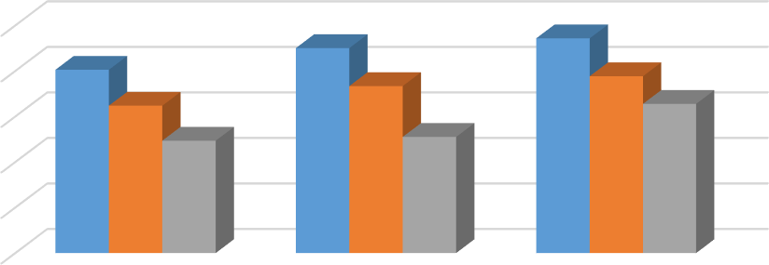

50

45.02

47.17

40.26

36.68

38.85

40

32.37

32.77

30

24.68

25.52

20

10

0

0% Steel Fibre

0.5% Steel Fibre

1.0% Steel Fibre

RECYCLED AGGREGATES (%age)

0% RCA 50%RCA 100%RCA

COMPRESIVE STRENGTH

(Mpa)

COMPRESSIVE STRENGTH

(Mpa)

### Fig. 2: Effect of adding RCA on 28 days compressive strength

The above results show that compressive strength decreases with the increase of partial replacement of coarse aggregates with recycled aggregates. And an increase in compressive strength was observed as the percentage of steel fiber increases.

* 1. The **splitting tensile strength** test was conducted at curing ages of 7 and 28 days. The average splitting tensile strength test results of all the mixes at different curing ages are shown in Table 3.

### Table 3: Average tensile strength at 7 and 28 Days

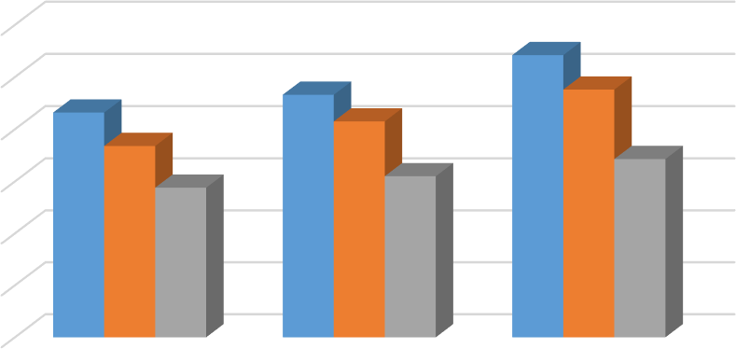

6

5.42

4.66

4.76

5

4.32

4.15

3.68

4

3.43

2.88

3.1

3

2

1

0

0% Steel Fibre

0.5% Steel Fibre

1.0% Steel Fibre

RECYCLED AGGREGATES (%age)

0% RCA 50%RCA 100%RCA

SPLIT TENSILE STRENGTH (Mpa)

|  |  |  |  |
| --- | --- | --- | --- |
| **S.**  **no.** | **Mix ID** | **Tensile strength** | |
| **7 days** | **28 days** |
| 1 | M 1 | 4.32 | 5.48 |
| 2 | M 2 | 4.66 | 6.48 |
| 3 | M 3 | 5.42 | 6.72 |
| 4 | M 4 | 3.86 | 5.41 |
| 5 | M 5 | 4.15 | 5.75 |
| 6 | M 6 | 4.76 | 6.23 |
| 7 | M 7 | 2.88 | 4.27 |
| 8 | M 8 | 3.10 | 3.86 |
| 9 | M 9 | 3.43 | 3.37 |

**Fig. 3: Effect of adding RCA on 7 Days Split tensile strength**

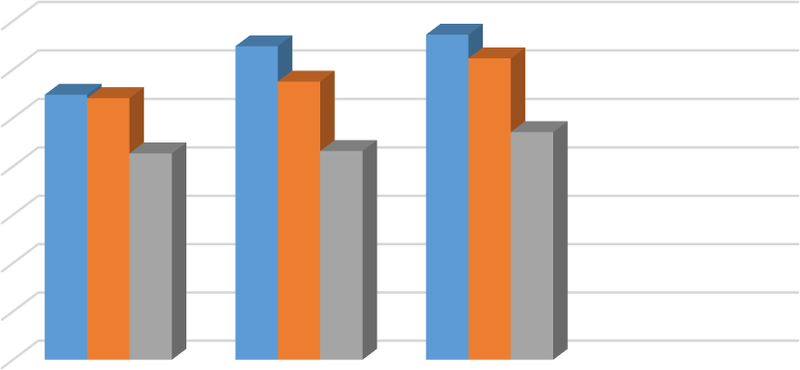

7

6.48

6.72

6.23

5.75

6

5.485.41

5

4.27

4.32

4.71

4

3

2

1

0

0% Steel Fibre 0.5% Steel Fibre 1.0% Steel Fibre

RECYCLE AGGREGATE (%AGE)

0% RCA 50%RCA 100%RCA

SPLIT TENSILE STRENGTH (Mpa)

### Fig. 4: Effect of adding RCA on 28 days Split tensile strength

The above results show that split tensile strength decreases with the increase of partial replacement of coarse aggregates with recycled aggregates. And an increase in split tensile strength was observed as the percentage of steel fibre increases.

* 1. The **Flexural strength test** was conducted at curing ages of 28 and 56 days. The average flexural strength test results of all the mixes at different curing ages are shown in Table 4.

### Table 4: Average flexural strength at 28 and 56 days

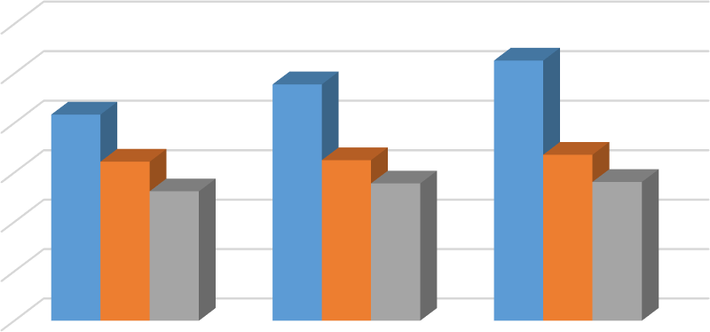

6

5.26

4.78

5

4.17

4

3.22

3.25

3.36

3

2.62

2.78

2.81

2

1

0

0% Steel Fibre

0.5% Steel Fibre

RECYCLE AGGREGATE (%age)

1.0% Steel Fibre

0% RCA 50%RCA 100%RCA

FLEXURAL STRENGTH (Mpa)

|  |  |  |  |
| --- | --- | --- | --- |
| **S. no** | **Mix ID** | **Flexural strength (Mpa)** | |
| **28 days** | **56 days** |
| 1 | M 1 | 4.17 | 5.23 |
| 2 | M 2 | 4.78 | 6.35 |
| 3 | M 3 | 5.26 | 6.40 |
| 4 | M 4 | 3.22 | 4.68 |
| 5 | M 5 | 3.25 | 5.85 |
| 6 | M 6 | 3.36 | 5.73 |
| 7 | M 7 | 2.62 | 4.10 |
| 8 | M 8 | 2.78 | 4.20 |
| 9 | M 9 | 2.81 | 3.78 |

**Fig. 5: Effect of adding RCA on 28 days flexural strength**

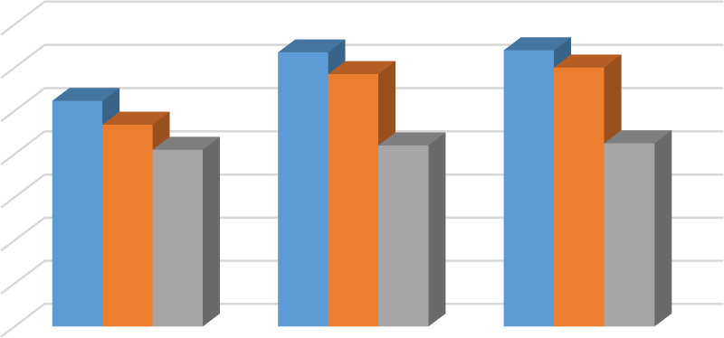

7

6.35

6.4

5.85

6

6

5

5.23

4.68

4.1

4.2

4.25

4

3

2

1

0

0% Steel Fibre

0.5% Steel Fibre

RECYCLE AGGREGATE (%age)

1.0% Steel Fibre

0% RCA 50%RCA 100%RCA

FLEXURAL STRENGTH (Mpa)

### Fig. 6: Effect of adding RCA on 56 days flexural strength

The above results show that flexural strength decreases with the increase of partial replacement of coarse aggregates with recycled aggregates. And an increase in split tensile strength was observed as the percentage of steel fibre increases. 50% replacement of RCA with NA gives similar flexural strength as normal concrete.

**Result**: Hence we can make 50% replacement OF NCA with RCA and addition of 1.0% steel fibers.

## CONCLUSION

* As the replacement of Natural aggregates by RCA in concrete mix increase, the workability of the concrete mix was found to decrease as compared to control mix and the additional of steel fibres into the concrete mix also decrease the workability.
* The addition of RCA in concrete mix there is reduction in the compressive strength at 50% as compare to control mix whereas further addition of RCA at 100% decrease the compressive strength inclusion of steel fibres into concrete mixes increases the compressive strength at 0.5% fibres content as compared to the control mix whereas further addition of fibre at 1% with RCA there is small increase in the compressive strength for all mixes as compared to control mix.
* The incorporation of RCA in the concrete mix was found to decrease in the split tensile strength at 50% and 100% replacement whereas slightly increases when amount 0.5% reinforced with steel fibres but was more than control mix into concrete mixes increases the splitting tensile strength and was maximum at 1% steel fibre content for all concrete mixes.
* The inclusion of RCA and fibre into the concrete mix gives same splitting tensile strength as compared to the control mix.
* Recycled and reuse of building waste has been found to be an appropriate solution to the problems of dumping hundreds of thousands of tons of debris accompanied by a shortage of natural aggregates.

## SCOPE FOR FUTURE RESEARCH WORK

Based on the present trend of using recycled aggregates in concrete, the possibility of research in the following areas can be explained.

* To promote sustainable development in the protection of natural resources and reduces the disposal of demolition waste from old concrete.
* Durability properties such as compressive strength, tensile strength, and flexural strength can be increased using steel fibre at different proportion.

## REFERENCES

1. Ajdukiewicz, A., (2012) “Influence of recycled aggregates on mechanical properties of HS/HPC”. Cement and concrete composite. Vol-24, pp 2691-2791.
2. Butter, L., (2021) “the effect of recycled concrete aggregates properties on the bond strength between RCA. Concrete & Steel Reinforcement”. Cement & concrete research. Vol-41, pp 10371-10491.
3. Carneiro, J., (2014) “Compressive Stress- strain Behavior of steel fibre reinforced-recycled aggregate concrete”. Cement & concrete composite. Vol-46, pp 651-721.
4. Conrinaldesi, V., (2010) “Mechanical and elastic behavior of concrete made of recycled-concrete coarse aggregates”. Construction & building material. Vol-24, pp 16161-16201.
5. Chai, C.W. & Yun, H.P, (2023) “long term deflection & flexural behavior of recycled concrete beam with recycled aggregates”. Materials & design. Vol-51, pp 7421-7501.
6. Dong, J.F., (2013) structural behavior of recycled aggregates filled steel tube”. Engineering Structures. Vol-48, pp 5321-5421.
7. Erdam, S., (2021) “Microstructure linked strength properties and impact response of conventional & recycled concrete reinforced with steel & synthetic macro-fibres”. Construction & building materials. Vol-25, pp 40251-40361.
8. Faithifozl, G., (2011) “Stress capacity evaluation of steel reinforced recycled concrete beams”. Engineering structures. Vol-33, pp 10251-10331.
9. Gull, I., (2011) “The strength of recycled waste concrete and its application”. Journal of construction Engineering & Management. Vol-137, pp 10-15.
10. Gabr, A.P., (2012) “properties of fresh & hardened concrete”. Journal of materials in Civil Engg. Vol-24, pp 4941-4981.
11. Kou, S.C., & Poon. C.S. (2022) “the durability properties of concrete prepared with coarse recycled aggregates”. Construction & building Materials. Vol-29, pp 3681-3771.
12. Kumar, P., and Dhinakaran, G., (2022) “The effect of admixture recycled aggregate concrete on properties of fresh and hardened concrete”. Journal of materials in civil engineering. Vol-24, pp 4941-4981.
13. Katz, A., (2003) “Properties of concrete made with recycled aggregates from partially hydrated old concrete”. Cement and concrete research. Vol-33, pp 7031-7111.
14. Kim, S., & Yun, H., (2023) “influence of recycled coarse aggregates on the bond behavior of deformed bars in concrete”. Engineering structures. Vol-48, pp 133-143.
15. Levy, S. & Helene, P., (2014) “Durability of recycled aggregates concrete a safe way to sustainable development” Cement and concrete research Vol-34..
16. Malesev, M., (2017) “the compressive stresses depend on the quality of recycled concrete aggregates for all load phases”. Cement & concrete composite. Vol-27, pp 197-191.