A COMPARATIVE ECONOMICAL ANALYSIS ON RCC AND PRESTRESS CONTINUOUS BEAM OF SPAN 6 M TO 24 M

**Kirokul Kikhi 1, Bhupender Malik2, Raman3**

1 (M.tech Scholar) 2nd year, Department of Civil Engineering, Ganga Institute of Technology and Managements, Jhajjar Haryana (India)

2Associate Professor, Department of Civil Engineering, Ganga Institute of Technology and Managements, Jhajjar Haryana (India)

3(M.tech Scholar) 2nd year, Department of Civil Engineering, Ganga Institute of Technology and Managements, Jhajjar Haryana (India)

# ABSTRACT

In this post, I'll contrast the costs of R.C.C. and pre-stressed concrete beams. This project designs and estimates RCCC beams and post-tensioned beams with spans ranging from 6 to 24 meters. In order to compare the results, this endeavor will design and estimate pre-stressed concrete and R.C.C. beams with 6 to 24 m spans. The objective is to make a clear decision regarding which of the two methods is superior to the other. The main objective of this work was to investigate the deflection, initial load carrying capacity, ultimate load carrying capacity, and flexural behavior of RCC and post-tensioned beam. The entire construction industry is entering a new era as a result of increased innovation in concrete and prestressed members. A study has been conducted to examine how prestressing affects load carrying ability. flexural Post-tensioned beam behavior.

**KEYWORDS:** RCC Beam, Prestress Continous Beam, STAAD Pro.

# INTRODUCTION

Through the method of prestressing, known permanent stresses can be created in a structure or member prior to the application of the full or live load. By mechanically fastening the member to the high-tensile strands, wires, or rods under tension, these stresses are produced.

Using the staad.pro software program, research was done on the traditional RCC and prestressing methods for designing beams to learn more about them and compare them. Pretensioning and post tensioning are two different ways to construct with prestressed concrete, based on the structure's design elements, techniques of applying prestress, and intended use. As a result, this beam, which is simply supported and has a span of at least 6 meters, is designed to accommodate both unusual approaches. Additionally, efforts were made to concentrate design economics research so that higher-quality structures may be built within the constraints of Indian Standard Design Codes of Practice IS:1343-2012 and IS:456-2000.

# METHODOLOGY

First, a R.C.C. beam was manually constructed using the limit state methodology of IS: 456-2000. Based on the processes and formulas employed, a design software called Staad.pro was developed. The program's validity was investigated by first using it to create the manually made beams and then comparing the results. The grade of concrete was maintained at M: 40 even though a mix richer than M: 40 is rarely used in the pitch for RCC.

Beams made of prestressed concrete received the same treatment. The manual design was based on the limit state method suggested by IS: 1343-1980. Because prestressing was the main consideration, the beams were built for concrete grades M 40. The design only made use of the most typical straight wire profile. Only rectangular pieces were assessed. Additionally, costing and estimating software was developed. Prices in the public works division of Chhattisgarh are based on the most recent CGSOR-2015. A prominent private infrastructure company provided some of the prestress concrete rates for the project.

**Table-1:** Concrete mix proportion

|  |  |  |  |
| --- | --- | --- | --- |
| **Type of Concrete** | **Cement** | **Sand** | **Coarse Aggregate** |
| **Normal RCC beam** | 1 | 2.56 | 3.25 |
| **Prestressed beam** | 1 | 1.36 | 2.77 |
| **Poststressed beam** | 1 | 1.36 | 2.77 |

# DESIGN PROCEDURE

## 1. Design procedure for conventional RCC simply supported beam of span of 6m, 12m, 18m and 24m -

**1. STEP 1 (Creation of Geometry):**

New Project → Select Plane → Length =meters; Force=KN; File Name=Plane 1 → Next

Select  Open Structure Wizard → Finish.

Change to Frame Models from Truss models → Select Continuous beam and double click on it.

Length=6.0m-24m  Click

(according to the requirement span may change from 6m, 12m, 18m and 24m ) No. of bays (Span) =1

Apply → Transfer model → Click yes → OK→ Go to Front view icon (first view)

## STPE 2 (Member Properties):

Select the member → From Main menu → Commands → Member Property → Prismatic →Rectangular YD=

0.4 ZD= 0.3 → Assign → Close. De select the member.

## STEP 3 (Supports):

Change to Node cursor (joint) and select the nodes (joints) .

(if more than one node use CTRL key and select the nodes) → From Main menu → Commands → Support specification → Pinned → Assign → Close → De select the nodes and change to beam cursor.

## STEP 4 (Loading ):

From Main menu → Commands → Loading → Primary Load →Load case 1 dead load→ Add → Close → Select Load case 1 dead load→ Add →self weight -1 KN/m → Add → Close Assign to selected beam → Assign → OK

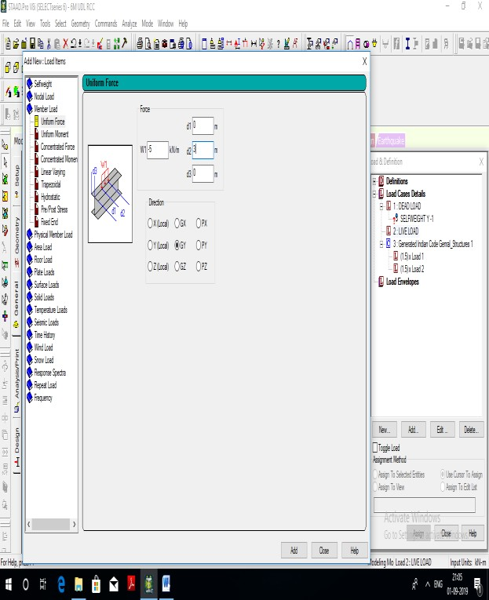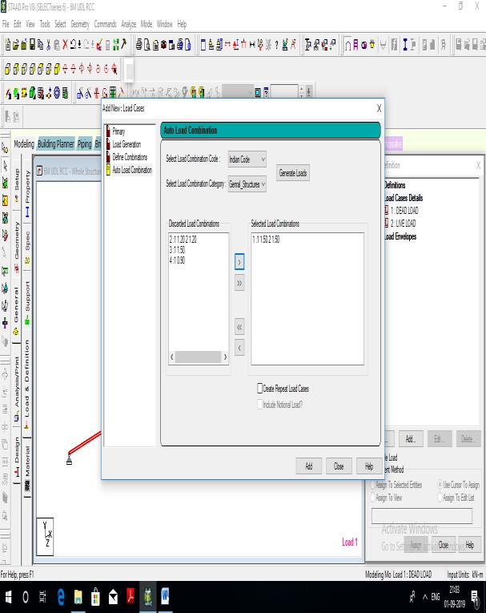

.

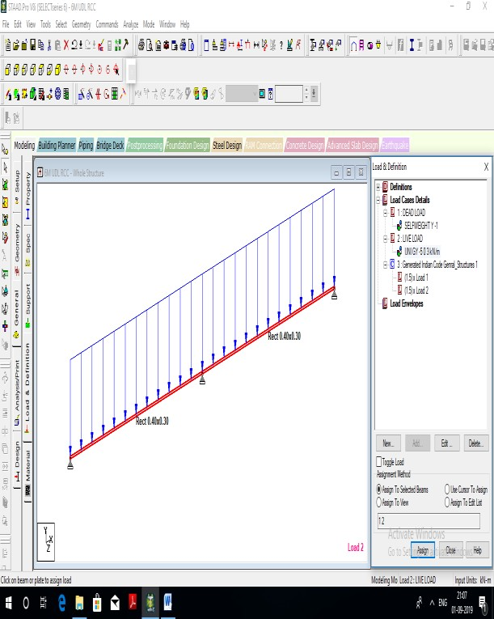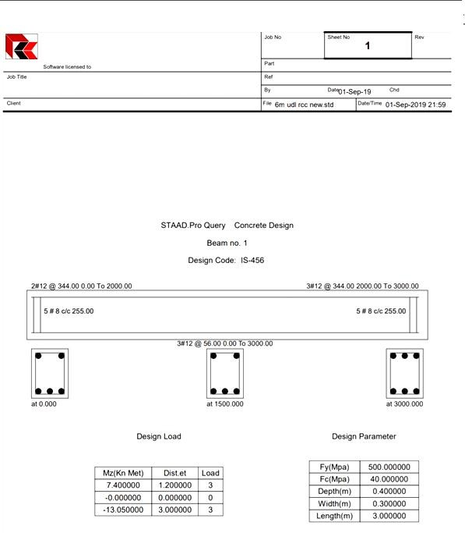

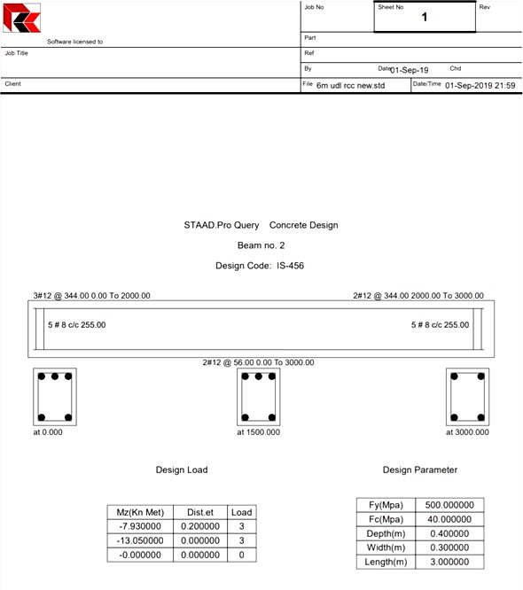 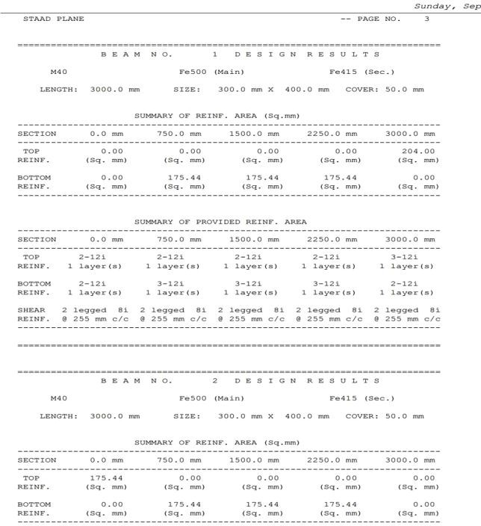

## STEP 5( Analysis ):

From Main menu → Commands – Analysis → Perform Analysis → No print → OK.

## STEP 6 (Postprocessing Print):

From Main Menu → Commands → Post Analysis Print → Support Reactions →

* To view → OK.

## STEP 7( Design) :

From Main menu → Commands → Design → Concrete Design → Current code=IS 456 → From Main menu →

Tools → Set current input unit Length =mm; Force = N → OK.

→Select the member → Define parameters FC =40 → Assign

FYMAIN= 500 → Assign FYSEC =415 → Assign

CLEAR COVER = 50 →Assign Close.

De select all members and select beam member only→ Commands (Concrete Design) → Design beam →

Assign → Close → Take off → Assign → Close. Note: Save the File and Run the Program.

## STEP 8 (Analysis):

From Main Menu → ` Analysis → Run Analysis → Run Analysis → Done Select the member and double click on it →Shear bending → Close.

# RESULTS AND DISCUSSION

This thesis' main objective is to precisely calculate the concrete mix ratio for a 0.3x0.4m beam made of M-40 grade. The span varies between 6 and 24 meters. The second objective is to design the beam using the staad.pro application and to estimate the costs associated with each type and size.

Comparing the cost requirements for a typical RC beam, a prestressed concrete beam, and a post-stressed concrete beam is the third most crucial goal. Continuous type beams with three hinged supports at the end and mid span are one form of beam.

Using IS 456:2000, IS 10262:2009, and IS 1343:1987, you may calculate the mix proportion of grade M 40 concrete to achieve the first goal. The mix proportions of M 40 grade concrete for typical RCC concrete beams can be designed utilizing the IS 456:2000 and IS 10262:2009 specifications. In compliance with Indian standard requirements, various design specification data are obtained, such as environmental exposure norms. This thesis develops concrete for incredibly exposed situations. This is the precise design process that IS 10262:2009 describes.

Similar formulas are used to determine the mix proportion for prestressed concrete by IS 1343:1987, IS 10262:2009, and IS 456:2000. The design of a beam with a continuous character is the second goal. Software called staad.pro is used to design this beam. All of the variables, including load, span length, beam size, and material qualities, are held constant to allow for an effective comparison. In methodology, concrete design methods are described.

The third and fourth most important objectives are the analysis of cost requirements for various spans and beam diameters and the comparison of cost requirements with bending moment capacity, shear force, and deflection. The Chhattisgarh Public Work Department's schedule of rate 2015 (SOR:2015) is used to calculate the design data that are received after the beam has been designed using the staad.pro tool. Each item's price is established using the CGPWD rate book.

Bending moment, shear force and deflection are also calculate for different span according to result obtained from staad.pro.

All the design data and cost comparison are discussed below for different span-

**Overall Result**

**Table-2:** Cost required for different types of beam of different span

|  |  |  |  |  |
| --- | --- | --- | --- | --- |
| **Cost /span** | **6m** | **12m** | **18m** | **24m** |
| **RCC** | 7366.18 | 14683.89 | 28715.45 | 42504.68 |
| **Prestress concrete** | 6584.53 | 13133.73 | 19700.6 | 26267.48 |
| **Post-stress concrete** | 7164.9 | 14349.81 | 25174.59 | 33644.6 |

**Graph-1:** Cost analysis for 6 m span **Graph-2:** cost analysis for 12 m span

**COST ANALYSIS FOR 6**

**M SPAN**

8500

8000

7500

7000

6500

6000

CONCRETE

**COST ANALYSIS FOR**

**12M SPAN**

16500

16000

15500

15000

14500

14000

13500

13000

12500

12000

RCC

PRESTRESSED POSTSTRESSED

6706.627

7410.454

7937.796

15875.566

POSTSTRESSE D

15432.95

PRESTRESSED

13526.94

RCC

CONCRETE

**COST (IN RUPEES)**

**COST (IN RUPEES)**

# COST ANALYSIS FOR 18 M SPAN

25875.35

POSTSTRESSE D

25878.35

PRESTRESSED

23891.01

RCC

CONCRETE

44607.464

POSTSTRESSED

44607.464

PRESTRESSED

43088.568

RCC

CONCRETE

26500

**COST (IN RUPEES)**

26000

25500

25000

24500

24000

23500

23000

22500

# COST ANALYSIS FOR 24 M SPAN

45000

**COST (IN RUPEES)**

44500

44000

43500

43000

42500

42000

**Graph-3:** Cost analysis for 18 m span **Graph-4:** Cost analysis for 24 m span

**Table-3:** Maximum and Minimum Bending Moment

|  |  |  |  |  |  |
| --- | --- | --- | --- | --- | --- |
| **Span** | **At end support (KNM)** | **At centre in span 1 (KNM)** | **At middle support (KNM)** | **At centre in span 2 (KNM)** | **At end support (KNM)** |
| **6 m** | 0 | -6.684 | 13.65 | -6.684 | 0 |
| **12m** | 0 | -26.458 | 52.674 | -26.458 | 0 |
| **18m** | 0 | -59.520 | 118.717 | -59.520 | 0 |
| **24m** | 0 | -105.751 | 211.178 | -105.751 | 0 |

**Table-4:** Shear Force at Various Point

|  |  |  |  |  |  |  |
| --- | --- | --- | --- | --- | --- | --- |
| **Span** | **For span 1** | | | **For span 2** | | |
| **At end support (KN)** | **At middle (KN)** | **At end support (KN)** | **At end support (KN)** | **At middle (KN)** | **At end support (KN)** |
| **6 m** | 13.262 | -4.350 | 21.961 | -21.961 | 4.350 | 13.262 |

|  |  |  |  |  |  |  |
| --- | --- | --- | --- | --- | --- | --- |
| **12 m** | 26.44 | -8.779 | 44.002 | -44.002 | 8.779 | 26.444 |
| **18 m** | 39.644 | -13.191 | 66.026 | -66.026 | 13.191 | 39.644 |
| **24m** | 52.848 | -17.598 | 88.045 | -88.045 | 17.598 | 52.848 |

**Table-5:** Deflection for Various Span

|  |  |  |
| --- | --- | --- |
| **Span** | **At centre for Span 1 (mm)** | **At centre for Span 2 (mm)** |
| **6 m** | 0.149 | 0.149 |
| **12 m** | 2.360 | 2.360 |
| **18 m** | 11.870 | 11.870 |
| **24 m** | 37.486 | 37.486 |

**Bending moment, shear force and displacement diagram for RCC beam**

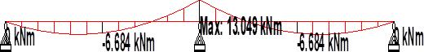

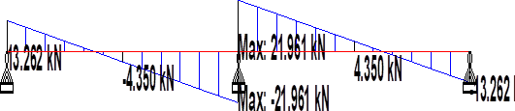



**Bending moment, shear force and displacement diagram for prestress beam**







**Bending moment, shear force and displacement diagram for poststress beam**







# DISCUSSION

For a typical RCC beam with a 6 m span from Table No. 2 and Graph No. 1, the cost is Rs. 6706.627; for prestressed and poststressed concrete beams, the cost is Rs. 7410.454 and Rs. 7937.796 accordingly. From the graph 1, it is clear that prestressed concrete beams are more expensive than regular RCC beams. Precast concrete beams cost 10.49% more to produce than regular RCC beams. Post-tensioned concrete beams cost 18.35% more than RCC beams, on average.

For the 12 m span shown in Table No. 2 and Graph 2, the conventional RCC beam costs Rs. 13526.44, while the costs for prestressed and poststressed concrete beams are Rs. 15432.95 and Rs. 15875.566, respectively. The graph-2 demonstrates that RCC concrete beams are more cost-effective than prestressed concrete beams. Precast concrete beams require 14.09% more money than regular RCC beams. In a similar vein, RCC beam costs 17.36% less than post-stressed concrete beam.

For 18 m span from TableNo.-2 and graph-3 cost required for normal RCC beam is Rs-23891.01 for prestressed and poststressed concrete beam cost required are Rs-25878.354 and Rs-25878.354 respectively. We can see that from the graph- 3 RCC concrete beam is more economical than prestressed concrete beam. For prestressed concrete beam is 8.31 % more cost required from normal RCC beam. Similarly RCC beam is 8.31 % more economical than post stressed concrete beam.

For 24 m span from Table No.-2 and graph-4 cost required for normal RCC beam is Rs-43088.568 for prestressed and poststressed concrete beam cost required are Rs-44607.464 and Rs-44607.464 respectively. We can see that from the graph- 4 RCC concrete beam is more economical than prestressed concrete beam. For prestressed concrete beam is 3.52 % more cost required from normal RCC beam. Similarly RCC beam is 3.52 % more economical than post stressed concrete beam.

Bending moment, shear force and deflection are obtained same for all type of concrete beam for same span length. In this thesis the main objective is to cost comparison between normal RCC beam, prestressed and post stressed concrete beam. All load, beam size and material properties its grade are kept constant hence Bending moment, shear force and deflection obtained are same.

For 6 m continuous beam bending moment at end support are 0 knm and bending moment at centre in span 1 is -6.684 knm. At middle support its value obtained is 13.65 knm and at centre in span 2 is -6.684knm also.

Shear force value at various point is also obtained from result for various beam . for 6 m beam of span 1 shear force value at end support 13.62 kn, at middle -4.350 kn and at end support 21.961 kn obtained. Similarly for span 2 shear force value at end support -21.961kn, at middle 4.350 kn and at end support 13.262 kn obtained.

Deflection value are also calculated from result for various beam. For 6 m beam for span 1 at middle support 0.149 mm deflection obtained similarly for span 2 at middle 0.149 mm deflection obtained.

For 12 m continuous beam bending moment at end support are 0 knm and bending moment at centre in span 1 is -26.458 knm. At middle support its value obtained is 52.674 knm and at centre in span 2 is -26.458 knm also.

Shear force value at various point is also obtained from result for various beam . for 12 m beam of span 1 shear force value at end support 26.44 kn, at middle -8.779 kn and at end support 44.002 kn obtained. Similarly for span 2 shear force value at end support -44.002 kn, at middle 8.779 kn and at end support 26.44 kn obtained.

# CONCLUSION

For 6 m span cost required for normal RCC beam is Rs-6706.627 for prestressed and poststressed concrete beam cost required are Rs-7410.454 and Rs-7937.796 respectively. We can see that prestressed concrete beam is more costlier than normal RCC beam. For prestressed concrete beam is 10.49 % more cost required from normal RCC beam. Similarly poststressed concrete beam is 18.35 % more costlier than RCC beam.

For 12 m span cost required for normal RCC beam is Rs-13526.94 for prestressed and poststressed concrete beam cost required are Rs-15432.95 and Rs-15875.566 respectively. We can see that RCC concrete beam is more economical than prestressed concrete beam. For prestressed concrete beam is 14.09 % more cost required from normal RCC beam. Similarly RCC beam is 17.36 % more economical than post stressed concrete beam.

For 18 m span cost required for normal RCC beam is Rs-23891.01 for prestressed and poststressed concrete beam cost required are Rs-25878.354 and Rs-25878.354 respectively. We can see that RCC concrete beam is more economical than prestressed concrete beam. For prestressed concrete beam is 8.31 % more cost required from normal RCC beam. Similarly RCC beam is 8.31 % more economical than post stressed concrete beam.

For 24 m span cost required for normal RCC beam is Rs-43088.568 for prestressed and poststressed concrete beam cost required are Rs-44607.464 and Rs-44607.464 respectively. We can see that RCC concrete beam is more economical than prestressed concrete beam. For prestressed concrete beam is 3.52 % more cost required from normal RCC beam. Similarly RCC beam is 3.52 % more economical than post stressed concrete beam.

From the above discussion it might be concluded that, ”when beam of small depth to width ratio is designed with specified span to depth ratio ;the prestressing method is quite help full in terms of saving percentage of steel and construction under controlled environment with same cross-sectional dimension and loading conditions.”

# REFERENCES

1. Comparative study of flexural behaviour of R.C.C. beam and prestressed concrete beam (M K MaroliyaNov-Dec 2012)
2. Economics of Continuous R.C.C. Beams Vis-à-vis Continuous Pre-stressed Concrete Beams(A.R.Mundhada, Mohammad Shahezad July-2012)
3. Flexural behavior of reinforced and prestressed concrete beams using FEA (Anthony J.Wolanski May 2004)
4. Z.Cohn, Z.Lounis “Optimum Limit of Continuous Prestressed Concrete Beams” Journal of Structural Engineering” Vol.119, No.12, December, 1993
5. Anthony J.Wolanski “Flexural BehaviorOf Reinforced And Prestressed Concrete Beams Using Finite Element Analysis” M.Tech Thesis.
6. K.H.Yang, A.F.Ashour “Load Capacity of Reinforced Concrete Continuous Deep Beams” Journal of Structural Engineering, Vol.134, No.6, June 1, 2008
7. IS: 456-2000. Indian Standard Code of Practice For Reinforced Concrete.
8. IS: 1343- 1980. Indian Standard Code of Practice For Prestressed Concrete (First Revision)
9. Dr. B. C. Punmia. 1990. “ Reinforced Concrete Structures (Volume I)”, Sixth Edition, Standard Publishers Distributors,1705-B, Nai Sarak, Delhi-6.
10. N. Krishna Raju, 2013. “Prestressed Concrete”, Fifth Edition, McGraw- Hill Education (India) Pvt. Ltd., New Delhi.
11. BSEN: 1992: Eurocode-2: Design of concrete structures.