ECO FLUSH INNOVATION FOR SWACHCHA BHARAT MISSION OF INDIA
Prof. Sandip Buradkar¹ , Shital Wakodikar² , Ritika Gokhale³ , Sakshi Ambhore⁴
¹ Assistant Professor , Department Of ETC, Guru Nanak Institute of Engineering and Technology, Nagpur, India
¹²³⁴Department of ETC, Guru Nanak Institute Engineering and Technology, Nagpur, India.

ABSTRACT
The paper describes to layout and builds a manually controlled surveillance system. The ultrasonic sensors are first-rate gear to distance without real touch and are used several places water degree measurement etc. This is an efficient manner to measure small exactly. The smart toilet will take care of opening and closing the toilet seat , and the IR sensor tracks the dirt present on the toilet seat and raises an alarm . The cleanliness of the toilet will be improved by monitoring the sweeper's activity to maintain the hygiene of the toilet , it also will deal with water conservation . So we most effectively want to calculate the touring time of each sound method outgoing time and returning time to the starting place after putting on the impediment. As the pace of the sound is known to us, after some calculation we will calculate the distance. The module works on the phenomenon of the ECHO of sound . A pulse is for about 10us to cause the module . Ultrasonic sensor HC-SR04 is used right here to measure distance in a variety of 2cm-400cm with an accuracy of 3mm. The sensor module consists of an ultrasonic transmitter, receiver, and the managed circuit. taking pictures of the space of an intruder and also shipping facts to telephone through wi-fi . The routinely takes the records from the sensor and sends them returned to the app immediately.
Key Words: Surveillance, NodeMCU, Arduino, UltraSonic Sensor, Echo.

INTRODUCTION
Our proposed system is a smart monitoring system designed to monitor the hygiene of public toilets. The unhygienic toilets can be detected by different parameters such as water levels, and various gases evolved , temperature etc . We will be using the gases present in the toilet as our primary parameter. A smart toilet system can use sensors to control flushing and auto-wash systems. They can also measure the distance, water level, and weight of the toilet bowl. You can also utilize voice command, mobile control, or motion detection to activate the features of the toilet. An intelligent toilet is a bathroom plumbing fixture or type of electronic bidet toilet that incorporates traditional bidet cleansing with added the enhancement of modern smart home technology. With a smart toilet cleaning the most intimate areas of your body can become as quick and hassle free as a toilet visit . Toilets with integrated bidets allow you to clean your anal and perianal areas water and many models also include a drying function, where hot air gently dries your skin after washing. Therefore, the most people think that the smart toilet originated in Japan and was invented by the Japanese. However, this not the case, American Arnold Cohen invented the world's first smart toilet in 1964.

Toilets are commonly made of ceramic, concrete, plastic, or wood. Newer toilet technologies include the dual flushing and low flushing, toilet seat warming, self-cleaning and waterless urinals. Japan is known for its toilet technology. In 2011, company Kohler released the Numi, hailed as the world's first smart toilet, for a whopping $6,400. The Numi was revolutionary, allowing users to set their own ambient lighting, adjust the water temperature, and even listen to music with the built-in radio. “With a lot of devices, security has never been uppermost in the mind and yet something like a smart toilet collecting some very personal data,” he says. “It is not just about storing private of information. The smart toilet seat is also commonly called the bidet toilet seat. While there are the dozens of models available on the market, must be include at least many of the same features.
Hygiene is also taken into the account with the remote option available with all our the smart toilets. This reduces the need to close and open toilet seat and eliminating the risk of touching any bacteria around the toilet. The smart toilet performs urinalysis and uroflowmetry. The toilets deploys and retracts the strip that becomes soaked in the urine. The strip is read for a change, which can screen across 10 biomarkers to indicate the presence of conditions diabetes. Here's how it works: When the flush handle is pressed, it pulls a chain connected to a flapper. The flapper and releases the tank water down the flush valve the toilet bowl. The pressure of the water waste over the trap at the bottom of the bowl and into the main drain. What will toilets look like in the future? Scientists are working on toilets that use and heat treatment to kill pathogens and make solids safe for the environment. They are also working on sustainable systems that will remove and recycle the water from the through filtration. The first patent for a flushing toilet was issued to Alexander Cummings in 1775 - 1777.

LITERATURE REVIEW

The literature on Smart toilets are like regular toilets but with superpowers! They're packed with fancy technology to make our bathroom experience better. This review looks at what makes them tick and why they're becoming popular.Benefits of Security System . Think of smart toilets like high-tech wizards. They have sensors that can analyze our pee and poop, flush themselves, and even clean up after us. Plus, they can connect to the internet and chat with other smart devices in our homes. Smart toilets aren't just about flushing and cleaning. They can keep an eye on our health too! Some can check for signs of diabetes or infections in our urine. Others can monitor water use or air quality to help we live greener.

The future looks bright for smart toilets. We're talking even smarter sensors, better connections with other gadgets, and maybe even predicting health issues before they happen. But we'll need to work on making them more affordable and making sure everyone feels comfortable using them.

3 . BLOCK DIAGRAM

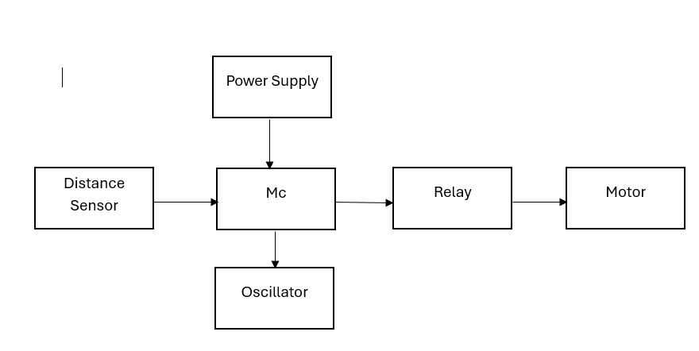

Figure 1: Proposed Block Diagram.

CIRCUIT DIAGRAM

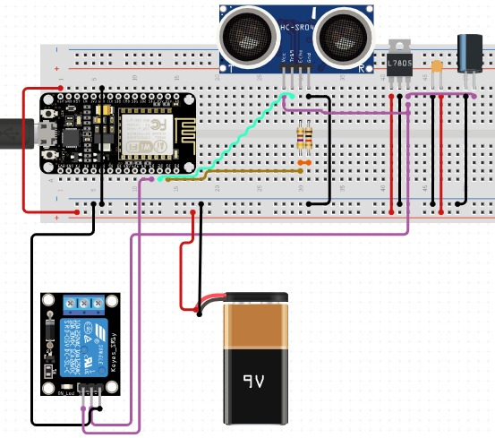

Figure . 2 : Circuit diagram

1 . Power Supply

A power supply is electrical device the supplies electric power to an electrical load. The main purpose a power supply is to convert electric current a source to the correct voltage and current and frequency to power load. As a result, power supplies are sometimes referred to electric power converters. Some power supplies are standalone pieces of equipment and while others are built into the load appliances that power. Examples of the latter power found in desktop computers and devices. Other functions that power supplies may perform include limiting the drawn by the load to safe levels, shutting off the current in the event of an electrical fault, power to prevent electronic noise or voltage surges on input from reaching the load, correcting and storing energy. So it can be the continue to the load in the of a temporary

interruption of the source power.

2. Node MCU

Node-MCU is open-source firmware for which open-source prototyping board designs are the available. The name combines "node" and "MCU" (Micro Controller unit). Strictly speaking the term "Node-MCU" refers to firmware rather than the associated kits.
NodeMCU is a low-cost open-source IoT platform. Initially included which runs on the ESP8266 Wi-Fi SoC from Systems, and hardware which was based the ESP-12 module. Later, support for the ESP32 32-bit MCU it was added.

3 . Single Channel Relay

The single-channel relay Module is a convenient board that can be used to control high voltage, and high current loads such as motors, solenoid valves, lamps, and AC loads. It is designed to interface with microcontrollers such as Arduino, Node-MCU, etc. The relay's terminal (COM, NO, and NC) is being brought out with a screw terminal. It also comes with an LED to indicate the status of the relay. The relay is the device that opens or closes the contacts to switch ON/OFF other operating system at high voltages. It is also used in safety circuits where it detects conditions with an assigned area and gives commands to the circuit breaker to disconnect the affected area through ON or OFF.

4 . Mini Water Pump Dc

12V 24V Water Pump — All products passed CE, RoHS, and REACH. Parts of pumps meet FDA, and UL. 24-hour technical support. The biggest supplier of Automobile water pumps in China, since 2004. Independent R&D team. Capacity 10000pcs/day. Automatic production line. Warranty 2 years.
Systems mini Water Pump DC 4V 12V Micro Submersible Motor Pump + 1M Clear Tubing Flexible PVC Tubing for Fish Tank Fountain Garden.

5 . 6V Submersible Motor

They take up to 120 liters per hour with a very low current of 220mA. Just the tube pipe to the motor outlet, submerge it in water and power it. Make sure that the water level is higher than the motor. The dry run damages the motor due to heating and it will also noise.
The micro DC 3-6V Mini Water Pump can be used for a variety of applications, including circulation in small aquariums or fountains, DIY projects, and other low-flow pumping needs.

6 . Ultrasonic Sensor(HC-05)

The HC-05 is Bluetooth module can be used for wireless communication in a master or slave configuration. It has a typical sensitivity of -80 dBm, a range of approximately 10 meters in open air, and supports profiles such as SPP (Serial Port Profile) and HID (Human Interface Device). It uses the 2.45GHz frequency band and has a transfer rate up to 1Mbps . The HC-05 can be used in many applications, including: Wireless headset, Game controllers, Wireless mouse, and Wireless keyboard.

7 . Solar Panel

The HC-05 is Bluetooth module can be used for wireless communication in a master or slave configuration. It has a typical sensitivity of -80 dBm, a range of approximately 10 meters in open air, and supports profiles such as SPP (Serial Port Profile) and HID (Human Interface Device). It uses the 2.45GHz frequency band and has a transfer rate of up to 1Mbps . The HC-05 can be used in many applications, including: Wireless headset, Game controllers, Wireless mouse, and Wireless keyboard.
Ultrasonic sensors can measure distance regardless of the color or illumination of obstacles. For example, the HC-SR05 is an ultrasonic distance sensor with five pins that can be used in one pin trigger/echo mode or two pins.

5. CONCLUSION

The study is shows that felt a smart toilet seat could be acceptable and effective, a as it fits everyday practices concerning toilet use and hygiene. The range of potential uses for a toilet seat is broad, as long as privacy and over disclosure and data are warranted.

6. REFERENCES

[1] C.D. Nugent, D.D. Finlay, P. Fiorini, Y. Tsumaki, and E. Prassler, “Home Automation as a Means of Independent Living,” IEEE Trans. On Automation Science and Engineering, vol. 5, no. 1, pp. 1-9, 2008 M. Young, The Technical Writer’s Handbook. Mill Valley, CA: University Science, 1989.

[2] Nikhil Agrawal Engineering Manager, Siemens,Noida nikhil.pa@gmail.com, SmitaSinghal ASET, Amity University, Noida singhal.smita@gmail.com, Smart Drip Irrigation System using Raspberry pi and Arduino, International Conference on Computing, Communication and Automation (ICCCA2015) ISBN:978-1-4799-8890- 7/15/$31.00 ©2015 IEEE.

[3] P. Wolkoff, “Indoor air humidity, air quality, and health – An overview”,
International Journal of Hygiene and Environmental Health, vol 221, April 2018,
pp. 376-390, 2018, WOS: 000438327900002
P. Wolkoff, “Indoor air humidity, air quality, and health – An overview”,
International Journal of Hygiene and Environmental Health, vol 221, April 2018,
pp. 376-390, 2018, WOS: 000438327900002
[3] H Katano, K Yokoyama, Y Takei, H Matsuki et al.(2011)The study of the bacterial contamination in the spray water of electronic toilets and in the gluteal and inguinal regions due to splashing following spray water. Microbial Ecology in Health and Disease. vol. 25, pp. 8-14.

[4] F Zakaria, J Ćurko, A Muratbegovic et al.(2018) Evaluation of a smart toilet in an emergency camp. International Journal of Disaster Risk Reduction .vol. 27, pp. 512-523.

[5] Andreas Schumacher et al.(2016)A maturity model for assessing Industry 4.0 readiness and maturity of manufacturing enterprises. Elsevier B.V.Vol 52,pp. 161-166.

