**DESIGNING A COMMON ADAPTABLE BOARD FOR BATTERY MANAGEMENT SYSTEM USING MATLAB SIMULINK**

# J.S. Poovizhisrinithi1, Dr. S. Rathinavel2

1,2Department of Electronics and Instrumentation, Bharathiar University, Coimbatore-641046,

Tamil Nadu, India

# ABSTRACT

The widespread adoption of electric vehicles contributes significantly to reducing carbon dioxide (CO2) and greenhouse gas emissions, as they rely solely on electricity as their primary source. Electric vehicles produce no tailpipe emissions, thereby improving air quality and reducing carbon footprints. The Battery Management System (BMS) is a specialized system that monitors and controls the workings of electric vehicles. It manages rechargeable batteries, individual cells, and battery packs, ensuring their operation within a safe operating area (SOA). The BMS monitors battery state, calculates and reports data, authenticates information, and balances the battery. Managing the battery's performance is vital, but the diverse range of available BMS boards poses challenges for effective implementation. The complexity increases with different types of boards, leading to difficulties in troubleshooting and poor maintenance due to varying specifications and compatibility. Periodic maintenance of the BMS is essential to ensure proper functioning, operation, and accuracy, which can increase overall maintenance costs. Therefore, creating a common adaptable board for BMS is necessary to reduce costs and improve efficiency. The BMS board also includes additional features such as continuous monitoring of battery temperature during charging and discharging. MATLAB’s Simulink is used to simulate the operation of a common adaptable board for BMS.

***Index Terms***: common adaptable board, Battery Management System, MATLAB software, active cell balancing, monitoring voltage and current, maintaining temperature.

# INTRODUCTION

Advancements in battery technology for Electric Vehicles (EVs) and renewable energy underscore the pivotal role of Battery Management Systems (BMS) in enhancing battery lifespan through precise state estimations and optimization methods. This transition corresponds to the urgent shift towards renewable energy and alternative transportation, which is essential for curbing greenhouse gas emissions [1]. Battery Management Systems (BMS) stress the importance of sophisticated physics-based models for precise monitoring and control in grid-scale energy storage, especially for lithium-ion and redox-flow batteries. Integrating these advanced models with real-time optimization enhances battery systems' performance and longevity in grid-scale applications [2]. The evolving research on Battery Management Systems (BMS) for Unmanned Aerial Vehicles (UAVs) encompasses battery charging, state estimation, and safety aspects crucial for enhancing stability and performance. Understanding UAVs, power batteries, and BMS individually is vital, considering classification based on power propulsion systems and UAV batteries' energy and power density alongside BMS functions [3]. The advanced Battery Management System (BMS) for smart grids monitors and manages individual batteries within a series array, enabling independent charging and utilizing pulsed charging for SOC balancing. Designed to address aging and performance issues, especially in lead-acid batteries, it enhances grid infrastructure resiliency and efficiency under varying loads, including heavy pulsed loads [4]. Predicting battery state in Electric Vehicles (EVs) through a digital twin framework enhances Battery Management Systems (BMS). It optimizes battery storage unit operations, focusing on accurately estimating state-of-health (SoH) and state-of-charge (SoC) using the XG Boost model and Extended Kalman Filter (EKF). This precision ensures maximized battery performance, lifespan, and overall health, emphasizing the significance of effective battery management in EVs [5]. The rise of battery energy storage systems in modern power grids is driven by the variability of renewable energy sources, highlighting the need for precise state estimation, effective balancing, and optimized strategies. Further research is vital for smart management, reliability assessment, and energy optimization in grid-connected battery storage to tackle emerging challenges and exploit opportunities [6]. The increasing use of lithium-ion batteries across multiple sectors highlights the need for robust management strategies and accurate prediction methods for their remaining useful life, focusing on enhancing performance and longevity through advanced forecasting techniques and precise state estimation [7]. Utilizing a hierarchical structure integrating global and local Battery Management Systems (BMSs), this system optimizes battery cell monitoring and management for electric vehicles (EVs), emphasizing energy efficiency and reliability to enhance battery lifespan and affordability. The evaluation of DESA's effectiveness encompasses metrics such as switch power dissipation, reliability, and cost savings in servicing [8]. Enhancing battery lifespan via proactive power management entails predicting future power demands and adapting to prediction errors, utilizing a T-S fuzzy-based control-oriented model to address system non-linearity. This approach demonstrates superior performance in mitigating battery degradation and improving efficiency in Hybrid Energy Storage Systems (HESS), promising extended battery life and enhanced HESS performance in electric vehicles [9]. Implementing a wavelet-based power management system for an electric motorcycle, optimized through wavelet decomposition levels and controller activation power, significantly improves battery lifespan, energy recovery, and cost efficiency, as demonstrated through federal test procedure (FTP) driving cycle evaluation and comparison with Hybrid Energy Storage System (HESS) strategies [10]. Reconfigurable battery packs offer dynamic adjustments based on individual cell conditions, enhancing fault tolerance and addressing shortcomings of conventional multi-cell setups. Their potential benefits are particularly relevant as battery systems expand into grid storage and backup power applications [11]. The effective management of various operational scenarios by the Battery Management System Control (BMSC) is crucial for maintaining frequency control within microgrids, particularly amidst challenges arising from integrating renewable energy sources and dynamic loads [12]. The evolution of identification algorithms tailored for individual battery cells is vital for real-time model updates. High-fidelity models are essential for efficient battery management amid diverse cell characteristics and dynamic changes, enabling real-time control and optimization [13]. A sophisticated battery model integrates aggregated circuitry, exhibiting non-linear SOC-dependent open circuit voltage. Microgrid operations benefit from closed-loop feedback control, guided by an upper-level SOC management system, offering key insights into battery modeling and control within microgrids [14]. A novel health indicator derived from a partial charge voltage curve enables accurate capacity estimation and Remaining Useful Life (RUL) prediction across various battery aging stages. Its implementation in real battery management systems enhances electric vehicle lithium-ion battery maintenance and management, advancing reliability and efficiency [15]. Explore diverse approaches encompassing charging strategies, operation tactics, and battery protection methods, analyzing commercial and industrial solutions for Lithium-ion Battery (LIB) balancing and online monitoring. Examine Polyethylene (PE) based techniques for LIB safety in industrial settings, addressing current challenges and outlining potential research avenues for the future [16]. Combining battery pack elements, controllers, and SoH estimation algorithms into one module offers a configurable solution for battery-powered devices, underscoring the significance of SoH prediction for battery health and operational longevity despite challenges in implementation for low-cost and low-power systems [17]. The significance of dynamic temperature variation in battery packs underscores the intertwined challenges of state parameter estimation and thermal management, particularly accentuating the critical influence of temperature on battery health and performance, notably in cold environments [18]. A SPICE model for a passive Battery Management System (BMS) targeting four LiFePO4 cells tackles state-of-charge imbalances, streamlining real-world BMS simulation in OrCAD Capture. This approach optimizes BMS design with high performance with <1.5% relative errors, offering a cost-efficient and time-saving solution while acknowledging potential challenges and underscoring the model's significance in electronics simulation [19]. The significance of reliable SoC estimation for cell strings in BESS and electric vehicles is ensuring efficient energy management. The proposed active cell balancing technique aims to achieve SoC balance among parallel-connected cells, enhancing overall system performance [20].

## OBJECTIVE

The main objective for creating a standard Battery Management System board is to standardize BMS technology across different electric vehicles, thereby reducing complexity, improving compatibility, lowering maintenance costs, and enhancing the overall efficiency and performance of electric vehicle battery management systems.

**Enhance Compatibility:**

- Minimize compatibility issues between different batteries and EV models.

- Ensure seamless integration and interoperability.

**Reduce Complexity:**

- Streamline production, troubleshooting, and maintenance processes.

- Provide a unified platform with standardized interfaces and protocols.

**Improve Maintenance Efficiency:**

- Enable quicker issue diagnosis and resolution, enhancing reliability.

**Optimize Cost-effectiveness:**

- Achieve economies of scale in manufacturing and procurement.

- Reduce customization efforts, benefiting manufacturers and consumers.

**Facilitate Innovation:**

- Provide a stable foundation for R&D in battery technology and energy management.

- Foster collaboration and knowledge sharing for advancements in vehicle performance.

## LITERATURE SURVEY

1. **Kumar, R. Ranjith et al.**, The study focuses on the progress in electric vehicle (EV) batteries, particularly in battery management systems (BMS), battery modelling, state of charge, state of health, and charge/discharge characteristics, which is pivotal for second-generation hybrid and electric vehicles and renewable energy storage. Various battery models, such as electrochemical, equivalent circuit, and data-driven models, accurately estimate SOC despite challenges like cell variations and pack non-uniformity. Cell calculation, screening processes, and bias correction are used for SOC estimation in battery packs. BMS ensures efficient battery performance by monitoring SOC SOH and managing charge/discharge cycles. These advances tackle battery dynamics' complexities, boosting EVs' and renewable energy systems' reliability and performance while underlining BMS's critical role in automotive and sustainable energy sectors.
2. **Lawder, Matthew T., et al.,** The electric grid's inefficiencies require energy storage to reduce waste and improve stability. Advanced modelling is crucial for monitoring storage systems, with Battery Management Systems (BMS) playing a pivotal role in utilizing energy storage for the grid. Modelling Li-ion and RFBs faces challenges in accurately measuring SOC and SOH. Optimizing charging for battery-solar hybrids demonstrates the benefits of model-based optimization on performance and longevity. Despite SOC and SOH estimation challenges, advanced physics-based models are vital for BMS. Reformulation techniques ease computational burdens, enabling real-time simulation and optimization. Model-based optimization in solar-tied storage optimizes energy use. It extends battery life, which is crucial for grid-scale applications, highlighting the need for real-time simulation and optimization.
3. **Rouholamini, Mahdi, et al.** The study delves into the multidisciplinary aspects of battery storage, explicitly focusing on Li-ion batteries. It aims to review material fundamentals, modelling, characterization, management, applications, and market participation of Li-ion batteries. Key topics include battery fundamentals, modelling, battery management systems (BMSs), battery energy storage systems (BESSs) participation in electricity markets, and global battery energy storage projects. The study also explores potential research areas such as innovative approaches for battery fire mitigation, battery recycling, and re-purposing of used batteries. Emphasizing the growing importance of Li-ion battery energy storage systems, it highlights the necessity for further research in developing intelligent batteries for smart power grids.

[9] **Hu, Yuying, et al.** This study introduces a Model Predictive Control (MPC) scheme for Hybrid Electric Storage Systems (HESS) in Electric Vehicles (EVs), aiming to enhance battery life by managing power distribution between batteries and super-capacitors (SCs). It leverages time-series forecasting for velocity prediction and power demand calculation. It employs a T-S fuzzy modelling method to handle non-linearity in the system. The MPC-based power management problem, considering prediction errors, enhances system robustness. Simulation shows a 17.81% battery life improvement by reducing current magnitude and fluctuations. This contribution lies in a real-time proactive HESS management scheme, addressing future power splitting and system non-linearity, surpassing other strategies in extending EV battery life and optimizing power allocation.

[12] **Ci, Song, Ni Lin, and Dalei Wu.,** The study "Reconfigurable Battery Techniques and Systems: A Survey" delves into crucial areas such as exploring reconfigurable battery pack designs, addressing challenges and hazards in pack design, and applying reconfigurable batteries in smart grids, electric vehicles, and data centres. It emphasizes the role of Battery Management Systems (BMS) in ensuring safety and efficiency. Additionally, it discusses the potential of reconfigurable battery systems in reducing energy consumption and carbon emissions in data centres, highlighting the importance of efficient sensing and thermal management in large-scale packs. The study also underscores lithium batteries as promising energy storage options and calls for further research to optimize BMS and understand the impact of reconfigurable batteries on the evolving energy landscape.

[15] **Xiong, Rui, et al.** The remaining useful life of lithium-ion batteries in electric vehicles is depicted in this study. It introduces an effective health indicator derived from partial charge voltage curves and a moving-window-based approach for RUL prediction. Validation using natural battery management systems shows accurate capacity estimation (<1.5% error) and RUL prediction (RMSE within 20 cycles in the last 20% of battery life). These techniques offer practical benefits for battery health prognosis in real-world scenarios, advancing the field and ensuring efficient battery state prediction for electric vehicle management systems.

[16] **Zhao, Zhaoyang, et al.** The study thoroughly analyses power electronics-based safety measures for lithium-ion batteries (LIBs), emphasizing safety's crucial role and power electronics' impact on battery management. It reviews current safety enhancement techniques, comparing their benefits and drawbacks and addressing ongoing challenges. Key areas covered include battery protection, balancing, real-time monitoring, and lifespan enhancement methods, with detailed explanations and proposed solutions for practical implementation. The study also underscores the need for robust design protocols for these techniques, offering viable strategies for industry and academia. Lastly, it outlines future research prospects in advancing power electronics-based safety enhancements for LIBs, highlighting opportunities for innovation and development in this critical field.

# BLOCK DIAGRAM

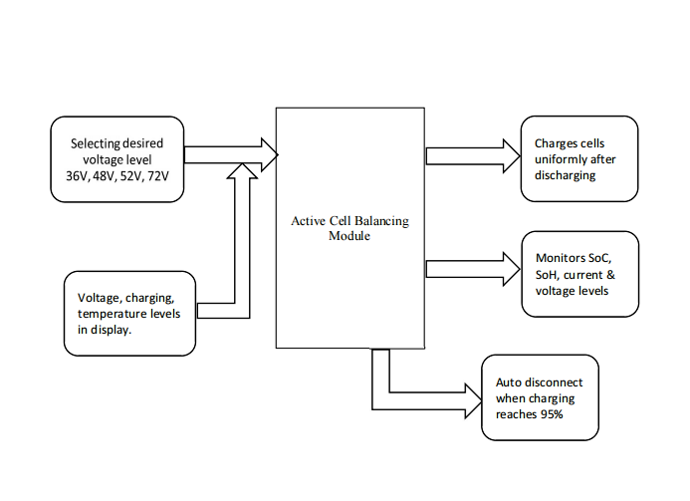

**Figure 1:** Mind map of the project

# METHODOLOGY

The utilization of MATLAB's Simulink software forms the fundamental framework for simulating the project and designing the common adaptable board for the battery management system, launching MATLAB, selecting the Simulink icon, and creating a new file. Here, we use the Active Cell Balancing method to balance the charge in the battery. Active cell balancing is a technique used in battery management systems to equalize individual cells' state of charge (SoC) within a battery pack. It is achieved by transferring charge between cells using active components such as switches, resistors, or DC-DC converters and indirectly using RLC Components. The goal is to ensure that each cell operates within its optimal voltage range, prolonging the battery pack's lifespan and performance. The common, adaptable board design needs a lithium-ion battery with 3.6 V as the nominal voltage. The cells' initial state of charge (SoC) can be directly determined internally within the cells. These cells are linked in series to create a circuit. As the positive terminal of the first cell is connected to the ideal switch, its negative terminal to connected the positive terminal of the next cell, and so on. The ideal switch is a mechanical device designed to toggle between on and off states based on a specific condition linked to a constant. It comprises three terminals: a control signal or gate (G), input signal 1, and input signal 2. Input signals one and two can open and close based on the signal's flow through the switch. The control signal or gate (G) is connected to constant to manage the system's continuous charging and discharging, with the cell's positive terminal linked to signal 2. The switch remains closed when the constant is 0, enabling the cell to discharge. Conversely, when the constant switches to 1, the charging process initiates. Input signal one is directed to the positive end of the power supply, while the negative end is grounded. The "m" in the battery signifies its role in modeling, simulating, and analyzing dynamic systems within the battery management system. This "m" is linked to a Bus Selector, which extracts specific elements from the bus signal. The Bus Selector, in turn, connects to a Goto block, creating a signal reference that facilitates connections to the Bus Selector and, subsequently, to the battery model for extracting relevant signals or data from the battery model's output bus. The input signal for the state of charge is transmitted to the Bus Selector, and its output is then linked to the cell. The Bus Selector is configured to select the state of charge, and each Goto block is renamed individually, such as soc1, soc2, and many others, for each cell. The signal transmitted from the Goto block is directed to the Bus Selector and the cell. The arrangement of capacitance from RLC components in parallel with the cells forms a storage reservoir for electrical energy, akin to a storage tank. During the charging phase of the battery, the capacitor can intake a portion of the incoming energy, thereby moderating the battery's charging rate. Conversely, the capacitor can release its stored energy during discharge, delivering additional power to the circuit. Scopes and Displays are connected to the bus selector to monitor the graphical representation and digital values of cell charging and discharging. Each cell is equipped with an ideal switch and an ideal diode, both connected in parallel to each other and parallel to the cell. The negative terminal of the diode and input signal 1 of the ideal switch are connected to the battery's positive terminal. The gate (G) is linked to "From," which receives signals from the "goto" block with specified tags. The negative terminal of the diode is connected to input signal 2 of the ideal switch, which then connects to the next ideal switch's input 1, creating a cascading flow until all capacitors, diodes, and ideal switches reach ground. For ten cells, there would be ten state of charge (SOC) values and corresponding "From" signals for each SOC. The process involves connecting resistors between two cells to combine their charging and discharging. This setup is iterated until the desired configuration is achieved. Create a series of four cells for charge and discharge; the State of Charge (SoC) values are summed up, and this sequence continues. The SoCs and their corresponding 'From' blocks are then linked to a MATLAB function for simulation. In MATLAB function, the code for cell balancing is written. A pulse generator is connected to a PWM (Pulse Width Modulation) module to generate triggering pulses for charging and discharging operations. A subsystem has been developed for 36V, with a toggle switch positioned externally for selection. Similarly, subsystems have been created for 48V, 52V, 60V, 72V, and 108V, each with their dedicated setup. Upon selecting a specific voltage setting, the system reads the voltage levels of the battery cells. Initially, it discharges the cells before commencing the charging process. Charge automatically ceases once the battery cells reach 95% charge. External monitoring allows for real-time observation of battery and cell voltage levels and temperature readings. This assists us in developing a universal adaptable board for battery management systems capable of charging all electric bikes regardless of their voltage levels.

1. **RESULT AND DISCUSSION:**

Thus, Designing a standard adaptable board for a battery management system offers several advantages that can significantly enhance efficiency and longevity:

**Increased Efficiency:** A standard adaptable board eliminates the need for multiple boards designed for different voltage levels. Streamlines the system, reduces complexity, and improves efficiency by optimizing resource utilization.

**Simplified Maintenance:** A single adaptable board design increases the availability of spare parts. The maintenance reduces downtime, as technicians only need to stock and work with a standardized set of components.

**Active Cell Balancing:** Active Cell Balancing is crucial in optimizing battery performance by ensuring a uniform charging and discharging process for each cell within the battery pack. This methodology minimizes energy wastage and maximizes the battery's usable capacity, consequently enhancing the vehicle's range and extending the battery's lifespan.

**Minimized Discharge Levels:** Active cell balancing also helps in minimizing discharge levels. The battery's overall health is preserved by preventing cells from over-discharging or overcharging, leading to longer-lasting and more reliable energy storage.

Creating a versatile board with active cell balancing features enhances effectiveness, streamlines upkeep, and significantly prolongs battery life and the vehicles they support. These advantages result in cost reductions, enhanced dependability, and an eco-friendly approach to energy control in electric vehicles.

**36 V DISCHARGING AND CHARGING:**

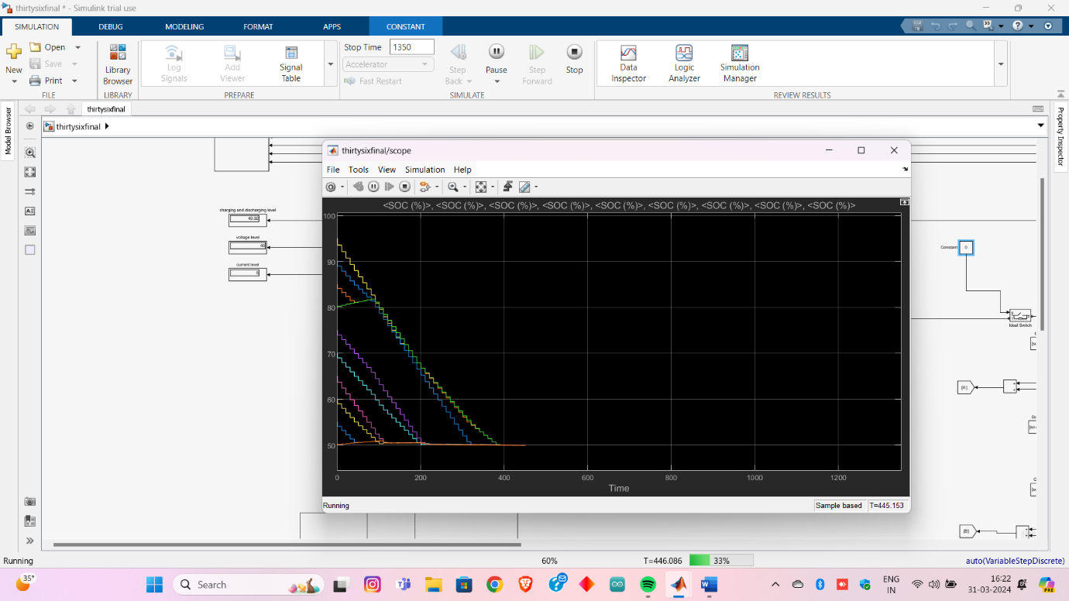

**Figure 1:** Discharging of 36V

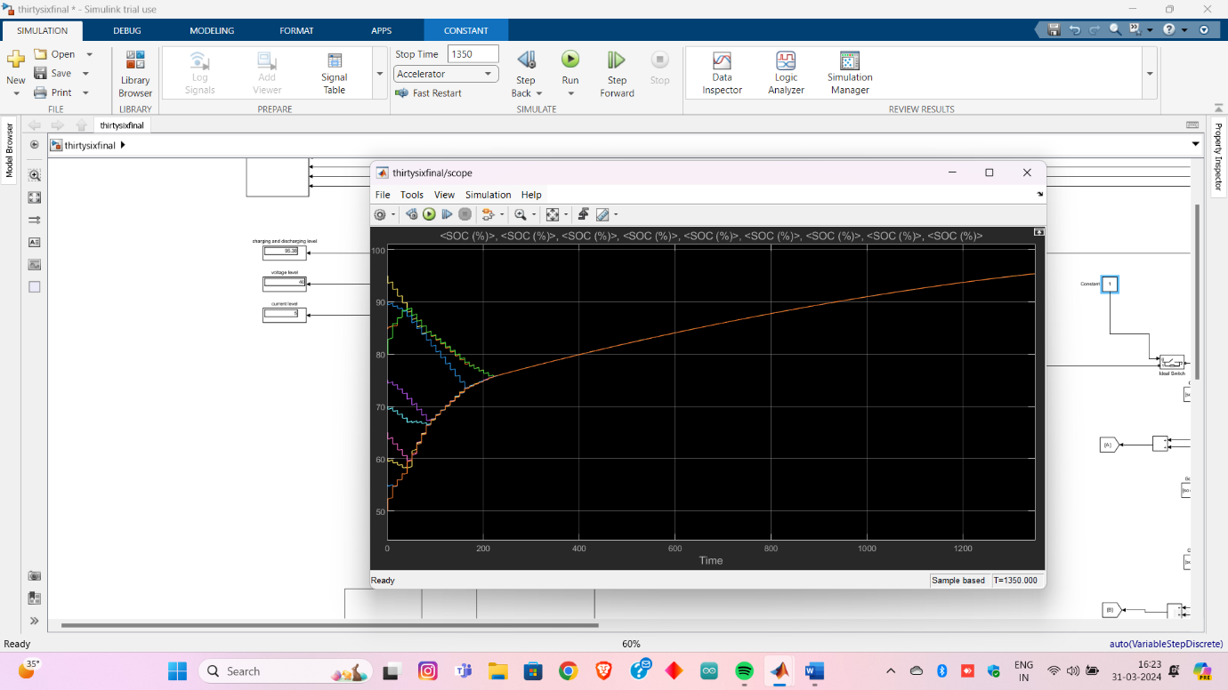

**Figure 2:** Charging of 36 V

**48 V DISCHARGING AND CHARGING:**

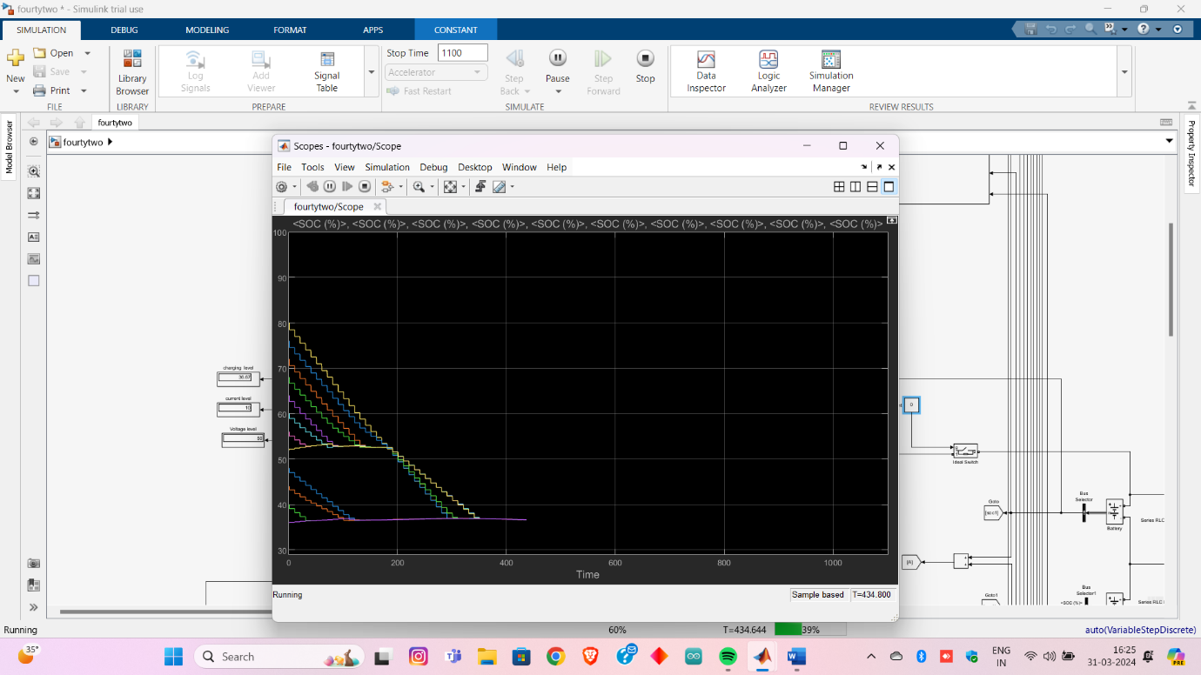

**Figure 3:** Discharging of 48 V

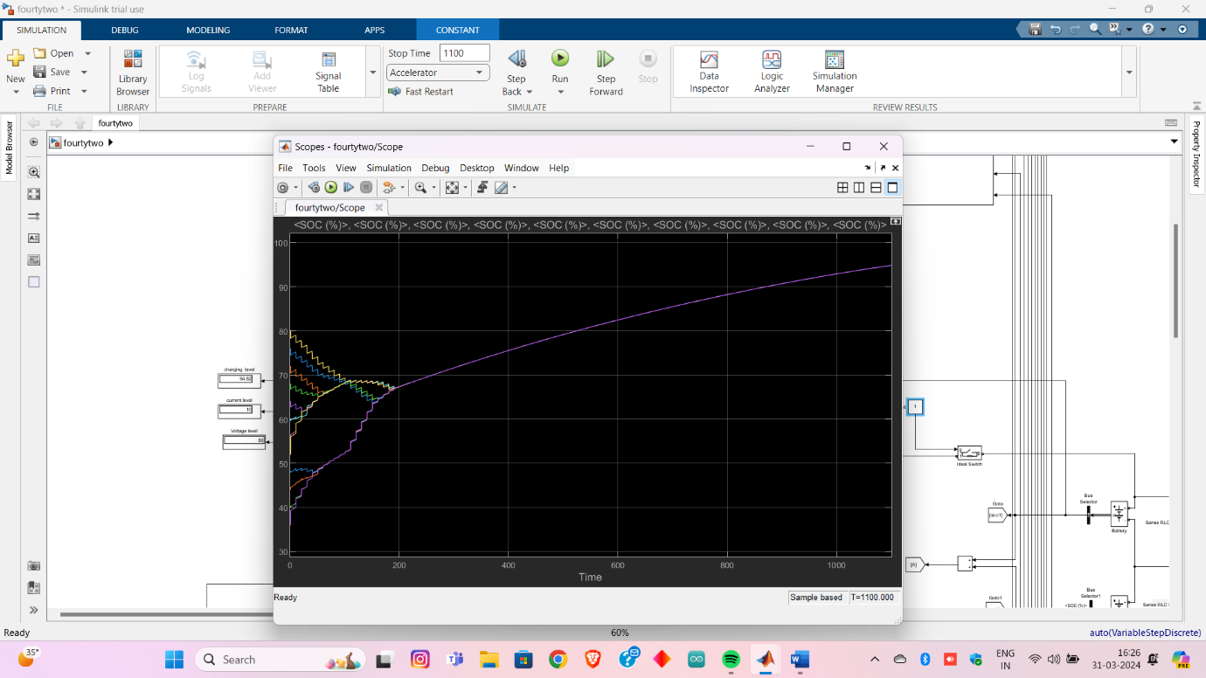

**Figure 4:**  Discharging of 48 V

**52 V DISCHARGING AND CHARGING:**

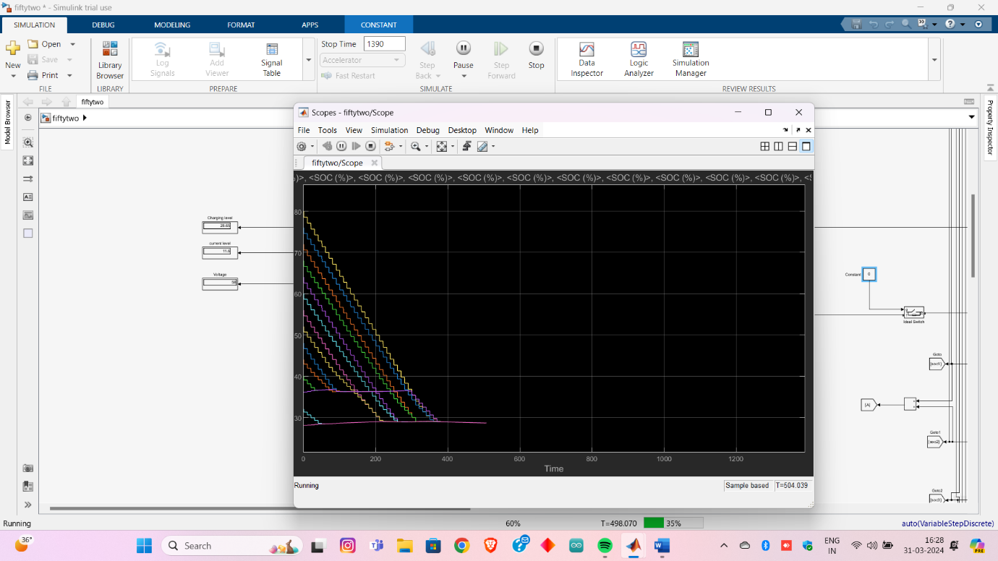

**Figure 5:** Discharging of 52 V

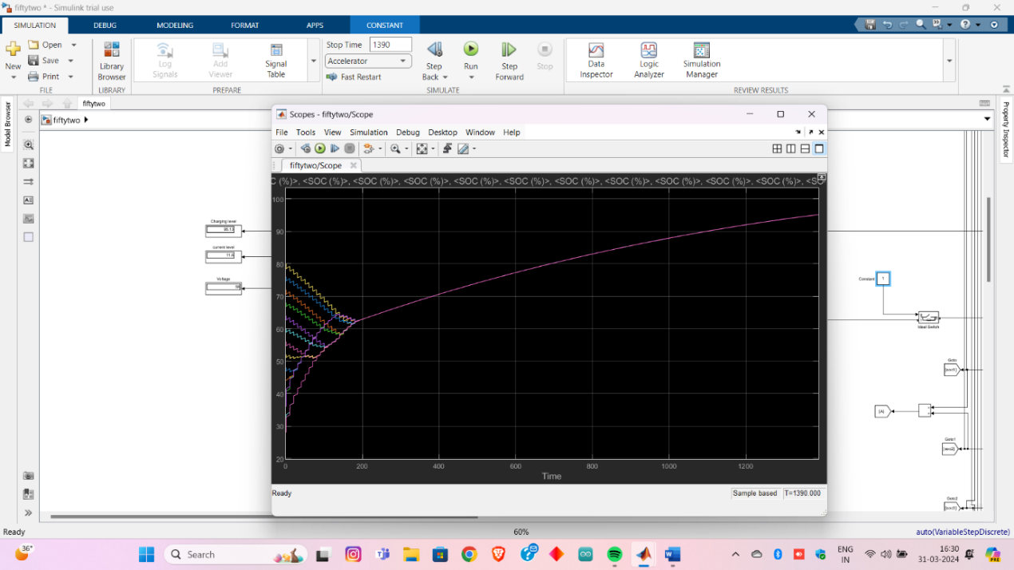

**Figure 6:** Charging of 52V

**72 V DISCHARGING AND CHARGING:**

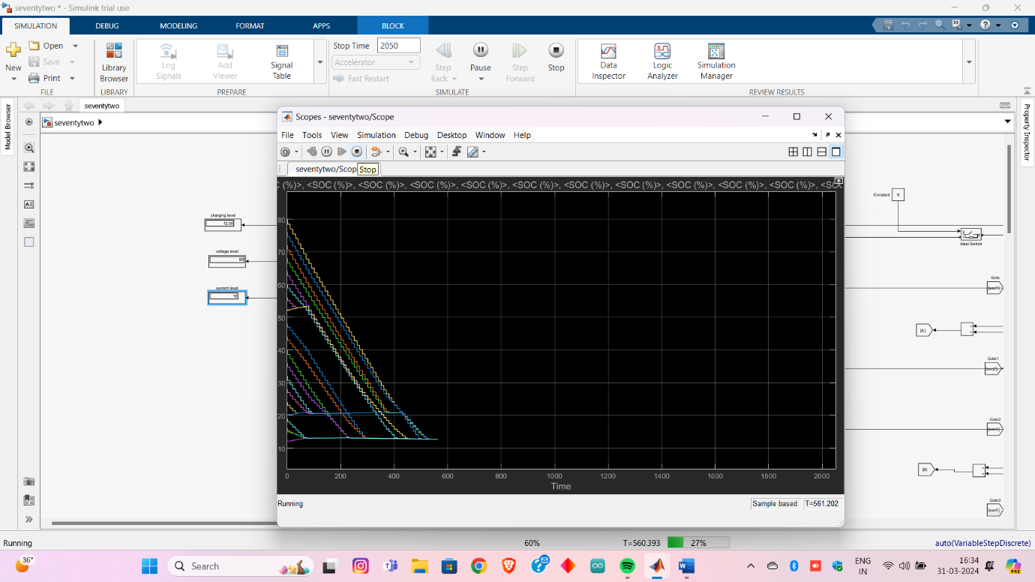

**Figure 7:** Discharging of 72 V

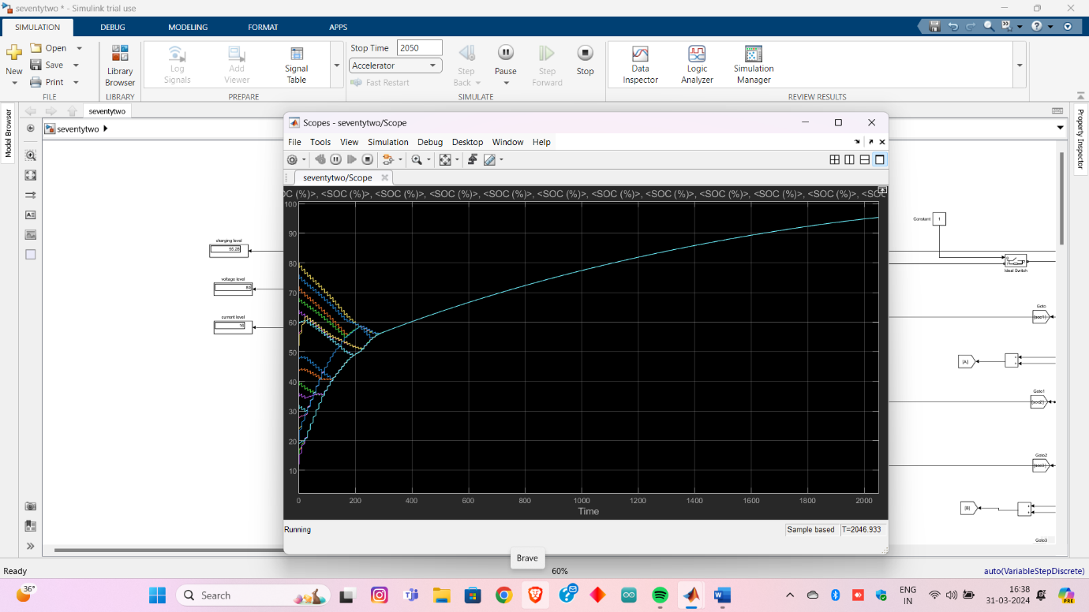

**Figure 8:** Charging of 72 V

# CONCLUSION

In conclusion, designing a standard adaptable board for a battery management system offers many benefits that significantly enhance electric vehicles' efficiency, reliability, and sustainability. This solution optimizes energy usage, prolongs battery life, and reduces maintenance costs by incorporating active cell balancing technology. The ability to accommodate various voltage levels, from 36V to 108V, streamlines production, minimizes spare parts inventory and facilitates compatibility across different electric bike models. Furthermore, incorporating external monitoring for cell voltage and temperature levels ensures electric vehicles' safe and efficient operation in various conditions. This integrated approach enhances performance and fosters a more environmentally friendly transportation ecosystem by encouraging responsible energy management practices. A standard adaptable board equipped with active cell balancing capabilities represents a strategic investment that increases the demand for sustainable solutions in the electric vehicle industry.

# REFERENCES

1. Kumar, R. Ranjith, et al. "Advances in batteries, battery modelling, battery management system, battery thermal management, SOC, SOH, and charge/discharge characteristics in EV applications." *IEEE Access* (2023).
2. Lawder, Matthew T., et al. "Battery energy storage system (BESS) and battery management system (BMS) for grid-scale applications." *Proceedings of the IEEE* 102.6 (2014): 1014-1030.
3. Jiao, Shiqin, et al. "A Comprehensive Review of Research Hotspots on Battery Management Systems for UAVs." *IEEE Access* (2023).
4. Elsayed, Ahmed T., Christopher R. Lashway, and Osama A. Mohammed. "Advanced battery management and diagnostic system for smart grid infrastructure." *IEEE Transactions on Smart Grid* 7.2 (2015): 897-905.
5. Jafari, Sadiqa, and Yung-Cheol Byun. "Prediction of the Battery State Using the Digital Twin Framework Based on the Battery Management System." *IEEE Access* 10 (2022): 124685-124696
6. Rouholamini, Mahdi, et al. "A Review of Modeling, Management, and Applications of Grid Connected Li-ion Battery Storage Systems." *IEEE Transactions on Smart Grid* (2022).
7. Hasib, Shahid A., et al. "A comprehensive review of available battery datasets, RUL prediction approaches, and advanced battery management." *Ieee Access* 9 (2021): 86166-86193.
8. Kim, Hahnsang, and Kang G. Shin. "DESA: Dependable, efficient, scalable architecture for management of large-scale batteries." *IEEE Transactions on Industrial Informatics* 8.2 (2011): 406-417.
9. Hu, Yuying, et al. "Proactive power management scheme for hybrid electric storage system in EVs: an MPC method." *IEEE Transactions on Intelligent Transportation Systems* 21.12 (2019): 5246-5257.
10. Masih-Tehrani, Masoud, et al. "Wavelet-based power management for hybrid energy storage system." *Journal of modern power systems and clean energy* 7.4 (2019): 779-790.
11. Ci, Song, Ni Lin, and Dalei Wu. "Reconfigurable battery techniques and systems: A survey." *IEEE Access* 4 (2016): 1175-1189.
12. Conde, Arturo, et al. "Frequency improvement in microgrids through Battery Management System control supported by a remedial action scheme." *IEEE Access* 10 (2022): 8081-8091.
13. Sitterly, Mark, G. George Yin, and Caisheng Wang. "Enhanced identification of battery models for real-time battery management." *IEEE Transactions on Sustainable Energy* 2.3 (2011): 300-308.
14. Miao, Zhixin, et al. "An SOC-based battery management system for microgrids." *Ieee transactions on smart grid* 5.2 (2013): 966-973.
15. Xiong, Rui, et al. "Lithium-ion battery health prognosis based on a real battery management system used in electric vehicles." *IEEE Transactions on Vehicular Technology* 68.5 (2018): 4110-4121.
16. Zhao, Zhaoyang, et al. "Power Electronics-Based Safety Enhancement Technologies for Lithium-Ion Batteries: An Overview from Battery Management Perspective." *IEEE Transactions on Power Electronics* (2023).
17. Micea, Mihai Victor, et al. "Online state-of-health assessment for battery management systems." *IEEE Transactions on Instrumentation and Measurement* 60.6 (2011): 1997-2006.
18. Karlsen, Haakon, et al. "Temperature-dependence in battery management systems for electric vehicles: Challenges, criteria, and solutions." *IEEE Access* 7 (2019): 142203-142213.
19. Guran, Ionuţ-Constantin, Adriana Florescu, and Lucian Andrei Perişoară. "SPICE Model of a Passive Battery Management System." *IEEE Access* (2024).
20. Qays, Md Ohirul, et al. "Active cell balancing control strategy for parallelly connected LiFePO 4 batteries." *CSEE Journal of Power and Energy Systems* 7.1 (2020): 86-92.