**HARVESTING PRECISION: A HOLISTIC APPROACH TO**

**SUSTAINABLE AGRICULTURE THROUGH ADVANCED WATER MANAGEMENT AND CROP HEALTH OPTIMIZATION**

**R. Sathishkumar1, Dr. S. Rathinavel2**

1,2Department of Electronics and Instrumentation Bharathiar University, Coimbatore-641046, Tamil Nadu, India

**ABSTRACT**

The agricultural sector faces critical challenges, including water scarcity, increased infestations of plant-eating insect worms, and soil pollution from excessive chemical fertilizer use which leads to the decline of beneficial earthworm populations, compromising soil fertility and consequently affecting plant growth. Chemical pesticides, while targeting harmful insects, also harm beneficial ones and pose health risks to users. Consumption of chemically-treated vegetables further endangers human health. To address these issues, A comprehensive technology solution is proposed. This system integrates various functionalists into a single app, providing farmers with crucial information on weather conditions, soil moisture, crop diseases, and solutions. Through this app, water management becomes more efficient, with automated controls directing water to fields lacking moisture, thus optimizing water usage. Soil health is monitored through the app, which analyses nutrient deficiencies and advises farmers on precise fertilizer application. This approach minimizes nutrient deficiencies, promoting better plant growth. Additionally, the app utilizes image processing to detect and diagnose plant diseases, providing farmers with recommended treatments and instructions on their application. To further empower farmers, a 500-liter artificial tank equipped with a microcontroller is introduced. The microcontroller analyzes water capacity, identifies disease-prone areas, and operates solenoid gate valves selectively. This targeted approach ensures that pesticides are applied only where needed, reducing chemical exposure and minimizing allergic reactions. The app acts as a comprehensive guide, recommending both synthetic and natural medicines based on the specific needs of crops. By adopting this technology, it empowers farmers to enhance crop yields while minimizing losses from pests, diseases, and environmental factors.

**Keywords:** Artificial Intelligence (AI), Internet of Things (IoT), ESP32, CNN, Deep Learning, Image Processing, Increased soil fertility, Weather monitoring.

1. **INTRODUCTION**

The convergence of IoT and AI has transformative potential in agriculture, necessitating a holistic system across the farming value chain. Collaboration among stakeholders - farmers, tech providers, and IT experts - is crucial for efficiency and sustainability. The IoT-AI platform aims to connect these actors and provide access to advanced technologies. Challenges include tackling security, privacy, and effective data management in developing and operating such a system [1]. Smart agriculture employs advanced control strategies by integrating technology, automation, imaging, IoT, AI models, and drones. This convergence addresses challenges in traditional farming, enhancing crop yield and detecting stress factors. The approach enables targeted interventions for optimized operations and improved agricultural outcomes [2]. The creation of a virtual soil moisture sensor for smart farming employs deep learning, particularly Long Short-Term Memory (LSTM) networks, to predict soil moisture based on environmental data. This involves constructing a dataset, normalizing the data, and designing the LSTM architecture. The study compares LSTM's performance with other methods like multivariate regression trees and fully recurrent neural networks (FRNN). Demonstrating the potential of DL algorithms in precision agriculture, utilizing virtual sensors offers benefits in accurately estimating soil moisture levels [3]. Emerging technologies like IoT, WSN, ML, AI, fog/edge computing, SDN, big data, and blockchain impact Precision Agriculture (PA), alongside industrial-based solutions and KPIs. Future research directions and challenges in implementing PA are also highlighted, underscoring the significance of these technologies in revolutionizing agricultural practices [4]. A smart agricultural system employing IoT and AI technologies focuses on identifying Tessaratoma papillosa pests to enhance crop protection. By integrating environmental sensors and deep learning algorithms, it predicts and controls pest occurrences, alerting farmers before infestations escalate. Utilizing image recognition and LSTM analysis of environmental data, it offers precise pest location information and recommends timely pesticide application, optimizing crop yield while minimizing environmental damage from excessive pesticide usage [5]. Smart farming, integrating artificial intelligence (AI) and Internet of Things (IoT) technologies, offers a promising solution to enhance the sustainability of agriculture. This addresses the imperative need for sustainable farming to tackle issues such as food scarcity, climate change, and the depletion of natural resources [6].AI in agriculture revolutionizes data collection through IoT and machine learning, aiding farmers with benefits like improved productivity. Despite challenges, AI offers opportunities for heightened productivity and sustainability. Its significance in image processing and machine learning enables precise crop and disease monitoring. Ultimately, AI ensures better data quality, fostering agricultural sustainability and efficiency [7]. An embedded AI approach for gas recognition in smart agriculture utilizes low-cost MOX gas sensors and a neural network algorithm to detect NH3, CH4, and N2O. The neural network is trained and integrated into STM32 microcontrollers, showcasing potential for enhanced greenhouse gas monitoring. Experimental results exhibit a testing accuracy of approximately 70%, highlighting ST's AI solutions' efficacy in simplifying neural network integration. Future research should focus on refining pre-processing techniques and measurement setups for improved outcomes. X-CUBE-AI facilitates the conversion of pre-trained neural networks into libraries for seamless integration into low-power microcontrollers [8].

* 1. **OBJECTIVE**

The main objective is to create a transformative ecosystem that empowers farmers with advanced tools, data-driven insights, and sustainable practices to optimize agricultural productivity, profitability, and environmental stewardship in the digital age.

* **Optimize Agricultural Operations:** Streamline farm management tasks such as crop monitoring, irrigation scheduling, pest control, and machinery automation to improve operational efficiency and resource utilization.
* **Enhance Decision-Making:** Provide farmers with real-time data insights, predictive analytics, and AI-driven recommendations to make informed decisions about crop planning, risk mitigation, and resource allocation.
* **Improve Crop Yield and Quality:** Utilize advanced sensors, image processing algorithms, and machine learning models to monitor crop health, detect diseases early, optimize nutrient delivery, and enhance yield potential while maintaining produce quality.
* **Promote Sustainability:** Implement precision farming techniques, smart irrigation systems, and environmental monitoring to reduce water usage, minimize chemical inputs, lower carbon footprint, and promote sustainable agriculture practices.
* **Enable Remote Monitoring and Control:** Facilitate remote monitoring and control of farm operations through mobile and desktop applications, allowing farmers to access real-time data, receive alerts, and manage devices from anywhere, enhancing convenience and productivity.
  1. **LITERATURE SURVEY**

**[14] Sarma, Kandarpa Kumar.,** A Smart agriculture system merges IoT with learning-based decision-making, featuring sensors for temperature, Moisture, and a NIR camera for leaf imaging. These enable real-time monitoring and water-sprinkling control. A Convolutional Neural Network (CNN) identifies vegetation types and tomato leaf diseases. Effective in disease detection, vegetation assessment, and watering control, it's validated through accuracy, PDR, recall, specificity, and F1 score metrics. On-field trials affirm its reliability in disease detection and crop watering. Authors' expertise includes electronics, communication engineering, AI, image processing, and machine learning, culminating in a robust agricultural assistance system.

**[15] Chukkapalli, Sai Sree Laya.,** The establishment of a connected cooperative ecosystem for smart farming merges IoT, AI, and precision agriculture to address agricultural challenges. The proposed architecture includes physical, edge, and cloud layers, integrating computational and physical elements. Member farm and cooperative agriculture ontologies depict ecosystem interactions, emphasizing cooperative agreements, compliance, and AI applications in marketing, resource management, and labor. Use-case scenarios showcase benefits for small member farmers, illustrating the potential of the smart cooperative ecosystem in modernizing agriculture.

**[16] Gupta, Maanak,** "Security and Privacy in Smart Farming: Challenges and Opportunities" delves into the critical need for robust security measures in the evolving realm of smart farming. It emphasizes the necessity for increased research attention towards addressing cybersecurity threats and privacy issues. The paper presents a security framework to enhance farmers' understanding of security risks, explores blockchain technology's potential in ensuring food supply chain security, and discusses challenges related to wireless sensor networks (WSN) and data protection. Advocating for industry standards, compliance, and cyber insurance, the study highlights the impact of cyberattacks on precision agriculture and outlines key security issues, attack scenarios, and future research directions.

[17] **Heble, Soumil.,** A low-power, cost-effective IoT network designed for Smart agriculture features the IITH mote with solar-powered sensor nodes for sustainable operation. Its architecture includes sensor nodes for soil and environmental data collection, a sink, and a gateway for data transmission. Power consumption and cost analysis reveal lower power usage, extended lifetime, and reduced costs compared to previous networks. Discussions cover hardware deployment, power, and cost analyses, with future directions including drone-based remote monitoring for precision agriculture. Emphasis is on the importance of affordable, energy-efficient IoT networks in agriculture, marking IoT's transformative role in transitioning traditional practices to Smart agriculture.

1. **METHODOLOGY**

In the agricultural sector, efficient water management is crucial for crop health and productivity. This project integrates various technologies and sensors to automate irrigation, monitor crop conditions, detect diseases, and optimize fertilizer and pesticide application for better yield of the crop. Drones equipped with cameras capture aerial images of the fields. The images are processed to identify locations and determine the nearest ESP32 module for data transmission. This information, along with the coordinates, is sent to a real-time database and then to Fire store for storage. Before processing, the data undergoes authentication to verify its accuracy. Using image analysis, the system detects plant diseases in the captured images. If a disease is identified, the information is sent to Tensor Flow for further analysis. The results are then relayed to a mobile app, which alerts farmers about the presence of diseases. The app provides detailed information about the detected disease, including potential solutions and treatment options. For disease management, the app generates prescriptions for the required fertilizers and pesticides. These prescriptions consider the severity of the disease and the affected area. Farmers can purchase the recommended products from local stores. The fertilizers are manually added to a tank, and the system calculates the appropriate ratios for application. Inside a large water tank, sensors monitor water levels, while a DC motor mixer ensures uniform distribution of nutrients. A 24-volt water pump, powered by solar panels, delivers water to the irrigation system. The Raspberry Pi controls these components, adjusting water flow and nutrient mixing based on crop and soil requirements. In response to disease outbreaks, the system automatically calculates the required number of pesticides and fertilizers. This information is transmitted to the Raspberry Pi, which activates solenoid valves for targeted spraying on affected areas. By precisely targeting the affected regions, the system minimizes chemical usage while effectively controlling disease spread. During the rainy season, the system automatically adjusts irrigation, eliminating the need for manual watering. However, in sunny weather with sufficient soil moisture, irrigation is also paused to prevent over watering. The system employs a Raspberry Pi to control an AC motor pump for water pressure and monitor water levels. Multiple ESP32 modules are strategically placed across the land, each equipped with moisture sensors, DHT22 sensors for humidity and temperature, and weather forecasting capabilities. The ESP32 modules continuously collect data to identify areas lacking water. When a moisture deficit is detected, the ESP32 sends signals to the Raspberry Pi, which then activates solenoid valves connected to water tanks. These valves regulate water flow to specific locations, ensuring targeted irrigation. Additionally, one of the solenoid valves can spray pesticides based on user input, enhancing crop protection. To optimize water usage, the system integrates real-time weather forecasts from Fire base Cloud. This data informs irrigation schedules, ensuring water is applied according to crop needs and weather conditions. Fire base Cloud also stores historical data for yield analysis, helping farmers make informed decisions for future seasons. Overall, this integrated system optimizes irrigation, monitors crop health, detects diseases, and automates nutrient application. It combines hardware components such as sensors, pumps, and valves with software solutions like Fire base, Tensor Flow, and a mobile app to provide farmers with real-time data, analysis, and actionable insights for efficient and sustainable agriculture.

1. **BLOCKDIAGRAM**

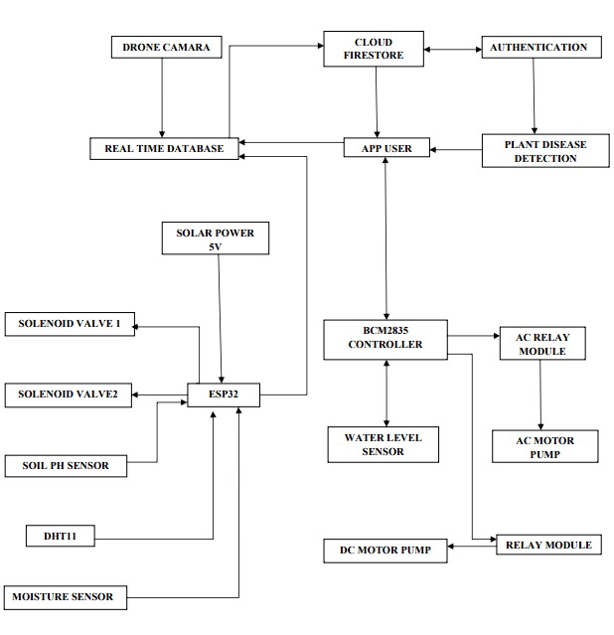

1. **HARDWARE**

**4.1 ESP32**

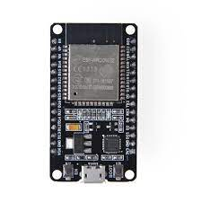

**Figure1**: Esp32

The ESP32 microcontroller is pivotal in agriculture due to its sensor compatibility with temperature, humidity, soil moisture, pH, and weather sensors. These sensors provide real-time environmental data crucial for crop monitoring and growth strategies. Additionally, the ESP32 supports Wi-Fi, Bluetooth, and LoRa for wireless data transmission to central systems or cloud platforms, facilitating real-time analysis and informed decision-making. Moreover, it enables remote monitoring via mobile apps or web interfaces, allowing farmers to track conditions, receive alerts for issues like water scarcity or extreme temperatures, and remotely control equipment such as irrigation systems and pumps.

**4.2 CAPACITIVE SOIL MOISTURE SENSOR**

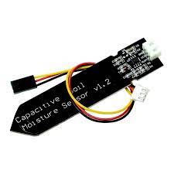

**Figure2:** Capacitive soil moisture sensor

Capacitive soil moisture sensors operate by measuring changes in soil dielectric constant as moisture content varies. They feature two electrodes that detect capacitance, with higher moisture leading to increased capacitance. These sensors excel in precise measurement, detecting minor moisture fluctuations crucial for efficient irrigation management. Their non-destructive nature allows long-term monitoring without soil damage. Moreover, they seamlessly integrate with IoT platforms, enabling automated data collection and irrigation scheduling for optimized crop health and yield.

**4.3 WATER LEVEL SENSOR**

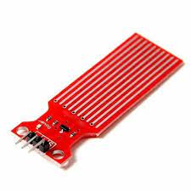

**Figure3 :** Water level sensor

**PRINCIPLE OF OPERATION:**

Float switches operate based on the buoyancy of the float, which changes with water levels, activating or deactivating a switch accordingly. Pressure transducers measure the hydrostatic pressure exerted by the water column, which correlates with the water depth. Capacitive sensors detect variations in capacitance caused by the water's presence between electrodes, allowing for precise water level detection.

**4.4 DHT22**

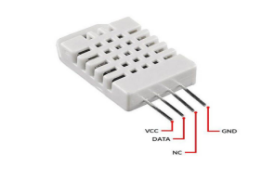

**Figure4:** Dht22

The DHT22 sensor comprises a capacitive humidity sensor and a thermistor for temperature measurement. The humidity sensor detects moisture-induced capacitance changes, providing digital relative humidity (RH) values. Known for high accuracy and stability, it operates on a single-wire digital interface protocol, facilitating integration with microcontrollers. This protocol sends digital data packets containing humidity and temperature information to the host system. Overall, the DHT22 offers precise and reliable readings for humidity and temperature monitoring applications.

**4.5 SOLENOID VALVE**

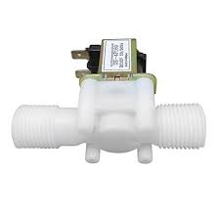

**Figure 5:** Solenoid Valve

A relay module serves as an electromechanical switch using an electromagnetic coil to control circuit switching. In irrigation systems it integrates with microcontrollers like Arduino or ESP32, acting as a switch for the power supply to pumps or valves. It connects to GPIO pins and power, receiving control signals from the microcontroller to turn water flow on or off. When the microcontroller sends a signal, the relay's coil energizes, switching the contacts and controlling the water flow. This setup allows automation based on schedules, sensor data or manual commands, optimizing irrigation efficiency and water usage.

**4.6 SOIL PH SENSOR**

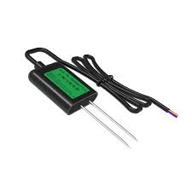

**Figure 6:** soil ph sensor

A soil pH sensor measures soil acidity or alkalinity using a probe inserted into the soil, based on ion concentration. The ESP32 integrates with the sensor, connecting to its pins for data acquisition. Analog sensors yield voltage proportional to pH, while digital sensors offer pH data directly. The ESP32 processes this data, enabling analysis for soil health assessments and crop suitability, aiding farmers with actionable insights.

**4.7 RELAY MODULE**

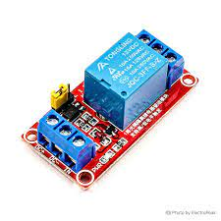

**Figure 7:** Relay Module

A relay module serves as an electromechanical switch using an electromagnetic coil to control circuit switching. It consists of a coil, normally open and normally closed contacts, and a switching mechanism. In irrigation systems, the relay module connects to a microcontroller like Arduino or ESP32, acting as a switch for the power supply to the irrigation pump or valve. Wiring involves connecting the relay module to GPIO pins and the power supply of the microcontroller. When the microcontroller sends a signal, the relay's coil energizes, switching the contacts to control water flow. Automation is achieved by programming the microcontroller to respond to sensor inputs or preset schedules, enabling tasks such as starting the pump based on soil moisture levels and stopping it when desired moisture levels are reached.

**4.8 BCM2835**

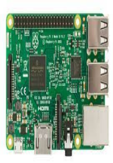

**Figure 8:** BCM2835

Raspberry Pi boards, powered by the BCM2835 SoC, facilitate sensor integration in smart agriculture, connecting various sensors like soil moisture, temperature, humidity, light, and pH sensors via GPIO pins. They collect and monitor data on soil conditions, weather, crop health, and environmental factors, enabling automation for irrigation, lighting, climate control, and livestock feeding. With networking capabilities, they support remote access for monitoring and management through web or mobile interfaces.

**4.9 DRONE CAMERAS**



**Figure 9: drone cameras**

Deep learning models, once trained, can run on Raspberry Pi boards for inference tasks like analyzing plant images for species classification, disease detection, growth stage assessment, or yield predictions based on environmental data. Drone cameras capture high-resolution aerial images, aiding in crop health monitoring, pest detection, and field condition assessment. Drones assist in detailed field mapping and surveying, providing valuable insights into land topography, soil variations, and drainage patterns, crucial for precision agriculture and efficient land management.

**4.10 SOLAR PANELS**

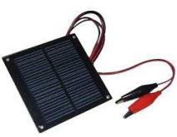

**Figure 10:** solar panels

The primary characteristic of 5V solar panels is their output voltage, which is typically around 5 volts when exposed to sunlight. This voltage level is suitable for charging or powering devices that require 5V DC input, such as microcontrollers, sensors, LED lights, and small electronic gadgets.

**4.11 RAIN SENSOR**

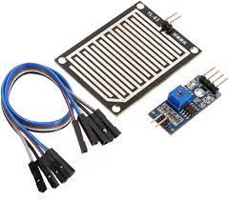

**Figure 11:** rain sensor

Rain sensors can detect the presence of rain and measure rainfall intensity. Some sensors can differentiate between light rain, moderate rain, and heavy rain based on the amount of water detected or the rate of rainfall. A typical rain sensor consists of sensing elements, a control circuit, and output interfaces. The sensing elements detect raindrops or water, and the control circuit processes the signal to determine rainfall intensity. The output interfaces may include digital signals, analog voltage levels, or communication protocols for interfacing with microcontroller or control systems.

**4.12 24V DC MOTOR PUMP**

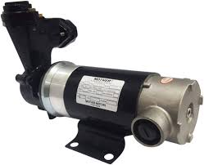

**Figure12:** dc motor pump

To operate a 24V DC motor pump with a Raspberry Pi, you'll use an L298N motor driver module for voltage and current control. Connect the motor driver to the Raspberry Pi's GPIO pins and the motor terminals, and link the power supply to the motor driver for the required voltage. Ensure the power supply can handle the motor's current needs. Exercise caution during wiring to avoid damaging components, verifying connections to prevent Raspberry Pi or motor damage.

**4.13 SOLAR AC MOTOR**

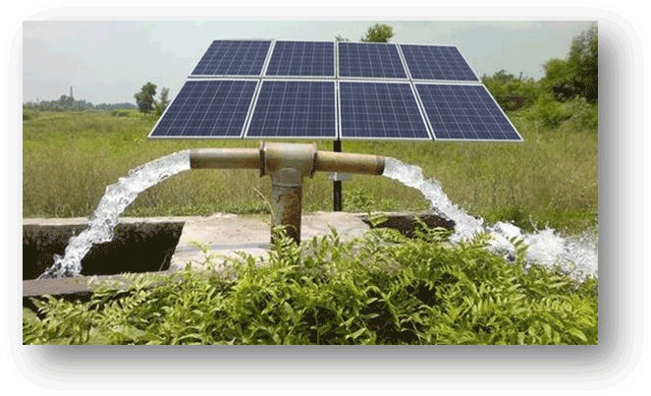

**Figure 13:** solar ac motor

To integrate a solar AC motor pump with a Raspberry Pi, first, ensure compatibility with your power source, considering single-phase or three-phase AC operation. Convert AC power from solar panels to suitable DC voltage for the Raspberry Pi using a power inverter or converter. Install a relay module to enable Raspberry Pi control via GPIO pins, ensuring it can handle the pump's voltage and current requirements for safe and reliable operation.

1. **RESULTS AND DISCUSSION**

Smart agriculture encompasses various technologies and tools aimed at improving agricultural practices and efficiency. Integrating Jupyter Notebook, Firebase cloud networking, Android Studio, Visual Studio, Flutter, IoT, image processing, and Proteus can create a robust system for modern farming.

**Jupyter Notebook:** Jupyter provides an interactive environment for data analysis, allowing farmers to analyze agricultural data, such as crop yield, weather patterns, and soil conditions. It facilitates data-driven decision-making for optimizing crop production.

**Firebase Cloud Networking:** Firebase offers cloud services for real-time data storage, synchronization, and sharing. In smart agriculture, Firebase can store sensor data from IoT devices deployed in the field, enabling remote monitoring and control of farm operations.

**Android Studio and Visual Studio:** These IDEs are used to develop mobile and desktop applications for farm management. Farmers can access real-time data, receive alerts, and control devices through user-friendly interfaces developed using these platforms.

**Flutter:** Flutter is a framework for building cross-platform mobile apps. Farmers can use Flutter to create mobile applications that provide insights into crop health, pest detection, irrigation scheduling, and machinery control, enhancing operational efficiency.

**IoT (Internet of Things):** IoT devices such as sensors, actuators, and drones play a crucial role in smart agriculture. They collect data on soil moisture, temperature, humidity, and crop health, allowing farmers to implement precision farming techniques and optimize resource utilization.

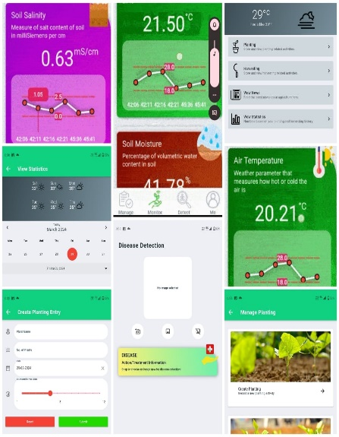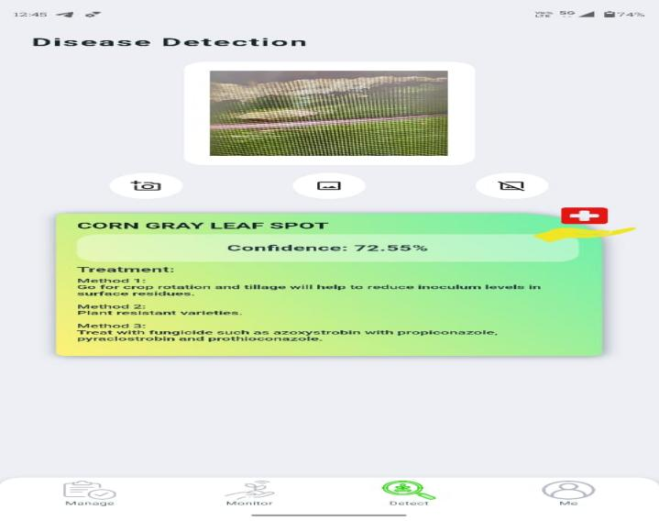

**Figure 14:** app result **Figure 15:** image result

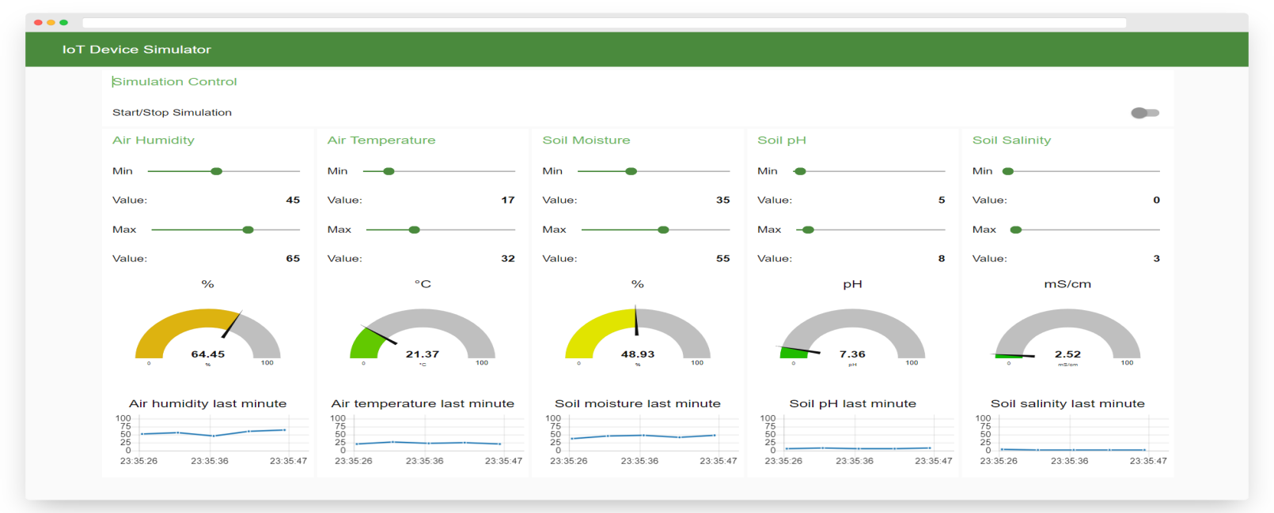

**Figure 15:** iot monitoring

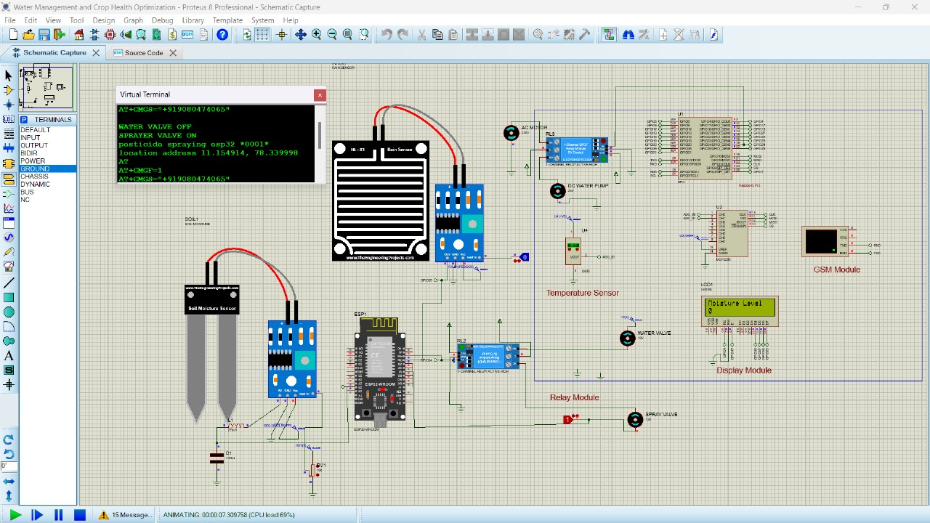

**Figure 16: simulation output**

1. **CONCLUSION**

Smart agriculture represents a transformative paradigm in modern farming, harnessing technology to optimize crop production, minimize resource usage, and enhance sustainability. Leveraging tools like Jupyter Notebook, Firebase cloud networking, Android Studio, Visual Studio, Flutter, IoT, image processing, and Proteus, agricultural practices are becoming more data-driven, efficient, and scalable. By integrating these technologies, farmers can monitor and manage crop health, soil conditions, and environmental factors in real time. This leads to informed decision-making, reduced waste, increased productivity, and improved crop quality. Additionally, smart agriculture fosters greater connectivity between farmers, researchers, and stakeholders, facilitating knowledge sharing and innovation. As we embrace the potential of smart agriculture, we pave the way for a more resilient and sustainable food system. Through continuous advancements and collaboration across disciplines, smart agriculture holds the key to addressing global challenges such as food security, climate change adaptation, and resource conservation, ensuring a brighter and more prosperous future for agriculture and society as a whole.

**7. REFERENCES**

[1] Barenkamp, Marco. "A new IoT gateway for artificial intelligence in agriculture." *2020 International Conference on Electrical, Communication, and Computer Engineering (ICECCE)*. IEEE, 2020.

[2] Hassan, Syeda Iqra, et al. "A systematic review on monitoring and advanced control strategies in smart agriculture." *Ieee Access* 9 (2021): 32517-32548.

[3] Patrizi, Gabriele, et al. "A virtual soil moisture sensor for smart farming using deep learning." *IEEE Transactions on Instrumentation and Measurement* 71 (2022): 1-11.

[4] Singh, Ritesh Kumar, Rafael Berkvens, and Maarten Weyn. "AgriFusion: An architecture for IoT and emerging technologies based on a precision agriculture survey." *IEEE Access* 9 (2021): 136253-136283.

[5] Chen, Ching-Ju, et al. "An AIoT based smart agricultural system for pests detection." *IEEE Access* 8 (2020): 180750-180761.

[6] AlZubi, Ahmad Ali, and Kalda Galyna. "Artificial intelligence and internet of things for sustainable farming and smart agriculture." *IEEE Access* (2023).

[7] Elbasi, Ersin, et al. "Artificial intelligence technology in the agricultural sector: a systematic literature review." *Ieee Access* 11 (2022): 171-202.

[8] Bruno, Claudia, et al. "Embedded artificial intelligence approach for gas recognition in smart agriculture applications using low cost mox gas sensors." *2021 Smart Systems Integration (SSI)*. IEEE, 2021.

[9] Adami, Davide, Mike O. Ojo, and Stefano Giordano. "Design, development and evaluation of an intelligent animal repelling system for crop protection based on embedded edge-AI." *IEEE Access* 9 (2021): 132125-132139.

[10] Friha, Othmane, et al. "Internet of things for the future of smart agriculture: A comprehensive survey of emerging technologies." *IEEE/CAA Journal of Automatica Sinica* 8.4 (2021): 718-752.

[11] AshifuddinMondal, Md, and Zeenat Rehena. "Iot based intelligent agriculture field monitoring system." *2018 8th International Conference on Cloud Computing, Data Science & Engineering (Confluence)*. IEEE, 2018.

[12] Qazi, Sameer, Bilal A. Khawaja, and Qazi Umar Farooq. "IoT-equipped and AI-enabled next generation smart agriculture: A critical review, current challenges and future trends." *Ieee Access* 10 (2022): 21219-21235.

[13] Anand, Tanmay, et al. "AgriSegNet: Deep aerial semantic segmentation framework for IoT-assisted precision agriculture." *IEEE Sensors Journal* 21.16 (2021): 17581-17590.

[14] Sarma, Kandarpa Kumar, et al. "Learning aided system for agriculture monitoring designed using image processing and IoT-CNN." *IEEE Access* 10 (2022): 41525-41536.

[15] Chukkapalli, Sai Sree Laya, et al. "Ontologies and artificial intelligence systems for the cooperative smart farming ecosystem." *Ieee Access* 8 (2020): 164045-164064.

[16] Gupta, Maanak, et al. "Security and privacy in smart farming: Challenges and opportunities." *IEEE access* 8 (2020): 34564-34584.

[17] Heble, Soumil, et al. "A low power IoT network for smart agriculture." *2018 IEEE 4th World Forum on Internet of Things (WF-IoT)*. IEEE, 2018.